**Java Spring Boot Restful Intro**

URL:[**https://springdoc.org/#getting-started**](https://springdoc.org/#getting-started)

**Getting Started**

For the integration between spring-boot and swagger-ui, add the library to the list of your project dependencies (No additional configuration is needed)

**<dependency>**

**<groupId>org.springdoc</groupId>**

**<artifactId>springdoc-openapi-starter-webmvc-ui</artifactId>**

**<version>2.6.0</version>**

**</dependency>**

This will automatically deploy [swagger-ui](https://springdoc.org/) to a [spring-boot](https://springdoc.org/) application:

* Documentation will be available in HTML format, using the official [swagger-ui jars](https://github.com/swagger-api/swagger-ui.git)
* The Swagger UI page will then be available at

<http://server:port/context-path/swagger-ui.html>

Open API description will be available at the following URL for Json format:

<http://server:port/context-path/v3/api-docs>

server: The server’s name or IP

port: The server port

context-path: The context path of the application

* Documentation can be available in yaml format as well, on the following path: /v3/api-docs.yaml

|  |  |
| --- | --- |
|  | For custom path of the [swagger](https://springdoc.org/) documentation in HTML format, add a custom springdoc property,  in your [spring-boot](https://springdoc.org/) configuration file: |

**Create a controller inside controller folder and insert this code**

package org.studyeasy.SpringRestdemo.controller;

import org.springframework.web.bind.annotation.GetMapping;

import org.springframework.web.bind.annotation.RestController;

@RestController

public class AccountController {

    @GetMapping("/")

    public String demo(){

        return "Hello World!..";

    }

}

**Output**

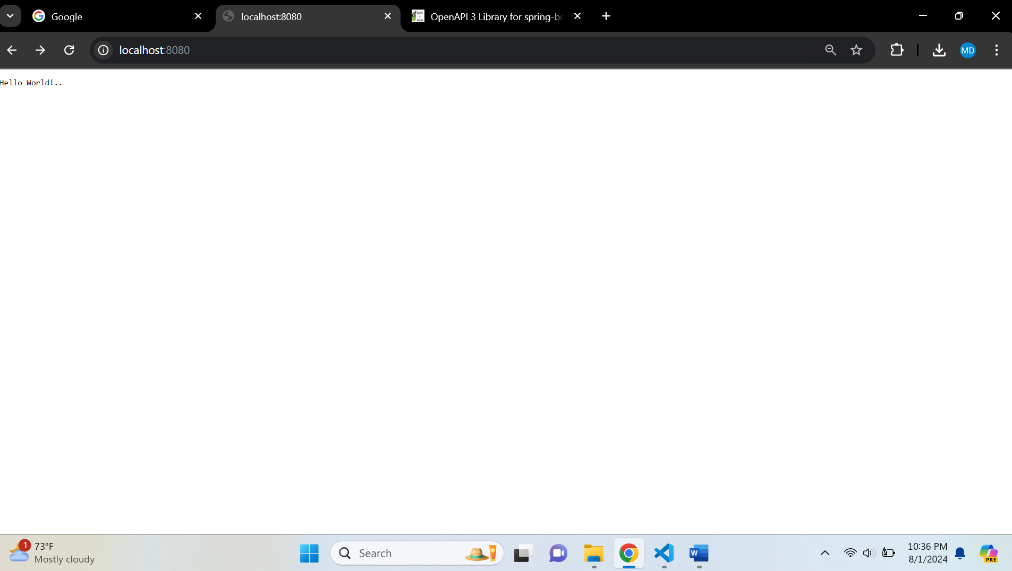

**After in json format**

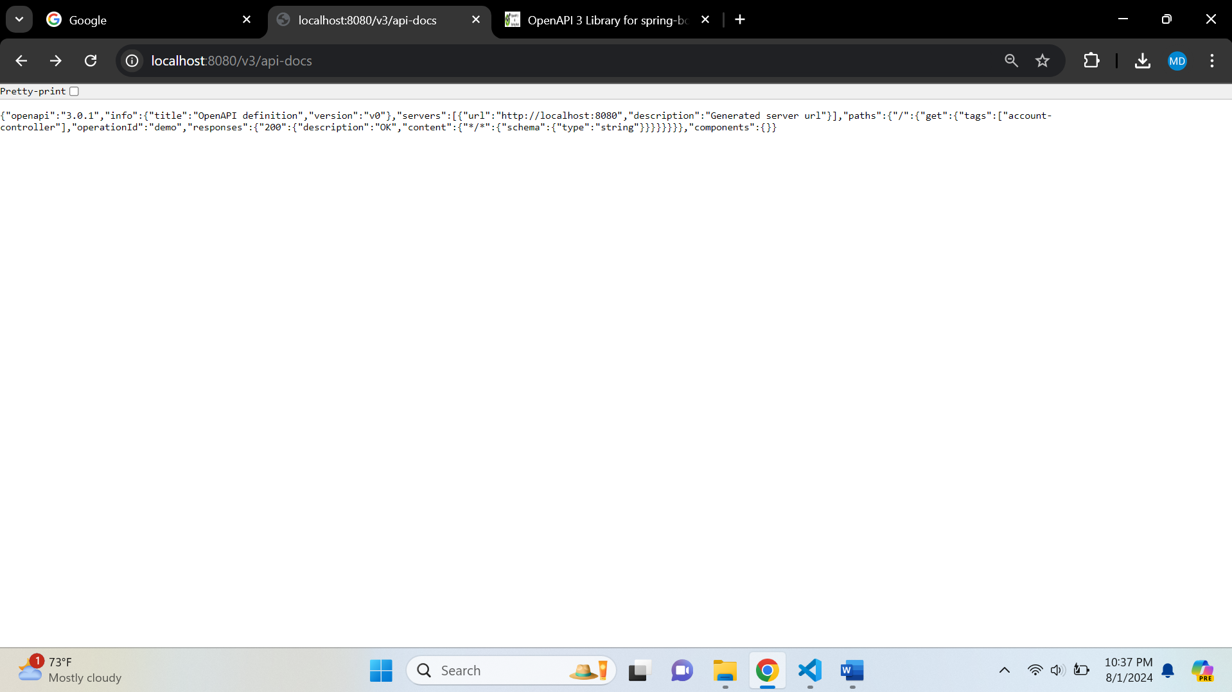

**Swagger UI**

