**Java Spring Boot Restful – OAuth2 - Getting Started with JWT**

Add this piece of code in SecurityConfig.java

.oauth2ResourceServer(oauth2 -> oauth2

     .jwt(Customizer.withDefaults()))

     .sessionManagement(session -> session

     .sessionCreationPolicy(SessionCreationPolicy.STATELESS));

  @Bean

    public SecurityFilterChain securityFilterChain(HttpSecurity http) throws Exception {

        http

                .authorizeHttpRequests(customizer -> customizer

                        .requestMatchers("/token").permitAll()

                        .requestMatchers("/").permitAll()

                        .requestMatchers("/swagger-ui/**").permitAll()

                        .requestMatchers("/v3/api-docs/**").permitAll()

                        .requestMatchers("/test").authenticated())

                .oauth2ResourceServer(oauth2 -> oauth2

                        .jwt(Customizer.withDefaults()))

                .sessionManagement(session -> session

                        .sessionCreationPolicy(SessionCreationPolicy.STATELESS));

        return http.build();

    }

This means enabling the OAuth resource server.

This means our backend will act as a OAuth server and it will be give us a token whenever there is requirement.

After executing, you get below error

**Consider defining a bean of type 'org.springframework.security.oauth2.jwt.JwtDecoder' in your configuration.**

**Java decoder**

 @Bean

  JwtDecoder jwtDecoder() {

     return NimbusJwtDecoder.withPublicKey(rsaKeys.publicKey()).build();

  }

**Rsa keys**

**Create a file in the resources folder -> certs**

chaand@Lenovo:/mnt/d/RECYCLE BIN EXTRAS/ONLY_DOCS/JavaUdemy/Java_SpringBootMiniProject_Restful_02/SpringRestdemo_04_OAuth2_JWT_GettingStarted$ cd src/main/resources/certs

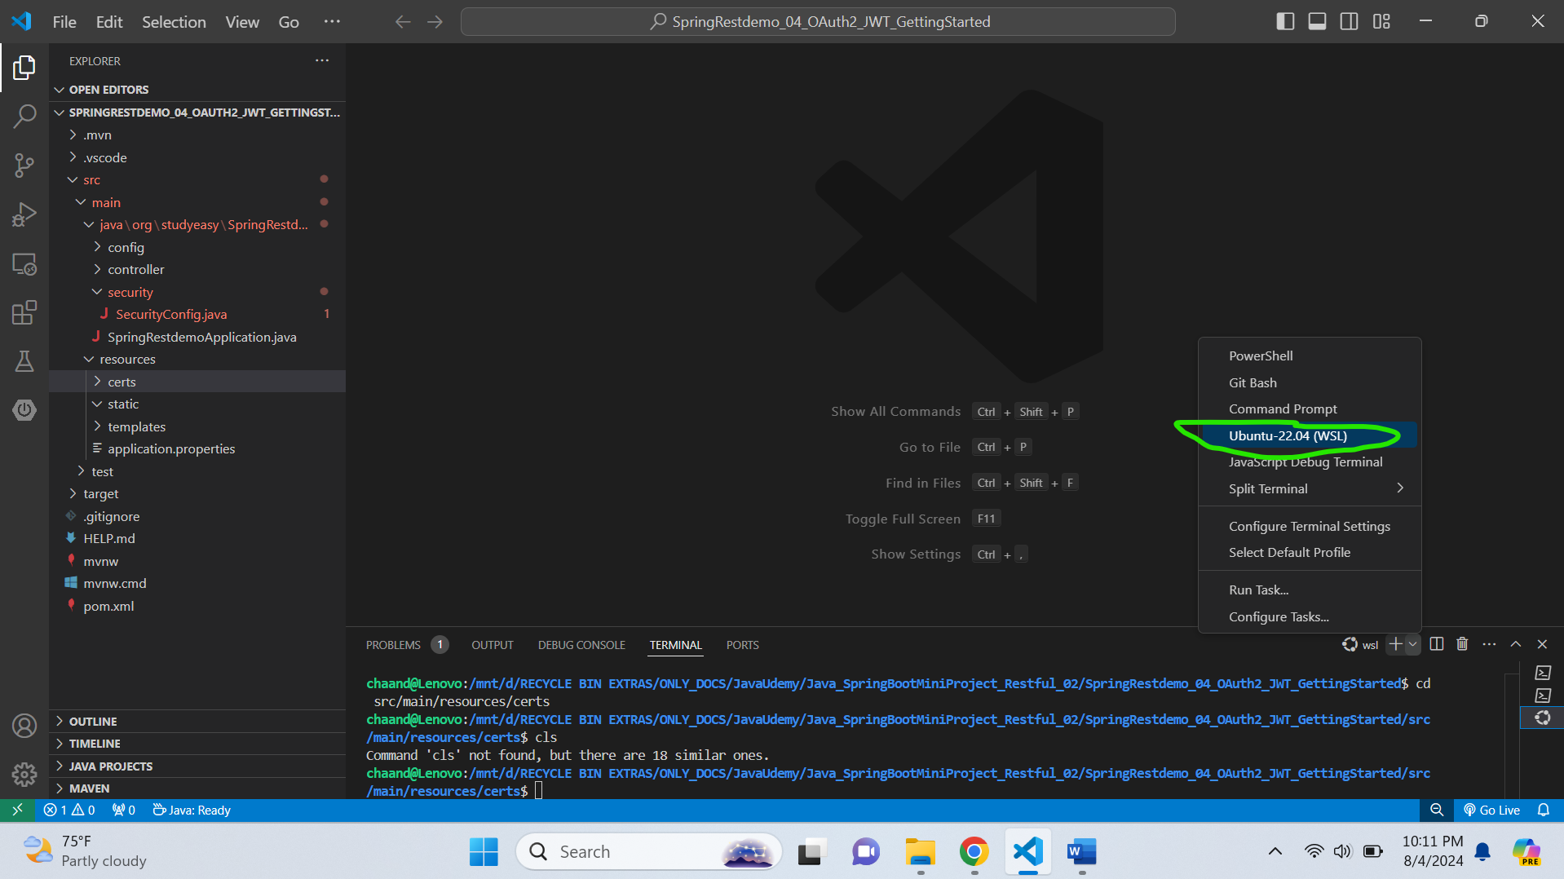

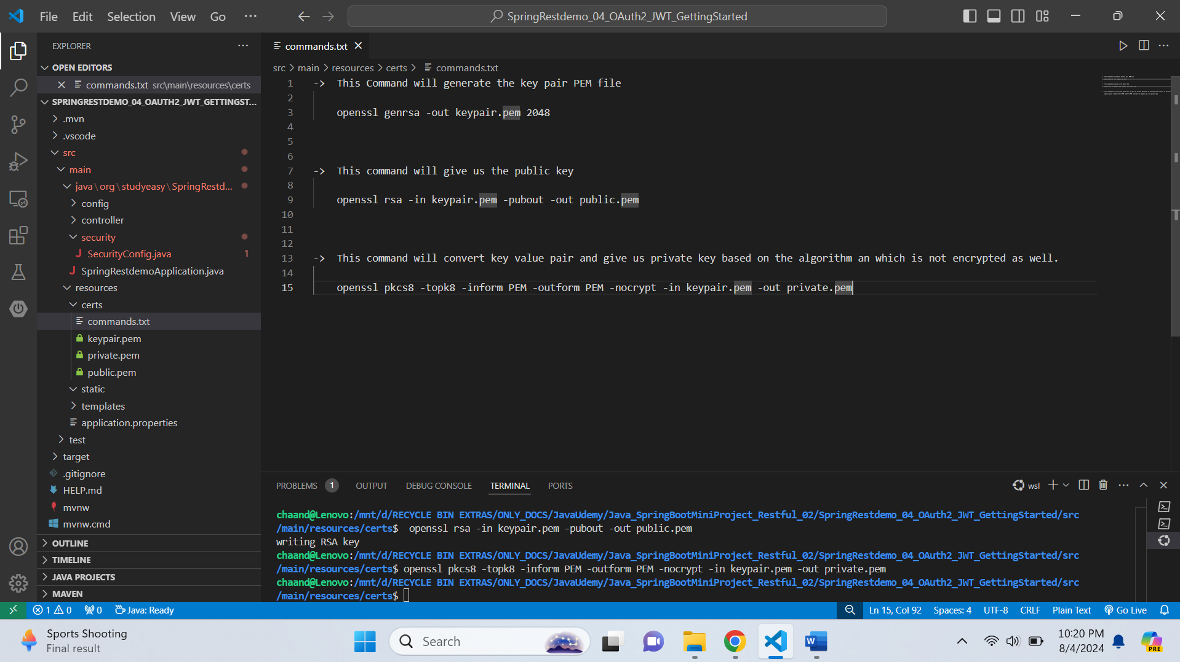

**RsaKeyProperties.java**

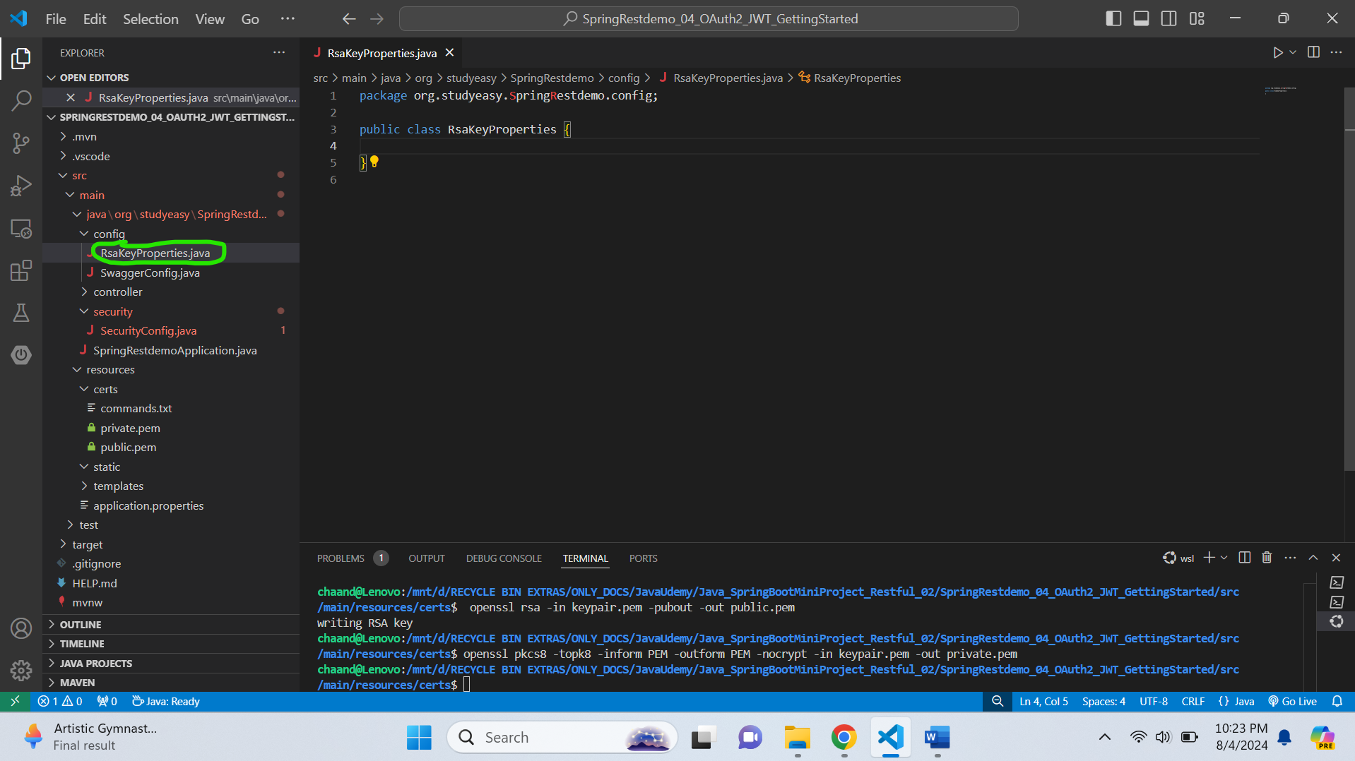

**RsaKeyProperties.java**

package org.studyeasy.SpringRestdemo.config;

import org.springframework.boot.context.properties.ConfigurationProperties;

import java.security.interfaces.RSAPrivateKey;

import java.security.interfaces.RSAPublicKey;

@ConfigurationProperties(prefix = "rsa")

public record RsaKeyProperties(RSAPublicKey publicKey, RSAPrivateKey privateKey) {

}

**Initialize the RSA Key -> Add this code in the SecurityConfig.java**

 private final RsaKeyProperties rsaKeys;

 public SecurityConfig(RsaKeyProperties rsaKeys) {

       this.rsaKeys = rsaKeys;

 }

**Output**

Consider defining a bean of type 'org.studyeasy.SpringRestdemo.config.RsaKeyProperties' in your configuration.

**Add an encoder**

  @Bean

  JwtEncoder jwtEncoder() {

      JWK jwk = new RSAKey.Builder(rsaKeys.publicKey()).privateKey(rsaKeys.privateKey()).build();

      JWKSource<SecurityContext> jwks = new ImmutableJWKSet<>(new JWKSet(jwk));

      return new NimbusJwtEncoder(jwks);

  }

**Authentication Manager is handled by spring.**

**Final Source Code of SecurityConfig.java**

package org.studyeasy.SpringRestdemo.security;

import org.springframework.context.annotation.Bean;

import org.springframework.context.annotation.Configuration;

import org.springframework.security.config.Customizer;

import org.springframework.security.config.annotation.web.builders.HttpSecurity;

import org.springframework.security.config.annotation.web.configuration.EnableWebSecurity;

import org.springframework.security.config.http.SessionCreationPolicy;

import org.springframework.security.core.userdetails.User;

import org.springframework.security.oauth2.jwt.JwtDecoder;

import org.springframework.security.oauth2.jwt.JwtEncoder;

import org.springframework.security.oauth2.jwt.NimbusJwtDecoder;

import org.springframework.security.oauth2.jwt.NimbusJwtEncoder;

import org.springframework.security.provisioning.InMemoryUserDetailsManager;

import org.springframework.security.web.SecurityFilterChain;

import org.studyeasy.SpringRestdemo.config.RsaKeyProperties;

import com.nimbusds.jose.jwk.JWK;

import com.nimbusds.jose.jwk.JWKSet;

import com.nimbusds.jose.jwk.RSAKey;

import com.nimbusds.jose.jwk.source.ImmutableJWKSet;

import com.nimbusds.jose.jwk.source.JWKSource;

import com.nimbusds.jose.proc.SecurityContext;

@Configuration

@EnableWebSecurity

public class SecurityConfig {

        private final RsaKeyProperties rsaKeys;

        public SecurityConfig(RsaKeyProperties rsaKeys) {

                this.rsaKeys = rsaKeys;

        }

        @Bean

        public InMemoryUserDetailsManager users() {

                return new InMemoryUserDetailsManager(

                     User.withUsername("chaand")

                           .password("{noop}password")

                           .authorities("read")

                           .build());

        }

        @Bean

        JwtDecoder jwtDecoder() {

                Return NimbusJwtDecoder.withPublicKey(rsaKeys.publicKey()).build();

        }

        @Bean

        JwtEncoder jwtEncoder() {

              JWK jwk = new RSAKey.Builder(rsaKeys.publicKey()).privateKey(rsaKeys.privateKey()).build();

           JWKSource<SecurityContext> jwks = new ImmutableJWKSet<>(new JWKSet(jwk));

        return new NimbusJwtEncoder(jwks);

        }

        @Bean

        public SecurityFilterChain securityFilterChain(HttpSecurity http) throws Exception {

                http

                .authorizeHttpRequests(customizer -> customizer

                .requestMatchers("/token").permitAll()

                .requestMatchers("/").permitAll()

                .requestMatchers("/swagger-ui/**").permitAll()

                .requestMatchers("/v3/api-docs/**").permitAll()

                .requestMatchers("/test").authenticated())

                .oauth2ResourceServer(oauth2 -> oauth2

                    .jwt(Customizer.withDefaults()))

                .sessionManagement(session -> session .sessionCreationPolicy(SessionCreationPolicy.STATELESS));

                return http.build();

        }

}