**Java Spring Boot Restful – OAuth2 – JWT – Token Generator**

How to secure?

 @SecurityRequirement(name = "studyeasy-demo-api")

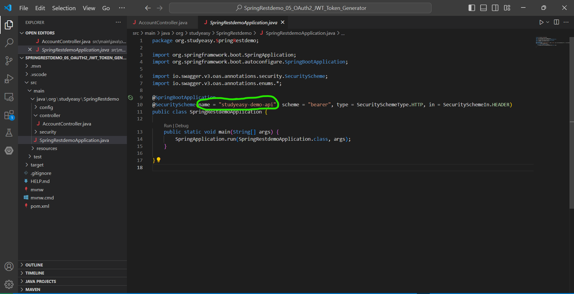

**Go to AccountController -> modify code**

@GetMapping("/test")

    @SecurityRequirement(name = "studyeasy-demo-api")

    public String test(){

        return "Test api..";

    }

**Tag – Add some description or name to a specific tag.**

@Tag(name = "Test", description = "The Test API.")

 @GetMapping("/test")

    @Tag(name = "Test", description = "The Test API.")

    @SecurityRequirement(name = "studyeasy-demo-api")

    public String test(){

        return "Test api..";

    }

**Authentication Manager**

@Bean

public AuthenticationManager authManager(UserDetailsService userDetailsService) {

      var authProvider = new DaoAuthenticationProvider();

       authProvider.setUserDetailsService(userDetailsService);

       return new ProviderManager(authProvider);

}

**Create a controller in controller folder -> AuthController.java and in order to create a token you need to generate a service as well -> new folder -> service**

**New file -> TokenService.java**

**TokenService.java**

package org.studyeasy.SpringRestdemo.service;

import java.time.Instant;

import java.time.temporal.ChronoUnit;

import java.util.stream.Collectors;

import org.springframework.security.core.Authentication;

import org.springframework.security.core.GrantedAuthority;

import org.springframework.security.oauth2.jwt.JwtClaimsSet;

import org.springframework.security.oauth2.jwt.JwtEncoder;

import org.springframework.security.oauth2.jwt.JwtEncoderParameters;

public class TokenService {

    private final JwtEncoder encoder;

    public TokenService(JwtEncoder encoder){

        this.encoder = encoder;

    }

    public String generateToken(Authentication authentication){

        Instant now = Instant.now();

        String scope = authentication.getAuthorities().stream()

                       .map(GrantedAuthority::getAuthority)

                       .collect(Collectors.joining(" "));

        JwtClaimsSet claims = JwtClaimsSet.builder()

                              .issuer("self")

                              .issuedAt(now)

                              .expiresAt(now.plus(1, ChronoUnit.HOURS))

                              .subject(authentication.getName())

                              .claim("scope", scope)

                              .build();

        return this.encoder.encode(JwtEncoderParameters.from(claims)).getTokenValue();

    }

}

**AuthController.java**

package org.studyeasy.SpringRestdemo.controller;

import org.springframework.web.bind.annotation.PostMapping;

import org.springframework.web.bind.annotation.RestController;

@RestController

public class AuthController {

    @PostMapping("/token")

    public String token(){

    }

}