* Arrays

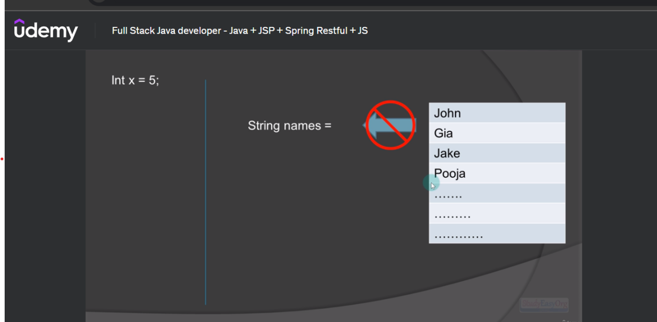



* Points to Remember:-
* All the elements in the array should be of same data type.
* All the elements are stored in adjustment memory location for a quicker and convienient access.
* Intialization of Array:-
* Syntax:- <name of datatype>[] <name of variable> = {val1,val2...};
* Example:

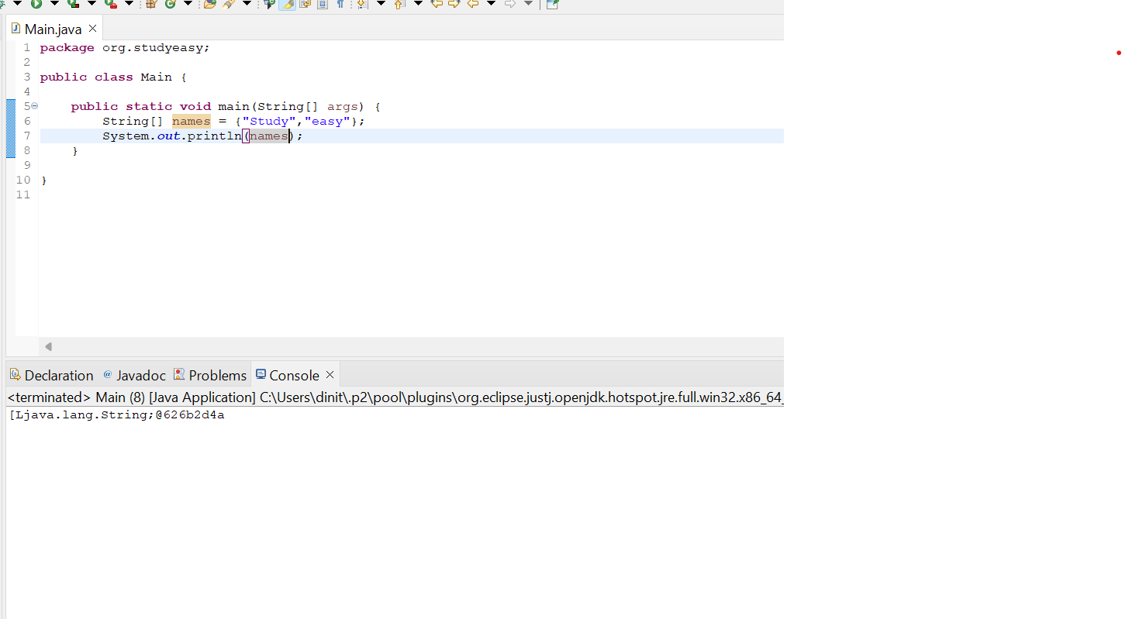

Base Address of Array Element

The indices always start from zero. If you want to access array element use indices([]).

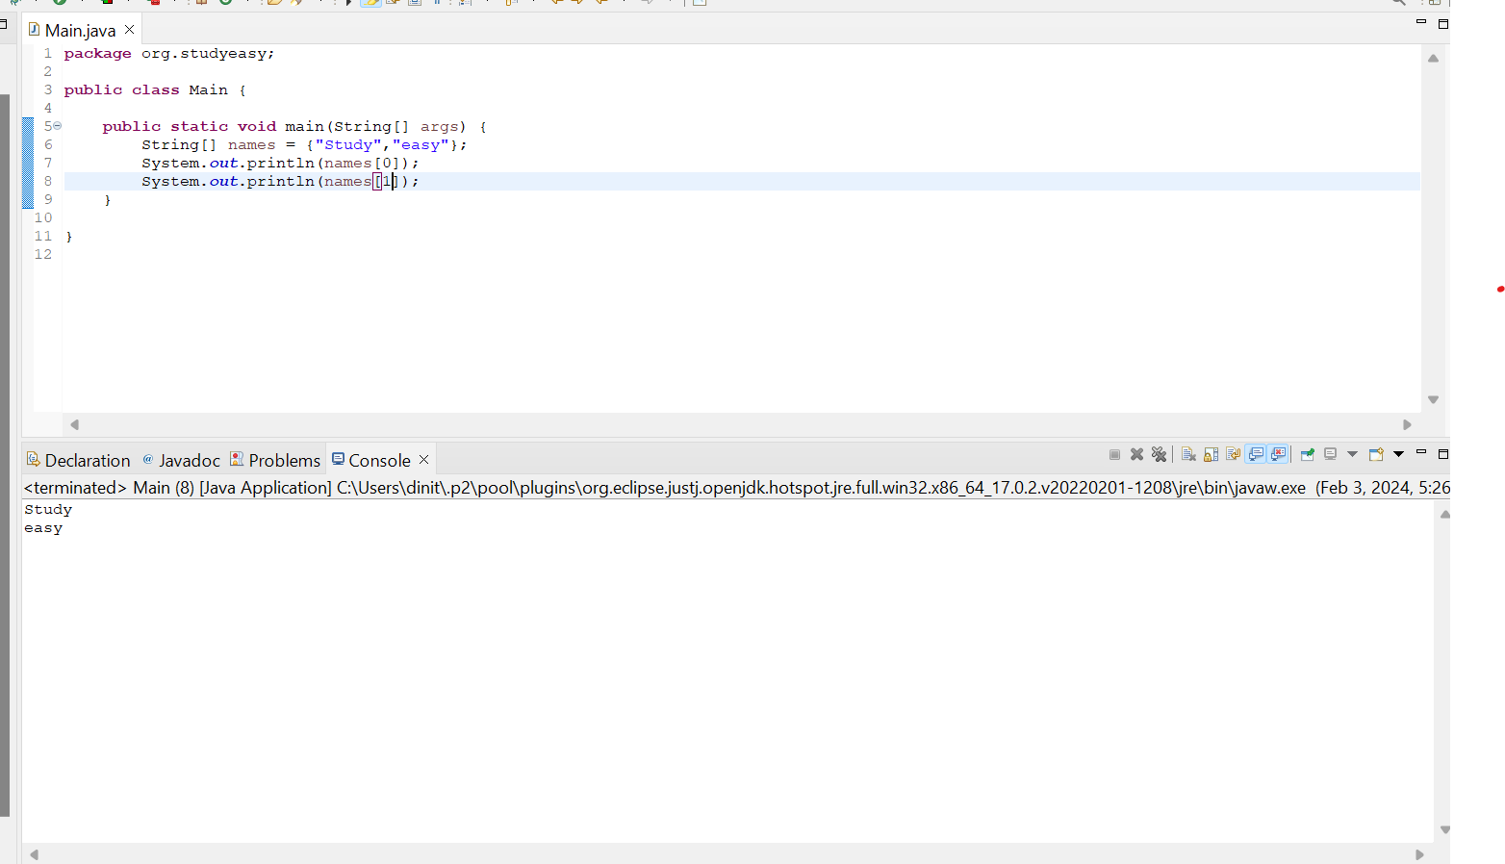

If you are trying to access the element which is not present, then you get an exception which is unchecked exception - ArrayIndexOutOfBound Exception.

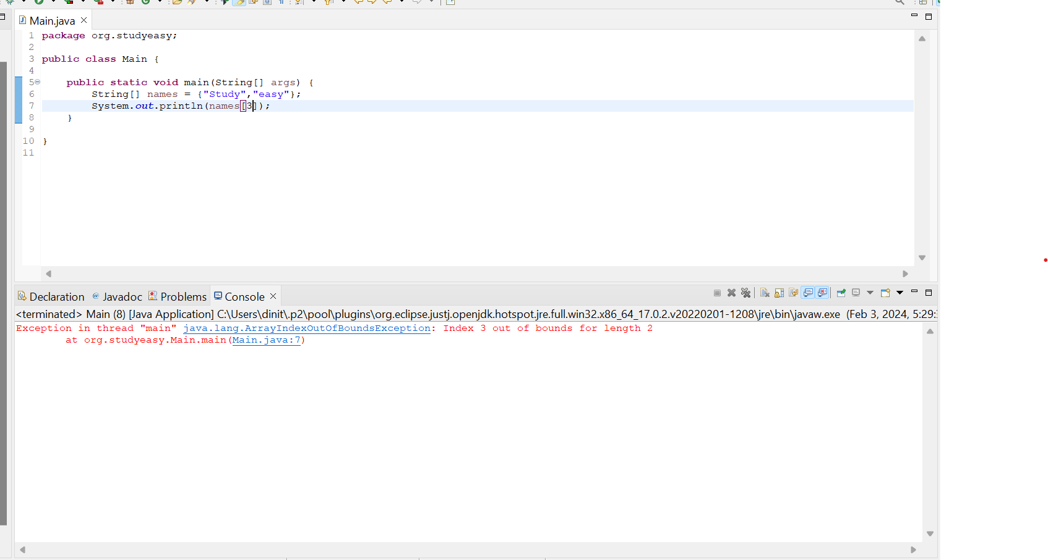

Without Intializing

What happens if we do not mention the length of the array? Then we get below error.

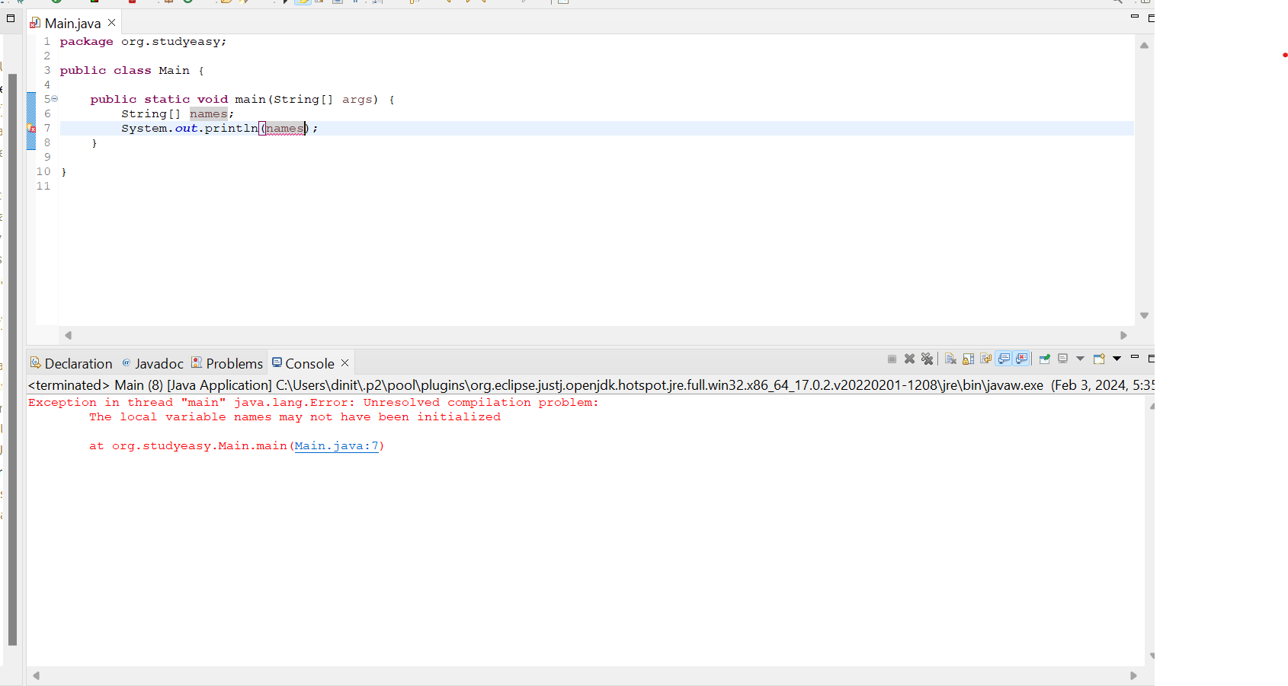

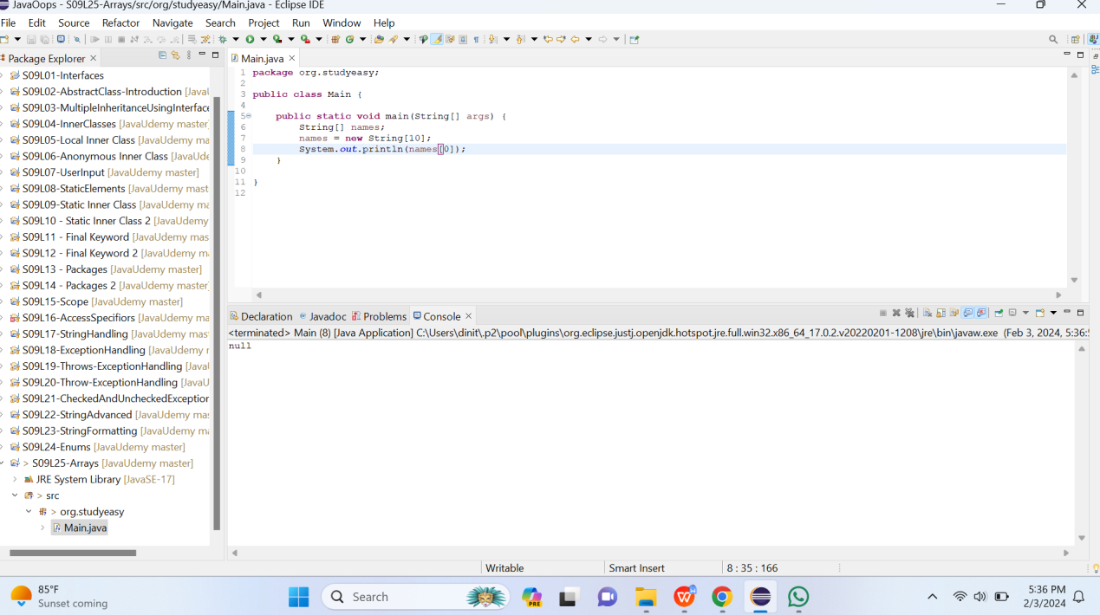

If value not assigned then, Java will assign null to all values for the specified length.

If we try to run the program where index is out of array, then we get the error stating that Index 10 out of bound.Below show is an example.(String -> default value -> null)

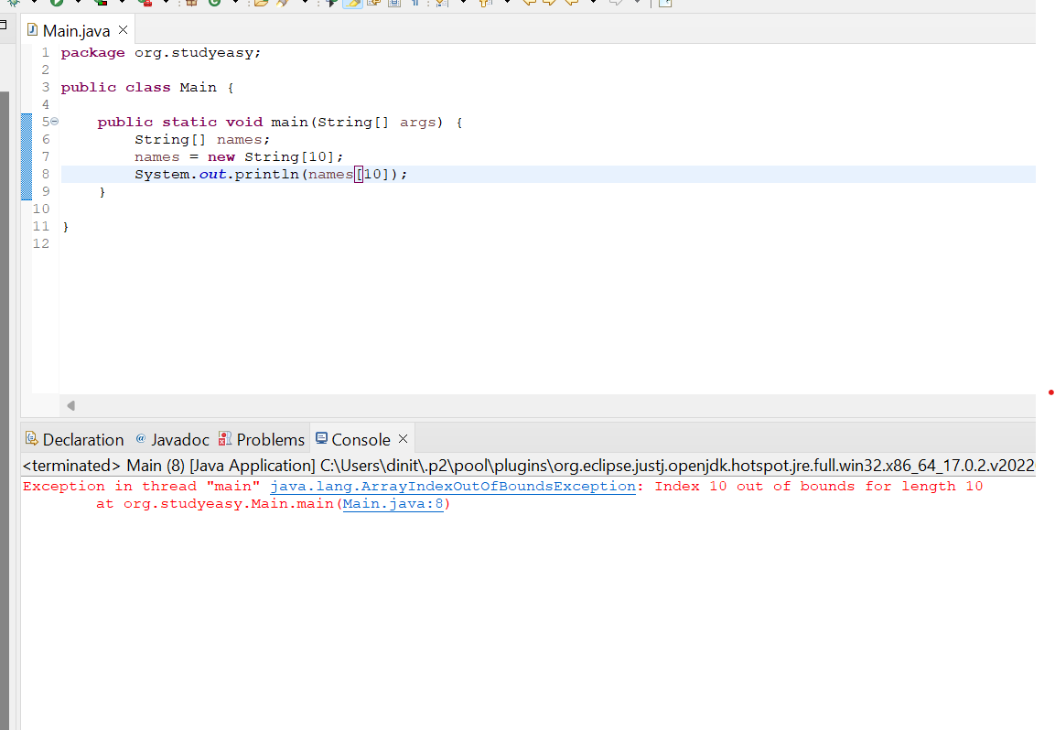

Assigning the values to the array:-

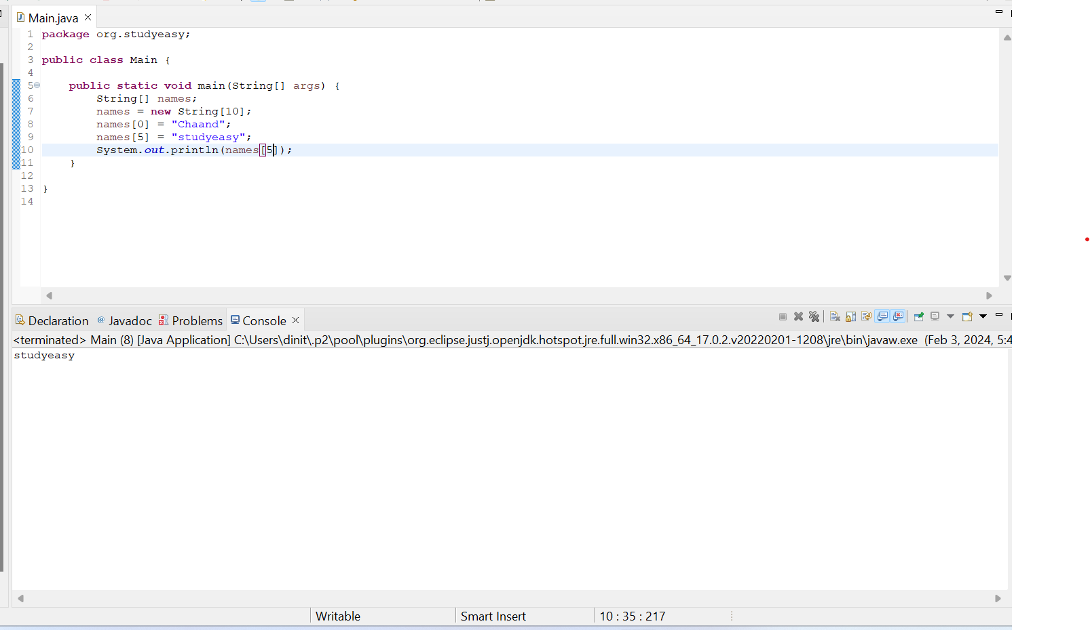

If we do not specify any value to the string array, then his what happens! (int Data Type -> default value -> 0)

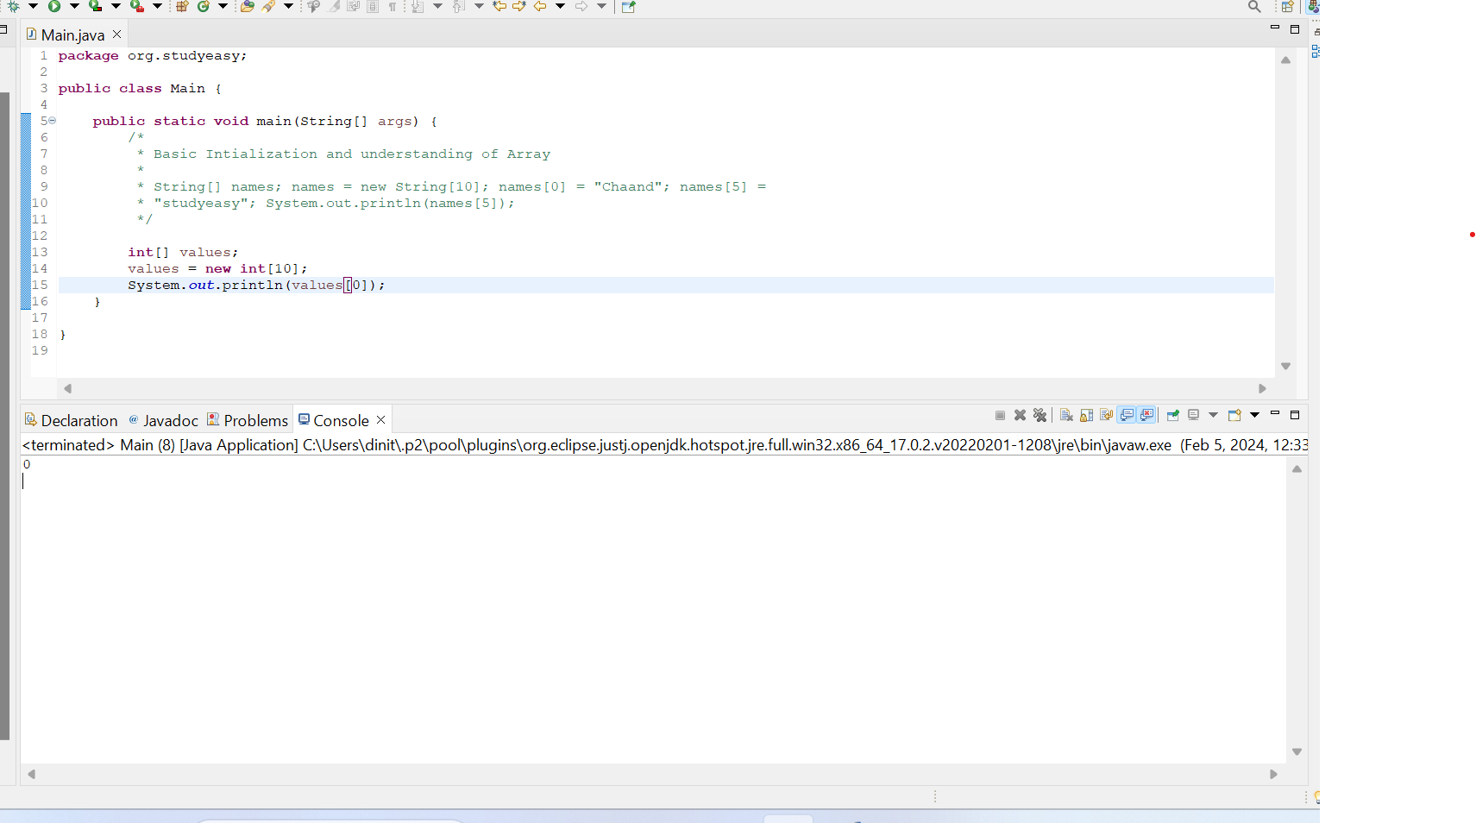

If we do not specify any value to the string array, then his what happens! (float Data Type -> default value -> 0.0)

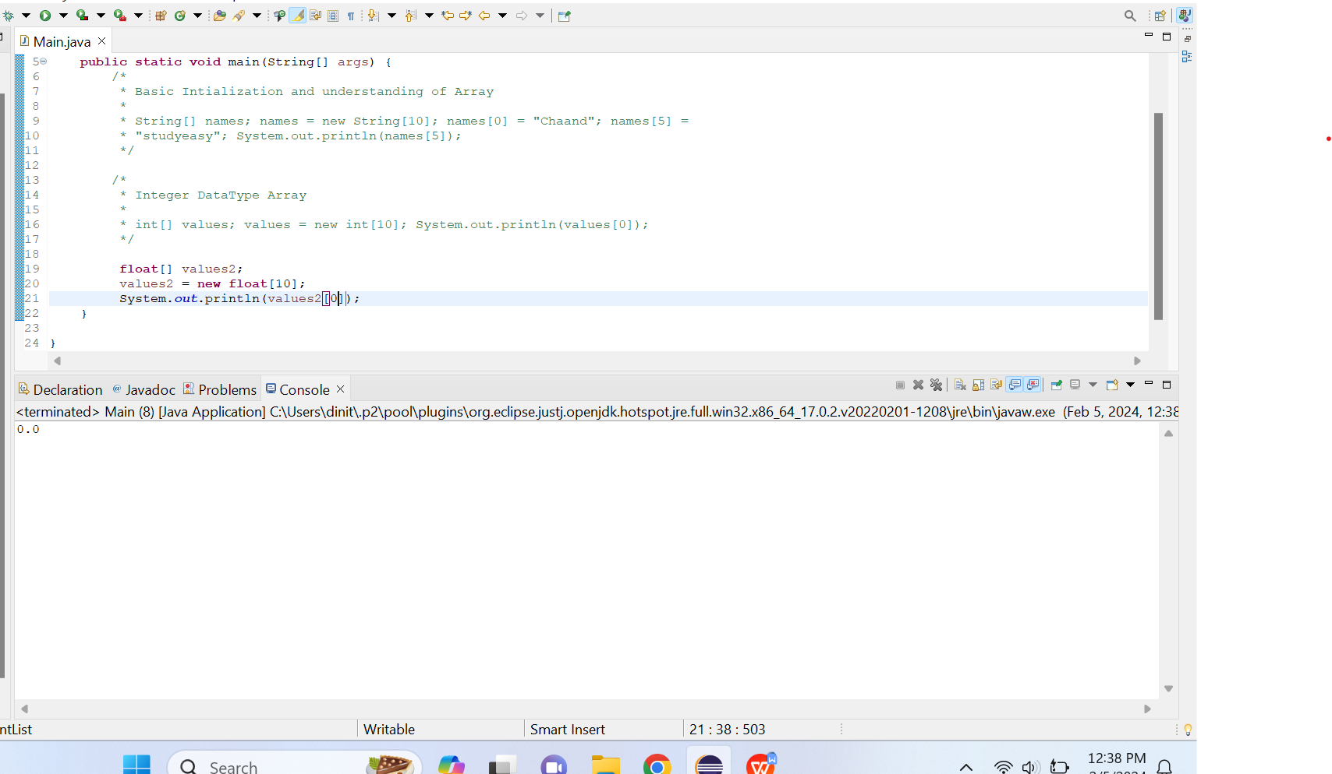

Assigning the values to the double type

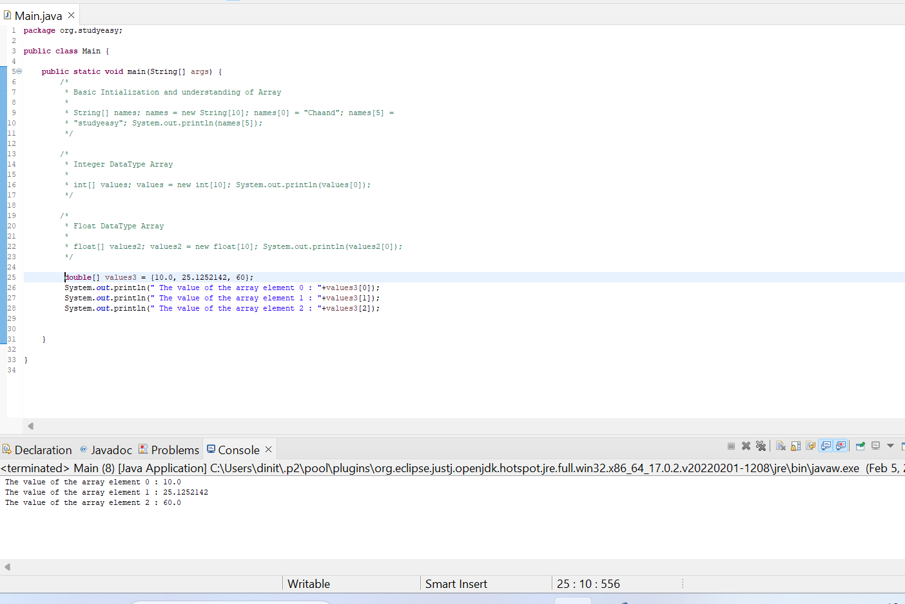

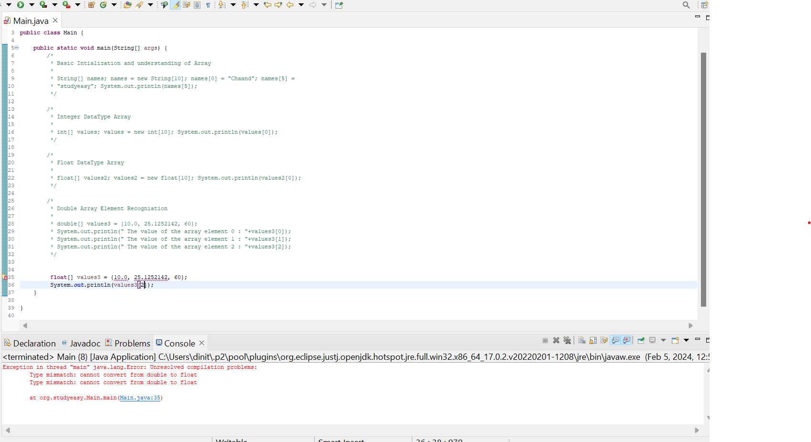

What’s going on here? Why there is error? Its because if we create 10.0, it will be double value. As a result we should explictly specify the literal f to floating point number.Refer below screenshot.

