**ReactJS_104_TokenValidationsAndRedirections**

**React Router DOM Installation**

npm i react-router-dom

**React Output Token**

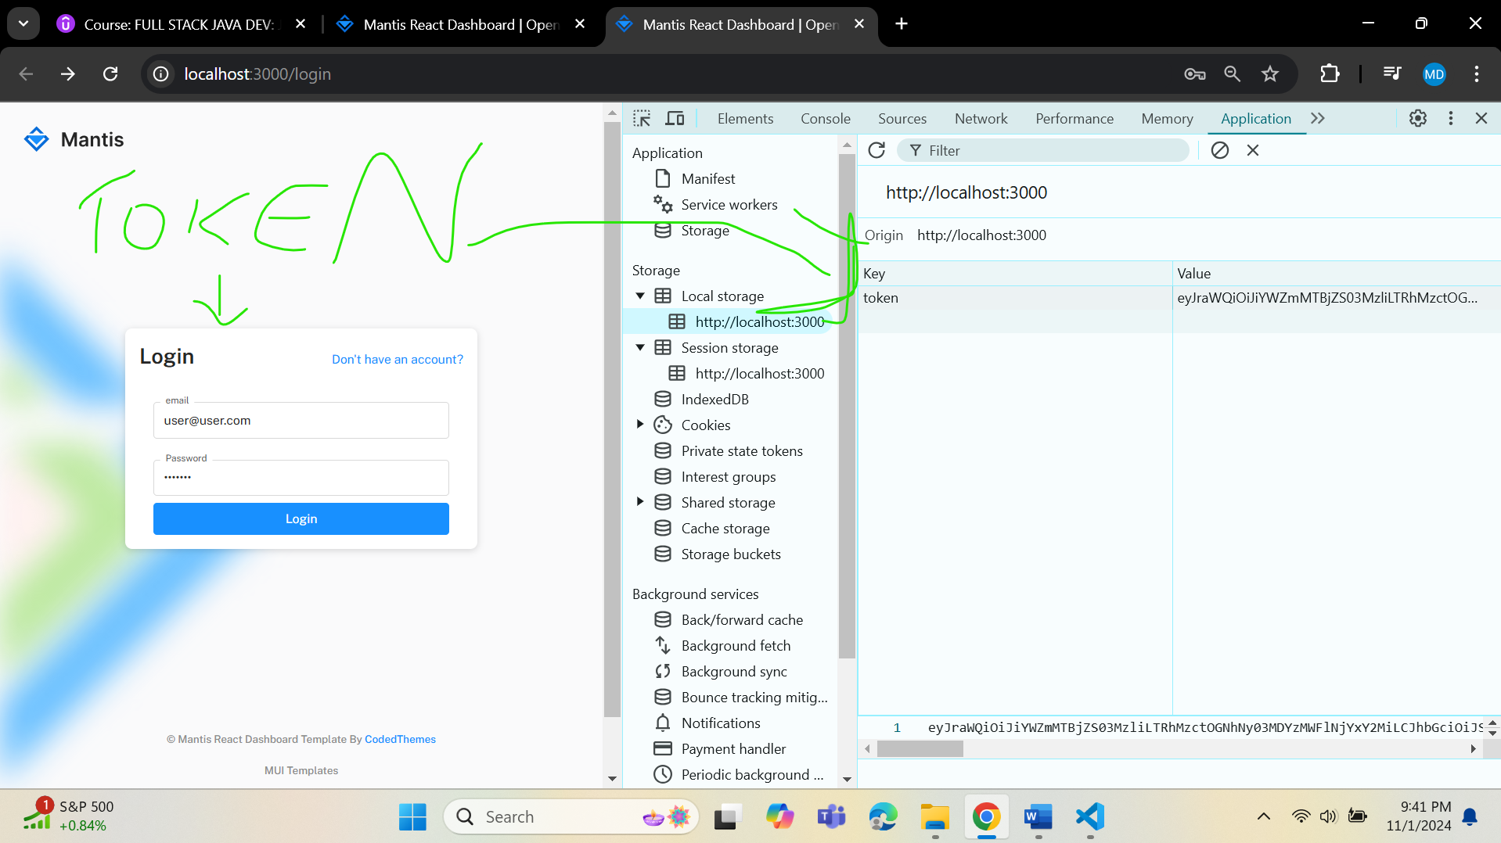

**AuthLogin.js**

 useEffect(() => {

    const isLoggedIn = localStorage.getItem('token');

    if(isLoggedIn){

      navigate('/');

    }

  },[]); //The empty dependancy array ensures that the effect runs only once,on mount