Parts Inside a Computer

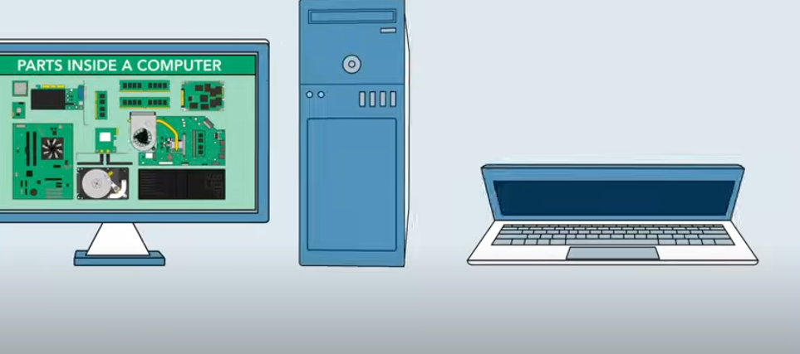

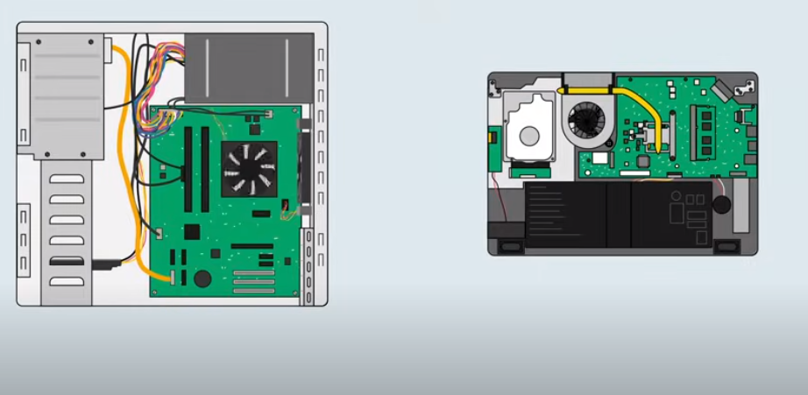

Various Components Inside A Computer

**MotherBoard**

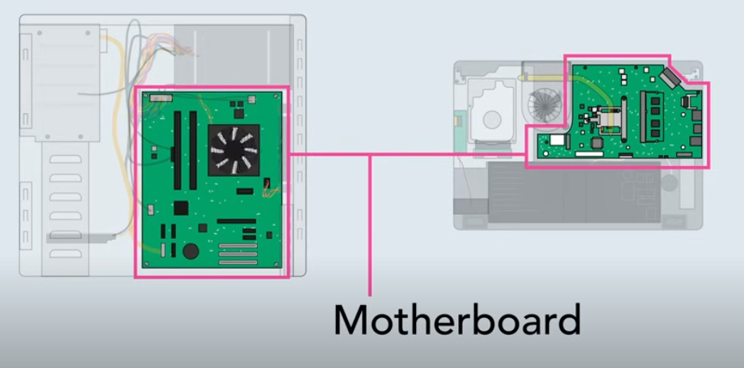

Whether it is a laptop or desktop, there is a huge circuit board called Motherboard.

It consist of many components like

**CPU**

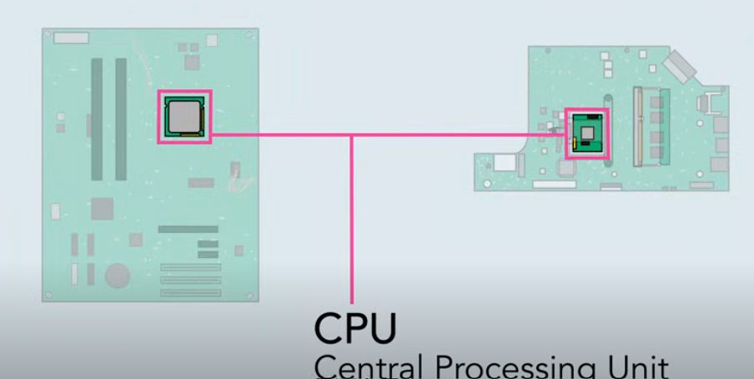

It is the Brain of the computer. It process information and carries out commands.

**Heatsink**

Since CPU -> it tends to get hot, it is covered by piece of metal called Heatsink, which draws heat from the processor.

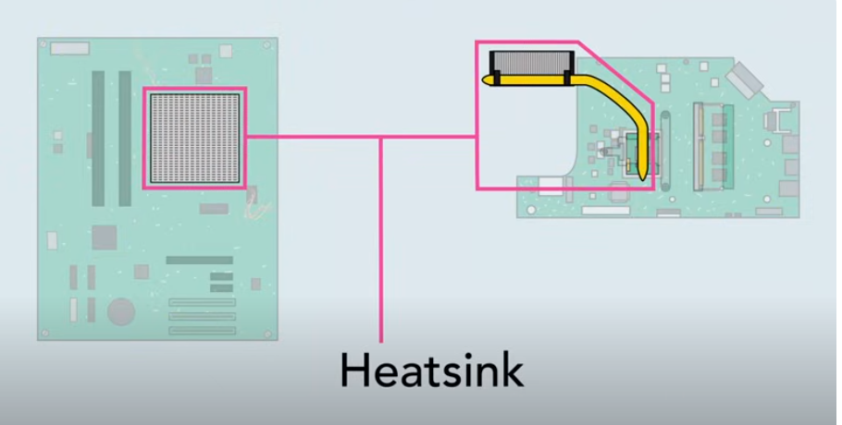

**Random Access Memory - RAM**

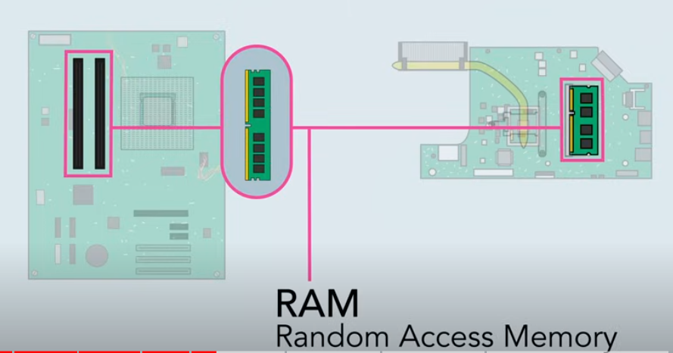

This is a short term memory the computer uses when it is performing calculations.

You cannot store files.

Because RAM is cleared when you shut off computer.

**Hard Drive**

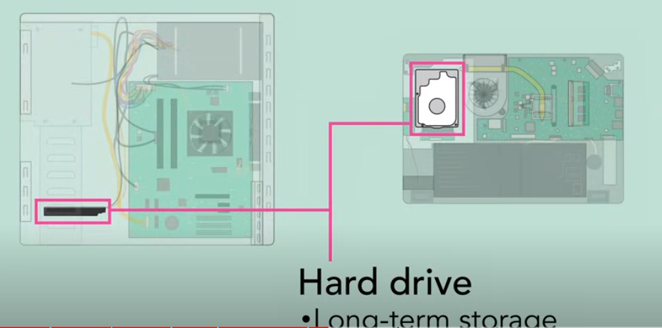

It provide Long Term storage.

Keeping all the computer data even when turned off.

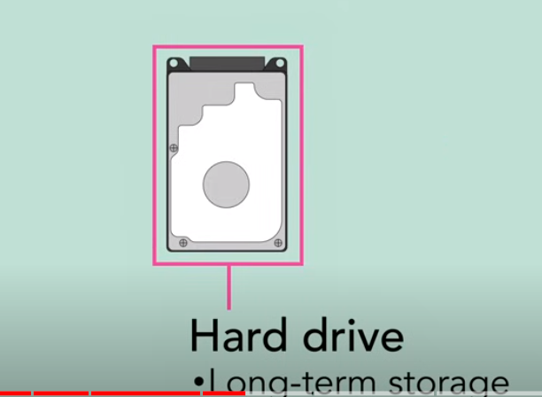

Many Hard drives use Magnetic Platter to store data.

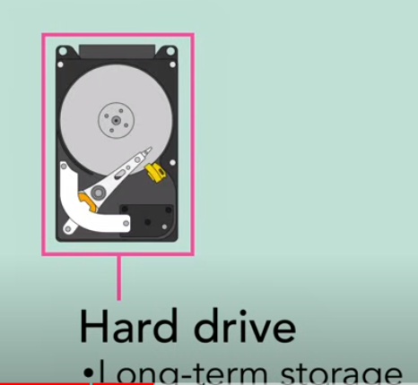

Many Newer Computers have Solid State Drive.

They are

1. Faster
2. Durable
3. More expensive

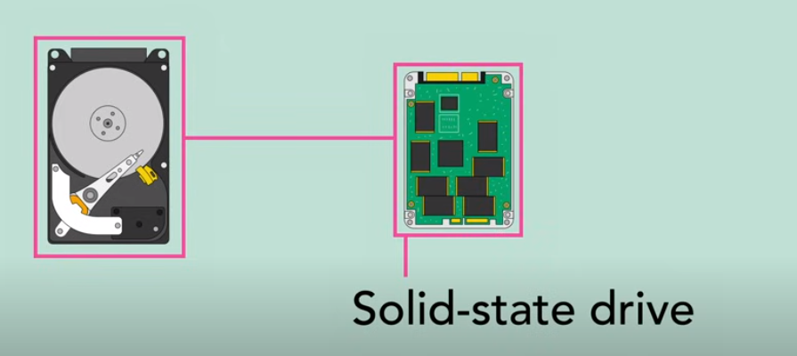

**Expansion Slots**

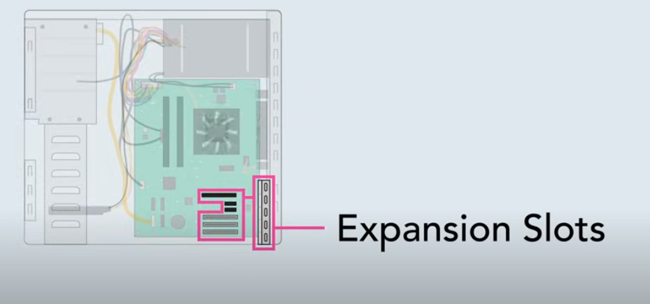

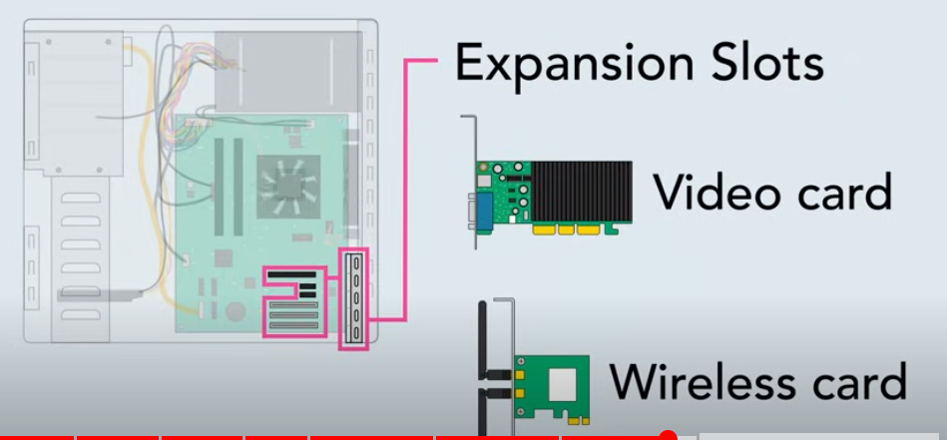

Motherboard have expansion slots that allow you to upgrade by adding Expansion guards. You can add

Video Card -> To get graphics performance.

Wirelss Card -> To connect your wireless home network.

Most Laptops do not have expansion slots.

**Power Supply**

Computer components require/need electricity to run.

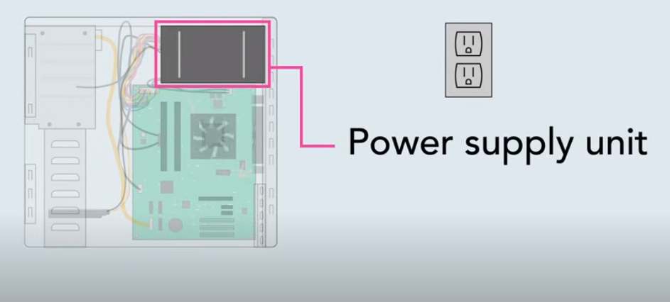

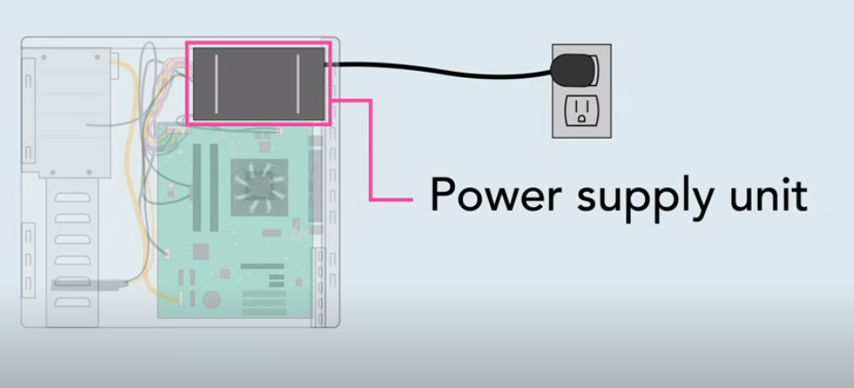

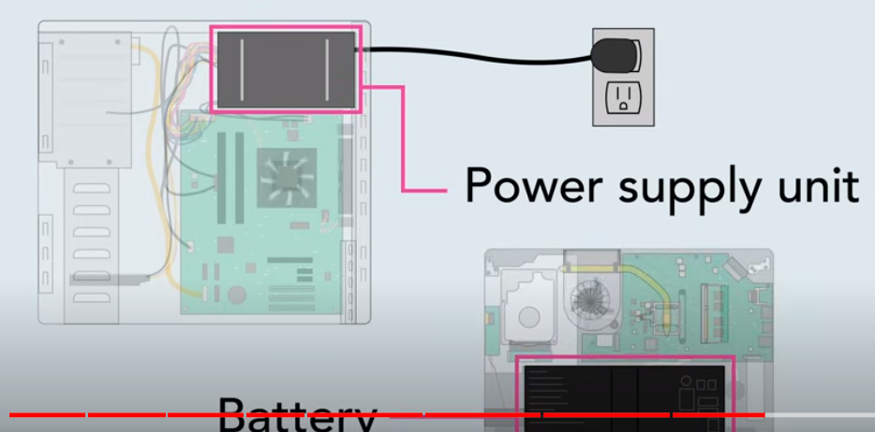

The Power Supply unit is designed to take power from the Wall Outlet and send it to all different components that need power.

Laptops have also Built In Battery that lets use anywhere.