**Abstract**

* **Project Idea**

Present-day advances in the computing and signal processing have allowed biometric systems to uniquely identify and authenticate humans in a computationally feasible manner. Biometric systems depend on a number of features including fingerprints, face, etc. However, both face and fingerprint can be compromised employing counterfeit credentials. Researchers have begun investigating electrocardiogram(ECG) signal as a biometric trait to identify individuals.

The purpose of this research project is to develop a real time system for biometric authentication with the electrocardiogram (ECG) signal. Like a fingerprint, the ECG is unique to an individual, because ECG waveforms depend on the anatomic features of the human heart and body. Also, it provides benefits such as resilience to replay attacks and spoofing. By examining the feature vectors obtained by processing ECG signals, and extracting unique features using discrete wavelet transform, our research investigates the possibility of biometric human identification based on the ECG.

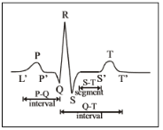

Fig. 1 ECG Signal

* **Implementation Prospects**

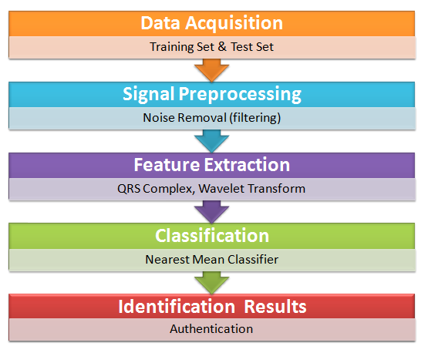

Fig. 2 System Structure

1. **Preprocessing :**

To eliminate noises, the signals are processed with filters. The filter is a combination high-pass filter and low- pass filter. Signal S denoted as:

*S* (*n*), *n* =1,2,3...*N*

1. **QRS Detection :**

The QRS Complex of ECG Signal is the most distinctive among all the features of ECG. Implementing Pan- Tompkin's Algorithm, allows efficient detection of QRS Complex, and thereby simplifying the task of feature extraction.

*R*(*nk* ), *k* =1,2,3..., *M* Where *nk* is the location of *R* peak.

Since the positions of *R* peaks *R*(*nk*) are determined, a 128-point signal segment *SSk* can be obtained by taking data points from the backward 43rd point to the forward 84th point.

*SSk* =[*S*(*nk* −43) : *S*(*nk* +84)]

Four such signal segments form a 512-points synthesis signal F:

*F* = [*SS*1 *SS*2 *SS*3 *SS* 4].

1. **Obtaining Wavelet Coefficients by Discrete Wavelet Transform :**

With 'Haar' wavelet, the 512-points wavelet coefficients decomposed from the signal were used as the biometric “identity card” of the subject. We decompose the signal with level-9 decomposition. Wavelet coefficients decomposed from 512-points synthetic signal is shown in Fig(4).

1. **Identification :**

ECG of an unknown individual is acquired; Euclidean distance measure is applied to calculate the difference in the 512-point wavelet coefficient feature set between the unknown subject and all enrolled subjects. The subject with minimum computed distance is the final identification result. LDA classifier can be used to classify QRS fragments.

I intend to develop a wearable device using AD8232 ECG sensor, to perform real time ECG based Authentication.

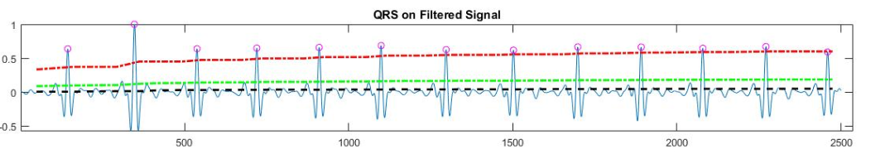

Fig. 3 QRS Detection

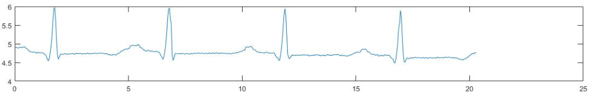

Fig. 4 512-points synthetic signal containing four QRS Complexes

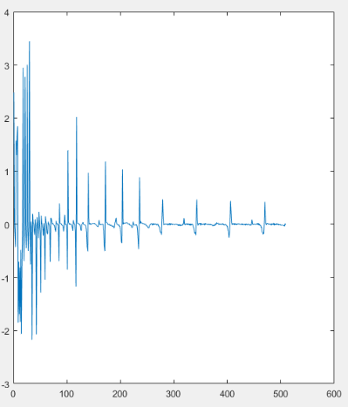 Untitled Diagram.png Fig. 5 Wavelet Decomposition Fig. 6 Flow of Execution