 **GUJARAT TECHNOLOGICAL UNIVERSITY**

Chandkheda, Ahmedabad

Affiliated

G.H. Patel College of Engineering

And Technology

A Project Report On

**Biometric Authentication based on ECG**

B. E. Semester – VII

(Department of Computer Engineering)

**Submitted By:**

|  |  |  |
| --- | --- | --- |
| Sr.no | Name | Enrollment No. |
| 1 | Darpen Patel | 130110107032 |
| 2  3 | Dhiraj Ramnani  Shail Patil | 130110107044  130110107053 |

Prof. Hetal Gaudani

(Faculty Guide)

**SELF-DECLARATION**

We

**Darpen Patel, Dhiraj Ramnani** and **Shail Patil**, the students of **Computer** Branch, having enrolment number **130110107032, 130110107044** and **130110107053** enrolled at **G.H. Patel College of Engineering & Technology** hereby certify and declare the following:

1. We have defined our project based on **ECG based Human Authentication** and each of us will make significant efforts to make attempt to solve the challenges. We will attempt the project work at our college or at any location under the direct and continuous monitoring of our internal and external guide. We will accept all ethical practices to share credit amongst all the contributors based on their contributions during the process.

2. We have not purchased the system developed by any 3rd party and the efforts are made by us under the guidance of our guide.

3. The project work is not copied from any previously done projects directly.

4. We understand and accept that he above declaration if found to be untrue, it can lead to punishment/cancellation of project definition to us, including failure in the subject of project work.

|  |  |
| --- | --- |
| **Name :** | **Contact Number :** |
| Darpen Patel | 9714950090 |
| Dhiraj Ramnani | 9409207654 |
| Shail Patil | 9427580044 |

**Date:** 08 October 2016

**Place:** Vallabh Vidhyanagar

**CERTIFICATE**

This is to certify that the User Defined Project entitled **“ECG based Human Authentication’’** has been carried out by Darpen Patel(130110107032), Dhiraj Ramnani(130110107044) and Shail Patil(130110107053) under my guidance and supervision for the degree of Bachelor of Engineering in Computer Engineering(Semester - VII) at G H Patel College of Engineering & Technology, Vallabh Vidyanagar during the academic year 2016-17.

**Date:**

**Faculty Guide: Head of Department :**

Prof. Hetal Gaudani Dr. Maulika S Patel

Computer Engineering Dept., Computer Engineering Dept.,

GCETGCET

**ACKNOWLEDGEMENT**

We take this momentous opportunity to express our heartfelt gratitude to our highly esteemed guides and our project guide Prof. Hetal Gaudani, Department of Computer Engineering, GCET for providing us an opportunity to present our project on ‘ECG based Human Authentication’.

We attribute heartiest thanks to all the faculty of Computer Department for their valuable advice and encouragement.

Darpen Patel

Dhiraj Ramnani

Shail Patil

**ABSTRACT**

*The electrocardiogram (ECG) is an emerging novel biometric approach for human identification. This project investigates the possibility of biometric human identification based on the electrocardiogram (ECG). The ECG, being a record of electrical currents generated by the beating heart, is potentially a distinctive human characteristic, since ECG waveforms and other properties of the ECG depend on the anatomic features of the human heart and body. Many aspects of our everyday lives are becoming dependent on automatic and accurate identity validation. The wide deployment of recognition mechanisms, based on something that people has (entity-based: tokens and ID cards) or something that people know (knowledge-based: PIN numbers and passwords), raises security concerns. The major benefit of security systems based on biometrics is the full dependency on the individual. The main purpose of this study is to present a novel personal authentication approach for human authentication.*

**TABLE OF CONTENTS**

|  |  |  |
| --- | --- | --- |
| 1. | Introduction  1.1 Problem Summary    1.2 Aim and Objective of the Project  1.3 Problem Specification  1.4 Literature Survey  1.5 Plan of work  1.6 Material/Tools Required | 112378 |
| 2. | Analysis and Design Methodology | 9 |
| 3. | Implementation | 12 |
| 4. | Conclusion & Future Work | 22 |
| 5. | References | 23 |

**TABLE OF FIGURES**

|  |  |  |
| --- | --- | --- |
| 1. | Empathy Canvas | 9 |
| 2. | Ideation Canvas | 10 |
| 3. | Product Development Canvas | 10 |
| 4. | AEIOU Canvas | 11 |
| 5. | ECG Complex | 12 |
| 6. | Plotting ECG | 13 |
| 7. | R-peak Detection | 14 |
| 8. | Filtering of ECG | 15 |
| 9. | Comparison | 16 |

1. **Introduction**

**1.1 Problem Summary**

The study of ECG and obtaining important and consistent data from it and matching it with pre-calculated numerics stored in the database is the key to its success. Extraction of unique features of ECG is a cumbersome task which gives the biometric cutting edge accuracy and uniqueness. Developing a system based on ECG will provide higher security because of its dependence on the individual.

**1.2 Aim and Objective of the Project**

We aim to develop an authentication system based on ECG. Being capable of performing transactions based on ECG, will provide high-end security. The pulse of an individual is recorded using ECG sensors. For pattern matching, high accuracy algorithms are used, for identification. The most crucial advantage of the system is that, it solely depends on the individual, who is being authenticated. Many aspects of our everyday lives are becoming dependent on automatic and accurate identity validation. The wide deployment of recognition mechanisms, based on something that people has (entity-based: tokens and ID cards) or something that people know (knowledge-based: PIN numbers and passwords), raises security concerns.

We need the hardware & sensors to track ECG signals, in order to form a data set of ECG signals used for Authentication purpose.

**1.3 Problem Specification**

The wide deployment of recognition mechanisms, based on something that people has (entity-based: tokens and ID cards) or something that people know (knowledge-based: PIN numbers and passwords), raises security concerns.The problems that we are trying to overcome are:

* **Security** : The potential of ECG as a powerful authentication entity has been lately explored in great depth owing to its characteristics of human anatomy which are almost implausible to replicate and its benefit of persistence and aliveness of the entity. Its prospective use as a biometric, surpassing its sole use of clinical diagnosis can be justified by the facets like:
* **Uniqueness**-there are no 2 individual with identical characteristics,
* **Universal**-it can be virtually found in every human being,
* **Measurability**-it can be easily acquired using suitable devices,
* **Permanence**-does not vanish over time,
* **Performance**-it has been shown to provide accurate results for the subset population.

## Secured Authentication: The system will provide high-end authentication based on ECG. The chance of replication will decrease, thereby providing secure transactions. The main purpose of this study is to present a novel personal authentication approach for human authentication.

**1.4 Literature Review**

The features, in most biometric methods, were extracted in the direct time-domain, frequency-domain and time-frequency-domain representation of the ECG signal. The spectral features are extracted from the Fourier transform (FT) of time-domain ECG signal or decomposed ECG signals. The performance of diverse methods depends on classiﬁers such as K-nearest neighbor (KNN), back propagation neural network (BPNN), hidden Markov model (HMM), Bayes Network (BN), Naive Bayes (NB), and support vector machine (SVM). Certain methods are based on feature analysis, using one or more techniques such as LDA, principal component analysis (PCA), independent component analysis (ICA), random projection (RP) in conjunction with K- SVD based dictionary learning, and within-class covariance normalization (WCCN) for dimensionality reduction. The test was conducted using the ECG signals taken from the well-known ECG databases: MIT-BIH arrhythmia (MITADB), MIT-BIH supra-ventricular arrhythmia database (MITSADB), MIT-BIH normal sinus rhythm (NSRDB), Physikalisch-Technische Bundesanstalt (PTB) and European ST-T (ESTTDB) [1].

In this section, we provide a review of the related works. Biel et al. [2] are among the earliest initiatives that demonstrates the plausibility of utilizing ECG for human identification purposes. A set of temporal and amplitude features are extracted from a SIEMENS ECG equipment directly. A feature selection algorithm based on simple analysis of correlation matrix is used to reduce the dimensionality of features. A multivariate analysis-based method is employed for classification. The system was tested on a database of 20 individuals, and 100% identification rate was achieved, based on empirically selected features. A major drawback of Biel et al.'s method is the lack of automatic recognition due to the usage of specific equipment for feature extraction. This declines the scope of applications. Irvine et al. [3] proposed a system to utilize heart rate variability (HRV) as a biometric for human identification. Israel et al. [4] subsequently proposed a more extensive set of descriptors to characterize ECG trace. An input ECG signal is first preprocessed by a bandpass filter. The peaks are established by finding the local maximum in a region surrounding each of the P, R, T complexes, and minimum radius curvature is used to find the onset and end of P and T waves. A total number of 15 features, which are time du-ration between detected fiducial points, are extracted from each heartbeat. This system was tested on a database of 29 subjects with 100% human identification rate and around 81% heartbeat recognition rate can be achieved. In a later work, Israel et al.[5] presented a multimodality system that integrate face and ECG signal for biometric identification. Israel et al.'s method provides automatic recognition, but the identification accuracy with respect to heartbeat is low due to the insufficient representation of the feature extraction methods. Shen et al. [6] introduced a two-step scheme for identity verification from one-lead ECG. A template matching method is first used to compute the correlation coefficient for comparison of two QRS complexes. A decision-based neural network (DBNN) approach is then applied to complete the verification from the possible candidates selected with template matching. The inputs to the DBNN are seven temporal and amplitude features extracted from QRS T wave. The experimental results from 20 subjects showed that the correct verification rate was 95% for template matching, 80% for the DBNN, and 100% for combining the two methods[25]. Shen [7] extended the proposed methods in a larger database that contains 168 normal healthy subjects. Template matching and mean square error (MSE) methods were compared for prescreening, and distance classification and DBNN compared for second-level classification. The features employed for the second-level classification are seventeen temporal and amplitude features. The best identification rate for 168 subjects is 95.3% using template matching and distance classification.[25]

Wang et al. [8] made the initial efforts that did not rely on fiducial based features by combining a set of analytic features derived from Fiducial points with appearance features obtained using PCA and LDA(principal component analysis and linear discriminate analysis) for feature extraction and data reduction . The accuracy for 13 subjects was 84% using analytic features alone and 96% using LDA with K-NN(K-nearest neighbor). The combination of the types of features was used to achieve 100% accuracy. Janani, et al [9] handled activity induced ECG variation by extracting a set of accelerometer features that characterize different physical activities along with fiducial and non fiducial ECG features. Chan et al. [10] proposed another non-Fiducial feature extraction framework using a set of distance measures including a novel wavelet transform distance. Data was collected from 50 subjects using button electrodes held between the thumb and finger. The wavelet transform distance outperforms other measures with an accuracy of 89%.[25]

Sebastian et al. [14] proposed biometric authentication algorithm for mobile devices. In this approach, user touches two ECG electrodes (lead I) of the mobile device to gain access. The algorithm was tested with a cell phone case heart monitor in a controlled laboratory experiment at different times and conditions with ten subjects and also with 73 records obtained from the Physionet database. The obtained results reveal that our algorithm has 1.41% false acceptance rate and 81.82% true acceptance rate.

Choudhary et al. [15] presented a simple uniﬁed accumulation of averaged heartbeat extraction framework for noise-robust ECG-based biometric authentication using heartbeat morphology. There are three major steps involved in the proposed method: preprocessing, combined averaged beat construction, and similarity matching. The signal blocking and mean removal operations are performed at the preprocessing stage. The ensemble averaging stage includes the steps of: discrete cosine transform (DCT) based ﬁlter for simultaneous removal of BW and PLI noises, straightforward Gaussian derivative ﬁlter (GDF)-based R-peak detector, peak-centering and period normalization, and ensemble averaging computation. A modified version of the k-Nearest Neighbor (kNN) classifier named Multiple Pulse k- Nearest Neighbor (MPkNN) was introduced by Safie et al. [16].Combining the special characteristic of the Pulse Active Width (PAW) technique with kNN led to the development of MPkNN. This approach was implemented for class attendance system. Kumar et al. [18] used Wavelet Transform (WT) and Independent Component Analysis (ICA) methods to extract morphological features that appear to offer excellent distinction among subjects. The proposed method is aimed at the two-lead ECG configuration that is routinely used in long-term continuous monitoring of heart activity. To achieve improved subject identification, the information from the two ECG leads is fused.

In [21], the cardiac signals were used to identify a total of 80 individuals obtained from four ECG databases from the Physionet database (MIT-BIH, ST-T, NSR, PTB) and an ECG database collected from 20 student volunteers from Paris Est. University.  Discrete Wavelet Transform (DWT) was used to perform Feature extraction. Wavelets have turned out to be particularly effective for extracting distinct features in ECG signal classification. The Random Forest was then suggested for the ECG signals authentication. Preliminary experimental results indicate that the system is accurate and can achieve a low false negative rate, low false positive rate and a 100% subject recognition rate for healthy subjects with the reduced set of features. In [22], a new authentication strategy is suggested, which uses the outlined features and taking decision for the identity of an individual with respect to the template database on the basis of match scores. Performance of the system is evaluated in both a unimodal framework and also in the multimodal framework where ECG is combined with the face biometric and with the fingerprint biometric. The equal error rate (EER) result of the unimodal system is 10.8%, while the EER results of the multimodal systems are reported to 3.02% and 1.52%, respectively for the systems when ECG is combined with the face biometric and ECG integrated with the fingerprint biometric. Fred et al. [23] employed the use of SVM and template matching for feature selection. The approach is partially fiducial as it focuses on R-wave segmentation.

**1.5 Plan of work**

**1.6 Material / Tools required**

The development of the planned system will incur the use of the following tools and methodologies:

* **Arduino Uno**: Microcontroller board with ECG sensor for signal acquisition.
* **Matlab**: Computation of Classificaion algorithms & development.
* **Hadoop**:  Open source, Java-based programming framework that supports the processing and storage of extremely large data sets in a distributed computing environment.
* **Machine Learning algorithms**: These algorithms are used to process large datasets, and thereby imparting decision making ability to the systems. The algorithm with high accuracy will be used to perform pattern matching for ECG templates.

   

**2. Analysis and Design Methodology**

The domain that we have started working upon with deals introduction of automation in the conventional methodologies used in the restaurant processing. Following is the work done – empathizing our idea, the ideation process, product development process, and AEIOU frameworks:

**1. Empathy Canvas**

By the end of making and during the Empathy Mapping Process we explored the concept of our domain and with various **People** and **Stakeholders** related to it; how they are interconnected and also the activities performed by users.



Fig 1

**2. Ideation Canvas**

The problem identification is done through this ideation process.

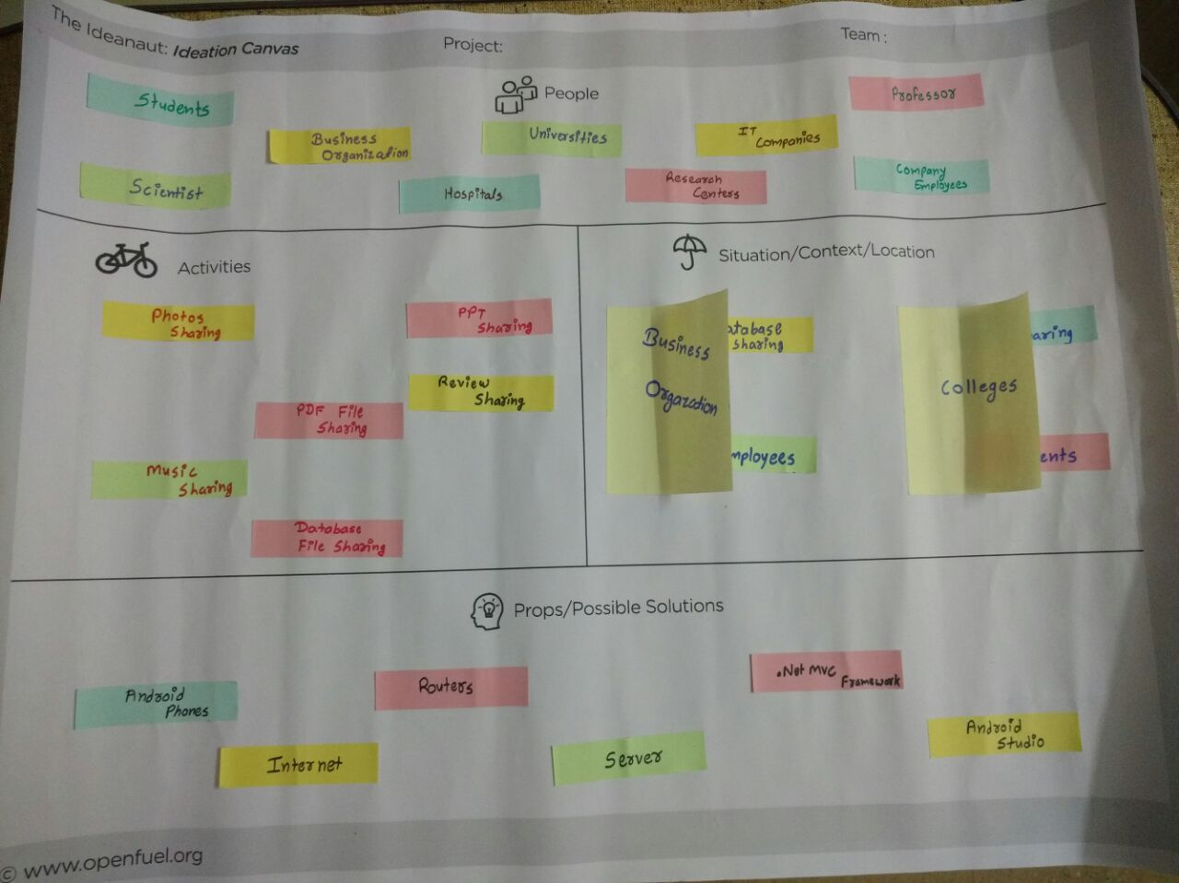

Fig 2

**3. Product Development Canvas**

This canvas deals with exploring and identifying the features, functionalities, various tools and components required in the project. Performing this activity helped us in discovering various features that can be added to enhance our project.

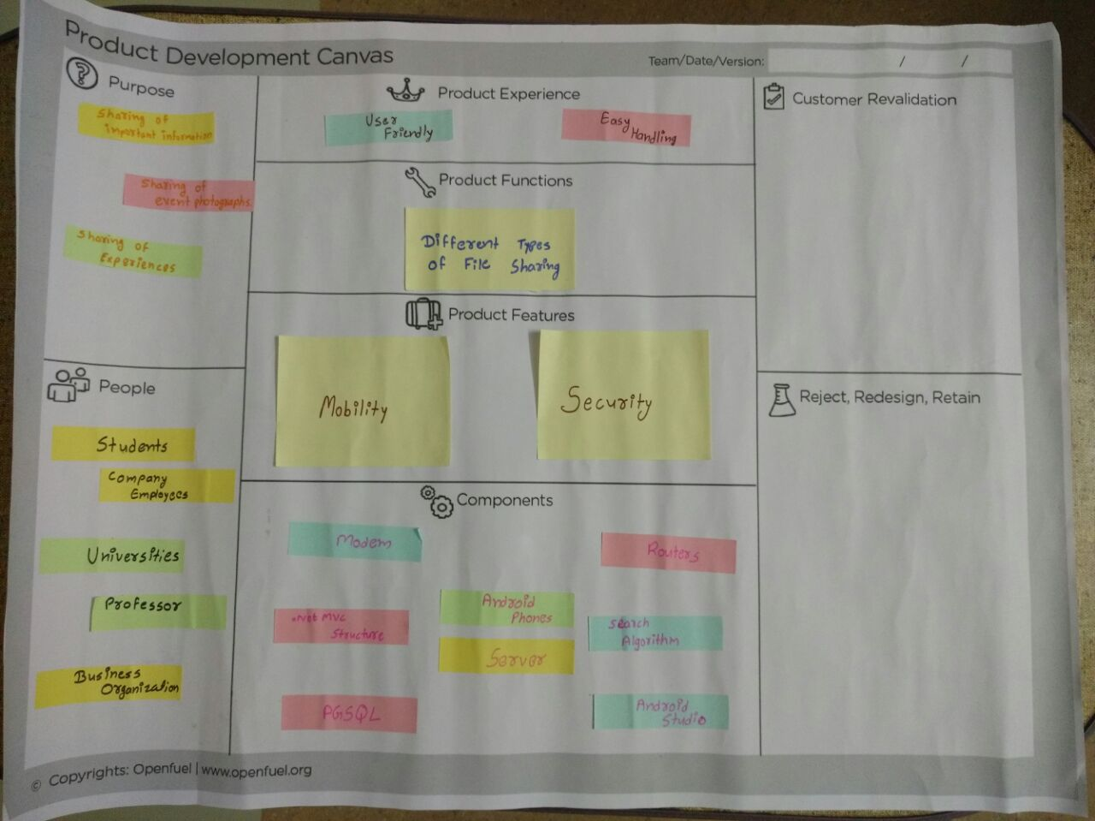

Fig 3

**4. AEIOU Framework Summary**

This activity aims at jotting down the analysis of various essentials of the system ranging from traditional environment that urged this system to evolve, interactions with the users and stakeholders involved, inventory of the required key components, summary of activities involved in the system, and the users in context.

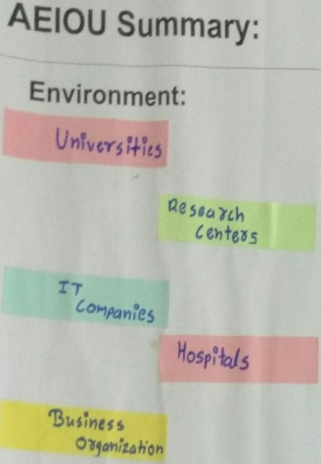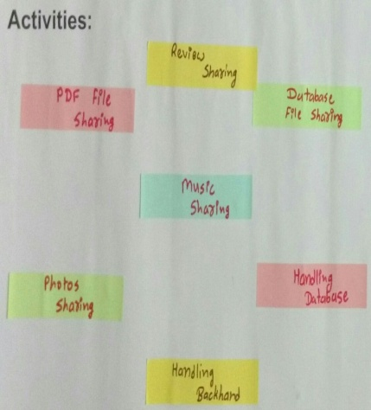

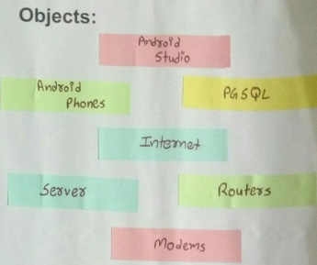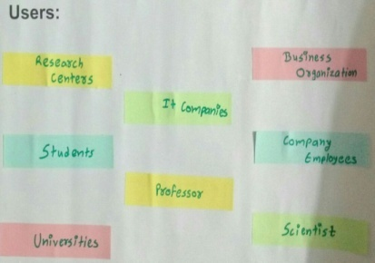

Fig 4

**3. Implementation**

* 1. ECG BASICS

The human electrocardiogram reflects the specific pattern of electrical activity of the heart throughout the cardiac cycle, and can be seen as changes in potential difference. The ECG is affected by a number of physiological factors including age, body weight, and cardiac abnormalities.

Electrocardiogram (ECG) recordings are quantitative measures of the electrical activity of a person’s heart over time[18]. It basically consists of P wave, QRS wave and T-wave. The QRS wave is usually called QRS composite or QRS-complex and it contains the most significant information in that heartbeat. A typical beat in an electrocardiogram consists of-

1. A low amplitude P-wave, representing atrial depolarization.

2. The QRS complex of much higher amplitude than the P-wave, representing ventricular depolarization.

3. A T-wave of smaller amplitude and larger duration than the QRS complex, representing ventricular repolarization.[25]

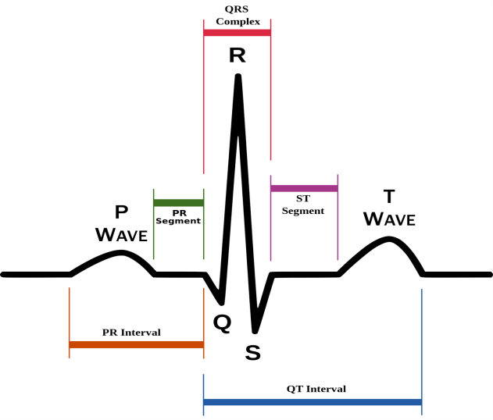

Fig. 5

ECG is a method to measure and record different electrical potentials of the heart. The ECG may roughly be divided into the phases of depolarization and repolarization of the muscle fibers making up the heart. The depolarization phases correspond to the P-wave (atrial depolarization) and QRS-wave (ventricular depolarization). The repolarization phases correspond to the T-wave and U-wave (ventricular repolarization). The elements in the ECG-complex are shown in Fig 1[19, 25].

Our project consists of the following modules:

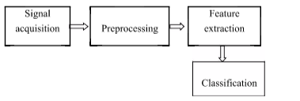

Fig 6

**Current Status of implementation:**

* Exploring options for Low cost Hardware
* Review of Available Algorithms.
* Plotting ECG dataset
* Detecting R-peak from PQRST features of the ECG complex
* Basics of Support Vector Machine

**Plotting ECG from the Dataset**

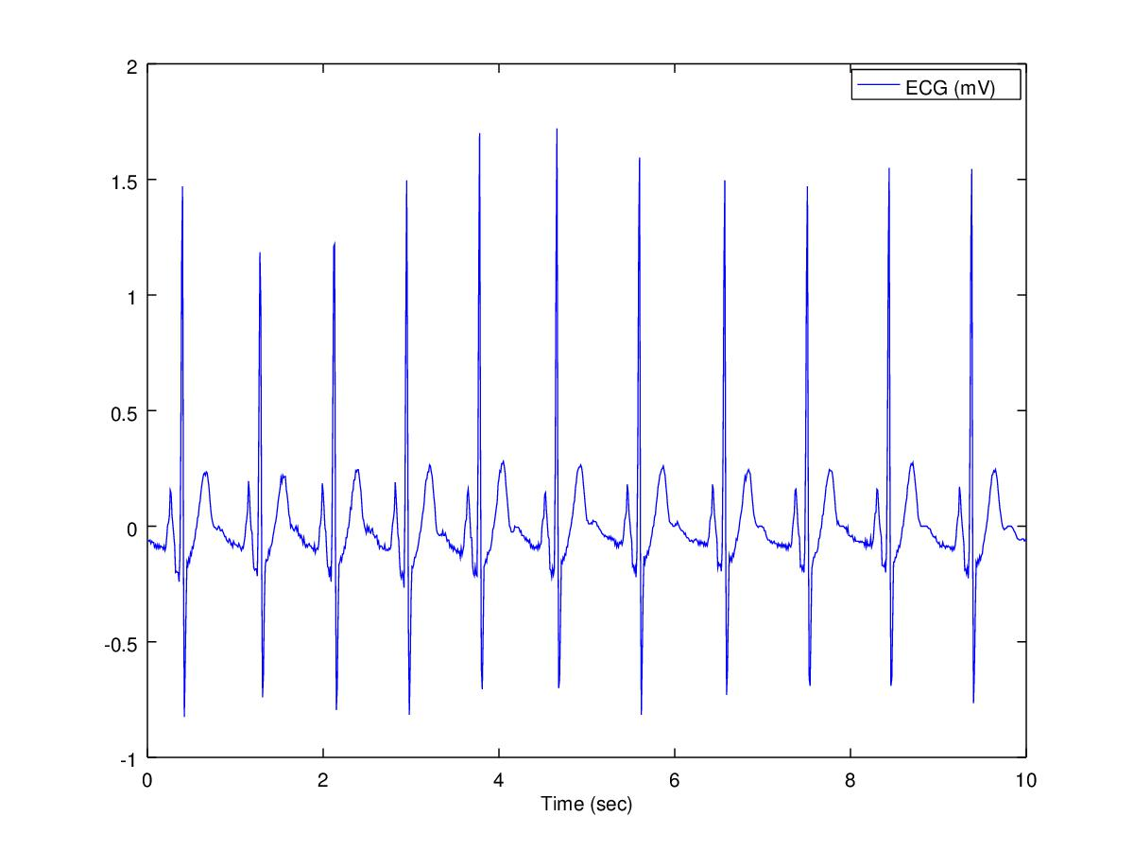 Fig 7

**Filtering ECG :**

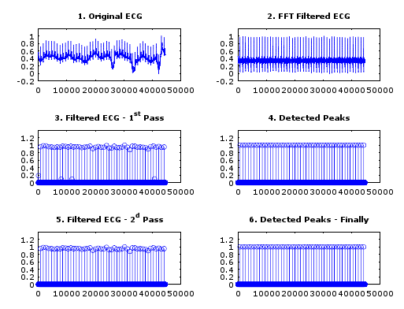

Fig 8

**Detecting R-Peaks from PQRST Complex :**

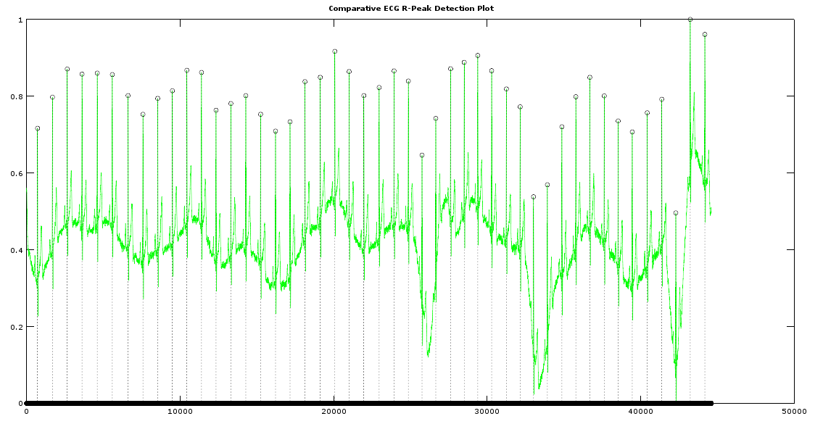 Fig 9

**SVM (Support Vector Machines)**

The SVM is yet another type of ***supervised*** machine learning algorithm which can generate optimal hyperplane for linearly separable patterns. We are given training data *{*x1*. . .* x*n}* that are vectors in some space *X⊆*R*d*. We are also given their corresponding output values*{y*1*-yn}* where *yi* can be either 1 or -1. In their simplest form, SVMs are hyperplanes that separate the training data by a margin with a maximum distance between the nearest data and the plane. All vectors lying on one side of the hyper-plane have their corresponding y values as *−*1, or negative, and all vectors lying on the other side have their corresponding y values as 1, or positive. The training data values that lie closest to the hyperplane are called **support vectors**.

The cost function for support vector machines,

Here, when we wish to regularize more (which basically is, reducing the overfitting) or we *decrease* the value of C, and when we wish to regularize less (which basically is, reducing the underfitting), we *increase* the value of C.

The hypothesis of the Support Vector Machine outputs either 1 or 0, as



Fig9

SVM can also extend to patterns that are not linearly separable by transformations of original data to map into new space, the **Kernel function**. It performs a transformation to a **new feature space** where the data point has *N* features, one for each support vector. The value of the *ith* feature is equal to the value of the kernel between the *ith* support vector and the data point being classified. In this space, the original (possibly non-linear) SVM classifier is just like any other linear one.After the transformation, the original features of the data point are irrelevant. It is represented only in terms of its **dot products with support vectors** (which are basically special data points chosen by the SVM optimization algorithm). For Example,

Given, compute new feature depending on proximity to landmarks

This "similarity" function is called a **Gaussian Kernel**. It is a specific example of a kernel.

Computing this gives us a "feature vector," of all our features.

Thus given training example

Now to get the parameters we can use the SVM minimization algorithm which will minimize the cost function but with substituted in for

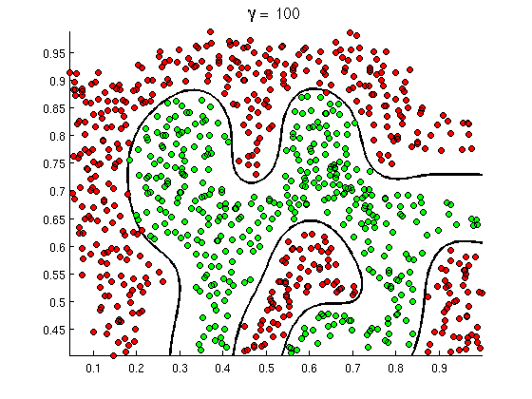

Fig 10

**Comparison Table:**

|  |  |  |  |  |
| --- | --- | --- | --- | --- |
| **Paper Studied** | **Features** | **Feature Selection Methods** | **No. of subjects used** | **Accuracy** |
| **Sebastian et al.**  **[14]** | Fiducial | Template Matching | 73 records  (Physionet database) | 81.82% |
| **Choudhary et al.**  **[15]** | Amplitude of QRS complex  R-peak alignment | Discrete Cosine Transform (DCT) and  Template Matching | 3969 imposters and 19404 test segments | FRR-11.6%  FAR-5.8%  Detection Accuracy-100% |
| **Safie et al.**  **[16]** | The peak of P to the peak of T (P2T) | Multiple Pulse k- Nearest Neighbor (MPkNN) | 20 | Classification-100% |
| **Kumar et al.**  **[18]** | ICA components and wavelet coefficients | Wavelet Transform (WT) and Independent Component Analysis (ICA) | The proposed method was tested on three public ECG databases.[1] | Recognition 99.6% |
| **Biel et al.**  **[19]** | Temporal, amplitude and slope | Correlation matrix | 20 | 100% |
| **Belgacem et al.**  **[21]** | Amplitude and normalized time distances between successive fiducial points. | Discrete Wavelet Transform &  Random Forest Algorithm- Authentication | 20 | 100% |
| **Fred et al.**  **[23]** | Partial Fiducial Approach | Template Matching & SVM | 64 | EER- 9.1% |

Table 1

**4. Conclusion & Future Work**

**Conclusion**

We reviewed several papers regarding biometric authentication, feature extraction and classification, used to for optimization of ECG processing. Learned about the preprocessing of the ECG (Electrocardiogram) signals, which are to be provided as input to the system, extracting features from those signals and SVM (Support Vector Machine) to get better intuition of the intended methodologies.

**Future Work**

We look forward to develop algorithms which can extract feature based on the PQRST features of the ECG wave of the heart. This Framework then could be used in many field such as a mechanism to assure the identification of an individual for vulnerable like financial transaction and can also be used as security barrier in areas of restricted access.

**5. References**

|  |  |
| --- | --- |
|  | L. Goldberger et al., “PhysioBank, PhysioToolkit, and PhysioNet: Components of a new research resource for complex physiologic signals,” Circulation, vol. 101, no. 23, pp. 215-220, 2000. |
|  | Dr. Boo-Ho yang, Prof Haruhiko H. Asada ,Yi Zhang “Cuff-less continuous monitoring of beat-to-beat Blood pressure using a kalman filter and sensor” ,Fusion-first joint IEEE conference of bmes/embs,1999. |
|  | L. Biel, O. Pettersson, L. Philipson, and P. Wide. ” ECG analysis: a new approach in human |
|  | Julio C.D Conway,Claudionor J.N Coelho ,Luis C.G Andrade, “Wearable computer as a multi-parametric monitor for physiological signals” IEEE international conference on bioinformatics and biomedical engineering, pp-236-242,2000. |
|  | M. Sanjeev Dasrao,Yeo Joon Hock,Eugene KW sim, “Diagnostic blood pressure wave analysis and ambulatory monitoring using a novel”, non-invasive portable device-proceeding of international conference on biomedical engineering, pp 267-272, 2001. |
|  | Peter Varady Benyo ,Balazs, “An open architecture patient monitoring system using Standard technologies”, IEEE transactions on information technology in biomedicine, vol. 6, 2002. |
|  | Paul Lucowicz, Urs Anliker, Jamie Ward, Gerhard Troster, “Amon: a wearable medical computer for high risk patients”, IEEE computer society, 6th international symposium on wearable computers (iswc.02), 2002. |
|  | Y. Wang, F. Agrafioti, D. Hatzinakos, and K. N. Plataniotis, "Analysis of human electrocardiogram for biometric recognition", EURASIP Journal on Advances in Signal Processing, 2008. |
|  | Janani S., Minho S., Tanzeem C., David K., ”Activity-aware ECG-based patient authentication for remote health monitoring”; , International Conference on Mobile Systems,ACM,Nov,2009. |
|  | D. C. Chan, M. M. Hamdy, A. Badre, and V. Badee. ”Wavelet distance measure for person identification using electrocardiograms”, Transactions on Instrumentation and Measurement, IEEE, Volume 57, issue 2, 2008. |
|  | Steven A. Israel, Jhon M.I,Andrew C.,Mark D.W,”ECG to identify individuals”, Virtual reality medical center, USA, Pattern Recognization, Volume 38,issue1,2005. |
|  | C. Chiu, C. Chuang, and C. Hsu. “A novel personal identity verification approach using a discrete wavelet transform of the ECG signal”, Proceedings of the International Conference on Multimedia and Ubiquitous Engineering, Volume 6, issue 4,2008. |
|  | T. W. Shen, W. J. Tompkins, and Y. H. Hu "One-lead ECG for identity verification",Proceedings of the 24th Annual Conference on Engineering in Medicine and Biology and the Annual Fall Meeting of the Biomedical  Engineering Society, Volume 57, issue 2, 2002. |
|  | Arteaga-Falconi, Juan Sebastian, Hussein Al Osman, and Abdulmotaleb El Saddik. "ECG Authentication for Mobile Devices." IEEE Transactions on Instrumentation and Measurement 65.3 (2016): 591-600. |
|  | Choudhary, Tilendra, and M. Sabarimalai Manikandan. "A novel unified framework for noise-robust ECG-based biometric authentication." Signal Processing and Integrated Networks (SPIN), 2015 2nd International Conference on. IEEE, 2015. |
|  | Safie, Sairul, et al. "Multiple pulse K-Nearest Neighbors authentication for Malay ECG based class attendance system." Engineering Technology and Technopreneuship (ICE2T), 2014 4th International Conference on. IEEE, 2014. |
|  | Kaul, Amit, A. S. Arora, and Sushil Chauhan. "ECG based human authentication using synthetic ECG template." Signal Processing, Computing and Control (ISPCC), 2012 IEEE International Conference on. IEEE, 2012. |
|  | Ye, Can, Miguel Tavares Coimbra, and BVK Vijaya Kumar. "Investigation of human identification using two-lead electrocardiogram (ECG) signals."Biometrics: Theory Applications and Systems (BTAS), 2010 Fourth IEEE International Conference on. IEEE, 2010. |
|  | Biel, Lena, et al. "ECG analysis: a new approach in human identification."IEEE Transactions on Instrumentation and Measurement 50.3 (2001): 808-812. |
|  | Matos, André Cigarro, André Lourenço, and José Nascimento."Embedded system for individual recognition based on ECG Biometrics." Procedia Technology 17 (2014): 265-272. |
|  | Belgacem, Noureddine, et al. "ECG based human authentication using wavelets and random forests." Int J Cryptography Inf Secur 2 (2012): 1-11. |
|  | Singh, Yogendra Narain, and Sanjay Kumar Singh. "Evaluation of electrocardiogram for biometric authentication." (2011). |
|  | Da Silva, Hugo Plácido, et al. "Finger ECG signal for user authentication: Usability and performance." Biometrics: Theory, Applications and Systems (BTAS), 2013 IEEE Sixth International Conference on. IEEE, 2013. |
|  | Lourenço, André, Hugo Silva, and Ana Fred. "Unveiling the biometric potential of finger-based ECG signals." Computational intelligence and neuroscience 2011 (2011): 5. |
|  | Nawal, Meenakshi, and G. N. Purohit. "Ecg based human authentication: A review." Int. J. Emerg. Eng. Res. Technol 2.3 (2014): 178-185. |
|  | Israel, J. Irvine, A. Cheng, M. Wiederhold, and B. Wieder- hold. ECG to identify individuals. Pattern Recognition, 38(1):133–142, 2005. |
|  | Coutinho, David Pereira, Ana LN Fred, and Mario AT Figueiredo."One-lead ECG-based personal identification using Ziv-Merhav cross parsing. "Pattern Recognition (ICPR), 2010 20th International Conference on. IEEE, 2010. |
|  | Plataniotis, Konstantinos N., Dimitrios Hatzinakos, and Jimmy KM Lee. "ECG biometric recognition without fiducial detection." 2006 Biometrics Symposium: Special Session on Research at the Biometric Consortium Conference. IEEE, 2006. |
|  | Ahuja, Pooja, and Abhishek Shrivastava. "A Review on ECG based Human Authentication." |
|  | Lugovaya, Tatiana S. "Biometric Human Identification Based On ECG." (2005). |
|  | Kaur, Gaganpreet, Dheerendra Singh, and Simranjeet Kaur."Electrocardiogram (ECG) as a Biometric Characteristic: A Review." (2015). |