Game Design Document

Fill up the following document

1. Write the title of your project.

Super tennis

1. What is the goal of the game?

To play tennis and get a large score against the computer

1. Write a brief story of your game.

You are a player and you like tennis. You are practicing while you can’t go to the court with a game to improve your timing.

1. Which are the playing characters of this game?

* Playing characters are the ones who respond to the user based on the input from the user.
* Cars, monkeys, dinos, wizards, etc., are the playing characters in the game.

|  |  |  |
| --- | --- | --- |
| Number | Character Name | What can this character do? |
| 1 | Player | Hit the tennis ball |
| 2 |  |  |
| 3 |  |  |
| 4 |  |  |
| 5 |  |  |
| 6 |  |  |
| 7 |  |  |
| 8 |  |  |

1. Which are the Non-Playing Characters of this game?

* Non-Playing characters are the ones that don't have an action or behavior when the user interacts with the game.
* Hurdles, stones, bananas, coins, etc., are non-playing characters in the game.

|  |  |  |
| --- | --- | --- |
| Number | Character Name | What can this character do? |
| 1 | Tennis ball | Get hit by the player |
| 2 | Enemy | Hit the tennis ball. |
| 3 |  |  |
| 4 |  |  |
| 5 |  |  |
| 6 |  |  |
| 7 |  |  |
| 8 |  |  |

Draw your imagination of this game. What does this game look like?

* Draw the game either on your computer or on paper.
* Add images of the game scenes to show each of the playing and non-playing characters at least once.

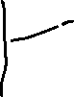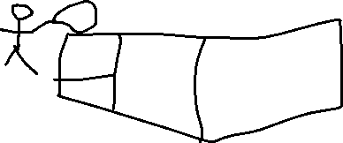

How do you plan to make your game engaging?

It is similar to pong, however with the added element of timing our shots to hit the ball back.