一，复述第一集故事

1

rich ran out of her wedding, and cut all her credit card, in the end, being a waitress of the cafeteria. She finally moved out to live on her own. It is very brave.

2

Monica dumped the Paul-the wine-guy, because he lied about the dis performed 2 years.

3

Ross asked rich it would be ok if he ask her out, she said maybe.

二，不会的单词、短语、长难句

1

……a hump and a hairpiece?

hump, 驼背，the hump of a camel，骆驼的驼峰。

hairpiece, 假发。

2

I am漏掉了两次。

3

all of a sudden，连读。

4

weird，听写时候拼错了。

5

all right, 好的。

alright, 行吧。

6

mortify，感到屈辱的，窘迫的，惭愧的。Ross出场特别忧愁的说：“Hi”。

7

I just feel like someone reached down my thorat, grabbed my small intestine and pulled it out my mouth and tied it annual my neck.

8

Carol moved her stuff out today. 有连读。

9

cleansing my aura

cleanse，清洗，洗掉罪恶（purge of 信仰、不好的想法）。突然想到一个：去污粉，cleanser，哈哈。

aura，灵气；气质；氛围。晦气，也可以。

10

I hope she will be very happy. “she will be”听不到。

11

Why does everyone keep **fixating on** that? 【为什么你们每个人都揪着那个不放？这句话可以适用于很多令人无奈的场合。】

She didn’t know, how should I know?

觉得很逗的两句话。

fixate, 专注和痴迷。比如眼神，专注在看。Her eyes fixated on a point。通常和on搭配。

Obsessively fixating on it is not my strong suit.一直让我想着那件事实在不是我的强项。

12

strip joint

strip，v，使去掉，剥夺，剥离。

joint，不体面的娱乐地方，还有连接什么的意思。

13

hammer

锤子。

14

survivor

幸存者。

15

gravy

肉汁。小红帽奶奶熬的汤，估计也是这种肉汤吧，gravy。gravy boat，肉汁瓶。

16

I realized that I was more turned on by the gravy boat than by Barry.

more+adj+by A+than by B

17

that’s when it hit me, how much Barry looks like Mr. Potato Head.

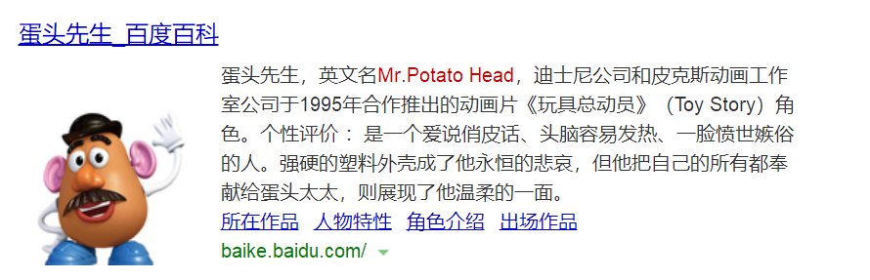

18

You and I kind of drifted apart…

drift apart，因为毕业好多人被迫drifted apart。

19

I was kind of hoping that wouldn’t be an issue.

20

metaphor

比喻。

21

This is probably for the best, you know?

22

You need anything, you can always come to Joey. Me, Ch, right acrooss the hall. He is away a lot.

他常常不在家。

23

I am sorry I didn’t catch your name? Paul, is it?[连读，li-sit？]

24

eyelash

眼睫毛

25

I was kinda supposed to be headed for Aruba on my honeymoon…

be supposed to 的丰富用法。

26

If you don’t feel like being alone tonigh, J and C are coming over to help me put together my new furniture.

27

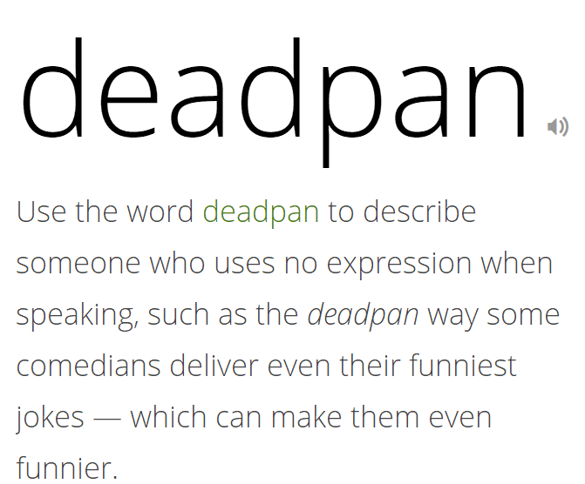Chan一本正经的说，去Ross那帮忙，very excited about it。

28

I am supposed to attach a brackety thing to the side things, using a bounch of these little worm guys. I have no brackety thing and I see no whim guys whatsoever and- I cannot feel my legs.

bracket, [],<>, class/group, a support projecting from a wall (as to hold a shelf)

支架似的东西。

worm, screw thread on a gear with the teeth of a worm wheel or rack（齿轮上的螺纹与蜗轮或齿条的齿）,worm guy 螺丝钉。

whim, strange, a sudden impluse or a change of mind, fanciful object.

29

drink it out of the can

直接用罐子喝，Emmm, 暗示了女女。

30

stereo

音响。

31



32

horny, stay out of my freezer.

horny，Emmmm，Ross被J说的心动。

stay out of sth

33

rocky road, cookie dough, cherry vanilla,

岩石路，曲奇饼，香草樱桃. Butter pecan, 奶油胡桃； neapolitan，那不勒斯（多层花色）。

Jimmies, or nuts, or whipped cream.

冰淇淋上的碎片；果仁；搅打起泡沫的稀奶油。

34

while you are on a roll, if you feel like you gotta make like a Western omelet or sth

35

I will not take this abuse.

我不会当真的。

36

Wish me luck.

37

I take credit for Paul. You know before me, there was no snap in his turtle for two years.

take credit for sb, 帮了sb的大忙啦。

38



39



hear，嗅到，侦测到。

40



41



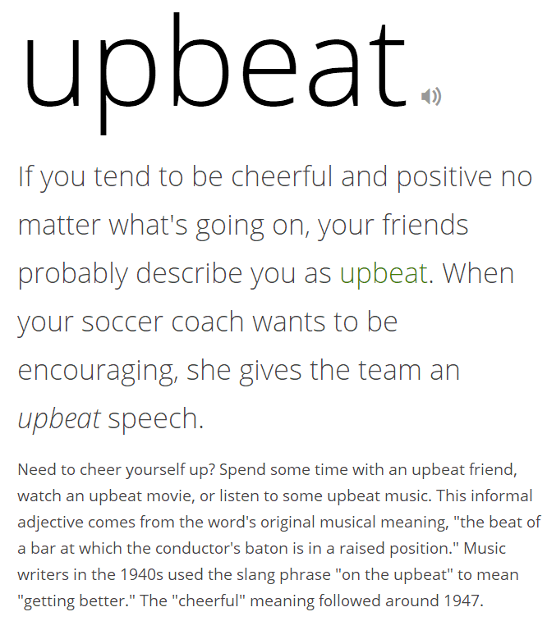

42

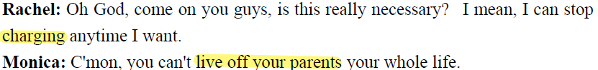

43

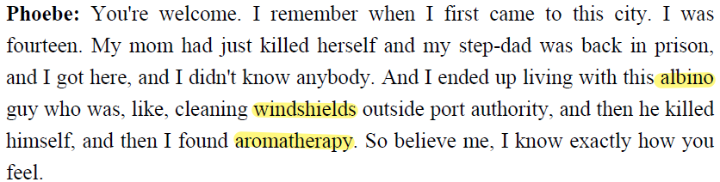

44

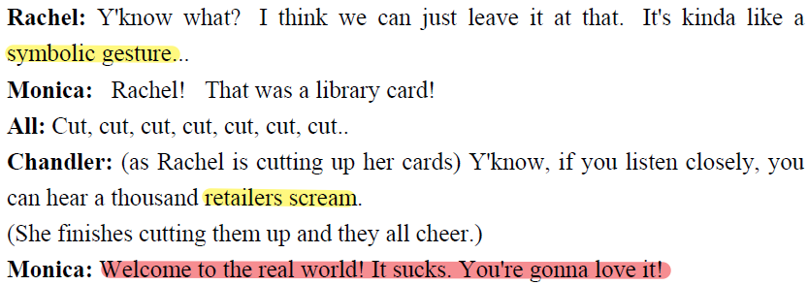

45



crash，崩溃，破坏，但是这里是 sleep in a convenient place.

46



47



三，有感必须发

1 What if I don’t want to be a shoe?

瑞秋的觉醒时刻：如果我不想做一只鞋子呢？

我觉得人活着很容易背负着他人的期待，他们希望你成为什么样子的人。

而即便是父母也好，最亲密的朋友也好，他们出于一种好意对你的未来有一种预设、有一种期待，但其实，我们真正要做决定的时候，要问自己究竟什么才是你真正想要的。你是想成为一只钱包还是一顶帽子呢？

就像哪吒说的，是魔是仙，我说了算。

2 Welcome to the real world.

欢迎开启独立生活。