HLZ Suitability Tool
User Manual
Screening high-resolution elevation data for helicopter landing zones in ArcGIS Pro
Version 0.10.4, October 2026
Planning aid only
Results are a planning aid. They do not certify a landing zone. Confirm every site by reconnaissance and with the aircraft operator’s performance data.

Contents
About this manual 5
What is new since version 0.6.9 5
What is new since version 0.6.5 5
Conventions 6
Verification status 7
1 Introduction 9
1.1 What the tool does 9
1.2 What the tool does not do 10
1.3 Typical workflow 10
2 Concepts and terminology 11
2.1 Landing-zone geometry 11
2.2 Terrain measures 12
2.3 Obstacles and exclusion areas 12
2.4 Approach analysis and the obstacle angle 12
2.5 Density altitude and hover mode 13
2.6 Rating, score, status and confidence 14
3 Requirements and installation 15
3.1 What you need 15
3.2 Install the toolbox 15
3.3 Check the installation 15
4 Preparing your data 16
4.1 Must have, recommended, optional 16
4.2 Preparation steps 16
4.3 How far the data must extend 17
4.4 The data folder and the audit 18
4.5 Rivers and streams as exclusion lines 20
4.6 Towers, masts and wires: the obstacle list 20
4.7 Data in latitude and longitude 23
4.8 Points as exclusion areas 23
5 Running an analysis 24
5.1 Open the tool 24
5.2 Step by step 24
5.3 Parameter reference 25
5.4 Messages in the dialog 28
5.5 While it runs 29
5.6 When it finishes 29
5.7 Searching around a point 29
5.8 Drawing the area of interest 30
5.9 What if the helicopter were bigger or smaller? 30
5.10 Spacing and sites 30
5.11 Report units and the overview grid 31
6 Understanding the results 32
6.1 The run folder 32
6.2 Map layers 32
6.3 Reading a candidate: two worked examples 33
6.4 The HTML report 34
6.5 The CSV table 35
6.6 Run metadata and the log 35
6.7 The pilot brief 36
6.8 Primary sites and alternates 37
6.9 The terrain overview grid 38
6.10 The rejection summary 38
6.11 Metres and feet 38
7 How scores and ratings are calculated 39
7.1 The search 39
7.2 Pass/fail limits (shipped medium class) 39
7.3 The score 39
7.4 The rating 40
7.5 Ranking 40
7.6 Why the rating and the score can look different 40
8 Profiles and customisation 41
8.1 Aircraft profile 41
8.2 Mission profile 41
8.3 Doctrine profile 42
8.4 Creating a custom aircraft profile 42
8.5 Named aircraft: Canada, United States and NATO Europe 43
8.6 Approval and provenance 44
9 Large areas 45
9.1 How tiling works 45
9.2 Memory and tile size 45
9.3 How long will it take? 45
9.4 Disk space 46
9.5 Cancel and resume 46
9.6 Tips for city-scale runs 46
9.7 Example: screening a whole city 47
9.8 Stage timing and run-time estimate 47
10 Accuracy, limitations and verification 48
10.1 What drives accuracy 48
10.2 What the tool does not assess 49
10.3 Behaviours to watch for 50
10.4 Recommended verification before use 50
10.5 Reporting a result 50
11 Troubleshooting 51
11.1 Messages in the dialog 51
11.2 Messages while running 52
11.3 Unexpected results 53
11.4 Getting help 54
12 Testing and maintenance 55
12.1 The self-test 55
12.2 Environments 55
12.3 Updating to a new version 55
12.4 The optional command-line tool 56
Appendix A Output field dictionary 57
Appendix B Example profile 59
Appendix C Glossary 60
Appendix D Release folder layout 62
Appendix E Licence and credits 63

About this manual
This manual describes HLZ Suitability Tool v0.10.4, an ArcGIS Pro Python toolbox that screens high-resolution elevation data for helicopter landing-zone (HLZ) candidates, rates them, and presents them as map layers, an HTML report and a CSV table.

Item | Detail
Applies to | HLZ Suitability Tool v0.10.4
Audience | GIS analysts and planners who prepare HLZ screening products, and the staff who review them
Companion documents | Quick Start (HTML, one page): the five steps to a first result.  Data Type Reference (HTML): every input and output, its data type, units and allowed values.  Data Requirements and Compatibility (Word): what data and software you need, what is mandatory, what is optional, and how each affects accuracy.
Licence | GPL-2.0-or-later. Copyright (c) 2026 Eui Soo SON. See Appendix E.

What is new since version 0.6.9
- Overview grid and point exclusions (v0.7.0). An optional coarse grid summarises where the ground passes (Section 6.9). A point layer (a crane, a pole, a known hazard) can now be an exclusion area (Section 4.8).
- Stage timing and run-time estimate (v0.7.1). The log ends with the time of each stage, and the estimate shown in the dialog is refined from it (Section 9.8).
- Rejection summary, dual units and drawn area (v0.8.0). The tool explains why cells failed (Section 6.10), reports lengths in metres and feet (Section 6.11) and lets you draw the area of interest on the map (Section 5.8).
- Sites, spacing, size what-if and latitude/longitude data (v0.9.0). Candidates at the same place are grouped into sites (Section 5.10). A minimum spacing can thin the list. You can test a bigger or smaller aircraft without a new profile (Section 5.9). A DTM or DSM in degrees is projected to UTM for you (Section 4.7).
- Primary sites and alternates (v0.10.0). Each site is shown once, by its safest candidate; the other candidates at the same site are alternates, drawn with dashed outlines (Section 6.8).
- Report map and speed (v0.10.1 to v0.10.3). The report map is square, then as wide as the page, with an Esri street layer in place of the OpenStreetMap layer, which refused file-based reports. A faster way of writing the result rasters in ArcGIS Pro (Section 9.8).
- Documentation (v0.10.4). This manual, the Quick Start, the Data Requirements and the README are updated, and the new Data Type Reference lists every data type the tool reads and writes.

What is new since version 0.6.5
- Data folder and audit (v0.6.6). The new tool 0. Set Up and Audit Data Folder creates one standard folder with a place for the DTM, DSM, hydrology and every other input, and checks what you put in it (Section 4.4).
- Analyze from the data folder (v0.6.6). 1. Analyze HLZ Suitability has a new first field, HLZ data folder. Choosing it fills the DTM, DSM, exclusion areas, area of interest and output folder for you.
- Rivers and streams as lines (v0.6.7). Exclusion areas accept line layers as well as polygons. A new field, Width given to exclusion LINES (m), gives each line a width (Section 4.5).
- Choose the helicopter by name (v0.6.8). The Aircraft profile list shows the landing-point and ring size of every type, so the area checked around each site follows the helicopter you pick (Sections 5.2 and 8.5).
- Obstacle list (v0.6.9). Lidar surface models often miss thin structures such as communication towers, antennas, masts and wires. You can now list obstacles (FAA Digital Obstacle File, CSV, GeoJSON or GIS layers). The tool adds them to the surface, removes landing zones next to them and tests every approach sector against them (Section 4.6). New fields in tool 1, a new data sub-folder 10_Obstacles, new CSV columns and new command-line options go with it.
- Tests. At that version 82 unit tests and 139 command-line checks passed in the development environment; the ArcPy smoke test had a new scenario J (obstacles: a layer with a height in feet, a CSV file and a GeoJSON file).

Conventions
- Bold text is a name you see on screen (a tool, a field or a button).
- Monospace text is a file name, folder, command or field value.
- Directions are true bearings in degrees (000 to 359). All distances are in metres unless stated.
- “LZ” means landing zone and “TDP” means touchdown point. Appendix C is a glossary.

Verification status
Software like this must be tested in the environment where it is used. This table says what has and has not been verified at the time of writing, so that nobody relies on more than is proven.
Area | Status
Core logic (terrain, tiling, approach, scoring, resume) | Automated unit tests pass (135 tests) and the command-line end-to-end test passes (214 checks) in the development environment. The v0.5 tests also passed (19 of 19) inside ArcGIS Pro 3.7.2 with Python 3.13.
ArcGIS Pro integration (reading rasters, writing the geodatabase, lat/long and MGRS) | Verified on ArcGIS Pro 3.7.2: the v0.5 smoke checks (41 of 41) and, for v0.10.1, smoke scenarios A to G (DTM with DSM, DTM only, a DSM on another grid, many tiles, a lake, a point search) and the data-folder audit (scenario H, status READY_WITH_WARNINGS). The scenarios for rivers (I), obstacles (J) and the features added after v0.10.1 have not been run in ArcGIS Pro yet.
Map styling (group layer, colours, labels, arrows) | Not yet confirmed in the ArcGIS Pro interface. This includes the primary and alternate styling (dashed outlines and layer definition queries, v0.10.0). If styling fails, the tool shows a warning and adds an unstyled layer.
Interactive map in the HTML report | Tested in a headless browser (no script errors, zoom, selection and filters, square then full-width map). The online basemap tiles were not tested against the live servers. OpenStreetMap tiles refuse reports opened from a file, so the layer was replaced by Esri Streets in v0.10.2.
Search around a point, plain-language columns and the pilot brief | Tested in the development environment: typed and layer centres, the MGRS conversion (checked against an independent library), and the pilot brief and wind helper in a headless browser. The ArcPy part (smoke scenario G) still needs to be run in ArcGIS Pro.
Large areas (billions of cells) | Memory and speed were measured on a simulated area in a development environment (100 M cells in 3 minutes, 2.2 GB peak). The tool has not yet been run on a real city-scale DTM.
Aircraft values and thresholds | The shipped aircraft and doctrine profiles are planning defaults, not operator or authority data. Only the four Canadian aircraft records were checked against official pages; the rest are marked as reference data.
Data folder and audit (v0.6.6) | Tested in the development environment: folder creation, header reading of GeoTIFF/BigTIFF (compared with GDAL on 84 variants), shapefile, GeoJSON and GeoPackage headers, and an audit of real tiles. Inside ArcGIS Pro the new tool and the dialog fields filled from the folder have not been run yet.
Rivers and streams as exclusion lines (v0.6.7) | The line-widening code and the command-line path are tested (unit tests and a river scenario). Reading real polyline layers through ArcPy has not been run yet.
Choosing the helicopter by name (v0.6.8) | The list labels, the sizes and the dialog guidance are covered by a unit test. The look of the list in ArcGIS Pro has not been confirmed.
Obstacle list (v0.6.9) | Tested in the development environment (unit tests and command-line checks on synthetic data). The FAA DOF reader was written from the FAA format description and tested on a synthetic file only, so check your first run against a real DOF.DAT. The ArcGIS Pro parts could not be tested outside ArcGIS Pro; smoke scenario J is shipped and still needs to be run there.
Features added in v0.7.0 to v0.10.4 | Tested in the development environment with unit tests and command-line checks on synthetic data: overview grid, point exclusions, rejection summary, dual units, spacing and sites, primary and alternates, latitude/longitude projection (rasterio), size what-if. Not yet confirmed in ArcGIS Pro: the drawn area of interest, ProjectRaster into HLZ_Projected.gdb, the alternate layers, and the faster raster writing (CopyRaster) of v0.10.3.
Run time inside ArcGIS Pro | A smoke log showed about 107 to 160 s of fixed ArcPy overhead per run, mostly in finishing the result rasters (mosaic, statistics, attribute table, pyramids). v0.10.3 shortens this and logs each step; the gain is not yet measured.

Planning aid only
Results do not certify a landing zone. Every site must be confirmed by ground or aerial reconnaissance and checked against the aircraft operator’s performance data before any operational use.

1 Introduction

1.1 What the tool does
Given a bare-earth elevation raster (DTM) and, ideally, a surface model that includes trees and buildings (DSM), the tool searches an area for places where a helicopter of a chosen class could land, and tells you how good each place is and why.
- Ground tests. Slope (with a separate upslope-landing limit), surface roughness, and the amount of valid data at each candidate.
- Obstacle tests. The height of anything above the ground inside the touchdown point and inside the cleared ring around it.
- Approach and departure tests. For 36 directions around each candidate, the steepest obstacle angle along the approach path, so you know which directions are clear.
- Exclusion areas. Optional polygon layers (water, wetlands, ...) and line layers (rivers, streams, shorelines) that a touchdown point may never overlap.
- Obstacle list. Optional towers, masts, wires and buildings that you list. They are added to the surface and tested against every approach, because a DSM often misses thin structures (Section 4.6).
- Data folder and audit. One standard folder holds all the inputs, and an audit checks them before you run (Section 4.4).
- Search around a point. Instead of a whole area, give a centre (a point layer, an MGRS grid reference or a latitude and longitude) and a radius. Every site then reports its distance and bearing from the centre.
- A pilot brief. A button in the report switches to one card per site written for the person who will fly there.
- Optional density altitude. From the air temperature and altimeter setting, with an optional hover-ceiling check if the aircraft profile defines ceilings.
- Ranking and reporting. Every candidate gets a score, a rating, the main limiting factor in plain words, an MGRS reference and latitude/longitude.
Any size of area can be analysed. Large areas are processed tile by tile, and an interrupted run can be resumed (Chapter 9).
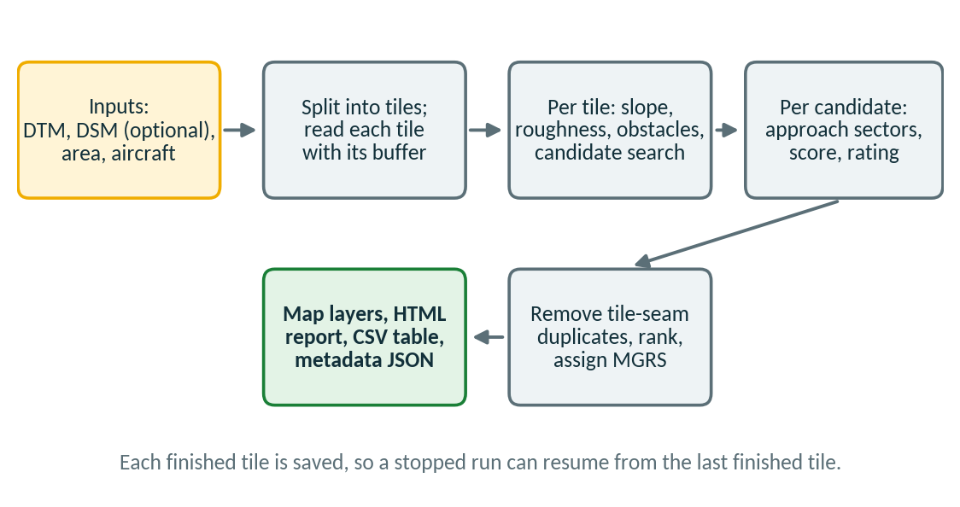
Figure 1. Overview of a run.

1.2 What the tool does not do
The tool reads terrain and surface heights only. It does not know what the ground is made of, who owns it, what is above it that a DSM cannot show, or what threatens it. Chapter 10 lists these gaps and how to cover them. The most important ones are:
- Surface type: ice, soft ground, roads and traffic. Water and wetlands are excluded only if you supply a polygon or line layer as Exclusion areas. Otherwise a calm lake is perfectly flat and smooth and looks like an ideal landing zone. Always check candidates against imagery.
- Thin obstacles that are not in your obstacle list. Wires, towers, masts and small poles are checked only where you list them (Section 4.6). Most DSMs do not capture them.
- Threat exposure, wind, live weather, airspace and noise restrictions.

1.3 Typical workflow
- Set up the data folder (recommended): run 0. Set Up and Audit Data Folder, copy your files into the folders it creates, and read the audit (Section 4.4).
- Prepare the data: one DTM raster, one DSM raster on the same grid and vertical datum, both in a projected coordinate system in metres, plus a layer of water bodies (polygons, or lines for rivers and streams) if there is water in the area (Chapter 4). Add a list of known towers, masts and wires if you have one (Section 4.6).
- Open 1. Analyze HLZ Suitability and choose the data folder (or the data), the area and the helicopter type (Chapter 5).
- Run. For a large area the tool shows the number of tiles and a time estimate first (Chapter 9).
- Review the ranked candidates on the map, in the HTML report and in the CSV table (Chapter 6).
- Confirm the short list against imagery, then by reconnaissance and with the operator’s performance data (Chapter 10).

2 Concepts and terminology

2.1 Landing-zone geometry
A candidate is a point with two concentric zones around it and a set of approach sectors.
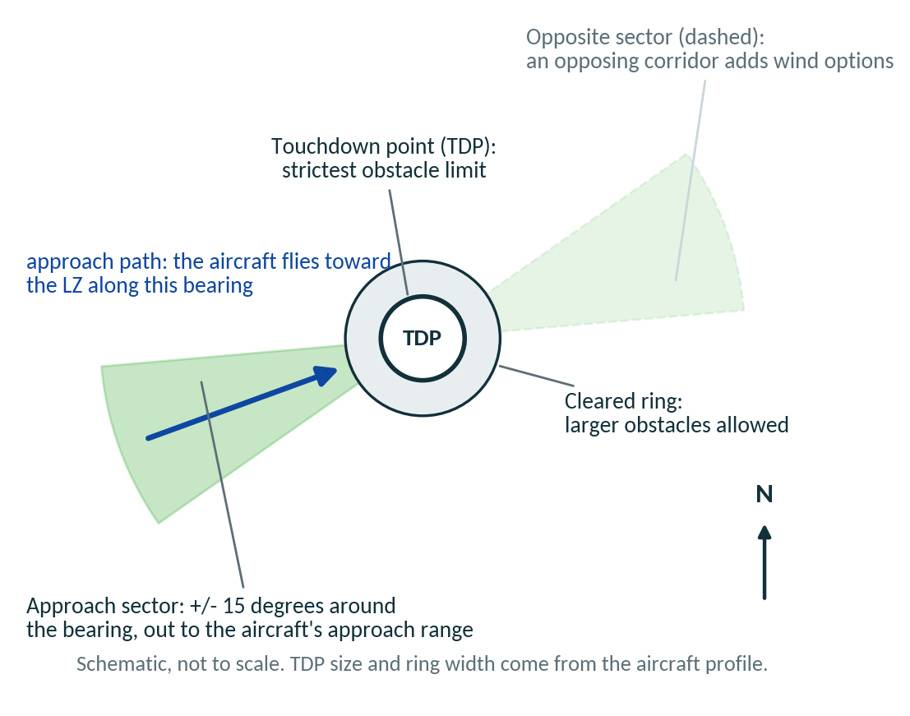
Figure 2. The touchdown point, the cleared ring and an approach sector (schematic).
Term | Meaning
Touchdown point (TDP) | The circle where the aircraft sets down. Its diameter comes from the aircraft profile (50 m for the generic medium class). The strictest limits apply here: ground slope, roughness and obstacle height.
Cleared ring | A band around the TDP (20 m wide for the medium class) where larger obstacles are tolerated than inside the TDP, but where trees and buildings still count.
Approach range | How far out the tool looks for obstacles along an approach (1,000 m for the medium class).
Approach sector | A direction of approach, ±15 degrees wide for the shipped profiles. The tool evaluates 36 sectors, one every 10 degrees.
Approach bearing and landing heading | The approach bearing is where the aircraft comes from, measured from the LZ. The landing heading is the direction the aircraft flies on final, which is the approach bearing plus 180 degrees. Example: approach from 250 means landing on heading 070.
Clearance height | The height above the LZ from which approach angles are measured (2 m for the medium class).
The size follows the helicopter you choose. A light type such as the H135 or UH-72A uses a 25 m touchdown point and a 10 m ring, a medium type such as the UH-60M or CH-146 uses 50 m and 20 m, and a heavy type such as the CH-47F or CH-53K uses 80 m and 30 m. Some types sit between (35 m and 20 m for the UH-1Y and AH-1Z). The area checked around each site has a radius of half the touchdown diameter plus the ring: 22.5 m, 45 m or 70 m for the three classes. A larger helicopter therefore finds fewer sites. Choose the type in the Aircraft profile field (Sections 5.2 and 8.1).

2.2 Terrain measures
- Slope. The slope of a plane fitted to all valid ground cells inside the TDP, in degrees. It is not a cell-to-cell slope.
- Aspect (downslope direction). The bearing the fitted plane descends toward. The uphill direction is aspect plus 180 degrees.
- Upslope landing only. Ground steeper than the general limit but not steeper than the upslope limit (for example between 7 and 15 degrees for the medium class) can still work if the aircraft lands facing uphill. The tool then only accepts approaches whose landing heading is within 30 degrees of the uphill direction, and caps the rating at Suitable.
- Roughness. The largest distance, in metres, between any ground cell in the TDP and the fitted plane. A ditch, boulder field or furrow raises it. The medium-class limit is 0.30 m.

2.3 Obstacles and exclusion areas
Obstacle height is the DSM minus the DTM at each cell, never below zero. The tool reports the tallest obstacle inside the TDP (limit 0.30 m for the shipped classes) and inside the cleared ring (limit 1.00 m). Without a DSM there is no obstacle information at all, and every rating is capped at Marginal. Thin structures that a DSM misses can be added from an obstacle list (Section 4.6).
Exclusion areas are layers you supply for places that look like good ground in elevation data but are not: lakes, ponds, wide rivers, reservoirs and wetlands (polygons), and rivers, streams, canals and shorelines (lines). A touchdown point can never overlap one. A line has no width of its own, so the tool widens it (Section 4.5). A candidate whose cleared ring touches an exclusion area is annotated, and every nearby candidate reports its distance to the nearest one.

2.4 Approach analysis and the obstacle angle
For each sector the tool samples the surface (the DSM where available, otherwise the DTM) along rays every 5 degrees, from the edge of the TDP out to the approach range. At every sample it computes the angle from a point at the clearance height above the LZ to the top of whatever is there. The sector’s obstacle angle is the steepest of those angles.
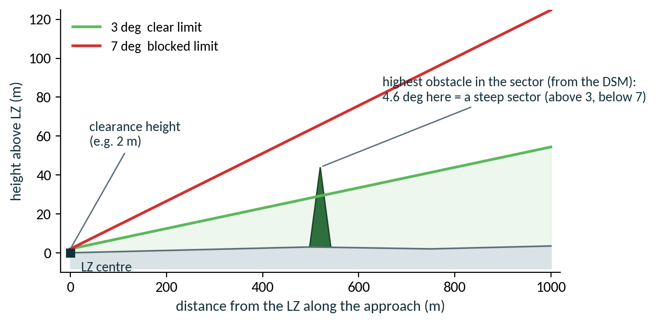
Figure 3. How the obstacle angle classifies a sector. The vertical scale is exaggerated.
Sector class | Meaning (shipped medium class)
CLEAR | Obstacle angle of 3 degrees or less. A normal glide path fits.
MARGINAL | Between 3 and 7 degrees. Only a steep approach fits.
BLOCKED | More than 7 degrees. No usable approach in this direction.
INCOMPLETE | Fewer than 80% of the samples along the sector had data (the sector runs off the edge of the data, or crosses NoData). The tool does not guess; it treats the sector as not assessed. A sector already blocked by the data that exists stays BLOCKED.
A negative angle simply means that nothing in the sector rises above the clearance height; the terrain falls away. Negative values such as -0.36 degrees in the examples are normal and good.
The tool picks the best approach: the usable sector with the lowest obstacle angle. It also records how many sectors are clear and whether two clear sectors face opposite ways (within 10 degrees of 180). Opposing corridors matter because they give the crew a choice when the wind changes. Obstacles that you list are tested exactly in every sector, in addition to the sampled rays (Section 4.6).

2.5 Density altitude and hover mode
Thin air reduces helicopter lift. Density altitude expresses how thin the air is as the altitude at which the standard atmosphere would have the same density. Hot days, high ground and low pressure all raise it. The tool uses these rule-of-thumb formulas:
- Pressure altitude = elevation in feet + (29.92 - altimeter setting in inHg) × 1,000.
- ISA temperature = 15 - 1.98 × (pressure altitude in thousands of feet), in degrees C.
- Density altitude = pressure altitude + 120 × (outside air temperature - ISA temperature).
Elevation | Air temperature | Altimeter (inHg) | Density altitude
100 m (328 ft) | 15 C | 29.92 | 406 ft
100 m (328 ft) | 30 C | 29.92 | 2,206 ft
100 m (328 ft) | 30 C | 29.50 | 2,726 ft
100 m (328 ft) | -20 C | 30.20 | -4,140 ft (denser than standard)
1,500 m (4,921 ft) | 30 C | 29.92 | 7,891 ft
The altimeter setting is the local sea-level pressure (QNH). A METAR group such as A2980 means 29.80 inHg. To convert from hectopascals, divide by 33.864 (1013 hPa is 29.92 inHg).
OGE (out of ground effect) means hovering more than about one rotor diameter above the ground, with no cushion of recirculated air, so more power is needed. IGE (in ground effect) means hovering close to the ground over firm, level terrain, which needs less power. The Hover performance mode field chooses which hover ceiling of the aircraft profile is compared with density altitude. OGE is the conservative default.
When the hover mode has an effect
Only when you enter an air temperature and the aircraft profile defines hover_ceiling_oge_ft or hover_ceiling_ige_ft. The shipped generic profiles define neither, so density altitude is reported but never rejects a site. Take ceilings from the aircraft’s performance charts and put them in a custom profile (Chapter 8).

2.6 Rating, score, status and confidence
Field | What it tells you
Score (0 to 100) | A weighted blend of five components: slope, roughness, approach, obstacles and data quality (Chapter 7).
Rating | Highly suitable, Suitable, Marginal, Unsuitable or Unassessed. Derived from the score, then limited by safety gates and caps. This is what the evidence supports.
Status | Whether the thresholds behind the rating are approved (Approved profile) or defaults (Planning only - profile not approved).
Confidence | HIGH: DSM present and cells of 1 m or finer. MEDIUM: DSM present and cells up to 2.5 m. SCREENING: no DSM, or cells coarser than 2.5 m.
Main limiting factor | The weakest component, in plain words, for example “Slope 9.7 deg (limit 7 deg)”.

3 Requirements and installation

3.1 What you need
Item | Requirement
ArcGIS Pro | Tested on 3.7.2 (Python 3.13). No extension is required. Other 3.x releases are expected to work but are untested.
Operating system | Windows, as required by ArcGIS Pro. Tested on Windows 11.
Memory | 8 GB or more recommended. With the default tile size the tool peaks at about 2.4 GB (measured in a development environment). With less than 8 GB, lower max_input_cells (Chapter 8).
Disk | A local drive with tens of GB free for city-scale runs. Do not use a OneDrive, Dropbox or similar synced folder for the tool or its output.
Elevation data | A DTM at minimum and a DSM strongly recommended. See Chapter 4 and the Data Requirements and Compatibility document.

3.2 Install the toolbox
- Unzip the release to a short local path, for example C:\GIS\HLZ_Suitability_Tool_v0.10.4. Keep the folder structure: the toolbox loads hlzcore\ and profiles\ from the folder above toolbox\.
- In ArcGIS Pro, open the Catalog pane, right-click Toolboxes, choose Add Toolbox, and select toolbox\HLZ_Suitability.pyt.
- Expand the toolbox. You should see 1. Analyze HLZ Suitability and 2. Validate Profiles.
- Hover over the information icon next to any field to read what it is, what it requires and what it changes.
Nothing needs to be installed for the toolbox itself. It runs in ArcGIS Pro’s own Python and uses only NumPy, SciPy and matplotlib, which Pro includes.

3.3 Check the installation
Run the self-test once after installing or updating. Use the ArcGIS Pro Python Command Prompt (not a regular Anaconda Prompt, which has no ArcPy) and a dedicated environment, never base or arcgispro-py3:
SETUP_HLZ_ENV.bat
activate hlz
cd /d "C:\GIS\HLZ_Suitability_Tool_v0.10.4"
RUN_ALL_TESTS.bat
SETUP_HLZ_ENV.bat creates the environment hlz once, as a clone of ArcGIS Pro’s Python (or of hlz-arcpy-v04 if it exists). RUN_ALL_TESTS.bat runs every test and writes one file, logs\hlz_test_logs_v0.10.4.zip, which is the only file you need to send for support.

4 Preparing your data
The tool is only as accurate as its inputs. The complete specification, with the reason for each requirement, is in the Data Requirements and Compatibility document. This chapter is the practical summary.

4.1 Must have, recommended, optional
Level | Item | If it is missing or wrong
Must have | A DTM: one band, projected coordinate system in metres, square cells | The tool stops with an error and says what to fix.
Must have | The correct Elevation (Z) units (Meters or Feet) | Every slope and obstacle height is scaled by 3.28. The tool cannot detect this.
Must have | Data that extends past the area of interest by the approach range plus 45 m (1,045 m for the medium class) | Approaches toward the edge are not assessed; the candidates are rated Unassessed.
Strongly recommended | A DSM from the same survey as the DTM, same vertical datum, same grid | No obstacle detection; all ratings capped at Marginal. A DSM with a different datum gives false obstacle heights.
Strongly recommended | Native cell size of 1 m or finer | Confidence drops to MEDIUM (up to 2.5 m) or SCREENING (coarser).
Strongly recommended | A polygon or line layer of water bodies and wetlands (Exclusion areas) | Lakes and ponds are flat and smooth, so they pass the terrain tests and can be rated as landing zones. The run warns that nothing is excluded.
Recommended | A list of the towers, masts and wires in and around the area (FAA DOF, OpenStreetMap, national data or your own CSV; Section 4.6) | A DSM often misses thin structures, so an approach through a tower can be shown as clear. The audit reports INFO when there is no obstacle list. Anything missing from the list is not seen.
Optional | An area-of-interest polygon | Without one, the map view is used, or the whole DTM.
Optional | A search centre (point layer, MGRS or latitude, longitude) and a radius | The area of interest, the map view or the whole DTM is searched instead.
Optional | Air temperature, altimeter setting and hover ceilings | Density altitude is not reported (and never gates a site without ceilings).
Optional | A custom aircraft profile with operator data | The generic planning values are used.
Optional | An HLZ data folder (HLZ_DATA) with the files in its standard sub-folders | You choose each file by hand, and the audit does not check them for you.

4.2 Preparation steps
- Create the data folder. Run 0. Set Up and Audit Data Folder and copy your files into the sub-folders it makes (Section 4.4). Then follow the steps below to make each file fit.
- Make one DTM raster. Lidar products arrive as tiles or projects. Combine them with Mosaic To New Raster (or export a mosaic) into a single raster, in a file geodatabase or as a BigTIFF GeoTIFF. The tool takes one raster, and mosaic datasets and image services are untested.
- Project to metres. Use Project Raster to the UTM zone of the area (for example NAD83(CSRS) / UTM zone 18N, EPSG 2959, for Ottawa, and zone 17N, EPSG 2958, for Toronto) if the data are in latitude/longitude. (Since version 0.9.0 the tool can do this for you; see Section 4.7.)
- Check the cell size with Get Raster Properties. It must be square. Use the native resolution; do not resample coarse data to 1 m to get a better confidence label.
- Make the DSM match. Same coordinate system and cell grid is best. A DSM on a different grid is resampled automatically with bilinear interpolation, which works but is slower on large areas.
- Check the vertical datum. The DTM and DSM must use the same one. The run warns when the lowest 5% of DSM minus DTM is more than 0.5 m from zero, but a smaller offset can go unnoticed. Over open flat ground the difference should be within about 0.2 m of zero.
- Check NoData. Water, voids and tile gaps should be NoData. The tool also treats elevations outside -1,000 to 9,000 m as NoData and warns you.
- Draw the area of interest if you do not want the whole DTM. Any polygon layer works, in any coordinate system.
- Get water and wetland polygons for the area, for example the Ontario Hydro Network Waterbody layer, and choose them as Exclusion areas. They can be in any coordinate system and any size. Water layers can be years old, so a recent pond or reservoir may be missing. A layer of rivers drawn as lines works too (Section 4.5).
- Collect obstacle data for towers, masts and wires, for example the FAA Digital Obstacle File (USA only) or an OpenStreetMap export, and put it in 10_Obstacles (Section 4.6).
Quick DSM check without Spatial Analyst
The Raster Calculator needs the Spatial Analyst extension. Without it, use Identify on a parking lot, runway or sports field in both rasters. The DSM and DTM values should match to within a few decimetres.

4.3 How far the data must extend
Approach checks read terrain out to the approach range from every candidate, so the data must extend that far, plus the TDP radius and cleared ring, beyond your area of interest.
Aircraft class | Approach range | TDP radius + ring | Data needed beyond the area
Generic light | 750 m | 12.5 + 10 = 22.5 m | 772.5 m
Generic medium | 1,000 m | 25 + 20 = 45 m | 1,045 m
Generic heavy | 1,500 m | 40 + 30 = 70 m | 1,570 m

The dialog checks this for a drawn area or the map view
If the area lies closer than this to an edge of the DTM, the dialog names the sides that are short. The run then rates candidates whose approaches run off the data as Unassessed and warns when more than a quarter of the approach sectors lack data. If you give no area, the whole DTM is analysed and candidates near its edge can be Unassessed.
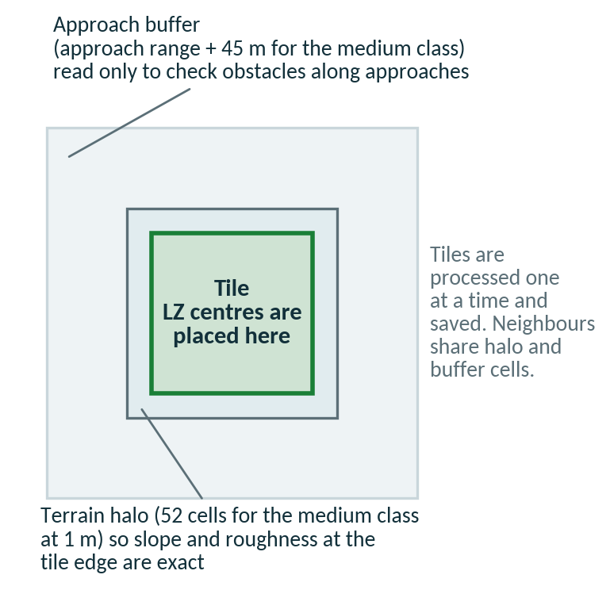
Figure 4. For every tile the tool reads the tile, a terrain halo and the approach buffer.

4.4 The data folder and the audit
To make a start easy, the tool can create one standard data folder, called HLZ_DATA by default, with a place for every input. You copy your files into the right sub-folder, run the audit, and the analysis then finds everything itself.

Create the folder
- Open the tool. In the Catalog pane, double-click 0. Set Up and Audit Data Folder.
- Choose where it goes. Set Data folder location to a local folder such as C:\GIS and keep the default Data folder name, HLZ_DATA. Keep Create missing folders ticked.
- Choose an aircraft (optional). Aircraft for the AOI margin check sets how far the DTM must extend beyond your area of interest. The generic medium class is the default.
- Run. The tool creates the sub-folders, writes a short README in each, audits the folder and, with Open the audit report when finished ticked, opens the report in your browser.
Without ArcGIS Pro, SETUP_DATA_FOLDER.bat and AUDIT_DATA_FOLDER.bat in the release folder do the same from the Python Command Prompt, and python -m hlzcore.cli init-data and audit-data are the command-line forms. Creating the folder is additive: nothing is moved, renamed or deleted, and running it again adds only what is missing.
Folder | What goes in it
01_Elevation\DTM | Required. ONE bare-earth elevation raster (GeoTIFF recommended).
01_Elevation\DSM | Recommended. ONE surface raster with trees and buildings, from the same survey as the DTM.
01_Elevation\Source_PointCloud | Optional. LAS or LAZ source files, kept for reference. They are listed but not read.
02_Hydrology | Recommended. Water polygons (lakes, reservoirs, wide rivers) or lines (rivers, streams, canals).
03_Exclusions | Optional. Other no-landing layers (wetlands, built-up land, restricted areas, power lines), as polygons or lines.
04_AOI | Optional. ONE area-of-interest polygon layer.
05_Search_Centres | Optional. Point layers to search around.
06_Reference | Not read. Imagery, roads, original tiles and documents for checking candidates by eye.
07_Profiles | Optional. Your own aircraft, mission and doctrine profile files; the audit validates them.
08_Runs | Output. One sub-folder per analysis run; the default Output folder of tool 1.
09_Audit | Output. The audit reports.
10_Obstacles | Recommended. Obstacle lists: FAA DOF (.dat), CSV or GeoJSON files, or point, line or polygon layers with a height (Section 4.6).

Read the audit
Run the same tool again after you copy files in. The audit reads only file headers (raster tags, shapefile and GeoJSON headers, GeoPackage tables), so it takes seconds even for multi-gigabyte rasters. Every finding is marked FAIL, WARN, INFO or PASS with what to do about it, and the folder gets one overall status.
Status | Meaning
READY | Every check passed. Choose the folder in tool 1.
READY WITH WARNINGS | The analysis can run, but read the warnings: each one says what will be less accurate.
NOT READY | At least one FAIL, or no single DTM. Fix the FAIL items first.

Typical findings are: no DTM or several DTM tiles that need a mosaic; a latitude/longitude or Web Mercator raster; elevations that look like feet; a DSM that is lower than the DTM (swapped, or a different vertical datum); a DSM on another grid or covering only part of the DTM; a water layer that holds only points; line layers, which are reported with the width they will be given; layers that do not overlap the DTM; a shapefile without its .prj; an area of interest too close to the DTM edge for the approach range; an invalid custom profile; ZIP files not yet extracted; files in the wrong folder; low disk space and cloud-synced paths. The audit also lists the obstacle files and layers in 10_Obstacles with their record counts, checks that they overlap the DTM, warns about obstacles whose height will be assumed, and reports INFO when there is no obstacle list.
The report is written to 09_Audit as HLZ_Data_Audit_latest.html, plus a dated .html, .txt and .json. It lists the inputs the analysis will use, an extent diagram and an inventory of every file. The audit checks the files, not the ground: it cannot tell whether a water layer is complete or recent.

Analyze from the data folder
In 1. Analyze HLZ Suitability choose the HLZ data folder first. It fills only the fields that are still empty: the DTM, the DSM, the Exclusion areas (every polygon and line layer in 02_Hydrology and 03_Exclusions), the area of interest (when 04_AOI holds exactly one layer) and the Output folder (08_Runs). Anything you chose yourself is kept, and you can change any filled field afterwards. The DTM field is optional while the folder supplies one. On the command line, use analyze --data-root. It also fills the two obstacle fields from 10_Obstacles: files with the extension .dat, .csv, .txt, .geojson or .json go into the obstacle files field, all other layers into the obstacle layers field.

4.5 Rivers and streams as exclusion lines
Exclusion areas accept line layers (shapefile geometry type Polyline) as well as polygons: rivers, streams, canals and shorelines, and also power lines or roads. A line has no width, so the tool gives every line a width, set in the field Width given to exclusion LINES (m).
- Width. 10 m in total by default (5 m on each side). The range is 0 to 500 m. One value applies to every line layer in a run. With 0 only the cells the line crosses are excluded.
- Distance. A touchdown point must stay a full touchdown radius away from the widened line, and the cleared ring is annotated, exactly as for polygons.
- Mixing. Polygon and line layers can be chosen together in the same field, and both folders of the data folder accept either kind.
- Wide rivers. Use a water polygon, or set the width to about the width of the river. A 10 m strip is right for a stream but far too narrow for a river 100 m across.
- Lake outlines. A lake drawn as a closed line excludes only the strip along the shore, not the water inside. Use the lake polygon.
- Points. Point layers are refused with an error that names the layer.
- Resume. The width is part of the inputs compared when an unfinished run is resumed (Section 9.5), so change it only when you mean to start a new run.
- Command line. Repeat --exclude for each GeoJSON file (polygons and lines) and use --line-width. Other formats are listed in a note and skipped.

4.6 Towers, masts and wires: the obstacle list
A lidar surface model (DSM) often misses thin structures such as communication towers, antennas, masts and wires. Where the DSM has no return from a tower, the glide slope through it can be shown green. Since version 0.6.9 you can list obstacles and checks every approach against them. The list is optional. Without it, towers, masts and wires are not looked for at all.

Where to get obstacle data
Source | Coverage and use
FAA Digital Obstacle File (DOF.DAT) | United States and territories only. Heights are above ground in feet. Records for dismantled obstacles are skipped. Put the file in 10_Obstacles.
OpenStreetMap (Overpass export as GeoJSON) | Wherever the structures have been mapped. Towers and masts (man_made=mast, man_made=tower), power lines (power=line) and buildings are read.
National aeronautical data | For areas outside the United States, for example the obstacle data of the national ICAO eAIP (Area 2). Convert it to a CSV file or a GIS layer.
Your own CSV or survey | A file with latitude, longitude and height columns in WGS84.
A GIS layer | Points, lines or polygons with a height field: shapefile, GeoPackage or geodatabase feature class, in any coordinate system.

Public obstacle data is never complete. An obstacle that is not in your list is not seen.

Formats and how heights are read
Format | What the tool reads
FAA DOF (.dat) | The DOF.DAT file. Heights are above ground in feet. Dismantled records are skipped. Valid for the United States and its territories only.
CSV (.csv, .txt) | One row per obstacle with latitude, longitude and height columns in WGS84. Many column names are accepted for each.
GeoJSON (.geojson, .json) | Including OpenStreetMap exports. The height comes from the height tag, or from building:levels multiplied by 3 m.
GIS layers | Point, line or polygon layers in shapefile, GeoPackage or geodatabase format, in any coordinate system.

- Height above ground. Every height is above the ground (AGL), not above sea level. The tool adds it to the DTM.
- Height field. Leave Obstacle height field empty to find it automatically. Names such as height, agl, hgt, height_m, height_ft and obst_height are recognised. Type the name if your field is called something else.
- Units. A field name that ends in _ft is read as feet. A unit written in the value, for example 100 ft, wins over everything else. Otherwise Obstacle height units applies (Meters by default). The FAA DOF is always in feet.
- No height. See the next heading.

Obstacles without a height
An obstacle with no height is given the value of Height (m) used for obstacles that have none, 30 m by default (range 1 to 500 m). It is flagged ASSUMED in the report, in run_metadata.json and in the data-folder audit, which warns before you run. In the report map such obstacles are drawn as hollow dots. An assumed height is a guess: set the default to a realistic value for the area, or add the real heights to the list.

What the tool does with the list
- Footprint. A point becomes a disk with the radius of Horizontal buffer around each obstacle (10 m by default, range 0 to 200 m). A line is widened by twice the buffer. A polygon is filled and its edge is included.
- Surface. Each footprint is burned into the surface as the higher of the DSM and the DTM plus the obstacle height. This also applies when there is no DSM; the surface is then used only by the approach analysis.
- Landing zone. A landing-zone cell is removed when it lies within the touchdown radius of a footprint taller than the TDP obstacle limit (0.3 m), or within the touchdown radius plus the cleared ring of a footprint taller than the ring limit (1.0 m).
- Approach. Each of the 36 approach sectors (plus and minus 15 degrees) gets an exact test against every listed obstacle. A thin mast between two rays of the normal 5-degree ray fan is still found. The thresholds are the same as for the profile: clear up to 3 degrees, marginal up to 7 degrees, blocked above 7 degrees. The obstacle that limits a sector is named in it.
- Reach. Obstacles up to about 5 km outside the DTM are read.

Reading the results
Where | What you see
Report map | Listed obstacles are purple dots. A hollow dot means the height was assumed.
Report inputs box | An Obstacles: line that says what was used.
CSV and geodatabase | Nearest_obstacle_m (Obst_Dist_m) is the distance to the nearest listed obstacle. Nearest_obstacle (Obst_Name) is its name (Appendix A).
Pilot brief and In plain words | A listed obstacle that limits the best approach, or that lies within 3 × (TDP radius + cleared ring) of the pad, is named. The brief’s caution says that towers, masts and wires were checked only where they are in the list.
run_metadata.json | A block called obstacles records the list that was used and which heights were assumed.

Limits
An obstacle that is not in the list is not seen
Public obstacle data is never complete. A tower that is missing from your list, or listed with a height that is too low, can still sit on a green approach. Keep checking imagery and confirm every site by reconnaissance.

- Coverage. The FAA DOF covers only the United States and its territories. Elsewhere use national aeronautical data (for example ICAO eAIP Area 2 obstacle data), OpenStreetMap or your own survey.
- FAA DOF reader. It was written from the FAA format description and tested on a synthetic file only. Check the first run against a real DOF.DAT.
- ArcGIS Pro. The ArcGIS Pro parts could not be tested outside ArcGIS Pro. Smoke test scenario J covers them (Section 12.1).
- Command line. Use --obstacles for FAA DOF, CSV or GeoJSON files, with --obstacle-height-field, --obstacle-units, --obstacle-default-height and --obstacle-buffer (Section 12.4). GIS layers are not used on the command line.

4.7 Data in latitude and longitude
Many public elevation products come in degrees (a geographic coordinate system such as WGS 84 or NAD83). The analysis needs metres, so from version 0.9.0 the tool projects such a raster for you.
- What happens. The DTM (and the DSM, if it is in degrees too) is projected to the UTM zone of its centre with bilinear resampling and square cells of about the same ground size. The dialog shows a yellow warning instead of the old red error.
- Which datum. NAD83 (including NAD83(CSRS)) sources use NAD83 UTM for zones 1 to 23 north; everything else uses WGS 84 UTM. Latitudes beyond 80 S and 84 N have no UTM zone and are refused.
- Where the copy goes. In ArcGIS Pro the projected copy is written to HLZ_Projected.gdb in the run folder under a short hashed name, so a resumed run reuses it. The command-line tool projects on the fly and needs no copy.
- When to project yourself. If you run the same area many times, run Project Raster once and use the result: it saves the projection time on every run. Untick Project a latitude/longitude DTM or DSM to UTM automatically (Advanced) to get the old behaviour back.
- Area of interest. On the command line a bounding box given with --aoi must be in the UTM coordinates named in the log, not in degrees.

4.8 Points as exclusion areas
Exclusion areas may now also be point layers or a mix of polygons, lines and points. A point is turned into a disk. Use this for a crane, a pole, a known hazard or any location that must stay clear.
- Radius. Radius given to exclusion POINTS (m) sets the disk, 0 to 500 m, 10 m by default. With 0 only the cell that holds the point is marked.
- Data folder. 02_Hydrology accepts polygons and lines; 03_Exclusions also accepts points.
- Resuming. The point radius is one of the inputs compared when an unfinished run is resumed. Command line: --point-radius.

5 Running an analysis

5.1 Open the tool
In the Catalog pane, expand the toolbox and double-click 1. Analyze HLZ Suitability. If a map view is open, zoom to the area you want before you start: with no polygon drawn, the tool uses the visible map extent as the area of interest.
The toolbox holds three tools: 0. Set Up and Audit Data Folder (Section 4.4), 1. Analyze HLZ Suitability and 2. Validate Profiles.

5.2 Step by step
- HLZ data folder (optional). If you made a data folder (Section 4.4), choose it first. The DTM, DSM, exclusion areas, area of interest and output folder are filled in wherever you have not already chosen something.
- Bare-earth elevation (DTM). Choose your DTM. The dialog checks the coordinate system, units and cell size at once and shows an error under the field if something must be fixed.
- Surface model (DSM). Choose the matching DSM. If you leave it empty, the dialog warns that obstacles will not be assessed and ratings will be capped at Marginal.
- Area of interest. Choose a polygon layer, or leave it empty to use the map view (or the whole DTM if you untick the map-view option). The dialog then shows the area in km², the number of tiles and a run-time estimate.
- Search around a point (optional). To look around one place instead of a whole area, choose a centre point layer or type an MGRS or latitude, longitude, and enter the radius in metres. Leave the area empty to search the whole circle, or give both to search only their overlap (Section 5.7).
- Exclusion areas. Choose one or more layers of water bodies and wetlands (polygons) or of rivers and streams (lines). A touchdown point will never overlap them. Leave empty only if the area has no water; the run warns when nothing is excluded.
- Width given to exclusion lines. Matters only when an exclusion layer holds lines. The default of 10 m suits a stream; use the river’s real width for a wide river (Section 4.5).
- Obstacles (optional, recommended). Choose layers of towers, masts, wires or buildings with a height field, and/or FAA DOF, CSV or GeoJSON files. The data folder fills these fields from 10_Obstacles. See Section 4.6.
- Obstacle settings. Leave Obstacle height field empty to find the height automatically. Set Obstacle height units (Meters or Feet; the FAA DOF is always in feet), the height used for obstacles that have none (30 m), and the horizontal buffer around each obstacle (10 m).
- Elevation (Z) units. Meters for most Canadian and international data. Feet for many US lidar products.
- Aircraft profile. Pick the helicopter from the list: generic light, medium or heavy, or a named Canadian, US or NATO type. Each entry shows its touchdown-point size and ring, for example CH-47F Chinook – 80 m landing point + 30 m ring, and the guidance under the field gives the radius checked around each site. Choose Custom profile file... for your own JSON file (Chapter 8).
- Weather (optional). Enter the air temperature and altimeter setting if you want density altitude (Section 2.5). Leave them empty otherwise.
- Output folder and Run name. Choose a local folder such as C:\GIS\HLZ_runs. The dialog warns if the path is in OneDrive, Dropbox or a similar synced folder, or is too long for Windows. The run name becomes a sub-folder.
- Leave the Advanced settings at their defaults for a first run, then click Run.

5.3 Parameter reference

Inputs
Field | Required | Default | What it does
HLZ data folder | No | none | A folder made by tool 0. Fills the fields below that are still empty: DTM, DSM, exclusion areas, AOI and output folder. See Section 4.4.
Bare-earth elevation (DTM) | Yes, unless the data folder holds one | none | Ground elevation without trees and buildings. One band, square cells. A projected system in metres is used as it is; a latitude/longitude raster is projected to UTM automatically (Section 4.7). Used for slope, roughness and terrain masking. Any size.
Surface model with trees/buildings (DSM) | No (strongly recommended) | none | Top-of-everything elevation. DSM minus DTM gives obstacle height. A DSM on another grid is resampled automatically.
Area of interest (polygon) | No | none | Where LZ centres may be placed (selected features only, if a selection exists). Data outside it is still read for approach checks. Any coordinate system and size.
Search around a point: centre point layer | No | none | A point layer. Several points give several circles. Needs a radius.
Search around a point: centre typed as MGRS or latitude, longitude | No | none | One position typed as text, for example 18T VR 45906 30941 or 45.4236, -75.7009 (WGS84). Added to any points of the layer. Needs a radius.
Search around a point: radius (m) | With a centre | none | How far from each centre landing zones are searched, 1 to 5,000,000 m. Ignored without a centre.
If no AOI is given, use the current map view extent | No | ticked | With no polygon, uses the visible map extent as the area. Untick it to analyse the whole DTM. Not used when a search centre is given.
Exclusion areas: water, wetlands, known hazards, ... (polygons, lines or points a landing zone must not touch) | No (strongly recommended) | none | One or more polygon, line or point layers, in any coordinate system and of any size (only the part near each tile is read). A touchdown point can never overlap them. Lines get the width and points the radius set below. Candidates whose cleared ring touches one are annotated.
Width given to exclusion LINES such as rivers and streams (m) | No | 10 | Total width given to every line layer in Exclusion areas, half on each side, 0 to 500. Ignored for polygons. See Section 4.5.
Radius given to exclusion POINTS such as a crane, pole or known hazard (m) | No | 10 | Radius of the disk given to every point in Exclusion areas, 0 to 500. Ignored for polygons and lines. See Section 4.8.
Or draw the area of interest on the map (polygon) | No | none | One or more polygons drawn in the dialog. Do not fill this and Area of interest at the same time. See Section 5.8.
Project a latitude/longitude DTM or DSM to UTM automatically | No | ticked | Projects a raster in degrees to the local UTM zone before the analysis. Untick to require a projected raster. See Section 4.7.
Obstacles: towers, masts, wires, buildings - layers (points, lines or polygons with a height field) | No | none | One or more feature layers (shapefile, GeoPackage, geodatabase feature class) in any coordinate system. Added to the surface and tested against every approach. See Section 4.6.
Obstacles: FAA Digital Obstacle File (.dat), CSV or GeoJSON files | No | none | One or more files. The FAA DOF covers the United States and territories only. CSV needs latitude, longitude and height columns (WGS84). See Section 4.6.
Elevation (Z) units | Yes | Meters | Unit of the elevation values in the rasters (not the map units). Wrong units scale slopes and heights by 3.28.

Obstacle settings
Field | Required | Default | What it does
Obstacle height field (leave empty to find it automatically) | No | empty | Name of the height field or CSV column. Empty: the tool looks for height, agl, hgt, height_m, height_ft, obst_height and similar names.
Obstacle height units (FAA DOF is always feet) | No | Meters | Meters or Feet, for heights without a unit of their own. A name ending in _ft or a unit in the value (100 ft) wins.
Height (m) used for obstacles that have none | No | 30 | 1 to 500 m. Flagged ASSUMED in the report, run_metadata.json and the audit.
Horizontal buffer around each obstacle (m) | No | 10 | 0 to 200 m. A point becomes a disk of this radius; a line is widened by twice this value.

Aircraft and weather
Field | Required | Default | What it does
Aircraft profile | Yes | Generic medium rotary-wing | The helicopter type. Each list entry shows its touchdown-point size and cleared ring. Sets that size, the slope, roughness and obstacle limits, the approach range and the approach angles. Shipped values are planning defaults.
Custom aircraft profile (.json) | Only with a custom profile | none | Your own limits. Copy generic_medium.json, edit the copy and check it with 2. Validate Profiles.
Outside air temperature (C) | No | empty | Expected air temperature at the LZ, -70 to +60. Needed for density altitude.
Altimeter setting (inHg) | No | 29.92 | Local sea-level pressure (QNH), 25.0 to 32.5. Use the METAR value (A2980 is 29.80). A value in hPa is rejected.
Hover performance mode | Yes | OGE | Which hover ceiling to compare with density altitude: OGE (conservative) or IGE. Has an effect only with a temperature and a profile that defines hover ceilings.
What-if: landing-point diameter (m), replaces the aircraft profile’s value | No | empty | 5 to 200 m. Tests a bigger or smaller touchdown point without a new profile. See Section 5.9.
What-if: cleared ring width (m), replaces the aircraft profile’s value | No | empty | 0 to 200 m. Replaces the cleared ring of the profile for this run. See Section 5.9.

Output
Field | Required | Default | What it does
Output folder | Yes | Project home folder | Parent folder for results. Use a local, fast drive with free space.
Run name | Yes | HLZ_date_time | Name of the sub-folder. Letters, digits, underscore and hyphen are kept. Re-using the name of an unfinished run resumes it; a finished run is never overwritten.
Add styled results to the current map | No | ticked | Adds a group layer with the results, coloured by rating. Untick for batch use.
Open the HTML report when finished | No | ticked | Opens HLZ_Report.html in your browser. The report is always written.
Minimum spacing between listed candidates (m) - 0 lists every candidate | No | 0 | 0 to 5,000 m. Drops candidates strictly closer than this to a better kept one. See Section 5.10.
Length units in the HTML report | No | Metres and feet | Metres and feet, Metres only, or Feet first (feet and metres). See Section 6.11.
Also create a terrain overview grid (coarse cells showing where the ground passes) | No | unticked | Adds the layer HLZ_Overview_Grid. See Section 6.9.
Overview grid cell size (m) | No | 500 | 20 to 20,000 m, and at least 16 analysis cells. Used only with the overview grid.

Advanced
Field | Required | Default | What it does
Mission profile (.json) | Yes | screening.json | Score weights, approach sampling, candidate limits, coverage thresholds and the tile size. quick_look.json is faster with fewer candidates.
Doctrine / threshold profile (.json) | Yes | generic_planning.json | Score thresholds for each rating and the approval status. An unapproved profile labels every result “Planning only”.
Maximum number of candidates | No | empty (1,000) | Total candidates kept, best first, 1 to 100,000. A city-wide run can find far more than 1,000.
Slope / roughness / obstacle rasters | No | AUTO | Diagnostic rasters that show why ground passed or failed. AUTO writes them only up to 100 million cells; ALWAYS forces them; NEVER skips them. Ground_Class is always written.
Basemap in the HTML report | No | Online imagery and topographic map | Online: the report’s map loads Esri imagery, topographic and street tiles from the internet when it is opened, which reveals the area being viewed. None (offline, no data leaves this PC): no map tiles and no network requests at all; choose it for sensitive work.
Explain each field in the dialog (guidance) | No | ticked | Shows a short explanation under each field, adapted to your inputs. Errors and warnings take priority over guidance.

5.4 Messages in the dialog
You see | Meaning | What to do
Red cross (error) | A problem that stops the run, for example a projected DTM in feet, non-square cells or a drawn area together with an area layer. | Fix what the message says. The Run button stays disabled.
Yellow triangle (warning) | The run is possible but something reduces accuracy or speed, for example a DTM in latitude/longitude (it will be projected), no DSM, a coarse cell size, a synced output folder, a DTM whose vertical unit is feet while Z units says Meters, or an area closer to the edge of the DTM than the approach range. | Read it. Proceed only if you accept the consequence.
GUIDANCE: ... | An explanation of the field, adapted to your current inputs. It appears only where there is no error or warning. | Optional reading. Untick Explain each field to hide it.
Area, tiles and time estimate | Shown under the DTM or the area field, for example AOI: 7.8 km2, 7,800,000 cells -> 1 tile(s), roughly 16 s-39 s. | Check that the area is the one you meant before you run.

5.5 While it runs
- The Messages pane reports each tile, for example Tile 3/9: 100 candidate(s), about 2 min left, and every warning as it happens.
- The progress bar advances one step per tile.
- Cancel stops the run after the current tile. Finished tiles are kept. If ArcGIS Pro closes or crashes, the finished tiles are kept as well.
- To continue, run the tool again with the same run name and the same inputs and settings. The dialog confirms with a note that the run will be resumed.

5.6 When it finishes
- The Messages pane lists the best 15 candidates in a table with rank, rating, score, slope, approach, MGRS and main limiting factor, followed by the paths of the geodatabase, report, CSV and log.
- If you left the options ticked, the layers are added to the map and the HTML report opens.
- A final warning repeats that the results are a planning aid only.

5.7 Searching around a point
Use this when you want landing zones near a place rather than across an area: a casualty location, a rendezvous, a position on a route. You give a centre and a radius, and the tool analyses only that circle.
You give | The tool searches
An area of interest only | The whole polygon.
A centre and a radius only | The circle (or circles) around the centre.
Both | Only the overlap of the polygon and the circle.
Neither | The map view, or the whole DTM if you untick the map-view option.

How to give the centre
- A point layer. Digitise a point in the map with Create Features, or use any point layer. Several points make several circles of the same radius. A selection is respected.
- A typed position. Type it in the text field. It is added to any points of the layer. The accepted forms are below.
Form | Example | Notes
MGRS | 18T VR 45906 30941 | Spaces are optional. With fewer digits the centre of that square is used (18T VR 45 30 is a 1 km square). WGS84.
Decimal degrees | 45.4236, -75.7009 | Latitude first. Letters can replace signs, in either order: 45.4236 N 75.7009 W or 75.7009 W, 45.4236 N.
Degrees, minutes, seconds | 45°25′25″N 75°42′03″W | Both coordinates need their N or S and E or W letter.

What you get
- Every candidate reports Distance_from_centre_m and Bearing_from_centre_deg (true bearing from the centre to the site). Sites with equal ratings and scores are ordered nearest first.
- The circle and its centre are drawn on the report map and written as the layer HLZ search area (HLZ_Search_Area in the geodatabase). The report table gets a From centre column.
- Only the circle is analysed, so a small search finishes in seconds even on a very large DTM.
What the radius does and does not limit
The radius limits where landing-zone centres are placed. The terrain and obstacles around the circle are still read, out to the approach range plus 45 m (1,045 m for the medium class), to check the approaches. The dialog warns when your data stops short of that, and reports the area and time estimate for the circle.
In the command-line tool use --centre (repeat it for several points) and --radius.

5.8 Drawing the area of interest
Instead of choosing a polygon layer you can draw one or more polygons in the dialog with Or draw the area of interest on the map (polygon). It is the quickest way to try a small area.
- One source only. Do not fill both the layer field and the drawn area: the tool refuses. Choose one.
- Checks. The dialog and the run check the size of the drawn area and the data margin around it, as for a layer.
- Status. The drawing tool itself has not been confirmed in the ArcGIS Pro interface yet (Section 12.1). If it does not work on your system, use a polygon layer.

5.9 What if the helicopter were bigger or smaller?
Two optional fields replace the size in the aircraft profile for this run only, so you can compare types or test a margin without writing a profile.
Field | Range | What it replaces
What-if: landing-point diameter (m) | 5 to 200 m | The touchdown-point diameter of the aircraft profile.
What-if: cleared ring width (m) | 0 to 200 m | The width of the cleared ring of the aircraft profile.

- Everything follows. The area checked around each site, the candidate spacing and the obstacle tests use the new size. The slope, roughness and approach limits stay those of the profile.
- Provenance. The values are recorded in run_metadata.json and shown in the report inputs box, marked as what-if values. Command line: --tdp-diameter and --cleared-ring.
- Resuming. A different what-if size is a different run: an unfinished run with other values is not resumed.

5.10 Spacing and sites
In an open field the top of the ranking can fill up with neighbours that are really one place. The tool deals with this in two steps.
- Sites (always on). Candidates whose cleared areas overlap, including chains of neighbours, form one site and share a Site_No. The link distance is twice the analysis radius, that is, twice the touchdown radius plus the ring. The best candidate of a site is its primary and the others are alternates (Section 6.8).
- Minimum spacing (optional). Minimum spacing between listed candidates (m) drops every candidate that is strictly closer than this distance to a better one that is kept. The range is 0 to 5,000 m; 0 lists every candidate. Command line: --min-spacing.
- Choosing a value. Spacing thins what you see; it does not change any rating. Leave it at 0 for a complete record and use the sites to read the result. Use a spacing of a few hundred metres when you need landing zones spread across an area.

5.11 Report units and the overview grid
- Length units in the HTML report. Metres and feet (default), Metres only, or Feet first (feet and metres). The CSV and the geodatabase always carry the metre columns and, in the CSV, matching _ft columns (Section 6.11). Command line: --units BOTH|METRIC|IMPERIAL.
- Terrain overview grid. Tick Also create a terrain overview grid and set Overview grid cell size (m), 20 to 20,000 m, 500 m by default and at least 16 analysis cells. It adds a coarse map of where the ground passes (Section 6.9). Command line: --overview-cell.
- Basemap. The report map loads Esri imagery, topographic and street layers from the internet. Choose None (offline, no data leaves this PC) to make no network request at all.

6 Understanding the results

6.1 The run folder
<Output folder>\<Run name>\
HLZ_Results.gdb candidates, approach layers, overview grid and rasters
HLZ_Report.html the report (open it in a browser)
HLZ_Pilot_Brief.html the pilot brief as a stand-alone file
HLZ_Candidates.csv every candidate, one row each, ready for Excel
HLZ_Rejection_Summary.csv why cells failed and how the list was reduced
HLZ_Projected.gdb projected copy of a latitude/longitude DTM or DSM (only then)
run_metadata.json inputs, profiles, settings, warnings, results
hlz_run.log step-by-step log of the run
_tiles\ per-tile checkpoints and tile rasters
Once a run has completed you can delete _tiles to save disk space. That run can no longer be resumed, but it is finished and nothing else depends on the folder.

6.2 Map layers
The layers are added in a group named HLZ results - <run name>.
Layer | Shows | Visible
HLZ candidates (rating) | The touchdown circle of the primary candidate of every site, coloured by rating and labelled with the ID and score, for example HLZ-01 (99). | Yes
HLZ best approach (line points to LZ) | A blue line from the start of the best approach to the LZ of each primary site; the arrow points into the LZ. The label gives the landing heading and obstacle angle. | Yes
HLZ cleared ring | The outline of the outer cleared ring of the primary sites, coloured by rating. | Yes
HLZ alternates (dashed circle) | The touchdown circle of every alternate candidate, drawn with a dashed blue-grey outline. Each can also be used (Section 6.8). | Yes
HLZ alternates ring | The cleared ring of each alternate, dashed. | Yes
HLZ search area | The search circles, when a search centre was given. | Yes
HLZ overview grid | Coarse cells coloured by the share of ground that passes, with the best rating found in each. Only when the grid was requested (Section 6.9). | No
Ground test (green any heading / amber upslope) | Green where ground passes for any heading, amber where it passes for an upslope landing only. Cells that fail, and cells outside the area, are transparent. | Yes
HLZ approach sectors (top candidates) | All 36 sectors for the top 10 candidates, coloured clear (green), steep (amber), blocked (red) or no data (grey). | No
Slope (deg), Roughness (m), Max obstacle height in LZ + ring (m) | Diagnostic rasters (when written). | No

Rating colour | Meaning
Dark green: Highly suitable | Score 80 or more and no gate or cap applies.
Light green: Suitable | Score 60 to 79, or capped at Suitable (upslope landing only).
Amber: Marginal | Score 40 to 59, or capped (steep approach only, or no DSM).
Grey: Unassessed | The approach cannot be assessed because the data does not cover the approach area.
Red: Unsuitable | Score under 40, or a gate applies (all approaches blocked, no usable approach, or density altitude above the hover ceiling).

6.3 Reading a candidate: two worked examples
The values below come from a real run of the tool on the synthetic test terrain that ships with the tests (1 m cells, UTM zone 18N, generic medium class, 22 C, altimeter 29.80). They show how to read the output; they are not real-world sites.
Field | HLZ-01 | HLZ-60
Rating and score | Highly suitable, 99.1 | Suitable, 79.4
Confidence | HIGH | HIGH
MGRS | 18T VR 45906 30941 | 18T VR 46460 31066
Slope | 0.26 deg | 9.72 deg
Upslope landing only | No | Yes
Roughness | 0.00 m | 0.00 m
Obstacles in TDP / ring | 0.00 m / 0.00 m | 0.00 m / 0.00 m
Best approach from / landing heading | 250 / 070 | 240 / 060
Obstacle angle on the best approach | -0.36 deg (clear) | -2.08 deg (clear)
Clear sectors | 29 of 36 | 21 of 36
Opposing corridors | Yes | Yes
Density altitude | 1,417 ft (not gated: no ceiling in the profile) | 1,549 ft (not gated)
Main limiting factor | None - all criteria well within limits | Slope 9.7 deg (limit 7 deg)
HLZ-01 is a flat, smooth, obstacle-free site with 29 clear directions. HLZ-60 is a slope of 9.7 degrees, steeper than the 7 degrees allowed for any heading but within the 15 degrees allowed for an upslope landing. Its downslope direction is 269, so uphill is 089, and the best usable approach lands on heading 060, within 30 degrees of uphill. Its score of 79.4 falls in the Suitable band, and as an upslope-only site its rating could not rise above Suitable in any case. The limiting factor is the slope.
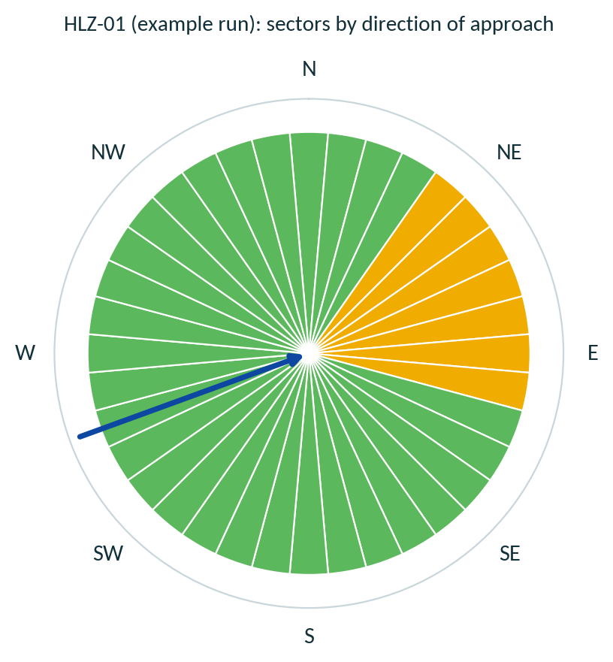
Figure 5. Approach rose for HLZ-01 from the example run: 29 clear sectors, 7 steep sectors (east), and the best approach (blue arrow).
The steep sectors to the east are where the example terrain has a hill and a forest block. This is exactly the kind of information the rose gives: not only whether a site works, but from which directions.

6.4 The HTML report
HLZ_Report.html is a single file; send it as it is. At the top, three buttons switch between the Planner report, the Pilot brief (Section 6.7) and Print. The planner report contains:
- A banner stating that the results are a planning aid and whether the profile is approved, and cards counting the candidates in each rating.
- An interactive map of the sites on a basemap, as wide as the page so that a site is easy to find. Layers: Esri imagery, topography and streets. Zoom, pan and a zoom-to-all button are provided, and the map stays in view while you scroll the table. Each site is drawn once, by its primary candidate. A search circle, if you used one, is drawn as a dashed blue line. Listed obstacles are drawn as purple dots; a hollow dot means the height was assumed (Section 4.6).
- A panel, How to read this table, that explains every column in plain words, what a good value looks like and why it matters, followed by a short glossary. The same text appears in a tooltip when you hover over or tap the ? next to a column heading.
- A ranked table of the best 500 sites (all candidates, including alternates, are in the CSV and the geodatabase). Click an ID to zoom the map to that site. Rating tickboxes under the map hide markers and rows together.
- For the selected site, the map draws the touchdown point, the cleared ring, all 36 approach sectors (green clear, amber steep, red blocked, grey no data) and the best approach as a blue arrow pointing into the landing zone. A pop-up gives the MGRS, slope, approach, clear sectors and main limiting factor. Clicking a marker highlights its row in the table.
- A detail card for each of the top 10 candidates, starting with a sentence in plain words, then an approach rose and a Show on map button, then the inputs and settings used, the warnings raised during the run and the limitations of the method. The inputs box has an Obstacles: line.
Reading the Best approach cell
Example: from 100° ESE and, below it, land on 280° WNW, obstacle angle 1.2°.
From 100° means the aircraft arrives from the east-south-east of the site (compass bearing 100° from true north, measured from the site). Land on 280° is the heading it flies as it lands, the opposite way, toward the west-north-west. Obstacle angle 1.2° is how high the tallest tree, building or hill on that path rises above the horizon, seen from 2 m above the pad. Up to 3° is clear, over 7° is blocked, and in between needs a steep approach. If nothing rises above the horizon the cell says so.
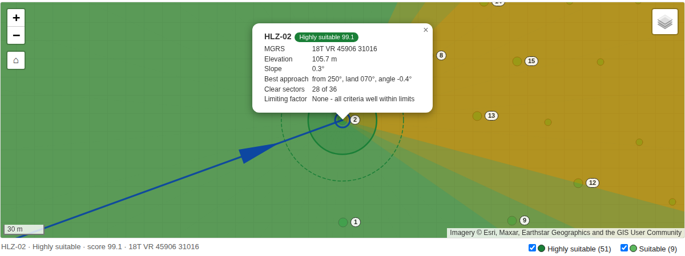
Figure 6. The report map after clicking HLZ-02 in the table (the background here is a stand-in; with internet access it is satellite imagery).
The basemap needs the internet, and tells the provider where you look
With the default option the browser requests map tiles from Esri servers when the report is opened, which reveals the area being viewed. For sensitive work choose None for Basemap in the HTML report: the report then makes no network request at all and draws the candidates on a plain background. The online tiles are third-party services with their own terms of use; they were not tested against the live servers.
A short plain overview without a map is kept in a collapsed section for viewers that cannot run scripts.

6.5 The CSV table
HLZ_Candidates.csv has one header row and one row per candidate, best first, encoded as UTF-8 with a byte-order mark so that Excel opens it correctly. Appendix A lists every column. The same attributes, with readable aliases, are in the HLZ candidates layer’s attribute table.

6.6 Run metadata and the log
- run_metadata.json records the inputs, the full aircraft, mission and doctrine profiles used, every setting, the number of tiles, the results, all warnings and the first 1,000 candidates (with approach sectors for the top 10). Keep it with the results: it is the provenance of the run. The block obstacles records the obstacle list and any assumed heights.
- hlz_run.log records each step with a time stamp. Send it, with the test zip, when asking for support.

6.7 The pilot brief
The planner report answers “which sites are good?”. The pilot brief answers “what do I need to know to land there?”. Click Pilot brief at the top of the report to switch to it, or open the file HLZ_Pilot_Brief.html that is written next to the report. It needs no map and no internet.

What is on a card
Part | What it tells the pilot
Header | The site ID, rating and score, and its rank.
Where | The MGRS reference in large type, latitude and longitude in degrees, minutes, seconds and in decimals, ground elevation in feet and metres, density altitude in feet (if a temperature was entered), and the distance and bearing from the search centre (if one was used).
The landing area | The landing circle and ring in metres and feet, the slope (a red warning to LAND FACING UPHILL where it applies), the ground roughness, and the tallest object in the circle and ring.
How to come in | The best approach in large type, for example “Come in from 250° (WSW). Land on heading 070° (ENE).”, then the highest obstacle on that approach in feet above the pad, how far out it is (metres and nautical miles) and its bearing. A listed obstacle that limits the best approach, or lies within 3 × (TDP radius + ring) of the pad, is named.
Directions you can come in FROM | Bearing ranges, read clockwise, for the clear, steep, blocked and no-data directions, for example “Clear 125°–035°”.
Rose | A small circle with N, E, S and W showing the same information graphically. The blue arrow is the best approach.
In plain words | The same one-paragraph description that the planner report gives. It names such a listed obstacle too.
Cautions | What the tool cannot check (towers, masts and wires that are not in the obstacle list, how firm the ground is, snow or dust, vehicles and people, wind, airspace), that bearings are true, the data confidence, any exclusion area close by, and whether the thresholds are approved. Towers, masts and wires were checked only where they are in the list.

The wind helper
Type the wind direction (the direction it blows from, degrees true) and, if you like, its speed in knots. Every card then shows the best approach for that wind. A helicopter lands into the wind, so the tool looks for the clear approach direction whose landing heading is closest to the direction the wind comes from, and reports how many degrees off the wind it is, with the head wind and cross wind. Example: wind from 270° means the best approach is from the east (090°), landing on heading 270°. If the nearest clear direction is far from the wind but a steep approach lines up with it, the card says so, and it adds a note when the best choice is more than 45° off the wind.

Printing, sharing and limits
- Print prints the pilot brief only, one site per page, so it can be used as kneeboard cards. Choose how many sites to show with show the best N sites.
- Download as a file (or the file HLZ_Pilot_Brief.html) gives a stand-alone copy that can be sent to a crew by itself; the wind helper works in it.
- The brief holds the best 30 sites. All bearings are true, not magnetic: the tool does not know the local magnetic variation, so apply it.
- It is a planning aid. It does not replace the aircraft’s performance data, charts, a reconnaissance or the pilot’s judgement.

6.8 Primary sites and alternates
A good field often holds many places where a helicopter could land. Listing them all hides the best one. From version 0.10.0 each site is shown once.
- Primary. The best candidate of the site, ranked by rating, then score, then the number of assessed sectors, then the number of clear sectors, then selection quality. It is the one to plan with first.
- Alternates. The other candidates whose cleared areas overlap the primary’s (or that are linked to it through a chain of neighbours). They are real landing zones that passed every test, so a crew that cannot use the primary can use one of them.
- Where you see them. The report and the map list primaries only, with a small note of how many alternates each has. The geodatabase layers draw alternates with dashed outlines. The CSV holds every candidate: Site_No, Site_Role (PRIMARY or ALTERNATE), Site_Primary_ID and Site_Alternates (Appendix A).
- Reading the numbers. The log and report say how many candidates and how many sites were found, for example 140 candidates at 12 sites.
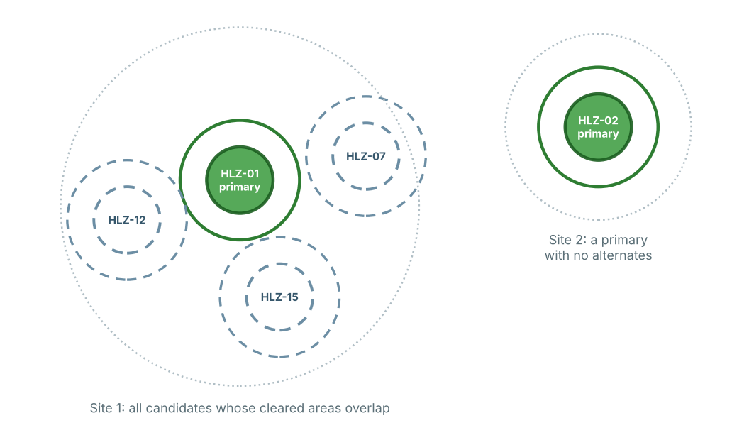
Figure 7. Two sites. The first has a primary (solid) and three alternates (dashed); the second has only a primary. Dotted circles show the extent of a site.
Alternates are not ranked separately on the map
To rank every candidate on its own, use the CSV and filter Site_Role. To spread landing zones over an area, set a minimum spacing (Section 5.10).

6.9 The terrain overview grid
A whole-city run can find thousands of candidates, yet the question is often where the ground is suitable at all. The overview grid answers this with coarse square cells (500 m by default).
- Fields. Each cell has its data coverage, mean and maximum slope, mean roughness, elevation minimum, maximum and range, the share of area that passes the ground test (for any heading and for an upslope landing only), a terrain class, a pass class, the number of ranked candidates inside and the best rating inside (Appendix A, Table A2).
- Where. The geodatabase layer HLZ_Overview_Grid (added to the map, off by default), or HLZ_Overview_Grid.geojson from the command line.
- Cost. It is computed from the tiles already processed, so it adds little time.

6.10 The rejection summary
HLZ_Rejection_Summary.csv, and a panel in the report, explain why ground was not accepted. Every analysed cell is given exactly one reason code, in test order, and the file counts the cells for each.
Code | Meaning
0 | Passes the ground test for any landing heading
1 | Passes the ground test only for an upslope landing
2 | Too little valid elevation data around the cell
3 | Ground too steep
4 | Ground too rough
5 | Too little surface-model (DSM) coverage to check obstacles
6 | Obstacle in the touchdown area taller than the limit
7 | Obstacle in the cleared ring taller than the limit
8 | Touchdown area would touch an exclusion area (water, wetland, ...)
9 | Too close to a listed obstacle (tower, mast, building, ...)

The file also shows how the candidate list was reduced afterwards (separation, the candidate limit, minimum spacing). Use it when a result is empty or smaller than expected: if most cells say Ground too steep, relax nothing, the terrain is simply steep; if they say Touchdown area would touch an exclusion area, check the exclusion layer.

6.11 Metres and feet
- CSV. The metre columns are always written. Matching _ft columns follow them (Elevation_ft, Roughness_ft, Max_obstacle_in_TDP_ft, Max_obstacle_in_ring_ft, Distance_to_exclusion_ft, Nearest_obstacle_ft and Distance_from_centre_ft).
- Report. The setting Length units in the HTML report chooses metres and feet, metres only, or feet first. It changes the display only; no rating or score changes.
- Elevation input. Elevation (Z) units still describes the input rasters, not the report.

7 How scores and ratings are calculated

7.1 The search
- Ground test on every cell. A fast screening pass fits a plane to the TDP-sized disk around each cell and applies the limits below. It produces the Ground_Class raster. Any cell whose distance to an exclusion polygon is less than the touchdown radius fails, so no touchdown point can overlap water.
- Candidate selection. Cells that pass are ranked by a quality surface (flat, smooth, free of obstacles and away from the edge of the passing area) and picked best first, keeping each pick at least one TDP diameter from the others (two diameters for quick_look).
- Exact check. Each pick is re-checked exactly: a plane is fitted to every valid cell in the TDP, the largest residual is the roughness, and obstacle heights are taken over the true disks. Picks that fail are discarded. The screening raster can therefore differ slightly from the final candidates at the margins.
- Approach analysis for 36 sectors (Section 2.4), then scoring, rating and ranking.

7.2 Pass/fail limits (shipped medium class)
Test | Limit | Notes
Valid data in the TDP | At least 95% of cells | minimum_valid_fraction
Slope | 7 degrees for any heading; up to 15 degrees for an upslope landing | max_landing_slope_deg, max_upslope_landing_deg
Roughness (largest plane residual) | 0.30 m | max_roughness_m
Obstacle height in the TDP | 0.30 m | tdp_obstacle_height_m; at least 95% of TDP cells need DSM data
Obstacle height in the cleared ring | 1.00 m | ring_obstacle_height_m; at least 90% of ring cells need DSM data
Exclusion areas (if given) | Touchdown point may not touch | Distance from the centre to the nearest excluded cell must exceed the touchdown radius

7.3 The score
Each component runs from 0 to 1. The score is 100 × the weighted average, with the default weights below.
Component | Weight | How it is computed
Slope | 25 | 1 - slope / general limit. For an upslope-only site: 0.5 × (1 - slope / upslope limit). Never below 0.
Roughness | 20 | 1 - roughness / roughness limit.
Approach | 30 | 0.8 × angle part + 0.2 × breadth part, plus 0.1 if opposing corridors exist (never above 1). Angle part: 1 at or below the clear angle, falling to 0 at the blocked angle. Breadth part: the share of clear sectors divided by 0.25, never above 1. Zero if there is no usable approach.
Obstacles | 15 | 1 - the larger of (TDP obstacle / TDP limit) and (ring obstacle / ring limit). Zero without a DSM.
Data quality | 10 | 1.0 with a DSM and cells of 1 m or finer; 0.65 with a DSM and cells up to 2.5 m; otherwise 0.25.

7.4 The rating
The rating starts from the score using the doctrine thresholds (default 80, 60 and 40), then these rules apply in order. The first gate that applies decides.
Order | Rule | Result
1 | Density altitude is above the chosen hover ceiling (only if both are defined) | Unsuitable
2 | No approach sector could be assessed (the data does not cover the approach area) | Unassessed
3 | No usable approach sector (for an upslope site: none lines up with uphill) | Unsuitable
4 | The best approach is steeper than the blocked angle | Unsuitable
5 | The best approach is steeper than the clear angle but not blocked | Capped at Marginal
6 | Upslope landing only (if no gate applied) | Capped at Suitable
7 | No DSM (if no gate applied) | Capped at Marginal

7.5 Ranking
Candidates are sorted by rating (Highly suitable, Suitable, Marginal, Unassessed, Unsuitable), then by higher score, more assessed sectors, more clear sectors, and higher selection quality. Ranks are 1, 2, 3 and so on, and the IDs are HLZ-01, HLZ-02 and so on.

7.6 Why the rating and the score can look different
A candidate can have a high score and a low rating. For example, a site with a perfect score on slope and roughness but whose every approach is blocked is rated Unsuitable, because the gates exist to stop a good-looking number from hiding a showstopper. Always read the Main limiting factor and the Notes.

8 Profiles and customisation
Three kinds of profile control a run. They are JSON files in the profiles\ folder, so they can be copied, edited and versioned. Copy a shipped profile before editing it; never edit the shipped files in place.

8.1 Aircraft profile
Field | Unit | Light | Medium | Heavy | Meaning
tdp_diameter_m | m | 25 | 50 | 80 | Touchdown-point diameter
cleared_ring_m | m | 10 | 20 | 30 | Width of the cleared ring
max_landing_slope_deg | deg | 7 | 7 | 6 | Slope limit for any landing heading
max_upslope_landing_deg | deg | 12 | 15 | 10 | Slope limit for an upslope landing
max_roughness_m | m | 0.30 | 0.30 | 0.25 | Largest allowed plane residual in the TDP
tdp_obstacle_height_m | m | 0.30 | 0.30 | 0.30 | Tallest obstacle allowed in the TDP
ring_obstacle_height_m | m | 1.00 | 1.00 | 1.00 | Tallest obstacle allowed in the ring (not below the TDP value)
approach_range_m | m | 750 | 1000 | 1500 | How far out approaches are checked
corridor_half_width_deg | deg | 15 | 15 | 15 | Half-width of an approach sector
suitable_angle_deg | deg | 3 | 3 | 3 | Obstacle angle up to which a sector is CLEAR
unsuitable_angle_deg | deg | 7 | 7 | 6 | Obstacle angle above which a sector is BLOCKED
clearance_height_m | m | 2 | 2 | 3 | Height above the LZ where approach angles start
hover_ceiling_ige_ft | ft | none | none | none | Optional hover ceiling, in ground effect
hover_ceiling_oge_ft | ft | none | none | none | Optional hover ceiling, out of ground effect

These values are generic
The profile files are marked PLANNING DEFAULTS ONLY. For operational use, replace every value with data approved by the aircraft operator or authority, and enter hover ceilings from the performance charts.
Choosing the helicopter. The Aircraft profile list shows the touchdown-point size and ring of every entry, for example United States: CH-47F Chinook – 80 m landing point + 30 m ring. The profile file name stays last in square brackets and is used in the default run name. The same sizes appear in Section 8.5.

8.2 Mission profile
Field | Default | Meaning
slope_weight, roughness_weight, approach_weight, obstacle_weight, data_quality_weight | 25, 20, 30, 15, 10 | Score weights. They need not sum to 100.
azimuth_step_deg | 10 (15 in quick_look) | Spacing of the approach sectors. 10 gives 36 sectors.
ray_step_deg | 5 | Spacing of the rays inside a sector. Must divide 360 and not exceed the corridor half-width.
max_candidates | 1,000 (200 in quick_look) | Total candidates kept for the run (1 to 100,000).
max_candidates_per_tile | 100 (25 in quick_look) | Candidates searched for in each tile (1 to 5,000).
minimum_candidate_separation_factor | 1.0 (2.0 in quick_look) | Minimum spacing between candidates, as a multiple of the TDP diameter.
max_input_cells | 16,000,000 | Cells analysed per tile. Controls memory (about 140 bytes per cell). It never limits the total area. Range 250,000 to 200,000,000.
minimum_valid_fraction | 0.95 | Share of TDP cells that must hold valid data.
minimum_ring_coverage_fraction | 0.90 | Share of ring cells that must hold DSM data.
minimum_approach_coverage_fraction | 0.80 | Share of samples along a sector that must have data, otherwise INCOMPLETE.
upslope_alignment_tolerance_deg | 30 | How far a landing heading may differ from uphill for an upslope site.
tile_target_cells | 1,500,000 | Internal working-slab size for the terrain filter. Leave unchanged.

8.3 Doctrine profile
Field | Default | Meaning
profile_id, display_name | generic-planning | Names shown in the report.
source_title, source_edition | Internal planning defaults | The document the thresholds come from. Fill these in when you adopt an approved source.
approval_status | planning_only | Only the value approved (upper or lower case) removes the “Planning only” label.
highly_suitable_score, suitable_score, marginal_score | 80, 60, 40 | Score thresholds. They must descend and lie between 0 and 100.

8.4 Creating a custom aircraft profile
- Copy profiles\aircraft\generic_medium.json to a new file, for example profiles\aircraft\my_aircraft.json.
- Change profile_id and display_name, then edit the values from your approved source. Use null for a hover ceiling you do not have.
- Run 2. Validate Profiles on the new file. It applies the same strict checks as an analysis and lists every value. Fix any error it reports.
- In 1. Analyze HLZ Suitability, choose Custom profile file... (or restart the tool so the new file appears in the list) and select the file.
The validator rejects values that cannot work, for example a ring obstacle limit below the TDP obstacle limit, an upslope limit below the general slope limit, slope or approach angles of 45 degrees or more, an approach range shorter than the TDP radius plus ring, or a ray step that does not divide 360 degrees.

8.5 Named aircraft: Canada, United States and NATO Europe
Besides the three generic classes, the aircraft list holds 26 named aircraft, grouped by country (the list shows, for example, Canada: CH-146 Griffon (Bell 412CF) [ca_ch146]). They are generated from one editable catalog, profiles\aircraft\_catalog\rotorcraft_catalog.csv. Each record holds the rotor diameter, length, maximum weight, operators, source and a data status.
- Weight class. Up to 4,500 kg is light, up to 14,000 kg medium, above that heavy. The class supplies every limit except the touchdown-point size and (optionally) the ring width.
- Touchdown-point size. Where US Army pathfinder doctrine (FM 3-21.38) lists the aircraft, its category is used: 25 m (UH-72A), 35 m (UH-1N/Y, AH-1W/Z), 50 m (all 60 series, AH-64) and 80 m (cargo aircraft and the MV/CV-22B). I read these categories in a training summary of the manual, not the manual itself, so check them against it. Other aircraft take the class size (25, 50 or 80 m).
- Data status. verified means the record was checked against an official page when the catalog was built (the four Canadian aircraft, on canada.ca). reference means the figures are published specifications that were not re-checked: verify them before relying on them.
- What the catalog does not contain. No restricted or classified doctrine, and no hover ceilings. Slope, roughness, obstacle and approach limits are the generic class values. Enter approved values in the CSV to replace them.

Canada
Aircraft | Class | TDP (m) | TDP taken from | Data
CH-146 Griffon (Bell 412CF) | medium | 50 | weight class | verified
CH-147F Chinook | heavy | 80 | weight class | verified
CH-148 Cyclone | medium | 50 | weight class | verified
CH-149 Cormorant (AW101) | heavy | 80 | weight class | verified

United States
Aircraft | Class | TDP (m) | TDP taken from | Data
UH-60M Black Hawk | medium | 50 | doctrine category | reference
HH-60W Jolly Green II | medium | 50 | doctrine category | reference
MH-60R Seahawk | medium | 50 | doctrine category | reference
UH-72A Lakota | light | 25 | doctrine category | reference
AH-64E Apache Guardian | medium | 50 | doctrine category | reference
CH-47F Chinook | heavy | 80 | doctrine category | reference
CH-53E Super Stallion | heavy | 80 | doctrine category | reference
CH-53K King Stallion | heavy | 80 | doctrine category | reference
UH-1Y Venom | medium | 35 | doctrine category | reference
AH-1Z Viper | medium | 35 | doctrine category | reference
UH-1N Twin Huey | medium | 35 | doctrine category | reference
MH-139A Grey Wolf (AW139) | medium | 50 | weight class | reference
CV-22B Osprey | heavy | 80 | doctrine category | reference

NATO Europe
Aircraft | Class | TDP (m) | TDP taken from | Data
NH90 TTH | medium | 50 | weight class | reference
H225M Caracal | medium | 50 | weight class | reference
AW101 Merlin | heavy | 80 | weight class | reference
CH-53G/GS | heavy | 80 | weight class | reference
H145M | light | 25 | weight class | reference
H135/H135M | light | 25 | weight class | reference
Tiger HAP/UHT | medium | 50 | weight class | reference
AW159 Wildcat | medium | 50 | weight class | reference
Mi-8/Mi-17 | medium | 50 | weight class | reference

Changing or adding an aircraft
- Open rotorcraft_catalog.csv in Excel. Edit a row or add one. Useful columns: tdp_diameter_m_override, cleared_ring_m_override, hover_ceiling_ige_ft, hover_ceiling_oge_ft and mtow_kg (which sets the class).
- Run python scripts\build_aircraft_profiles.py from the release folder in the ArcGIS Pro Python Command Prompt. It writes one JSON profile per row and validates each with the same checks as the tool.
- Restart the toolbox (or refresh it in Catalog) so the new profiles appear in the aircraft list.

8.6 Approval and provenance
The tool never decides that a profile is approved. You do, by setting approval_status to approved after your authority has approved the aircraft values and the thresholds. Every report then records which profile files were used, so that a result can always be traced to its source.

9 Large areas
There is no limit on the size of the area. A whole city at 1 m resolution, several billion cells, is processed the same way as a small park: tile by tile.

9.1 How tiling works
- The area is cut into non-overlapping tiles. With the default settings and a 1 m medium-class run each tile is about 3,900 × 3,900 cells (3.9 km square).
- For each tile the tool reads the tile, a terrain halo around it (52 cells for the medium class at 1 m) and the approach buffer (1,045 m for the medium class). The halo makes slope and roughness at the tile edge identical to what an untiled run would give; this is checked by an automated test.
- Each tile is analysed on its own and its results are saved to disk before the next tile starts. Only one tile is ever in memory.
- At the end, candidates from all tiles are merged. Near-duplicates on either side of a tile seam are removed, the best candidates are kept, and the rasters are mosaicked into the geodatabase.

9.2 Memory and tile size
Memory use is set by the tile size, not by the area. The max_input_cells setting of the mission profile is the number of cells analysed per tile.
max_input_cells | Tile edge at 1 m (medium class) | Peak memory (measured) | Speed (measured) | Use when
16,000,000 (default) | about 3,900 m | about 2.4 GB | 0.3 to 0.6 million cells/s | 8 GB of RAM or more
4,000,000 | about 1,900 m | about 0.6 GB | 0.4 million cells/s | Less than 8 GB of RAM
1,000,000 | about 900 m | about 0.5 GB | 0.17 million cells/s | Only if memory is very short
*Measured on simulated terrain in a single-CPU development environment, 1 m cells, generic medium class.
Do not shrink the tiles without a reason. Below about 4 million cells the memory hardly falls, because every tile still reads the whole 1 km approach buffer, while the run gets much slower, since the buffer is read again for every tile. To change the value, copy screening.json, edit max_input_cells, and choose the copy as the Mission profile.

9.3 How long will it take?
The dialog shows an estimate before you run, based on 2 to 5 seconds per million cells. It is deliberately cautious and uses the bounding box of the area, so for an irregular boundary it overestimates: tiles that lie wholly outside the polygon are skipped almost instantly.
Area at 1 m | Cells | Tiles | Dialog estimate | Measured on a simulated area*
10 × 10 km | 100 million | 9 | 3 to 8 min | 3.1 min, 2.2 GB peak
14 × 14 km | 196 million | 16 | 7 to 16 min | 10.8 min, 2.4 GB peak
Ottawa, about 2,790 km² | about 2.8 billion | about 200 or more | 1.6 to 3.9 h | 1.5 to 2.6 h (extrapolated)
Greater Toronto Area, about 7,125 km² | about 7.1 billion | about 500 or more | 4 to 10 h | 3.7 to 6.5 h (extrapolated)
*A procedural test terrain run in a single-CPU development environment. Real data differ (more or fewer candidates, more failed checks), and your PC will differ. Run tests\benchmark_large_area.py (it is part of RUN_ALL_TESTS.bat) to measure your own speed.

9.4 Disk space
- Ground_Class is one byte per cell before compression. The tile rasters are kept in _tiles as well as in the geodatabase, so budget for both until you delete _tiles.
- As a planning estimate, expect on the order of 1 to 3 GB of results per 1,000 km² at 1 m with the default settings. This has not yet been measured on real data.
- The slope, roughness and obstacle rasters are float32: about 12 GB per 1,000 km² at 1 m before compression. AUTO skips them above 100 million cells; use ALWAYS only for areas where you need them.
- Candidate tables, the report and the metadata are small.

9.5 Cancel and resume
Each finished tile is saved in _tiles. A run can be resumed only if it is the same run:
Situation | What happens
Same run name, same inputs and settings, unfinished | The run is resumed from the last finished tile. The dialog says so, and the log records “Resuming: N of M tiles already finished”.
Same run name, but inputs, settings or the tool version changed | The tool refuses to mix results. It starts a new numbered run (name_2) and logs a warning.
Run already finished | It is never overwritten. A new numbered folder is created.
_tiles was deleted | The run can no longer be resumed.

9.6 Tips for city-scale runs
- Use the city boundary as the Area of interest. Only candidates inside it are reported.
- To examine one place, give a centre and radius instead of an area: only that circle is analysed, so it takes seconds even on a huge DTM.
- Give the DSM the same cell size and alignment as the DTM. Otherwise every tile is resampled, which is slower.
- Keep the inputs and the output on a local SSD, not on a network share or a synced folder.
- Set Slope / roughness / obstacle rasters to NEVER if you only need the candidates.
- Raise Maximum number of candidates if you want more than the best 1,000.
- Stop Windows from sleeping during a long run, and keep ArcGIS Pro open. If it is interrupted, run again with the same run name.
- Do a small trial first (a few km²) to check the data and the settings before committing to hours of processing.

9.7 Example: screening a whole city
- Mosaic the lidar DTM tiles into one raster and the DSM tiles into another, in the same UTM zone and with the same cell grid.
- Run a trial on a 5 km square. Check the report, the warnings and a few candidates against imagery.
- Run the whole city with the boundary polygon as the area of interest, the generic medium class and NEVER for the diagnostic rasters.
- Check the dialog’s tile count and estimate, then start the run, and leave the PC alone.
- Open the report, sort the CSV by rating, and take the best candidates to the verification steps in Section 10.4.

9.8 Stage timing and run-time estimate
hlz_run.log ends with a line Stage timing (s) that lists the seconds spent in each stage (reading, terrain, approach, writing and so on). run_metadata.json holds the same values. The estimate shown in the dialog uses typical speeds and is refined from the timing of earlier runs.
- Fixed ArcPy overhead. A run inside ArcGIS Pro has a fixed cost of about two minutes however small the area is, mainly in finishing the result rasters (mosaic, statistics, attribute table, pyramids). A small test area therefore takes minutes, not seconds.
- Faster finishing (v0.10.3). When a result is made of a single tile the raster is copied instead of mosaicked, and the log lists the seconds of each step (Raster step timing). Send the log if a run is slower than expected.
- Vector writing. Writing the footprints is normally quick. One run with a 2 m DSM took much longer; the cause is not known. The stage timing shows it.

10 Accuracy, limitations and verification

10.1 What drives accuracy
A result can be no better than its inputs. The table lists what matters most, whether the tool tells you about it, and what you can do.
Factor | Effect on the result | Does the tool report it? | What you can do
No DSM | Trees, buildings and towers are invisible; every rating is capped at Marginal. | Yes: warning, cap, SCREENING confidence | Always use a DSM.
Obstacle missing from the list, or listed too low | A tower, mast or wire that is not listed is not seen, and a height that is too low lets an approach through. Public obstacle data is never complete. | Partly: the audit and the report show how many obstacles were used. A missing obstacle is not detected. | Use several sources, check imagery and confirm by reconnaissance (Section 4.6).
Assumed obstacle heights | Obstacles without a height get the default (30 m). The real structure can be taller or shorter. | Yes: flagged ASSUMED in the report, run_metadata.json and the audit; hollow dots on the report map. | Add real heights, or set a realistic default.
DSM and DTM on different vertical datums | Every obstacle height is shifted by a constant. Sites become falsely blocked or falsely clear. | Partly: the run warns when the lowest 5% of DSM minus DTM is more than 0.5 m from zero. A smaller offset is not detected. | Use products from the same survey. Check DSM minus DTM over open ground.
Coarse or resampled cells | Roughness and small obstacles are not resolved. | Yes: warnings; confidence MEDIUM or SCREENING. A resampled grid is not detected. | Use the native resolution of 1 m or finer.
DTM vertical accuracy | Noise in the ground surface is read as roughness or slope. The roughness limit is only 0.30 m. | No | Prefer data whose vertical error is small next to the limit (a third or less is a sensible aim).
Misregistration of the DSM and DTM | Edges of buildings and trees shift, producing false obstacles. | No | Use matching products.
Age of the data | New buildings, cleared or regrown vegetation and construction are missing. | No | Check the acquisition dates; confirm by reconnaissance.
Leaf-off lidar | Deciduous canopy may be underestimated in winter or spring data. | No | Check the acquisition season of the DSM.
Seams between survey projects | National products join separate projects without edge-matching, so a small step can appear along the seam and look like slope or roughness. | No | Treat candidates along straight seams with suspicion.
Data edge near the area | Approaches that run off the data cannot be assessed. | Yes: a warning in the dialog naming the short sides, INCOMPLETE sectors, an Unassessed rating | Provide data beyond the area by the approach range plus 45 m.
Voids and NoData | In the TDP or ring (under 95% and 90% valid) the candidate fails. In the approach path a DSM void falls back to bare terrain, so an obstacle inside a void is not seen. | Partly | Fill voids or inspect the approach roses of the top candidates.
Generic aircraft values | Limits are planning defaults. | Yes: Status says “Planning only” | Use operator-approved values.
MGRS and latitude/longitude | Reported in WGS84. The elevation data are usually in a NAD83-based datum, and the two realisations differ by up to about two metres. The tool does not claim metre-level absolute accuracy. | The datum transformation used is written to the log | Use the reference to find the site, then confirm on the ground.

10.2 What the tool does not assess
Not assessed | Why it matters | How to cover it
Surface type: ice, soft or loose ground, snow | Bearing strength and brown-out or white-out are unknown. | Review each candidate on recent imagery and by reconnaissance.
Water and wetlands NOT in your exclusion layer | A lake, a pond or a wet field is flat and smooth, so the terrain tests pass. Water layers can be years old and miss recent ponds or reservoirs. | Supply a water polygon layer as Exclusion areas, and still review each candidate on recent imagery.
Wires, cables, thin poles, antennas, fences | Most DSMs miss them. Towers, masts and wires are checked only where you list them (Section 4.6). They are among the most dangerous approach hazards. | Add an obstacle list (FAA DOF, OpenStreetMap, national data or your own survey), use obstacle databases and reconnaissance.
Moving and temporary objects | Vehicles, people, livestock, crops and temporary structures. | Reconnaissance.
Wind, weather and visibility | Approach direction and performance depend on them. | Use the live forecast. The corridor and opposing-corridor information helps.
Airspace, noise and land restrictions | A technically good site may not be usable. | Check with the responsible authority.
Threat exposure | Overlooking buildings, high ground and lines of sight are not analysed in this version. Planned for a later version. | Tactical assessment.
Aircraft performance | Density altitude is a rule-of-thumb figure, not a performance-chart calculation. | Use the operator’s charts.

10.3 Behaviours to watch for
- Flat water and open airfields look perfect. Water is excluded only where your exclusion layer covers it. A cluster of top-rated candidates on a lake, reservoir or runway is a sign to check the layer and the surface type.
- Negative approach angles are normal. They mean the terrain falls away and nothing rises above the clearance height.
- Many Unassessed candidates mean the data does not extend far enough past the area. The tool warns when more than a quarter of the sectors lack data.
- Everything capped at Marginal means there is no DSM.
- A candidate with only steep approaches is Marginal at best. Look at its rose: if every sector is amber, the site needs a steep approach.
- Very few clear sectors (for example 1 of 36) mean a single narrow approach lane. The rating may be good, but the site is less flexible.
- Candidates on both sides of a tile seam are normal in the raw tile results. The merge removes the near-duplicates.

10.4 Recommended verification before use
- Open the top candidates on current imagery and check the surface (water, wetland, road, crops, buildings, wires visible from above).
- Check the obstacle list. Open the audit or the report: how many obstacles were used, which heights are ASSUMED (hollow purple dots), and whether the list overlaps the DTM. See Section 4.6.
- Read each candidate’s Notes and the Warnings section of the report.
- Check the approach rose of each short-listed site and choose directions that match the wind.
- Compare the density altitude with the operator’s performance data for the planned load.
- Check the data dates and the DSM/DTM consistency (Section 4.2).
- Confirm by ground or aerial reconnaissance, including wires and soft ground.
- Record the decision with the version, profile files and data sources used. run_metadata.json holds most of this.

10.5 Reporting a result
When you share a result, state: the tool version, the aircraft, mission and doctrine profile names and whether the profile is approved, the DTM and DSM sources with acquisition dates and cell size, the area, and the confidence level. The HTML report and run_metadata.json contain all of these.

11 Troubleshooting

11.1 Messages in the dialog
Message (starts with) | Cause | Fix
The DTM is in latitude/longitude. The tool will project it ... (yellow warning); The DTM uses a geographic (lat/long) coordinate system (red error) | The DTM is in degrees. Since v0.9.0 this is only a warning when the automatic projection is ticked; it is an error when you untick it. | Leave Project a latitude/longitude DTM or DSM to UTM automatically ticked, or run Project Raster once to the UTM zone of the area.
The DTM horizontal unit is ... | Projected, but not in metres (for example feet). | Project to a metre-based system. The Z units are set separately.
DTM cells must be square | Cell width and height differ by more than 1%. | Resample to a square cell size (keep the native resolution).
The DTM must be a single-band elevation raster | A multi-band image was chosen. | Choose the elevation raster, or extract the band.
The DSM is the same raster as the DTM | The same file was chosen twice. | Choose the surface model.
Without a DSM, trees and buildings are not assessed | No DSM chosen. | Add the DSM, or accept the Marginal cap.
Cell size ... is coarse for a ... m touchdown point | The cells are larger than half the TDP radius. | Use finer data, or treat results as screening only.
Enter the altimeter in inHg (25.0-32.5) | A value in hPa or in the wrong units. | Divide hPa by 33.864.
Outside air temperature must be between -70 and +60 C | Out-of-range or Fahrenheit value. | Enter degrees Celsius.
Enter the search radius in metres ... | A search centre was given without a radius. | Type the radius, for example 2000.
A radius needs a centre ... | A radius was given without a centre layer or typed position. | Give a centre, or clear the radius.
... is not a recognised position | The typed centre could not be read. | Use an MGRS reference (18T VR 45906 30941) or latitude, longitude (45.4236, -75.7009).
The DTM ends less than ... m from this area on the ... side(s) | Not enough data around the area on those sides. | Provide more data, or accept Unassessed ratings near that edge.
... holds Point features. Exclusion areas must be polygons ... or lines ... | A point or raster layer was chosen as Exclusion areas. | Choose polygon layers (water bodies) or line layers (rivers, streams).
... does not overlap the DTM, so it will exclude nothing | The exclusion layer lies outside the DTM. | Check the layer’s coordinate system and extent.
... is inside a cloud-synced folder | The output folder is in OneDrive, Dropbox or similar. | Use a local folder such as C:\GIS\HLZ_runs.
An unfinished run with this name exists: it will be RESUMED | A previous run with the same name stopped. | Keep the name to resume, or change it to start over.
This threshold profile is not approved doctrine | The doctrine profile is planning_only. | Expected with the shipped profile. See Section 8.6.
This is not an HLZ data folder (no hlz_data_root.json) | The folder chosen as HLZ data folder was not made by tool 0. | Run 0. Set Up and Audit Data Folder, or choose the HLZ_DATA folder itself.
No single DTM in 01_Elevation\DTM | The data folder holds no DTM, or several tiles. | Run tool 0 to read the audit. Mosaic the tiles into one raster.
No water polygons in 02_Hydrology: lakes are NOT excluded | The hydrology folder is empty. | Add water polygons or lines, or accept that water is not excluded.
Both a drawn area and an area layer ... | The area of interest was filled twice: a layer and a drawn polygon. | Clear one of the two.
... latitude beyond the UTM range | A raster in degrees lies outside the UTM zones (beyond 80 S or 84 N). | Project it yourself to a suitable metre-based system.

11.2 Messages while running
Message (starts with) | Meaning
... cells with elevations outside -1,000..9,000 m were treated as NoData | The raster holds an undeclared NoData value (such as -9999) or the Z units are wrong. Check Elevation (Z) units.
DSM grid differs from the DTM: it is resampled | The DSM is being aligned to the DTM grid, tile by tile. Works, but slower.
The search circle does not overlap the DTM | The centre and radius lie outside the DTM (or outside the area of interest, if you gave one). Check the centre, its coordinate system and the radius.
No exclusion layer: water, wetlands ... are NOT excluded | No polygon layer was given as Exclusion areas, so lakes can be rated as landing zones. Add a water polygon layer and re-run, and check candidates on imagery.
DSM and DTM look inconsistent in N of M tile(s) | The lowest 5% of DSM minus DTM is more than 0.5 m from zero (or over 5% of cells have the DSM below the ground). The two rasters probably use different vertical datums or are misregistered. Use a DSM and DTM from the same survey; do not trust obstacle heights until fixed.
... % of approach sectors lack data | The data does not extend far enough. Affected candidates are rated Unassessed.
... tile(s) reached the exact-check budget | In very rough or obstructed tiles, some marginal areas were not examined. The best candidates are unaffected.
... candidates found; keeping the best ... | More candidates than Maximum number of candidates. Raise it to keep more.
Cancelled after N of M tiles. Run again with the same run name to resume. | You cancelled. Nothing is lost.
The unfinished run ... used different inputs or settings; starting a new run in ... | A same-name run exists but cannot be continued safely, so a new folder was created.
Not running inside an open ArcGIS Pro project; layers were not added to a map. | Run from the Pro dialog with a map open, or add the geodatabase layers by hand.
Layer added but styling failed for ... | The layer is in the map but unstyled. Send the message with the test zip.
Latitude/longitude conversion failed | MGRS and coordinates are blank; the rest of the result is valid.
No obstacle applied ... | The obstacle list holds nothing inside the DTM area (plus about 5 km), so nothing was added to the surface. Check the coordinate system, the units of latitude and longitude and the file chosen.
... height field ... not found | The height field named in Obstacle height field does not exist in an obstacle layer. Type the exact field name, or leave the field empty to find it automatically.
... obstacle(s) ... height ... assumed | Some obstacles have no height and get the default (30 m by default). They are flagged ASSUMED. Add heights or set a realistic default.
Raster step timing (s) ... | Information from v0.10.3: the seconds of each step of finishing a result raster. Not a problem.
Stage timing (s) ... | Information: the seconds of each stage of the run (end of hlz_run.log).
... projected to UTM ... | Information: a latitude/longitude raster was projected. The log names the zone and the cell size.
... candidates at ... sites | Information: how many candidates were found and how many separate sites they form (Section 6.8).

11.3 Unexpected results
Symptom | Likely cause | Check
No candidates at all | Limits too strict for the terrain, wrong Z units, no valid data, or an area over forest, water or buildings. | Open the Ground_Class layer. If it is empty, look at the diagnostic rasters. Confirm the Z units and the area.
Every candidate is Marginal | No DSM. | The Notes column says “No DSM”.
Many Unassessed | Data ends close to the area. | Extend the data by the approach range plus 45 m.
Slopes look about three times too steep or too flat | Z units wrong (feet versus metres). | Set Elevation (Z) units.
Tall obstacles appear everywhere, or none do | DSM and DTM on different vertical datums, or the DSM is not a surface model. | Section 4.2, step 5.
Rows of odd candidates along a straight line | A seam between survey projects. | Look at the DTM along the line.
Top candidates sit on a lake | No exclusion layer was given, or it does not cover this water body. | Add an up-to-date water polygon layer (Section 4.2) and re-run.
The run is very slow | Large area, DSM resampling, synced or network disk, or tiny tiles. | Section 9.6.
A tower does not stop an approach (the sector is clear) | The tower is not in the obstacle list, its height is assumed too low, the buffer is too small, or it lies outside the area read (the DTM plus about 5 km). | Section 4.6: check the obstacle list, the ASSUMED flag, the height units and Horizontal buffer.
A site next to a listed obstacle is rejected or limited | The obstacle has an assumed height of 30 m, a height in the wrong units, or a large buffer. | Read Nearest_obstacle and Nearest_obstacle_m in the CSV. Correct the height, units or buffer.
The report map shows grey tiles or Access blocked | An older report used OpenStreetMap tiles, which refuse reports opened from a file. Or the computer is offline. | Re-run with v0.10.2 or later (Esri layers), or choose None for the basemap.
A site shows only one circle but the CSV has many rows | The report and map show primaries only. The other rows are alternates at the same site. | Section 6.8; filter Site_Role in the CSV.
A run of a few square metres still takes two minutes | Fixed ArcPy overhead for finishing the result rasters. | Section 9.8.

11.4 Getting help
Run RUN_ALL_TESTS.bat and send logs\hlz_test_logs_v0.10.4.zip. If the problem is in a particular run, also send that run’s hlz_run.log and run_metadata.json, and copy the text of any Geoprocessing messages.

12 Testing and maintenance

12.1 The self-test
RUN_ALL_TESTS.bat runs every test in the active environment. Each step runs separately, so one failure never hides the others, and a summary tells you what passed. Use --quick for a shorter benchmark.
Step | What it tests | Needs
core | 135 unit tests: data folder and audit, obstacle lists, profiles, terrain, tiling, resume, exclusion areas (polygons, lines, points), search around a point, overview grid, rejection summary, dual units, spacing and sites, primary and alternates, latitude/longitude projection, size what-if, report map, plain-language report, pilot brief, aircraft catalog, approach analysis, scoring, guidance, environment rules. | NumPy, SciPy
smoke | The real toolbox through scenarios A to J: DTM + DSM + AOI, DTM only, a DSM on a 2 m grid, many tiles with an AOI, many tiles over the whole DTM, a lake that must be excluded, a point-and-radius search, the data folder (tool 0, then an analysis from the folder alone), a river line excluded as a 20 m strip and obstacles (scenario J). It prints the seconds of each step. Run it in the cloned environment, not in base. | ArcPy
benchmark | Speed and peak memory on a simulated area, with Ottawa and GTA estimates. | NumPy, SciPy
cli | Optional command-line test (214 checks, including a river line, a data folder, obstacle lists, a latitude/longitude DTM and sites). | rasterio (skipped if absent)

12.2 Environments
- Test in a dedicated clone named hlz, never in base or arcgispro-py3. SETUP_HLZ_ENV.bat creates it without installing anything.
- Use the ArcGIS Pro Python Command Prompt. A regular Anaconda Prompt has no ArcPy.
- Do not install rasterio into the ArcGIS clone. It brings its own GDAL build, which can conflict with the one ArcPy uses. The optional command-line tool has its own environment (environment.yml, environment name hlz-cli-v04).

12.3 Updating to a new version
- Unzip the new release into a new folder next to the old one. Do not overwrite the old folder.
- In ArcGIS Pro, remove the old toolbox from Catalog and add toolbox\HLZ_Suitability.pyt from the new folder.
- Copy any custom profiles into the new profiles\ folders and check them with 2. Validate Profiles. Profile files from older versions load; keys introduced later take their defaults.
- Run RUN_ALL_TESTS.bat and read the summary.
- Unfinished runs from an older version cannot be resumed by the new one; finish them first, or start them again.

12.4 The optional command-line tool
The command-line tool runs the same engine without ArcGIS and writes GeoTIFF and GeoJSON files instead of a geodatabase. It needs rasterio (see above) and reads the same profiles.
python -m hlzcore.cli analyze --dtm C:\data\dtm.tif --dsm C:\data\dsm.tif \
--output C:\data\hlz --oat-c 25
python -m hlzcore.cli list-profiles
Add --aoi XMIN YMIN XMAX YMAX to limit the area to a bounding box in the DTM’s coordinate system.
Obstacle options of analyze (Section 4.6):
Option | What it does
--obstacles | One or more FAA DOF, CSV or GeoJSON files.
--obstacle-height-field | Name of the height field or column.
--obstacle-units | Units of heights that carry no unit: meters or feet.
--obstacle-default-height | Height in metres for obstacles that have none (30 by default).
--obstacle-buffer | Horizontal buffer around each obstacle in metres (10 by default).
Other options added since version 0.6.9 (Sections 4.7 to 5.11):
Option | What it does
--point-radius | Radius in metres of the disk given to exclusion points (10 by default).
--overview-cell | Writes the overview grid with cells of this size in metres.
--no-auto-reproject | Does not project a latitude/longitude DTM or DSM; such an input is then refused.
--min-spacing | Minimum spacing between listed candidates in metres (0 lists all).
--tdp-diameter, --cleared-ring | What-if landing-point diameter and cleared ring width in metres.
--units | Report units: BOTH (default), METRIC or IMPERIAL.
--basemap | ONLINE (default) or OFFLINE for the report map.
--diagnostic-rasters | AUTO, ALWAYS or NEVER for the slope, roughness and obstacle rasters.
--exclude-crs | Coordinate system of GeoJSON exclusion files (EPSG:4326 by default).
--data-root | An HLZ data folder; its DTM, DSM, exclusions, area and obstacles are used.

--data-root also picks up 10_Obstacles, but only GeoJSON, CSV and DOF files. GIS layers are not used on the command line.

Appendix A Output field dictionary
The first column is the CSV header; the second is the field name in the geodatabase layer HLZ_Footprints.
CSV column | GDB field | Meaning
Rank, HLZ_ID | Rank, HLZ_ID | Position in the ranking and the ID (HLZ-01, HLZ-02, ...).
Rating | Rating | Highly suitable, Suitable, Marginal, Unassessed or Unsuitable.
Score_0_100 | Score | Weighted score, 0 to 100.
Status | Status | Approved profile, or Planning only - profile not approved.
Confidence | Confidence | HIGH, MEDIUM or SCREENING (Section 2.6).
MGRS | MGRS | Military grid reference to 1 m, for example 18T VR 45906 30941. Blank outside latitudes -80 to 84.
Latitude, Longitude | Latitude, Longitude | WGS84 decimal degrees.
X_projected, Y_projected | (layer geometry) | Coordinates of the LZ centre in the DTM’s coordinate system, in metres.
Elevation_m | Elev_m | Ground elevation at the centre, in metres, rounded to 0.01 m.
Slope_deg | Slope_deg | Slope of the plane fitted to the TDP, in degrees.
Aspect_downslope_deg | Aspect_deg | Bearing the ground descends toward. Blank on flat ground.
Upslope_landing_only | Upslope_Only | Yes when the slope exceeds the general limit and the site needs an uphill landing.
Roughness_m | Rough_m | Largest distance from the fitted plane inside the TDP, in metres.
Max_obstacle_in_TDP_m | Obst_TDP_m | Tallest DSM-minus-DTM height in the TDP. Blank without a DSM.
Max_obstacle_in_ring_m | Obst_Ring_m | Tallest height in the cleared ring. Blank without a DSM.
Distance_to_exclusion_m | Excl_Dist_m | Distance from the LZ centre to the nearest exclusion area (water etc.), reported when within 3 × (touchdown radius + ring). Blank when no layer was given or none is near.
Nearest_obstacle_m | Obst_Dist_m | Distance from the LZ centre to the nearest listed obstacle, in metres. Blank when no obstacle list was given.
Nearest_obstacle | Obst_Name | Name of that obstacle.
Distance_from_centre_m | Dist_Ctr_m | Distance from the nearest search centre. Blank when no search centre was given.
Bearing_from_centre_deg | Brg_Ctr | True bearing from the search centre to the site (0 = north, 90 = east).
Approach_from_deg | Appr_From | Bearing of the best approach, measured from the LZ toward where the aircraft comes from.
Landing_heading_deg | Land_Hdg | Heading flown on final: Approach_from plus 180.
Approach_obstacle_angle_deg | Appr_Angle | Steepest obstacle angle along the best approach. Negative means nothing rises above the clearance height.
Clear_sectors, Assessed_sectors | Clear_Sect, Assess_Sect | Clear sectors and sectors with enough data (of 36 by default).
Opposing_corridors | Opposing | Yes when two clear sectors face opposite directions.
Approach_basis | Appr_Basis | DSM, or TERRAIN_ONLY when no DSM was used.
Density_altitude_ft | DA_ft | Density altitude, when an air temperature was entered.
Main_limiting_factor | Limiting | The weakest aspect, or the gate that decided the rating, in plain words.
Notes | Notes | Extra remarks: upslope only, steep approach only, no DSM, coarse DEM, no hover ceiling.
Elevation_ft, Roughness_ft, Max_obstacle_in_TDP_ft, Max_obstacle_in_ring_ft, Distance_to_exclusion_ft, Nearest_obstacle_ft, Distance_from_centre_ft | (CSV only) | The same quantities as their metre columns, in feet. Written to the CSV and shown in the report according to Length units.
Site_No | Site_No | Number of the site the candidate belongs to (Section 5.10).
Site_Role | Site_Role | PRIMARY (the best candidate of its site) or ALTERNATE.
Site_Primary_ID | Site_Primary | The HLZ_ID of the primary of the site. For a primary, its own ID.
Site_Alternates | Site_Alts | The IDs of the alternates of the site, separated by semicolons. Blank when there are none.
Table A2. Fields of the overview grid layer HLZ_Overview_Grid (Section 6.9).
Field | Meaning
Cell_ID | Overview cell number
Cells_Valid | Valid analysed cells
Pct_Cover | Data coverage of the cell (%)
Slope_Mean, Slope_Max | Mean and maximum plane-fit slope (deg)
Rough_Mean | Mean surface roughness (m)
Elev_Min, Elev_Max, Elev_Range | Lowest and highest elevation and their range (m)
Pct_Pass, Pct_Any, Pct_Upslope | Area passing the ground test (%): in total, for any landing heading, and for an upslope landing only
Terr_Class, Pass_Class | Terrain class from the mean slope; class of the share of area passing
Cand_Count, Best_Rating | Ranked candidates inside the cell; the best rating found inside

Appendix B Example profile
The shipped profiles\aircraft\generic_medium.json is shown exactly as installed. Keys that start with an underscore are notes and are ignored.
{
"_license": "SPDX-License-Identifier: GPL-2.0-or-later",
"_copyright": "Copyright (c) 2026 Eui Soo SON",
"_notes": "PLANNING DEFAULTS ONLY - replace every value with operator/authority-approved data before operational use.",
"profile_id": "generic-medium-v0.4",
"display_name": "Generic medium rotary-wing",
"description": "Medium utility helicopter class (v0.3 defaults). PLANNING DEFAULTS ONLY - replace every value with operator/authority-approved data before operational use.",
"tdp_diameter_m": 50,
"cleared_ring_m": 20,
"max_landing_slope_deg": 7,
"max_upslope_landing_deg": 15,
"max_roughness_m": 0.3,
"tdp_obstacle_height_m": 0.3,
"ring_obstacle_height_m": 1,
"approach_range_m": 1000,
"corridor_half_width_deg": 15,
"suitable_angle_deg": 3,
"unsuitable_angle_deg": 7,
"clearance_height_m": 2,
"hover_ceiling_ige_ft": null,
"hover_ceiling_oge_ft": null
}

Appendix C Glossary
Term | Meaning
AOI | Area of interest: the polygon inside which landing-zone centres are placed.
Approach bearing | The direction from the LZ toward where the aircraft comes from.
Cleared ring | The band around the TDP with a looser obstacle limit.
Density altitude | Altitude at which the standard atmosphere has the density of the actual air. Higher means less lift.
DSM | Digital Surface Model: heights of the top of everything, including trees and buildings.
DTM | Digital Terrain Model: heights of the bare ground.
Halo | Extra cells read around a tile so terrain values at the tile edge are exact.
HLZ | Helicopter landing zone.
IGE, OGE | In ground effect, out of ground effect: hovering low over firm ground, or high enough that the ground gives no cushion.
MGRS | Military Grid Reference System.
nDSM | DSM minus DTM: height above ground.
QNH | Local sea-level pressure, as set on the altimeter.
Roughness | Largest distance from the fitted plane inside the TDP.
Search circle | The circle of a given radius around a search centre, inside which landing zones are searched.
TDP | Touchdown point: the circle where the aircraft sets down.
Tile | One piece of a large area, processed and saved on its own.
Upslope landing | A landing facing uphill, which allows a steeper slope than a landing in any direction.
Data folder | The standard HLZ_DATA folder made by tool 0, with one sub-folder per input (Section 4.4).
Audit | A check of the data folder that reports FAIL, WARN, INFO or PASS findings and an overall status, without reading the whole rasters.
Exclusion line | A river, stream or shoreline layer given a width, so that a touchdown point stays clear of it (Section 4.5).
Obstacle list | The towers, masts, wires and buildings you give the tool, from FAA DOF, CSV, GeoJSON or GIS layers (Section 4.6).
FAA DOF | FAA Digital Obstacle File (DOF.DAT): a list of obstacles in the United States and its territories, with heights above ground in feet.
AGL | Above ground level: a height measured from the ground, not from sea level.
Assumed height | The default height given to an obstacle that has none. Flagged ASSUMED in the report, run_metadata.json and the audit.
Site | A group of candidates whose cleared areas overlap. Shown once, by its primary (Section 6.8).
Primary | The best candidate of a site.
Alternate | Another candidate at the same site; it also passed every test and can be used if the primary cannot.
Minimum spacing | An optional distance below which a candidate is dropped in favour of a better one nearby (Section 5.10).
What-if size | A landing-point diameter or ring width that replaces the aircraft profile’s value for one run (Section 5.9).
UTM | Universal Transverse Mercator: a set of 60 metre-based map projections, one per 6-degree zone.
Overview grid | A coarse grid of cells summarising where the ground passes (Section 6.9).
Rejection summary | The count of cells for each reason code, in HLZ_Rejection_Summary.csv (Section 6.10).

Appendix D Release folder layout
HLZ_Suitability_Tool_v0.10.4\
README.md CHANGELOG.md LICENSE VERSION MANIFEST.sha256
RUN_ALL_TESTS.bat every test, one zip of logs
SETUP_HLZ_ENV.bat create the 'hlz' test environment
RUN_CORE_TESTS.bat RUN_ARCPY_SMOKE_TEST.bat RUN_CLI_END_TO_END_TEST.bat
SETUP_DATA_FOLDER.bat AUDIT_DATA_FOLDER.bat create and audit the data folder
environment.yml pyproject.toml
toolbox\ HLZ_Suitability.pyt (3 tools) and its help (.xml) files
hlzcore\ the engine (Python modules, incl. obstacles.py)
profiles\ aircraft\ missions\ doctrine\ (JSON)
profiles\aircraft\_catalog\ rotorcraft_catalog.csv, the editable aircraft data
tests\ scripts\ test programs and build tools (test_v0100.py, package_hlz_v0.10.4.py)
docs\ this manual, the Quick Start, the Data Type Reference and the Data Requirements
The data folder made by tool 0 has a sub-folder 10_Obstacles for obstacle lists (Section 4.4).

Appendix E Licence and credits
HLZ Suitability Tool is free software released under GPL-2.0-or-later. Copyright (c) 2026 Eui Soo SON. The full text of the licence is in the LICENSE file and at https://www.gnu.org/licenses/old-licenses/gpl-2.0.html. The software comes with no warranty.
The HTML report embeds the Leaflet map library, released under the BSD 2-Clause licence (Copyright (c) 2010-2023 Volodymyr Agafonkin; (c) 2010-2011 CloudMade). Its licence text is in hlzcore\assets\leaflet\.
The tool does not include any elevation data. When you use public data, follow the provider’s licence and attribution rules (for example the Open Government Licence - Canada for NRCan products, and the Ontario Ministry of Natural Resources attribution requirement for Ontario products). Check the current terms at the source.

