周报 — Unitree Go2 平地行走任务迁移

任务概述
将 IsaacLab 中 Unitree Go2 平地行走任务（Isaac-Velocity-Flat-Unitree-Go2-v0）迁移至 Motrix 框架，包括环境配置参数、奖励函数设计以及动作空间定义。

迁移对应关系
IsaacLab | Motrix
flat_env_cfg.py + rough_env_cfg.py | _cfg.py

walk_np.py 里面的内容——观测空间构成、奖励函数实现、动作计算逻辑——这些本身就是对应 IsaacLab 环境实现的结果，所以没有进行更改。

参数迁移情况

直接对应迁移的参数
- action_scale：0.25
- tracking_lin_vel 权重：1.5
- tracking_ang_vel 权重：0.75
- orientation 惩罚权重：-2.5
- feet_air_time 权重：0.25
- dof_acc 惩罚权重：-2.5e-7

有意调整的参数
- `torques` 惩罚：IsaacLab 中为 -0.0002，Motrix 中设为 0。原因是两个框架对力矩的计算方式不同，且 flat 任务中关闭该项对训练结果无显著影响，经实践验证。
- 速度指令范围：IsaacLab 中 x 方向最大 2.0 m/s，角速度最大 π rad/s；迁移版统一收窄为三轴对称的 [-1.0, 1.0]，训练分布更保守均匀。

关键问题发现与修正过程

1. action_rate 参数
在对照两版 Motrix 代码时发现，action_rate 惩罚权重从原版的 -0.001 变为了 -0.01，放大了 10 倍。是迁移过程中引入的无意改动，并非来自 IsaacLab 原始配置。经实际训练验证，该改动对结果无负面影响，予以保留。

2. action space 定义错误（已修正）
这是迁移中唯一的实质性错误。

问题根源：原版 Motrix 的设计是以 actuator_ctrl_limits（实际关节角度物理限位）作为动作空间边界，配合较小的 action_scale=0.05，两者是配套设计。迁移时只将 action_scale 改为 0.25 对齐 IsaacLab，但未同步修改动作空间定义。
验证问题：
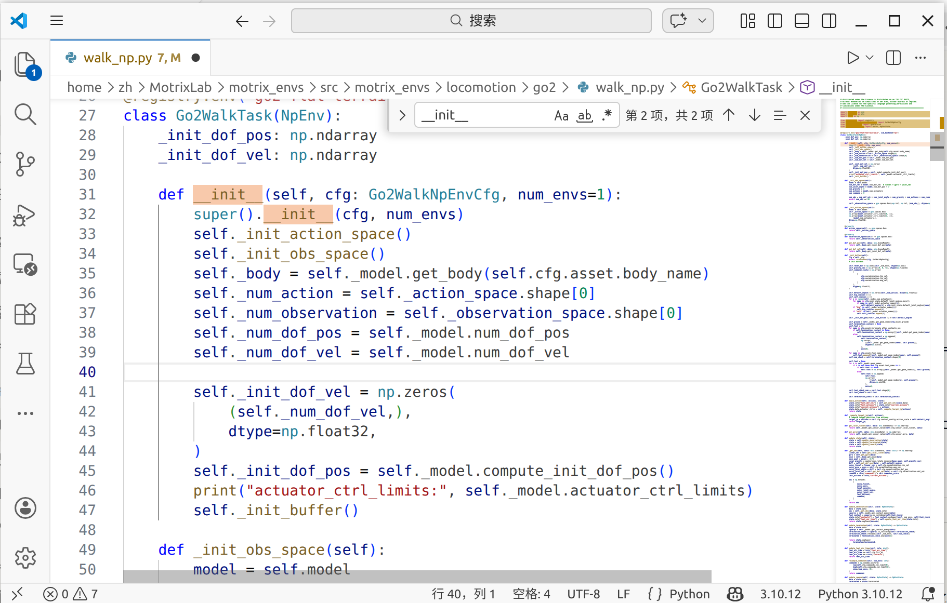
加上print("actuator_ctrl_limits:", self._model.actuator_ctrl_limits)
测试脚本：
from motrix_envs.locomotion.go2 import walk_np # 触发注册
from motrix_envs.locomotion.go2.cfg import Go2WalkNpEnvCfg
from motrix_envs.locomotion.go2.walk_np import Go2WalkTask

cfg = Go2WalkNpEnvCfg()
env = Go2WalkTask(cfg, num_envs=1)
测试结果：
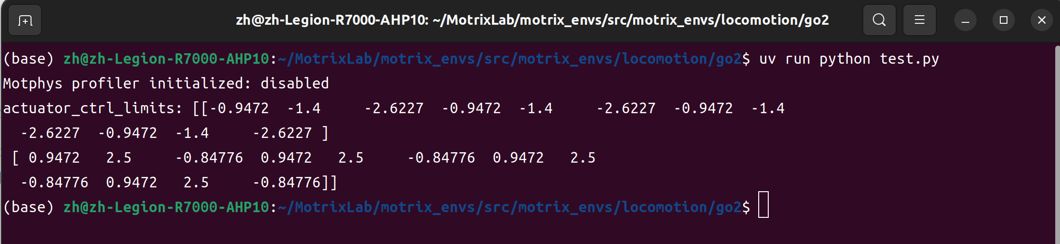
12个执行器按腿重复4次，每条腿三个关节的范围是：
关节 | min | max
hip | -0.9472 | 0.9472
thigh | -1.4 | 2.5
calf | -2.6227 | -0.8478
单位是弧度，这是​实际物理关节角度的限位​。
Calf最能说明问题：范围是 [-2.62, -0.85]，全是负数，因为 Go2 的小腿在物理上确实永远是向后弯的。这作为关节角度是合理的
但是IsaacLab 的 action 是无实际意义的归一化信号 [-1, 1]，由 action_scale 换算成关节角度。
Motrix 原版的 action 直接就是关节角度本身，范围就是关节的物理限位。

实际影响：打印 actuator_ctrl_limits 后发现其范围并非 [-1, 1]，例如 calf 关节的范围为 [-2.62, -0.85]，全为负值。这导致：
- 与 IsaacLab 的 action ∈ [-1,1] × 0.25 语义不等价
- calf 关节动作空间异常，小腿抬起空间极为受限

训练仍能成功，是因为 RL 策略在实践中自适应地输出了较小的值，绕开了该问题，属于"歪打正着"。

修正方案：将 _init_action_space 中的动作空间边界改为固定的 [-1, 1]，使其与 IsaacLab 完全对齐。

# 修正前：以物理限位作为边界
gym.spaces.Box(actuator_ctrl_limits[0], actuator_ctrl_limits[1], ...)
# 修正后：固定归一化范围
gym.spaces.Box(-np.ones(n), np.ones(n), ...)
原来的函数：
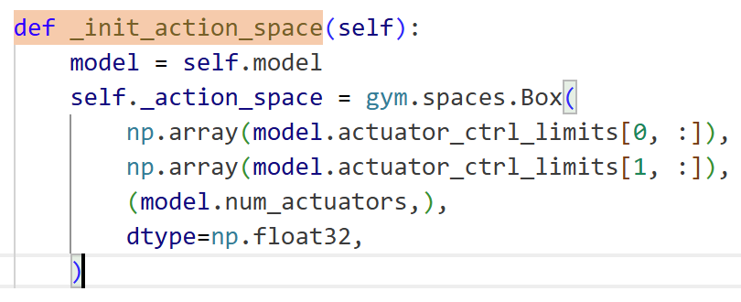
修改过后：
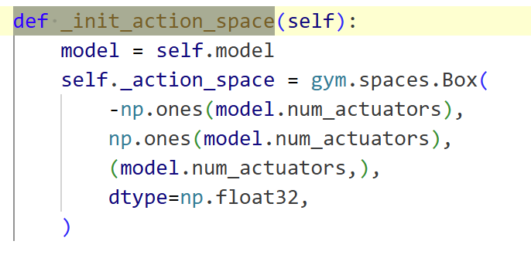

训练结果
修正后训练可以正常达成平地行走任务，机器人能够跟踪线速度和角速度指令，步态稳定。

附录

Motrix的代码cfg.py
# Copyright (C) 2020-2025 Motphys Technology Co., Ltd. All Rights Reserved.
#
# Licensed under the Apache License, Version 2.0 (the "License");
# you may not use this file except in compliance with the License.
# You may obtain a copy of the License at
#
# http://www.apache.org/licenses/LICENSE-2.0
#
# Unless required by applicable law or agreed to in writing, software
# distributed under the License is distributed on an "AS IS" BASIS,
# WITHOUT WARRANTIES OR CONDITIONS OF ANY KIND, either express or implied.
# See the License for the specific language governing permissions and
# limitations under the License.
# ==============================================================================

import os
from dataclasses import dataclass, field

from motrix_envs import registry
from motrix_envs.base import EnvCfg

model_file = os.path.dirname(__file__) + "/xmls/scene_flat.xml"

@dataclass
class NoiseConfig:
level: float = 1.0
scale_joint_angle: float = 0.03
scale_joint_vel: float = 1.5
scale_gyro: float = 0.2
scale_gravity: float = 0.05
scale_linvel: float = 0.1

@dataclass
class ControlConfig:
# action scale: target angle = actionScale * action + defaultAngle
action_scale = 0.05

@dataclass
class InitState:
# the initial position of the robot in the world frame
pos = [0.0, 0.0, 0.42] # 0.278

# the default angles for all joints. key = joint name, value = target angle [rad]
default_joint_angles = {
"FL_hip": 0.1, # [rad]
"FL_thigh": 0.9, # [rad]
"FL_calf": -1.8, # [rad]
"FR_hip": -0.1, # [rad]
"FR_thigh": 0.9, # [rad]
"FR_calf": -1.8, # [rad]
"RL_hip": 0.1, # [rad]
"RL_thigh": 0.9, # [rad]
"RL_calf": -1.8, # [rad]
"RR_hip": -0.1, # [rad]
"RR_thigh": 0.9, # [rad]
"RR_calf": -1.8, # [rad]
}

@dataclass
class Commands:
vel_limit = [
[-2.0, -1.0, -3.1416], # min: vel_x [m/s], vel_y [m/s], ang_vel [rad/s]
[2.0, 1.0, 3.1416], # max
]

@dataclass
class Normalization:
lin_vel = 2
ang_vel = 0.25
dof_pos = 1
dof_vel = 0.05

@dataclass
class Asset:
body_name = "base"
foot_name = "foot"
penalize_contacts_on = ["thigh", "calf"]
terminate_after_contacts_on = [
"base_collision_0",
"base_collision_1",
"base_collision_2",
"fl_hip_0",
"fr_hip_0",
"rl_hip_0",
"rr_hip_0",
]
ground = "floor"

@dataclass
class Sensor:
local_linvel = "local_linvel"
gyro = "gyro"

@dataclass
class RewardConfig:
scales: dict[str, float] = field(
default_factory=lambda: {
"termination": -0.0,
"tracking_lin_vel": 1.0,
"tracking_ang_vel": 0.5,
"lin_vel_z": -2.0,
"ang_vel_xy": -0.05,
"orientation": -0.0,
"torques": -0.00001,
"dof_vel": -0.0,
"dof_acc": -2.5e-7,
"base_height": -0.0,
"feet_air_time": 1.0,
"collision": -1.0 * 0,
"feet_stumble": -0.0,
"action_rate": -0.001,
"stand_still": -0.0,
"hip_pos": -1,
"calf_pos": -0.3 * 0,
}
)

tracking_sigma: float = 0.25
max_foot_height: float = 0.1

@registry.envcfg("go2-flat-terrain-walk")
@dataclass
class Go2WalkNpEnvCfg(EnvCfg):
max_episode_seconds: float = 20.0
model_file: str = model_file
noise_config: NoiseConfig = field(default_factory=NoiseConfig)
control_config: ControlConfig = field(default_factory=ControlConfig)
reward_config: RewardConfig = field(default_factory=RewardConfig)
init_state: InitState = field(default_factory=InitState)
commands: Commands = field(default_factory=Commands)
normalization: Normalization = field(default_factory=Normalization)
asset: Asset = field(default_factory=Asset)
sensor: Sensor = field(default_factory=Sensor)
sim_dt: float = 0.01
ctrl_dt: float = 0.01

IsaacLab上的flat_env_cfg.py
# Copyright (c) 2022-2026, The Isaac Lab Project Developers (https://github.com/isaac-sim/IsaacLab/blob/main/CONTRIBUTORS.md).
# All rights reserved.
#
# SPDX-License-Identifier: BSD-3-Clause

from isaaclab.utils import configclass

from .rough_env_cfg import UnitreeGo2RoughEnvCfg

@configclass
class UnitreeGo2FlatEnvCfg(UnitreeGo2RoughEnvCfg):
def __post_init__(self):
# post init of parent
super().__post_init__()

# override rewards
self.rewards.flat_orientation_l2.weight = -2.5
self.rewards.feet_air_time.weight = 0.25

# change terrain to flat
self.scene.terrain.terrain_type = "plane"
self.scene.terrain.terrain_generator = None
# no height scan
self.scene.height_scanner = None
self.observations.policy.height_scan = None
# no terrain curriculum
self.curriculum.terrain_levels = None

class UnitreeGo2FlatEnvCfg_PLAY(UnitreeGo2FlatEnvCfg):
def __post_init__(self) -> None:
# post init of parent
super().__post_init__()

# make a smaller scene for play
self.scene.num_envs = 50
self.scene.env_spacing = 2.5
# disable randomization for play
self.observations.policy.enable_corruption = False
# remove random pushing event
self.events.base_external_force_torque = None
self.events.push_robot = None

IsaacLab上的rough_env_cfg.py
# Copyright (c) 2022-2026, The Isaac Lab Project Developers (https://github.com/isaac-sim/IsaacLab/blob/main/CONTRIBUTORS.md).
# All rights reserved.
#
# SPDX-License-Identifier: BSD-3-Clause

from isaaclab.utils import configclass

from .rough_env_cfg import UnitreeGo2RoughEnvCfg

@configclass
class UnitreeGo2FlatEnvCfg(UnitreeGo2RoughEnvCfg):
def __post_init__(self):
# post init of parent
super().__post_init__()

# override rewards
self.rewards.flat_orientation_l2.weight = -2.5
self.rewards.feet_air_time.weight = 0.25

# change terrain to flat
self.scene.terrain.terrain_type = "plane"
self.scene.terrain.terrain_generator = None
# no height scan
self.scene.height_scanner = None
self.observations.policy.height_scan = None
# no terrain curriculum
self.curriculum.terrain_levels = None

class UnitreeGo2FlatEnvCfg_PLAY(UnitreeGo2FlatEnvCfg):
def __post_init__(self) -> None:
# post init of parent
super().__post_init__()

# make a smaller scene for play
self.scene.num_envs = 50
self.scene.env_spacing = 2.5
# disable randomization for play
self.observations.policy.enable_corruption = False
# remove random pushing event
self.events.base_external_force_torque = None
self.events.push_robot = None

