Article title
Author Name¹, Author Name² and Author Name^{1,2}
¹ Department One, Institution One, City One, Country One
² Department Two, Institution Two, City Two, Country Two

E-mail: xxx@xxx.xx
Abstract
Sample text inserted for illustration. Replace with abstract text. Your abstract should give readers a brief summary of your article. It should concisely describe the contents of your article, and include key terms. It should be informative, accessible and not only indicate the general scope of the article but also state the main results obtained and conclusions drawn. The abstract should be complete in itself; it should not contain undefined abbreviations and no table numbers, figure numbers, references or equations should be referred to. It should be suitable for direct inclusion in abstracting services and should not normally be more than 300 words.

Keywords：term, term, term (3-5 terms)

Highlights
Highlights are three to five bullet points that help increase the discoverability of your article via search engines. These bullet points should capture the novel results of your research as well as new methods that were used during the study (if any). Think of them as the "elevator pitch" of your article. Please include terms that you know your readers will be looking for online. Don't try to capture all ideas, concepts or conclusions as highlights are meant to be short: 95 characters or fewer, including spaces.
- The micro force control principle is proposed to fabricate nanoindentation arrays at different annuli on the whole microsphere surface.
- The key technical issues, such as the alignment of target ball center and the coordinated movement of each axis, are solved during the cutting process of micro-ball surface by using the micro force control principle.
- The influence of processing parameters on the nanoindentations over micro-ball surface under the micro force loading was revealed, and the nanoindentation machining with controllable size over the almost whole surface of target ball was realized.

1. Section heading
The introduction is a critical part of your paper because it introduces the reasons behind your paper’s existence [1]. It must state the objectives and scope of your work, present what problem or question you address, and describe why this is an interesting or important challenge. It is important to introduce appropriate and sufficient references to prior works so that readers can understand the context and background of the research and the specific reason for your research work. Having explored those, the objectives and scope of your work must be clearly stated. The introduction may explain the approach that is characteristic to your work, and mention the essence of the conclusion of the paper [2].
1.1 subsection heading
1.1.1 subsubsection heading
The experimental and/or theoretical methods provide sufficient detail of theoretical and experimental methods and materials used in your research work so that any reader would be able to repeat your research work and reproduce the results. Be precise, complete and concise: include only relevant information. For example, provide a reference for a particular technique instead of describing all the details.
If you need to use equations, especially display equations, they should be prepared using the Equation Editor if possible.
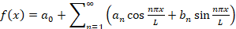 (1)
The results present the facts, findings of the study, by effectively using figures and tables. This part must present the results clearly and logically to highlight potential implications. Combine the use of text, tables, and figures to digest and condense the data, and highlight important trends and extract relationships among different data items. Figures must be well designed, clear, and easy to read. Figure captions should be succinct yet provide sufficient information to understand the figures without reference to the text.
In the discussion, present your interpretation and conclusions gained from your findings. You can discuss how your findings compare with other experimental observations or theoretical expectations. Refer to your characteristic results described in the part of the results to support your discussion, since your interpretation and conclusion must be based on evidence. By properly structuring this discussion, you can show how your results can solve the current problems and how they relate to the research objectives that you have described in the part of the introduction. This is your chance to clearly demonstrate the novelty and importance of your research work.
The part of conclusion summarizes the important results and impact of the research work. Future work plans may be included if they are beneficial to readers.

Acknowledgments
All authors and co-authors are required to disclose any potential conflict(s) of interest when submitting an article (e.g. employment, consulting fees, research contracts, stock ownership, patent licences, honoraria, advisory affiliations, etc). This information should be included in an acknowledgments section at the end of the manuscript (before the references section). All sources of financial support for the project must also be disclosed in the acknowledgments section. The name of the funding agency and the grant number should be given, for example: This work was partially funded by the National Institutes of Health (NIH) through a National Cancer Institute grant R21CA141833. When completing the online submission form, we also ask you to select funders and provide grant numbers in order to help you meet your funder requirements.

References
- Each reference number should correspond to only one reference. Different papers by the same authors should be listed separately in the reference list under different numbers (excluding errata). The term “ibid.” should not be used even if the same journal or book is cited with different page numbers.
- All authors should be listed for papers with up to five authors; for papers with more than five authors, the fifth author should be listed, followed by et al.
- Spell all letters and capitalize the first letter of the author’s last name, followed by the first character upper case of the first name and middle name (e.g. Daily G C).
- De/de/van/von/van der/van den, etc. are all special formats of the author's surname in English. The "Jr" in the author's name cannot be deleted (e.g. Peebles P Z Jr).
- The first and last page numbers for each reference should be provided (if there is only one page, the formats like 3, 22, 456 are proper and recommended).
- Volume number in bold fonts, no issue number.
- Examples for References
- Journal article
[NO.] Author name. Title. Journal name Volume, page number (Year).
Notes: For the title, capitalize the first letter of the first word (except for proper nouns), and use italic fonts. E.g:
- Belkaid Y, Rouse B T. Natural regulatory T cells in infectious disease. Nat. Immunol. 6, 353–360 (2005).
- Yang S, Xue C, Zhao J, Wang L, Wu Y et al. Parallel direct writing achromatic talbot lithography: a method for large-area arbitrary sub-micron periodic nano-arrays fabrication. Nanotechnology. 30, 315301 (2019).
- Bonin M, Pursche S, Bergeman T, Leopold T, Illmer T et al. F-ara-A pharmacokinetics during reduced-intensity conditioning therapy with fludarabine and busulfan. Bone Marrow Transplant. 39, 201-206 (2007). doi: 10.1038/sj.bmt.1705565. (The format is for your reference only if the DOI is provided.)
- Book
[NO.] Author name. Title of book. Edn. (name, place and year of publication), page NO.
Notes: For the title of book, capitalize the first letter of the first word (except for proper nouns), and use italic fonts. E.g: (please note yellow marks)
- Peebles P Z Jr. Probability, random variable, and random signal principles. 4th edn. (McGraw Hill, New York, 2001), 100-110.
- Armitage P. Statistical methods in medical research. (Blackwell Scientific Publishers, Oxford, 1971), 239.
- Paper in published conference proceedings/Books
- Paper in Conference proceedings: [NO.] Author name. Title. In name of proceeding. Page NO. (name of conference, place, year).
- Paper in Books: [NO.] Author name. Title. In name of book (information of editors). Page NO. (name , place, year of publication).
Notes: For the title of proceedings/books, capitalize the first letter of each notional word, and use italic fonts. E.g:
- He K M, Zhang X Y, Ren S Q, Sun J. Deep residual learning for image recognition. In Proc. 2016 IEEE Conference on Computer Vision and Pattern Recognition. 770-778 (IEEE: Las Vegas, NV, USA, 2016).
- Morley J E, Kaiser F E, Jonson L E. Male sexual function. In Geriatric Medicine (eds Cassel C K, Riesenberg D E, Sorensen L B). 25-63. (Springer, New York, 1990).
- Dissertation/Thesis
[NO.] Name. Title (University, place, year).
Notes: For the title, capitalize the first letter of each notional word, and use italic fonts. E.g:
- Urbanetto P B. Experimental Dental Composites with Electrospun Nanofibers and Nanofibrous Composites (University of British Columbia at Vancouver in Canada, 2016).
- Young W R. Effects of Different Tree Species on Soil Properties in Central New York (Cornell University, Ithaca, NY, 1981).
- Patent
[NO.] Name. Title. Country. NO. (Year)
- Houser D E. Single flute drill for drilling holes in printed circuit boards and method of drilling holes in a printed circuit board. U.S. Patent. No. 5, 584, 617. 17. (1996).
- Report
[NO.] Name. Title (publisher, place, year).
Notes: For the title, capitalize the first letter of each notional word, and use italic fonts. E.g:
- World Health Organization. Factors Regulating the Immune Response: Report of WHO Scientific Group 16-38 (WHO, Geneva, 1970).
- Materials Online
[NO.] Name. Title. Website. (Year).
- World Health Organization (WHO). Water sanitation and health. http://www.who.int/water_ sanitation_health/en/ (2015).

NOTE: Fonts used in the main text should be the Times New Roman, No less than 12pt, with 1.5 times line space.

Tables
Fonts used in tables should be restricted to the Times New Roman, 9pt
Table I. The following expressions should be used.
At the beginning of a sentence | Within a sentence
Section 1 | Sect. 1
Section 2 and 3 | Sects. 2 and 3
Equation (1) | Eq. (1)
Equations (2) and (3) | Eqs. (2) and (3)
Equations (4) – (10) | Eqs. (4) – (10)
Table I | Table I
Tables I and II | Tables I and II
Tables II– VI | Tables II– VI
Figure 1 | Fig. 1
Figures 1(a) and 1(b) | Figs. 1(a) and 1(b)
Figures 2–5 | Figs. 2–5
Reference 1 | Ref. 1
References 1 and 2 | Refs. 1 and 2
References 3–5 | Refs. 3–5

Figures
Figures are converted and sized to the journal template as part of the production process for accepted articles, but they are not normally edited further. The authors should ensure that the figures you supply are legible and technically correct. Micrographs should include a scale bar of appropriate size, e.g. 1 μm.
Figures should be numbered in the order in which they are referred to in the text.
Figures divided into parts should be labelled with a lower-case, boldface '(a)', '(b)', etc. Labelling of axes, keys and so on should be in 'sentence case' (first word capitalized only) with no full stop. Units must have a space between the number and the unit, and follow the nomenclature common to your field. Spaces, not commas should be used to separate thousands. Unusual units or abbreviations should be spelled out in full, or defined in the legend.
- Font in Figure
- Font should be restricted to Arial;
- No less than 9 pt (9 pt is Recommended);
- Bold.

- Figure Size(Recommended)
- The width for single-column figure: 85 mm;
- The width for full-column figure: 175 mm.

- Figure Resolution
- No less than 600 dpi.

- Figures Types
- We prefer vector files with editable layers. Acceptable formats are: .eps, .emf, .pdf for fully editable vector-based art; .psd, .tif, .jpeg or .png for bitmap images;
- Images/drawings coded using TeX/LaTeX package
- Images/figures embedded in MS Word, Excel or PowerPoint
- Graphics application source files (Photoshop, Illustrator, CorelDraw).

- Figure Captions
- The list of figure captions should be provided after the reference list.

- Figure Submission
- Save each figure in a separate file, name your figure files with “Fig” and the figure number, e.g. Fig 1. eps., upload all figures as one compressed file. (Acceptable file formats are rar. or 7z.)

- Examples of Figures
- Example Fig.1

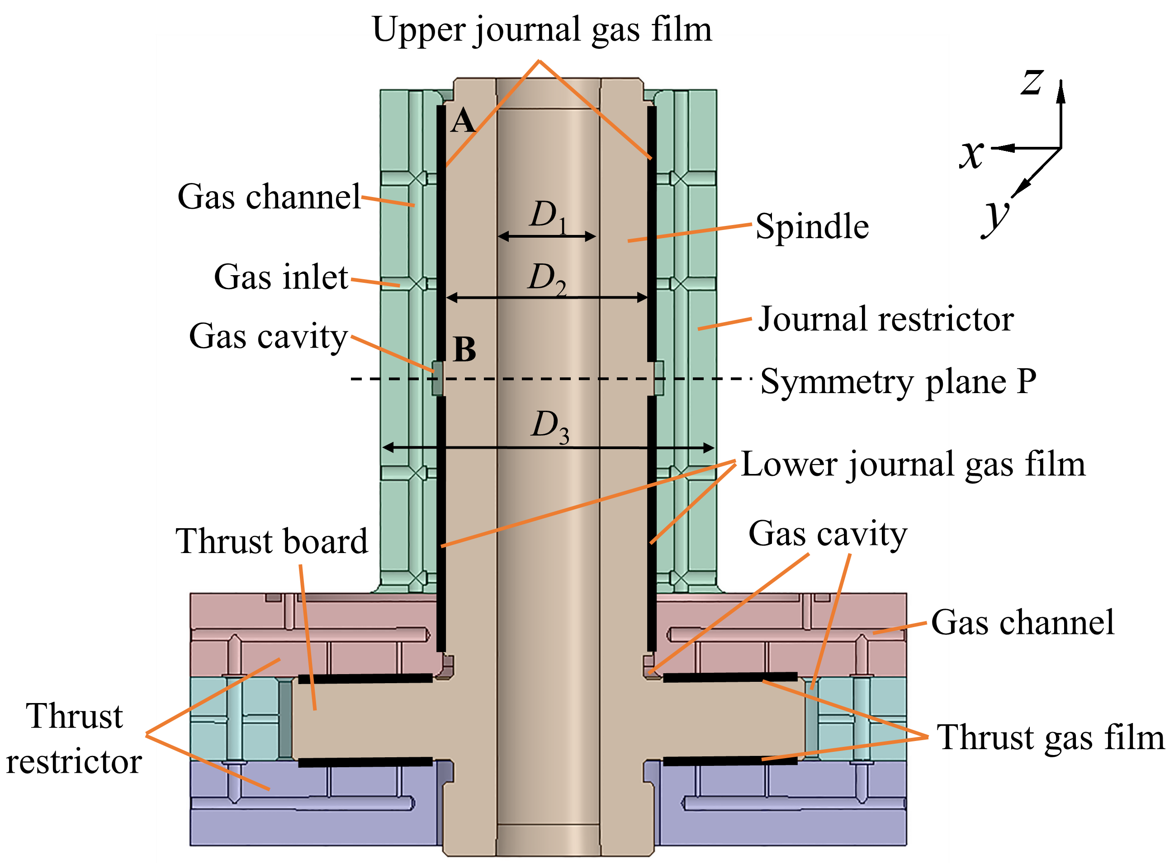
(×) Fig.1. (Inappropriate)
NOTES：
- Font is not Arial, not bold, and small than 9 pt.
(√) Fig.1. Recommended
NOTES：
- Font is Arial, bold, and 9pt.

- Example Fig.2

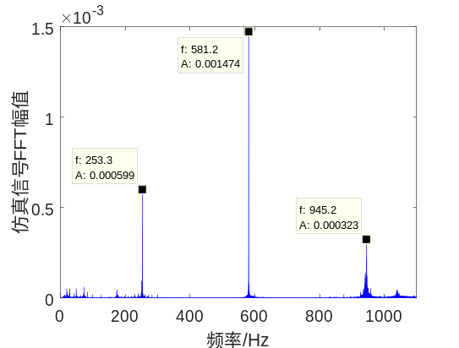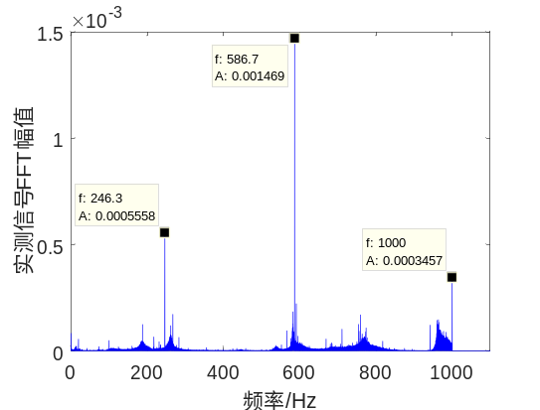
Frequency (Hz)
Amplitude (m/s²)
Frequency (Hz)
Amplitude (m/s²)

(a) Experimental acceleration FFT (b) Simulated acceleration FFT
(×) Fig.2. (inappropriate)
NOTES：
- Font is inconsistent, not bold, and small than 9pt.
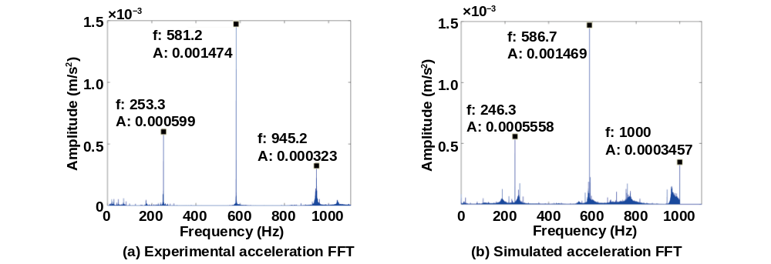
(√) Fig.2. After Editing (Recommended)
NOTES：
- Font size is uniformly bold, 9pt.

- Example Fig.3
(×) Fig.3. (inappropriate)
NOTES：The Greek letters in red rectangle seem to be smaller even the size is 9pt.
(√) Fig.3. (Recommended)
NOTES：The Greek letters in red rectangle could be set as 10pt.

- Permissions of Figures
Note that it is also your responsibility to obtain written permission from the copyright holder for any figures you have reused from elsewhere. This will also include any figures that you created yourself but have previously been published by another publisher, unless that publisher allows you to reuse them without permission under their author rights policy. Check individual publisher’s policies for details. Many scientific, technical and medical publishers use RightsLink to grant permission. Information on how to request permission can usually be found on the website of each publisher. For further information about permissions and when permission is required, please see the Permissions section.

- Example for original figure
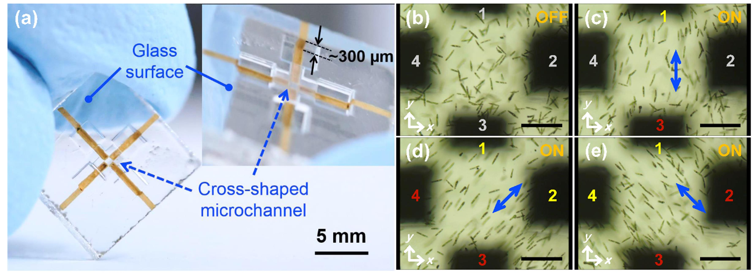
Fig. 2. (a) Photograph of the electrofluidic device in which two pairs of opposing microelectrodes are formed on the bottom surface of a cross-shaped closed glass microchannel for 2D electromanipulation of Euglena cells. The inset is a tilted view of the same chip, showing the preparation of continuous metal structures from inside of the microchannel to the glass chip surface. Swimming behaviors of Euglena cells in a microfluidic environment (b) in the absence of an electric field and under an applied electric field (20 Vp-p, 0.8 MHz) between electrodes (c) “1 and 3” and (d-e) “1 and 3” and “2 and 4.” (c-e) represent, respectively, 90°, +45°, and -45° orientations of cell motion with respect to the x-axis. “ON” and “OFF” correspond to experiments with and without electric power, respectively. The numbers in gray in (b-c) indicate that no AC voltage was applied. The numbers in yellow and red in (c-e) represent the opposite polarities. The blue arrows in (c-e) indicate the directions of the electric field. The scale bars in (b-e) indicate 200 µm.

- Example for figure with permission
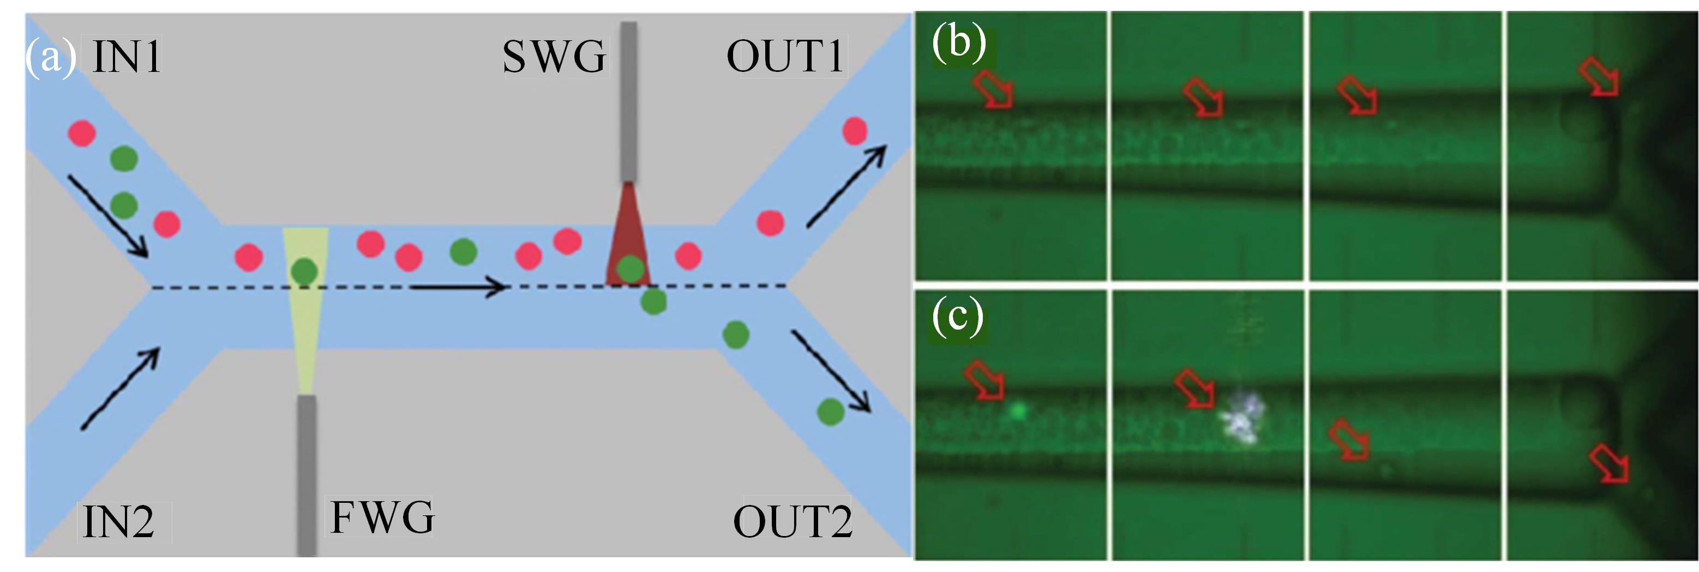
Fig. 2. (a) Principle for cell sorting that utilizes optical forces combined with fluorescence detection. Demonstration of cell sorting when (b) nonfluorescent and (c) fluorescent cells are detected in the optofluidic device [53]. (Reproduced with permission from RSC. ©2012 by the Royal Society of Chemistry.)

