Cross-species separability of radar cardiorespiratory signatures is no larger than cross-hardware separability: a leakage-aware re-evaluation of three public datasets
Yudong Xu
School of Mechanical Engineering, Heilongjiang University of Science and Technology, Harbin 150022, China
E-mail: 3468858545@qq.com
Abstract
Objective: Radar cardiorespiratory signatures have been proposed as soft biometrics and for separating people from search dogs. Reported accuracies rest on window-level cross-validation, where overlapping windows of one recording appear in both folds, and on a species contrast confounded with the radar platform. We ask how much separability survives when both are controlled.
Approach: Three public datasets (30 dogs, 7.3 GHz ultra-wideband; 110 adults, 60 GHz; 24 adults, 120 GHz) were processed with one 20 Hz chain. A 16-dimensional invariant and a 19-dimensional identification descriptor set were evaluated under window-level, subject-grouped temporal-block and 25 min horizon protocols, with three same-data negative controls, a rate-matched decimation control, permutation tests and age regression.
Main results: Vital-sign accuracy reproduced published values (dog heart-rate MAE 7.11 bpm, breathing-rate 1.27 bpm). Closed-set identification of 30 dogs fell from 54.4 ± 1.5 % (window-level, chance 3.3 %) to 46.1 % (temporal block) and 16.3 % (25 min horizon). Open-set rejection of 89.6 % at AUROC 0.949 fell to 0.52–0.59 over 20 partitions. Dogs versus humans reached 86.2 % balanced accuracy, less than the 93.8 % of a cross-platform control (humans at 60 versus 120 GHz). Grid-dependent descriptors lost 14.7 points under rate matching, invariant descriptors 0.2; age regression did not beat the mean (R² = −0.15, p = 0.26).
Significance: On these public data, cross-species separability is no larger than acquisition-condition separability, so such claims require a cross-platform control and a rate-matched ablation.
Keywords: radar vital signs; cardiorespiratory biometrics; leakage-aware validation; cross-species comparison; negative controls; open-set recognition
1. Introduction
Non-contact vital-sign monitoring is attractive wherever contact sensors are poorly tolerated or impractical: triage after a disaster, continuous monitoring of older adults, sleep assessment, and security screening (Chen et al 2020, Adib et al 2015). Millimetre-wave radar suits these settings because it penetrates clothing and debris, needs no visible light, and preserves privacy compared with cameras. The physical basis is small: respiration displaces the chest wall by roughly 1–12 mm and cardiac activity by 0.1–0.6 mm, which modulates the phase of the reflected signal (Droitcour et al 2004).
Beyond rate estimation, the retrieved waveform carries subject-specific information. ECG-based identification has been studied for two decades (Biel et al 2001, Israel et al 2005, Odinaka et al 2012), and the same reasoning has been transferred to radar: the morphology and variability of cardiac and respiratory cycles, not only their frequencies, should reflect anatomy and physiology. Recent work reports open-set radar identification from heartbeat signatures with high accuracy (Xing et al 2025). A parallel and less examined claim is that cardiorespiratory signatures separate species, which would matter at a rescue site where people and search dogs are both present, and in veterinary monitoring.
Two methodological problems complicate both claims. The first is window overlap. A long recording is cut into overlapping windows to obtain enough samples, and the windows are then split at random into training and test folds. Adjacent windows share most of their samples, so the test fold is not independent; the resulting error estimate is optimistically biased. This failure mode is well documented outside radar (Kaufman et al 2012, Varma and Simon 2006, Roberts et al 2017, Saeb et al 2017, Vabalas et al 2019, Kapoor and Narayanan 2023) but is still common in radar vital-sign work, where the number of independent recordings is small and the number of windows is large.
The second problem is confounding by acquisition. When dogs are recorded with a 7.3 GHz ultra-wideband radar at 50 Hz and humans with a 60 GHz frequency-modulated continuous-wave (FMCW) radar at 10 Hz, a classifier that separates the two groups may be keying on carrier frequency, bandwidth, sampling rate, range resolution, or subject posture rather than on species. The published comparison cannot distinguish these explanations, because no same-species, cross-platform contrast is reported alongside it. Without such a control, a high species accuracy is not evidence of species information.
This paper re-evaluates three public datasets with a single processing chain and asks a deliberately narrow question: after removing window overlap and after matching the sampling grid, how much species separability remains, and is it larger than what the same pipeline extracts from a change of platform within one species? The answer we obtain is negative, and the paper is organised around making that negative result trustworthy rather than around a new classifier.
The contributions are: (i) a leakage ladder of three protocols, from window-level cross-validation through a subject-grouped temporal-block split to a 25 min horizon, applied unchanged to identification, open-set verification and cross-species classification; (ii) a cross-platform negative control (110 adults at 60 GHz against 24 other adults at 120 GHz) and a physiological negative control (rest versus post-exercise) that bound what the pipeline can extract without any species difference; (iii) a rate-matched decimation control that separates descriptors which depend on the sampling grid from descriptors which do not, with the per-descriptor drift quantified; (iv) a transfer test in both directions between radar platforms; and (v) a published, tested code base and result tables from which every number below can be regenerated.
2. Materials and methods
2.1. Datasets
Three public datasets were used, spanning two species and three radar platforms (Table 1). No new data were collected. The dog dataset contains 30 dogs in two scenarios: 10 anaesthetised dogs recorded for 180 s and 20 awake dogs recorded for 1800 s, with respiratory rate (BR) and heart rate (HR) references from a BIONET monitor (Ahmed et al 2024). VITALSENSE contains 24 healthy adults recorded at 120 GHz during rest and voluntary apnoea, 120 s each, with synchronous electrocardiography, respiratory belt and pulse oximetry (Wu et al 2026). The age-balanced set contains 110 adults aged 22–76 years recorded at 60 GHz in four conditions (lying or sitting, rest or post-exercise), with a Movesense ECG reference (Parralejo et al 2026).
Table 1. Public datasets used in this study. No raw recordings are redistributed; the identifiers point to the original releases.
Dataset | Radar and sampling | Subjects | Conditions | Reference
Dogs vital signs  (Ahmed et al 2024) | UWB 7.3 GHz, 50 Hz,  real-valued samples | 30 dogs (10 anaesthetised,  20 awake) | Scenario 1: 180 s  Scenario 2: 1800 s | BIONET HR/BR,  1 Hz
VITALSENSE  (Wu et al 2026) | FMCW 120 GHz, 333.33 Hz,  displacement channel | 24 adults | rest, voluntary apnoea  (120 s each) | ECG, respiratory belt,  SpO₂
Age-balanced mmWave  (Parralejo et al 2026) | FMCW 60 GHz, 10 Hz frames,  64 range bins | 110 adults,  22–76 years | lying or sitting ×  rest or post-exercise | Movesense ECG,  256 Hz
Identifiers: 10.6084/m9.figshare.23820915.v1; 10.34810/data2962; Zenodo record 18599983.
The three datasets differ in almost every acquisition parameter, which is precisely why they are useful for the question posed here and why the species contrast cannot be interpreted without a control. The dog radar delivers real-valued samples of the mixed signal at 50 Hz, so respiratory and cardiac components are separated in the frequency domain and no phase demodulation is applied. The 60 GHz set provides complex range-FFT cubes with 64 range bins at 10 Hz frames. The 120 GHz set provides a single displacement channel at 333.33 Hz whose respiratory band is weak by construction, because the release was designed around cardiac motion.
One cohort is smaller than the journal's guideline of 30 subjects for human measurement studies: the 120 GHz set contains 24 adults. It is a secondary analysis of a published dataset and contributes no primary estimate of its own. It appears only in the vital-sign agreement table, in the cross-platform negative control (NC1) and in the direction-specific transfer test, while every primary human result reported below uses the 110-adult 60 GHz cohort.
2.2. Processing chain
Every recording passes through the same five stages (figure 1). Stage 1 extracts a displacement or range profile: for FMCW data the complex range-FFT is formed and a range bin is selected; for the ultra-wideband dog data the real-valued samples are used directly. Stage 2 separates the respiratory and cardiac bands with zero-phase Butterworth filters (0.15–0.5 Hz and 0.8–2.6 Hz) after removal of the mean and of linear trend, and resamples the two components onto a common 20 Hz grid so that descriptors computed from different platforms are comparable. Stage 3 computes the descriptor layers described in section 2.3. Stage 4 reduces each recording to a fixed number of windows. Stage 5 applies the evaluation protocols of section 2.4.
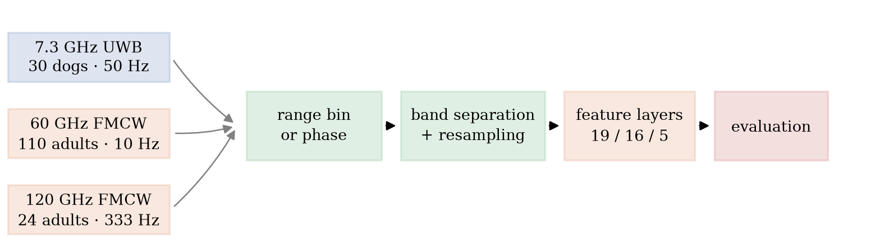
Figure 1. Measurement chain. Three acquisition platforms are reduced to a common representation before any comparison: range-bin or phase extraction, respiratory and cardiac band separation with resampling to a 20 Hz grid, the three descriptor layers (19, 16 and 5 descriptors), and evaluation under the leakage ladder described in section 2.4.
Range-bin selection deserves a note because it interacts with the species contrast. The 60 GHz radar provides 64 range bins and the cardiac displacement is a small fraction of a bin, so the phase is recovered from the complex range-FFT rather than from a magnitude peak. We rank bins by the ratio of cardiac-band to respiratory-band power and by cardiac-band signal-to-noise ratio, and we keep the selection as a hyperparameter of the pipeline rather than tuning it per dataset. Section 3.1 reports an ablation of this choice, including the naive alternative of taking the single strongest bin and the alternative of averaging all bins.
Two resolution limits bound what any of these data can support. The frequency resolution of a window is Δf = 1/T, so a 20 s window resolves 0.05 Hz (3 bpm) and a 50 s recording resolves 0.02 Hz (1.2 bpm). This is adequate for peak picking but not for heart-rate variability: RMSSD requires several minutes of stable recording (Task Force 1996, Shaffer and Ginsberg 2017). The phase sensitivity is 4πΔd/λ, so at 60 GHz a 0.1 mm displacement gives about 0.25 rad and at 120 GHz about 0.50 rad. The difference between the 120 GHz heart-rate error of section 3.1 and the 60 GHz error is therefore partly a difference of wavelength and sampling rate, not of algorithm quality, and we report it as such.
2.3. Descriptor layers
Three descriptor layers are used, and which layer is used matters more than which classifier is used.
The invariant layer has 16 descriptors computed from quantities that do not depend on the sampling grid: hr_freq_hz, hr_period_s, hr_period_cv, hr_skew, hr_kurt, hrv_rmssd_s, br_freq_hz, br_period_s, br_period_cv, br_skew, br_kurt, ie_ratio (inspiration-to-expiration duration ratio), hr_br_ratio, hr_power_frac, br_power_frac, br_hr_power_ratio and cardioresp_coupling (the coherence between the respiratory and cardiac envelopes at the respiratory frequency). All of them are ratios, durations, dimensionless shape statistics, or band-power fractions, so they are defined identically at 10, 50 and 333 Hz after resampling.
The grid-dependent layer has five descriptors inherited from earlier work: spectral_centroid, spectral_entropy, lf_hf_ratio, br_zero_cross_rate and br_spectral_flatness. Each is computed from the power spectral density of the resampled signal without normalising by bandwidth, so its value changes when the sampling rate changes even if the underlying physiology does not. They are retained in this study only as a deliberate positive control for leakage of acquisition parameters: a classifier that uses them should show a large accuracy drop under rate matching, and section 3.5 shows exactly that.
The identification layer has 19 descriptors: the 16 invariant ones plus the three shape descriptors of the cardiac envelope that were found useful for dog identification, giving the set used for the closed- and open-set experiments. Feature standardisation is fitted inside each training fold, never on the full table.
2.4. Evaluation protocols
Three protocols of increasing strictness are applied to the same windows (figure 2). Protocol P0 is the common practice: windows are drawn with 50 % overlap and split at random into five cross-validation folds, so windows from one recording appear in both training and test folds. Protocol P1 forbids that: the timeline of each recording is cut into a training prefix and a test suffix, and a guard gap of g windows is discarded between them so that no test window shares samples with any training window. Protocol P2 keeps the P1 split but moves the test suffix to at least 25 min after the end of the training prefix, which is the shortest interval at which a subject's physiology can be expected to have drifted measurably.
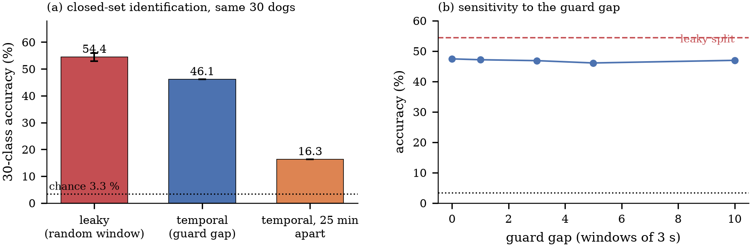
Figure 2. Leakage ladder. P0 splits overlapping windows at random into cross-validation folds, so windows of one recording appear on both sides. P1 cuts each recording into a training prefix and a test suffix separated by a guard gap g, with every fold grouped by subject. P2 places the test suffix at least 25 min after the training prefix.
Protocol P1 is parameterised by the guard gap, and section 3.2 sweeps g from 0 to 10 windows. All cross-validation in P0 and P1 is subject-grouped: folds are formed over subject identifiers, so no subject contributes windows to both sides of a fold. For the two human datasets the subject grouping is trivial because the recordings are short, but for the 20 awake dogs, which contribute 90 windows each, grouping is what separates a real result from a memorised recording.
Open-set verification adds an unknown class. A verification score is computed for each window against the enrolled identities, and a threshold is chosen on the training portion. Two operating points are reported: a single fixed split, which is the usual way such results are quoted, and the distribution over 20 random partitions of the same data, which shows how much of the fixed-split number is partition luck. Four scoring rules are compared: Mahalanobis distance to the nearest class centroid, Euclidean distance, maximum posterior probability, and the margin between the top two posteriors.
Cross-species classification uses the same 16 invariant descriptors and the same grouped five-fold protocol, with dogs as class 0 (560 windows from 30 dogs) and humans as class 1 (1408 windows from 110 adults). Three negative controls are run on the identical pipeline. NC1 replaces the species contrast with a cross-platform contrast inside one species: 110 adults recorded at 60 GHz against 24 different adults recorded at 120 GHz. Because subjects, protocol and hardware all change with the dataset, NC1 bounds what a change of acquisition condition contributes rather than hardware in isolation. NC2 replaces it with a session-state contrast inside one species and one platform: anaesthetised versus awake dogs. NC3 replaces it with a physiological contrast inside one species and one platform: human rest versus post-exercise. If the pipeline extracts species information, the species contrast must exceed all three.
The rate-matched control decimates every dog recording from 50 to 10 Hz before feature extraction, which removes the sampling-rate difference to the 60 GHz humans while leaving the carrier-frequency and bandwidth differences in place. Descriptors are then compared between the two rates, and the median relative change is reported per descriptor.
2.5. Statistics and software
Agreement between radar and reference rates is reported as mean absolute error (MAE), root-mean-square error, bias, and 95 % limits of agreement by the Bland–Altman construction (Bland and Altman 1986), with the reference as the independent measurement. Classification is reported as accuracy, balanced accuracy and area under the receiver-operating-characteristic curve (AUROC); for imbalanced two-class problems balanced accuracy is the primary metric. Significance of a contrast is assessed with a permutation test that shuffles labels at the subject level and repeats the whole cross-validation 200 times; the p value is the fraction of permutations reaching the observed statistic. Variability across folds and across partitions is reported as a standard deviation, not as a standard error, because the folds are not independent draws.
All code is Python 3.12 with NumPy, SciPy and scikit-learn (Harris et al 2020, Virtanen et al 2020, Pedregosa et al 2011). Random seeds are fixed. The repository contains the cache builder, the feature extractor, the five experiment scripts, the figure script and 39 unit tests, including consistency tests that recompute the headline numbers from the committed feature tables.
No ethics approval was required: all data are previously published, de-identified public datasets, and the original publications report the consent and animal-care procedures under which they were collected.
2.6. Sex and gender
Sex is recorded for the 110 adults of the 60 GHz cohort (60 female, 50 male; mean age 53.2 years and 45.5 years respectively) and is distributed almost evenly, but it was not available in machine-readable form for the 24 adults of the 120 GHz cohort at the time of analysis, and it is not used in the dog analyses, where the unit of analysis is the animal rather than a human subject group. No analysis was stratified by sex. The claims of this paper concern the effect of the evaluation protocol on separability, which is estimated within subjects and within folds; the per-sex subgroups (60 and 50) are too small to support sex-specific estimates with the present window counts, and reporting them would add subgroup noise without testing a hypothesis. Sex is therefore treated as a reported but unmodelled biological variable. The age difference between the two subgroups (7.7 years) is a property of the source cohort, is disclosed here, and is not interpreted.
3. Results
3.1. Vital-sign estimation reproduces published accuracy
The pipeline reproduces the accuracy reported for these datasets, which establishes that the differences found later are not caused by a weak implementation (Table 2, figure 3). At the recording level the dog data give a heart-rate MAE of 7.11 bpm (bias −1.57 bpm, 95 % limits of agreement −21.5 to 18.4 bpm, r = 0.62, n = 10 recordings) and a breathing-rate MAE of 1.27 bpm (r = 0.74, n = 10). Splitting the same recordings into 30 s windows raises the heart-rate MAE only to 6.88 bpm over 110 windows, while the breathing-rate MAE rises to 1.85 bpm, which is the expected penalty for resolving 0.033 Hz with a 30 s window.
Table 2. Agreement between radar-derived and reference rates. MAE, bias and the 95 % limits of agreement are in bpm; r is the Pearson correlation. The reference is the independent measurement.
Condition (unit of analysis) | n | HR  MAE | HR  bias | HR 95 %  LoA | r | BR  MAE | BR  bias | r
Dogs, recording level | 10 | 7.11 | −1.57 | −21.5 to 18.4 | 0.62 | 1.27 | 0.41 | 0.74
Dogs, 30 s windows | 110 | 6.88 | −0.33 | −18.7 to 18.0 | 0.65 | 1.85 | 0.99 | 0.52
120 GHz, recording level | 48 | 1.54 | −0.19 | −3.9 to 3.5 | 0.96 | 4.37 | −4.00 | —
120 GHz, 30 s windows | 336 | 2.23 | −0.60 | −7.7 to 6.5 | 0.87 | 4.46 | −3.98 | —
60 GHz, rest | 220 | 9.31 | −4.12 | −29.7 to 21.5 | 0.08 | — | — | —
60 GHz, post-exercise | 220 | 20.26 | −18.59 | −52.9 to 15.7 | 0.19 | — | — | —
60 GHz, both conditions | 440 | 14.79 | −11.36 | −44.7 to 22.0 | 0.23 | — | — | —
LoA, limits of agreement. The 60 GHz release has no independent frame-level respiratory reference, so its breathing-rate cells are empty. The 120 GHz breathing-rate error is a property of the released channel, which is tuned for cardiac displacement, and is therefore not interpreted as algorithm performance.
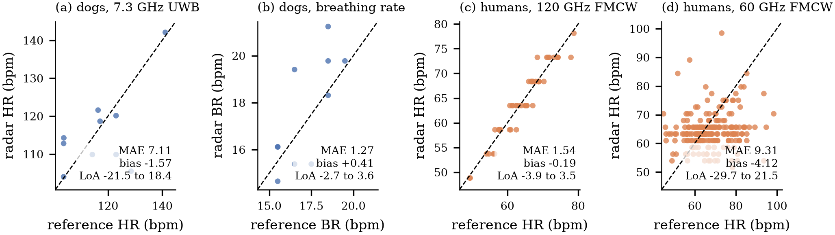
Figure 3. Radar-derived against reference rates: (a) dog heart rate, (b) dog breathing rate, (c) human heart rate at 120 GHz, (d) human heart rate at 60 GHz. The dashed line is identity. MAE, bias and the 95 % limits of agreement are given in each panel. Panel (d) shows the rate-dependent failure that the 10 Hz frame rate imposes on that platform.
The 120 GHz data give a heart-rate MAE of 1.54 bpm with all 48 recordings inside 5 bpm (r = 0.96), and 2.23 bpm over 336 windows. The corresponding breathing-rate error is 4.37 bpm, which we attribute to the dataset rather than to the algorithm: the released channel is a displacement signal tuned for cardiac motion, and its respiratory component is weak. The 60 GHz data are the hardest: resting heart-rate MAE is 9.31 bpm over 220 windows, post-exercise MAE is 20.26 bpm, and the error is strongly rate-dependent, rising from 5.78 bpm below 70 bpm to 12.33 bpm between 70 and 90 bpm and 42.31 bpm above 90 bpm (8 windows). The 10 Hz frame rate of that radar is the binding constraint, not the estimator.
The ablation in Table 3 shows where the accuracy comes from. On the dog data the full chain gives 7.11 bpm; removing the harmonic notch gives 8.29 bpm; taking a single strongest range bin instead of the ratio-gated selection gives 9.16 bpm and degrades the breathing estimate from 1.27 to 6.03 bpm; plain median fusion across bins gives 11.02 bpm; and using the maximum-SNR channel alone, the most common choice in the literature, gives 18.45 bpm. One component is honestly neutral: removing the cardiac-to-respiratory power-ratio gate slightly improves the dog heart-rate estimate (6.97 versus 7.11 bpm), so we do not claim that gate as a contribution. On the 60 GHz data the ordering differs, and dropping the harmonic notch improves the resting estimate from 9.31 to 8.24 bpm, which is consistent with a 10 Hz frame rate that cannot resolve the second harmonic of a 60 bpm rhythm in the first place.
Table 3. Ablation of the processing chain, reported as heart-rate MAE (bpm) and breathing-rate MAE (bpm). Rows beginning “without” remove one stage from the full chain; the last three rows replace range-bin selection rather than removing a stage.
Configuration | Dog HR  MAE | Dog BR  MAE | 60 GHz rest  HR MAE
Full chain | 7.11 | 1.27 | 9.31
Without harmonic notch | 8.29 | 1.31 | 8.24
Without power-ratio gate | 6.97 | 1.31 | —
Single strongest range bin | 9.16 | 6.03 | 13.01
Plain median fusion across bins | 11.02 | 1.27 | —
Maximum-SNR channel only | 18.45 | 1.27 | —
The power-ratio gate is reported even though removing it slightly improves the dog heart-rate estimate, so it is not claimed as a contribution. The 60 GHz rows without a value were not run: they change range-bin selection, which is only defined for the multi-bin FMCW data.
3.2. Closed-set identification loses half its accuracy when overlap is removed
Closed-set identification of 30 dogs from 19 descriptors reaches 54.4 ± 1.5 % under protocol P0, against a chance level of 3.3 %, which is the kind of number that invites the conclusion that cardiorespiratory signatures are identifying (Table 4). Under P1, with a subject-grouped temporal split and a five-window guard gap (1010 training and 510 test windows), the same descriptors and the same classifier give 46.1 %. Under P2, where the test suffix begins at least 25 min after the training prefix, they give 16.3 %, and the best of the five classifiers on the full descriptor set gives 16.4 %.
Table 4. Closed-set identification of 30 dogs from the 19 identification descriptors, ordered by protocol. Window-level folds are subject-grouped but not recording-grouped. Values are accuracy over five folds (mean ± SD); chance is 3.3 %.
Protocol | Windows (train / test) | Resp.+cardiac  (RF) | All 19  (RF) | Best of five  classifiers
P0 window-level, 50 % overlap | 1 670 (5-fold) | 54.4 ± 1.5 | 52.9 ± 2.0 | 54.4
P1 temporal split, g = 5 | 1 010 / 510 | 46.1 | 44.5 | 46.1
P1, g = 0 | — | 47.4 | — | 47.4
P1, g = 1 | — | 47.1 | — | 47.1
P1, g = 3 | — | 46.8 | — | 46.8
P1, g = 10 | — | 46.9 | — | 46.9
P1, awake dogs only | 1 800 total | — | — | 35.3
P2, 25 min horizon | 1 010 / 510 | 16.3 | 16.4 | 16.4
The gap sweep is reported on the respiratory-plus-cardiac subset, which is the best-performing configuration under P0, and only for that subset so that the effect of g is not confounded with a change of descriptor set. The awake-only row uses the full descriptor set on the 20 awake dogs, which contribute 90 windows each.
The gap sweep is flat: 47.4 % at a zero-window gap, 47.1 % at one, 46.8 % at three, 46.1 % at five and 46.9 % at ten. This is informative in two ways. It means the P1 result is not an artefact of the particular gap chosen, and it means that the optimism of P0 is not explained by immediate sample overlap alone: with a zero gap the accuracy is already 47.4 %, seven points below P0. The remaining optimism of P0 therefore comes from the random assignment of windows of the same recording to different folds, which lets a classifier match recording-specific nuisance characteristics rather than identity.
Restricting P1 to the 20 awake dogs, which contribute 90 windows each and are the subset most exposed to leakage, gives 35.3 %. The ordering P0 > P1 > P2 is the same for every classifier in Table 4, and the respiration-only and cardiac-only feature subsets reproduce it, so the effect is a property of the protocol rather than of one model.
3.3. Open-set verification does not survive repartitioning
With a single fixed split and the anaesthetised dogs as the known class, Mahalanobis scoring accepts 91.2 % of known windows and rejects 88.4 % of unknown windows, for a balanced accuracy of 89.8 % and an AUROC of 0.949 (Table 5, figure 4). Euclidean scoring gives 89.6 % and 0.950. This is the headline number such systems usually report.
Table 5. Open-set verification with the 10 anaesthetised dogs as the known class and the 20 awake dogs as unknown. Values are percentages except AUROC. The fixed split is one partition; the random-partition columns are mean ± SD over 20 partitions of the same windows.
Scoring rule | Fixed split:  accept known | Fixed split:  reject unknown | Fixed split  AUROC | 20 partitions:  accept known | 20 partitions:  reject unknown | 20 partitions  AUROC
Mahalanobis | 91.2 | 88.4 | 0.949 | 86.7 ± 5.5 | 19.3 ± 7.4 | 0.525 ± 0.046
Euclidean | 90.6 | 88.6 | 0.950 | 84.0 ± 7.2 | 23.1 ± 9.5 | 0.522 ± 0.044
Maximum posterior | 87.6 | 25.5 | 0.655 | 84.4 ± 6.4 | 23.6 ± 10.1 | 0.594 ± 0.059
Top-two margin | 80.6 | 23.8 | 0.623 | 85.9 ± 6.3 | 18.7 ± 8.4 | 0.579 ± 0.053
The closed-set accuracy on the known test windows is 49.4 % for the fixed split and 55.3 ± 6.8 % across the 20 partitions, so the verification score is not operating on a well-separated embedding.
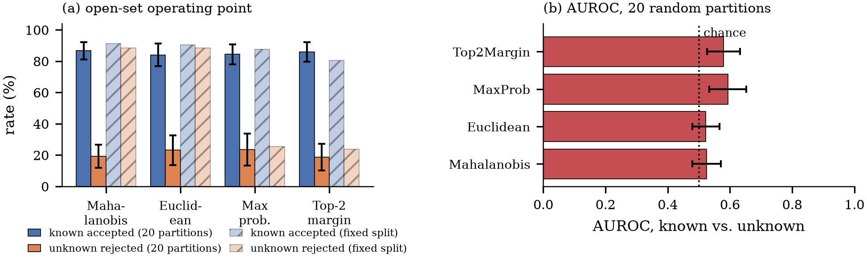
Figure 4. Open-set verification. (a) Operating point for a single fixed split (hatched) and the mean of 20 random partitions (solid, error bars one standard deviation). (b) AUROC of the known-versus-unknown score across the 20 partitions, with chance marked. The high rejection rate of the fixed split does not survive repartitioning.
Repeating the experiment over 20 random partitions of the same data changes the picture. Mahalanobis scoring accepts 86.7 ± 5.5 % of known windows but rejects only 19.3 ± 7.4 % of unknown windows, for an AUROC of 0.525 ± 0.046; Euclidean scoring gives 0.522 ± 0.044, maximum posterior 0.594 ± 0.059 and the top-two margin 0.579 ± 0.053. In other words the verification score is at chance, and the fixed split happens to be one on which a threshold separates the two classes. The accept rate stays high because the threshold is chosen to keep it high; the rejection rate is what collapses. Maximum-posterior and margin scoring are already near chance on the fixed split (0.655 and 0.623), which is a warning that the apparent success of the distance scores is a property of that partition.
The same collapse appears when only awake dogs are used, where AUROC stays between 0.522 and 0.533 for all four rules. We therefore read the open-set result as a negative one: with 20 s windows and 30 identities, the verification score does not generalise beyond the partition on which it was tuned.
3.4. Species separability is bounded by a cross-platform control
Dogs versus 110 adults, with the 16 invariant descriptors and subject-grouped five-fold cross-validation, gives 90.2 % accuracy and 86.2 % balanced accuracy (AUROC 0.945) from 560 dog and 1408 human windows over 140 groups (Table 6, figure 5). A permutation test that shuffles labels at the subject level gives p = 0.005 against a null of 0.500 ± 0.002, so the contrast is real in the sense that it is not produced by the fold split.
Table 6. Species contrast and same-species controls, all with the 16 invariant descriptors and subject-grouped five-fold cross-validation. Every row uses the identical pipeline; only the labels change. NC1 changes subjects, protocol and platform together, so it bounds acquisition-condition separability; NC2 holds the platform fixed, and NC3 holds the subjects as well.
Contrast | Windows  (class 0 / class 1) | Accuracy  (%) | Balanced  accuracy (%) | AUROC
Dog vs. human (species) | 560 / 1 408 | 90.2 | 86.2 | 0.945
NC1: 110 adults 60 GHz vs. 24 adults 120 GHz | 704 / 480 | 94.2 | 93.8 | 0.980
NC1 plus the 5 grid-dependent descriptors | 704 / 480 | 100.0 | 100.0 | 1.000
NC2: dogs anaesthetised vs. awake (session state) | 160 / 400 | 87.7 | 83.5 | 0.955
NC3: adults rest vs. post-exercise (physiology) | 704 / 704 | 67.1 | 67.0 | 0.708
Transfer: trained dog + 60 GHz, tested on 120 GHz adults | 480 test | 96.3 as human | — | —
Transfer: trained dog + 120 GHz, tested on 60 GHz adults | 1 408 test | 24.1 as human | — | —
Three-class: dog / 60 GHz / 120 GHz | 1 744 | — | 86.0 | —
Permutation test on the species contrast, shuffling labels at the subject level over 200 permutations: observed balanced accuracy 0.846, p = 0.005, null mean 0.500 (95th percentile 0.504). The transfer rows report the fraction of test windows labelled “human” by the random forest.
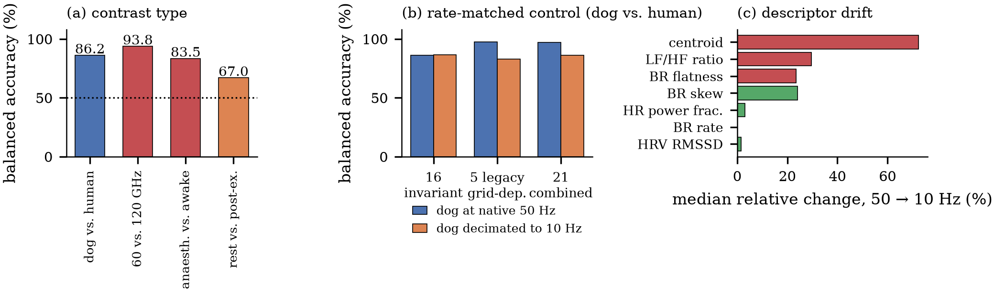
Figure 5. Cross-species contrast and its controls. (a) Balanced accuracy of the 16 invariant descriptors for the species contrast and for three same-species controls; the cross-platform control (93.8 %) exceeds the species contrast (86.2 %). (b) Rate-matched control: decimating the dogs from 50 to 10 Hz leaves the invariant set unchanged and costs the grid-dependent set 14.7 points. (c) Median relative change of individual descriptors under the same decimation.
The three negative controls decide how to read it. NC1, 110 adults recorded at 60 GHz against 24 different adults recorded at 120 GHz, gives 94.2 % accuracy and 93.8 % balanced accuracy (AUROC 0.980) from 704 and 480 windows. A cross-dataset contrast inside one species is therefore seven points larger than the species contrast, and its AUROC is higher. Because subjects, protocol and platform all change with the dataset, this figure bounds acquisition-condition separability rather than hardware alone. NC2, anaesthetised versus awake dogs on one radar, gives 87.7 % accuracy and 83.5 % balanced accuracy. NC3, human rest versus post-exercise on one radar, gives 67.1 % accuracy and 67.0 % balanced accuracy (AUROC 0.708). Adding the five grid-dependent descriptors raises NC1 to perfect separation (100 %), which confirms that those descriptors encode the acquisition platform.
The descriptor-level view explains the ordering (figure 6). Standardised mean differences for the species contrast and for the hardware contrast overlap in magnitude and, for several descriptors, disagree in sign. hr_power_frac separates species with d = 1.52 but hardware with only d = 0.32, whereas br_power_frac separates hardware with d = −2.09 and species with d = 0.59; br_period_s separates hardware with d = −1.25 and species with d = −0.42. Six of the sixteen descriptors have |d| < 0.2 for species, including cardioresp_coupling (d = −0.02) and hrv_rmssd_s (d = 0.10), which are the descriptors a physiological argument would nominate first. No single descriptor carries species information that the same descriptor does not also carry about the platform; the classifier's success therefore depends on a combination that is available to it in both contrasts.
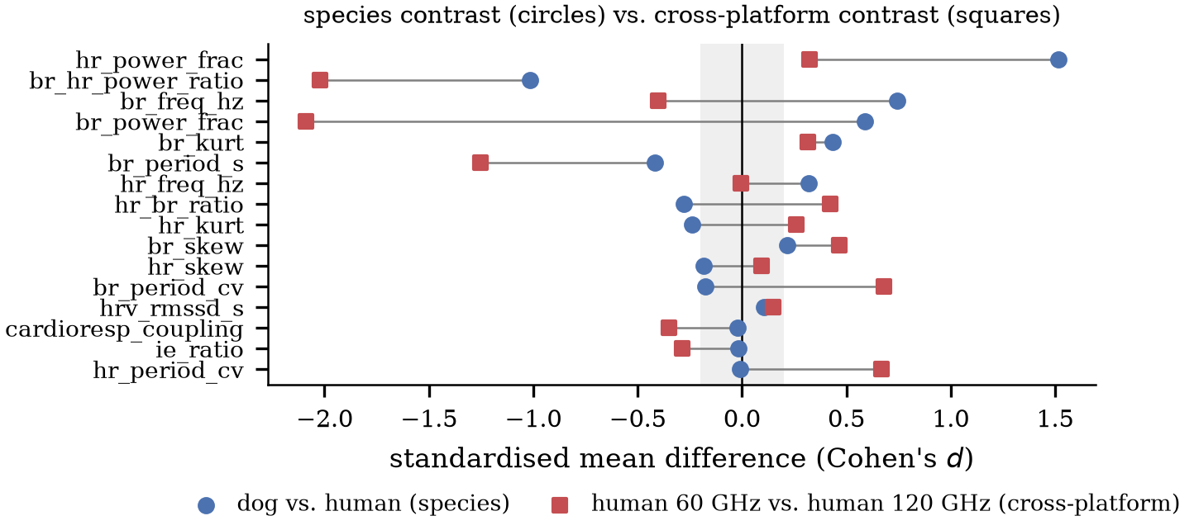
Figure 6. Standardised mean differences (Cohen's d) for each invariant descriptor, for the species contrast (circles) and for the same-species cross-platform contrast (squares). The shaded band marks |d| < 0.2. Descriptors that separate species also separate platforms, and several disagree in sign.
Two further tests make the interpretation explicit. The transfer test trains on dogs plus 60 GHz humans and applies the classifier to the 120 GHz adults: 96.3 % of those windows are labelled human by the random forest (97.5 % resting, 95.0 % apnoea). Trained the other way round, on dogs plus 120 GHz humans and applied to the 60 GHz adults, only 24.1 % are labelled human, so 76 % of adults recorded on a different 60 GHz platform are called dogs. The asymmetry is the point: the classifier's notion of ‘human’ is bound to the platform it was trained on, and changing the platform moves humans across the decision boundary while leaving dogs where they were. A three-class model over dog, 60 GHz human and 120 GHz human reaches 86.0 % balanced accuracy, with the 60 GHz adults most often confused with dogs (60 of 704 windows) rather than with the other human group (27 of 704).
The descriptor ablation points the same way. Using only band-power fractions, which is where most of the species signal sits, gives 83.6 % balanced accuracy; without them, 71.7 %; using rates only, 59.8 %; using morphology only, 69.5 %; using variability only, 50.9 %, which is chance. The discriminative content is thus carried by the partition of power between the respiratory and cardiac bands, a quantity that depends on the radar's band limits, on the range-bin selection and on the subject's posture as much as on species.
3.5. Rate matching separates grid-dependent from invariant descriptors
Decimating every dog recording from 50 to 10 Hz, the frame rate of the 60 GHz humans, removes the sampling-rate difference and leaves carrier frequency, bandwidth and range resolution untouched (Table 7, figure 5(b)). The five grid-dependent descriptors fall from 97.6 % to 82.9 % balanced accuracy, a loss of 14.7 points, while the 16 invariant descriptors move from 86.2 % to 86.4 %, a change of 0.2 points, and the combined set falls from 97.0 % to 86.0 %, converging on the invariant set. The invariant descriptors are therefore doing what they were designed to do, and the high accuracies obtainable with the legacy set are largely a measurement of the sampling rate.
Table 7. (a) Rate-matched decimation control: balanced accuracy (%) of the dog-versus-human contrast with the dogs left at their native 50 Hz and with the dogs decimated to 10 Hz, the frame rate of the 60 GHz adults. (b) Age regression on the 110 adults.
(a) Descriptor set | Dog at 50 Hz | Dog at 10 Hz | Change
16 invariant descriptors | 86.2 | 86.4 | +0.2
5 grid-dependent descriptors | 97.6 | 82.9 | −14.7
21 combined | 97.0 | 86.0 | −11.0
(b) Age model | MAE (years) | R² (%) | vs. mean MAE
Random forest | 15.4 | −15.0 | +0.6
Ridge regression | 14.8 | −3.7 | 0.0
Constant predictor | 14.8 | −2.7 | —
Permutation test on the ridge age model gives p = 0.26. The age range is 22–76 years, so a constant predictor already achieves 14.8 years of MAE.
The per-descriptor drift quantifies this. From 50 to 10 Hz the median relative change is 72.4 % for spectral_centroid, 29.7 % for lf_hf_ratio, 23.5 % for br_spectral_flatness, 24.0 % for br_skew and 3.2 % for hr_power_frac, while br_freq_hz is unchanged by construction and hrv_rmssd_s moves by 1.6 %. The drift is per-descriptor rather than uniform, which is why a single global statement about ‘sampling-rate robustness’ is not sufficient: two descriptors in the legacy set (br_zero_cross_rate and lf_hf_ratio) barely move, so dropping the whole set would discard usable information, while spectral_centroid loses three quarters of its value.
3.6. Age regression does not beat the mean
As a final test of whether these descriptors carry subject-level physiology beyond identity, we regressed age on the 16 invariant descriptors for the 110 adults (figure 7). The random forest gives a mean absolute error of 15.4 years and R² = −0.15; ridge regression gives 14.8 years and R² = −0.04; the constant predictor gives 14.8 years and R² = −0.03. A permutation test on the ridge model gives p = 0.26. The age range is 22–76 years and the standard deviation of the target is 17.0 years, so both models are performing at the level of predicting the sample mean.
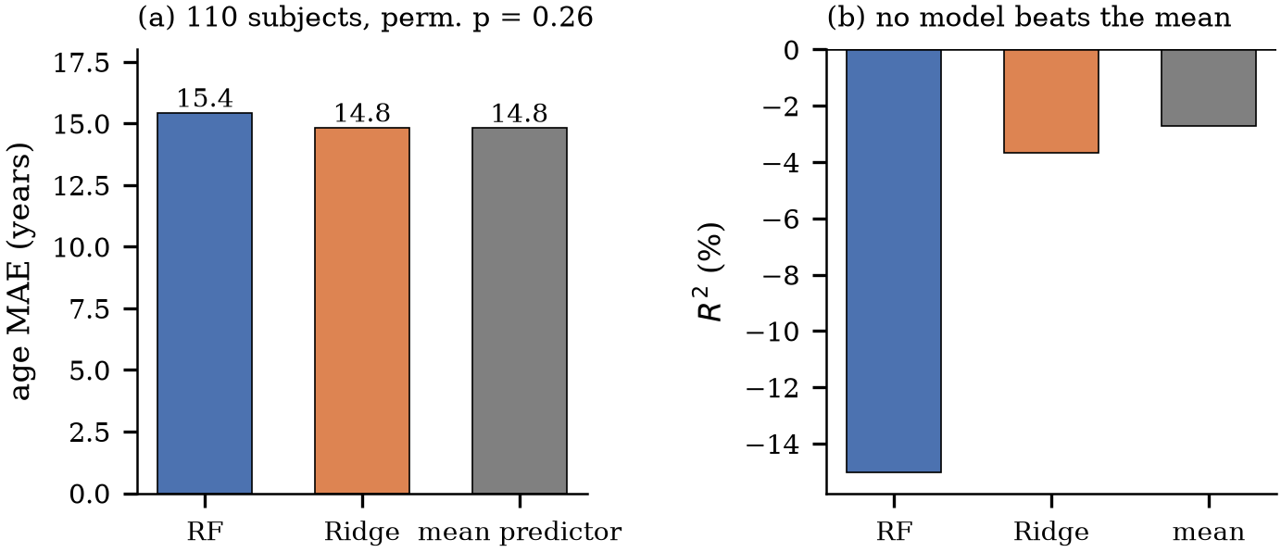
Figure 7. Age regression on the 110 adults. (a) Mean absolute error of the random forest, ridge regression and the constant predictor. (b) The corresponding R²; both models are negative, so neither beats predicting the mean. A permutation test on the ridge model gives p = 0.26.
We report this as a negative result rather than omitting it, because it bounds the claim that can be made for cardiorespiratory descriptors. With 20 s windows and 10 Hz frames, the descriptors that would carry age information, namely HRV measures such as RMSSD and the low-frequency to high-frequency ratio, cannot be estimated reliably: RMSSD needs minutes of stationary recording and the 10 Hz frame rate truncates the cardiac waveform at 5 Hz. The negative result is therefore consistent with the resolution analysis of section 2.2 and does not, by itself, show that radar-derived descriptors cannot predict age.
4. Discussion
4.1. What the negative result does and does not say
The result we report is conditional and specific: with 20 s windows, a 16-descriptor invariant set, and the three public datasets as released, the separability between dogs and humans is no larger than the separability between two groups of humans recorded on two different radars. That statement does not claim that species information is absent from radar cardiorespiratory signals. It claims that these datasets, analysed this way, cannot demonstrate it, and that a study which reports 86 % species accuracy without a hardware control is reporting a number whose interpretation is open.
The transfer asymmetry is the clearest single piece of evidence. A classifier that labels 96.3 % of 120 GHz adults as human labels only 24.1 % of 60 GHz adults as human. If the discriminant were species, the second number should be close to the first; if the discriminant is the platform, the second number is exactly what one expects, because the test platform differs from every training platform. The three-class confusion matrix says the same thing more quietly: adults recorded at 60 GHz are confused with dogs more often than with adults recorded at 120 GHz.
4.2. Why window-level validation inflates radar biometrics
The closed-set ladder quantifies a bias that is familiar in principle but rarely measured in this literature: 54.4 % under window-level cross-validation, 46.1 % under a grouped temporal split, 16.3 % at a 25 min horizon, against 3.3 % chance. The gap sweep shows that sample overlap between adjacent windows is not the main mechanism, because a zero-window gap already loses seven points. The mechanism is that a recording has a stable nuisance signature, ranging from the subject's posture and the radar's mounting geometry to slow gain drift, and random fold assignment lets the classifier learn that signature and call it identity. Grouping by recording removes it; grouping by subject is necessary but not sufficient when one subject contributes many windows from one session.
The same mechanism explains the open-set collapse. A verification threshold fitted on one partition exploits the nuisance signature of the specific known and unknown recordings in that partition. Across 20 partitions the score is at chance (AUROC 0.52 for the distance rules), while the accept rate stays above 84 % because the threshold is set to keep it there. Reporting only the fixed split would have produced a publishable 89.6 % rejection rate that does not survive repartitioning.
4.3. Practical implications
Three practices follow. First, any radar biometric result should be accompanied by a same-species, cross-platform control, or by an explicit statement that the reported accuracy is an upper bound that includes acquisition differences. The control is not expensive: it can be built from a subset of the same subjects measured on a second device, and it converts an ambiguous number into an interpretable one.
Second, descriptor sets should be screened for grid dependence before they are compared across platforms. A decimation control costs one pass over the data and identifies the descriptors whose apparent discriminative power is a measurement of the sampling rate. In our legacy set, spectral_centroid loses 72 % of its value under a 5× decimation, which is a larger effect than most of the physiological effects the set was meant to capture.
Third, the horizon should be stated. A 25 min horizon is a modest requirement for a biometric that would be used across a shift, and it is enough to reduce dog identification from 54 % to 16 %. Systems that report window-level accuracy should report the horizon at which that accuracy was measured.
4.4. Limitations
The study has four limitations. The species contrast is unavoidably confounded with hardware, because no public dataset contains dogs and humans measured on the same radar at the same sampling rate; our response is to bound the effect with controls rather than to remove it, and a same-radar, same-protocol animal–human dataset would settle the question directly. The controls hold different things fixed: NC1 changes platform, subjects and protocol together, so its 93.8 % bounds acquisition-condition separability rather than hardware alone; NC2 keeps the platform but not the animals (83.5 %); only NC3 holds both, and it yields 67.0 %. The claim rests on that comparison, not on reading any single figure as a pure hardware or physiological effect. The number of independent dog recordings is small (30), so the confidence intervals on the identification results are wide even though the fold count is large; we report standard deviations across folds and partitions rather than standard errors for that reason. The 60 GHz frame rate of 10 Hz truncates the cardiac waveform and prevents the HRV descriptors from contributing, which is a limitation of the data rather than of the pipeline. Finally, the evaluation targets identity and species, not clinical endpoints; nothing here speaks to the accuracy of these descriptors for sleep staging or arrhythmia detection, which are different tasks with different failure costs.
4.5. Relation to prior work
The high identification accuracies reported for radar heartbeat signatures (Xing et al 2025) are not contradicted by our results, because the acquisition conditions differ: longer windows, different enrolment protocols, and in some cases same-session verification. What our results do suggest is that the margin between a reported accuracy and chance is not by itself evidence of identity information, and that the two controls used here, a cross-platform contrast and a temporal horizon, are cheap enough to become standard. The same argument applies to the physiological side of the literature: cardiorespiratory coupling and RMSSD, the descriptors a physiological argument nominates first, have the smallest species effect (d = −0.02 and 0.10), as expected if acquisition dominates the measured differences.
5. Conclusion
We re-evaluated three public radar datasets with one processing chain and a ladder of three validation protocols. Vital-sign accuracy reproduces published values, so the pipeline is not the limiting factor. Identification of 30 dogs falls from 54.4 % under window-level cross-validation to 46.1 % under a grouped temporal split and 16.3 % at a 25 min horizon; open-set verification falls to chance (AUROC 0.52–0.59) across random partitions; and dogs versus humans reaches 86.2 % balanced accuracy, which is smaller than the 93.8 % obtained by the same pipeline on two groups of adults recorded on different radars. A rate-matched decimation control separates descriptors that encode the sampling grid from those that do not, and age regression does not beat the mean. The practical conclusion is procedural: radar cardiorespiratory studies should report a cross-platform negative control, a rate-matched ablation and a prediction horizon alongside their accuracy, because without them a high number cannot be attributed to the physiology it is meant to measure.
Data availability
No new data were collected. The three datasets are public and are cited in Table 1 with their DOIs. Raw recordings are not redistributed. Derived feature tables and all result summaries needed to reproduce every number and figure in this paper are available at https://github.com/Xbotsd/Radar_Cardiorespiratory_Biometrics under the MIT licence.
Code availability
The repository contains the cache builder, the feature extractor, the five experiment scripts that produce the tables in this paper, the figure script, and 39 unit tests including consistency tests that recompute the headline numbers from the committed feature tables. The package is installable with pip install -e . and the environment is pinned in requirements.txt.
Ethics statement
This study is a secondary analysis of previously published, de-identified public datasets. The original publications report the ethical approval, informed consent and animal-care procedures under which the data were collected. No new human or animal subjects were involved.
Funding
This research received no specific grant from any funding agency.
Conflict of interest
The author declares no conflict of interest.
ORCID
Yudong Xu: 0009-0002-3231-0444
Acknowledgements
The author thanks the authors of the three public datasets for releasing their recordings and reference signals.
References
Adib F, Mao H, Kabelac Z, Katabi D and Miller R C 2015 Smart homes that monitor breathing and heart rate Proc. 33rd Annual ACM Conf. on Human Factors in Computing Systems (CHI ’15) (Seoul) pp 837–46 doi:10.1145/2702123.2702200
Ahmed S, Yoon S H and Cho S H 2024 A public dataset of dogs vital signs recorded with ultra-wideband radar Sci. Data 11 145 doi:10.6084/m9.figshare.23820915.v1
Biel L, Pettersson O, Philipson L and Wide P 2001 ECG analysis: a new approach in human identification IEEE Trans. Instrum. Meas. 50 808–12
Bland J M and Altman D G 1986 Statistical methods for assessing agreement between two methods of clinical measurement Lancet 327 307–10
Chen L, Liu J, Wang Y, Li H and Zhang Z 2020 Non-contact vital sign monitoring: a review IEEE Rev. Biomed. Eng. 13 300–14 doi:10.1109/RBME.2019.2930632
Droitcour A D, Boric-Lubecke O, Lubecke V M, Lin J and Kovacs G T A 2004 Range correlation and I/Q performance benefits in single-chip silicon Doppler radars for noncontact cardiopulmonary monitoring IEEE Trans. Microw. Theory Tech. 52 838–48
Harris C R et al 2020 Array programming with NumPy Nature 585 357–62
Israel S A, Irvine J M, Cheng A, Wiederhold M D and Wiederhold B K 2005 ECG to identify individuals Pattern Recognit. 38 133–42
Kapoor S and Narayanan A 2023 Leakage and the reproducibility crisis in machine-learning-based science Patterns 4 100804
Kaufman S, Rosset S, Perlich C and Stitelman O 2012 Leakage in data mining: formulation, detection, and avoidance ACM Trans. Knowl. Discov. Data 6 15
Odinaka I, Lai P-H, Kaplan A D, O’Sullivan J A, Sirevaag E J and Rohrbaugh J W 2012 ECG biometric recognition: a comparative analysis IEEE Trans. Inf. Forensics Secur. 7 1812–24
Parralejo F, Parra D, Fernández J and others 2026 Extensive age-balanced mmWave radar dataset (Zenodo) record 18599983
Pedregosa F et al 2011 Scikit-learn: machine learning in Python J. Mach. Learn. Res. 12 2825–30
Roberts D R et al 2017 Cross-validation strategies for data with temporal, spatial, hierarchical, or phylogenetic structure Ecography 40 913–29
Saeb S, Lonini L, Jayaraman A, Mohr D C and Kording K P 2017 The need to approximate the use-case in clinical machine learning GigaScience 6 1–9
Shaffer F and Ginsberg J P 2017 An overview of heart rate variability metrics and norms Front. Public Health 5 258
Task Force of the European Society of Cardiology and the North American Society of Pacing and Electrophysiology 1996 Heart rate variability: standards of measurement, physiological interpretation, and clinical use Circulation 93 1043–65
Vabalas A, Gowen E, Poliakoff E and Casson A J 2019 Machine learning algorithm validation with a limited sample size PLoS ONE 14 e0224365
Varma S and Simon R 2006 Bias in error estimation when using cross-validation for model selection BMC Bioinform. 7 91
Virtanen P et al 2020 SciPy 1.0: fundamental algorithms for scientific computing in Python Nat. Methods 17 261–72
Wu R et al 2026 A dataset of 120 GHz millimetre-wave radar vital signals with synchronised reference recordings Sci. Data 13 741 doi:10.34810/data2962
Xing Z et al 2025 Beyond contact: an open-set biometric identification system using radar-extracted heart signals IEEE J. Biomed. Health Inform. early access doi:10.1109/JBHI.2025.3606776

