PhysFormer: A Physics-Guided Transformer for Physically Consistent Virtual Power Plant Forecasting
Xingyu Liua,*, Zhong Tanga
aShanghai University of Electric Power, Department of Electrical Engineering, Shanghai, 200090, China
*Corresponding author. Email: y24203228@mail.shiep.edu.cn; tangzhong64@163.com

Abstract
Virtual power plant (VPP) forecasting requires joint prediction of load, photovoltaic (PV), and wind power while avoiding non-physical outputs such as negative generation or nighttime PV power. Simple post-processing can remove some violations at deployment, but it does not affect training or explain how weather priors shape model behavior. To address this issue, we propose PhysFormer, a physics-guided Transformer for physically consistent VPP forecasting. PhysFormer combines an explicit physical mapping stream, a bounded residual output mechanism, a physics-guided gating and alignment module, and curriculum-based constraint training. The bounded residual design yields structurally non-negative outputs under the adopted normalization, while the gating module aligns PV and wind activation with exogenous weather cues. Experiments on a real 3-year VPP dataset show that PhysFormer achieves a boundary violation rate of 0.00% and remains competitive with strong Transformer baselines in MSE, reaching 0.0128 versus 0.0121 for Informer and 0.0122 for iTransformer. The results show that PhysFormer offers a practical balance between forecasting accuracy, physical consistency, and interpretable weather-response behavior.
Keywords: Virtual power plant, Forecasting, Physics-guided learning, Physical consistency, Transformer, Renewable power

1. Introduction

1.1. Background and Motivation
Virtual power plants (VPPs) aggregate distributed resources and coordinate them as a single operating entity. Their performance depends on accurate forecasts of load, photovoltaic (PV) generation, and wind power [1, 2, 3, 4, 5]. In practice, these forecasts must be both accurate and physically plausible. PV output should vanish at night, and wind output should respect basic turbine operating limits.
Early VPP forecasting methods were mainly statistical. More recently, recurrent models and Transformers have become standard tools for multivariate time-series prediction [6, 7, 8, 9]. Recent studies have also adapted these models to load forecasting and VPP scheduling [3, 10, 11, 12]. These models can reduce forecast error, but low error alone is not sufficient for VPP operation. The predictions should also remain consistent with basic operating conditions.

1.2. Challenges of Data-Driven VPP Forecasting
Recent advances in deep learning have improved time-series forecasting accuracy, yet their application to VPP prediction still involves several practical challenges [13, 14]:
1) Output feasibility and activation consistency: Purely data-driven models can achieve low error while still producing non-physical outputs, such as non-zero PV generation at night or negative renewable power. These violations may be small, but they reduce the value of the forecast for downstream operation.
2) Limits of post-processing and static penalties: Post-hoc clipping is useful at deployment, but it does not shape the model during training. Physics-informed penalties help, but fixed penalties alone may not capture weather-driven activation changes in PV and wind generation [15, 16, 17]. A practical model should therefore combine train-time guidance with flexible residual prediction.
3) Need for interpretable weather-response behavior: In deployment, it is useful to know whether the model reacts to weather in a reasonable way. Existing interpretability tools can reveal such patterns after training, but they do not necessarily encode them into the model itself [13, 18, 14].

1.3. Overview of This Work
To address these issues, we propose PhysFormer — a physics-guided Transformer for physically consistent VPP forecasting. The model combines an explicit physical mapping stream, a bounded residual output mechanism, a physics-guided gating and alignment module (PGCC), and curriculum-based constraint training. In this work, PGCC is used for guidance and alignment rather than causal discovery.
The main contributions of this paper are as follows:
1. We propose a Bounded Physical Act-Residual (BPAR) mechanism that combines theory-based baselines with residual corrections. Under the adopted normalization, it preserves differentiability while maintaining a structurally non-negative output form.
2. We introduce a Physics-Guided Gating and Alignment module (PGCC) that injects weather-dependent priors into PV and wind activation. Its main role is to improve alignment and interpretability.
3. We adopt a Physics-Constrained Curriculum Training strategy to stabilize optimization, and we evaluate the full framework on a real 3-year VPP dataset.
Experiments show that PhysFormer eliminates boundary violations while remaining competitive with strong Transformer baselines in MSE. The results indicate a useful balance among accuracy, physical consistency, and engineering interpretability.

2. Proposed PhysFormer Framework

2.1. Mathematical Formulation
Throughout this paper, we adopt the following notation: Pload, Ppv, and Pwind denote load, PV, and wind power [MW]; G, T, and v represent irradiance [W/m²], temperature [°C], and wind speed [m/s]; ηpv and βT are the PV conversion efficiency and temperature coefficient; vci, vr, and vco are the wind turbine cut-in, rated, and cut-out speeds; apv and awind are physics activity masks ∈ [0, 1]; gpv and gwind are PGCC gates; α is the curriculum factor; S = 672 and P = 96 are the sequence and prediction lengths; and D = 512 is the model dimension.
The forecasting target contains three VPP components: load (Pload), PV generation (Ppv), and wind generation (Pwind). Their net demand is Pnet = Pload − Ppv − Pwind. We denote the historical component sequence by Xstat ∈ R^(B×S×3), the historical weather sequence by Xweather_hist ∈ R^(B×S×3), and the future weather forecasts by Xweather_future ∈ R^(B×P×3). The model outputs Y ∈ R^(B×P×3), which contains the future trajectories of load, PV, and wind.

2.2. Overall Architecture
PhysFormer follows a compact dual-stream design. As shown in Fig. 1, historical operational records and weather are processed by a statistical stream and an explicit physical stream, fused in PGCC, conditioned on future weather through a GLU block, and mapped to bounded component forecasts by BPAR with activity gating. The statistical stream is implemented with a Transformer encoder (dmodel = 512, dff = 1024, 8 heads, 3 layers), while the physical stream produces theory-based baselines from weather variables before fusion.
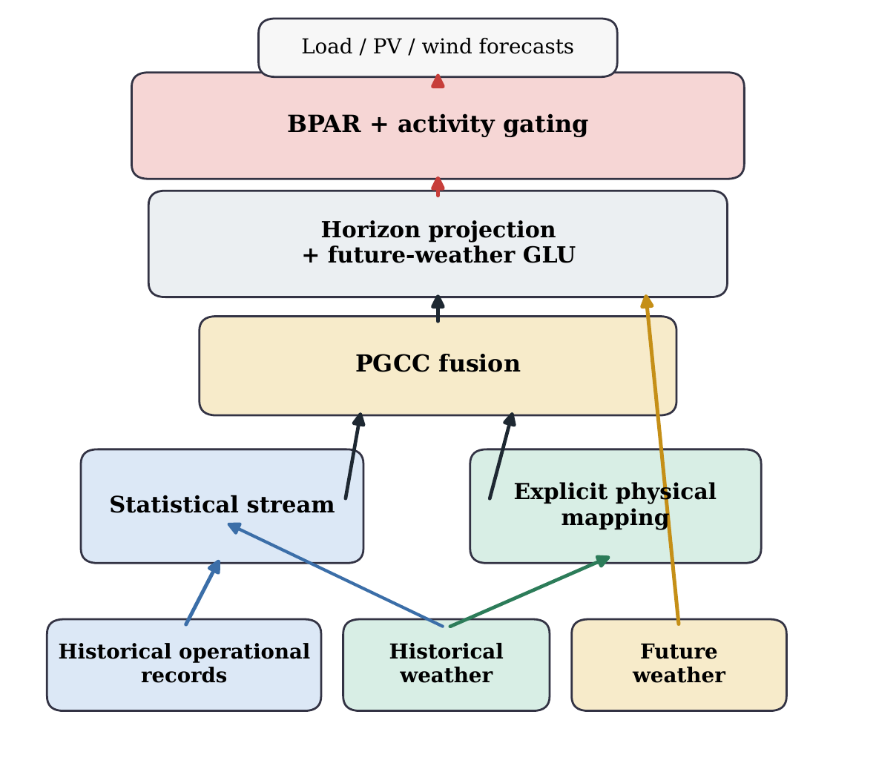
Figure 1: Overview of PhysFormer. Historical records and weather are processed by the statistical and explicit physical streams, fused by PGCC, conditioned on future weather, and converted into bounded component forecasts through BPAR with activity gating.

2.3. Explicit Physical Mapping
The ExplicitPhysicalMapping layer injects physics by mapping weather variables to theory-based power baselines.

2.3.1. PV Model
The theoretical PV generation is driven by irradiance G and degraded by cell temperature, modeled as:
Ppv = G · ηpv · clamp(1 − βT · (T − 25), 0, 1.5) (1)
where T is the temperature. The learnable conversion efficiency is ηpv = 0.33 · σ(θeff), and the temperature coefficient is βT = softplus(θtemp_coef) × 0.01 ∈ [0.003, 0.005]/°C.

2.3.2. Wind Model
Wind power is largely determined by three operating thresholds: the cut-in speed vci, rated speed vr, and cut-out speed vco. To preserve their order during training, we use a cumulative delta form: vci = softplus(θci), vr = vci + softplus(θr_delta), and vco = vr + softplus(θco_delta). The power output then follows an idealized soft curve:
Pwind = scalewind · σ(5 · (wnorm − 0.5)) · Irunning (2)
where wnorm is the normalized speed, scalewind is a learnable amplitude factor, and Irunning is 1 within [vci, vco] and 0 otherwise. To maintain differentiability, PhysFormer replaces Irunning with a continuous physics activity mask awind:
Pwind,actual = scalewind · σ(5 · (wnorm − 0.5)) · awind (3)
This design keeps the threshold structure differentiable and avoids Straight-Through Estimators. The cumulative delta form also preserves the ordering of the operating limits during training.

2.3.3. Load Model
We abstract the power load variations triggered by human cooling and heating activities through a quadratic thermal comfort model:
Pload = Pbase + softplus(γ) · (T − Tc)² (4)
where Tc is an optimizable thermal comfort baseline initialized at 20°C. In our design, the Transformer captures the main temporal patterns of load, while the physical mapping stream captures the temperature-driven deviation around that baseline.
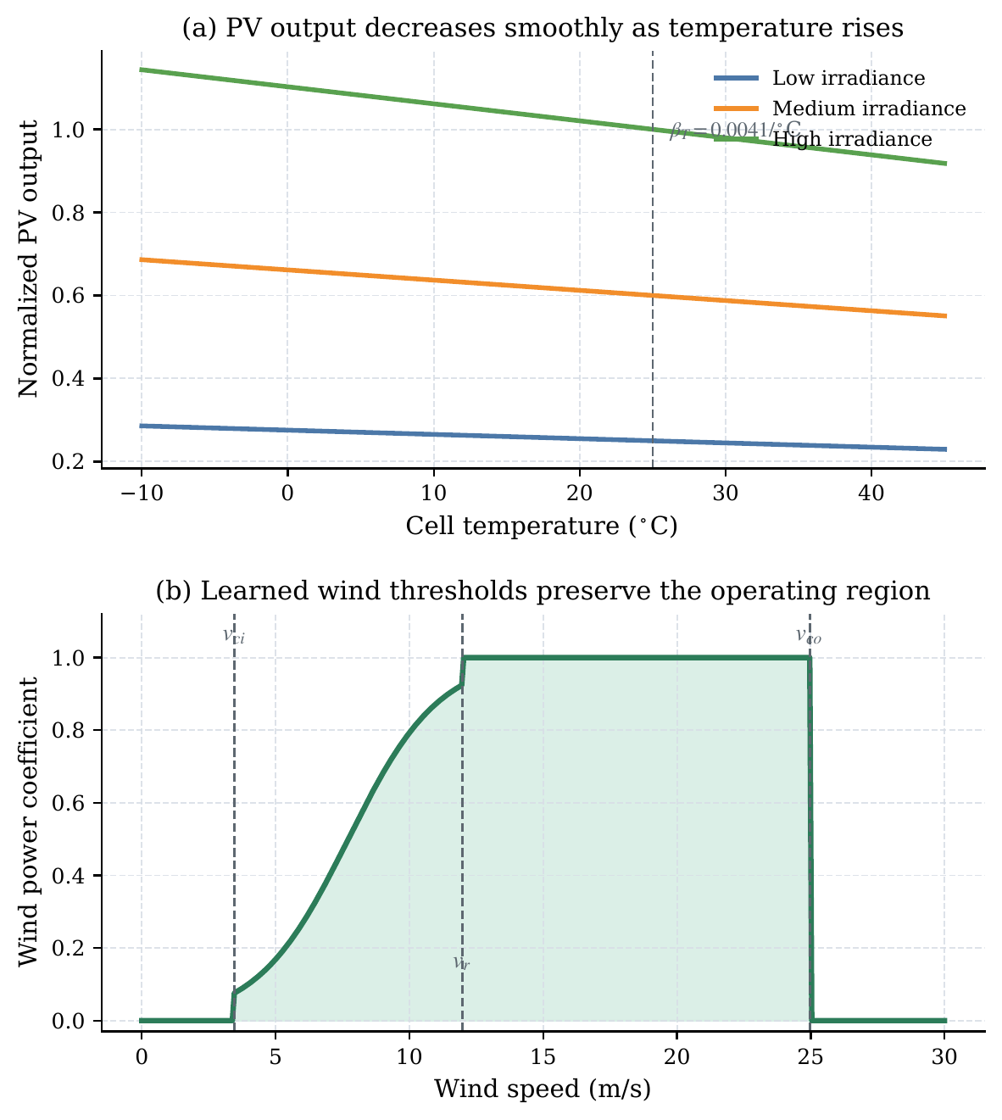
Figure 2: The learned PV and wind mappings preserve physically meaningful monotonicity and operating thresholds. The PV branch maintains smooth temperature degradation, while the wind branch retains the cut-in, rated, and cut-out structure reported in Table 5.

2.3.4. Physics Activity Gating
To reduce non-physical artifacts, we introduce an explicit activity gate. For PV, apv = tanh(10 · Ppv_theory). For wind, awind = tanh(10 · softplus(v − vci) · softplus(vco − v)). The load uses aload = 1. These masks keep the model differentiable and connect active operating states to null-generation periods.

2.4. Physics-Guided Gating and Alignment (PGCC)
The Physics-Guided Gating and Alignment (PGCC) module coordinates the interaction between the statistical stream and the physically encoded representations. In this work, PGCC is used to guide weather-response behavior and improve alignment with known physical cues rather than to infer causality from data alone.

2.4.1. Physics-Anchored Illumination Prior
We first build an illumination prior to suppress spurious activation. The prior is defined as p_pv^prior = σ(kirr · (Gnorm − θirr)), with θirr ∈ [−2.0, 0.5] and slope kirr ∈ [1, 100]. This term separates day from night and reduces the impact of noisy activations in the data embeddings.

2.4.2. Volatility-Aware Soft Gate
To adapt the trust placed in the physical stream, we compute a sequence-level volatility term υ = (1/C) Σc Vart(Xweather,c). This term, together with the statistical embeddings and attention outputs, is fed to a downsampling multilayer perceptron that produces the soft gate maps.

2.4.3. Source-Differentiated Gate Bounds
The coupling implements separate activation ranges to accommodate generation source characteristics:
gatepv = smooth(p_pv^prior · (0.5 + gsoft_pv)) ∈ [0, 1.5] (5)
gateload = smooth(gsoft_load) ∈ [0, 1.0] (6)
The upper bound of 1.5 for gatepv leaves headroom for the residual stream. With gate-response regularization, the learned gatepv reaches a Pearson correlation of r = 0.8306 with irradiance.

2.4.4. Physics-to-Data Curriculum Transition
We condition the alignment phase via a curriculum factor α. As the fusion queries retrieve features, the module integrates inputs dynamically scaled as:
q = α · Fphysics + (1 − α) · gsoft · Fstat (7)

2.4.5. Temporal Smoothing
Raw gate values can be locally discontinuous. We therefore smooth all temporal gating variables with a grouped one-dimensional depthwise convolution (kernel size 3, groups = dmodel).

2.5. Exogenous Weather Integration
After horizon projection, the model incorporates future weather information that is not available in the history sequence alone. We concatenate the future physical latent space Fweather_future with the history representation Fhistory and fuse them with a Gated Linear Unit:
Ffuture = gate · proj(Fcat) + Fhistory (8)

2.6. Bounded Physical Act-Residual (BPAR) Mechanism
To reduce non-physical anomalies while preserving gradient flow, we propose the Bounded Physical Act-Residual (BPAR) mechanism. Let μx and σx denote the global mean and standard deviation of component x. We define the normalized physical zero-point as Px,zero = (0 − μx)/σx. BPAR combines the theory baseline and the neural residual through a differentiable Softplus form:
P̂x,raw = Softplus(Px,theory + rx) − Px,zero + Px,zero (9)
Because Softplus(z) > 0 for all z, this form keeps P̂x,raw > Px,zero in the normalized domain. Under the adopted normalization and anti-normalization setting, the output therefore remains structurally non-negative for σx > 0. We further use a small numerical floor ε = 10⁻⁵ for degenerate variance cases such as night-time PV. Subsequently, the prediction is fused with the physics activity mask ax ∈ [0, 1]:
P̂x,final = ax · P̂x,raw + (1 − ax) · Px,zero (10)
When ax → 0, BPAR smoothly pulls the output toward the physical zero baseline.
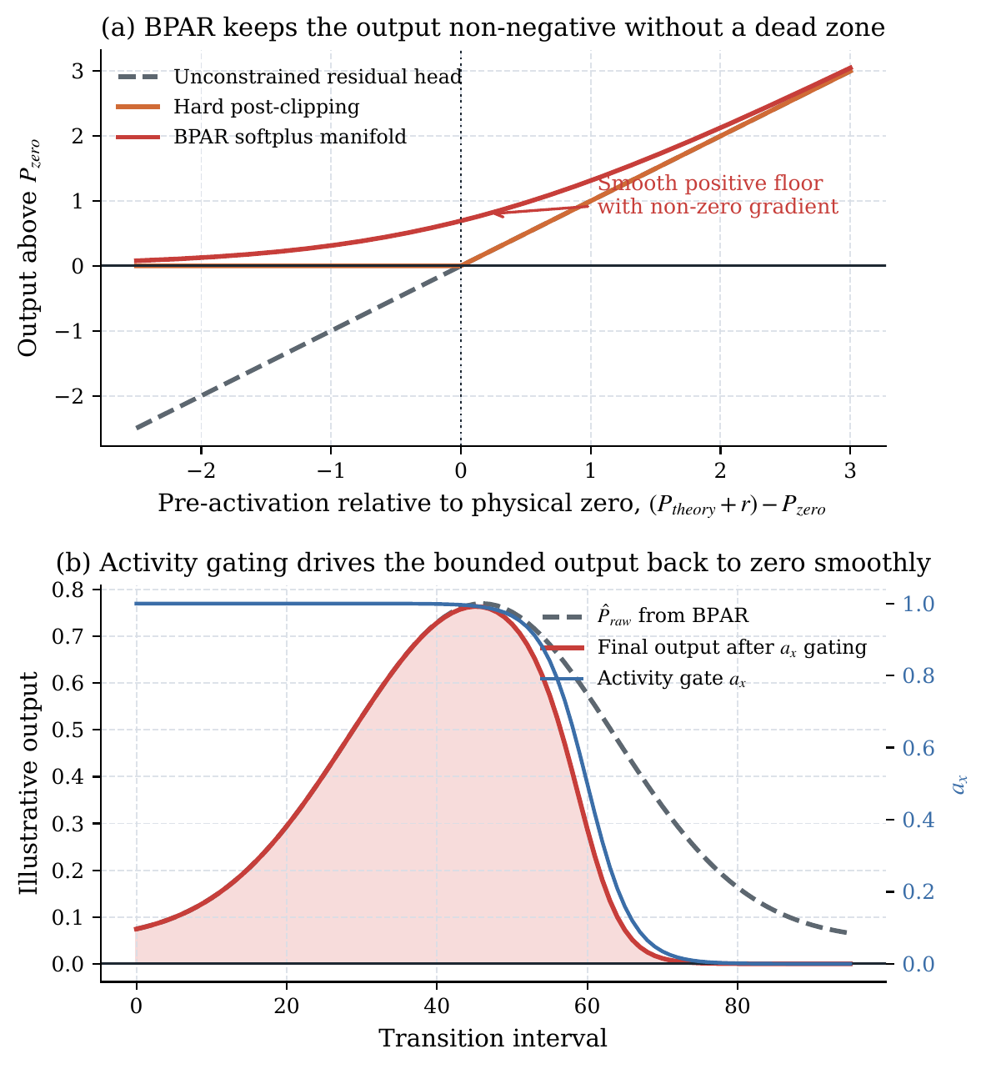
Figure 3: BPAR removes the hard dead zone of post-clipping and, together with activity gating, smoothly pulls the forecast back toward the physical zero boundary. Panel (b) is an illustrative mechanism plot under the adopted normalization setting.

2.7. Physics-Constrained Curriculum Training
Training with physical constraints introduces conflicts between the forecasting loss and the physics losses. We therefore use a Physics-Constrained Curriculum Training strategy. It separates metric spaces, balances amplitudes dynamically, and activates constraints in phases.

2.7.1. Loss Function Design
The regression loss (MSE) is computed in normalized space for stable optimization. All physics constraints (Lphys) are computed after denormalization in MW. We use six penalties (Table 1): four soft constraints for structure and two hard constraints for safety-critical violations.
Table 1: Components of Physics-Guided Loss Function
Component | Weight | Formula | Motivation
Lnet (Soft) | 1.0 | |Σŷcomp − ynet| | Ensures models sum to net demand.
Lenergy (Soft) | 0.5 | |Et[ŷ] − Et[y]| | Enforces macro energy conservation.
Lderiv (Soft) | 0.3 | |Δŷ − Δy| | Captures ramp rate magnitudes.
Ldir (Soft) | 0.1 | E[1 − simcos] | Preserves accurate trend switching.
Lbvr (Hard) | 2.0 | E[(max(0, −ŷreal))²] | Penalizes negative power strictly.
Lrvr (Hard) | 2.0 | E[(max(0, |Δŷ| − ρk))²] | Penalizes sudden jumps.

We use an adaptive amplitude balancing factor γema to track the ratio between forecast error and physical loss:
γema ← 0.9 · γema + 0.1 · (Lmae_phys / Lphys_ref) (11)
The combined objective becomes:
Ltotal = Lmse(normalized) + γema · Lphys_weighted(MW) (12)

2.7.2. Four-Phase Curriculum
To stabilize optimization, we use the four-phase constraint schedule listed in Table 2.
Table 2: Four-Phase Physics Curriculum
Phase | Epochs | Active Constraints | Notes
I (Init.) | 0–4 | None | Physics frozen; base mapping.
II (Safety) | 5–14 | Lnet, Lbvr, Lrvr, Ldir | Safety bounds ramped.
III (Integ.) | 15–29 | Phase II + Lenergy, Lderiv | Macro conservation.
IV (Satur.) | 30–99 | All | Full regularized training.

Table 2b: Layer-wise Learning Rates
Layer Group | Learning Rate | Rationale
Physics (ExplicitPhysicalMapping) | 10⁻⁵ | Preserves priors.
Gating (PGCC) | 5×10⁻⁵ | Stable alignment.
Statistical (all other) | 10⁻⁴ | Fast convergence.

2.7.3. Layer-wise Learning Rates
We further separate the optimizer into three AdamW parameter groups. The statistical backbone uses a learning rate of 1×10⁻⁴. After epoch 5, the physical parameters are unfrozen at 1×10⁻⁵, and the PGCC parameters use 5×10⁻⁵.

2.7.4. Regularization and Early Stopping
We use three regularization paths. First, a Physics Prior Regularizer compares the learned physical parameters with nameplate values by MSE (weight 0.1). Second, a Gate Response Regularization anchors the temporal PV gate to irradiance (weight 0.05). Gradient clipping uses a dynamic bound of 0.5 during critical curriculum transitions, releasing to 1.0 otherwise. Early stopping uses channel-equalizing NRMSEavg with patience of 15 epochs.

3. Case Study and Performance Evaluation

3.1. Dataset and Experimental Setup
We evaluate PhysFormer on a real VPP dataset built from aggregated regional measurements of a distributed energy cluster in Germany. The dataset contains 15-minute load, PV, and wind trajectories over three years (2012–2014), for a total of 105,120 samples. We use a chronological split of 70% for training, 10% for validation, and 20% for testing.
The main model settings are dmodel = 512, dff = 1024, nheads = 8, and elayers = 3. PhysFormer has 11.4M parameters, whereas Informer has 17.9M. The reported inference latency of 2.10 ms/sample was measured on an NVIDIA RTX 3090 GPU with batch size 1.
We compare PhysFormer with eight baselines: LSTM, GRU, PINN [15], Informer [6], Autoformer [7], PatchTST [8], DLinear [9], and iTransformer [19]. All models receive the same future weather covariates. We report MSE, MAE, RMSE, and physical-compliance metrics: Boundary Violation Rate (BVR), Mean Violation Severity (MVS), and Ramp Violation Rate (RVR).

3.2. Forecasting Performance Analysis
The main results are reported in Table 3. PhysFormer reaches an MSE of 0.0128, close to the strongest unconstrained baselines (Informer at 0.0121 and iTransformer at 0.0122), while reducing BVR to 0.00%. By contrast, iTransformer reaches a BVR of 16.26%. Under the strict ramp threshold, PhysFormer records an RVR-S of 0.198%. PatchTST and DLinear perform worse in this VPP setting, suggesting that cross-channel interaction remains important.
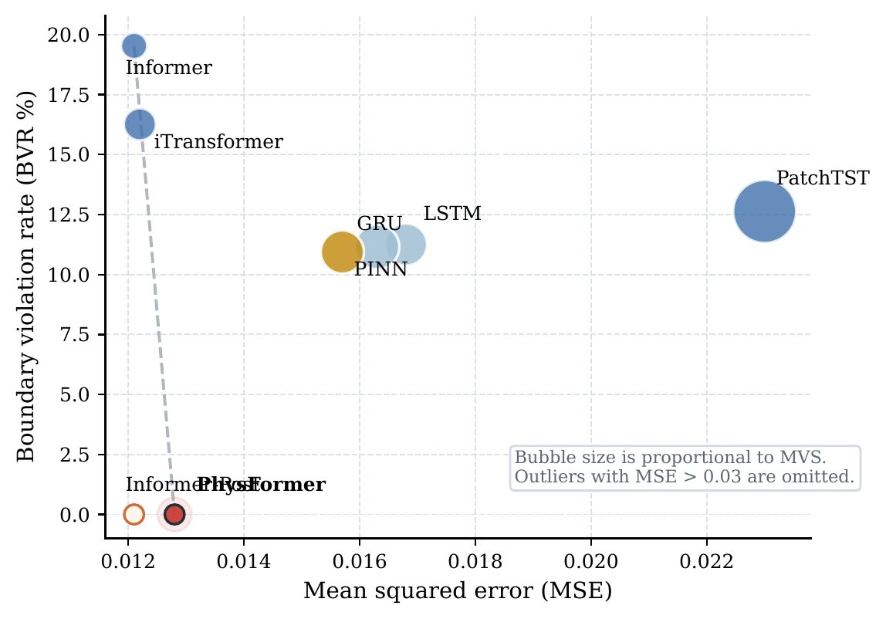
Figure 5: PhysFormer combines zero boundary violations with accuracy close to the strongest unconstrained baselines. High-error outliers with MSE > 0.03 are omitted.
Table 3: Forecasting Performance on the Global Test Set
Model | MSE | BVR (%) | MVS (MW) | RVR-S (%) | NET MAE
LSTM | 0.0168 | 11.25% | 0.0093 | 0.01% | 0.1760
GRU | 0.0163 | 11.15% | 0.0103 | 0.01% | 0.1740
PINN | 0.0157 | 10.94% | 0.0097 | 0.02% | 0.1702
Informer | 0.0121 | 19.53% | 0.0036 | 0.05% | 0.1471
Informer-Post | 0.0121 | 0.00% | 0.0000 | 0.05% | 0.1471
iTransformer | 0.0122 | 16.26% | 0.0054 | 0.028% | 0.1482
Autoformer | 0.1253 | 12.67% | 0.0737 | 0.00% | 0.4846
DLinear | 0.1015 | 7.03% | 0.0295 | 0.00% | 0.4279
PatchTST | 0.0230 | 12.63% | 0.0207 | 0.00% | 0.2052
PhysFormer | 0.0128 | 0.00% | 0.0000 | 0.198% | 0.1527

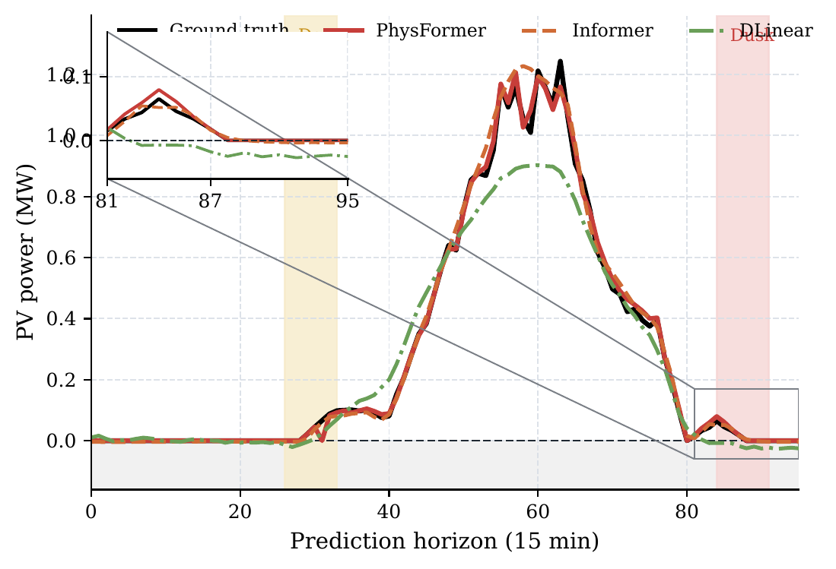
Figure 6: PhysFormer tracks the PV shutdown transition without crossing the zero boundary. The inset highlights the dusk window.

3.3. Verification of Physical Compliance and Safety

3.3.1. Limitations of Heuristic Post-Processing
Table 3 also shows that hard zero-clipping applied to Informer (Informer-Post) reduces BVR to zero without changing the reported MSE. The difference is structural: post-processing acts only after prediction, whereas BPAR changes the output parameterization during training and keeps the boundary treatment differentiable.

3.3.2. Robustness Under Extreme Conditions
To evaluate model stability under stronger distribution shifts, we isolate the top 10% highest-volatility samples. The corresponding results are listed in Table 4. PhysFormer keeps BVR at 0.00% while remaining close to the best MSE values.
Table 4: Extreme Weather Performance (Top 10% Volatility)
Model | MSE | BVR (%) | MVS (MW) | RVR-S (%) | NET MAE
LSTM | 0.0192 | 13.43% | 0.0086 | 0.000% | 0.1941
GRU | 0.0182 | 13.79% | 0.0097 | 0.000% | 0.1864
PINN | 0.0177 | 13.29% | 0.0082 | 0.000% | 0.1807
Informer | 0.0146 | 21.38% | 0.0017 | 0.070% | 0.1632
iTransformer | 0.0143 | 19.79% | 0.0053 | 0.046% | 0.1639
PatchTST | 0.0261 | 12.22% | 0.0132 | 0.000% | 0.2240
PhysFormer | 0.0150 | 0.00% | 0.0000 | 0.294% | 0.1715

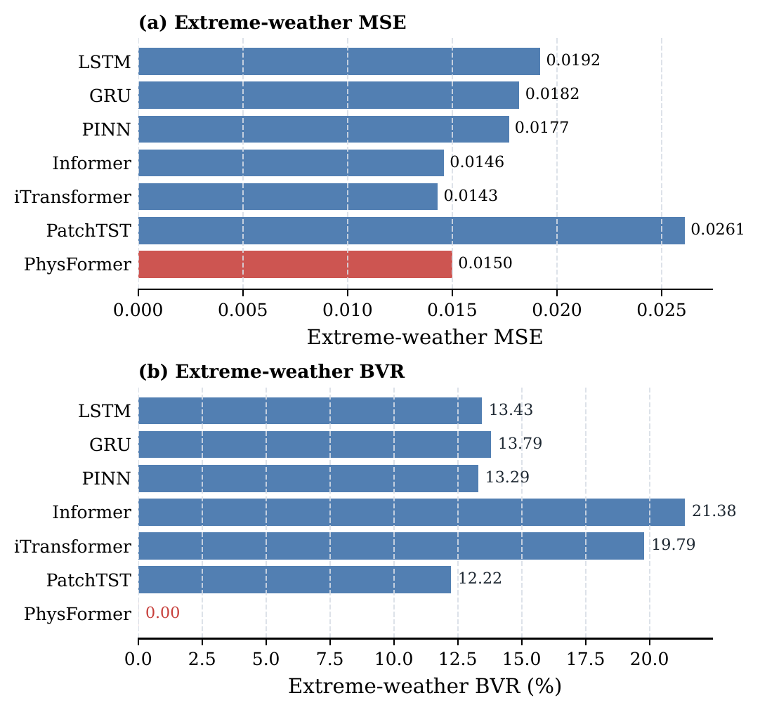
Figure 7: On the extreme-weather subset, PhysFormer stays near the best MSE tier and is the only model with zero boundary violations.

3.4. Model Interpretability and Efficiency

3.4.1. Evaluation of Physical Interpretability
A key advantage of PhysFormer is that its physical parameters remain readable after training. As shown in Table 5, the learned values stay within typical engineering ranges [16, 17]. The PV temperature coefficient changes by only +2.5%. PGCC yields a global Pearson correlation of r = 0.8306 (p < 0.001). Under additional sensor-noise tests, the correlation remains at r = 0.8377 with 20% white noise and stays above 0.81 even at 50% noise amplitude.
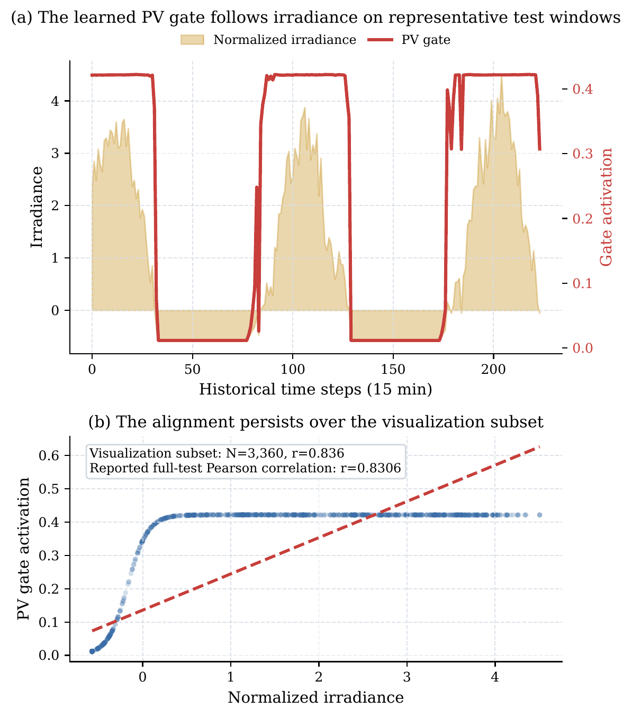
Figure 4: PGCC keeps the learned PV gate aligned with irradiance over both representative windows and the saved visualization subset. The full-test Pearson correlation reported in the text remains r = 0.8306.

3.4.2. Distinction Between Supervised Alignment and Emergent Causality
The high correlation (r = 0.8306) does not indicate emergent meteorological causality discovered ab initio from raw data. Instead, Gate Response Regularization provides supervised alignment to a known physical prior.

3.4.3. Computational Complexity Analysis
PhysFormer uses dmodel = 512 but has 11.4M parameters, compared with Informer’s 17.9M. The measured latency is about 2.10 ms/sample on an RTX 3090 GPU.
Table 5: Physical Parameter Convergence Tracking
Parameter | Initial | Converged | Lit. Range | Δ
pv_temp_coef | 0.0040 | 0.0041/°C | 0.003–0.005 | +2.5%
wind_cut_in | 3.50 m/s | 3.458 m/s | 3–5 m/s | −1.2%
wind_rated | 12.00 | 11.970 m/s | 10–15 m/s | −0.2%
wind_cut_out | 25.00 | 24.968 m/s | 20–25 m/s | −0.1%
load_base | 2.832 MW | 2.823 MW | ≈ mean | −0.3%
temp_comfort | 20.0°C | 19.992°C | 18–22°C | ≈ 0

Table 6: Model Complexity and Inference Overhead
Model | Params (M) | Latency (ms)
LSTM / GRU | 5.42 / 4.10 | 1.20 / 2.19
PINN / DLinear | 2.74 / 0.13 | <0.10 / <0.10
Informer / Autoformer | 17.90 / 17.88 | 1.96 / 4.28
PatchTST / iTransformer | 1.62 / 9.85 | 0.10 / 1.81
PhysFormer | 11.4 | 2.10

3.5. Ablation Study

3.5.1. Component-wise Ablation Analysis
Table 7 shows four main trends. First, removing the physics stream increases MSE by 4.7%, so the theory-based baseline remains useful. Second, removing PGCC leaves MSE unchanged, consistent with its role in alignment rather than raw accuracy. Third, removing curriculum training increases MSE by 8.7%. Fourth, removing the future GLU increases MSE by 1.6%.
Table 7: Ablation Study on Real Data
Variant | MSE | BVR (%) | RVM | r(gatepv)
Full PhysFormer | 0.0128 | 0.00 | 0.0000 | 0.8306
w/o Physics Stream | 0.0134 | 0.00 | 0.0000 | N/A
w/o PGCC | 0.0128 | 0.00 | 0.0000 | N/A
w/o Future GLU | 0.0130 | 0.00 | 0.0000 | 0.8024
w/o Curriculum | 0.0139 | 0.00 | 0.0000 | 0.7866

An additional variant (‘w/ PGCC but w/o Gate Response Regularization’) keeps competitive MSE (0.0128) but fails to produce clear gate-weather alignment (r < 0.12). This confirms that explicit regularization is the main source of the alignment result.

4. Conclusion
This paper presented PhysFormer, a physics-guided Transformer for physically consistent VPP forecasting. The model combines an explicit physical mapping stream, a bounded residual output mechanism, a physics-guided gating and alignment module, and curriculum-based constraint training.
On the 3-year VPP dataset used in this study, PhysFormer achieves a boundary violation rate of 0.00% and remains competitive with strong unconstrained Transformer baselines in MSE. PGCC mainly improves alignment and interpretability, while BPAR is responsible for the consistent non-negative output behavior.
This study is limited to one regional dataset, one prediction setting, and component-level forecasting without explicit storage, state-of-charge, or dispatch feedback. Future work will extend the framework to additional datasets and forecasting horizons, and examine how physically consistent forecasts can support downstream VPP scheduling and control [1, 14, 11].

References
[1] T. Ma, R. Fu, T. Li, Z. Liu, Z. Wang, K. Zhou, A multi-time scale scheduling strategy for virtual power plants considering source-load uncertainty and demand response, IEEE Access 13 (2025) 207873–207892.
[2] W. Cao, J. Yu, M. Xu, Optimization scheduling of virtual power plants considering source-load coordinated operation and wind–solar uncertainty, Processes 12 (1) (2023) 11.
[3] Z. Qiu, Y. Tian, Y. Luo, T. Gu, H. Liu, Wind and photovoltaic power generation forecasting for virtual power plants based on the fusion of improved k-means cluster analysis and deep learning, Sustainability 16 (23) (2024) 10740.
[4] G. Moreno, P. Martin, C. Santos, F. J. Rodriguez, E. Santiso, A day-ahead irradiance forecasting strategy for the integration of photovoltaic systems in virtual power plants, IEEE Access 8 (2020) 204226–204240.
[5] Y. Wu, R. Chen, Y. Chen, X. Chen, J. Yuan, H. Mao, J. Wang, A joint electricity-reserve trading model for virtual power plants to mitigate naked selling, Journal of Modern Power Systems and Clean Energy 13 (5) (2024) 1813–1822.
[6] H. Zhou, S. Zhang, J. Peng, S. Zhang, J. Li, H. Xiong, W. Zhang, Informer: Beyond efficient transformer for long sequence time-series forecasting, in: Proc. AAAI, Vol. 35, 2021, pp. 11106–11115.
[7] H. Wu, J. Xu, J. Wang, M. Long, Autoformer: Decomposition transformers with auto-correlation for long-term series forecasting, in: NeurIPS, Vol. 34, 2021, pp. 22419–22430.
[8] Y. Nie, N. H. Nguyen, P. Sinthong, J. Kalagnanam, A time series is worth 64 words: Long-term forecasting with transformers, ICLR, 2023.
[9] A. Zeng, M. Chen, L. Zhang, Q. Xu, Are transformers effective for time series forecasting?, Proc. AAAI 37 (9) (2023) 11121–11128.
[10] O. Ashraf, L. Bononi, U. Adeel, C. Gambetti, G. Monti, Advanced techniques for joint weather and electricity demand prediction survey, IEEE Access 13 (2025) 196479–196496.
[11] G. Du, S. Li, S. Cao, G. Wang, J. Duan, Weekly economic scheduling of virtual power plant with electric vehicles, Electric Power Systems Research 241 (2025) 111362.
[12] L. Li, X. Guo, R. Jing, Short-term electric load forecasting based on series decomposition and meta-informer algorithm, Electric Power Systems Research 243 (2025) 111478.
[13] O. Våle, S. Zhang, S. Maharjan, G. Klæboe, Exploring the interpretability of forecasting models for energy balancing market, Artificial Intelligence Science and Engineering 1 (4) (2025) 295–306.
[14] V. Arabzadeh, R. Frank, A four-dimensional analysis of explainable AI in energy forecasting, Machine Learning and Knowledge Extraction 7 (4) (2025) 153.
[15] M. Raissi, P. Perdikaris, G. Karniadakis, Physics-informed neural networks, Journal of Computational Physics 378 (2019) 686–707.
[16] C. Li, L. Sheng, X. Xi, M. Zhong, Physics-informed adaptive-weight nbeatsx for short-term wind power forecasting, IEEE Trans. Ind. Informat. 22 (2) (2026) 1129–1140.
[17] J. Asinyo, O. Ceylan, A. Polycarpou, Enhancing solar irradiance prediction: A physics-informed ML approach, ELECO 2025, pp. 1–6.
[18] A. Lovo, A. Lancelin, C. Herbert, F. Bouchet, Tackling the accuracy–interpretability trade-off in ML models for extreme heatwaves, Artif. Intell. Earth Syst. 4 (3) (2025).
[19] Y. Liu, T. Hu, H. Zhang, H. Wu, S. Wang, L. Ma, M. Long, iTransformer: Inverted transformers are effective for time series forecasting, ICLR, 2024.

