Rebecca Essenburg
Daniel Fryer
Case Study: Outland Adventures
ERD:
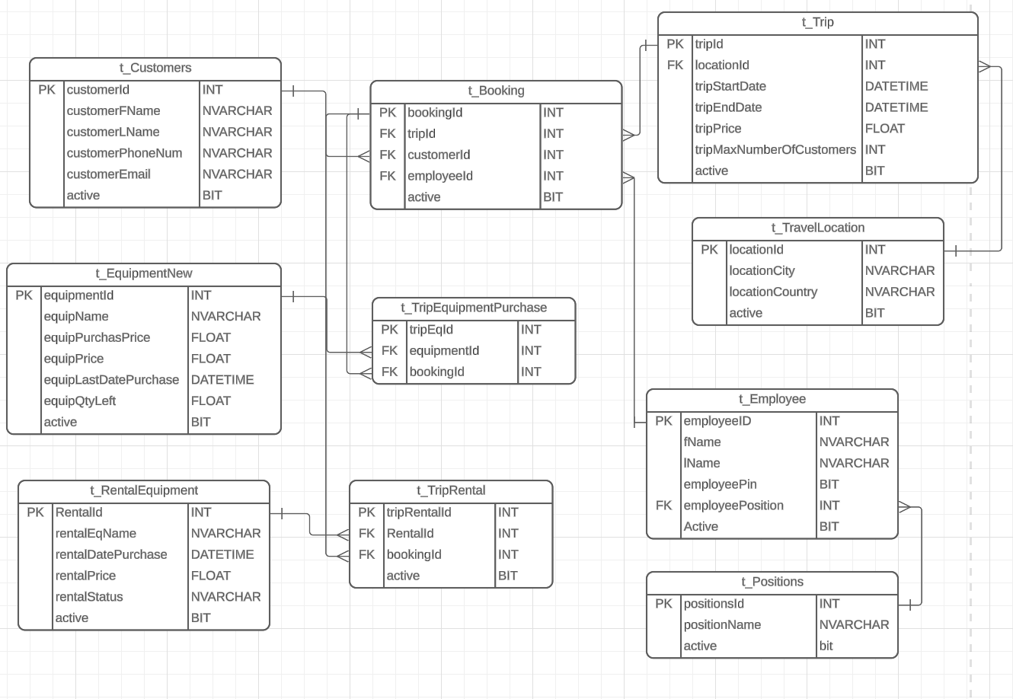

Buisness Rules:
- CUSTOMERS can Buy or Rent EQUIPMENT
- TRIP BOOKINGS do not include EQUIPMENT (must be separate Equipment Order)
- TRIPS can include multiple LOCATIONS
- equip_stockDate must not be > 5 years ago.
- Multiple customers can book trips.
- Employee can lead many trips.
- Location can be booked multiple times.
- Customers can rent or purchase equipment. Can do both.

Assumptions:
- Customers would have to register before booking no guest accounts.
- Purchased equipment can't be used as rental and rental equipment can't be sold as new equipment.

