Group members:
Rebecca Essenburg & Daniel Fryer

Case Study:
Outland Adventure – This case study was about two people who enjoyed the outdoors and decided to open a business of taking people on outdoor adventures around the world. They have 2 guides, a marketing director, a supply manager, and an ecommerce developer. They wanted to find ways to optimize their operations. They wanted to know if they had enough equipment sales, if they had old inventory in their gear, and if their treks have a downward trend to where they went.

ERD:
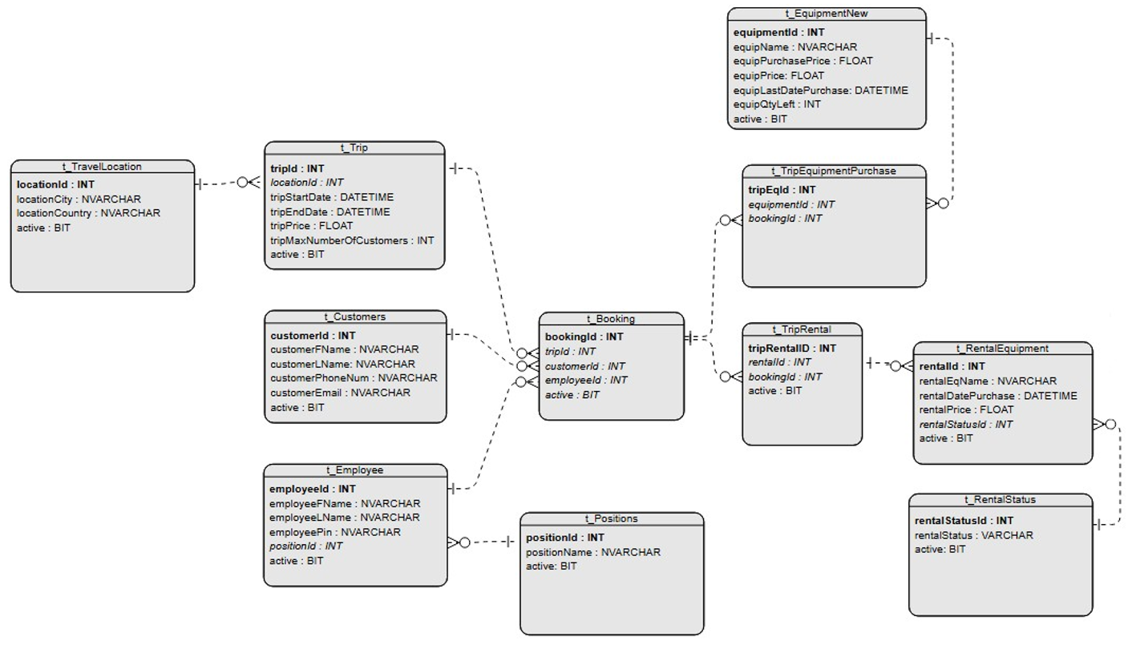

Reports:
The first two reports deal with the purchased request. The first report below shows the customers who purchased item and which destinations they were traveling to. The second report shows the total quantity of equipment has been purchased.
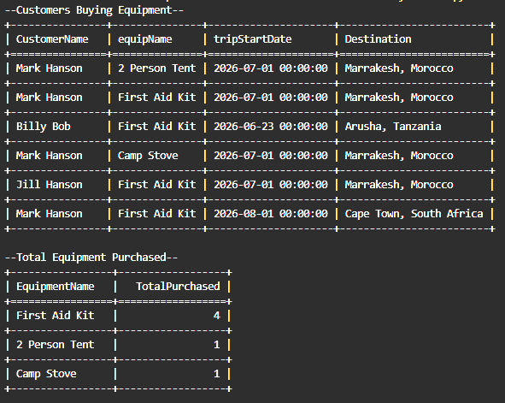

The third report deals with rental equipment that is over 5 years old and may need to be replaced.
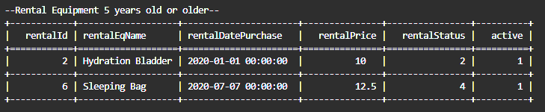
The fourth and last report deals with bookings by region that they can then turn into graphs over time to monitor where people are wanting to travel. Currently they only had people wanting to travel to Africa but over time this may change.
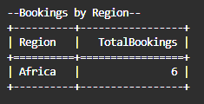

Assumptions made:
- Customers would have to register before booking. No guest accounts.
- Purchased equipment can’t be used as rental and rental equipment can’t be sold as new equipment
- A person can purchase or rent equipment for each trip.
- Trips don’t include equipment and people would have to purchase or rent the equipment.
- There would need to be a max number of customers that could attend a trip
- An employee can only be on one trip at a time.

