Interview questions:
- What are your favorite hobbies?
Video games, art, digging holes, and swimming. Games he likes are COD, wreak fest, Minecraft, grow a garden, fortnight
- What is your favorite color?
Black, likes to wear it because it helps him blend in
- What is your favorite foods?
Reese’s take 5 or black-tie mousse cake for deserts, raspberries, asparagus, a good hamburger, and husker roll from Hiro 88
- When you grow up what do you want to go to school for and why?
Mechanical engineer, involves his talents for art and creativities and sounds like it would be a fun job
- What has been your best vacation you have been on?
Vacations to Florida to go to the beach or the trip to Disney World. Disney world because it was the first time he got to go on big rollercoaster for the first time, also really enjoyed the tea cups and all the different kinds of food. Favorite ride between the pizza planet spinning or the Guardians of the galaxy rollercoaster

- Who is your favorite super hero?
Iron man, spider man has been moved to second place. Wants to be smart like Tony Stark and invent new items
- If you could go anywhere in the world, where would you go?
Japan, Wants to try their sushi restaurants and see their culture. See the Pokémon/ anime stores.
- If you could meet anyone past or present, who would you want to meet and why?
Jesus to ask questions about why certain things are the way they are and about other places in our universe. And what other sea creatures are there that we haven’t seen or found yet.
- Where would you like to live if you could pick any place?
On a farm by a river and forest area. Maybe like Colorado but out in open.
- What is your favorite subject in school? What about least?
Favorite PE because he get to use his body and grow stronger. Least is Language arts because they always seem to have follow up questions that are hard to answer.

Biography
James is a 12-year-old boy living in a small town in Nebraska. His favorite color is black because when he wears it, he feels like he can blend in with his friends as he doesn’t like to be the center of attention. In school the subject he looks forward to the most is PE as he gets to use his body and make it stronger. He isn’t a fan of language arts because a lot of the time they ask follow-up questions that he finds hard to answer. When not in school he enjoys playing video games, art, swimming, and digging holes in the area where we took a tree out of the yard. Right now, he is enjoying Minecraft and fortnight with his friends.
When it comes to dinner time his go-to meal would be a good hamburger with asparagus. For dessert he would eat a piece of black-tie mousse cake or a Reese’s Take 5 candy bar. If he has to have a healthy desert his go-to would be raspberries.
His best vacation was when he went to Disney World in Florida. He really enjoyed the vacation because he got to go on his first rollercoaster and got to eat lots of different foods. The rides he would really like to go on again are the tea cups, space aliens from Toy Story, and Guardians of the Galaxy.
For his future he would like to go to school for mechanical engineering as he wants to be able to build and create new items that will help people. This goal leads to his favorite super hero, Iron Man. He likes Iron Man because he is really smart, can build really cool robots, and he want to help people.
One day he would like to live in a country house possibly by a river and surrounded by a forest. He would like to be surrounded by nature.
If he could meet someone past or present, he would have like to meet and talk with Jesus to ask him questions about why somethings are the way they are and about other places in the galaxy.
Lastly if he could visit anywhere in the world, he would like to visit Japan to try their sushi and see if it is any different then ours. He would also like to view the big Pokémon/anime store they have in Tokyo.

Style Guide:
Introduction
This document is to help provide guidance for the design of the James biographical website by defining the colors to be used, the fonts on the sites, link setup, and what/how icons should look.
Color Palette
Colors should be used consistently across all pages to maintain a uniformed look. These are the approved colors if you need additional colors make sure they match the color scheme and don’t distract.
Primary Color: #FA313F
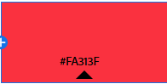
This will be used for Headers on the different pages.
Secondary: #FA5132
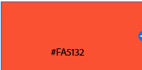
This is used as links not yet visited
Alternate color: #DD32FA
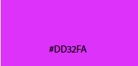
This is used for visited links.
Background color: #FADEE1
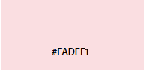
This is the main background color for the site.

Typography
Use the same font and style for the header/sub header on each page. Body of each web page should not include more than 1 font style.
Primary Font (Header)
- Courier New
- Style Bold
- Used in Title and subtitle
Secondary Font
- Arial
- Used in any text in the main part of the web page. Links.
H1
- Use should be restricted to title
- Should be centered
- Should be the primary color
H2
- Use should be restricted to sub title
- Should be centered
- Should use the primary color

Iconography
If using icons with text always try and combine the icon and text instead of using the icons alone.

Example: Correct Avoid

Photos
Any photo uploaded should be respectfully shot.
Photos of trademarked items should be noted.
Navigation
Use the secondary and alternate for clickable links.
Users will be able to get to any page from the page they are on. Example if user is in the hobbies page they will be able to get to the about page without having to go back to the home page.
Links to outside web pages will open in a new tab.
Layout
Content should be spaced evenly and easy to read.
Avoid clutter and keep pages clean and separated.

WireFrame
Home Page
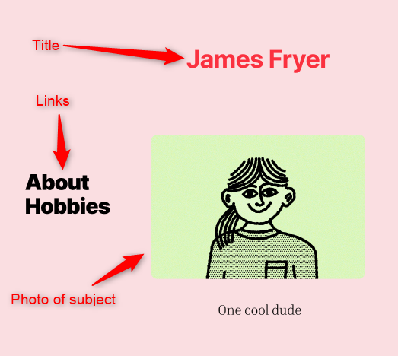
About
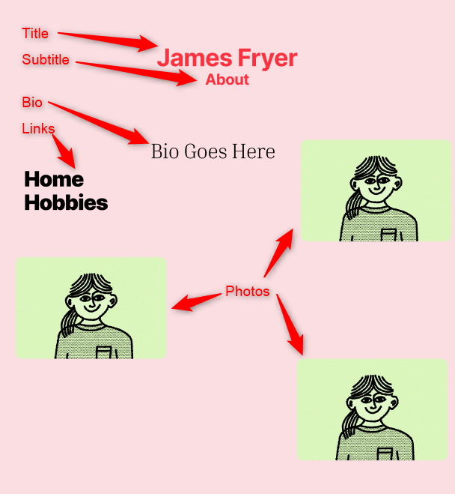

Hobbies
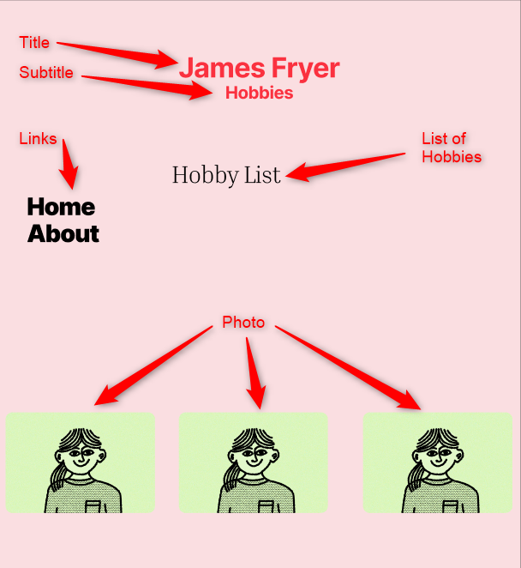

Images to be used:
Profile picture:
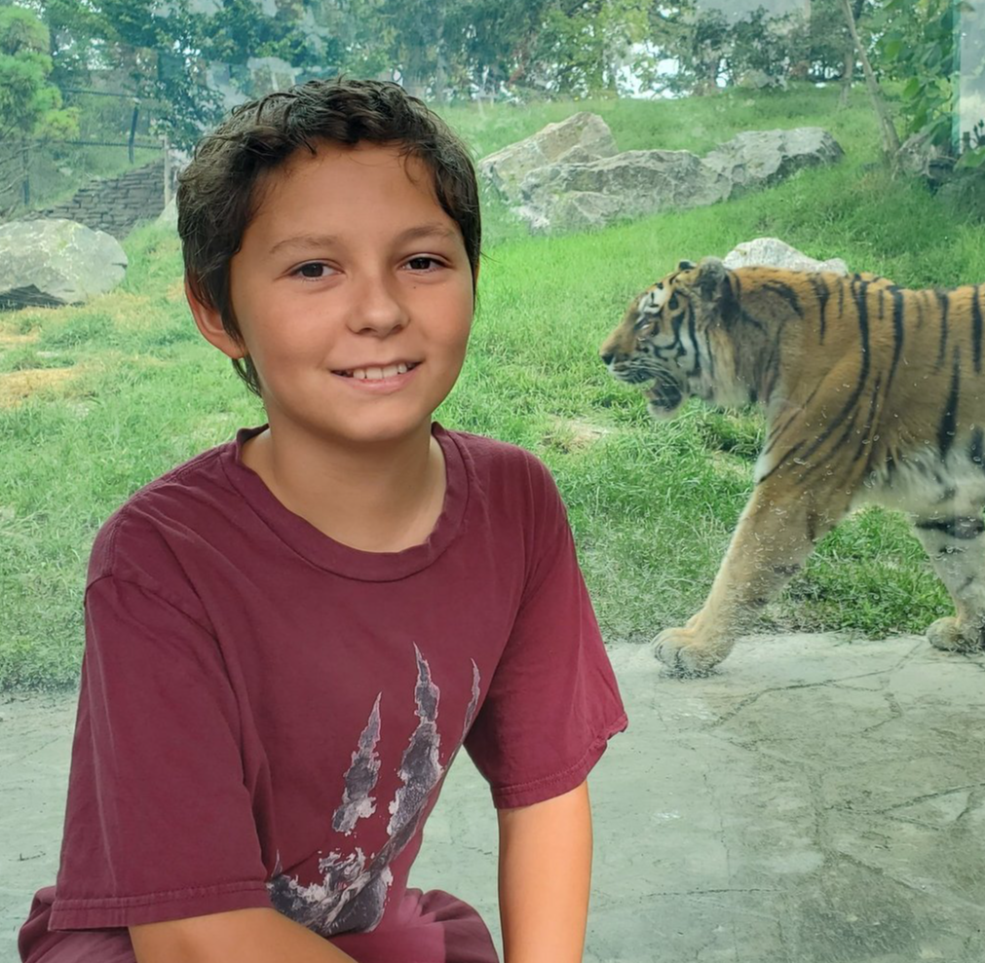

Hobbies:
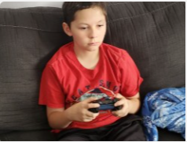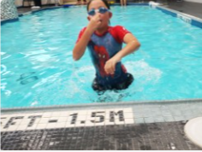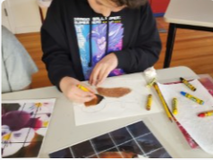

Achievements/Goals:
