Project: Todo Application Test Plan
Course: CSD 380
Description: Functional Test Plan for the Todo Application
Date: 9/3/2026
Name: Ryan Barber
Assignment: Module 4.2 Test plan

Test 1 | View Existing Todo Task Items
 | Test Objective: Verifies that users can view the existing list of Todo task items when the application loads. | Developer: Ryan Barber  Date tested: 9/3/2026 | Peer tester: Daniel Fryer  Date tested: 9/4/206
Step | Action | Expected results: | Developer pass/fail | Tester pass/fail  + Screenshot
1 | Open a web browser | Browser opens successfully | Yes | Yes  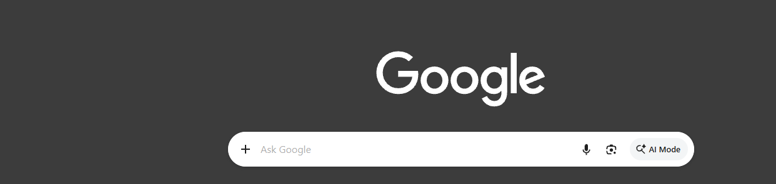
2 | Navigate to the Todo application website | Todo application loads without errors | Yes | Yes  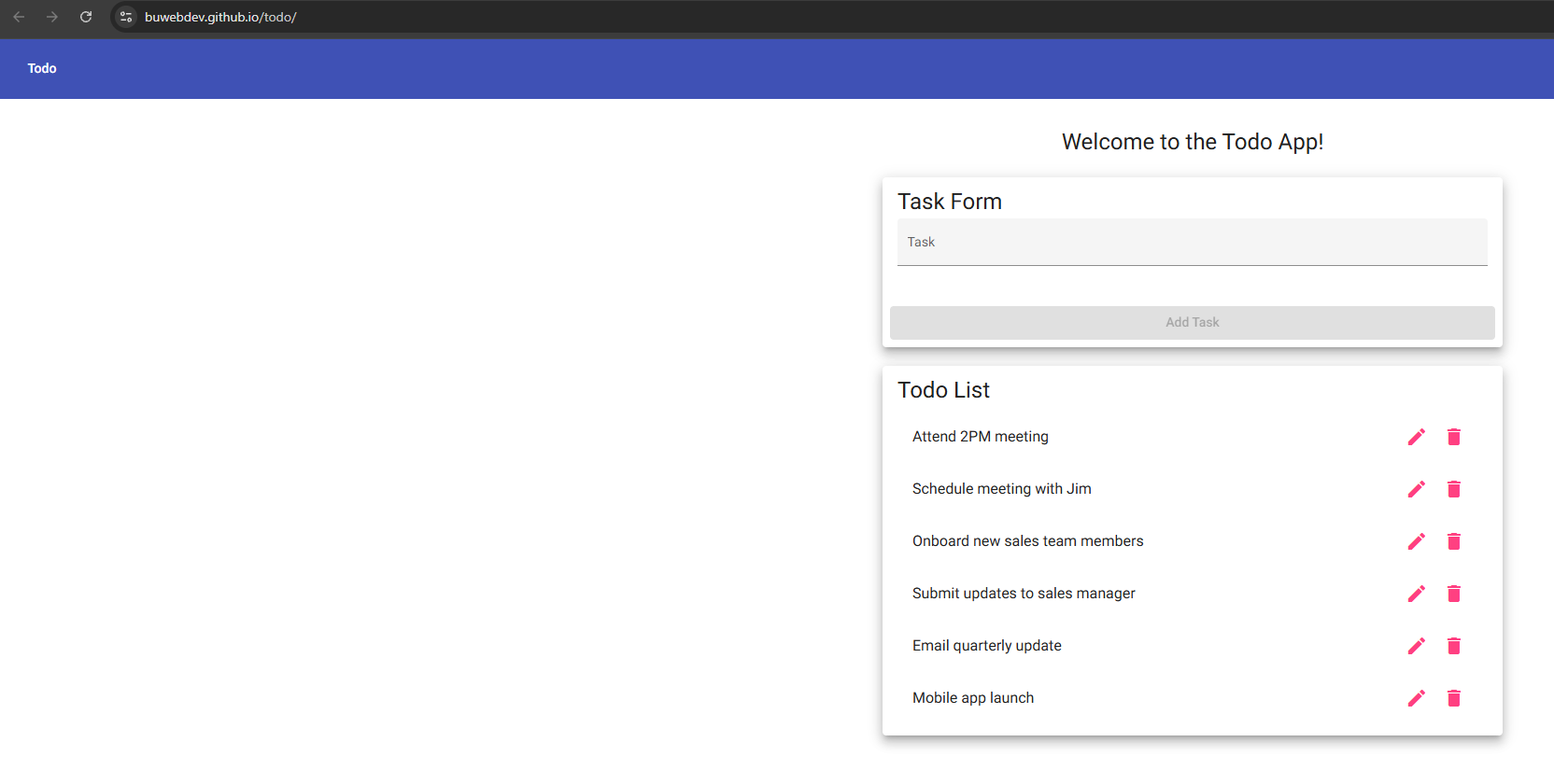
3 | Locate the Todo List section | Todo List section is visible on the page | Yes | Yes  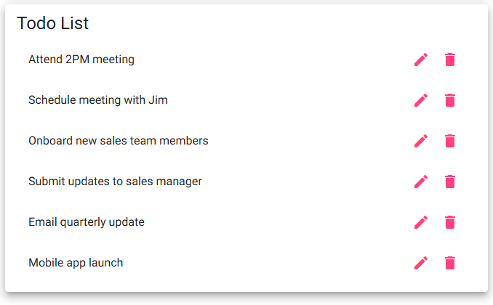
4 | Review the listed Todo items | Existing Todo task items are displayed | Yes | Yes
5 | Refresh the browser page | Application reloads and the Todo List remains visible | Yes | Yes  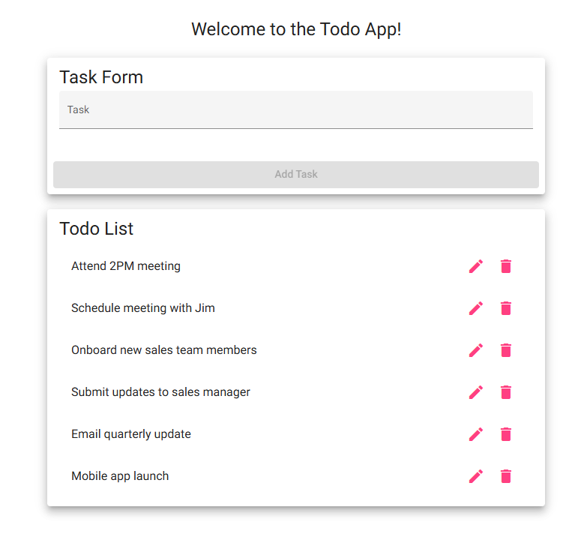
Comments | The Todo application successfully displays the existing task list when the website loads. The task items remain visible after refreshing the browser confirming that users can access and view the Todo List as required. – Tester Notes: All tasks have completed to their expected results. Screenshot 4 is the same as task 3.

Test 2 | Create a New Todo Task Item
 | Test Objective: Verify that users can create and add a new Todo task item to the Todo List. | Developer: Ryan Barber  Date tested: 9/3/2026 | Peer tester: Daniel Fryer  Date tested: 9/4/2026
Step | Action | Expected results: | Developer pass/fail | Tester pass/fail  + Screenshot
1 | Navigate to the Todo application website | Todo application successfully loads | Yes | Yes  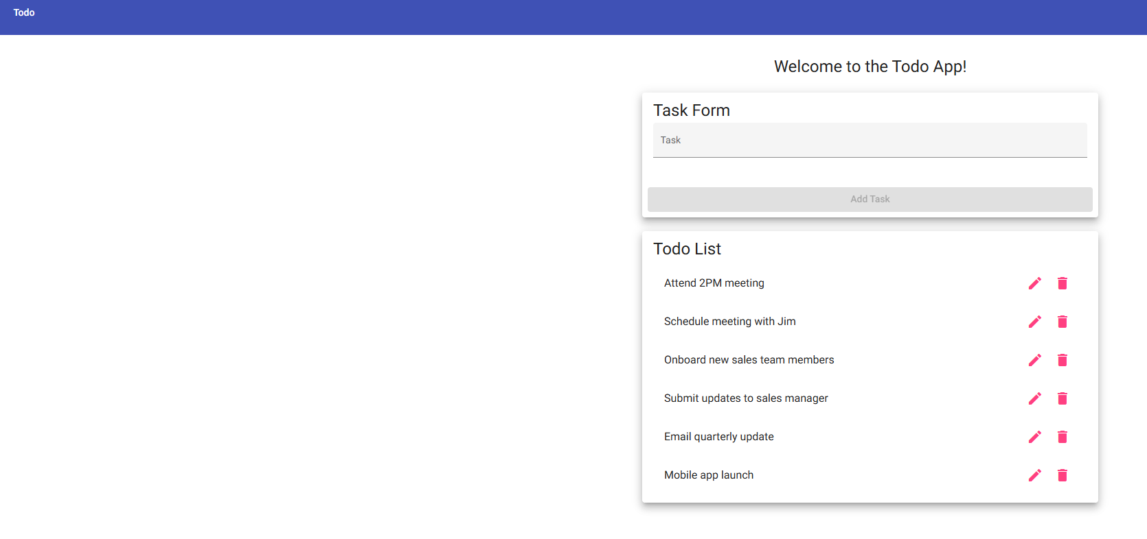
2 | Click inside the Task input field | Task field becomes active and accepts input | Yes | Yes  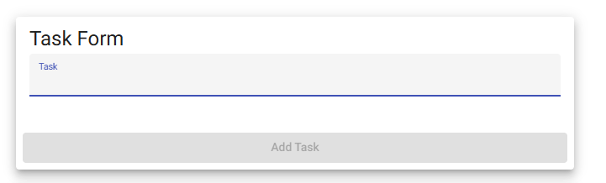
3 | Enter ‘Go to the Movies’ | Entered text appears in the Task field | Yes | Yes  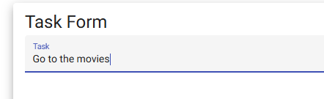
4 | Click Add Task | The task is submitted successfully | Yes | Yes
5 | Review the Todo List | ‘Go to the Movies’ appears in the Todo List | Yes | Yes  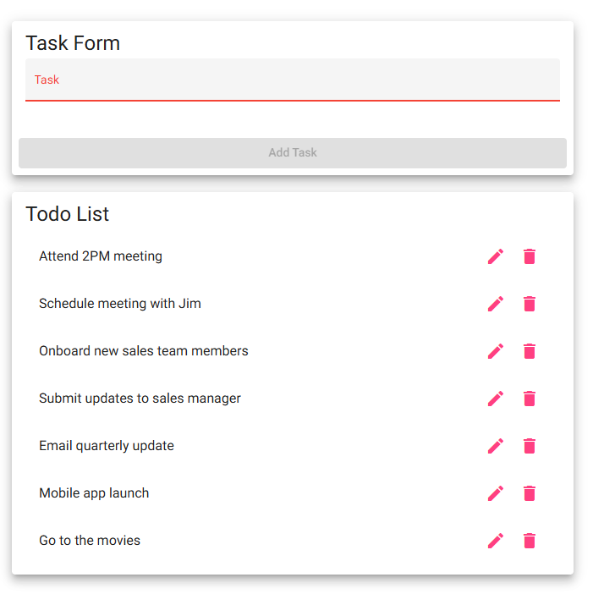
Comments | The Application allows the user to enter a new task and add it to the Todo List. The new task appears in the list after selecting Add Task, demonstrating that the crate-task functionality works correctly. – Tester Notes: All tasks successfully completed to the expected results. Step 2 when clicking into the text box the Task default text shrank showing field was active. Screenshot for task 4 is the same as task 5.

Test 3 | Edit an Existing Todo Task Item
 | Test Objective: Verify that users can edit an existing Todo task and save the updated information | Developer: Ryan Barber  Date tested: 9/3/2026 | Peer tester: Daniel Fryer  Date tested: 9/4/2026
Step | Action | Expected results: | Developer pass/fail | Tester pass/fail  + Screenshot
1 | Locate ‘Go to the Movies’ in the Todo List. | The task is visible in the Todo List | Yes | Yes  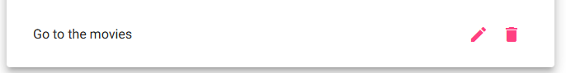
2 | Click the pencil/edit icon next to the task | The Edit Form opens and displays the selected task | Yes | Yes  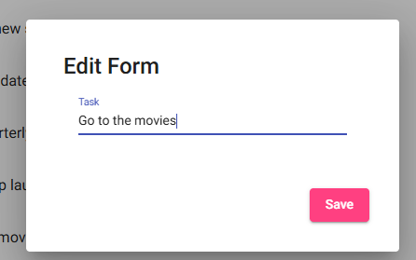
3 | Change the task to ‘Cook dinner’ | Updated text appears in the Edit Form | Yes | Yes  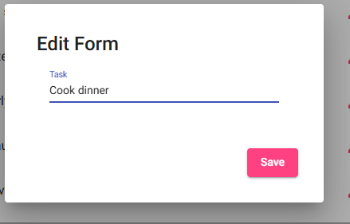
4 | Click Save | The updated task is saved successfully | Yes | Yes
5 | Review the Todo List | ‘Cook dinner’ appears instead of the original task | Yes | Yes  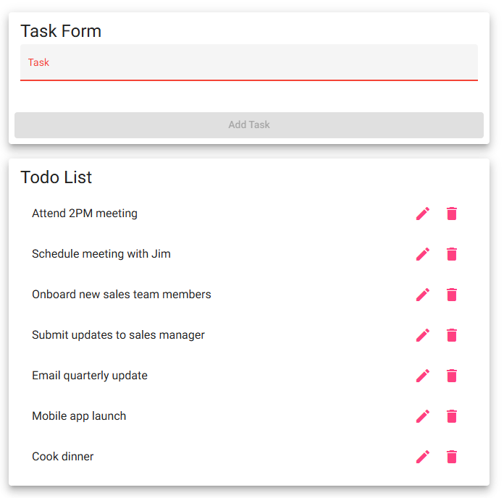
Comments | The edit function allows an existing Todo item to be selected and edited. After saving the change, the Todo List displays the updated task information, confirming that task edits are processed correctly. – Tester Notes: All Tasks completed successfully to the expected results. Tasks 4 screenshot is the same as task 5.

Test 4 | Delete an Existing Todo Item
 | Test Objective: Verify that users can delete an existing task from the Todo List | Developer: Ryan Barber  Date tested: 9/3/2026 | Peer tester: Daniel Fryer  Date tested: 9/4/2026
Step | Action | Expected results: | Developer pass/fail | Tester pass/fail  + Screenshot
1 | Locate ‘Cook dinner’ | The task is visible in the Todo List | Yes | Yes  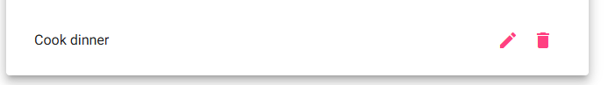
2 | Click the trash/delete icon next to the task | The application processes the delete request | Yes | Yes:  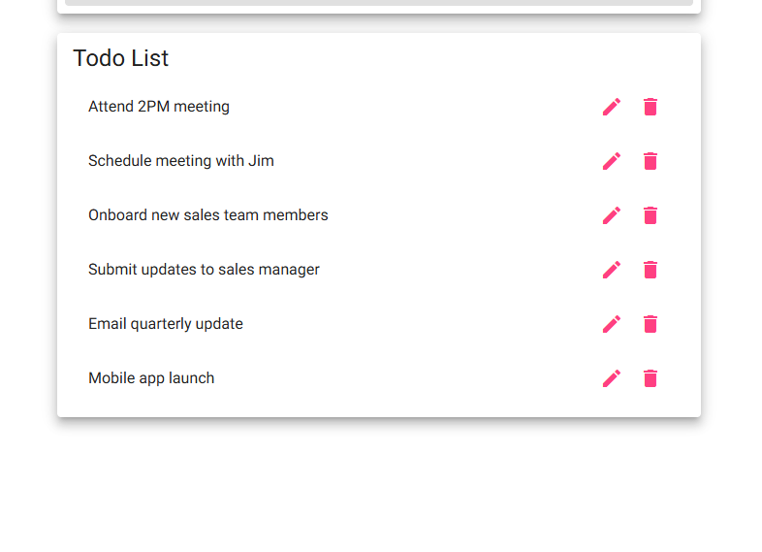
3 | Review the browser page | The deleted task no longer appears | Yes | Yes  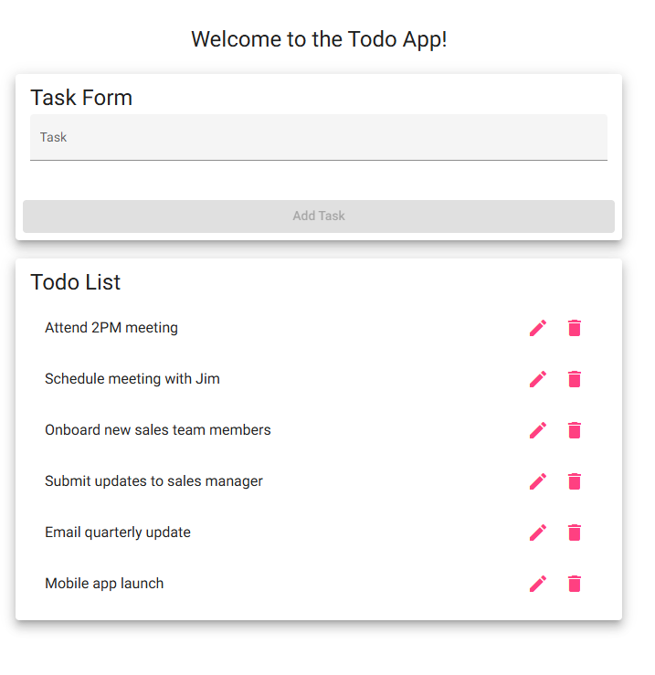
4 | Refresh the browser page | The Todo application reloads successfully | Yes | Yes
5 | Review the Todo List again | The deleted task remains absent after refreshing | Yes | Yes
Comments | The delete function successfully removes the selected task from the Todo List. After refreshing the application, the deleted item does not return, confirming that the task was removed successfully. – Tester Notes: All tasks completed successfully to the expected results. For step 4 refreshing the screen clears all entered data need to verify that the tasks are being saved on the back end so they are there each time the user comes to the site. Screenshot for task 5 is the same as task 4.

Test 5 | Prevent Submission of an Empty Todo Task
 | Test Objective: Verify that the application prevents users from creating a task without entering a Todo item | Developer: Ryan Barber  Date tested: 9/3/2026 | Peer tester: Daniel Fryer  Date tested: 9/4/2026
Step | Action | Expected results: | Developer pass/fail | Tester pass/fail  + Screenshot
1 | Navigate to the Todo application website | Todo Application loads successfully | Yes | Yes  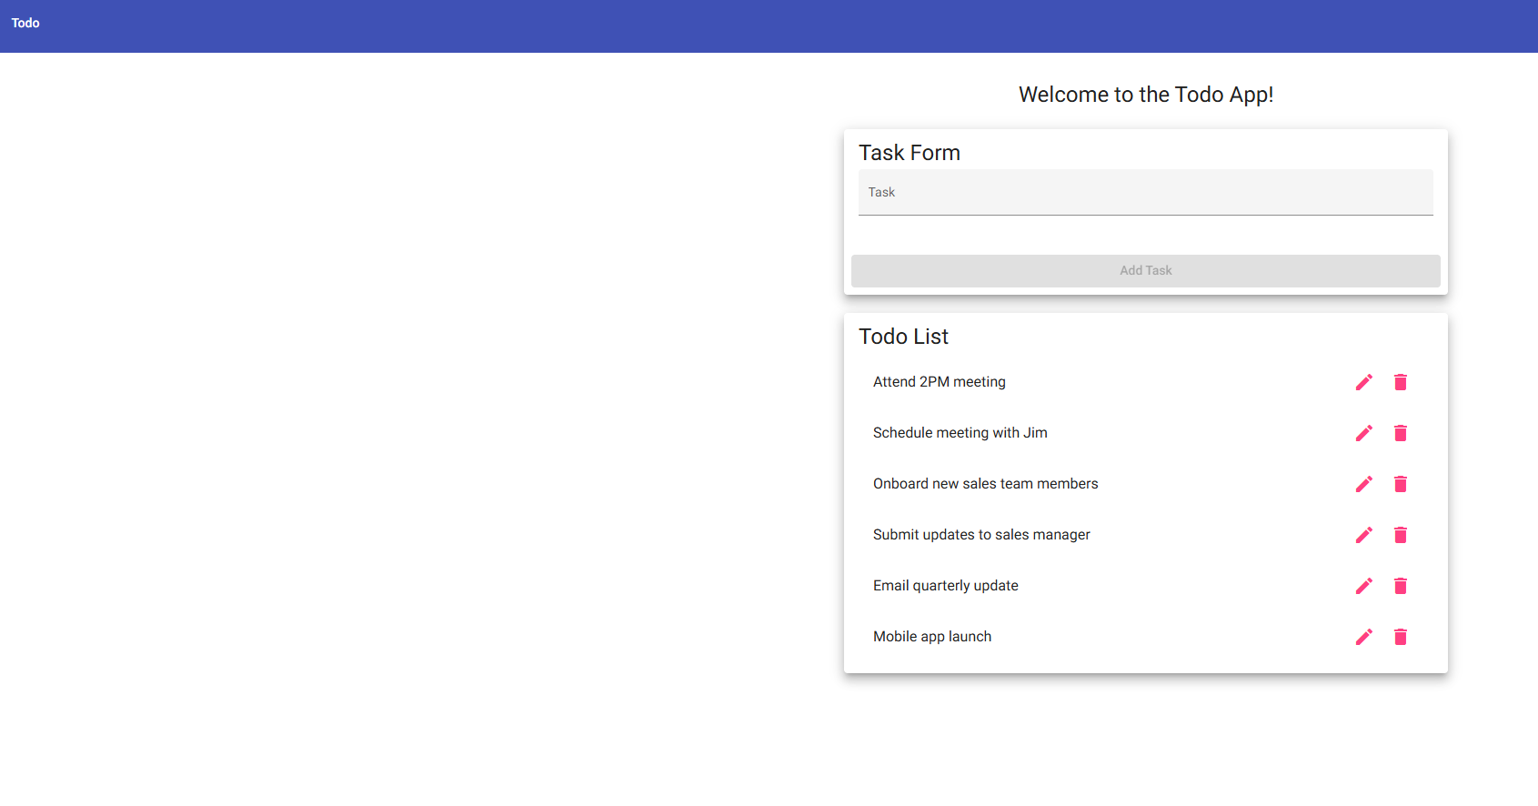
2 | Locate the Task input field | Task input field is visible | Yes | Yes  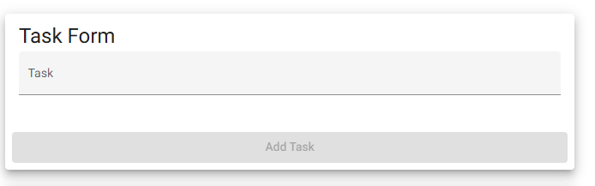
3 | Leave the Task input field empty | No text is present in the Task field | Yes | Yes
4 | Attempt to click Add Task | The application prevents an empty task from being submitted | Yes | Yes  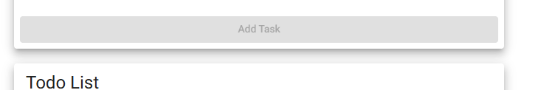
5 | Review the Todo List | No blank task appears in the Todo List | Yes | Yes  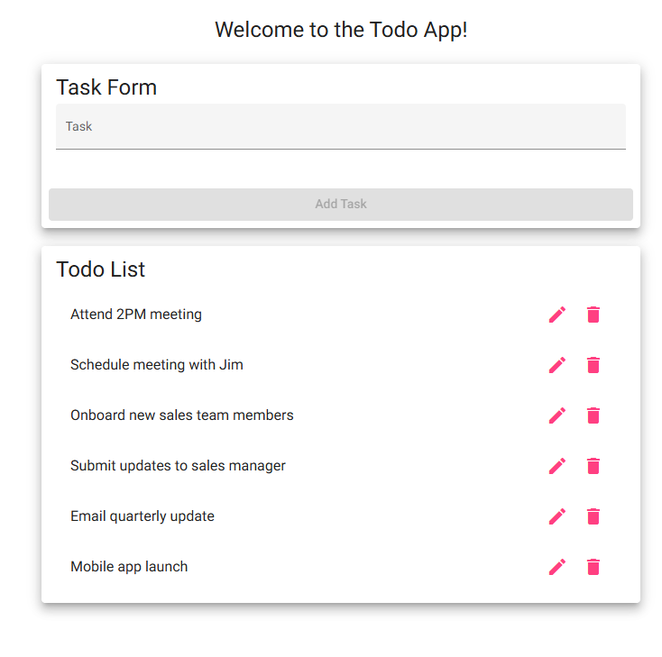
Comments | The applications prevent users from creating an empty Todo item when no task information has been entered. No blank entry appears in the Todo List, demonstrating that the input validation requirement functions correctly. – Tester Note: All tasks in this test successfully completed to expected results. Screenshot for task 3 was the same as task 4. **If user enters 4 spaces into the Task entry field the application will allow a blank entry to be inserted: 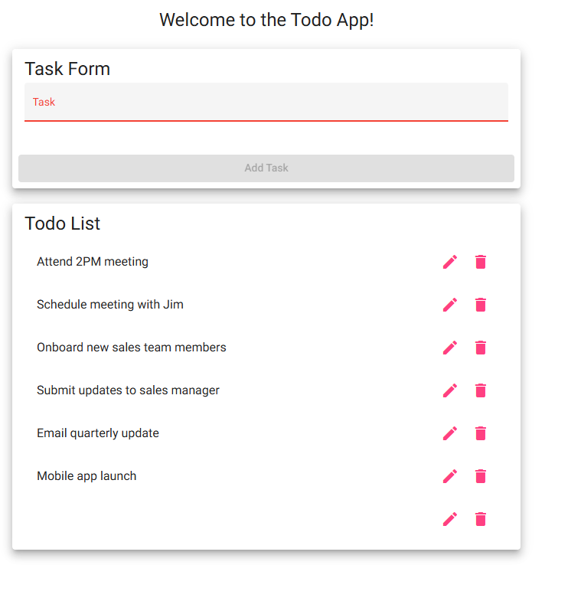  Suggestion to make the application check for empty strings before enabling the Add Task button

