Project: Module 4.2
Course: CSD 380 DevOps
Description: Test Cases
Date: 2026/09/01
To complete the test case plan, fill out the information for Project, Course, Description and Date in the header below.
.
TABLE OF CONTENTS
Access and View Todo Website 2
Create a Todo 3
Edit a Todo 3
Delete a Todo 4
Mobile/Tablet View 4

For each test, the developer should: provide a test description, a test objective, the developer name and date tested. For each step, fill out the actions to be taken and describe the expected results, and indicate yes or no for each step depending upon the result. The peer tester should provide their name, date tested, indicate yes or no for each step depending upon the result, and a screenshot (thumbnail) of the result.
Test 1 | Access and View Todo Website
 | Test Objective: Verify that a user can access the Todo website through the standard URL, view the Todo list, and is directed to a custom page for an invalid URL. | Developer: Amanda Brock  Date tested: 2026/09/01 | Peer tester: Daniel Fryer  Date tested: 9/4/2026
Step | Action | Expected results: | Developer pass/fail | Tester pass/fail  + Screenshot
1 | Enter the Todo website URL in a browser. | The Todo website loads without errors. | yes | Yes 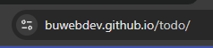
2 | View the Todo list. | The Todo items and available controls are displayed. | yes | Yes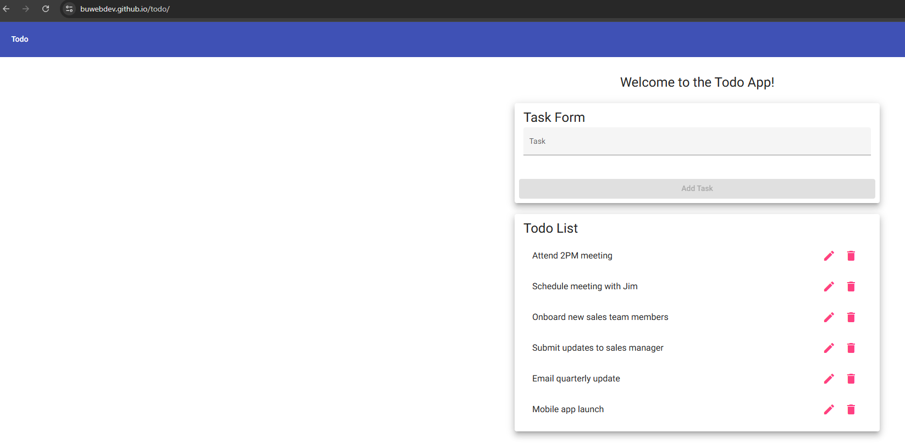
3 | Refresh the browser. | The Todo website reloads correctly. | yes | Yes
4 | Enter an invalid Todo URL, such as /todo/hello. | The user is directed to the application's custom not-found page. | yes | Yes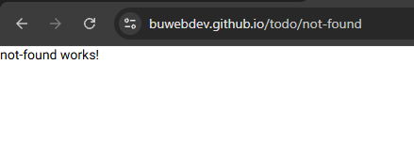
5 | View the not-found page. | The custom not-found message is displayed instead of the normal Todo page. | yes | Yes
Comments | The Todo website loaded correctly using the provided URL, and the Todo list displayed without any problems. When I entered an invalid URL, I was sent to the custom not-found page instead of the normal Todo page. Both parts of this test worked as expected. – Tester notes – All steps passed the expected results. Screenshot for task 5 is the same as task 4.

Test 2 | Create a Todo
 | Test Objective: Verify that a user can create a new Todo task and cannot submit a blank task. | Developer: Amanda Brock  Date tested: 2026/09/01 | Peer tester: Daniel Fryer  Date tested: 9/4/2026
Step | Action | Expected results: | Developer pass/fail | Tester pass/fail
1 | Leave the task field blank. | The Add Task button is disabled. | yes | Yes 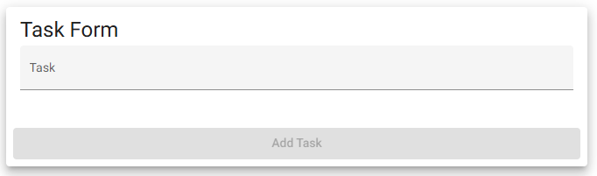
2 | Type a new task into the text area. | The task text appears and the Add Task button becomes enabled. | yes | Yes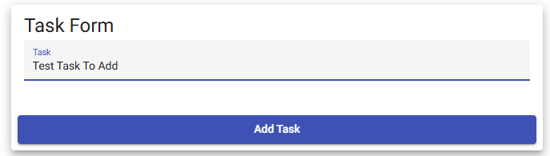
3 | Delete all text from the field. | The Add Task button becomes disabled again. | yes | Yes  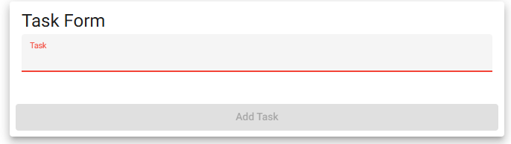
4 | Enter a valid task and click Add Task. | The task is added to the Todo list. | yes | Yes  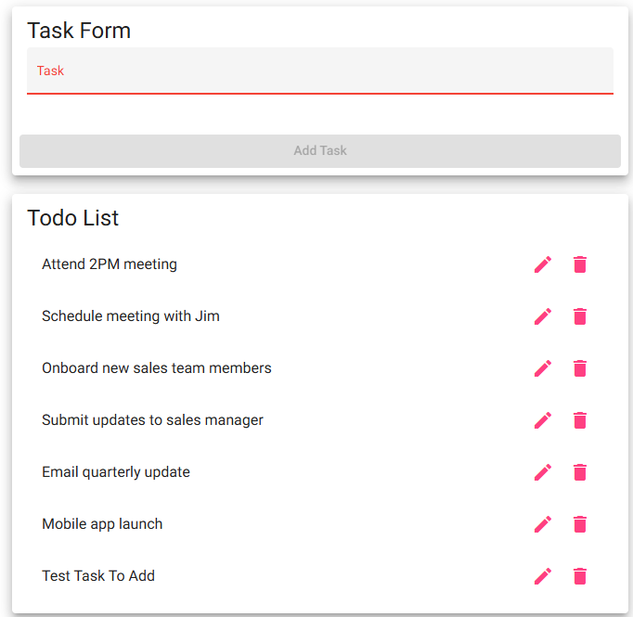
5 | Find the newly added task in the Todo list. | The new task appears correctly in the list. | yes | Yes
Comments | The new task was added without any problems. The Add Task button stayed disabled until text was entered, and the task showed up in the Todo list after it was submitted. I did not run into any errors during this test. –Tester Note: All tasks completed to the expected results. Add task button enabled/disable as expected. The task was added to the list as expected. Screenshot for task 5 is the same as task 4.

Test 3 | Edit a Todo
 | Test Objective: Verify that a user can edit an existing Todo task and that a blank task cannot be saved. | Developer: Amanda Brock  Date tested: 2026/09/01 | Peer tester: Daniel Fryer  Date tested: 9/4/2026
Step | Action | Expected results: | Developer pass/fail | Tester pass/fail
1 | Click the edit icon next to an existing Todo. | A pop-up opens with the current task text and a Save button. | yes | Yes  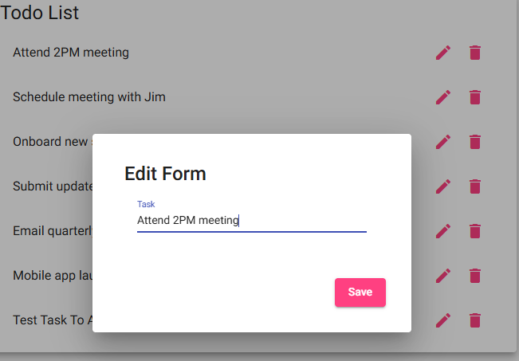
2 | Change the task text and click Save. | The updated task appears correctly in the Todo list. | yes | Yes  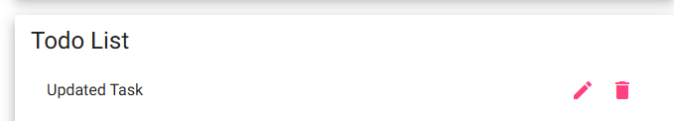
3 | Open the same task for editing again. | The edit pop-up opens with the current task text. | yes | Yes  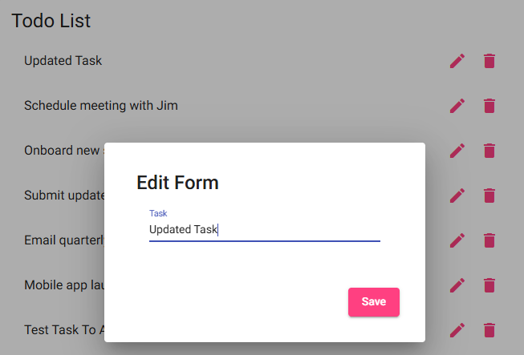
4 | Delete all text from the edit field. | The Save button should be disabled or the blank task should not be accepted. | yes | No  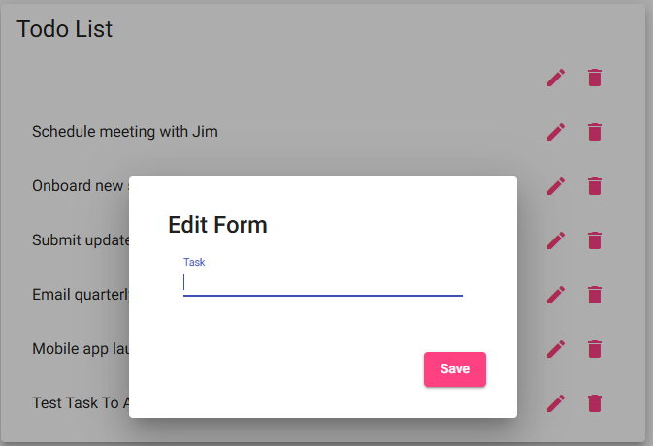
5 | Click Save with the field blank. | The blank task should not be saved. | no | No  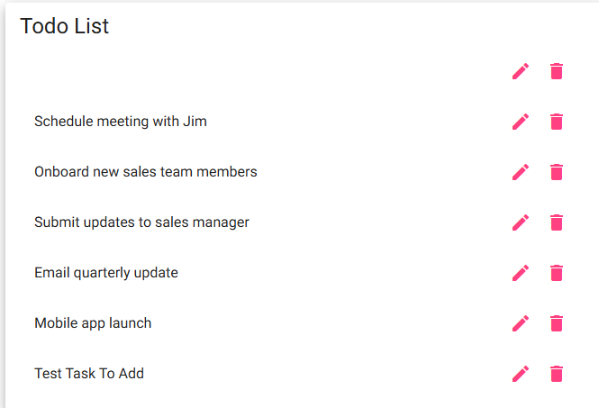
Comments | Editing a task worked correctly when I entered valid text. However, the app also allowed me to save the task with no text at all, which left a blank Todo in the list. This does not meet the requirement that blank edits should be prevented. –Tester Note: Step 4 failure the Save button didn’t disable. Step 4/5 failure as the app let me save a blank edit to the list. Recommend adding in checks in the edit screen pop up checking for blank strings.

Test 4 | Delete a Todo
 | Test Objective: Verify that a user can delete an existing Todo task. | Developer: Amanda Brock  Date tested: 2026/09/01 | Peer tester: Daniel Fryer  Date tested: 9/4/2026
Step | Action | Expected results: | Developer pass/fail | Tester pass/fail
1 | Find an existing task in the Todo list. | The task is displayed with a trash icon. | yes | Yes
2 | Click the trash icon next to the task. | The selected task is removed from the Todo list. | yes | Yes  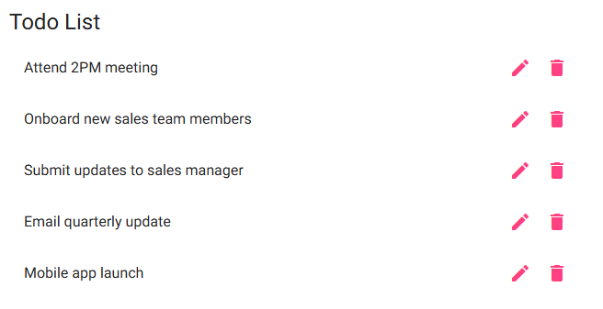
3 | Check the Todo list for the deleted task. | The deleted task no longer appears in the Todo list. | yes | Yes
4 | Delete another existing Todo task using the trash icon. | The selected task is removed from the Todo list. | yes | Yes  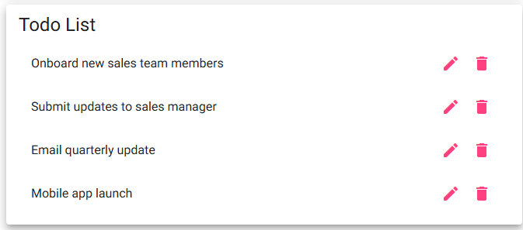
5 | Verify the other Todo tasks remain in the list. | Only the selected task is removed and the other tasks remain unchanged. | yes | Yes
Comments | The selected task was deleted right away when I clicked the trash icon. Only the task I selected was removed, and the other tasks stayed in the list. I also noticed that refreshing the page resets the Todo list, so the changes are not saved permanently. –Tester Note: All task completed to the expected results. Task 3 screen shot will be same as task 2. Screen shot for task 5 will be the same as task 4.

Test 5 | Mobile/Tablet View
 | Test Objective: Verify that the Todo website displays correctly on mobile and tablet screen sizes. | Developer: Amanda Brock  Date tested: 2026/09/01 | Peer tester: Daniel Fryer  Date tested:9/4/2026
Step | Action | Expected results: | Developer pass/fail | Tester pass/fail
1 | Open the Todo website in Chrome Developer Tools device mode. | The website displays in the selected device view. | yes | Yes  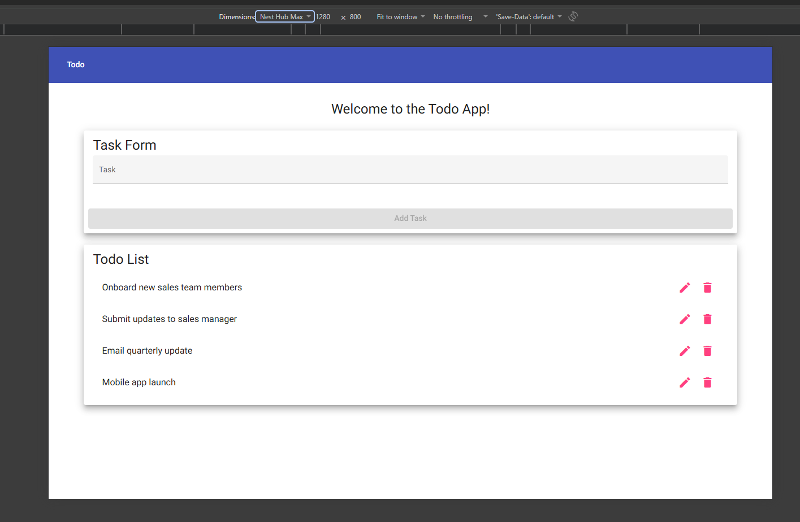
2 | Set the device view to a mobile screen size. | The Todo website adjusts to fit the mobile screen. | yes | Yes  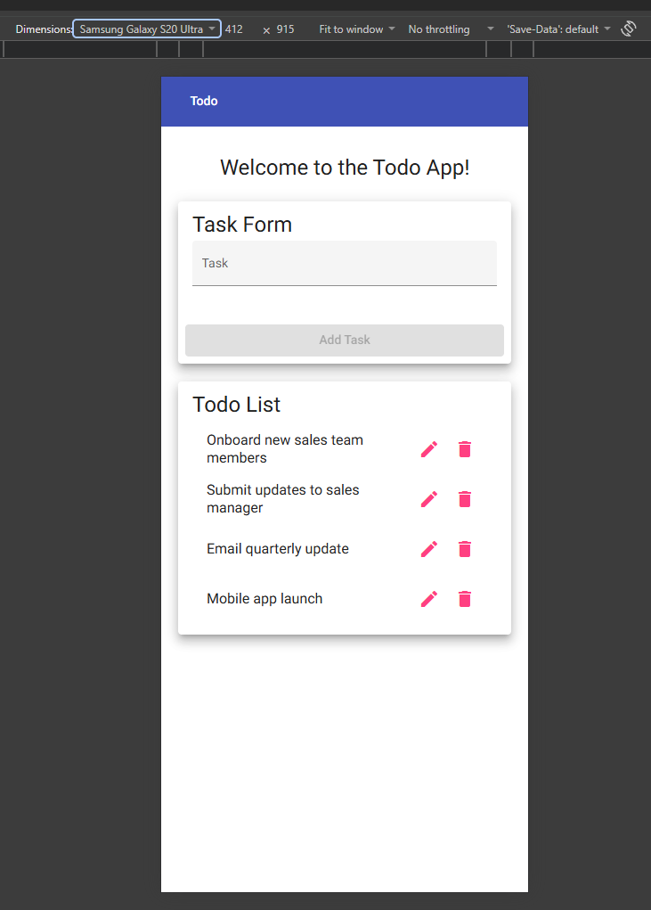
3 | Check the task form, Todo list, and edit/delete icons in mobile view. | All content is readable and usable without being cut off or overlapping. | yes | Yes
4 | Change the device view to a tablet screen size. | The Todo website adjusts to fit the tablet screen. | yes | Yes  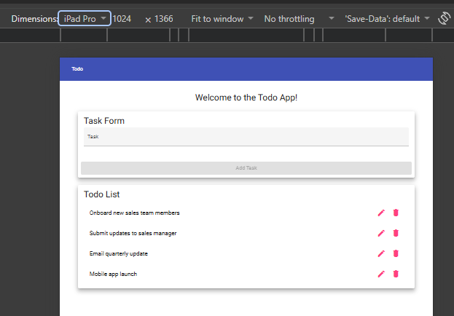
5 | Check the task form, Todo list, and edit/delete icons in tablet view. | All content is readable and usable without being cut off or overlapping. | yes | Yes
Comments | The Todo website displayed correctly on both the mobile and tablet screen sizes. Everything adjusted to fit the screen, and I could still read the tasks and access the edit and delete icons. I did not notice anything overlapping or being cut off. –Tester Note: Al tasks have completed successfully to the expected results. Screenshot for task 3 is the same as 2. The screenshot for task 5 is the same as 4.

