Daniel Fryer
Assignment 1.2
GitHub Link: https://github.com/XcitedMonkie/csd-402.git
Dir screen shot
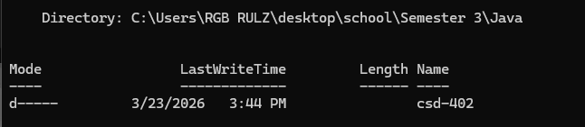
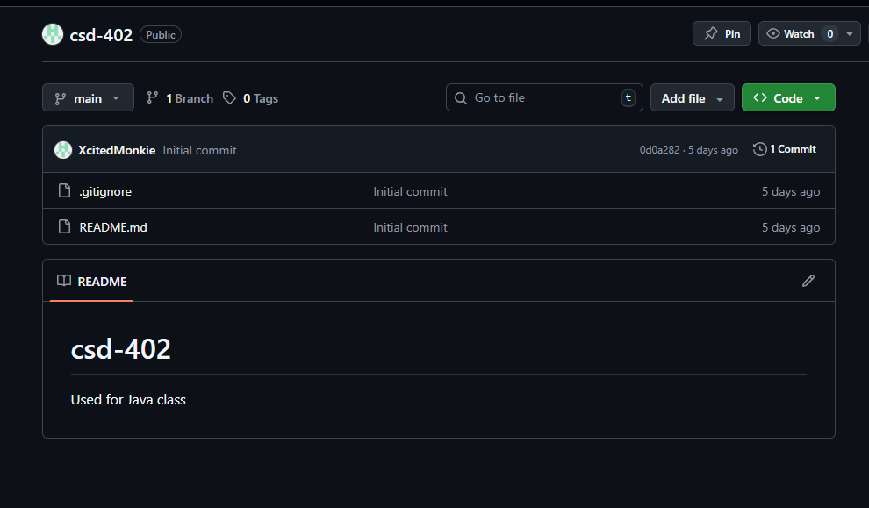
Local Directory:
