Daniel Fryer
Assignment 5.2/6.2 – Screenshots
9/11/2026

Create database:
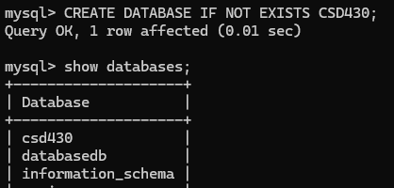

Create Table:
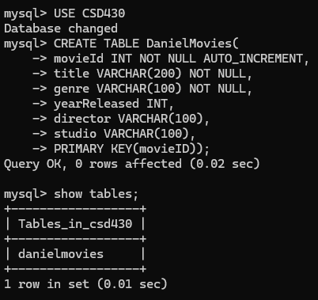

Create user and grant permission:
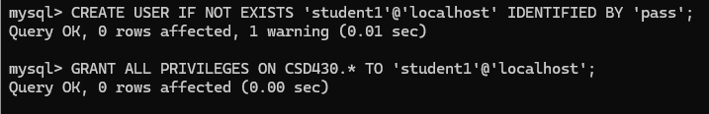

Insert into table:
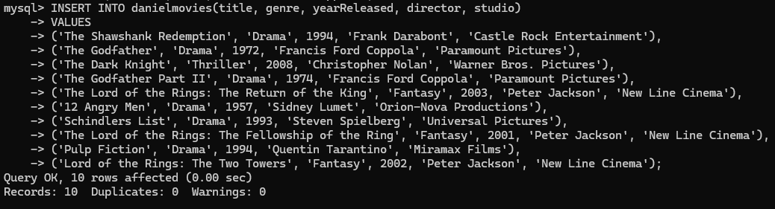

Table:
