Daniel Fryer
Assignment 1.2
10/21/2026

GitHub:
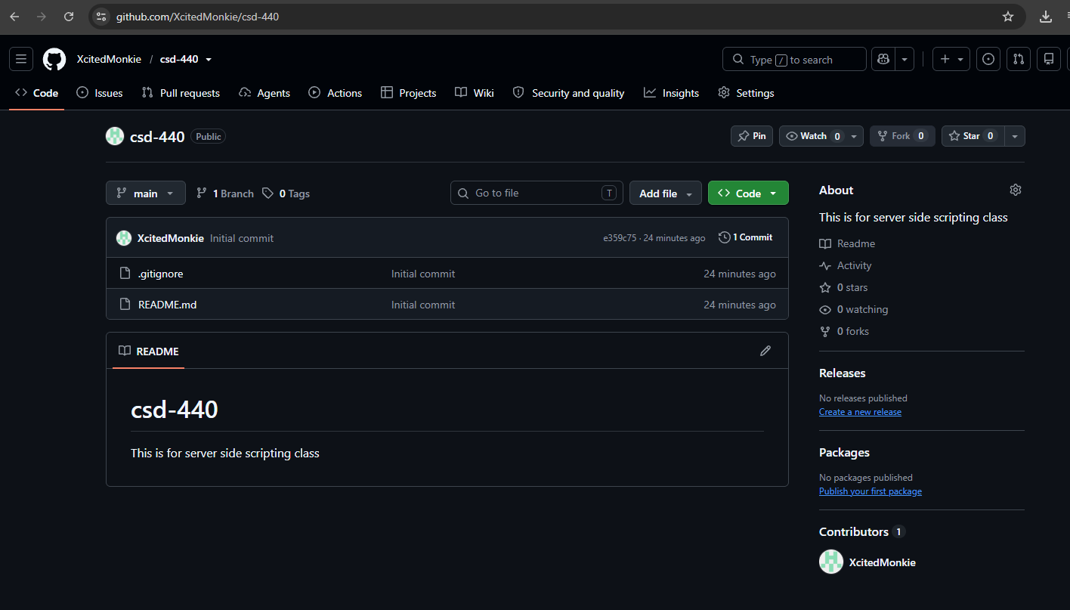

Local Files:


