Daniel Fryer
Assignment 1.3
10/21/2026

XAMPP running:
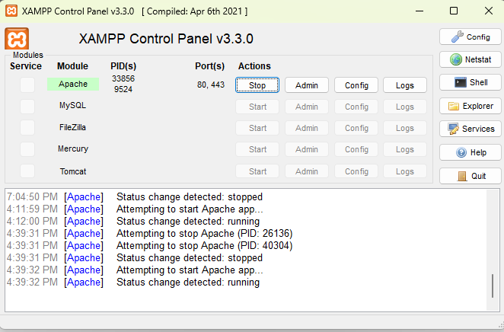

Website:


