ABOUT US: The Bremerton Farmers Market is an organization dedicated to supporting local farmers and artisans by providing their produce and goods to the community. We currently have markets in two locations, and are celebrating our 10th year in Bremerton!
The Thursday market is at Evergreen Park, and operates from 4-7 pm.
The Sunday market is at the Bremerton Ferry Terminal, and operates from 10:30 am - 2:30 pm.

HISTORY: The market began in 2004 as a small group of local farmers and crafters who would gather and sell their goods to passersby. Over time, interests grew and more vendors began to join the cause.
In 2006 the vendors applied to become an official farmers market with business licenses and a board of directors. The market continued to grow and repeatedly move locations, until finally landing in Evergreen Park.
Today the market still operates from the park, and a second location was added in 2011 at the ferry terminal.

MAP OF LOCATIONS:

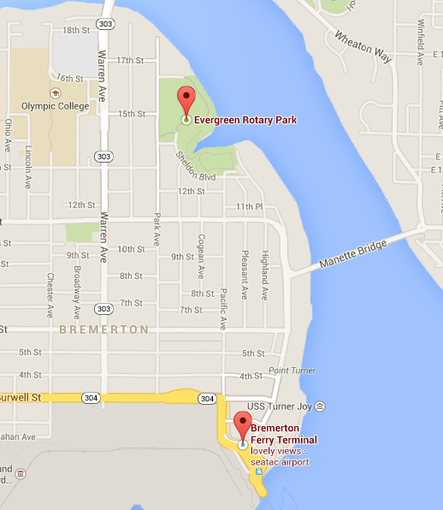

CONTACT INFORMATION:
bremertonfarmersmarket@gmail.com

360-633-6137 (Julia, Market Manager)

P.O. Box 5662
Bremerton, WA 98312



Evergreen Park
Thursdays, 4pm - 7pm
May 1 - October 16, 2014

Bremerton Ferry Terminal
Sundays, 10:30am - 2:30pm
May 4 - October 12, 2014

FEATURES:

- Fresh produce grown by local farmers

- Hand-crafted goods made by local artisans

- Live music

- Face painting for kids of all ages

- Fresh Bucks, a program by which the Bremerton Farmers Market will provide extra money for those who receive benefits from SNAP/EBT

- And much more!

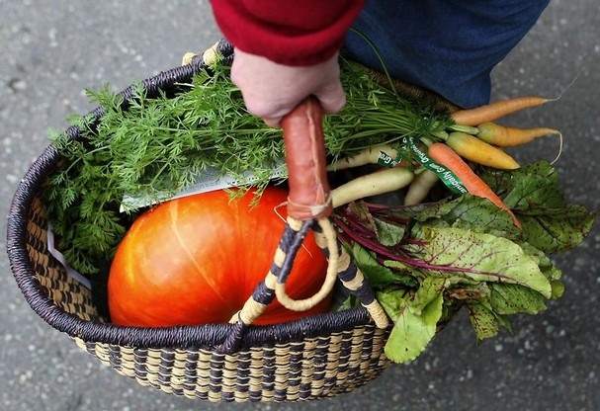

SOME OF OUR 2014 VENDORS:
- Flying Dog Farm
- Gregory Farm & Johnson Orchard
- Pheasant Fields Farm
- Start Now
- CJ's Evergreen General Store
- Mad Moose Pizza
- Viking Feast Ice Cream
- Made in Manette

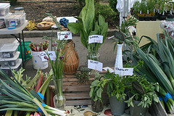

BECOME A VENDOR:
- Visit our website at bremertonmarket.wordpress.com
- Download and read the 2014 BFM Rules and Bylaws
- Download and fill out the 2014 BFM Vendor Application
- Mail the form to our P.O. Box with your membership fee
- Wait for approval via a welcome email
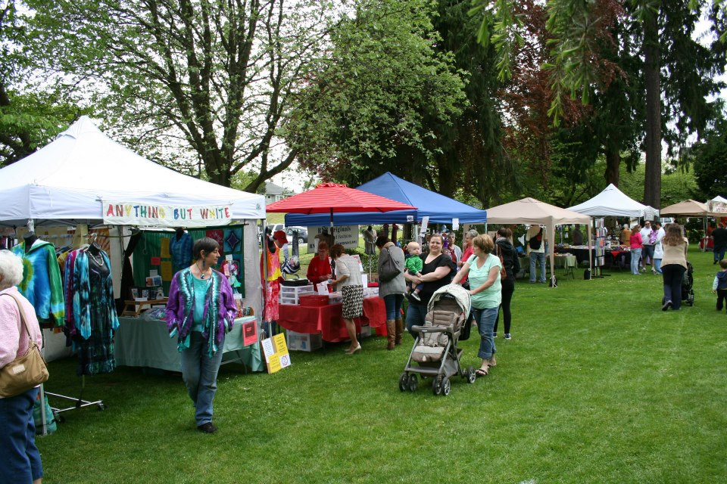

BECOME A SPONSOR:
The Bremerton Farmers Market is highly interested in forming partnerships with other businesses in the area. The BFM, in exchange, would provide advertisement for such businesses at the markets.

The baseline package is the Single Shot Event, which will provide a business with recognition in BFM newsletters and press releases, the display of a banner (provided by the sponsor) at the event, and brochures and business cards available for customers. This costs $75 and there are many more options ranging up to $1,000.

More information can be found on our website. We hope that you will help us support a green, sustainable, and viable local economy!

