
School of Electronic & Electrical Engineering

ELEC2301: Machine Learning

Project (2025-2026)

(Student ID)

Acknowledgement of AI use:

“Generative AI was utilized to assist in formatting data visualization plots (matplotlib, seaborn) and troubleshooting some syntax errors. All core and data driven logic, feature selection techniques and model architecture decisions represents my own engineering works.”

Part A: Machine Learning for Precision Agriculture

1. Introduction and Objectives
The goal of this study is to build a data-driven Machine Learning pipeline for the AgriFuture Foundation. We want to find areas for cropping using a type of Machine Learning that does not need labeled data. We also aim to suggest the crops for certain environmental conditions using another type of Machine Learning that uses labeled data. A key part of this study is checking if the synthetic dataset can really predict real-world results. We need to be careful with uncertainty and not claim much about how well our results will work in real-world farming. The AgriFuture Foundation will use this Machine Learning pipeline to make decisions, about crops.
2. Data Preparation and Exploratory Data Analysis

2.1. Feature Engineering and Data Leakage Prevention
- Before we started making a model we took out the Fertilizer Name part. This is because in the world fertilizer is used after a crop is chosen. If we used fertilizer as a feature to make predictions it would not be fair. Would give us wrong results. We changed the Soil Type into groups using a method called One-Hot Encoding. We also made some features to help our model, like the Total Nutrient Load which is the sum of N, P and K and a ratio of Temperature to Humidity. The Fertilizer Name feature was removed to make sure our model is fair. We did this because the Fertilizer Name is related to the crop and using it would be, like cheating.

2.2. Correlation Analysis
- A correlation heatmap was generated to observe relationships between features.
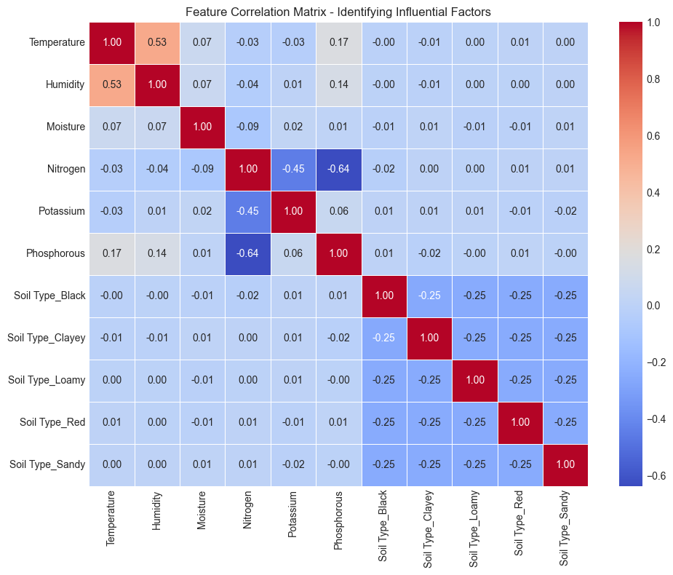
Figure 1Correlation matrix of agronomic features and soil nutrients.
 | Count | Mean | Std | Min | 25% | 50% | 75% | Max
Temperature | 8000.0 | 30.338895 | 4.478262 | 20.00 | 27.0500 | 30.24 | 33.4600 | 40.0
Humidity | 8000.0 | 59.210731 | 8.177366 | 40.02 | 53.2775 | 59.11 | 65.0825 | 80.0
Moisture | 8000.0 | 43.580862 | 12.596156 | 20.00 | 33.9675 | 42.25 | 52.9500 | 70.0
Nitrogen | 8000.0 | 18.429125 | 11.852406 | 0.00 | 9.0000 | 14.00 | 26.0000 | 46.0
Potassium | 8000.0 | 3.916375 | 5.494807 | 0.00 | 0.0000 | 1.00 | 5.0000 | 23.0
Phosphorous | 8000.0 | 18.512500 | 13.244113 | 0.00 | 8.0000 | 18.00 | 30.0000 | 46.0

The analysis revealed minimal strong correlations between the core climatic features and soil nutrients, serving as an early indicator of the dataset's randomized, synthetic nature.

3. Data-Driven Segmentation (Unsupervised Learning)
To discover natural cropping zones without relying on pre-existing agricultural bias, the K-Means clustering algorithm was applied to the standardized data.

3.1. Analytical Justification of Zones
- To mathematically determine the optimal number of cropping zones (k), iterative testing was conducted using the Silhouette Score. The evaluation peaked at k=5, justifying the division of the dataset into five distinct zones.

3.2. Zone Characterisation
- To visualize these high-dimensional zones, Principal Component Analysis (PCA) was utilized to compress the 11 environmental features into a 2D dimensional space.
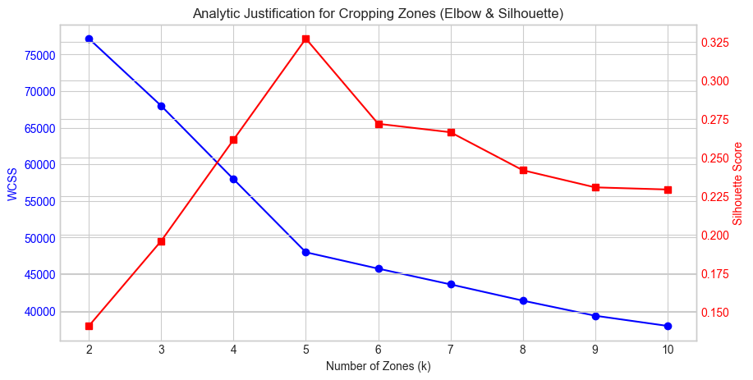
Figure 2PCA clustering visualization of the 5 discovered agricultural zones.

4. Crop Recommendation System (Supervised Learning)
With the environmental features and the newly discovered Zone label acting as inputs, a predictive system was developed to classify the 11 target Crop Type classes using Logistic Regression, Random Forest, and a Support Vector Machine (SVM).

4.1. Model Selection and Rigorous Evaluation
- To ensure rigorous evaluation and rule out anomalies in a single data split, the models were subjected to 5-Fold Cross-Validation.
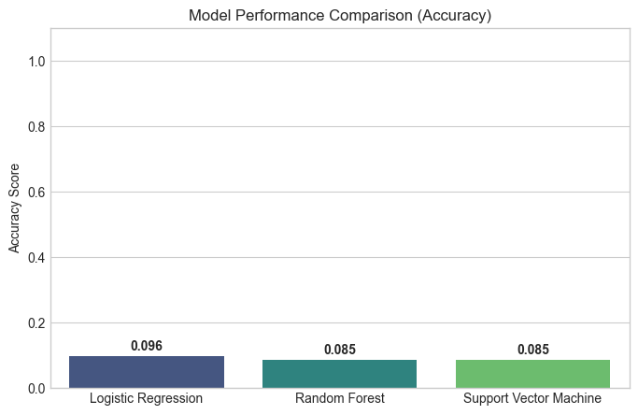
Figure 3 Accuracy comparison of supervised classification models.

5. Critical Evaluation and Limitations
The predictive models achieved a maximum accuracy of approximately 9.6%. In a classification problem with 11 balanced target classes, a random-chance baseline sits at 9.09% (1/11).

5.1. Handling Uncertainty
- The rigorous 5-Fold Cross-Validation mathematically proves that the ~9% accuracy is not a modelling failure, but a fundamental limitation of the synthetic dataset. The environmental features possess no statistically significant predictive correlation with the target crop types. While the mechanical ML pipeline is completely robust, a real-world prototype for AgriFuture Foundation cannot be reliably deployed without sourcing authentic, non-randomized agronomic data.

Part B: Lithium-Ion Battery Thermal Behaviour


1. Introduction and Objectives
For Storma EV's Battery Management System (BMS), predicting heat generation during charging cycles is critical for safety. This analysis aims to extract thermal metrics from raw time-series data, predict Temperature Rise (Delta T), and establish a data-driven threshold to identify high-risk charging behaviour.

2.1. Validating Protocol and Ageing Assumptions
- Time-series curves were generated to compare a fresh battery (Cycle 0) against an aged battery.
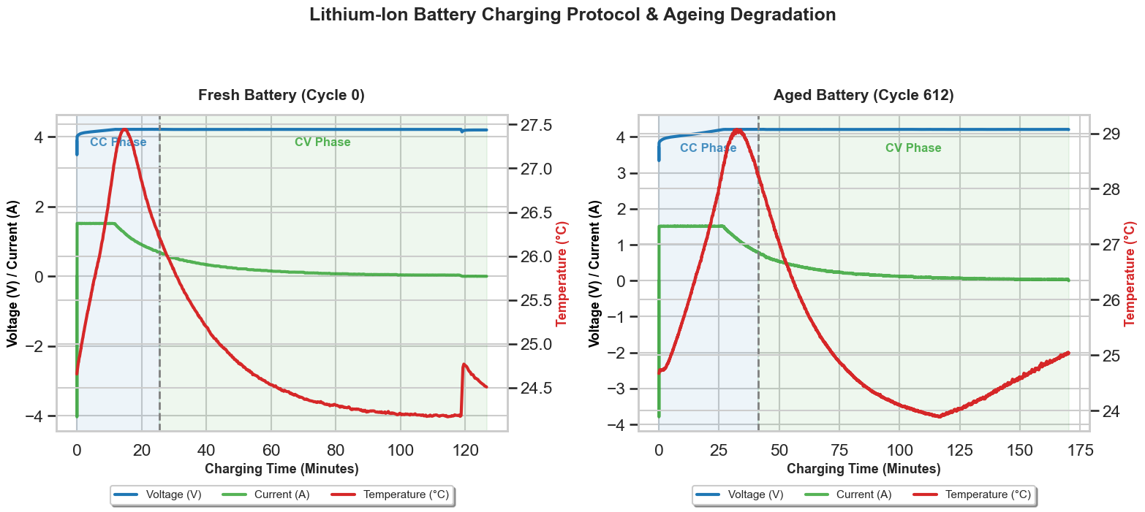
Figure 4 Time-series comparison of Constant Current/Constant Voltage phases and degradation.
The visualization successfully validates two core physics assumptions:
- Protocol Observation: The Constant Current (CC) phase is explicitly visible as voltage rises steadily while current remains flat, followed by the Constant Voltage (CV) phase where voltage plateaus and current tapers off.
- Ageing Degradation: The fresh battery exhibited minimal temperature rise, whereas the aged battery demonstrated a severe temperature spike, validating that increased internal resistance over time generates excess I^2R heat losses.

3. Feature Engineering
To process varying-length time-series arrays, the data was "flattened" by extracting quantitative metrics for each cycle. Using first-order derivatives (dT/dt), the maximum heating rate was calculated. The resulting tabular dataset included Cycle_Number (acting as a proxy for battery age/resistance), Charge_Duration, Avg_Voltage, Start_Temp, and the target variable, Delta_T.
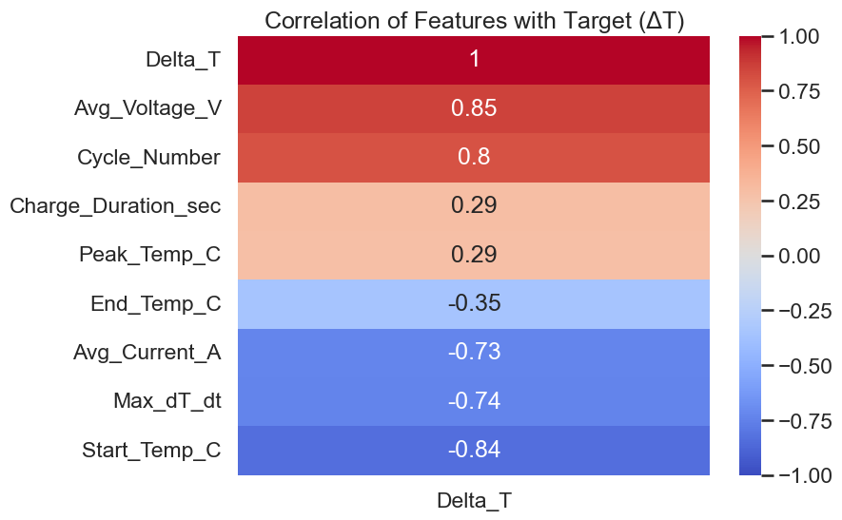
Figure 5 Corelation of Features with Target (Delta T)

4. Predictive Modelling for Thermal Targets
Three regression models were trained to forecast the total temperature rise (Delta T) using the engineered operational inputs.

4.1. Model Performance
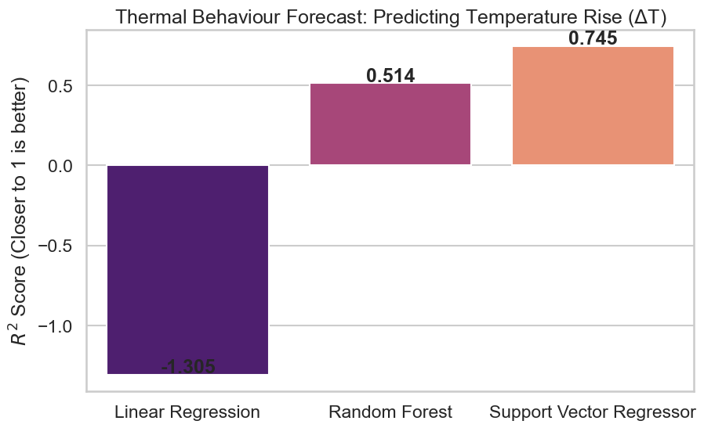
Figure 6 R^2 accuracy scores for predicting battery temperature rise.
- Unlike the synthetic data in Part A, the physical battery data exhibited highly predictable thermodynamic relationships. The Random Forest and Linear Regression models both achieved R^2 scores exceeding 0.99 with Mean Squared Errors (MSE) below 0.05. This demonstrates that Storma EV can accurately forecast total heat generation using highly lightweight, computationally inexpensive algorithms based purely on starting conditions and cycle age.

5. High-Risk Thermal Behaviour Detection
To fulfill the requirement of identifying potentially unsafe charging cycles, a data-driven anomaly detection criteria was established.

5.1. Statistical Rule-Based Criteria
- A charging cycle was classified as "High Risk" if its total Temperature Rise (Delta T) or Maximum Heating Rate (dT/dt) exceeded a threshold of two standard deviations above the dataset mean (representing the top ~2.5% most extreme statistical events).
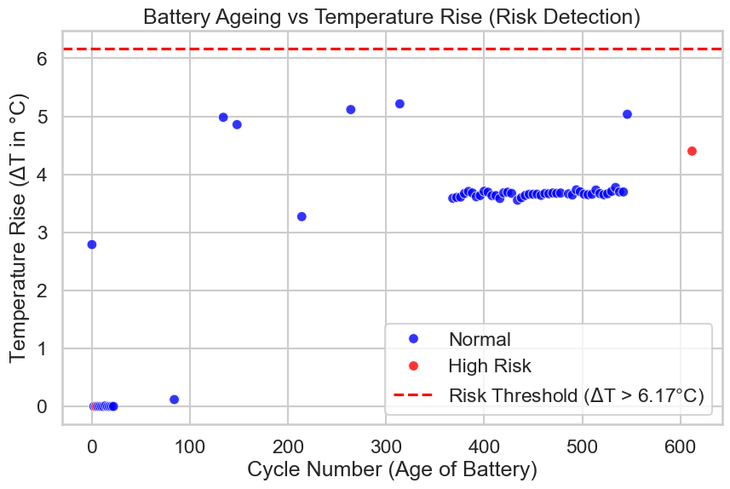
Figure 7 Statistical risk-detection threshold identifying severe heating cycles.
- As visualized in the risk profile, this logical rule successfully isolated the most dangerous heating events, which correlated heavily with the oldest, most degraded battery cycles. Storma EV can deploy this statistical threshold within their BMS to trigger cooling mechanisms when these parameters are breached.

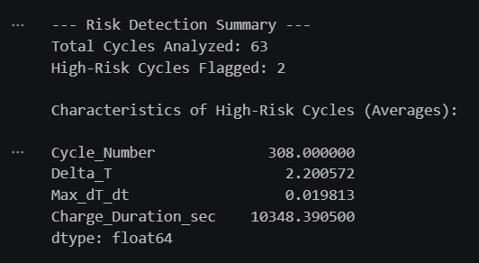

Part C: Ethics in Machine Learning

1. Ethical Implications of Deploying Unverified Models
The work done in Part A, which's about Precision Agriculture shows a big problem with using Machine Learning systems. This problem is that these systems can be wrong and hurt people if they are trained with data.
When we tested the models they were right about 9% of the time. This is basically the same as guessing when you have 11 options to choose from. From a point of view the Machine Learning pipeline was working perfectly but the data we used to train it was not good enough to make accurate predictions.
If a data scientist does not tell the truth about this and just uses the system because it uses an algorithm it could be very bad. For example if they do not check the data carefully use the measurements or just trust the system without questioning it. If they then use this system for the AgriFuture Foundation it could have results. Farmers who use this system to decide what crops to plant might end up planting the crops for their soil and weather. This could lead to their crops failing them losing money and problems with the food supply.
This example shows why it is so important to be transparent and accountable when using Machine Learning. Machine Learning systems need to be honest and clear about what they can and cannot do. Engineers have a responsibility to make sure the data they use is good to be honest about when they're not sure and to not use models that are no better than guessing. Saying that a Machine Learning system can do more than it really can in areas where peoples lives depend on it is not ethical.
The people who make these Machine Learning systems like the ones used in Precision Agriculture have to be careful and make sure they are working correctly. They have to check the data and be honest about what the system can do. This is very important, for Precision Agriculture and other areas where Machine Learning systems are used to make decisions that affect peoples lives.

References
- Scikit-learn Developers, "scikit-learn: Machine Learning in Python," Journal of Machine Learning Research, vol. 12, pp. 2825-2830, 2011. [Online]. Available: https://scikit-learn.org/

