
WithEase
User Manual
Modular assistive software for people with motor impairments
Windows · free and open source (MIT)
Version 0.3.0

This guide explains step by step how to install, set up and use WithEase in everyday life.

Contents
Disclaimer
1. What is WithEase?
2. Installation
3. Getting started
4. General settings
5. The emergency stop
6. Mouse module
7. Keyboard module
8. Macros
9. Profiles
10. Actions & favourites overlay
11. Module library
12. Dictation
13. About, feedback & sharing
14. Tips & troubleshooting
15. Help & contact

Disclaimer
An honest word up front: I'm not a trained software developer, but someone with an interest in programming – and with ideas I'm convinced can help others.
WithEase was built with “vibe coding”, that is, with the help of artificial intelligence. I'm open about that. The way I see it, that's nothing to be ashamed of but rather quite normal today. Without this option, the ideas in my head would never have become reality – at least not to a degree that now lets me offer the program free of charge.
That is exactly why your feedback matters to me: it helps make WithEase better step by step.

1. What is WithEase?
WithEase is a small helper program that makes operating the mouse and keyboard easier for people with limited fine motor skills. It runs unobtrusively in the background (in the system tray, bottom right next to the clock) and only steps in where you want it to.
Every function is its own module and can be switched on and off individually. That keeps the program uncluttered and does exactly what you need – nothing more.

What WithEase can do
- Mouse: center the cursor automatically, precision mode, click-lock, keys as mouse buttons, jump to screen areas, highlight the cursor
- Keyboard: suppress repeated keystrokes (key delay), sticky keys with a status display
- Macros: text snippets, keyboard shortcuts, launch programs
- Profiles: several sets of settings, e.g. Work / Home / Guest
- Emergency stop: one key turns everything off instantly
Good to know
WithEase is free, needs no user account, shows no ads and sends your input nowhere. All settings stay on your PC.

2. Installation

Windows
No installation is needed – just unpack and start:
- Open the WithEase releases page on GitHub.
- Download the file WithEase-<version>-win64.zip.
- Right-click the ZIP file → Extract all …
- Open the extracted WithEase folder and start WithEase.exe with a double-click.
Windows warning “Windows protected your PC”
This message appears because the program is not signed with a (paid) certificate – not because anything is wrong with it. Click More info and then Run anyway. Tip: if you unblock the ZIP file before extracting via right-click → Properties → Unblock, the warning won't appear at all.

WithEase then starts in the system tray. No administrator rights are required. Your settings are stored under %APPDATA%\WithEase.

Linux
A dedicated Linux version does not exist yet. It is, however, being considered for the future.

3. Getting started
After starting, you'll find the WithEase icon in the system tray (bottom right, possibly behind the small “^” arrow).
- Double-click the icon → open settings
- Single click → menu (switch profile, pause, quit)
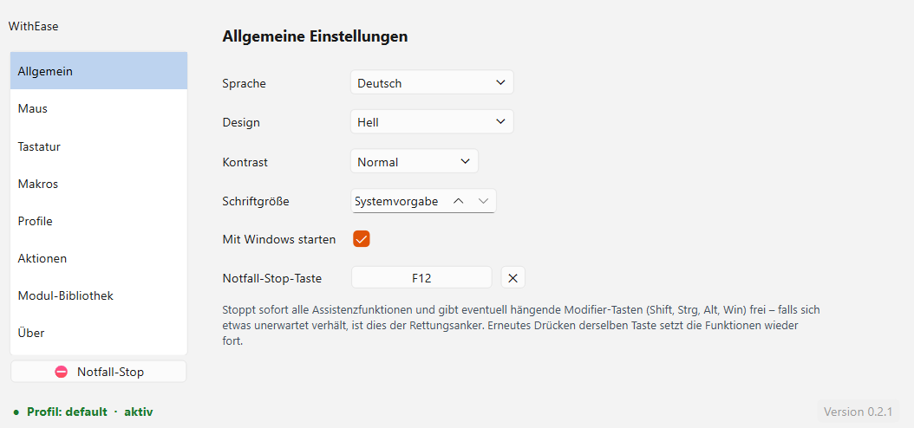
The WithEase settings window

How the window is laid out
- On the left the navigation: General, Mouse, Keyboard, Macros, Profiles, Actions, Module library, About
- On the right the content of the selected page
- Bottom left the emergency stop – turns all aids off instantly
- At the very bottom the status bar with the active profile and version
Changes are saved instantly
You don't have to confirm anything – every change is saved automatically in the active profile.

4. General settings
Here you set how WithEase looks and starts.
- Language: German or English
- Theme: Light, Dark or system default
- Contrast: high contrast for better readability
- Font size: enlarges the whole interface (8–16 pt) – helpful if small text is hard to read
- Start with Windows: WithEase starts automatically at login
- Emergency-stop key: the rescue key (see next chapter)
Recommendation
Be sure to assign an emergency-stop key (e.g. F12). Without it, the tray menu is your only option in an emergency.

5. The emergency stop
The emergency stop is your safety anchor. Pressing the assigned key (or clicking the red button at the bottom left):
- turns off all assistance functions instantly,
- releases any stuck keys (Shift, Ctrl, Alt, Win) again.
Pressing the same key again turns everything back on. Use it whenever the keyboard or mouse behaves unexpectedly.
Tip: you can also use the emergency stop to disable WithEase completely in an instant – for example when someone else briefly uses your PC and doesn't need WithEase's aids. The computer then behaves completely normally until you press the emergency stop again.

6. Mouse module
Tick the box at the top for Enable mouse module. After that you can switch on each function individually – only then do its settings unfold.
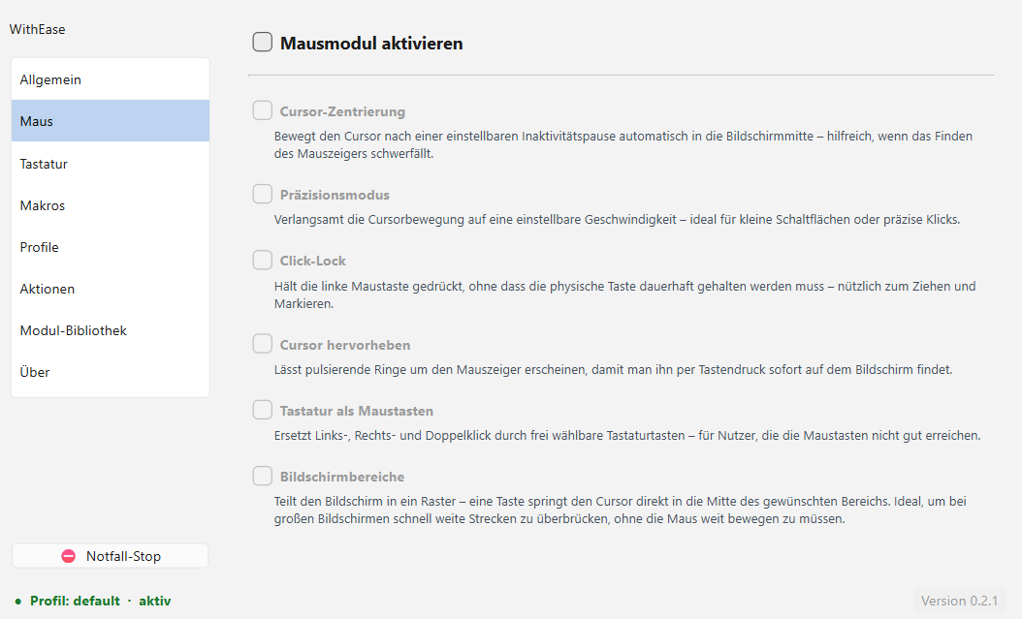
All mouse functions at a glance

The functions in detail
- Cursor centering: after an adjustable pause without input, the mouse pointer jumps to the center of the screen – so you always find it again.
- Precision mode: slows the pointer down at the press of a key – ideal for small buttons.
- Click-lock: holds the left mouse button down without you having to hold it – for dragging and selecting.
- Highlight cursor: pulsing rings around the pointer so you spot it immediately.
- Keyboard as mouse buttons: left, right and double click via freely chosen keys.
- Screen areas: one key jumps the pointer straight into a screen area – saving long distances.

Example: setting up cursor centering
Enable Mouse module and then Cursor centering. The settings unfold:
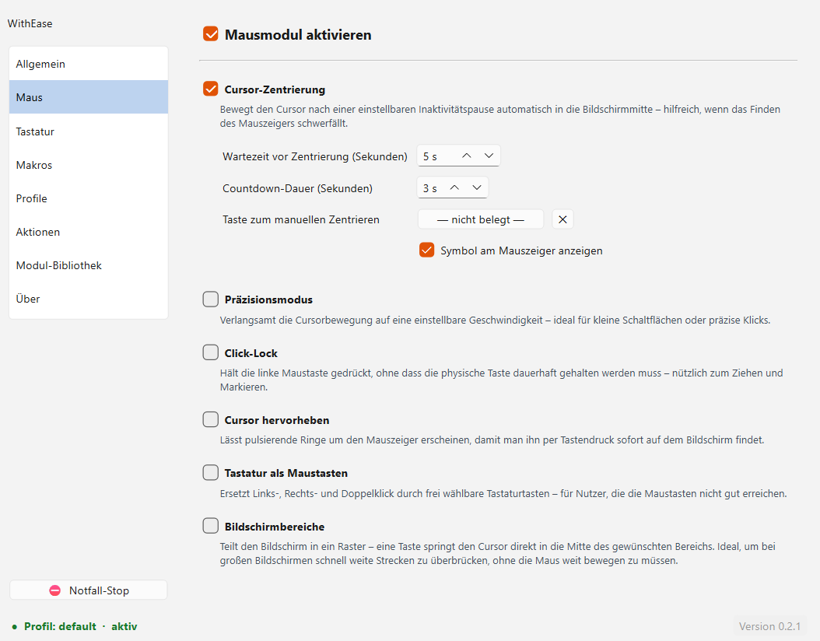
The unfolded cursor-centering settings
- Wait time before centering: how long it waits without input (default 5 seconds).
- Countdown duration: a warning before the pointer jumps – any movement or key press cancels it.
- Key for manual centering: centers immediately at the press of a key.
- Show symbol at the mouse pointer: displays a small target symbol.

7. Keyboard module
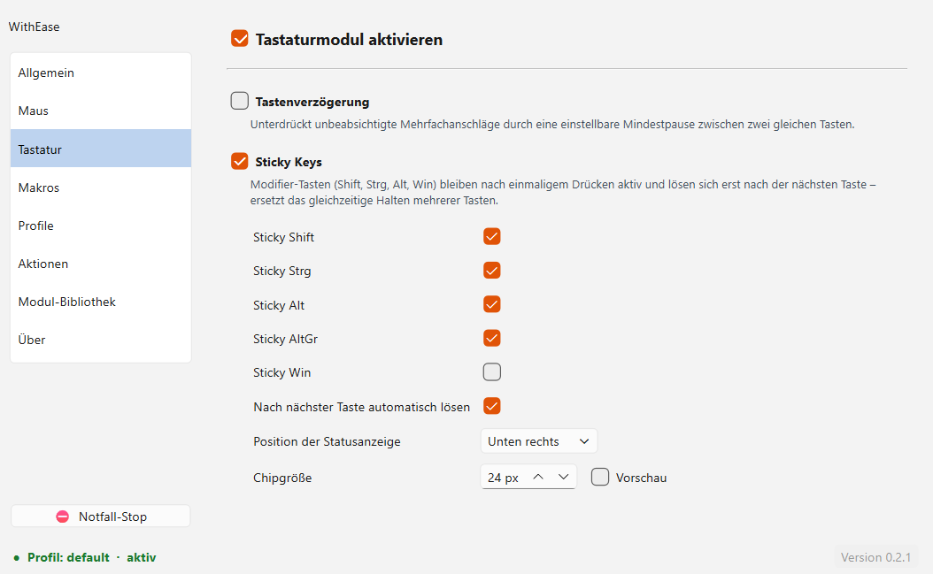
The keyboard module with sticky keys

Key delay
Suppresses accidental repeated keystrokes: after a key press, the same key is ignored for an adjustable time (e.g. 500 ms). You can enter individual keys as exceptions.

Sticky keys
This means you don't have to hold two keys at once. You briefly tap the modifier (Shift, Ctrl, Alt, AltGr or Win) – it stays armed and applies to the next key, then releases automatically.
- Example: tap Shift, then a → gives A.
- Example: tap AltGr, then Q → gives @.
- Tapping again releases an armed modifier.
- Normal holding (e.g. Shift+A) still works exactly as usual.
Status display
Enable Show modifier status, and you'll see at the edge of the screen at all times which keys are currently armed. Position and size are adjustable.

8. Macros
With macros you insert text snippets, send keyboard shortcuts or launch programs at the press of a key.

How macro mode works
- You press the trigger key (e.g. F9) → macro mode becomes active (an indicator appears).
- You press the macro key (e.g. Num 1).
- The action runs, and macro mode ends automatically.

Creating a macro
Go to Macros → Add macro. Give it a name, record the key and choose the type.
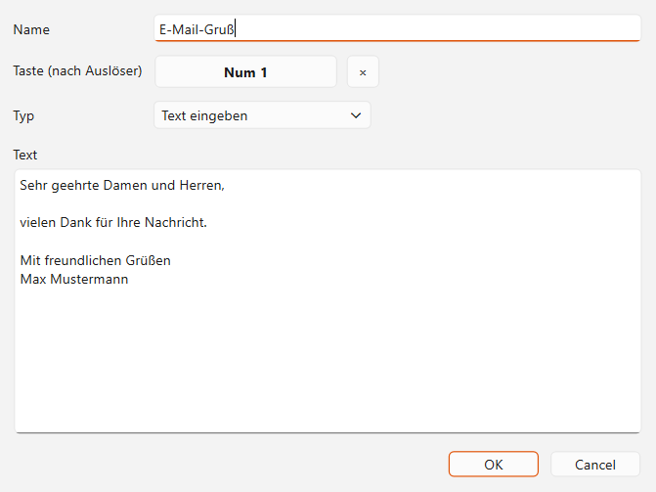
A text-snippet macro: multi-line text for an email

The macro types
- Insert text: inserts any text – multi-line too, e.g. a complete email template or your signature.
- Send keyboard shortcut: e.g. Ctrl+C.
- Launch program: starts an application or a script.
- Sequence (mouse & keyboard): several steps one after another – clicks, text, keys, wait times, bringing a window to the front.
Note on text snippets
The text is inserted via the clipboard (like Ctrl+V). That is reliable and preserves umlauts and line breaks. Your previous clipboard is restored afterwards. In chat fields a line break can send the message – there it's better to use single-line snippets.

9. Profiles
Profiles store all module settings separately – handy when several people share the same PC or you need different aids depending on the situation (e.g. Work, Gaming, Guest).
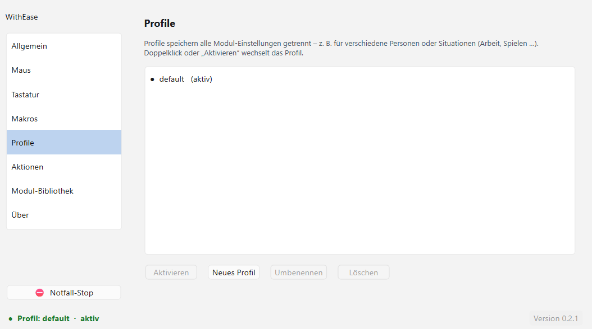
Profile management
- Create a new profile, rename, delete
- Double-click or Activate switches the profile
- Quick switching also works via the tray menu

10. Actions & favourites overlay
On the Actions page you see all functions and macros with their shortcuts at a glance. WithEase has no hard-wired shortcuts – you can assign any trigger to any action.
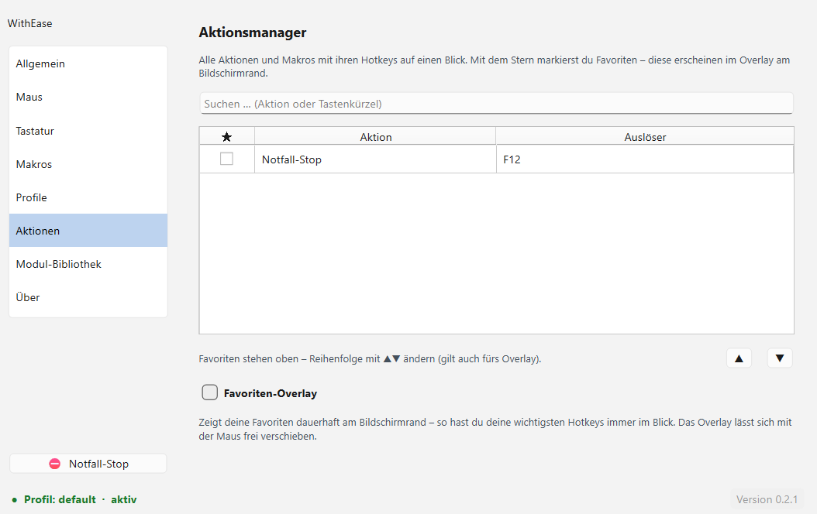
Overview of all actions and shortcuts
- Use the star to mark favourites.
- Favourites appear permanently in the overlay at the edge of the screen – so your most important keys are always in view.
- The overlay can be moved freely with the mouse; font size and position are adjustable.

11. Module library
Here you extend WithEase with additional modules. All modules shown come directly from WithEase and are vetted. A single click on Install is enough – after a restart the module is ready to use.
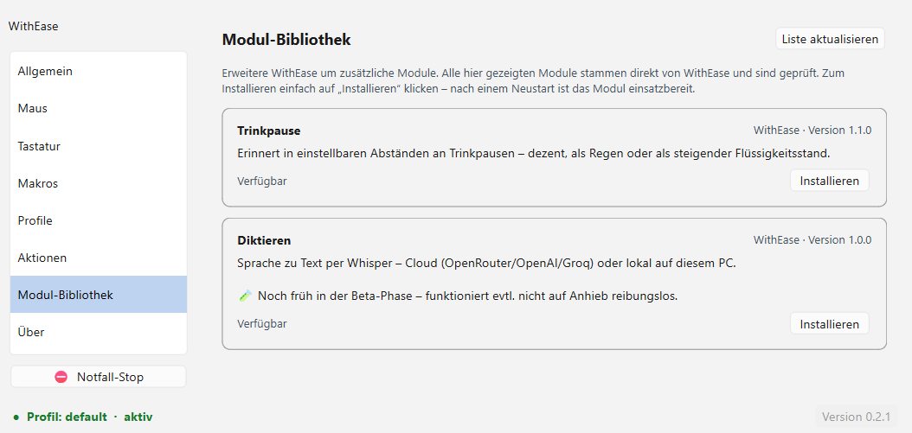
The module library (free)
- Hydration break: reminds you to drink at adjustable intervals – subtly as a notice or as a rain overlay.
- Dictation: speech to text via Whisper (cloud or local).

12. Dictation
The dictation module turns spoken language into text and inserts it into the previously chosen application. You enable it in the module library. Privacy: with the cloud backend the recording is sent to the chosen provider; with the local backend everything stays on this PC.

The settings at a glance
The dictation module's settings are grouped into clear areas so you quickly find what you need:
- Basics: dictation key, recording mode (toggle or hold) and language.
- Speech recognition: switch between Cloud and Local – only the matching fields are shown for each. The Test button is here too.
- Text output: whether the text first appears in the dictation window or is inserted directly, plus the insertion method (clipboard or typing).
- Dictionary & AI: your personal dictionary and the optional AI functions.
- Advanced (collapsed by default): rarely needed options such as a separate command key, the microphone selection, the maximum recording length and the diagnostic option “raw recognition only”.

The two operating modes
- Cloud: fast and without your own model, but needs the internet and an access key. The recording is sent to the provider.
- Local (Whisper): runs fully offline on this PC and is very accurate. The model is loaded once.

How to dictate
- Press the dictation key (hotkey), speak and press the key again. The recognized text appears in the dictation window.
- Choose target app: usually not necessary – WithEase automatically inserts into the window that was active when dictation started. Only if you want to insert into a different application do you click “Choose target app” and then into the desired window. WithEase remembers this app; the dictation window then automatically comes back to the front, because that's where your next step is.
- “Insert” transfers the text into the remembered target app, “Copy” puts it on the clipboard.

Local recognition
- Whisper model: “small” is fast, “medium” noticeably more accurate (recommended). “large-v3” only with a powerful graphics card.
Tip: a good microphone placed close to the mouth (a headset) improves recognition by far the most.

Voice commands
During dictation you navigate and format with spoken commands. The commands are spoken in German (shown below in quotes). Tip: set a second “command key” – then the dictation key always counts as text and the command key always as a command.
- Place the cursor: “Cursor vor [Wort]”, “hinter [Wort]”, “an den Anfang”, “ans Ende”.
- Select: “markiere [Wort]”, “markiere alles”, “markiere von … bis …”, “markiere den letzten Satz”.
- Delete: “lösche [Wort]”, “lösche das”, “lösche alles”.
- Punctuation: “Punkt”, “Komma”, “Fragezeichen”, “Doppelpunkt”, “Klammer auf/zu”, “Anführungszeichen oben/unten”.
- More: “neue Zeile”, “neuer Absatz”, “großschreiben”, “kleinschreiben”, “rückgängig”, “einfügen”, “kopieren”, “schließen”.

The dictionary
In the dictionary you store your own words: names and technical terms improve recognition, and you can optionally specify how a word is pronounced (“when I say X, write Y”).
- Search & add: type a word on the left – the list filters immediately so you see whether it already exists. On the right, optionally the spoken form.
- Edit: double-click a cell. The origin of each entry (mine, learned, imported, corrected) is on the right; you can filter by it below.
- Learn from text: paste a text – WithEase suggests technical terms and names. Only ticked entries are adopted (ordinary words are deliberately not preselected).
- Export/import: save your dictionary as a text file or load one in. “Clear category” removes all displayed entries at once.

AI functions (optional)
If you like, an AI helps you polish the dictated text. This needs either a local AI service (Ollama) on this PC or cloud access. Without AI, dictation keeps working perfectly normally.
- AI actions: freely assignable buttons on the left edge of the dictation window – each with its own task (e.g. “phrase as an email” or “into bullet points”). One click applies the task to the current text. You edit the order and text via “AI actions” in the settings (or by right-clicking a button).
- AI preview: after an AI action you see the result with the changes highlighted in colour and only apply it after your confirmation – so your original text is never lost without asking.
- AI post-processing: optional automatic cleanup after each dictation. Off by default, since it costs a little wait time – for occasional tidying the AI actions are enough.

Using corrections properly
If a word is recognized wrongly, you have two options – with different behaviour:
- Overwrite manually (select the word and re-speak or type it): corrects only this one spot and learns nothing.
- “korrigiere das” (or “ersetze A durch B”): corrects the spot and remembers the misrecognition.
Why “korrigiere das” doesn’t make things worse: a single “korrigiere das” does not automatically affect future dictations – it only remembers the mistake. Only when the same misrecognition occurs a second time and you correct it again does the rule become permanent. Only the exact word is replaced. And the function is self-healing: if a rule once replaces a wanted word by accident and you correct it back, the rule is forgotten again.
Rule of thumb:
- A one-off slip: doesn’t matter – “korrigiere das” is safe, or simply overwrite manually.
- A word keeps coming out wrong (a name, a technical term): “korrigiere das” – from the second time on it’s corrected automatically.
- The misrecognition is a word you also genuinely mean regularly: better overwrite manually.
- The misrecognition is gibberish (e.g. “Kaser” instead of “Cursor”): always “correct that” – you'd never want to write “Kaser” anyway.
Example: “Spalte” comes out as “Spalter”. Since “Spalter” is a real word and it was a one-off, it’s best to overwrite it manually. Save “korrigiere das” for words that come out wrong repeatedly.
Managing: learned corrections appear in the dictionary under the category “corrected” and can be edited or removed there at any time.

13. About, feedback & sharing
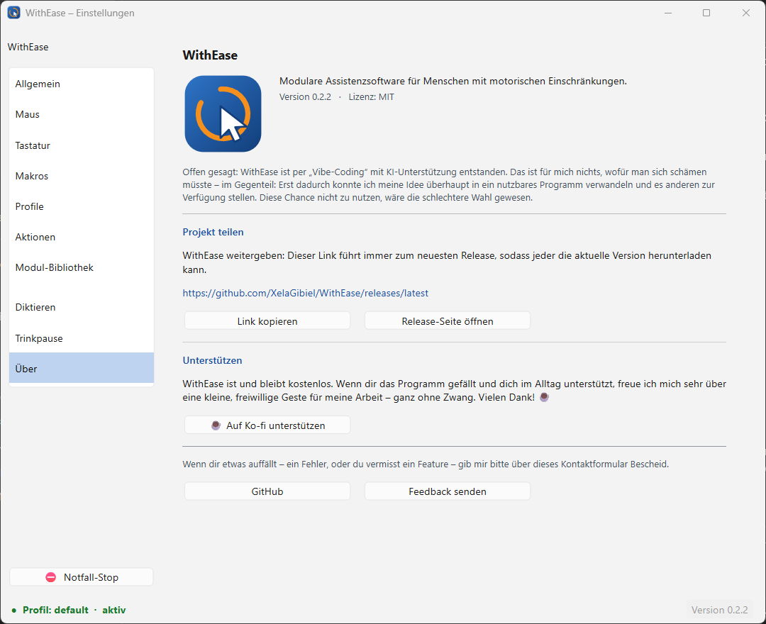
The About page with feedback and sharing
- Send feedback: write directly from within the program – no email program needed. Version and operating system are sent along automatically.
- Copy link / open release page: the link always leads to the newest version – ideal for sharing.
- GitHub: source code, bug reports and improvement suggestions.
- Support (Ko-fi): WithEase is and stays free. If you like the program and it helps you in everyday life, you can support my work with a small, voluntary contribution on Ko-fi – entirely without obligation.

14. Tips & troubleshooting

A key is stuck or everything behaves strangely
Press the emergency-stop key (default F12) – it releases stuck keys and turns off all aids. Press again to turn them back on.

Windows warns about the program at startup
This is due to the missing (paid) signature, not a problem with the file: More info → Run anyway.

I can't see the tray icon
Click the small “^” arrow at the bottom right. In the Windows settings you can show the icon permanently.

The text snippet inserts nothing
Check whether the input field allows Paste (Ctrl+V). In rare cases it helps to trigger the macro again.

Sticky AltGr doesn't work
In Keyboard → Sticky keys, tick the box for Sticky AltGr – each modifier is activated individually.

15. Help & contact
Found a bug, have a wish or a question? Feedback is explicitly welcome – it makes WithEase better.
- Easiest: About → Send feedback right in the program.
- Or on GitHub: github.com/XelaGibiel/WithEase
Every piece of feedback helps
Whether it's a bug, a wish or an idea that would make your everyday life easier – feel free to write to me. WithEase thrives on the people affected saying what they really need.

