Solid Edge Admin Utils

Contents

Overview 2

Setup 3

Installing Solid Edge Admin Utils 3

Removing Solid Edge Admin Utils 4

Usage 6

Reset Solid Edge User Preferences 6

Backup & Reset 6

No Backup & Reset 7

Prompt 7

Solid Edge Install 7

Start menu 7

Desktop right click and Windows Explorer right click. 9

<standard> - All Data Mgmt 10

<standard> - INS 10

<standard> - SEEC 10

<standard> - SESP 10

<standard> - Standalone 10

Prompt 11

Add Custom Files to Install 11

Change Install Standard on Right-Click Context Menus 12

Solid Edge Uninstall 14

Backup & Reset 14

No Backup & Reset 15

Prompt 15

Known Limitations 16

Support 17

Updates and Fixes 17

Troubleshooting 18

Execution of scripts is disabled 18

# Overview

A set of PowerShell utilities to automate and simplify the installing of base Solid Edge and data management clients, uninstalling Solid Edge, and resetting of Solid Edge user preferences.

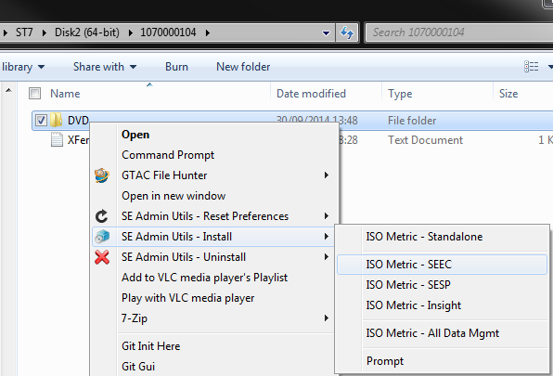

These utilities are not intended for the everyday Solid Edge end user. However, for support engineers, CAD administrators, etc., that must frequently install, uninstall, and reset Solid Edge these utilities will help automate and reduce the amount of clicks and input required for performing these various repetitive functions.

The real power in these scripts comes in the ability to create shortcuts that pre-populate the required command line parameters such that each of the three utilities can be automated to the point that a simple double-click will reset a user's Solid Edge preferences, or uninstall Solid Edge, or a simple drag and drop or right-click of the Solid Edge install media location can automatically install Solid Edge, the data management clients, and various configurations files e.g. selicense.dat.

# Setup

## Installing Solid Edge Admin Utils

Download the source files from the [GitHub repository](https://github.com/uk-dave/SolidEdge/blob/master/SE_Admin_Utils/SE_Admin_Utils.7z?raw=true).

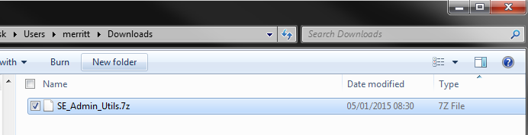

Manually extract the downloaded source files.

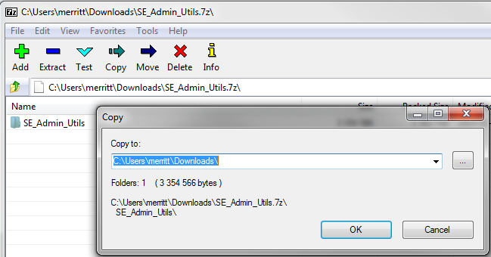

From the downloaded extracted files run "install.exe".

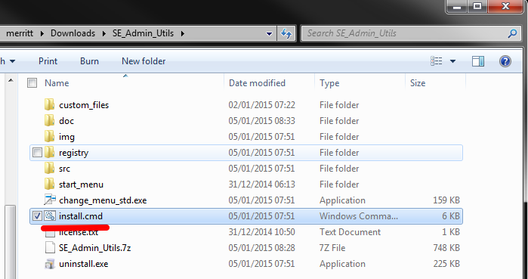

When prompted, selected the default drafting standard and templates to install Solid Edge with. This default standard can be changed at any time once the utilities are installed.

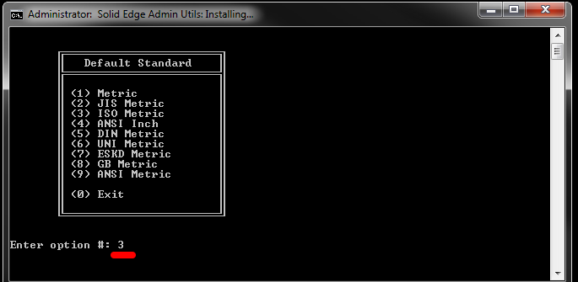

Once the utilities are installed, the installer will automatically exit and Start menu will be automatically opened.

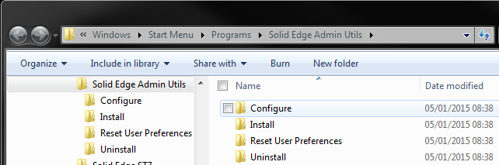

## Removing Solid Edge Admin Utils

From the Start menu -> Solid Edge Admin Utils -> Configure select "Remove Solid Edge Admin Utils".

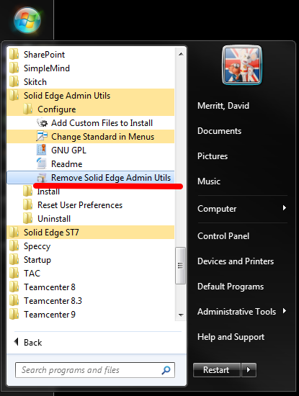

Respond "Y" to the prompt.

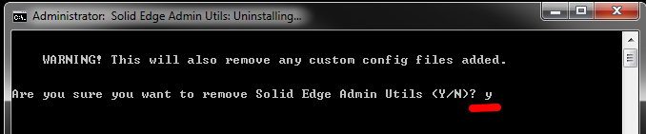

Once uninstalled, press any key to exit the uninstall.

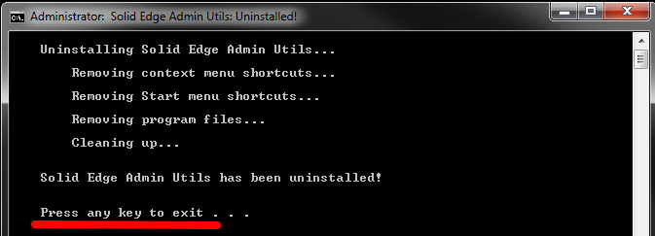

# Usage

## Reset Solid Edge User Preferences

This utility will allow you to quickly reset the active user’s Solid Edge preferences, and optionally back up the preferences before resetting.

Start menu:

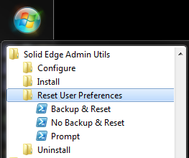

Desktop right click and Windows Explorer right click:

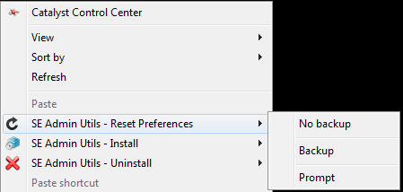

### Backup & Reset

Will back up the existing Solid Edge user preferences ("%APPDATA%\Unigraphics Solutions" and "HKEY_CURRENT_USER\Software\Unigraphics Solutions"), and then reset the user's Solid Edge preferences.

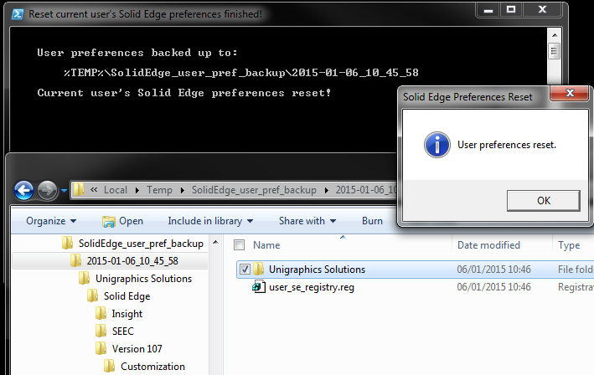

### **No Backup** & Reset

Does not back up the existing Solid Edge user preferences ("%APPDATA%\Unigraphics Solutions" and "HKEY_CURRENT_USER\Software\Unigraphics Solutions", and resets the user's Solid Edge preferences.

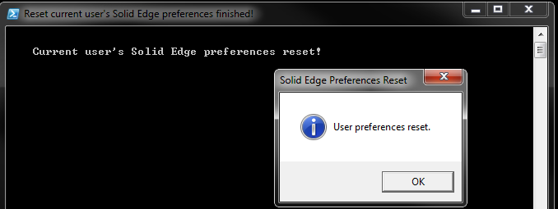

### Prompt

Will prompt you to provide the various desired options for uninstalling Solid Edge.

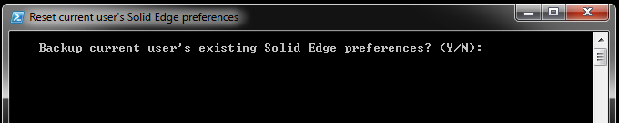

## Solid Edge Install

This utility will allow you to quickly install Solid Edge, and optionally install the data management clients by providing limited input to the installer interface.

The utility will also automatically install seadmin.exe and copy into the Solid Edge installation any provided Solid Edge configuration files such as a valid selicense.dat file, etc. that have been added using the "Add Custom Files to Install" option.

### Start menu

Note that Solid Edge can be installed with any desired drafting standard when using the menu shortcuts.

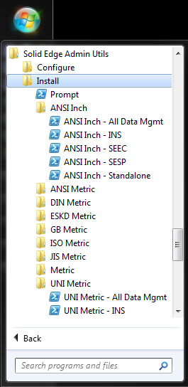

If you drag and drop the Solid Edge DVD install media folder over the install shortcut, then the utility will be pre-populated and automatically use the provided DVD install media location to install Solid Edge with:

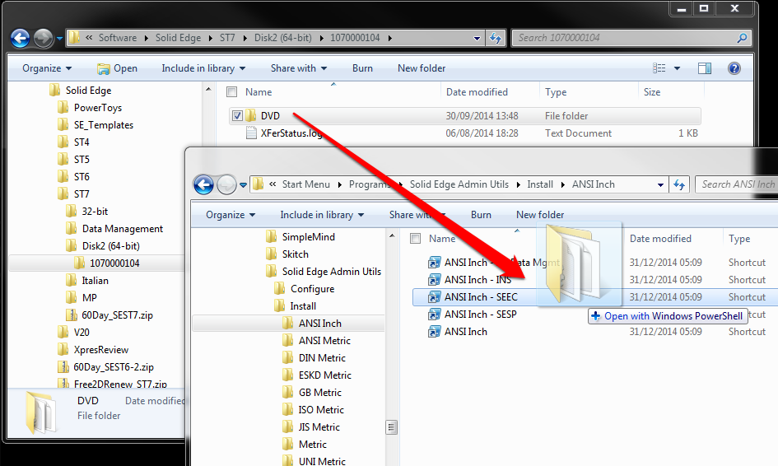

### Desktop right click and Windows Explorer right click.

Note that only the default standard selected when the utiltites were installed is available for installing Solid Edge with. This default standard can be changed using the "Change Install Standard on Right-Click Context Menus".

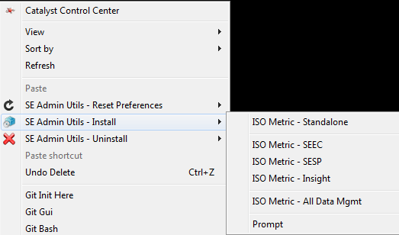

If you right-click install over the Solid Edge DVD install media folder, then the utility will be pre-populated and automatically use the provided DVD install media location to install Solid Edge with:

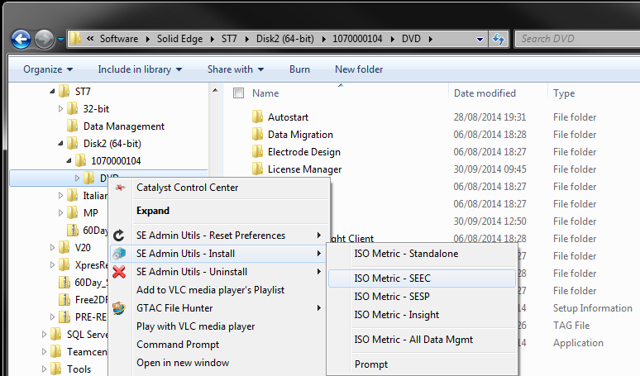

Regardless of which shortcut method is used to start the Solid Edge install, if a Solid Edge install media location has not been selected at the time of starting the install, you will be prompted to provide the location of the Solid Edge install media. The Solid Edge install media location can be dragged and dropped from Windows Explorer into the utility's prompt.

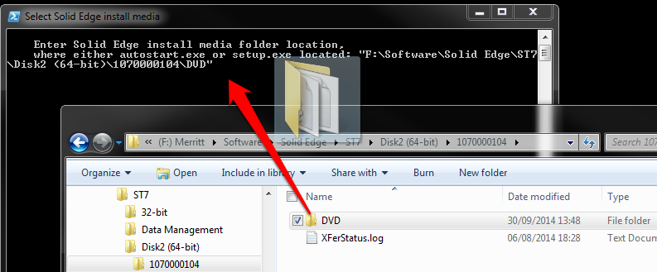

### <standard> - All Data Mgmt

Will install Solid Edge with the selected drafting template standard. Will also install the Insight, SEEC, SESP data management clients.

### <standard> - INS

Will install Solid Edge with the selected drafting template standard. Will also install the Insight data management client.

### <standard> - SEEC

Will install Solid Edge with the selected drafting template standard. Will also install the SEEC data management client.

### <standard> - SESP

Will install Solid Edge with the selected drafting template standard. Will also install the SESP data management client.

### <standard> - Standalone

Will install Solid Edge with the selected drafting template standard. Will also install the Insight, SEEC, SESP data management clients.

### Prompt

Will prompt you to provide the various desired options for installing Solid Edge with.

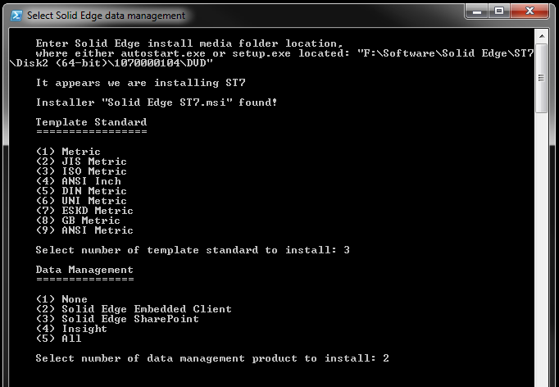

## Add Custom Files to Install

This will allow you to quickly license and configure Solid Edge at the same time as installing Solid Edge so that you can have Solid Edge installed and running with a single click of the install media.

By using this option, the next time you use the utilities to install Solid Edge, any files included in this location e.g. selicense.dat will automatically be included in the installation.

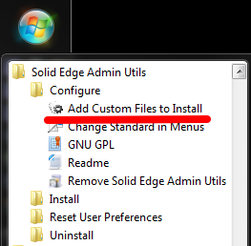

This option will then open the "%ProgramFiles%\Solid Edge Admin Utils\custom_files" folder.

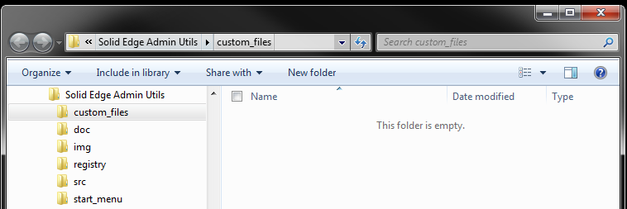

Copy into this folder any Solid Edge configuration files, preferences, etc., that you want to include automatically when installing Solid Edge e.g. an up-to-date working selicense.dat, a pre-configured data management client file, searchscope.txt, etc.

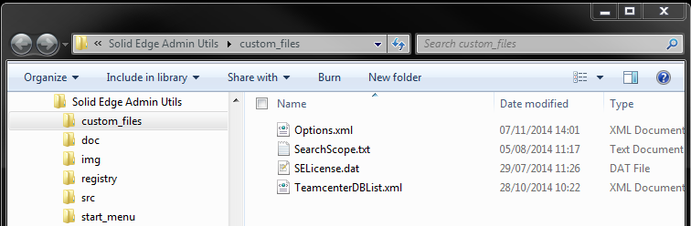

The next time you install Solid Edge using the utilities these files will automatically be included as part of the install.

## Change Ins**t**all Standard on Right-Click Context Menus

This option will allow you to quickly change the Solid Edge drafting and template standard used with the Desktop and Windows Explorer right-click Install methods.

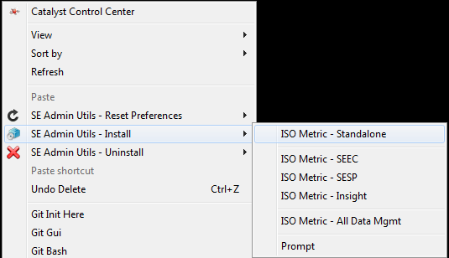

From the Start menu select "Change Standard in Menus":

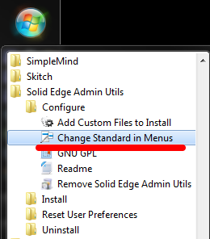

At the Standards menu, select the desired default standard:

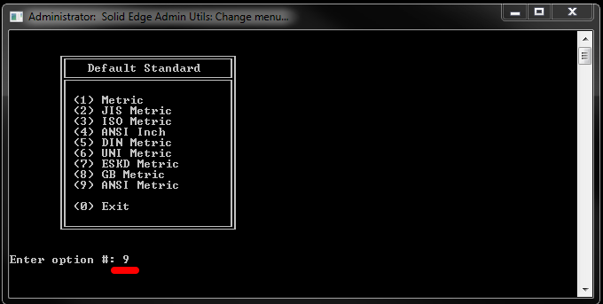

The default Solid Edge standard installed from the Desktop and Windows Explorer menus has been updated:

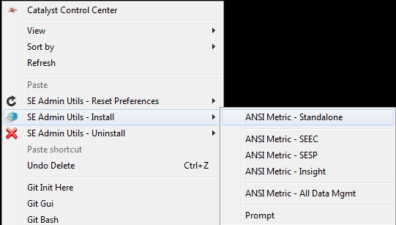

## Solid Edge Uninstall

This utility will allow you to quickly uninstall Solid Edge and the Solid Edge data management clients, and optionally back up the active user’s Solid Edge preferences and the Solid Edge program preferences before uninstalling.

Start menu:

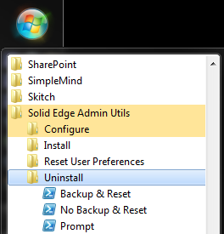

Desktop right click and Windows Explorer right click:

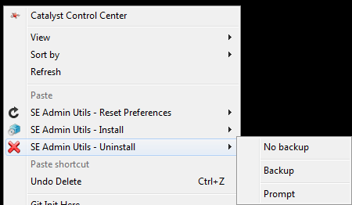

Regardless of which uninstall option you run, before uninstalling you will always be prompted to confirm that you want to uninstall Solid Edge.

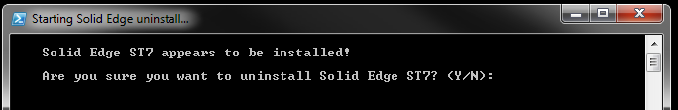

### Backup & Reset

Will back up the existing Solid Edge user preferences ("%APPDATA%\Unigraphics Solutions" and "HKEY_CURRENT_USER\Software\Unigraphics Solutions") and the Solid Edge site preferences ("%ProgramFiles%\Solid Edge <version>\Preferences"); reset the user's Solid Edge preferences; and then silently uninstall Solid Edge.

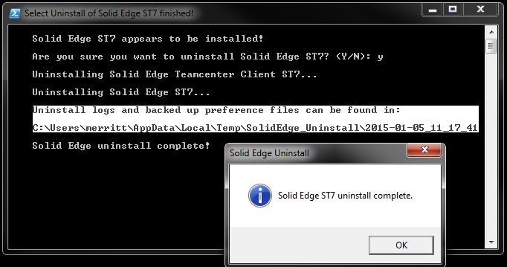

### **No Backup** & Reset

Does not back up the existing Solid Edge user preferences ("%APPDATA%\Unigraphics Solutions" and "HKEY_CURRENT_USER\Software\Unigraphics Solutions") and the Solid Edge site preferences ("%ProgramFiles%\Solid Edge <version>\Preferences"); resets the user's Solid Edge preferences; and then silently uninstall Solid Edge.

### Prompt

Will prompt you to provide the various desired options for uninstalling Solid Edge.

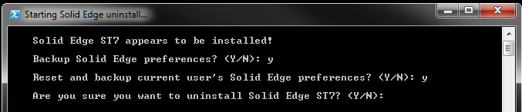

# Known Limitations

The following is a list of current limitations with these various scripts:

* Does not install and Solid Edge server products e.g. SESP server, etc.
* Can only be installed to the default “%ProgramFiles%\Solid Edge ST<version>” folder.
* Cannot install using the downloaded executable installer directly. Downloaded executable must be manually extracted before using.
* Does not install maintenance packs (but I am contemplating ways to implement automated maintenance pack installation. I am open to any thoughts on this.).
* Does not install any prerequisites e.g. KeyShot, etc.
* Does not install any add-ons other than data management e.g. Standard Parts, etc.
* Does not configure the data management clients. However you can provide pre-configured data management connection files and the installer will automatically copy these into the Solid Edge installation.
* Does not uninstall any prerequisites e.g. KeyShot, etc.
* Does not uninstall any add-ons other than data management e.g. Standard Parts, etc.

# Support

Per the GNU license agreement, these scripts are provided without any warranty. Further these scripts are provided without any formal support.

Although no formal support is explicitly offered or provided, should you have any issues, questions, and/or suggestions please [send an e-mail](mailto:david.c.merritt@siemens.com?subject=Solid%20Edge%20Admin%20Utils) and I will attempt to respond.

## Updates and Fixes

The source code, latest updates, fixes, corrections, etc. can be downloaded at any time from the [GitHub site](https://github.com/uk-dave/SolidEdge/tree/master/SE_Admin_Utils).

# Troubleshooting

## Execution of scripts is disabled

This issue should be avoided by using the install script. However, if you installed manually or for some reason the installer could not automatically set the required preference, you may encounter a PowerShell error when running these utilities.

If when you attempt to run these scripts you receive an error message about "the execution of scripts is disabled on this system", you will need to manually modify the PowerShell execution policy.

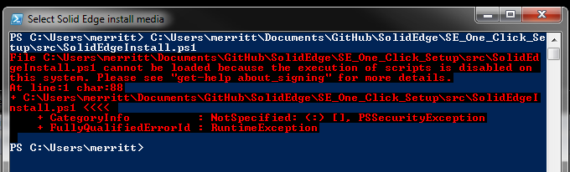

The setting of the PowerShell execution policy is a one-time change. Once set, it will not need to be set again.

To manually modify the PowerShell execution policy:

Open a PowerShell command line window by selecting the start button, type "powershell", and hit Enter:

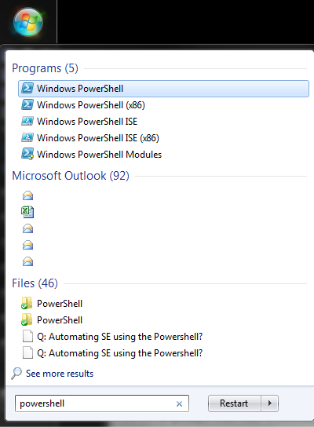



In the PowerShell command window type the command "Set-ExecutionPolicy Unrestricted" and hit Enter:

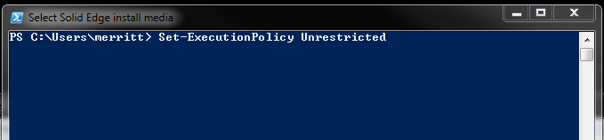

Type "Y" and hit Enter to confirm changing the execution policy:

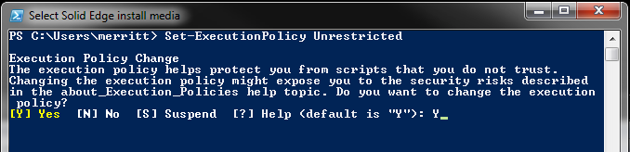

The PowerShell execution policy has now been updated and you can run the utilities without any execution policy errors.