Solid Edge Admin Utils

Contents

Overview 1

Installation 2

Reset SE User Pref [src/ResetUserPreferences.ps1] 4

SE Install [src/SolidEdgeInstall.ps1] 4

SE Uninstall [src/SolidEdgeUninstall.ps1] 5

Shortcuts 5

Limitations 6

Updates and Fixes 6

Support 6

Execution of scripts is disabled 6

# Overview

A set of PowerShell utilities to automate the installing of base Solid Edge, uninstalling Solid Edge, and resetting of Solid Edge user preferences.

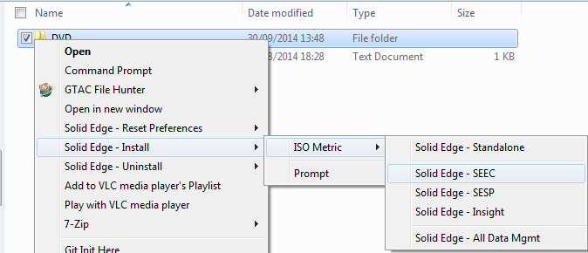

These utilities are not intended for the everyday Solid Edge end user. However, for support engineers, CAD administrators, etc., that must frequently install, uninstall, and reset Solid Edge these utilities will help automate and reduce the amount of clicks and input required for performing these various repetitive functions.

The real power in these scripts comes in the ability to create shortcuts that pre-populate the required command line parameters such that each of the three utilities can be automated to the point that a simple double-click will reset a user's Solid Edge preferences, uninstall Solid Edge, or a simple drag and drag or right-click of the install media location can automatically install Solid Edge.

There are three PowerShell scripts provided in the "src" folder:

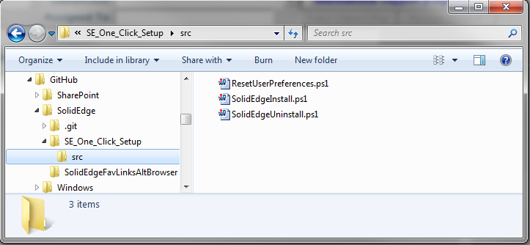

* ResetUserPreferences.ps1 - backup and reset a user's Solid Edge preferences.
* SolidEdgeInstall.ps1 - perform a silent install of Solid Edge.
* SolidEdgeUninstall.ps1 - perform a silent uninstall of Solid Edge and optionally backup and reset the user's Solid Edge preferences.

# Installation

Currently there is no automatic installer and everything must be configured manually.

Simply copy all of the provided files to some location on your local disk e.g. C:\SE_One_Click_Setup:

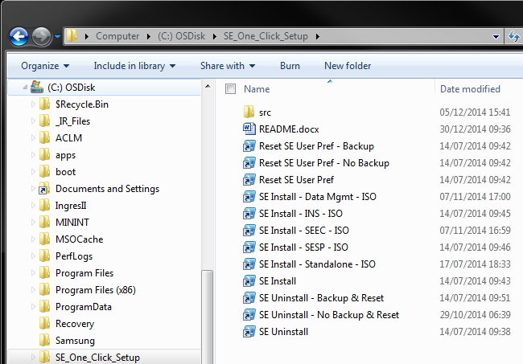

On each of the provided shortcuts, right-click -> Properties and update the "Start in" location to point to the folder location you copied all of the files to e.g. C:\SE_One_Click_Setup:

Optionally, create your own shortcuts to suit your own personal needs.

Optionally, create shortcuts to your desktop, desktops menu, etc., for fast easy access to reset, uninstall, and install Solid Edge.

Optionally, using a text editor update the provided registry scripts in the \registry sub-folder to point to your install location, and then double-click on the registry script to install and add menu shortcuts to your desktop and Windows Explorer context menus.

# Reset Solid Edge User Preferences

This shortcut will run the src/ResetUserPreferences.ps1 utility without any parameters and will reset the user's Solid Edge preferences, optionally backing up the preferences before resetting.

# Solid Edge Install

This shortcut will run the src/SolidEdgeInstall.ps1 utility without any parameters and will silently install Solid Edge and optional data management clients.

# Solid Edge Uninstall

This shortcut will run the src/SolidEdgeUninstall.ps1 utility without any parameters and will silently uninstall Solid Edge, optionally backing up and resetting the user's Solid Edge preferences.

# Shortcuts

Each of the source scripts can be run from the command line and manual responses input for each of the required parameters. However, where the real power in these scripts comes into play is creating as a series of shortcuts that automate the input of the required parameters such that each utility then simply requires a one-click or drag-n-drop to complete the desired operation.

Sample shortcuts have been provided in the "SE_One_Click_Setup" folder:

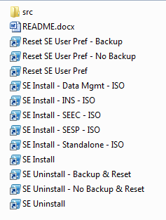

* Reset SE User Pref - Backup; automatically backup the user's Solid Edge preferences and then reset the user preferences.
* Reset SE User Pref - No Backup; automatically reset the user's Solid Edge preferences without backing up the preferences.
* Reset SE User Pref; the basic command to reset the user's Solid Edge preferences by manually providing the required parameters.
* SE Install - Data Mgmt - ISO; silently install Solid Edge and all of the data management clients with the ISO templates.
* SE Install - INS - ISO; silently install Solid Edge and Insight data management client with the ISO templates.
* SE Install - SEEC - ISO; silently install Solid Edge and SEEC data management client with the ISO templates.
* SE Install - SESP - ISO; silently install Solid Edge and SESP data management client with the ISO templates.
* SE Install - Standalone - ISO; silently install standalone Solid Edge with the ISO templates.
* SE Install; the basic command to silently install Solid Edge by manually providing the required parameters.
* SE Uninstall - Backup & Reset; silently uninstall Solid Edge, backup and reset the user's Solid Edge preferences
* SE Uninstall - No Backup & Reset; silently uninstall Solid Edge, do not backup the preferences, and reset the user's Solid Edge preferences
* SE Uninstall; the basic command to silently uninstall Solid Edge by manually providing the required parameters.

The sample shortcuts provided are suitable for my specific needs. You will need to create your own shortcuts that are appropriate for your own requirements. Shortcuts are created using basic Windows shortcut methods. For the parameters to specify for the shortcuts, run each of the underlying \src command line utilities and review the parameters.

# Limitations

The following is a list of current limitations with these various scripts:

* Does not install any prerequisites e.g. Keyshot, etc.
* Does not install any add-ons other than data management e.g. Standard Parts, etc.
* Does not configure the data management client.
* Does not uninstall any prerequisites e.g. Keyshot, etc.
* Does not uninstall any add-ons other than data management e.g. Standard Parts, etc.

# Updates and Fixes

The source code for these utilities is maintained on [my personal GitHub](https://github.com/uk-dave) site.

The latest updates, fixes, corrections, etc. can be downloaded at any time from the GitHub site:

<https://github.com/uk-dave/SolidEdge/tree/master/SE_One_Click_Setup>

# Support

Per the GNU license agreement, these scripts are provided as is and without any warranty. However, should you have any issues, questions, and/or suggestions please send me an e-mail and I will attempt to respond to you.

# Execution of scripts is disabled

This issue should be avoided by using the install script. However, if you installed manually you may then encounter the following error.

If when you attempt to run these scripts and you receive an error message about "the execution of scripts is disabled on this system", you will need to manually modify the PowerShell execution policy.

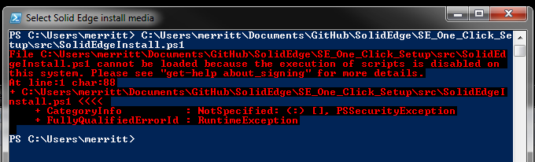

The setting of the PowerShell execution policy is a one-time change. Once set, it will not need to be set again.

To modify the PowerShell execution policy:

Open a PowerShell command line window by selecting the start button, type "powershell", and hit Enter:

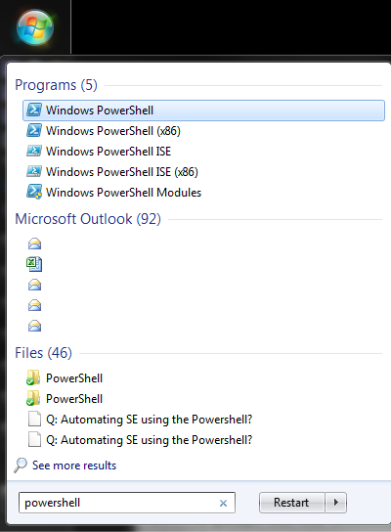



In the PowerShell command window type the command "Set-ExecutionPolicy Unrestricted" and hit Enter:

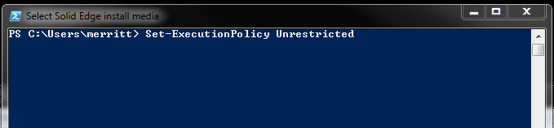

Type "Y" and hit Enter to confirm changing the execution policy:

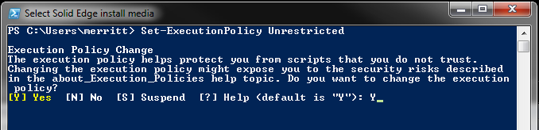

The PowerShell execution policy has now been updated and you can run the utilities without any execution policy errors.