SE_One_Click_Setup

Contents

Overview 1

Shortcuts 1

Execution of scripts is disabled 3

# Overview

A set of PowerShell utilities to automate the installing of base Solid Edge, uninstalling Solid Edge, and resetting of Solid Edge user preferences.

These utilities are not intended for the everyday Solid Edge end user. However, for support engineers, CAD administrators, etc., that must frequently install, uninstall, and reset Solid Edge these utilities will automate and reduce the amount of clicks and input required for performing these various repetitive functions.

There are three PowerShell scripts provided in the "src" folder:

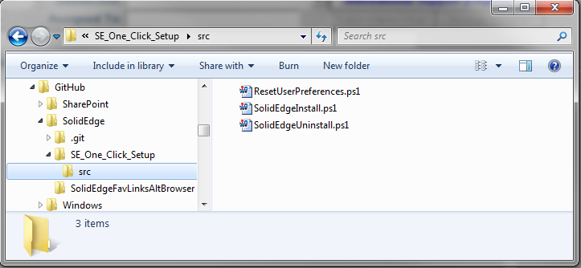

* ResetUserPreferences.ps1 - backup and reset a user's Solid Edge preferences.
* SolidEdgeInstall.ps1 - perform a silent install of Solid Edge.
* SolidEdgeUninstall.ps1 - perform a silent uninstall of Solid Edge and optionally backup and reset the user's Solid Edge preferences.

# Shortcuts

Each of these scripts can be run from the command line and manual responses input for each of the required parameters. However, where the real power in these scripts comes into play is creating as a series of shortcuts that automate the input of the required parameters such that each utility then simply requires a one-click to complete the desired operation.

Sample shortcuts have been provided in the "SE_One_Click_Setup" folder:

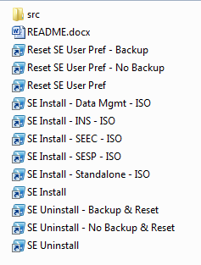

* Reset SE User Pref - Backup; automatically backup the user's Solid Edge preferences and then reset the user preferences.
* Reset SE User Pref - No Backup; automatically reset the user's Solid Edge preferences without backing up the preferences.
* Reset SE User Pref; the basic command to reset the user's Solid Edge preferences by manually providing the required parameters.
* SE Install - Data Mgmt - ISO; install Solid Edge and all of the data management clients with the ISO templates.
* SE Install - INS - ISO; install Solid Edge and Insight data management client with the ISO templates.
* SE Install - SEEC - ISO; install Solid Edge and SEEC data management client with the ISO templates.
* SE Install - SESP - ISO; install Solid Edge and SESP data management client with the ISO templates.
* SE Install - Standalone - ISO; install standalone Solid Edge with the ISO templates.
* SE Install; the basic command to install Solid Edge by manually providing the required parameters.
* SE Uninstall - Backup & Reset; uninstall Solid Edge, backup and reset the user's Solid Edge preferences
* SE Uninstall - No Backup & Reset; uninstall Solid Edge, do not backup the preferences, and reset the user's Solid Edge preferences
* SE Uninstall; the basic command to uninstall Solid Edge by manually providing the required parameters.

The sample shortcuts provided are suitable for my specific needs. You will need to create your own shortcuts that are appropriate for your own requirements. Shortcuts are created using basic Windows shortcut methods. For the parameters to specify for the shortcuts, run the command line utility and review the parameters.

Reset SE User Pref

This utility will reset the user's Solid Edge preferences, and optionally backup the preferences before resetting.

SE Install

This utility will silently install Solid Edge and optional data managament clients

SE Uninstall

# Execution of scripts is disabled

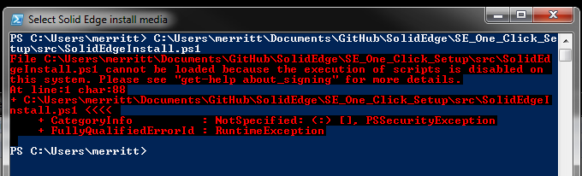

If when you attempt to run these scripts and you receive an error message about "the execution of scripts is disabled on this system", you will need to manually modify the PowerShell execution policy.

The setting of the PowerShell execution policy is a one-time change. Once set, it will not need to be set again.

To modify the PowerShell execution policy:

Open a PowerShell command line window by selecting the start button, type "powershell", and hit Enter:

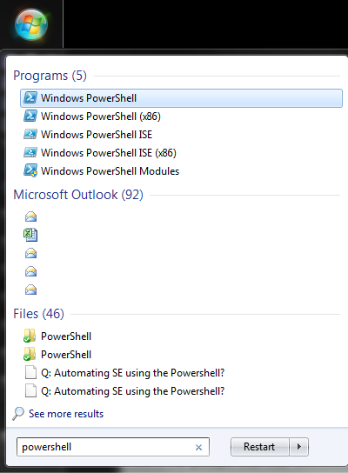



In the PowerShell command window type the command "Set-ExecutionPolicy Unrestricted" and hit Enter:

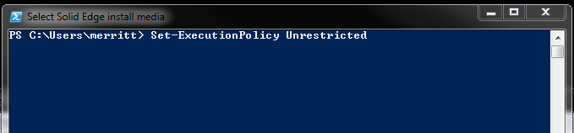

Type "Y" and hit Enter to confirm changing the execution policy:

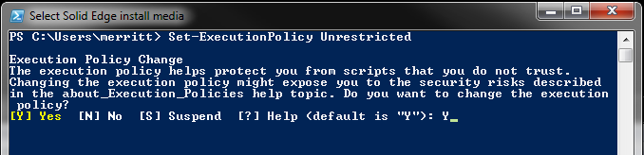

The PowerShell execution policy has now been updated and you can run the utilities without any execution policy errors.