Solid Edge Beautify Log

Contents

Overview 2

Setup 3

Installing Solid Edge Beautify Log 3

Removing Solid Edge Beautify Log 4

Usage 6

Reset Solid Edge User Preferences 6

Backup & Reset 6

Known Limitations 7

Support 8

Updates and Fixes 8

Troubleshooting 9

Execution of scripts is disabled 9

# Overview

ST8 introduced a new telemetry log File. Solid Edge is now writing out the full command history for a user by default, along with some system configuration information as well. This data can be useful with helping to resolve/reproduce customer issues.

The telemetry log file can be found under “%APPDATA%\Unigraphics Solutions\Solid Edge\<version>\User Experience Improvement”:

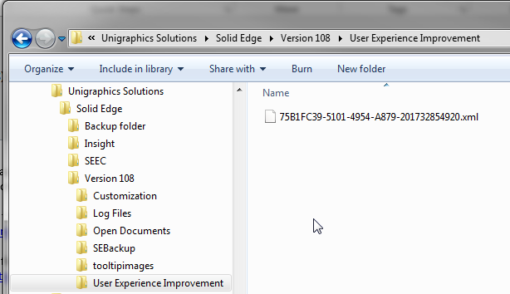

There is only one telemetry log generated per Solid Edge session. As soon as a new Solid Edge session is started the old telemetry log is automatically deleted. Therefore if this log file is to be used for resolving issues it must be captured immediately. If the problem happened two or more sessions ago, the log is already gone.

The log file is an XML file that can be opened in Internet Explorer. However, although readable it is not in a friendly usable format:

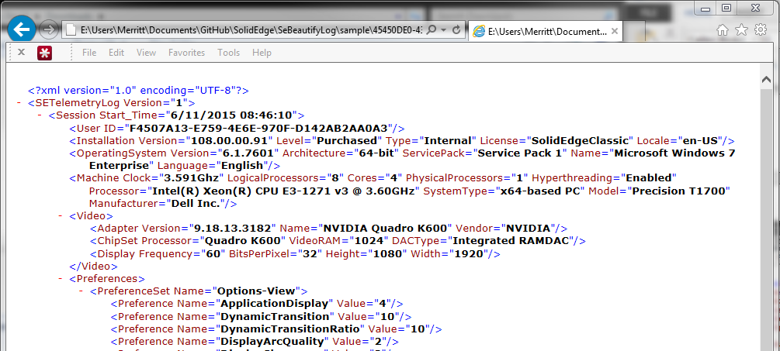

If you are lucky enough to have access to the development tool to convert this XML log file into a more readable format you will then see something similar to the following:

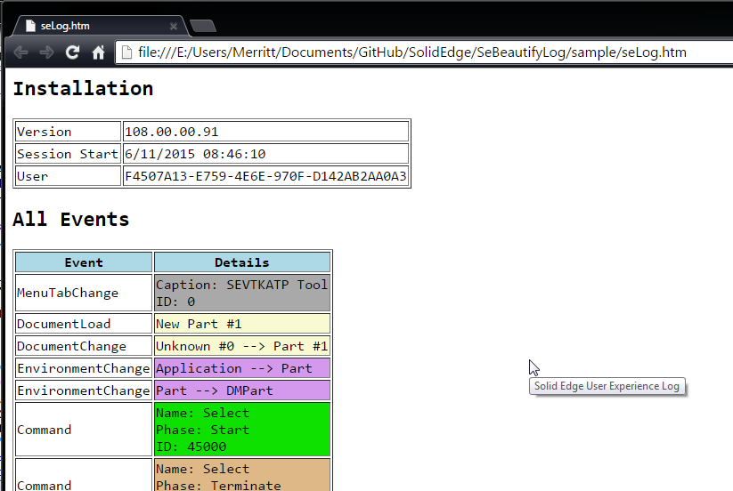

However this development tool does not display all of the information contained in the log file and omits various details from the log file.

This utility is designed to convert the XML log file more readable format but also attempts to include all of the information contained in the log file:

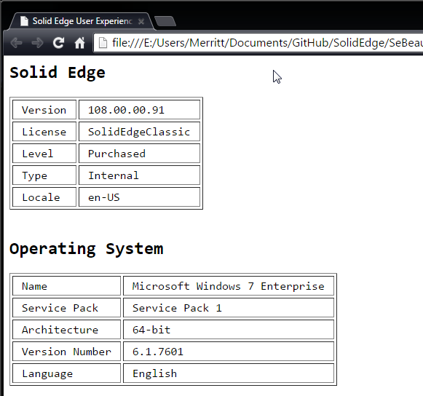

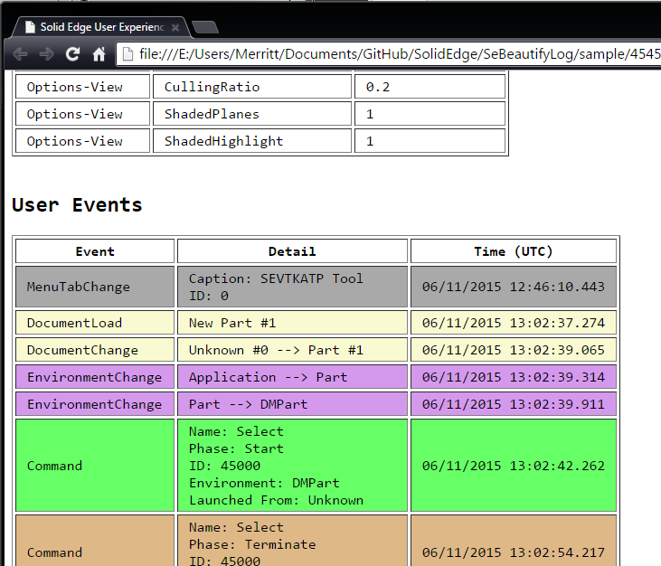

# Setup

## Installing Solid Edge Beautify Log

Download the latest distributable compressed file from the [GitHub repository](https://github.com/uk-dave/SolidEdge/blob/master/SeBeautifyLog/SeBeautifyLog.7z?raw=true):

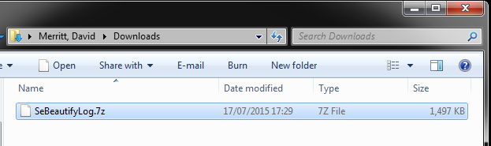

Manually extract the downloaded source files:

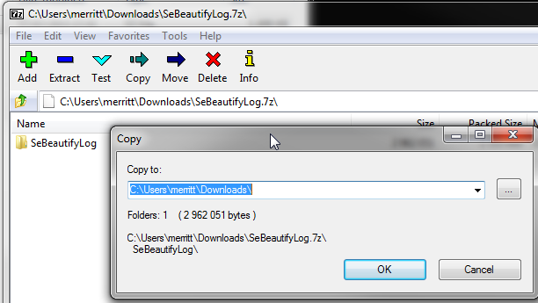

From the extracted files run "install.exe":

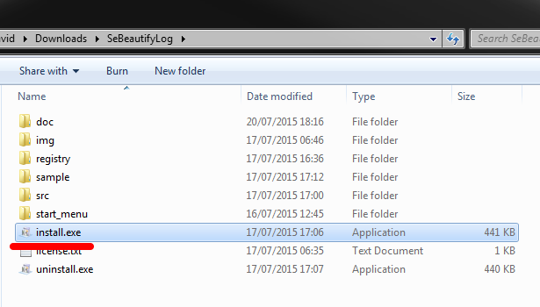

Once the utilities are installed, the installer will automatically exit and the Start menu will be automatically opened.

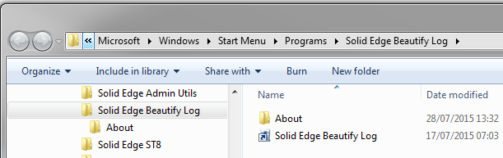

## Removing Solid Edge Beautify Log

From the Start menu -> Solid Edge Beautify Log -> About select "Remove Solid Edge Beautify Log".

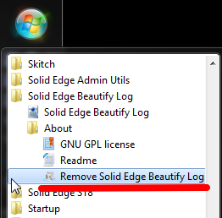

Respond "Y" to the prompt.

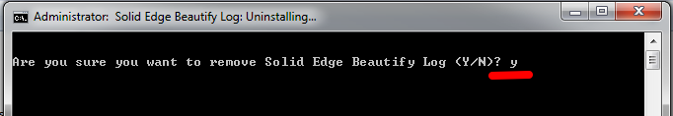

Once uninstalled, press any key to exit the uninstaller.

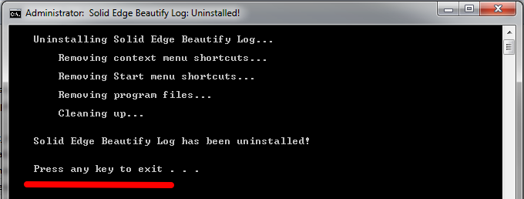

# Usage

## Reset Solid Edge User Preferences

xxx

### Backup & Reset

xxx.

# Known Limitations

The following is a list of current limitations with utility:

* At this time there are no known limitations with this utility.

# Support

Per the GNU license agreement, these scripts are provided without any warranty. Further these scripts are provided without any formal support.

Although no formal support is explicitly offered or provided, should you have any issues, questions, and/or suggestions please [send an e-mail](mailto:david.c.merritt@siemens.com?subject=Solid%20Edge%20Beautify%20Log) and I will attempt to respond.

## Updates and Fixes

The source code, latest updates, fixes, corrections, etc. can be downloaded at any time from the [GitHub site](https://github.com/uk-dave/SolidEdge/tree/master/SeBeautifyLog).

# Troubleshooting

## Execution of scripts is disabled

This issue should be avoided by using the install script. However, if you installed manually or for some reason the installer could not automatically set the required preference, you may encounter a PowerShell error when running these utilities.

If when you attempt to run these scripts you receive an error message about "the execution of scripts is disabled on this system", you will need to manually modify the PowerShell execution policy.

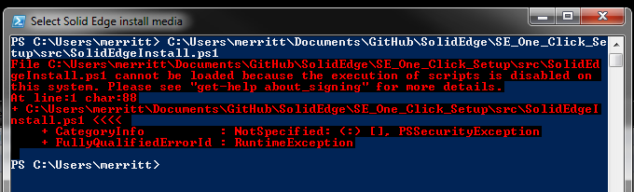

The setting of the PowerShell execution policy is a one-time change. Once set, it will not need to be set again.

To manually modify the PowerShell execution policy:

Open a PowerShell command line window by selecting the start button, type "powershell", and hit Enter:

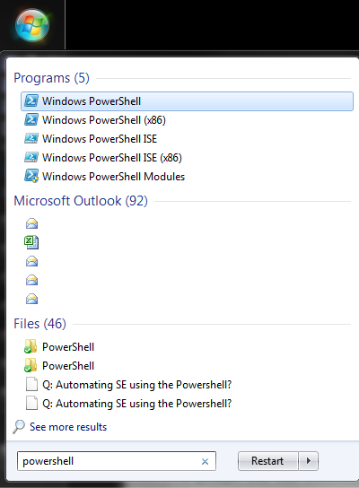



In the PowerShell command window type the command "Set-ExecutionPolicy Unrestricted" and hit Enter:

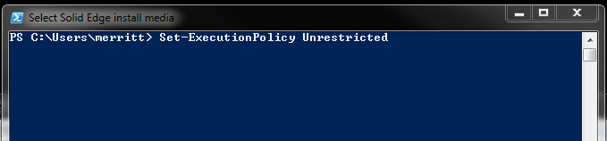

Type "Y" and hit Enter to confirm changing the execution policy:

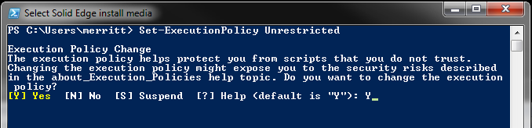

The PowerShell execution policy has now been updated and you can run the utilities without any execution policy errors.