# SolidEdgeTranslationServices.exe Command Line Switches

SolidEdgeTranslationServices.exe is an internal utility for use with Teamcenter translation Services. As such, there is no formal documentation available for this internal utility. However, the utility can be used outside of Teamcenter directly from the command line to automate automatic translation of Solid Edge files:

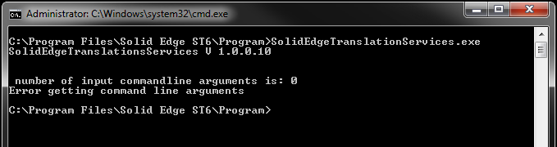

The following are the command line switches available for SolidEdgeTranslationServices.exe:

–i = input file

–o = output file

–t = what format to convert to (i.e. pdf, tif, dwg, jt, bmp, igs, etc.)

–w = width

–h = height

–r = resolution (100, 200, 300, 600, 1200)

–c = colour depth (1, 8, 24 where 1=MONOCHROME, 8=256 COLORS, 24=TRUE COLOR)

–v = visibility of Solid Edge (TRUE, FALSE)

–q = image quality (LOW, MEDIUM, HIGH)

–m = multiple sheets (TRUE, FALSE)

Sample command line for SolidEdgeTranslationServices.exe:

SolidEdgeTranslationServices.exe -i="C:\Program Files\Solid Edge ST6\Training\stddb3d.dft" -o=C:\Temp\test.pdf -q=high -t=pdf

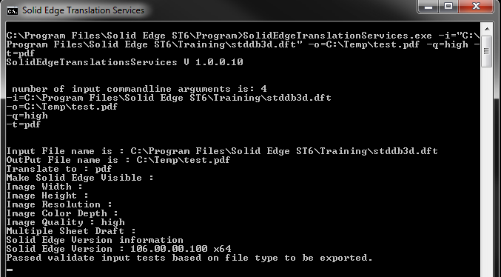

David C. Merritt