Roberts:
1 | 0
0 | -1
0 | -1
1 | 0

G_{x}= G_{y}=

Sobel:
-1 |  | 0 |  | 1
-2 |  | 0 |  | 2
-1 |  | 0 |  | 1
1 | 2 |  | 1
0 | 0 |  | 0
-1 | -2 |  | -1
G_{x=} G_{y=}

a11 | a12 | a13
a21 | a22 | a23
a32 | a32 | a33

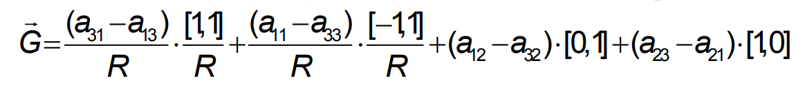

1 | 1 | 1
0 | 0 | 0
-1 | -1 | -1
Prewitt:
-1 | 0 | 1
-1 | 0 | 1
-1 | 0 | 1
G_{x}= G_{y}=

P1 | P2 | P3
P4 | P5 | P6
P7 | P8 | P9

pixel = (p1+p2+p3-p7-p8-p9)+(p3+p6+p9-p1-p4-p7)

