CRYPTO TA PRO v6
Trading Bible + Pine Strategy Build Guide
A branded supplement for building a Pine Script v6 crypto strategy from the bottom up.
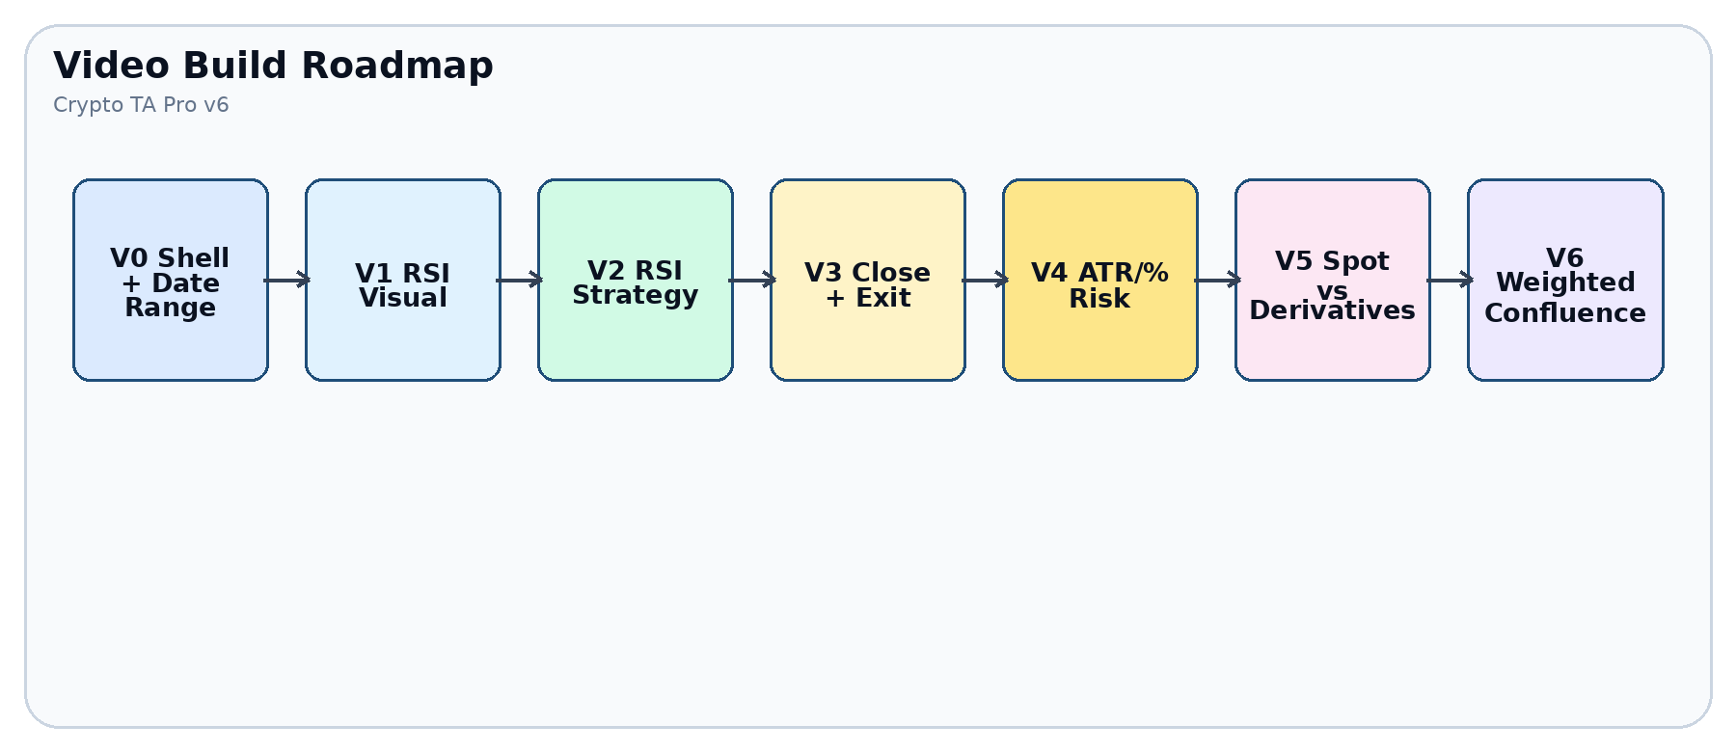
How to use this guide
Read only the current milestone while filming or coding. Each section tells you what to build, what to ignore, what to test, and what must be true before moving forward.
Risk note
This document is educational strategy-engineering guidance. It is not financial advice and does not prove future profitability.

1. Cognitive Load Map
Layer | Question | Script object | Decision rule
Price | What did the candle do? | open, high, low, close | Never decide without knowing the source value.
Visual | What do I need to see? | plot, plotshape, table | Visuals do not have to influence trades.
Setup | What makes the idea worth watching? | recent condition | Setup is not entry.
Confirmation | What confirms action? | cross/reclaim/close break | Entry waits for confirmation.
Weight | How much does this module matter? | module vote x weight | No single indicator should silently dominate.
Risk | Where am I wrong? | stop, target, breakeven | Risk is defined before proof.
Validation | Does it survive unseen data? | IS/OOS/Paper windows | No retuning inside OOS.
Minimum viable strategy
Start with the shell, date range, confirmed-bar gate, RSI visual, RSI setup, RSI confirmation, and a simple close rule. Add risk before adding more indicators.
Final strategy theory
A multi-indicator, weight-based execution model where indicators can be visual-only, entry-influencing, exit-influencing, or disabled. AI may explore combinations only inside locked validation rules.

2. Build Roadmap for the Video

Milestone | Build | Keep out until later | Pass gate
V0 | Strategy declaration, market mode, date range | Indicators | Compiles and filters bars correctly.
V1 | RSI visual and settings | Orders | RSI plots only where expected.
V2 | RSI setup + RSI reclaim entry | Risk complexity | One clear entry reason exists.
V3 | Exit/close behavior | Extra indicators | Entry and exit are explainable.
V4 | ATR/% stops, target, breakeven | AI optimization | Every trade has defined invalidation.
V5 | Spot vs derivatives toggle | Leverage assumptions | Spot cannot short; derivatives can.
V6 | Weighted modules | Unbounded search | Each module has vote, weight, and toggle.

3. Pine Script Architecture
Delivered file
ctapv6_megalithic_v1.pine contains the full research framework: RSI, Fibonacci Bollinger Bands, Trend/HTF MA, Ichimoku, ATR/% risk, candlestick patterns, chart/breakout patterns, weighted scoring, dashboard, alerts, and IS/OOS/Paper windows.
Module | Visual toggle | Entry toggle | Exit toggle | Weight | Output
RSI | RSI data-window plot | Oversold + reclaim | Opposite extreme | Entry/exit weight | Momentum vote
Fib BB | Bands and fill | Band touch + reclaim | Basis/outer band event | Entry/exit weight | Volatility envelope vote
Trend MA | Chart + HTF MA | Regime permission | Trend flip | Entry/exit weight | Context vote
Ichimoku | Cloud and lines | Cloud trend context | Cloud reversal | Entry/exit weight | Trend structure vote
Candles | Pattern labels | Bull/bear pattern event | Opposite pattern | Entry/exit weight | Price-action vote
Patterns | Pivot and breakout labels | Double/flag/wedge break | Opposite break | Entry/exit weight | Structure vote
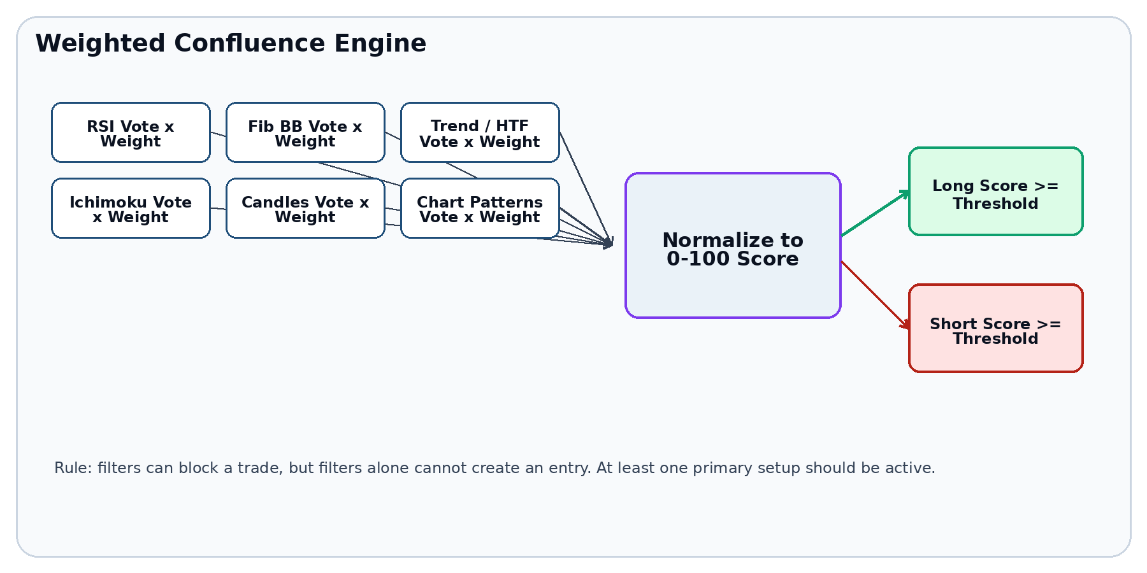

4. Candlestick Pattern Decision Layer
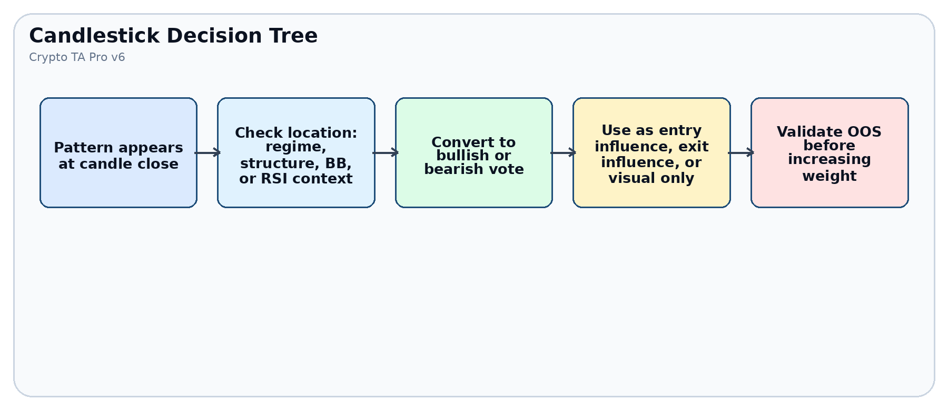
Pattern | Bullish definition | Bearish definition | Best use
38.2 pressure candle | Body closes in upper pressure zone after sellers fail. | Body closes in lower pressure zone after buyers fail. | Visual pressure + weighted confirmation.
Engulfing | Green body larger than prior red body. | Red body larger than prior green body. | Confirmation at value area.
Close above/below | Close breaks prior high. | Close breaks prior low. | Momentum confirmation.
Wick rejection | Lower wick dominates body. | Upper wick dominates body. | Rejected level / failed push.
Decision rule
A candle pattern should not be treated as proof. In the script, it becomes a vote. You decide if that vote is visual only, entry-influencing, exit-influencing, or disabled.

5. Indicator Modules from the Previous Script
Indicator | Purpose | Core settings | Trade role | Failure mode
RSI | Momentum and exhaustion context | Source, length, OS/OB, lookback | Setup/reclaim or exit extreme | Can stay oversold/overbought in strong trends.
Fibonacci BB | Volatility envelope and reclaim logic | Length, source, basis MA, deviation multiplier | Band touch + reclaim | Can overreact during extreme volatility.
Trend/HTF MA | Regime filter and context | MA type, length, HTF, confirmed HTF option | Permission filter or weighted vote | Can lag reversals.
Ichimoku | Cloud trend and equilibrium context | Conversion, base, span B, displacement | Optional confluence module | Can clutter visuals and add lag.
ATR | Volatility-aware stop/target sizing | ATR length and stop multiplier | Risk engine, not entry signal | Dynamic ATR can distort fixed-entry tests if not frozen.
Volume filter | Liquidity / participation proxy | SMA length and multiplier | Trade blocker | Crypto volume can vary by venue/feed.
Best-practice default
Use confirmed-bar mode, freeze ATR risk at entry during research, and turn on only one new module at a time while testing OOS viability.

6. Risk, Entry Price, and Close Logic
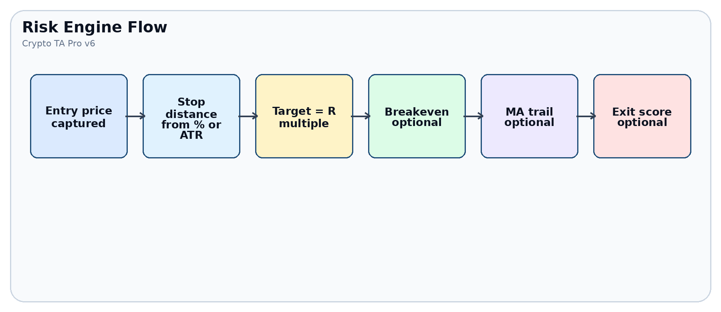
Risk object | Meaning | Script control | Preferred research setting
Entry price | Simulated average entry after order fill | strategy.position_avg_price | Use as the anchor for stop and target.
Percent stop | Fixed distance from entry | Stop loss % | Simple baseline.
ATR stop | Volatility-aware distance | ATR length x multiplier | Better cross-symbol comparability.
Tighter/wider model | Chooses conservative/aggressive stop | Stop model input | Test both, then lock before OOS.
Breakeven | Moves stop after R trigger | Breakeven toggle | Use only after baseline is stable.
MA trailing | Trend-following stop | MA trail toggle | Use only for trend systems.

7. Honest Out-of-Sample Testing
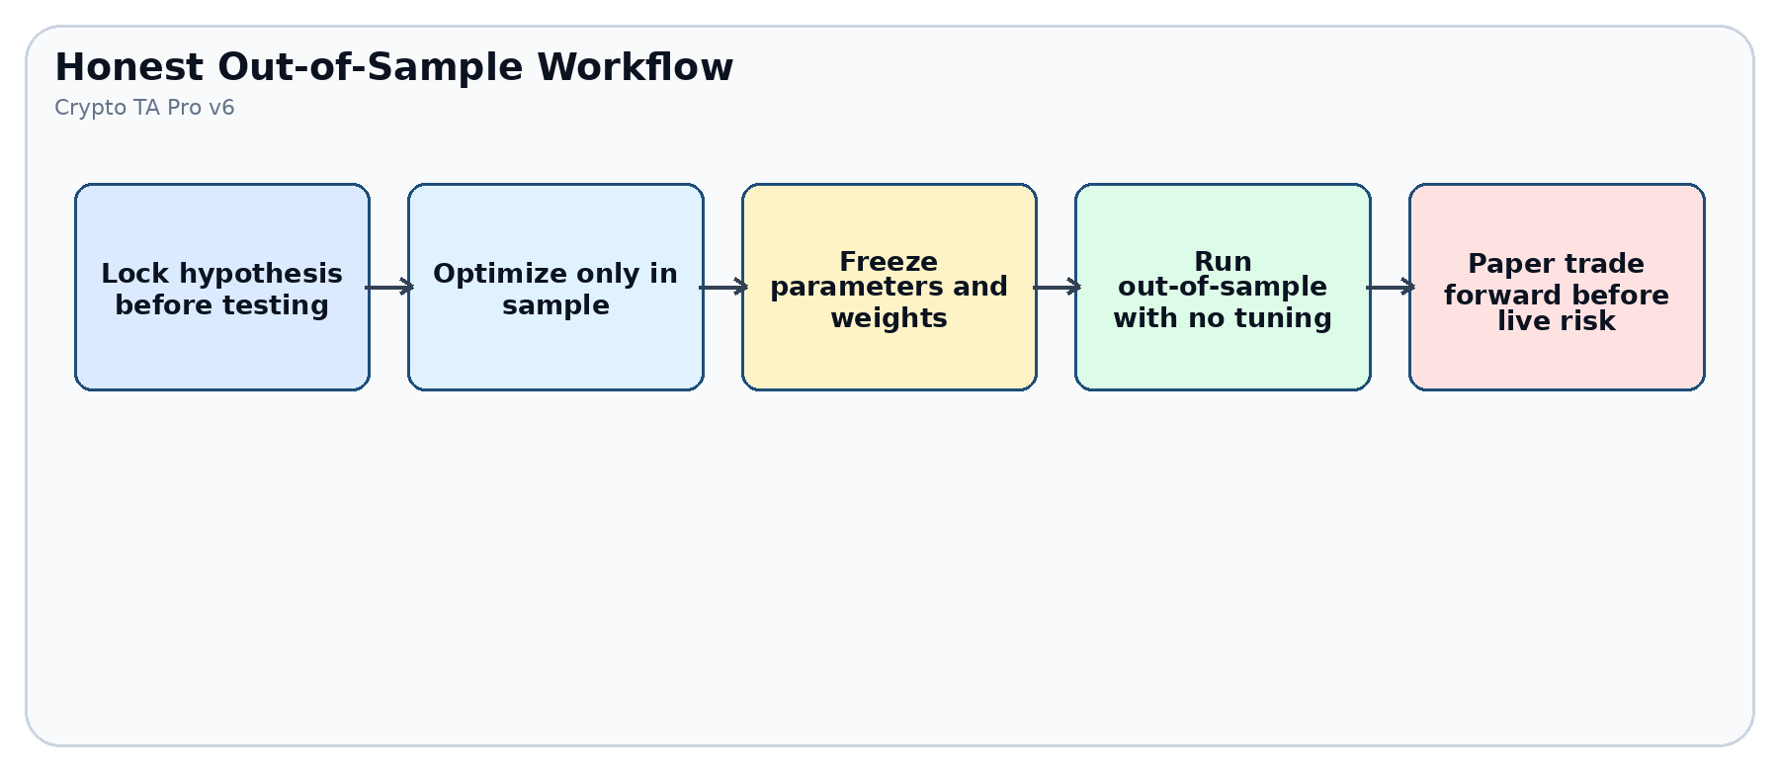
Golden rule
Once you enter an out-of-sample window, you may observe results but you may not tune parameters, weights, date windows, or filters based on that result. If you tune, that period is no longer honest OOS.
Step | Action | What to record | Fail condition
1. Baseline | Run RSI only on in-sample. | Net profit, drawdown, trade count, profit factor, win rate, average R. | Too few trades or undefined risk.
2. Candidate | Unlock exactly one new module. | Delta vs baseline, long/short split, drawdown change. | Improves IS but collapses OOS.
3. Freeze | Lock settings before OOS. | Screenshot/export of inputs. | Any parameter changed after seeing OOS.
4. OOS | Run unseen segment. | Same metrics; compare decay. | Catastrophic drawdown or unstable behavior.
5. Paper | Forward test without retuning. | Alert accuracy and execution behavior. | Missed/duplicate alerts or unexplainable trades.

8. Indicator Unlock Matrix
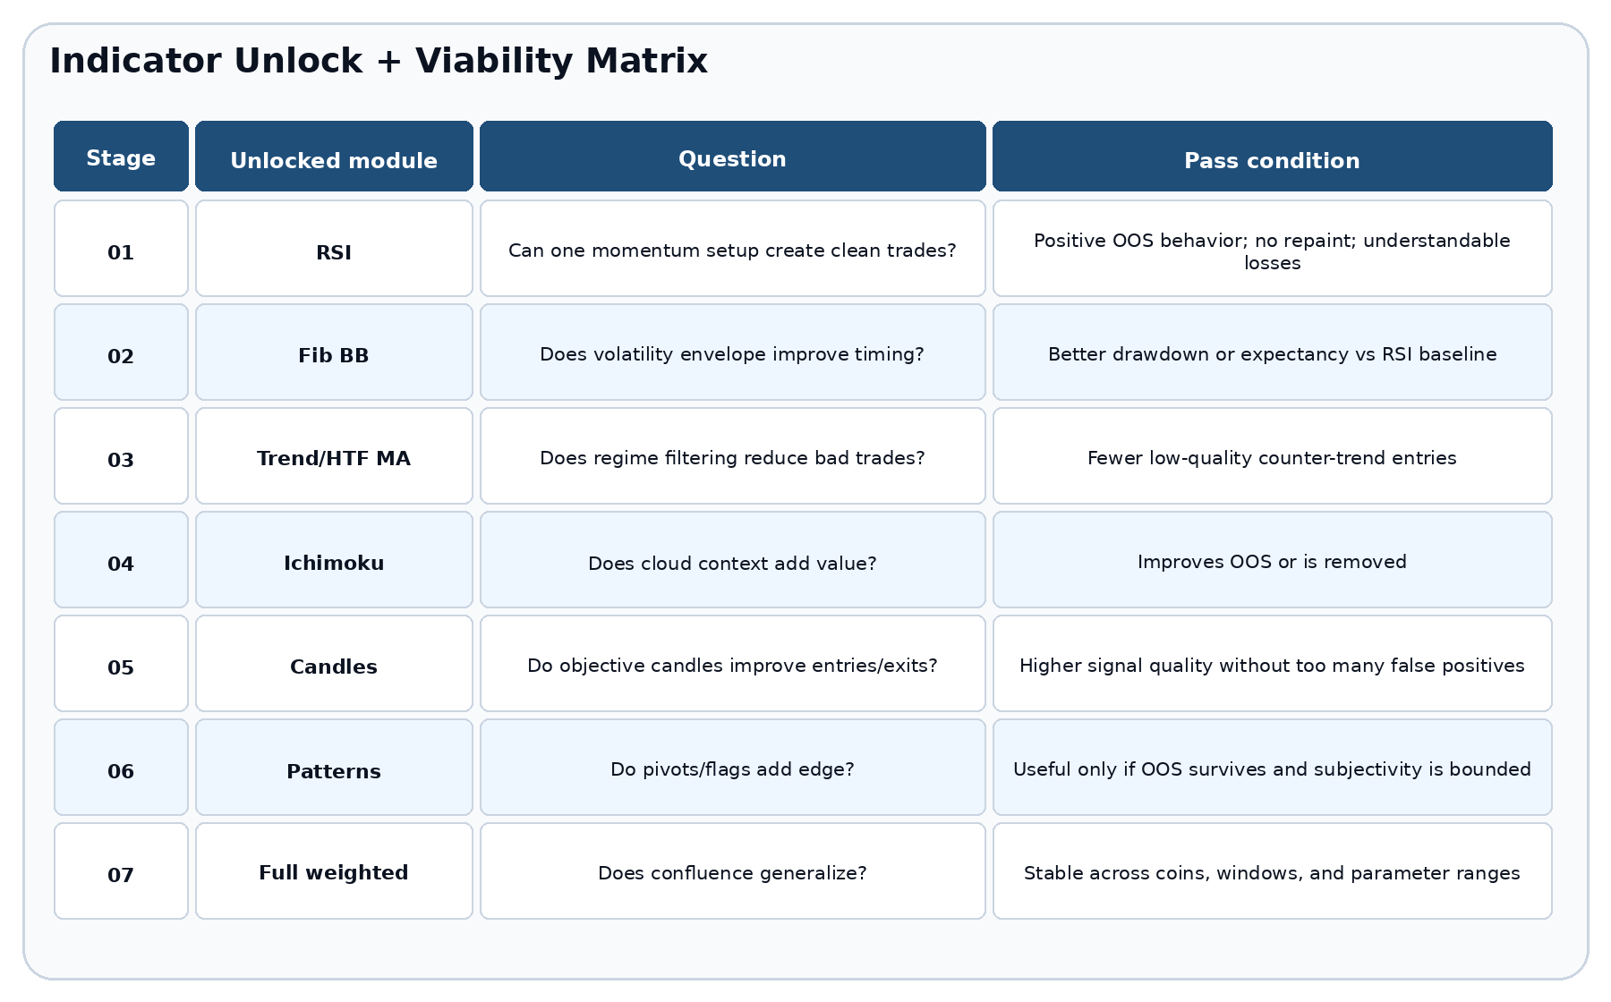
Preset | Modules active | Use case
Custom toggles | Whatever you turn on manually | Exploration after you understand the framework.
01 RSI only | RSI | Minimum viable baseline.
02 RSI + FibBB | RSI, FibBB | Test whether envelope reclaim improves timing.
03 Add Trend/HTF | RSI, FibBB, MA/HTF | Test regime filtering.
04 Add Ichimoku | Adds Ichimoku | Test whether cloud context helps or clutters.
05 Add Candles | Adds candle patterns | Test price-action confirmations.
06 Add Chart Patterns | Adds pivots/flags/wedges | Test structural pattern logic.
07 Full weighted | All enabled modules | Final confluence model only after prior gates.

9. Trading Decision SOP
Question | Green-light answer | Blocker answer
Is the chart standard candles? | Yes; no synthetic chart dependency. | Renko/Heikin Ashi/etc. unless explicitly modeled.
Is the date segment correct? | IS, OOS, or Paper is intentionally selected. | You are mixing tuning and validation windows.
Is a primary setup present? | RSI, FibBB, candle, or pattern event exists. | Only filters are agreeing.
Is the regime allowed? | Trend/HTF gate agrees or is intentionally disabled. | Regime blocks direction.
Is the score high enough? | Long/short score meets threshold. | Score is below threshold or dominated by one noisy module.
Is risk defined? | Stop, target, and R are visible. | No stop, unclear target, or dynamic risk changed unexpectedly.
Is it validated? | OOS/paper behavior is acceptable. | Only in-sample performance looks good.
Paper/live rule
Backtest profit is not proof. Treat it as a candidate. Paper trading tests whether alerts, timing, slippage, and emotional discipline survive live market conditions without risking capital.

10. Readiness Gates: Backtest -> Paper -> Live
Gate | Minimum evidence | Advance only if
Backtest ready | Compiles, no known future leak, commission/slippage modeled, standard candles, clean date windows. | Trades are explainable and risk is defined.
OOS ready | Parameters locked before OOS; no retuning after seeing test segment. | Performance decay is tolerable and drawdown is acceptable.
Paper ready | Strategy survives multiple OOS windows and more than one coin/timeframe. | Alert behavior matches chart behavior.
Small-live ready | Paper trading matches expected behavior over a meaningful sample. | Loss limits, pause rules, and order assumptions are documented.
Scale ready | Small-live fills and drawdowns match model closely enough. | You have a rule-based scale plan and kill switch.
Metric | Why it matters | Red flag
Max drawdown | Shows pain tolerance and capital risk. | One event wipes out many wins.
Profit factor | Gross profit vs gross loss. | High PF with tiny trade count.
Trade count | Determines whether stats are meaningful. | Only a handful of cherry-picked trades.
Avg win/loss | Shows payoff asymmetry. | Wins small, losses large without intended design.
OOS decay | Compares unseen vs tuned performance. | Excellent IS, poor OOS.
Long/short split | Separates directional behavior. | One side carries all performance.

11. Strategy Terminology Glossary
Term | Plain meaning | Use in CTAPv6
Setup | A condition worth watching. | RSI oversold, BB touch, candle event.
Confirmation | The action trigger. | RSI reclaim, BB reclaim, close break.
Vote | A module opinion. | 0.0, 0.5, or 1.0 contribution.
Weight | Importance of the vote. | Input controlling module influence.
Threshold | Score needed for action. | Entry or exit score minimum.
Regime | Market context. | Bull, bear, or neutral MA/HTF state.
R | Risk unit. | Entry to stop distance.
OOS | Unseen validation data. | Used only after settings are frozen.
Repainting | Signal changes after realtime bar resolves. | Reduced with confirmed-bar gate and confirmed HTF option.
Data snooping | Finding patterns by over-searching history. | Controlled by unlock matrix and OOS rules.

12. Source Notes and Implementation References
TradingView Pine Script strategies documentation: https://www.tradingview.com/pine-script-docs/concepts/strategies/
TradingView repainting documentation: https://www.tradingview.com/pine-script-docs/concepts/repainting/
TradingView profiling and optimization documentation: https://www.tradingview.com/pine-script-docs/writing/profiling-and-optimization/
Coinbase Advanced Trade fees: https://help.coinbase.com/en/coinbase/trading-and-funding/advanced-trade/advanced-trade-fees
Gort et al., Deep Reinforcement Learning for Cryptocurrency Trading: Practical Approach to Address Backtest Overfitting: https://arxiv.org/abs/2209.05559
Pham et al., AlgoXpert Alpha Research Framework: https://arxiv.org/abs/2603.09219
Transcript source integration
The teaching structure in this bible is derived from the provided technical-analysis transcript and the provided Pine v6 strategy draft. The Pine deliverable expands the previous script into a staged research framework.

