CRYPTO TA PRO v6
Day-Trading S/R Execution Bible + Long-Hold Companion
A branded, low-cognitive-load guide for building, testing, and explaining CTAPv6 from the bottom up.
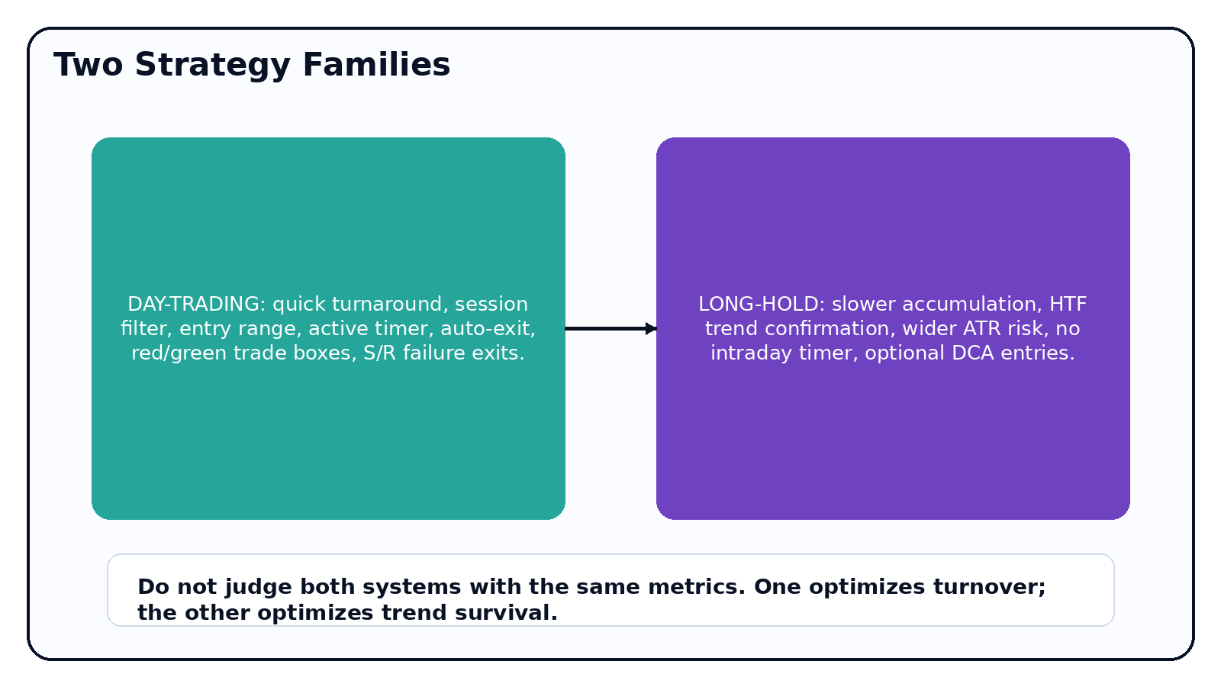
Scope and risk posture
This guide and scripts are for technical research and education. TradingView strategies simulate hypothetical orders. Use standard candles, model fees/slippage, validate out-of-sample, and paper trade before live capital.

1. Executive map
Core idea: price context first, indicator score second, risk/timeout always.
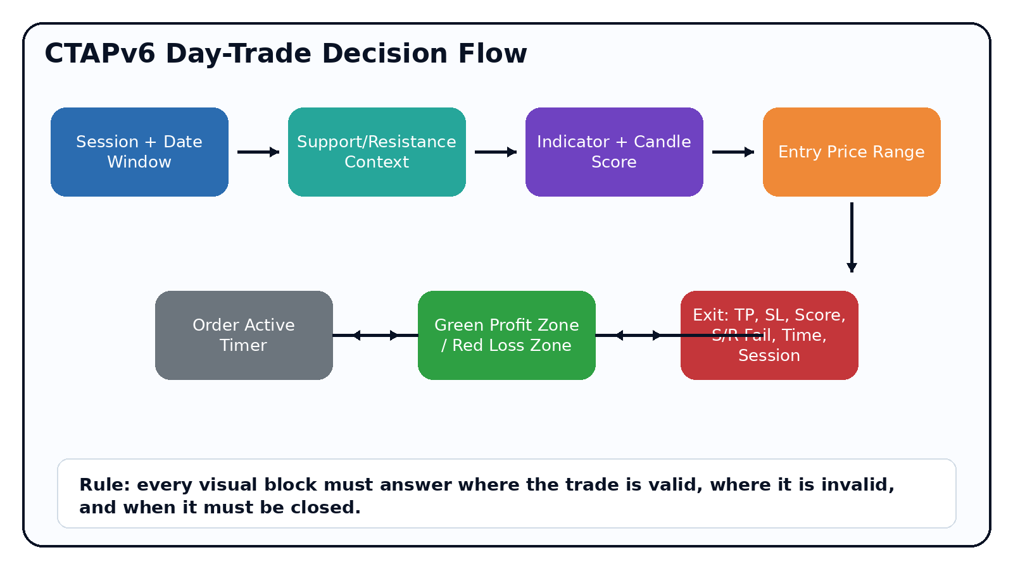
Layer | Question answered | Script feature
Date/session | Am I allowed to open a trade now? | Date windows + session filter + segment gate
Support/resistance | Where is price likely to react? | Pivot zones, support hold/fail, resistance hold/fail
Indicators | Does momentum/regime agree? | RSI, FibBB, MA/HTF, Ichimoku, candles, chart patterns
Entry range | What fill/retest area is acceptable? | ATR/SR/hybrid entry price range box
Trade map | Where is profit/loss/time shown? | Green profit box, red loss box, blue fill range, active timer
Exit | Why did it close? | TP, SL, score exit, S/R fail, session, date, timed exit

2. Day-trading execution model
Day-trading definition for CTAPv6
A quick-turnaround research strategy that expects trades to resolve inside a controlled session or maximum time window. It is not designed to hold indefinite exposure.
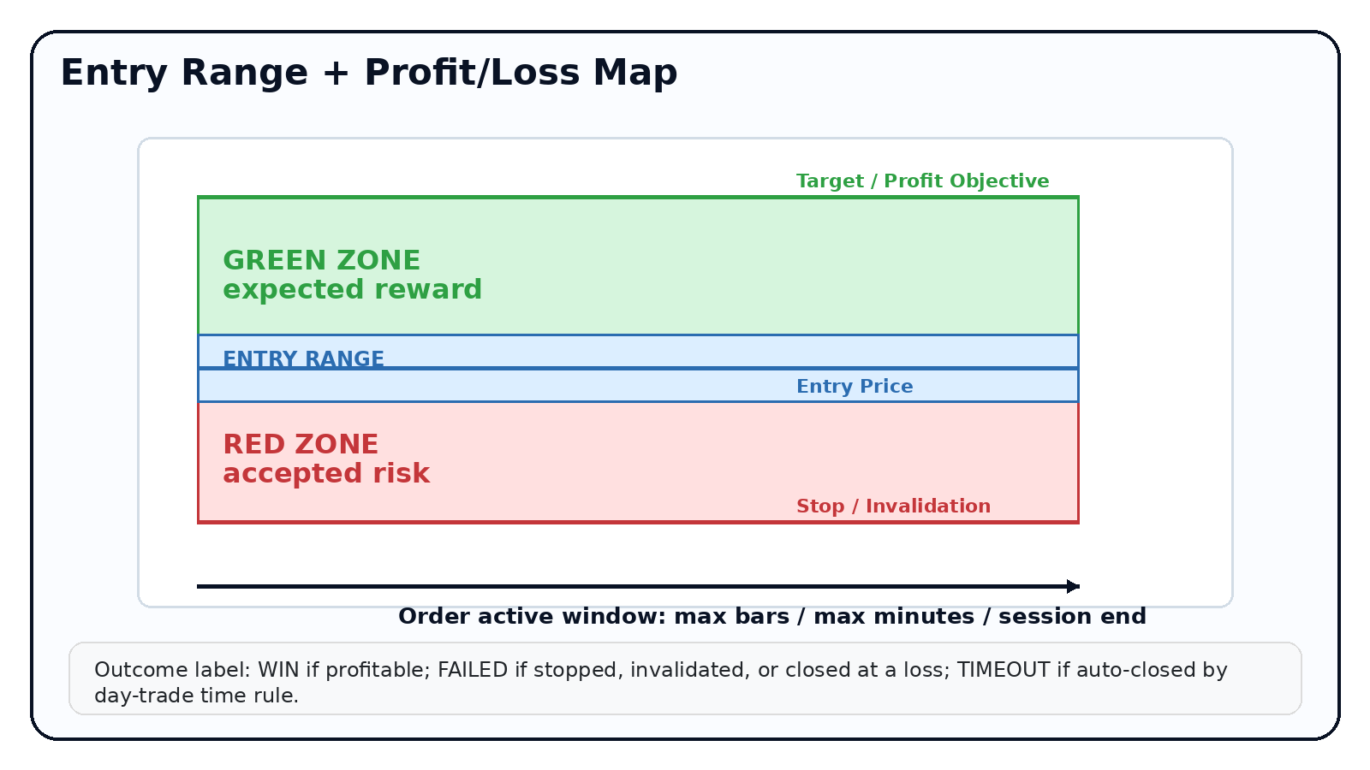
Visual element | Meaning | Decision use
Blue entry range | Acceptable entry/fill/retest area around signal close or nearest S/R zone. | Avoid chasing outside the planned entry context.
Green profit zone | Distance from average entry to target. | Shows expected reward and trade objective.
Red loss zone | Distance from average entry to stop/invalidation. | Shows accepted risk before entry.
Timer label | Bars and minutes since position opened. | Forces day-trade discipline and prevents accidental swing holds.
Outcome label | WIN, FAILED, TIME, SESSION, SCORE, DATE, or S/R. | Makes post-trade review faster and less ambiguous.

3. Support/resistance system
- Support zones are built from confirmed pivot lows plus/minus an ATR-based buffer.
- Resistance zones are built from confirmed pivot highs plus/minus an ATR-based buffer.
- Support hold contributes to long score; support fail can close a long.
- Resistance hold contributes to short score; resistance fail can close a short.
- Entry range can use ATR, nearest S/R zone, or a hybrid ATR + S/R model.
Condition | Long interpretation | Short interpretation
Near support | Potential value/reaction zone. | Potential profit-taking or caution zone.
Support hold | Long confluence: buyers defended the zone. | Short caution: downside may pause.
Support fail | Long invalidation; close if enabled. | Short continuation evidence.
Near resistance | Long caution: upside may pause. | Potential value/reaction zone for shorts.
Resistance hold | Long caution or exit context. | Short confluence: sellers defended the zone.
Resistance fail | Long breakout evidence. | Short invalidation; close if enabled.
Best-practice rule
Support and resistance should not be treated as exact prices. The script uses ATR-buffered zones to reduce false precision.

4. Indicator unlock ladder
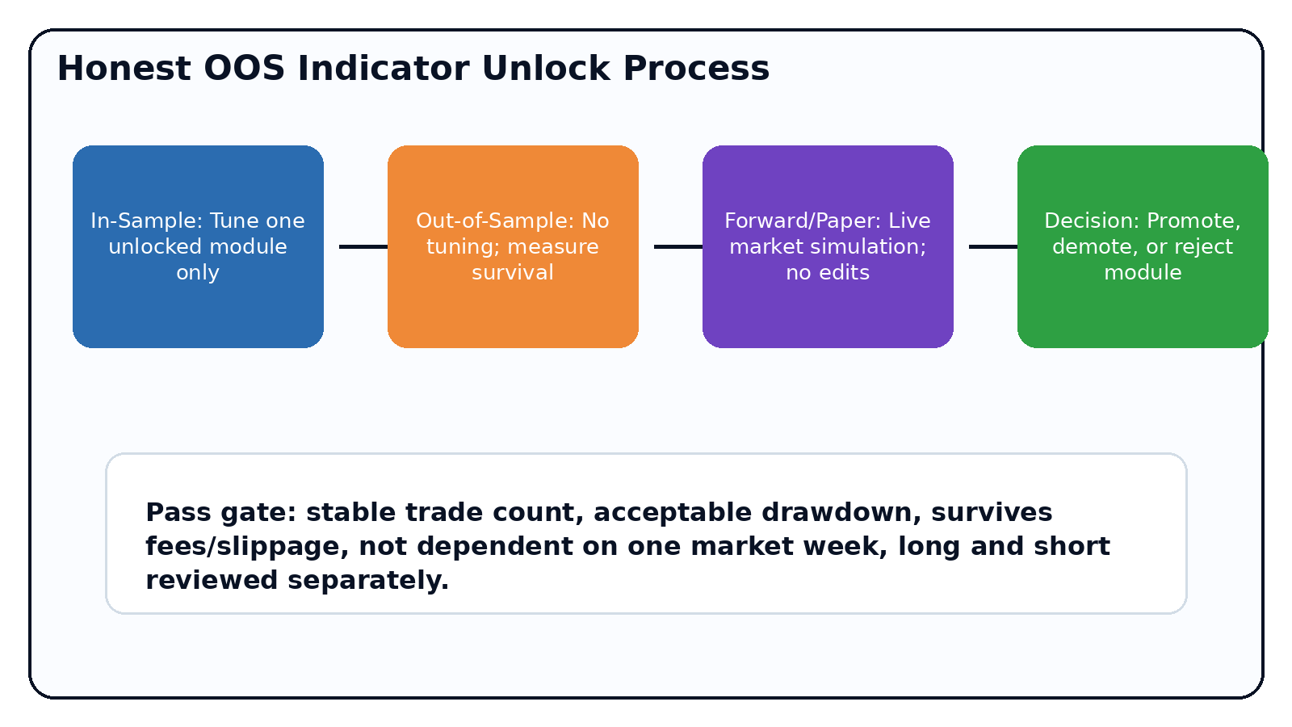
Preset | Unlocked modules | Purpose
01 RSI only | RSI | Baseline momentum setup and reclaim behavior.
02 RSI + S/R | RSI + support/resistance | Tests whether price context improves RSI.
03 Add FibBB | + Fibonacci Bollinger Bands | Tests volatility-envelope exhaustion/reclaim.
04 Add Trend/HTF | + MA and HTF regime | Tests whether trend permission improves expectancy.
05 Add Ichimoku | + Ichimoku | Tests cloud/trend confirmation separately.
06 Add Candles | + candlestick patterns | Tests visual price-action decisions.
07 Add Chart Patterns | + chart/breakout patterns | Tests broader structure patterns.
08 Full weighted | All modules | Only after previous modules survive OOS review.

5. Honest OOS protocol
Step | Rule | Pass / fail check
Freeze hypothesis | Choose one module to unlock before looking at OOS. | No mid-test tuning.
Tune in-sample | Adjust only the newly unlocked module. | Core risk settings stay fixed.
Run OOS | Switch Trade segment to Out-of-sample only. | Must survive without editing.
Forward/paper | Switch to Forward/Paper only. | Alerts and fills must behave as expected.
Decide | Promote, demote, or reject the module. | Document the decision before next module.
- Do not optimize all modules at once; that invites curve fitting.
- Compare each module against the previous accepted version, not against a fantasy perfect strategy.
- Review long and short columns separately in TradingView Strategy Tester.
- Use standard candles. Do not judge this system on synthetic charts unless that is intentionally part of the research design.

6. Day strategy settings map
Group | High-impact inputs | Recommended first-pass stance
Execution | Session, max bars, max minutes, market mode | Keep session/time strict for quick turnaround.
Support/Resistance | Pivot length, ATR buffer, entry range mode | Start Hybrid ATR + S/R with moderate buffer.
Weights | Entry threshold, module weights | Start simple; increase only after OOS.
Risk | Stop model, ATR multiplier, R target | Use modest day-trading R and timed exits.
Visuals | Entry boxes, trade zones, outcome labels | Keep on for educational review.
Visual review loop
After each test, screenshot several trades and verify: entry range respected, green/red zone size makes sense, active timer closes expected trades, and failed trades have a clear invalidation reason.

7. Candlestick decision layer
Pattern | Bullish decision use | Bearish decision use
38.2 pressure candle | Buyers reclaimed upper body area after a wick. | Sellers reclaimed lower body area after a wick.
Engulfing | Current body overtakes prior red body. | Current body overtakes prior green body.
Close above/below | Close breaks previous high. | Close breaks previous low.
Wick rejection | Lower wick shows rejection near support. | Upper wick shows rejection near resistance.
- Candlestick labels are educational visuals first and trading inputs second.
- For the video, show labels before enabling candle influence on entry/exit.
- When candle influence is enabled, keep its weight modest until OOS confirms viability.

8. Long-hold companion model

Dimension | Day-trading script | Long-hold companion
Goal | Quick turnaround inside time/session constraints. | Accumulate and hold while major trend is valid.
Entry | Weighted score near S/R and pattern context. | Trend + HTF confirmation + pullback/near support.
Exit | TP, SL, time, session, score, S/R fail. | Major trend break, HTF bear, catastrophic ATR stop.
Risk | Tighter stops and active timer. | Wider ATR stop and slower invalidation.
Metrics | Win rate, expectancy, average bars in trade. | Max drawdown, time in market, trend survival.

9. TradingView implementation notes
- Paste the .pine file into TradingView Pine Editor and compile before teaching from it.
- Use Coinbase symbols/charts for your target market, but remember backtests are chart-data simulations.
- Keep visuals on while filming: S/R zones, entry range boxes, trade zones, and outcome labels teach the strategy faster than raw numbers.
- When a module fails OOS, do not hide it. Mark it as rejected or reduce its weight and preserve the evidence trail.
Common mistake | Why it hurts | Safer replacement
Adding all indicators at once | No way to know what helped. | Unlock one module at a time.
Treating S/R as exact prices | Creates false precision. | Use ATR-buffered zones.
Ignoring time in trade | Day trades become accidental swings. | Auto-exit by bars/minutes/session.
Optimizing OOS | Turns validation into curve fitting. | Freeze settings before OOS.

10. Operator checklist
Before test | During test | After test
Select one preset and one coin/timeframe. | Do not change settings mid-run. | Record net profit, drawdown, trades, average bars, long/short split.
Confirm session and date range. | Watch visual boxes for obvious logic errors. | Screenshot winners, failures, timeouts, and S/R failures.
Confirm fees/slippage assumptions. | Check alerts if enabled. | Promote, demote, or reject the unlocked module.
Live-readiness reminder
A backtest is not proof. Treat backtest -> OOS -> paper -> small live as separate gates. Do not scale a strategy that has not survived the previous gate without edits.

