Flagship Systems SDLC and Maintenance Cycle
A visual, language-agnostic, agentic handbook for defining, architecting, building, operating, diagnosing, and improving software systems
Version 1.0 | March 18, 2026

Purpose. This handbook is designed to become a flagship grassroots reference for a new software development ecosystem: one that lets a human define intent, constraints, and desired outcomes while an orchestrated AI system translates that definition into architecture, code, tests, deployment paths, diagnostics, and continuous improvement.
Design should reduce ambiguity before implementation begins. Better definition reduces hallucination, clarifies responsibility, and lowers the cost of change.
Grounded in the attached position statement, continuity files, SDLC charter, task-state schema, orchestrator rules, and a curated set of public standards and references.

How to Read This Book
This handbook is intentionally multi-audience. It is meant to help a complete novice understand how systems are structured, help architects visualize and define systems cleanly, help builders implement language-specific solutions from language-agnostic artifacts, and help operators maintain, observe, and improve those systems over time.
Use the book in one of three ways:
- Novice path: Chapters 1–5, then Chapter 16 and the appendices.
- Architecture path: Chapters 2–8, then the visualization and hardening appendices.
- Execution path: Chapters 9–15, then the templates and checklists.
Operating principle. Do not treat the SDLC as only a coding workflow. Treat it as a system-definition workflow that continuously produces artifacts, decisions, telemetry, and learning.

Contents
- 1. Position, doctrine, and system intent
- 2. A visualization grammar for software systems
- 3. The universal SDLC and maintenance cycle
- 4. Artifact authority, source of truth, and continuity
- 5. Agentic orchestration and sub-agent execution
- 6. Architecture, boundaries, and responsibility
- 7. Execution models, concurrency, load, and timing
- 8. Frontend, interface, and user-experience engineering
- 9. Backend, data, and API architecture
- 10. Cloud, platform, deployment, and CI/CD
- 11. Observability, diagnostics, performance, memory, and reliability
- 12. Security, compliance, and supply-chain integrity
- 13. AI system engineering and agentic implementation
- 14. Maintenance, incident response, and continuous refinement
- 15. Maturity model and adoption roadmap
- 16. Novice-to-expert implementation path
- Appendix A. Visualization catalog
- Appendix B. Concept clusters and terminology banks
- Appendix C. Templates, prompts, and checklists
- Appendix D. References and internal source packet

1. Position, Doctrine, and System Intent
This handbook extends the position that software should be defined more deliberately before implementation begins. In this model, the human remains accountable for mission, constraints, business intent, risk tolerance, and acceptance criteria, while AI systems are used to transform those decisions into consistent, testable, and reviewable implementation outputs [I01][I04][I06].
The primary claim is simple: better visualization and better definition reduce ambiguity. Reduced ambiguity lowers implementation drift, limits hallucination, clarifies handoffs, and increases the odds that a system can be reproduced, audited, and upgraded safely. That is true whether the system is a UI, backend service, extension, workflow engine, CLI, data pipeline, integration layer, or multi-agent platform [I01][I02].

Doctrine: the rules of the ecosystem
- Humans own intent, priorities, ethics, and approval boundaries.
- AI agents own transformation work only inside declared guardrails.
- Every meaningful decision produces an artifact.
- Every artifact has an owner, a source of truth, and an update rule.
- Every phase has explicit entry criteria, exit criteria, and verification.
- Every runtime must be observable, diagnosable, and recoverable.
- Every deployment path must support rollback, rate control, and safe release.
- Every system must be designed for maintenance, not just initial delivery.
Why this matters. A system becomes teachable and maintainable when its structure, decisions, and operational behavior are visible. A system becomes agentic in a trustworthy way only when those same decisions are machine-readable and resumable.

The flagship mental model
A modern development ecosystem should work like a definition engine. An idea is translated into a progressively less ambiguous set of artifacts: mission, glossary, context, requirements, diagrams, contracts, state models, acceptance criteria, tests, deployment plan, observability plan, and maintenance plan. Only after those artifacts exist should the ecosystem choose a language, framework, cloud platform, or code generator.
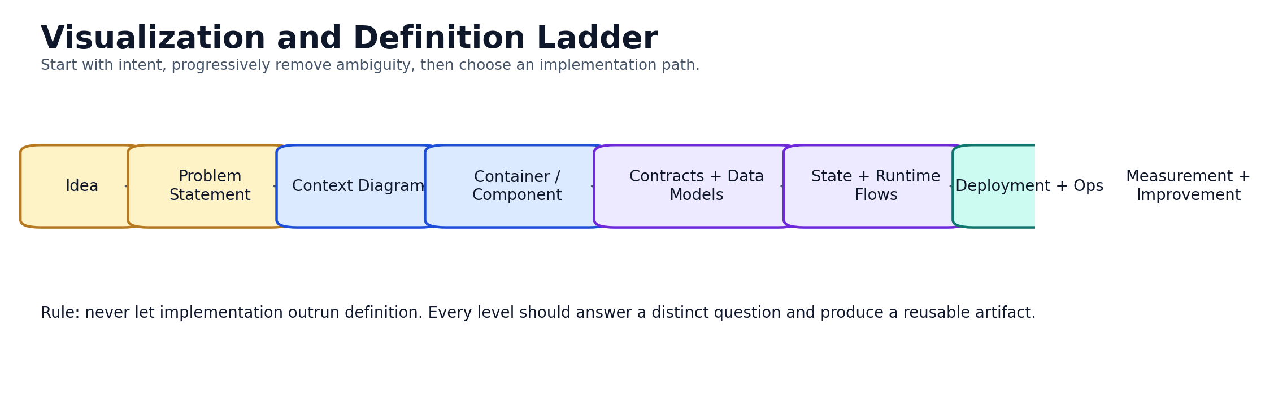
Figure 1. Visualization and definition ladder. Use it to remove ambiguity before implementation begins.

2. A Visualization Grammar for Software Systems
Visualization is not decoration. It is an analytical language. Good diagrams answer specific questions for specific audiences and deliberately suppress irrelevant detail. A good system context diagram is not improved by showing every class, and a good deployment diagram is not improved by showing every user story.
The most useful approach is to choose diagrams by decision need. The C4 model is especially helpful because it provides a simple hierarchy—software system, container, component, and code—plus landscape, dynamic, and deployment diagrams [E08][E09].

Choose the visual that answers the question
Visualization | Question answered | Primary audience
System context | What is the system, who uses it, and what surrounds it? | Leaders, product, architecture, operators
System landscape | How does this system fit inside a portfolio or ecosystem? | Enterprise, platform, leadership
Container diagram | What major runtime units exist and how do they communicate? | Architecture, dev, ops
Component diagram | What modules live inside a container and what do they do? | Architecture, dev
Dynamic / sequence view | How does a scenario execute over time? | Dev, QA, operators
State machine | What states can the system enter and what transitions are legal? | Dev, QA, reliability
Deployment diagram | Where does each runtime live in dev, staging, and production? | Platform, SRE, security
Data flow / event flow | How does information move, transform, and persist? | Data, integration, architecture
Trust boundary diagram | Where do permissions, identity, or sensitivity levels change? | Security, architecture
Observability map | Where do logs, metrics, traces, and alerts come from? | Ops, SRE, debugging
Incident timeline | What happened, in what order, and with what evidence? | Operations, leadership, postmortems

Practical diagram rules
- One diagram, one question.
- Every diagram should have a title, scope, audience, and legend.
- Name boundaries explicitly: system boundary, trust boundary, data boundary, runtime boundary.
- Use arrows intentionally. Unlabeled arrows usually hide assumptions.
- Show ownership, not just connectivity.
- Keep dynamic diagrams for meaningful scenarios and failure paths.
- Create separate deployment views per environment when the topology changes across development, staging, and production.
- Do not overload a single diagram with both static structure and operational detail unless that detail is the point of the diagram.
Minimum visual set for most systems. System context → container diagram → one dynamic/sequence view → one deployment view → one observability map. Expand beyond this only when the system’s complexity justifies it.
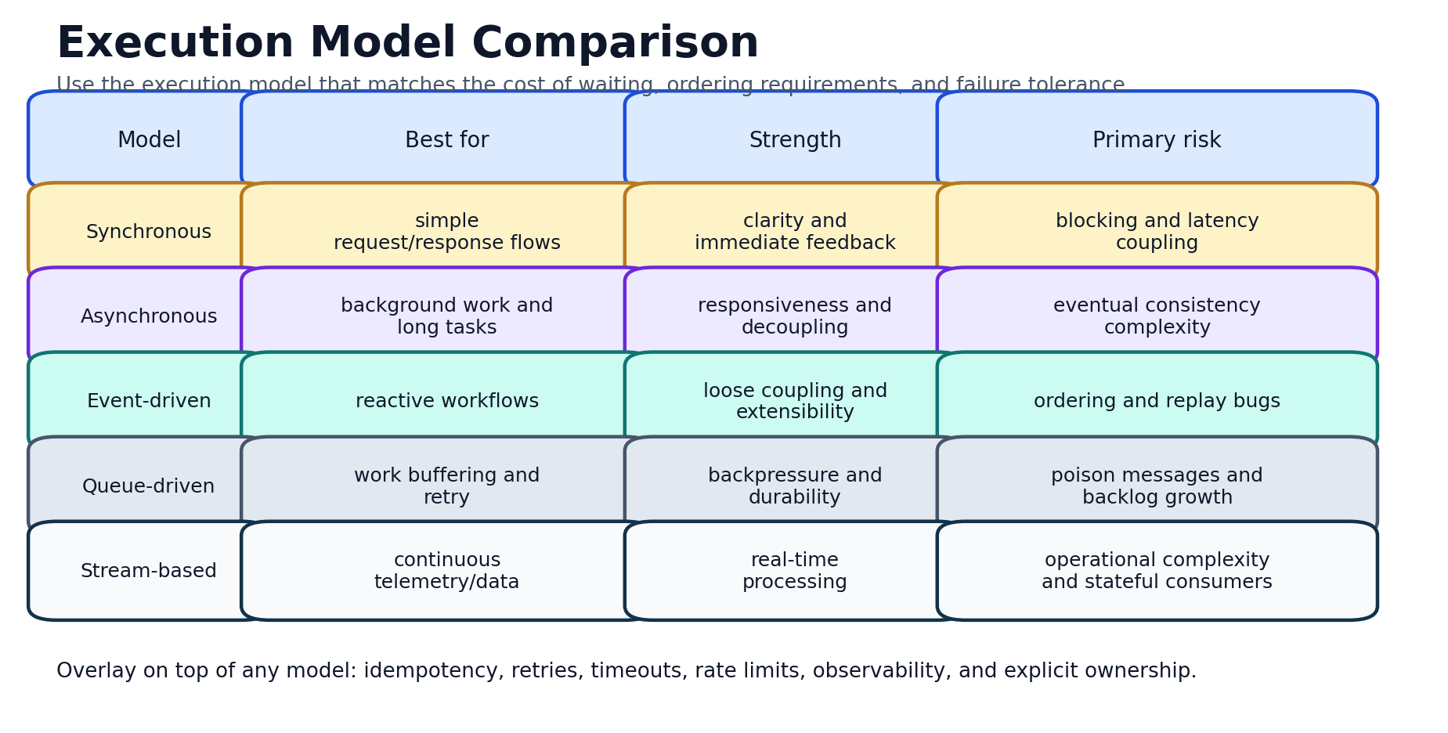
Figure 2. Execution model comparison. This is often the missing bridge between static diagrams and real runtime behavior.

3. The Universal SDLC and Maintenance Cycle
A useful SDLC is not a list of ceremonies. It is a repeatable lifecycle with phase outputs, phase gates, and continuous feedback. The internal continuity files in your attached source pack already model part of this discipline through current task state, branch phase, next command set, artifacts, and done criteria [I02][I03][I04][I05][I06].
For a language-agnostic ecosystem, the SDLC should be phrased in terms of artifacts and evidence rather than tooling. The recommended lifecycle is: Discover, Define, Visualize, Architect, Plan, Implement, Verify, Release, Operate, Diagnose, Improve.
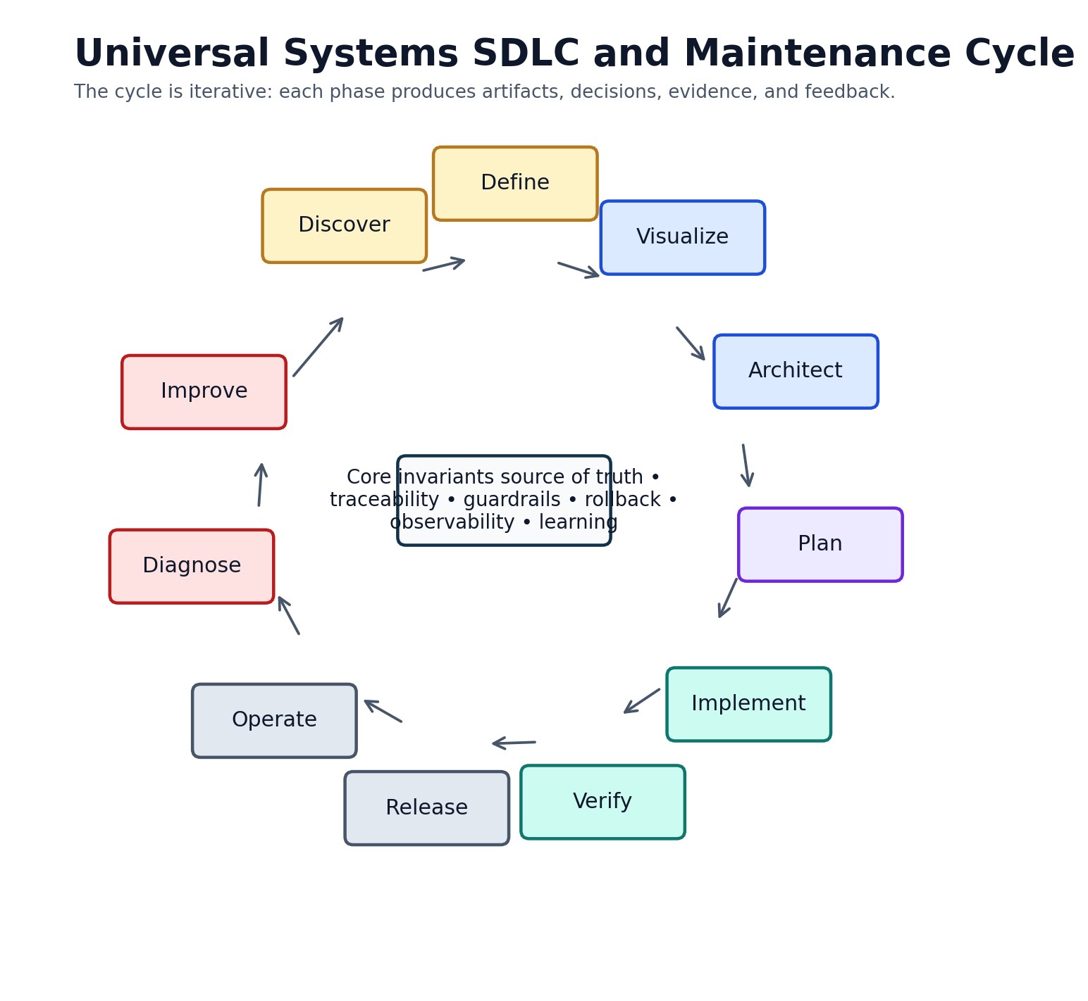
Figure 3. Universal SDLC and maintenance cycle.
Phase | Primary objective | Required outputs
Discover | Clarify the user, problem, constraints, risks, and desired outcomes. | problem statement, user map, constraints, glossary
Define | Write measurable acceptance criteria and explicit non-goals. | scope, success metrics, DoR, risks
Visualize | Choose the diagrams and system views required to remove ambiguity. | context, containers, runtime flows, boundaries
Architect | Select structure, responsibilities, contracts, state ownership, and qualities. | ADRs, interfaces, schemas, state models
Plan | Create task breakdown, test strategy, rollout path, and rollback path. | backlog, task state, verification plan
Implement | Generate or write code, configuration, infrastructure, and docs. | code, IaC, workflows, fixtures
Verify | Prove behavior at unit, integration, E2E, performance, security, and accessibility levels. | tests, reports, sign-off evidence
Release | Promote builds safely through environments and controlled rollout. | artifacts, release notes, deployment logs
Operate | Observe behavior in production and compare it with intended behavior. | dashboards, alerts, SLOs, runbooks
Diagnose | Investigate failures, regressions, capacity issues, and anomalies. | incident notes, traces, profiles, heap snapshots
Improve | Feed what was learned back into architecture, standards, automation, and backlog. | postmortems, ADR updates, new guardrails

Phase gates
- Definition of Ready: goal, scope, acceptance criteria, risks, rollback idea, and test outline.
- Definition of Done: acceptance criteria passed, tests added, docs updated, operational impact reviewed.
- Release gate: build artifacts produced, environment-specific configuration validated, staged verification green, rollback rehearsed.
- Operate gate: telemetry, alerting, runbooks, and owner assignment exist before declaring a system production-ready.

4. Artifact Authority, Source of Truth, and Continuity
Systems fail when artifacts disagree. A requirements document says one thing, the task tracker says another, the code implements a third interpretation, and the dashboard measures none of them. A healthy ecosystem solves this by establishing an authority stack: doctrine, phase state, architecture records, contracts, implementation, verification, and operations evidence.
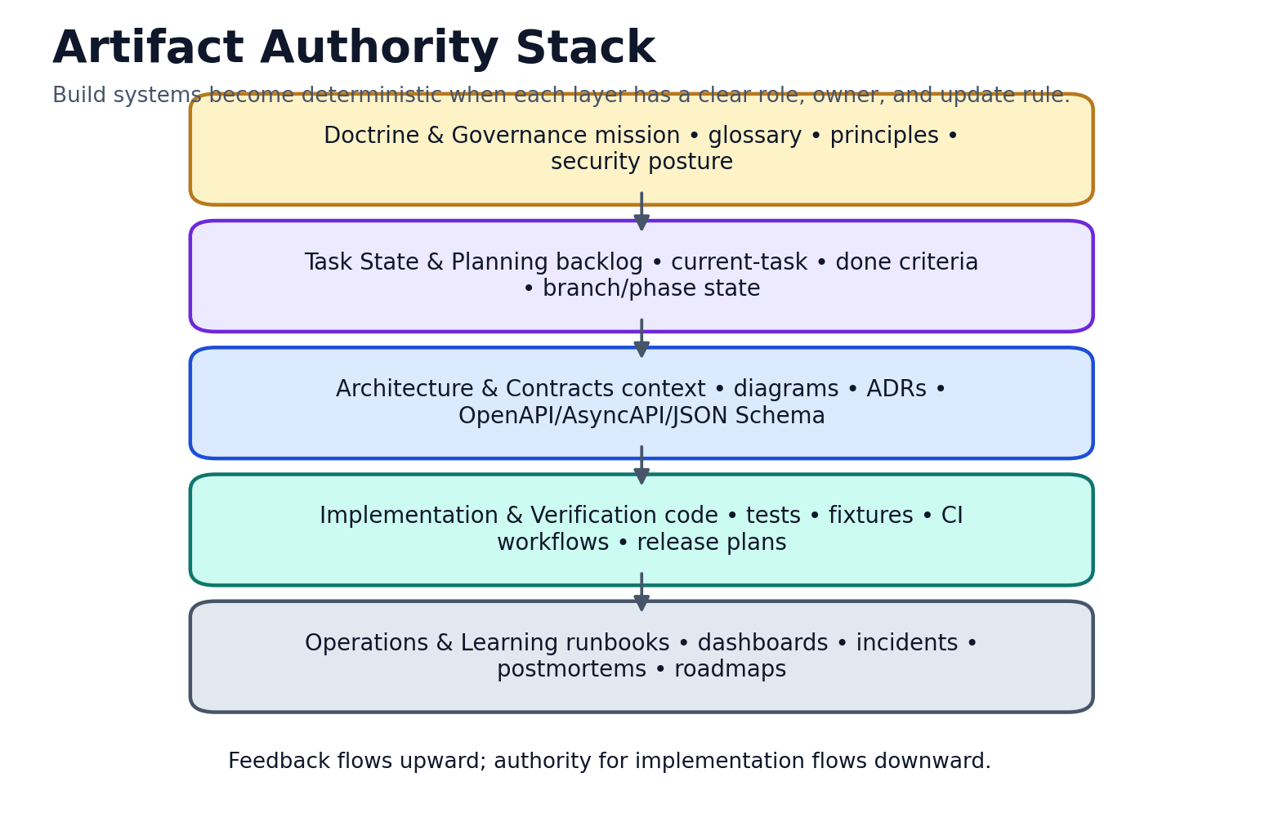
Figure 4. Artifact authority stack. Upward feedback improves doctrine; downward flow drives implementation.

Recommended artifact stack
- Position statement or product doctrine.
- Glossary and terminology bank.
- Charter, guardrails, and definition of authority.
- Machine-readable task state and handoff continuity.
- Architecture Decision Records (ADRs).
- Context, container, and deployment diagrams.
- Contracts and schemas (OpenAPI, AsyncAPI, JSON Schema where applicable) [E10][E11][E23].
- State model and execution model.
- Implementation backlog and change plan.
- Code, configuration, infrastructure, and feature flags [E12].
- Verification evidence: unit, integration, E2E, performance, accessibility, and security.
- Operational assets: dashboards, alerts, runbooks, release notes, postmortems.

Continuity pattern
The attached continuity files already demonstrate a pattern worth generalizing: machine-readable state, human-readable charter, project-local handoff docs, and a known verification command set [I02][I03][I04][I05]. This should become standard for agentic development because resumability is a first-class requirement, not an afterthought.
Rule. If an AI system cannot determine the current phase, active branch, next verification commands, blocked conditions, and done criteria from committed artifacts, the development process is not yet deterministic.

5. Agentic Orchestration and Sub-Agent Execution
An agentic SDLC does not mean “let agents code freely.” It means a coordinator decomposes work into typed tasks, assigns those tasks to specialist agents, and requires every task to inherit context, guardrails, test obligations, and exit criteria.
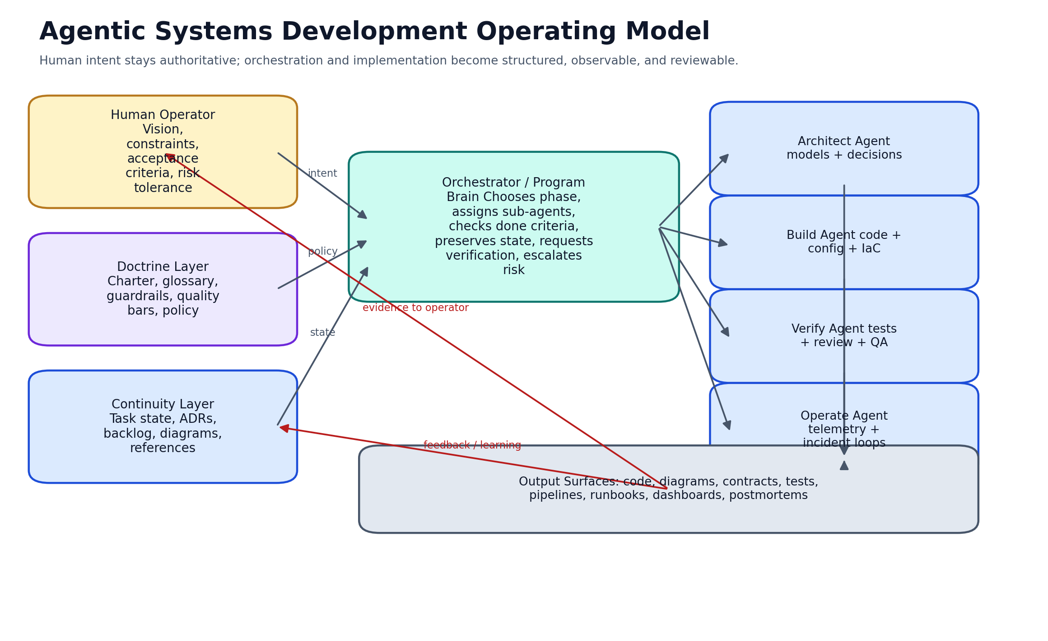
Figure 5. Agentic operating model: human intent remains authoritative while the orchestrator coordinates specialist agents.
Agent | Responsibility | Primary outputs
Orchestrator | Choose phase, assign work, enforce done criteria, preserve continuity. | updated task state, work orders, escalations
Context curator | Assemble source packet, references, artifacts, and known constraints. | clean working context
Systems architect | Define structure, boundaries, contracts, and key decisions. | diagrams, ADRs, architecture notes
Builder | Implement code, config, IaC, and scripts from approved artifacts. | implementation outputs
Verifier | Run tests, review flows, inspect artifacts, compare expected vs actual. | test reports, defects, confidence summary
Security reviewer | Assess permissions, secrets, trust boundaries, and supply-chain concerns. | security findings, control recommendations
Performance reviewer | Profile, measure hot paths, capacity, churn, and resource usage. | performance baselines, tuning plan
Docs/release agent | Package outputs, update runbooks, release notes, diagrams, and reference bundles. | deliverables and publication artifacts

Agent execution rules
- Every sub-agent receives explicit inputs, constraints, and expected outputs.
- No sub-agent may silently change the authoritative source of truth.
- Every generated artifact must be attributable to a task, phase, or decision.
- High-risk actions require human approval or a policy gate.
- Verification agents must be independent enough to disagree with build agents.
- Release agents must consume evidence, not assumptions.
Good default. Build a system in which the orchestrator thinks in phases, not prompts; in artifacts, not chat history; and in contracts, not vibes.

6. Architecture, Boundaries, and Responsibility
Architecture is the assignment of responsibility under constraints. It defines not only what exists, but what is allowed to talk to what, what owns state, what can fail, what must recover, and what evidence is required to trust the result.

Boundary vocabulary
- System boundary: what is in scope and what is external.
- Trust boundary: where identity, permission, or sensitivity changes.
- Responsibility boundary: which component owns behavior or state.
- Runtime boundary: which process, worker, or environment executes a concern.
- Data boundary: where data is created, transformed, stored, and redacted.
- Control boundary: who can issue commands, deployments, or approvals.

Architecture styles to know
- Layered architecture: presentation, business logic, data access.
- Hexagonal / ports-and-adapters: domain core with external interfaces at the edge.
- Modular monolith: one deployable unit with strong internal boundaries.
- Microservices: independently deployable services with explicit contracts.
- Event-driven architecture: producers and consumers connected by events or streams [E11].
- Pipeline architecture: ordered stages of transformation.
- Plugin / extension architecture: stable host with dynamically attached capabilities.
- Client-host-server and tool-protocol architectures for agentic ecosystems [E24].

Architecture decisions should be recorded
ADRs provide a disciplined way to capture a single architecturally significant decision together with its context, options, consequences, and rationale. Use ADRs whenever a design choice changes the cost, behavior, or risk profile of the system [I07].
Architectural Decision Records (ADRs) help teams capture a justified design choice and its trade-offs in a durable form. They are especially useful for agentic systems because they convert tacit reasoning into an artifact that can be reviewed, cited, and reused [I07].

7. Execution Models, Concurrency, Load, and Timing
A great many failures are not caused by bad business logic, but by choosing the wrong execution model or by ignoring the consequences of timing. This is where concepts such as synchronous versus asynchronous execution, threading, queues, locking, event ordering, backpressure, rate control, and load distribution become foundational rather than optional.

Execution model selection
- Use synchronous execution when ordering is simple and the cost of waiting is acceptable.
- Use asynchronous execution when user responsiveness matters or work may outlast the request.
- Use event-driven flows when you need loose coupling, replay, or multiple downstream reactions.
- Use queues when you need buffering, retry, backpressure, and durable work handoff.
- Use streaming when data is continuous and low-latency processing matters.

Concurrency concepts to model explicitly
- Thread, process, worker, execution context, event loop, task queue, microtask queue, callback, promise/future, await point.
- Fan-out, fan-in, barrier, mutex, semaphore, lock, critical section, atomic operation, ordering guarantee, happens-before relationship.
- Deadlock, livelock, starvation, contention, out-of-order completion, stale reads, duplicate work, split-brain state, retry race.

Load and stability controls
- Rate limiting and throttling for consumer protection.
- Backpressure for overload control.
- Token bucket or leaky bucket for rate governance.
- Circuit breakers for unstable dependencies.
- Retries only where operations are idempotent and bounded.
- Timeouts, budgets, and explicit cancellation.
- Queue depth, latency, tail latency, throughput, and resource saturation as first-class operational signals.
Heuristic. If a path cannot explain its retry policy, timeout policy, idempotency strategy, and ordering assumptions, the path is not production-ready.

Load balancing and work distribution
Load balancing exists at several layers: request routing across service instances, job distribution across workers, queue consumption across consumers, and even task selection across agents. Choose the simplest strategy that matches your constraints: round robin for simplicity, weighted strategies for heterogeneous capacity, least-connections or least-latency strategies for adaptive routing, and queue-driven distribution when work must be decoupled from the request path.

Memory and runtime concepts
Many reliability issues are really memory issues: excessive allocation, retained objects, detached DOM nodes, listener leaks, timer leaks, observer leaks, serialization overhead, or repeated storage writes that produce churn. A serious diagnostics culture must therefore understand heap, stack, object lifetime, reachability, garbage collection, GC pressure, allocation pressure, heap growth, memory leaks, retainer paths, and flame charts. These concepts are part of the operating literacy of any mature engineering team [I01].

8. Frontend, Interface, and User-Experience Engineering
Frontend engineering should be specified independently of any single framework. Think in terms of information architecture, navigation model, content model, state model, interaction model, accessibility model, and rendering strategy first. React, Vue, Svelte, vanilla web components, native mobile shells, or server-rendered HTML are implementation choices that come later.

Framework-agnostic frontend model
- Information architecture: pages, views, tasks, navigation routes, and content hierarchy.
- State architecture: local state, shared state, cached state, persisted state, derived state, and authority.
- Interaction architecture: forms, shortcuts, undo/redo, optimistic updates, focus order, empty states, error states, and progressive disclosure.
- Rendering architecture: client-rendered, server-rendered, edge-rendered, hybrid, incremental, or static.
- Design system: tokens, spacing, typography, controls, icons, motion, and accessibility patterns.

Frontend quality bars
- Accessible by design, not retrofitted at the end. WCAG 2.2 is the current recommended baseline [E13][E14].
- Responsive across viewport classes and input modalities.
- Observable through user-visible signals, analytics, errors, and performance metrics.
- Performant under realistic network and device constraints.
- Stateful without drift: every persisted control must have an authority and a reconciliation strategy.
- Recoverable: the user should understand what happened and what to do next.

Frontend artifacts to require
- Site map or route map.
- Screen inventory and component inventory.
- State chart or view model per major workflow.
- Accessibility acceptance criteria.
- Loading, empty, degraded, and failure-state designs.
- Interaction telemetry plan.

9. Backend, Data, and API Architecture
Backend design should begin with domain language, business capabilities, and contract boundaries. A backend is not just a collection of handlers; it is a system that owns decisions about validation, persistence, transactions, message flows, durability, authorization, data retention, auditability, and operability.

Backend design questions
- What domain capabilities exist and which component owns each one?
- What is synchronous, what is asynchronous, and what is eventually consistent?
- What data is authoritative, derived, cached, or ephemeral?
- What APIs are public, private, internal, or third-party?
- What retry, timeout, and idempotency rules apply to each boundary?
- What personally identifiable, regulated, or sensitive data exists, and where?

Contract-first systems
For HTTP APIs, use OpenAPI as the contract backbone [E10]. For event-driven systems, use AsyncAPI as the contract between senders and receivers [E11]. For task state, configuration, payload validation, and machine-readable structured artifacts, use JSON Schema or an equivalent schema language [E23].

Data techniques to know
- Relational modeling, document modeling, key-value, graph, and time-series patterns.
- Normalization and denormalization.
- Read models and write models.
- Caching and cache invalidation.
- Schema migration and schema compatibility.
- Event sourcing, outbox pattern, change data capture, and replay.
- Data lineage, provenance, classification, and retention policies.

API and integration techniques
- Versioning, compatibility guarantees, deprecation policy, and sunset policy.
- Pagination, partial failure handling, correlation IDs, idempotency keys.
- Webhook signing, replay defense, and delivery receipts.
- Message contracts, dead-letter queues, poison-message handling, and consumer lag.

10. Cloud, Platform, Deployment, and CI/CD
A deployment model is part of the architecture, not an afterthought. Every system should define how it is built, how it is packaged, how configuration is injected, how environments differ, how releases are promoted, how changes are rolled back, and how evidence is preserved.

Platform principles
- Separate build, release, and run stages [E15].
- Store environment-specific configuration outside the codebase [E15].
- Treat logs as event streams [E15].
- Use explicit environment promotion: preview, development, staging, production.
- Automate build, test, package, deploy, smoke test, and rollback where practical.
- Protect production with approvals, concurrency controls, and least-privilege credentials [E16].

CI/CD pipeline anatomy
Stage | Typical outputs
Source & review | branching, PR checks, ADR updates, docs diffs, static analysis
Build | compile, bundle, dependency lock, package, SBOM, provenance
Verify | unit, integration, contract, E2E, accessibility, security, performance
Publish | artifact registry, versioning, release notes, signatures
Deploy | preview → staging → production with environment-specific controls
Observe | health checks, canaries, dashboards, rollout metrics, rollback triggers

Deployment strategies
Strategy | How it works | When to use it
Rolling | replace instances gradually | simple for stateless services
Blue-green | switch traffic from one complete environment to another | strong rollback posture
Canary | progressively increase exposure | excellent for high-risk changes
Shadow / mirror | duplicate traffic for observation only | useful for system comparison
Feature-flag rollout | release code before enabling behavior | great for incremental exposure and kill switches [E12]

Pipeline reuse and orchestration
GitHub Actions illustrates a useful pattern even if you later choose another CI platform: reusable workflows, environment controls, approval gates, concurrency limits, and OIDC-based cloud authentication [E16][E17]. The key lesson is not “use GitHub” but “centralize workflow logic, preserve reviewability, and reduce duplication in deployment policy.”

Cloud and infrastructure techniques to know
- Infrastructure as Code (IaC).
- Immutable artifacts and image promotion.
- Secrets management and short-lived credentials.
- Network segmentation and zero-trust access models.
- Autoscaling, capacity buffers, and queue-based smoothing.
- Multi-region and disaster-recovery planning where the objective requires it.

11. Observability, Diagnostics, Performance, Memory, and Reliability
Observability is the ability to understand a system from the outside by asking questions using emitted signals—logs, metrics, traces, and related context [E01]. A mature system does not merely log errors; it produces enough telemetry to answer “what happened?”, “why did it happen?”, “what changed?”, and “what should we do next?”

Core observability stack
- Logs for discrete events and explanatory context.
- Metrics for rates, counts, durations, saturation, and budgets.
- Traces for end-to-end request or workflow visibility [E01].
- Profiles for CPU and memory behavior.
- Events and audit trails for significant state transitions.
- Dashboards, alerts, SLOs, and runbooks for operational response.

Reliability measurements
DORA’s current guidance defines five software delivery performance metrics: change lead time, deployment frequency, failed deployment recovery time, change fail rate, and deployment rework rate [E18]. Use them to measure delivery behavior, then combine them with service-level indicators (SLIs), service-level objectives (SLOs), and error budgets to measure user-facing reliability [E01].

Performance and memory techniques
Technique | What it solves | Where to apply it
Sampling | reduces telemetry overhead while preserving insight | high-volume logs, traces, events
Batching and buffering | reduces write amplification and network chatter | telemetry export, queue flush, storage writes
Debounce / throttle | limits repeated work in noisy paths | UI handlers, observers, polling
Backpressure | prevents overload by slowing producers | queues, stream consumers, APIs
Ring buffers | bound memory use for high-frequency diagnostics | runtime debug stores, rolling logs
Heap snapshots and retainer trees | reveal leak sources and retention paths | memory regressions
Flame charts and profiling | find hot paths and blocking work | rendering, API handlers, workers
Circuit breakers + timeouts | contain unstable dependencies | third-party services, internal RPC
Idempotency + retries with jitter | improve resilience without duplicating side effects | network paths, queue consumers

Reliability patterns
- Timeouts everywhere a dependency can stall.
- Retries only for transient faults and only when side effects are controlled.
- Circuit breakers and bulkheads for unstable integrations.
- Graceful degradation when a non-critical dependency fails.
- Health checks, readiness checks, and kill switches.
- Postmortems that feed architecture and standards, not blame.

12. Security, Compliance, and Supply-Chain Integrity
Security must be integrated into the SDLC rather than appended to it. NIST’s SSDF is designed specifically to integrate secure practices into any SDLC implementation [E02]. OWASP ASVS gives you a verification vocabulary for application controls [E06], while OWASP SAMM helps you assess and improve security maturity across the lifecycle [E07].

Security architecture essentials
- Threat modeling and trust boundary analysis.
- Authentication, authorization, least privilege, and session controls.
- Secrets management and credential rotation.
- Input validation, output encoding, and schema enforcement.
- Dependency governance and vulnerability management.
- Encryption at rest and in transit where sensitivity requires it.
- Security logging and tamper-evident audit trails.

Supply-chain integrity
Modern delivery systems should generate software bills of materials (SBOMs) and provenance evidence. SPDX and CycloneDX are the two most important open ecosystems to know [E20][E21][E22]. SLSA provides a progressive model for improving build and artifact integrity over time [E19].

AI-specific secure development
When your system includes models or agents, extend the SDLC to cover model artifacts, prompts, tool permissions, evaluation data, and training or grounding pipelines. NIST SP 800-218A and the AI RMF provide practical guidance for AI-specific secure development and risk management [E03][E04][E05].

13. AI System Engineering and Agentic Implementation
AI engineering deserves its own discipline. The goal is not simply to call a model API; the goal is to create a trustworthy system that decides when to use a model, what context to provide, what tools are available, how outputs are validated, how risk is bounded, and how learning occurs over time.

Agentic architecture building blocks
- Planner or orchestrator.
- Context assembly layer.
- Prompt or instruction contract.
- Tool contract and permissions.
- Memory model: ephemeral, task, project, reference, or learned.
- Evaluation and policy layer.
- Human approval gates and escalation paths.
- Runtime telemetry and replayable evidence.

AI techniques to design for
- Retrieval-augmented generation (RAG) and grounding.
- Tool use and function calling.
- Structured outputs and schemas.
- Prompt templates, rubric-based evaluation, and guardrails.
- Agent role specialization and message protocols.
- Context window budgeting, summarization, and continuity state.
- Fallback modes: smaller models, deterministic rules, human takeover, or safe abort.

Protocol thinking for agents
The Model Context Protocol (MCP) is useful not because it is the only valid pattern, but because it demonstrates how resources, prompts, tools, lifecycle management, and authorization can be separated cleanly in an agentic ecosystem [E24]. Treat that separation as a design principle even if you adopt a different transport or host.

AI risk posture
NIST’s AI RMF and AI RMF Playbook are strong anchors for defining governance, measurement, and management around AI systems [E03][E04]. Your orchestrator should be able to explain: what model was used, what context was supplied, what tools were available, what validations ran, what approvals were required, and what evidence was retained.

14. Maintenance, Incident Response, and Continuous Refinement
Maintenance is not post-project work. It is the second half of the system lifecycle. The maintenance cycle should be as intentionally designed as the implementation cycle: observe, detect, diagnose, mitigate, restore, learn, refine.

Maintenance work types
- Corrective maintenance: fix defects and regressions.
- Adaptive maintenance: respond to dependency, platform, API, or regulatory change.
- Perfective maintenance: improve performance, usability, or maintainability.
- Preventive maintenance: reduce risk before visible failure occurs.

Incident response loop
- Detect the anomaly and establish scope.
- Stabilize the system and protect users.
- Collect evidence: logs, metrics, traces, profiles, heap snapshots, config state, recent change set.
- Identify the most likely failure mode and choose the smallest safe mitigation.
- Restore service and monitor for recurrence.
- Write a postmortem focused on conditions, decisions, and guardrails—not blame.
- Update code, tests, diagrams, runbooks, and standards so the same class of failure is less likely to recur.

Operational readiness checklist
- Owner, on-call path, and escalation path are named.
- Critical dashboards and alerts exist and are tested.
- Runbooks cover startup, deploy, rollback, incident, and recovery.
- The system can explain its current version, configuration, dependencies, and last successful release.
- A known-good baseline and rollback point exist.

15. Maturity Model and Adoption Roadmap
Do not attempt to adopt the full ecosystem in one step. Maturity should climb in layers. Each level should make the next one cheaper and safer.
Level | State | Minimum assets
Level 0 – Ad hoc | Work is prompt-driven, undocumented, and difficult to resume. | basic README, branch discipline, issue tracking
Level 1 – Defined | Scope, acceptance criteria, and major diagrams exist. | glossary, context diagram, DoR/DoD
Level 2 – Structured | Contracts, ADRs, tests, and CI/CD are standardized. | schemas, pipelines, reusable workflows, release gates
Level 3 – Observable | Telemetry, SLOs, diagnostics, and incident loops are operating. | logs, metrics, traces, runbooks, postmortems
Level 4 – Agentic | Orchestrator and sub-agents work from explicit continuity files and task-state artifacts. | machine-readable state, agent roles, quality gates
Level 5 – Self-improving | The system uses evidence to recommend refactors, guardrails, and standards updates. | feedback mining, automated audits, maturity scoring

Adoption order
- Start with glossary, doctrine, and artifact authority.
- Add context and container diagrams for important systems.
- Standardize DoR, DoD, ADRs, schemas, and verification obligations.
- Introduce CI/CD, release gates, feature flags, and rollback policy.
- Instrument observability and incident learning.
- Only then formalize agentic orchestration and sub-agent roles.

16. Novice-to-Expert Implementation Path
A complete novice should be able to take an idea and move through a guided sequence of questions and artifacts. The ecosystem should not ask the novice to choose a framework first. It should ask what the system is, who it serves, what good looks like, what can go wrong, and what evidence will prove the result.

The first questions every new system should answer
- What problem exists and for whom?
- What is the desired outcome, and how will success be measured?
- What is in scope, out of scope, and explicitly deferred?
- What data, events, or user actions enter the system?
- What components or services are likely required?
- What risks, compliance constraints, or sensitive data exist?
- What does the user or operator need to see, control, approve, or understand?
- What would failure look like and how would we detect it?
- What diagrams will remove ambiguity fastest?
- What is the smallest executable slice that proves the architecture is viable?

Starter artifact pack
Artifact | What it contains
Idea brief | one paragraph: problem, user, outcome
Glossary | 10–30 key terms with plain-English definitions
Context diagram | people, systems, boundaries
Container diagram | major runtime parts and protocols
Acceptance criteria | measurable behaviors
Risk list | security, reliability, performance, compliance
First ADRs | major decisions and trade-offs
Task state | current phase, commands, blockers, done criteria
Novice-friendly rule. If the novice cannot explain the system in a context diagram and one-page glossary, it is too early to choose a framework or start generating code.

Appendix A. Visualization Catalog
Use this appendix as a quick selector. If you need to explain a system, start with the question and choose the corresponding visual.
- System context diagram – shows the system boundary, users, and external systems.
- System landscape – shows multiple systems in an enterprise or portfolio view.
- Container diagram – shows major runtime units and communication paths.
- Component diagram – shows internal module responsibilities inside one container.
- Dynamic / sequence view – shows scenario execution over time.
- State machine – shows legal states and transitions.
- Activity / workflow diagram – shows process branches, loops, waits, and completion.
- Data flow diagram – shows movement and transformation of information.
- Event flow diagram – shows emitted events, listeners, handlers, and propagation.
- Deployment diagram – shows runtime placement by environment.
- Observability map – shows where logs, metrics, traces, alerts, and exports originate.
- Trust boundary diagram – shows where permissions, identities, or data classifications change.
- Ownership map – shows which component owns which state or decision.
- Hot-path map – shows the highest-value or most performance-sensitive path.
- Failure and recovery diagram – shows degraded paths, retries, fallbacks, and rollback triggers.

Appendix B. Concept Clusters and Terminology Banks
These concept banks are included so the handbook can serve as a research starter pack. Use them as prompts for deeper study and as a shared language for system definition.

Core structure
architecture, runtime architecture, component, module, layer, subsystem, service, interface, contract, schema, topology, orchestration, dependency graph, abstraction, adapter, provider, registry, controller, pipeline, workflow, lifecycle.

Boundaries and responsibility
boundary, system boundary, trust boundary, responsibility boundary, ownership, source of truth, separation of concerns, encapsulation, isolation, scope, surface area, blast radius, coupling, cohesion, guardrail, constraint, invariant.

State and storage
application state, runtime state, persisted state, ephemeral state, session state, hydration, rehydration, reconciliation, snapshot, serialization, deserialization, cache, buffer, ring buffer, queue, retention, eviction, state machine.

Events and messaging
event, signal, trigger, message, message bus, event bus, publish/subscribe, dispatch, emit, listener, observer, handshake, heartbeat, acknowledgment, correlation ID, run ID, event stream, replay, deduplication.

Observability and diagnostics
observability, telemetry, instrumentation, structured logging, metrics, traces, spans, audit trail, diagnostic bundle, signal quality, sampling, context propagation, redaction, postmortem, root cause analysis, health check.

Performance and memory
latency, throughput, tail latency, capacity, saturation, contention, bottleneck, churn, write amplification, thrashing, jank, freeze, stall, heap, stack, allocation pressure, GC pressure, main-thread blocking, heap snapshot, retainer tree, flame chart.

Reliability and recovery
reliability, resilience, graceful degradation, graceful failure, retry policy, timeout, circuit breaker, fallback, failover, error budget, failure mode, idempotency, reentrancy, determinism, race condition, teardown, cleanup, rollback.

Concurrency and coordination
thread, process, worker, execution context, event loop, microtask, macrotask, scheduler, work queue, mutex, semaphore, critical section, deadlock, livelock, starvation, fan-out, fan-in, ordering guarantee, happens-before relationship.

Networking and realtime
request, response, payload, header, cookie, auth token, 429 handling, polling, adaptive polling, long polling, WebSocket, heartbeat, reconnect, push model, pull model, GraphQL mutation, query, subscription, HAR, request provenance.

Testing and delivery
SDLC, requirements, acceptance criteria, unit test, integration test, E2E test, fixture replay, fault injection, battle testing, release gate, rollback, runbook, smoke test, canary test, verification, validation.

AI and agentic systems
orchestrator, sub-agent, prompt contract, tool contract, grounding, RAG, evaluation harness, policy gate, model selection, memory model, context window, MCP, human-in-the-loop, safe abort, fallback model, structured output.

Appendix C. Templates, Prompts, and Checklists

1) One-page problem statement template
Template. Problem: ___ User: ___ Desired outcome: ___ Why now: ___ Constraints: ___ Risks: ___ Success metrics: ___ Non-goals: ___

2) ADR template
Template. Title: ___ Status: proposed/accepted/replaced Context: ___ Decision: ___ Alternatives considered: ___ Consequences: ___ Migration / rollback notes: ___

3) Task-state template
Template. project • objective • sdlcPhase • activeBranch • currentPhase • nextCommit • nextCommandSet • blockedBy • artifacts • doneCriteria

4) CI/CD rollout checklist
- Build and package are reproducible.
- Environment config is validated before deploy.
- Reusable workflow or pipeline template is used where possible.
- Smoke tests run after deploy.
- Rollback path is documented and tested.
- Observability dashboards are checked during rollout.
- Feature flags or canary controls exist for high-risk changes.

5) Hardening checklist
- Authentication and authorization reviewed.
- Input validation and schema enforcement in place.
- Retry, timeout, and circuit breaker policies declared.
- Rate limiting / throttling strategy declared.
- Observability plan defined.
- Accessibility criteria defined.
- Load and memory budgets defined.
- Incident, rollback, and recovery runbooks exist.

Appendix D. References and Internal Source Packet
Reference markers in this handbook use [E##] for external standards and [I##] for internal source material. All internal sources listed below are included in the companion zip package.

External references
[E01] OpenTelemetry – Observability primer. Core observability concepts, telemetry, traces, metrics, logs, SLIs, and SLOs. https://opentelemetry.io/docs/concepts/observability-primer/
[E02] NIST SP 800-218 – Secure Software Development Framework (SSDF) v1.1. Secure software development practices that can be integrated into any SDLC. https://csrc.nist.gov/pubs/sp/800/218/final
[E03] NIST AI RMF 1.0. Trustworthy and responsible AI risk management across the AI lifecycle. https://www.nist.gov/publications/artificial-intelligence-risk-management-framework-ai-rmf-10
[E04] NIST AI RMF Playbook. Suggested actions and outcomes for operationalizing the AI RMF. https://www.nist.gov/itl/ai-risk-management-framework/nist-ai-rmf-playbook
[E05] NIST SP 800-218A. Secure software development practices for generative AI and dual-use foundation models. https://csrc.nist.gov/pubs/sp/800/218/a/final
[E06] OWASP ASVS. Application security verification requirements and control catalog. https://owasp.org/www-project-application-security-verification-standard/
[E07] OWASP SAMM. Risk-driven software assurance maturity model for improving the secure SDLC. https://owasp.org/www-project-samm/
[E08] C4 model. Hierarchy of software systems, containers, components, code, plus supporting diagrams. https://c4model.com/
[E09] C4 diagram types. System context, container, component, code, landscape, dynamic, and deployment diagrams. https://c4model.com/diagrams
[E10] OpenAPI Specification. Language-agnostic standard for describing HTTP APIs. https://spec.openapis.org/oas/latest
[E11] AsyncAPI – Introduction. Contract model for event-driven and message-based APIs. https://www.asyncapi.com/docs/concepts/asyncapi-document
[E12] OpenFeature specification. Vendor-agnostic API and standard for feature flagging. https://openfeature.dev/specification/
[E13] W3C WCAG 2.2. Accessibility guidelines for web content across devices. https://www.w3.org/TR/WCAG22/
[E14] WCAG 2 Overview. Current guidance and versioning context for WCAG 2.x. https://www.w3.org/WAI/standards-guidelines/wcag/
[E15] The Twelve-Factor App. Build/release/run, config, disposability, logs as event streams, and deploy hygiene. https://www.12factor.net/
[E16] GitHub Actions – Continuous deployment. Automation patterns for build/test/deploy workflows, environments, approvals, concurrency, and OIDC. https://docs.github.com/actions/deployment/about-continuous-deployment
[E17] GitHub Actions – Reusing workflows. Centralized reusable workflow patterns for CI/CD and governance. https://docs.github.com/actions/using-workflows/reusing-workflows
[E18] DORA software delivery performance metrics. Current guidance on software delivery throughput and instability metrics. https://dora.dev/guides/dora-metrics/
[E19] SLSA. Progressive supply-chain hardening levels for software artifacts. https://slsa.dev/
[E20] SPDX overview. Open standard for SBOM and related supply-chain artifacts. https://spdx.dev/about/overview/
[E21] SPDX specifications. Current SPDX specification versions and formats. https://spdx.dev/use/specifications/
[E22] CycloneDX – SBOM capability. SBOM standard focused on software supply chain transparency and risk reduction. https://cyclonedx.org/capabilities/sbom/
[E23] JSON Schema Draft 2020-12. Schema language for validation, documentation, and machine-readable contracts. https://json-schema.org/draft/2020-12
[E24] Model Context Protocol – Overview. A modular JSON-RPC-based protocol for resources, prompts, tools, and lifecycle management. https://modelcontextprotocol.io/specification/2025-06-18/basic

Internal references
[I01] Planning and Engineering Systems .docx. Position statement and early manifesto for visualization-first, human-to-AI systems design. Included in the companion zip.
[I02] README.md. Codex continuity layer read order and maintenance rules. Included in the companion zip.
[I03] task-state.schema.json. Machine-readable schema for task state, branches, next commands, and done criteria. Included in the companion zip.
[I04] SDLC_CHARTER.md. Project charter with guardrails, phase order, branch policy, quality gates, and resume protocol. Included in the companion zip.
[I05] current-task.json. Current phase checkpoint and verification plan example. Included in the companion zip.
[I06] ai-sdlc-orchestrator.mdc. Orchestrator rule mapping change intent to SDLC phases and gates. Included in the companion zip.
[I07] cursor-rules-context.txt. Rule index and standards source pack for workflow, testing, observability, security, CI/CD, and architecture. Included in the companion zip.

Final note. This handbook is designed to be implemented incrementally. The goal is not to freeze creativity; the goal is to reduce ambiguity, increase trust, and make system definition, delivery, and maintenance observable enough that both humans and agents can work with confidence.

