Digital Memory Evidence Gallery
Review document | Source docs/EVIDENCE.md
19 October 2026 · Current audit run · Android 15/API 35 · Pixel 6a emulator

1 Provenance
All 35 final PNGs below were captured from the running emulator in this review and opened for visual inspection. Images were saved as exact ADB screencap PNG bytes; none were generated, retouched, or assembled from older screenshots. Captures caught during a transition or with the wrong state were rejected and recaptured before this final gallery. Image 01 deliberately retains a system startup blocker. Image 18 is a collapsed task, not a completed subtask. Some screens include Android floating-input UI.
The screenshot manifest records dimensions, byte length, SHA-256, capture time, device, and observation. Capture utility saves the emulator image and optional UI hierarchy. All app images are 1080 × 2400. The separate diagram image was generated through tldraw, not from the Android app.
The installed app was absent before this run. Content entered into Digital Memory was synthetic. Existing unrelated emulator Downloads were not opened; final gallery images do not use their contents. PIN setup was canceled and no biometric credential was configured. No backup was sent to another person or service.

2 Screenshots in flow order
Click an image or filename to inspect the original full-resolution PNG.

Screenshot evidence 1 to 2
01-startup.png  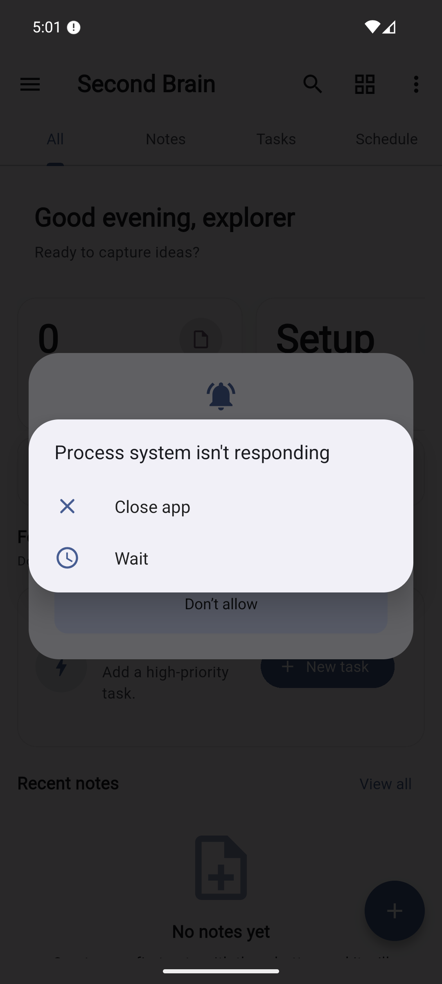  Android system ANR dialog over the app. Retained as startup blocker evidence, not a healthy app state.  Original full resolution screenshot | 02-permission.png  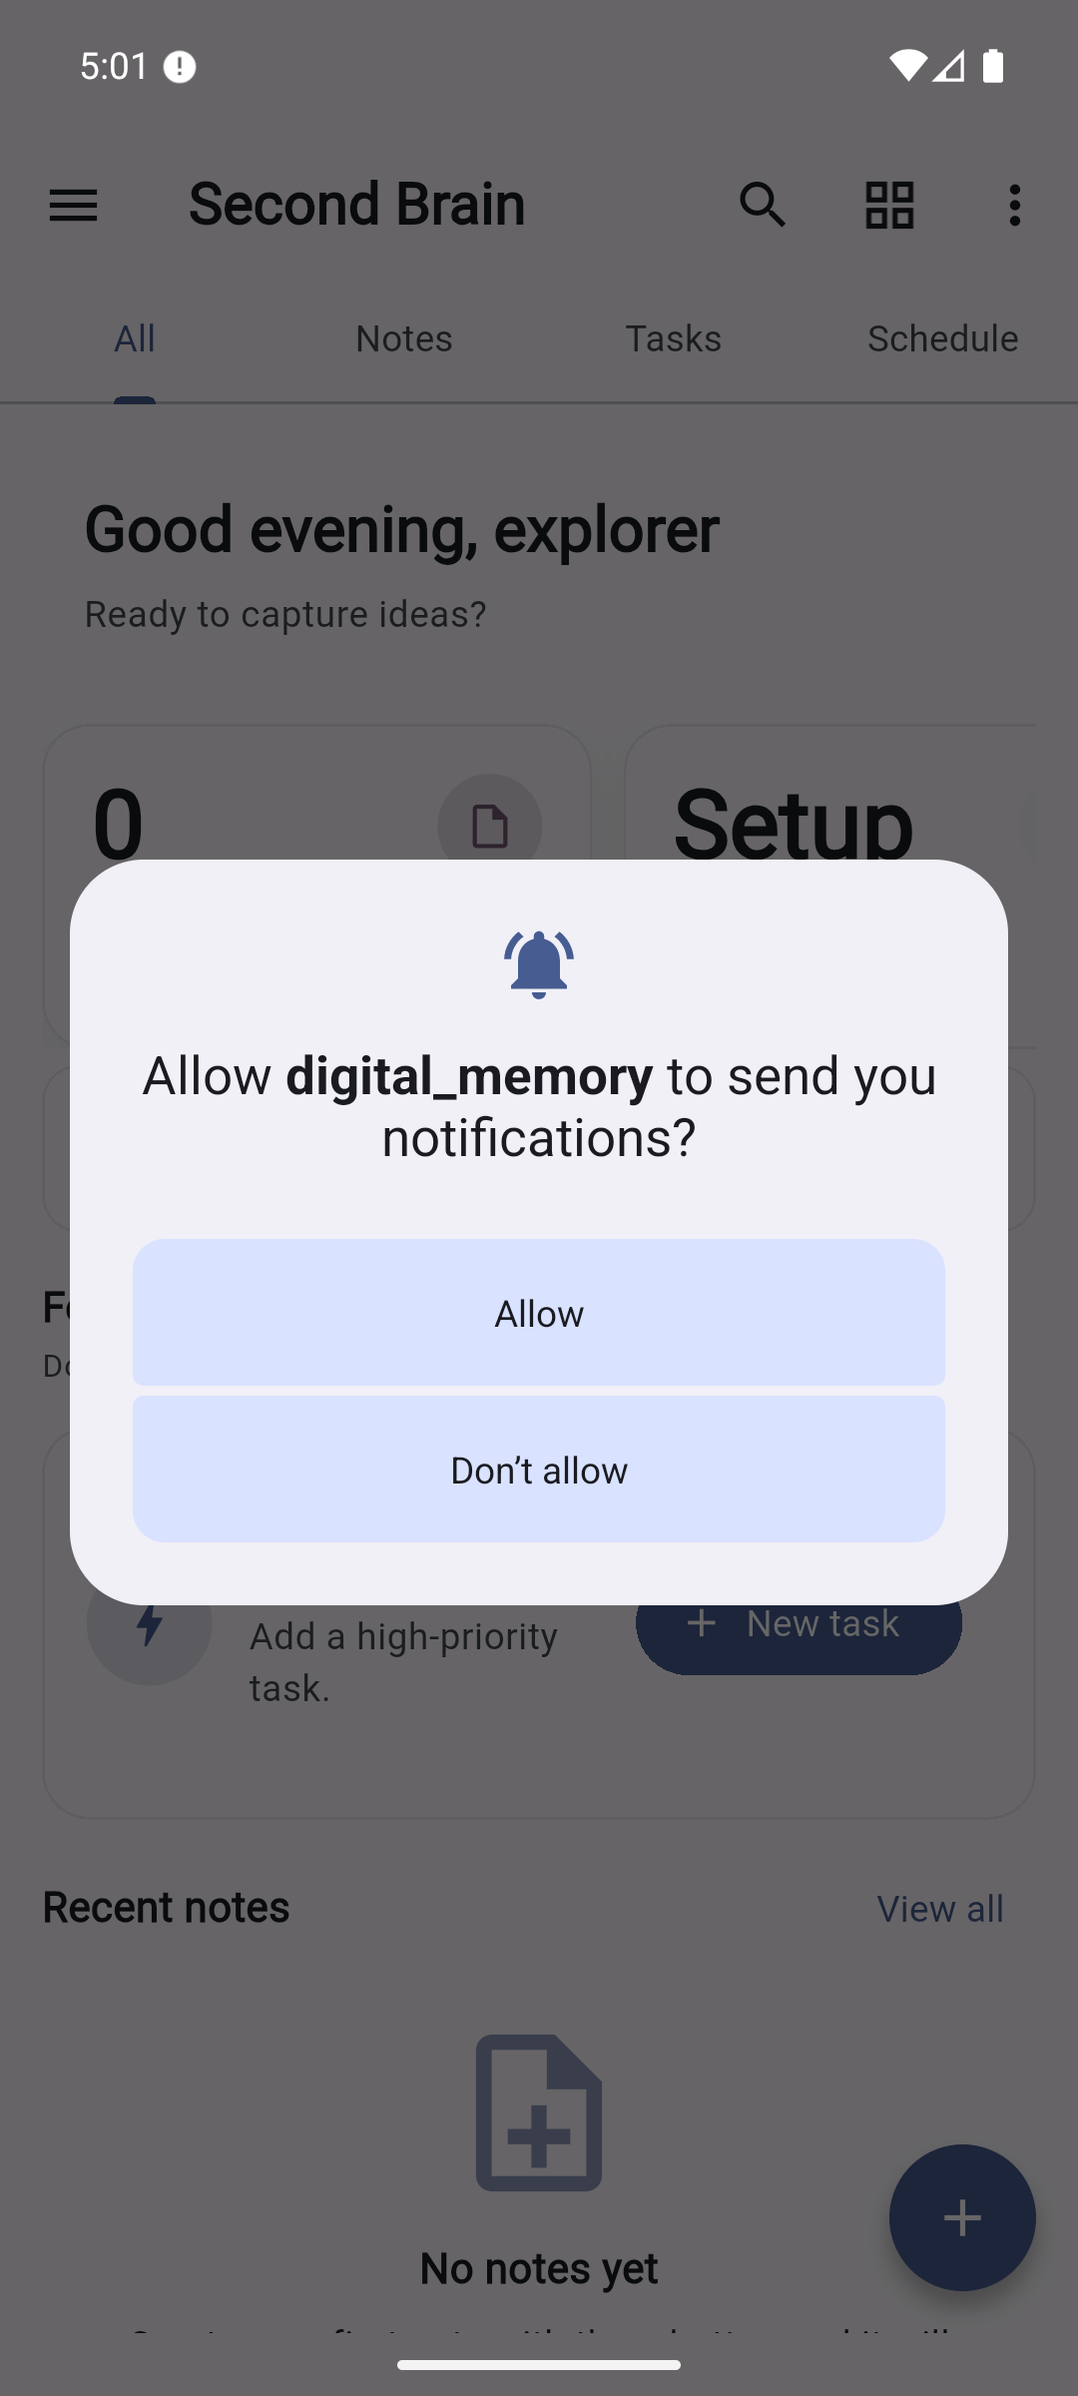  First-run notification prompt before reminder creation.  Original full resolution screenshot

Screenshot evidence 3 to 4
03-alarm-permission.png  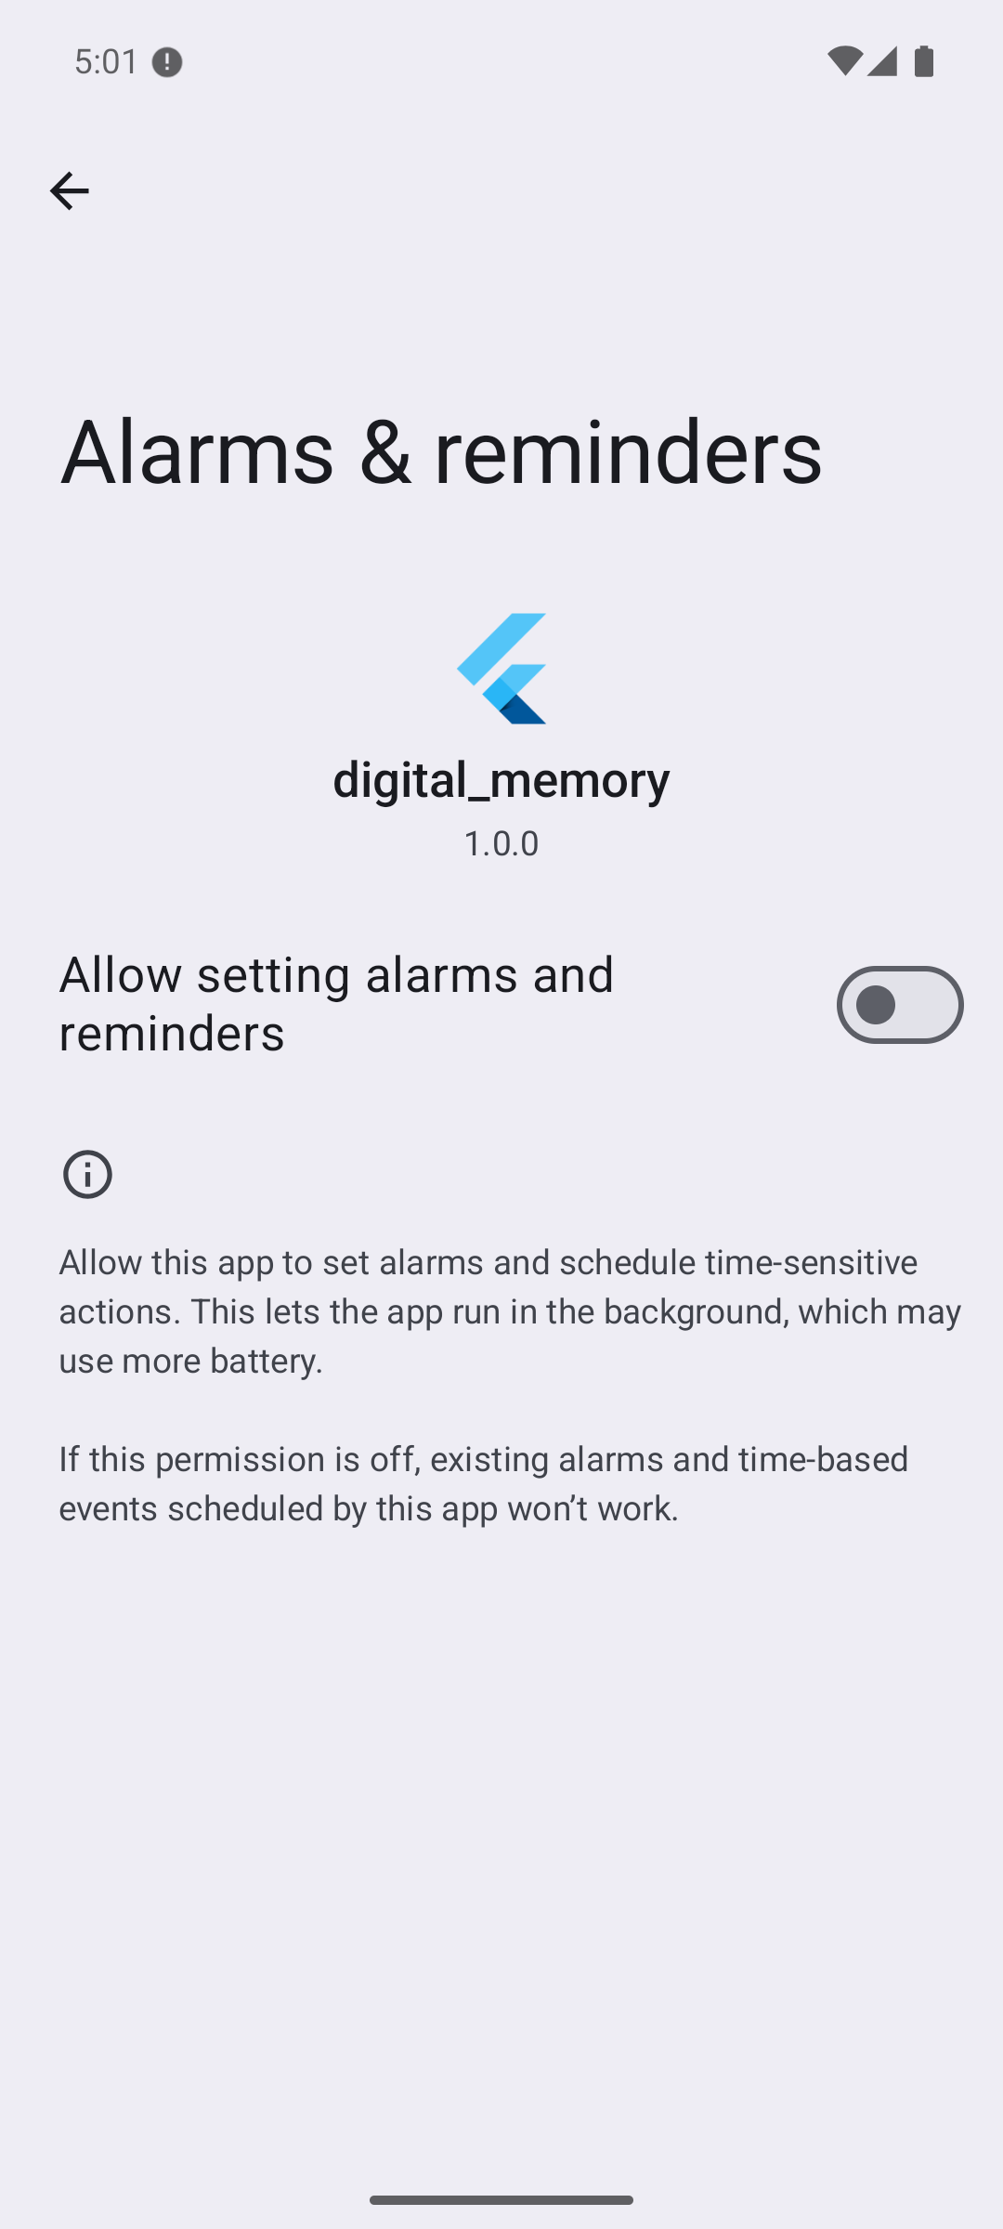  Android alarms/reminders access screen, initially off; enabled to continue review.  Original full resolution screenshot | 04-home.png  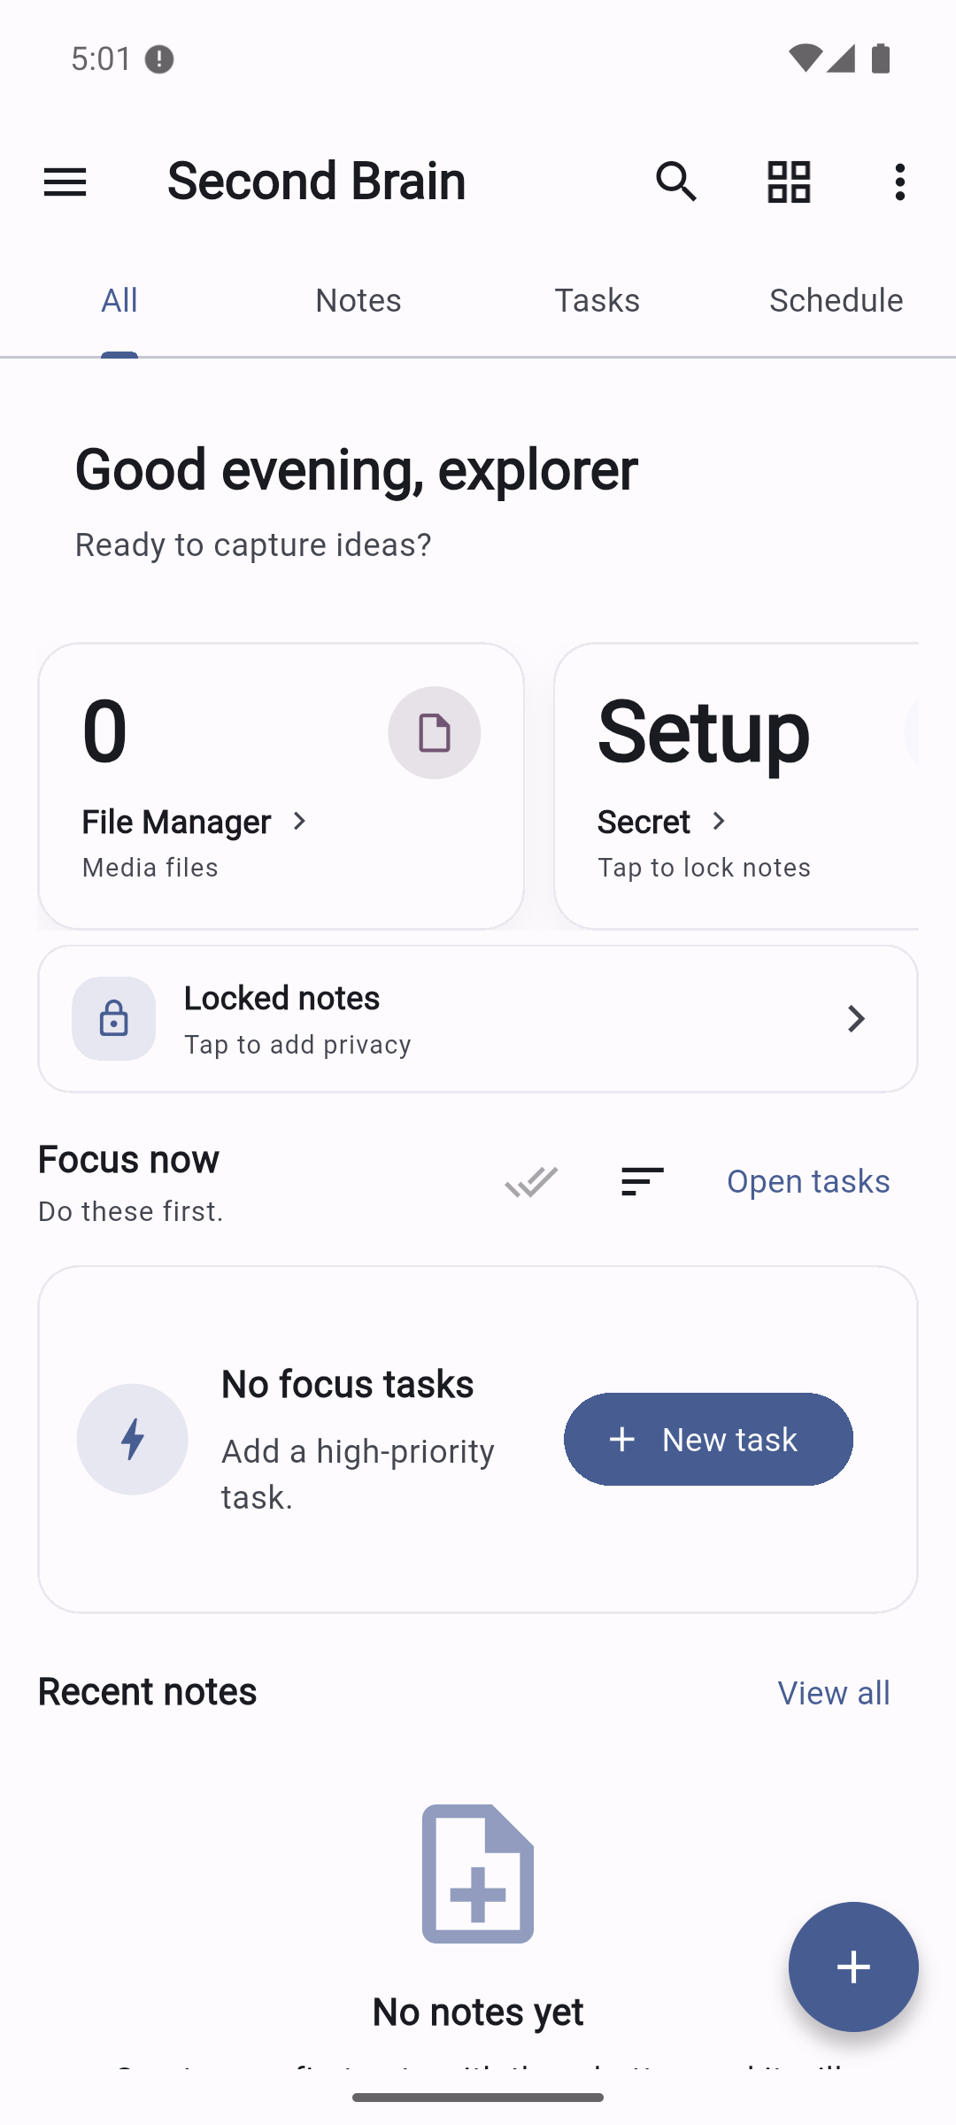  Stable All dashboard with empty fixture data.  Original full resolution screenshot

Screenshot evidence 5 to 6
05-notes-empty.png  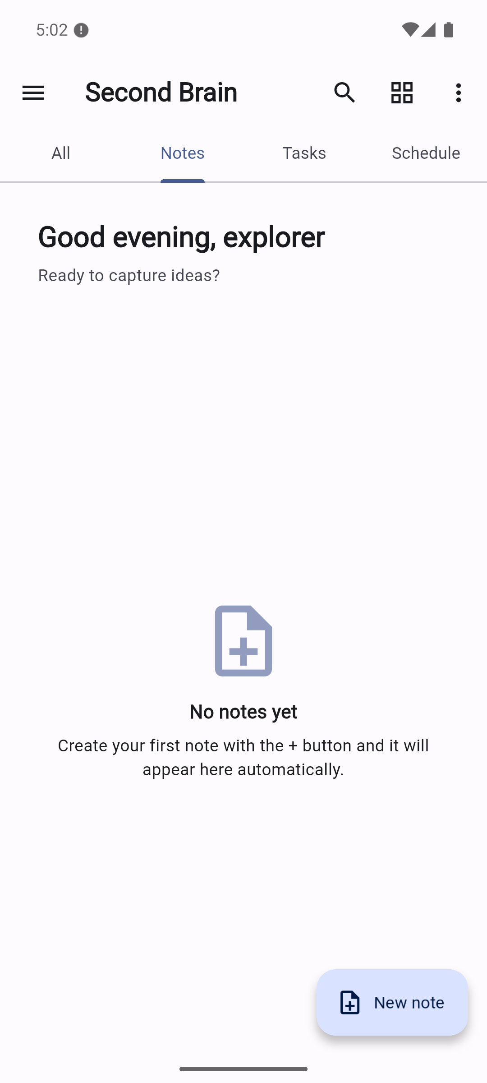  Notes empty state and New note action.  Original full resolution screenshot | 06-note-editor.png  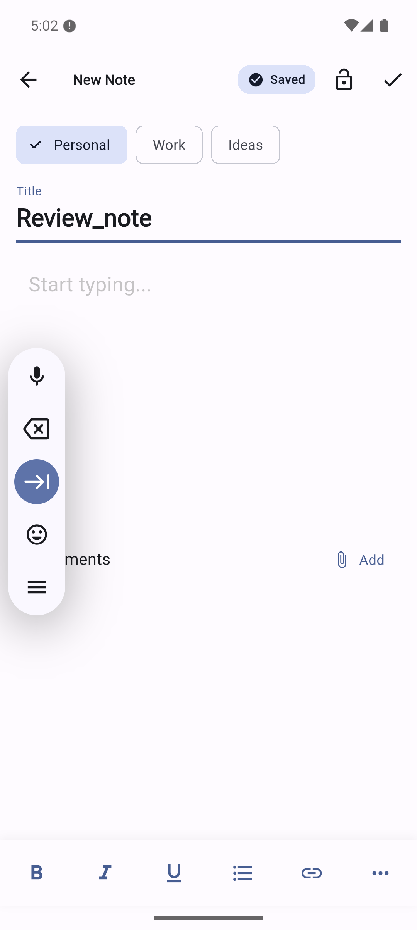  Title entered; Saved indicator; body empty. Floating input toolbar belongs to Android IME.  Original full resolution screenshot

Screenshot evidence 7 to 8
07-note-with-attachment.png  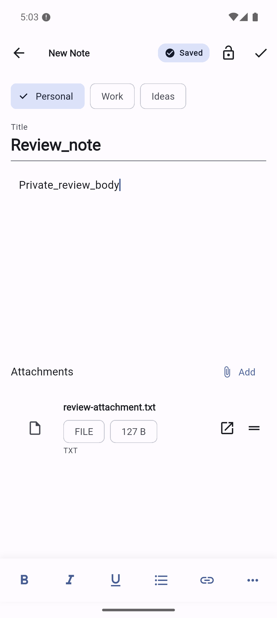  Synthetic note body and text attachment present in editor.  Original full resolution screenshot | 08-notes-saved.png  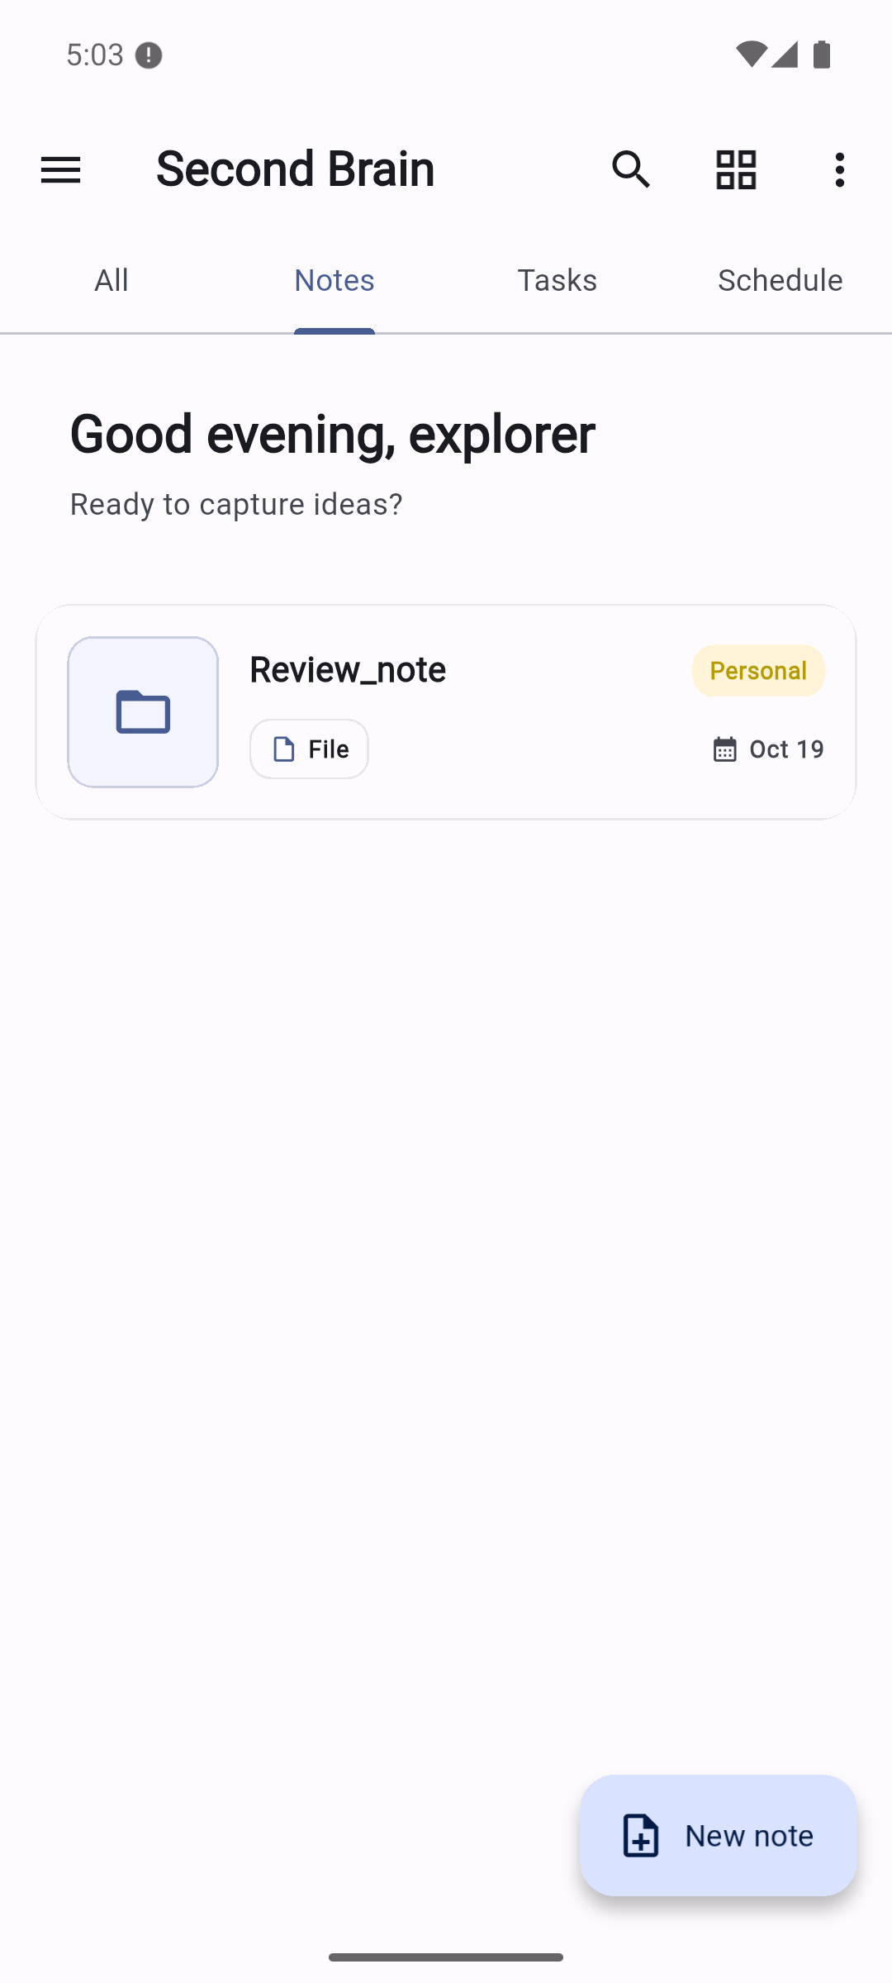  Saved note visible in Notes collection.  Original full resolution screenshot

Screenshot evidence 9 to 10
09-note-preview.png  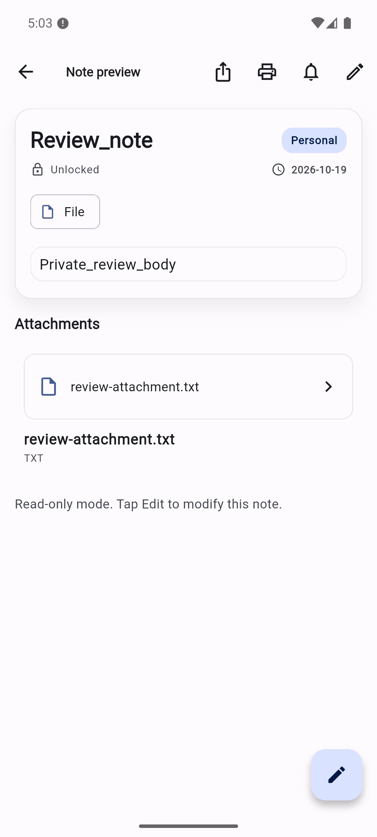  Read-only body and attachment preview.  Original full resolution screenshot | 10-lock-authentication.png  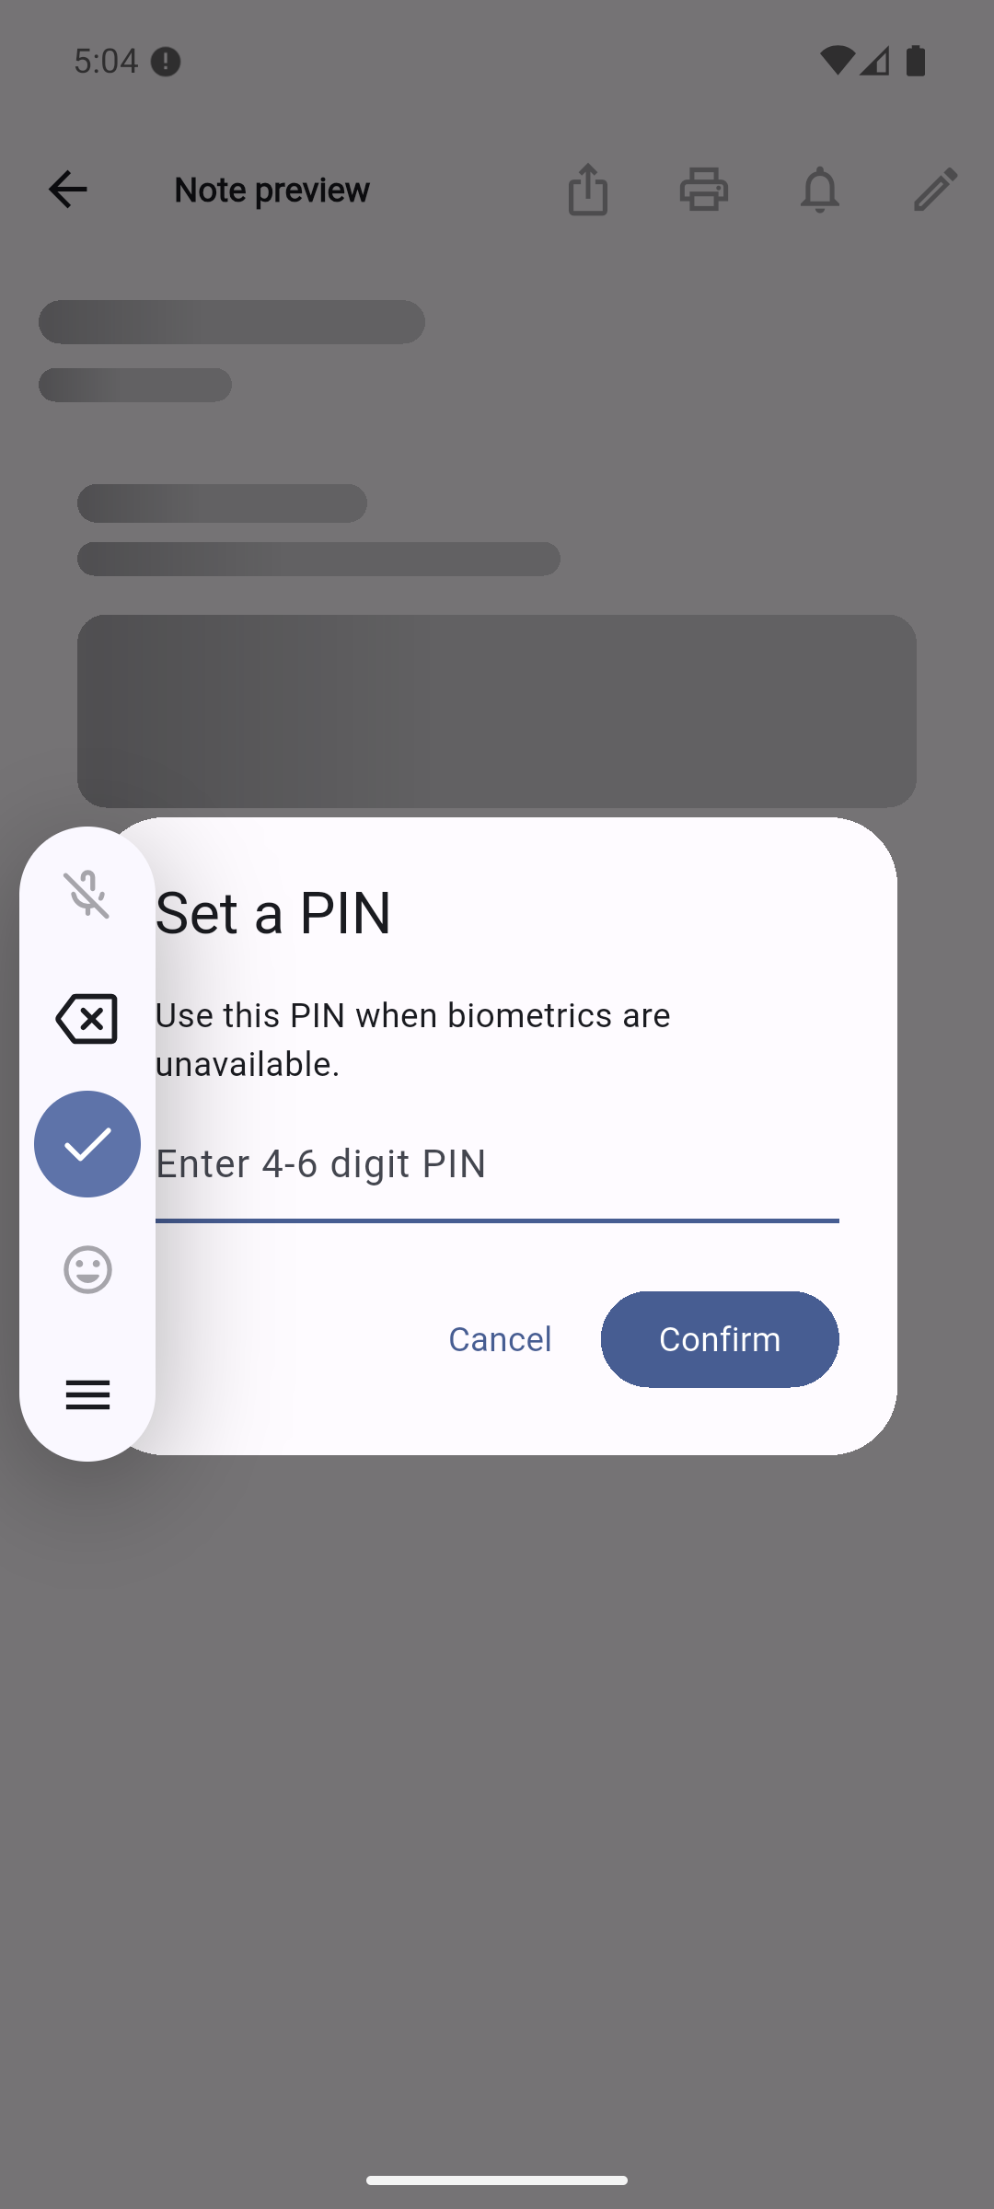  Normal locked-note path requests PIN setup. Canceled without setting a PIN.  Original full resolution screenshot

Screenshot evidence 11 to 12
11-locked-notes.png  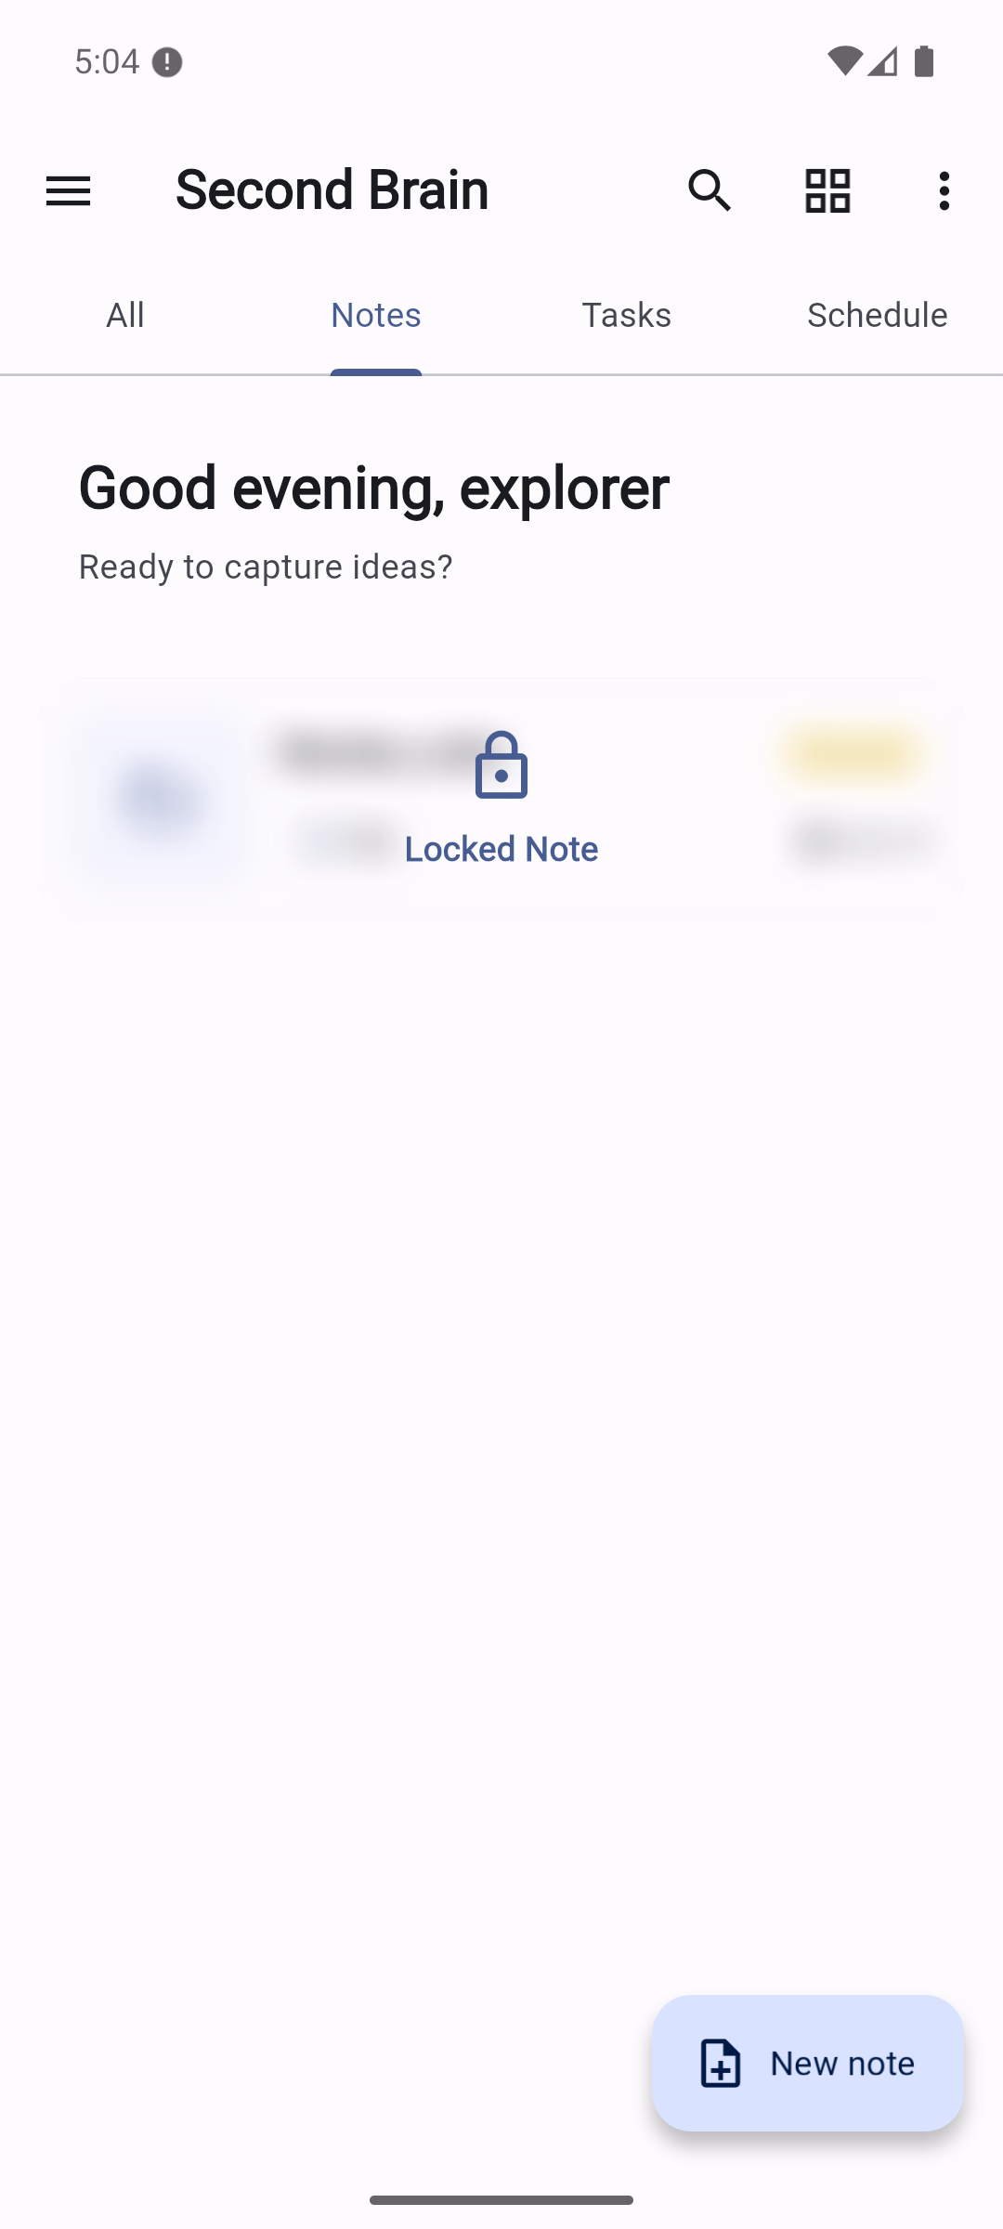  Visually blurred locked card after canceling authentication.  Original full resolution screenshot | 12-private-attachment-visible.png  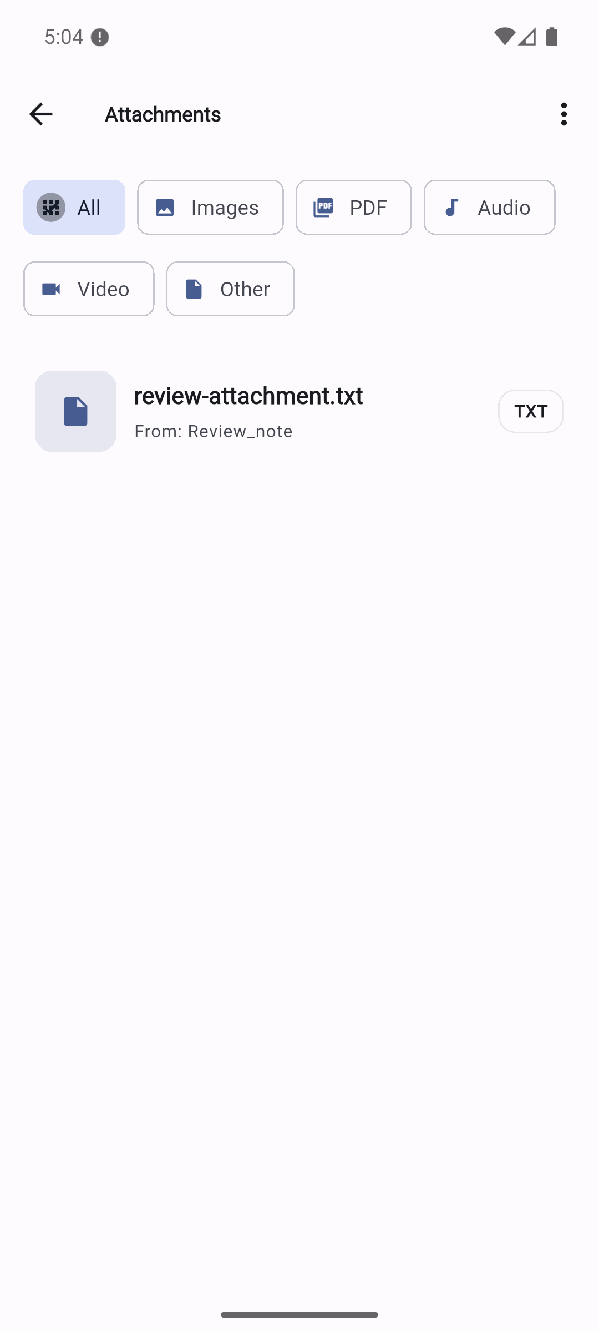  File Manager reveals attachment and locked owner title without authorization.  Original full resolution screenshot

Screenshot evidence 13 to 14
13-lock-bypass-confirmed.png  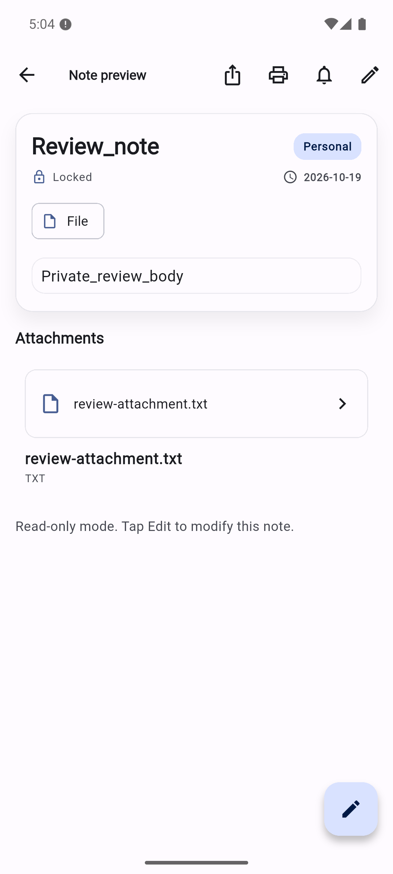  Locked note body visible through attachment path without authentication. F01.  Original full resolution screenshot | 14-task-editor.png  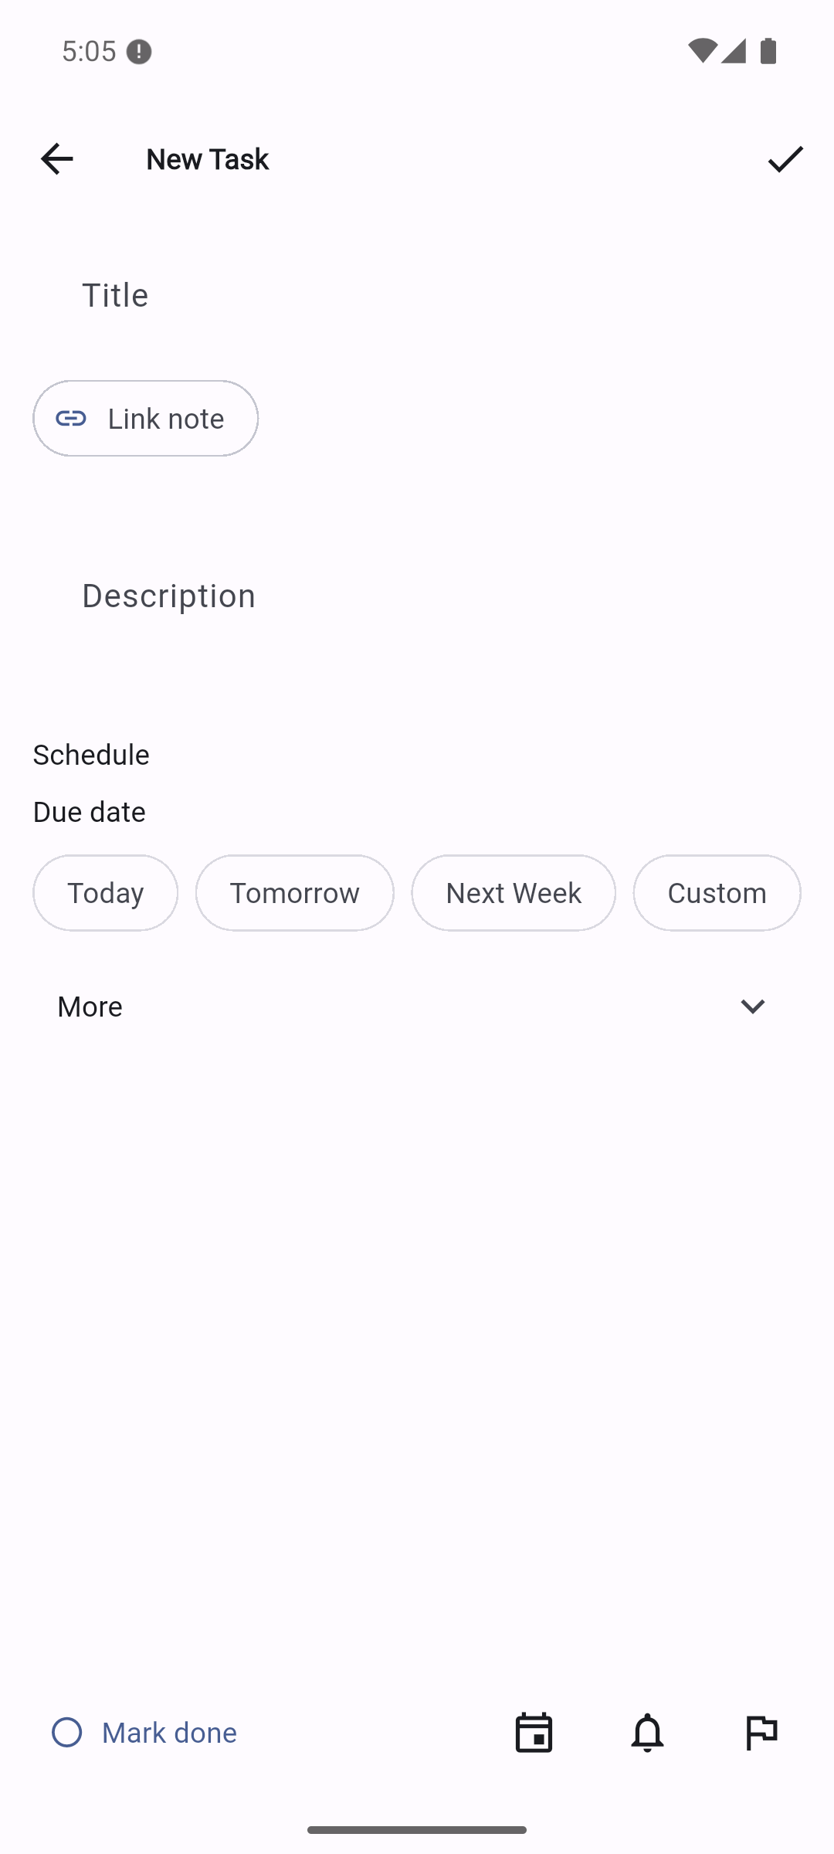  Basic task form before data entry.  Original full resolution screenshot

Screenshot evidence 15 to 16
15-task-details.png  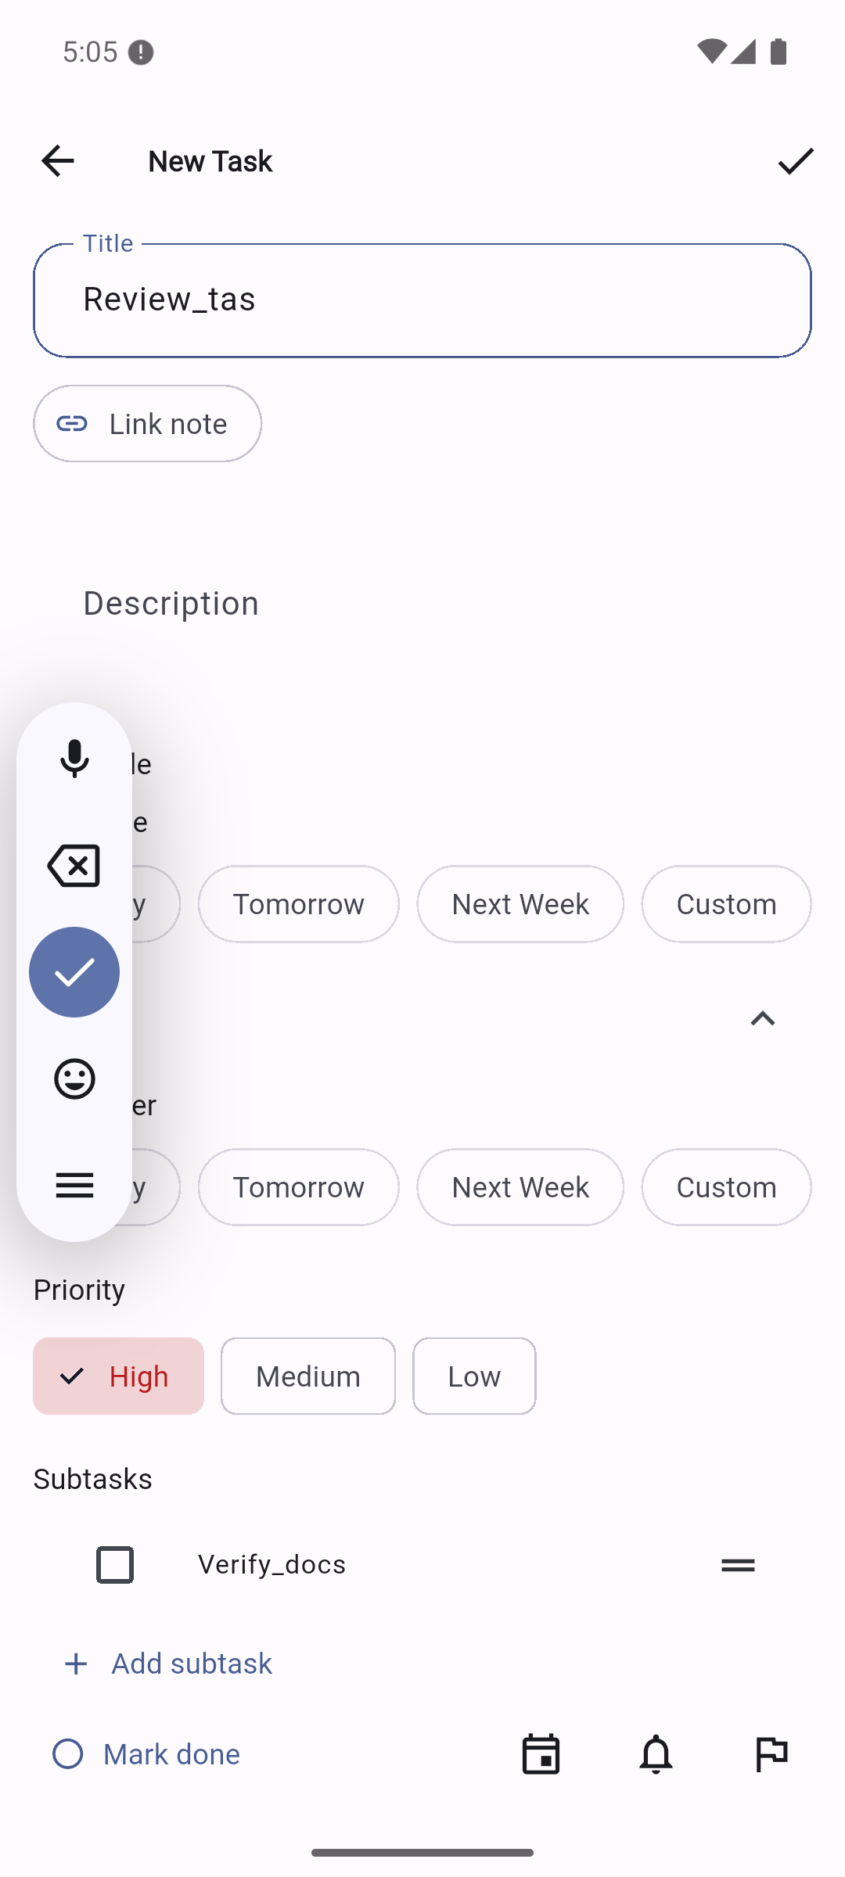  High priority and Verify_docs subtask in More. Saved title is Review_tas.  Original full resolution screenshot | 16-tasks-saved.png  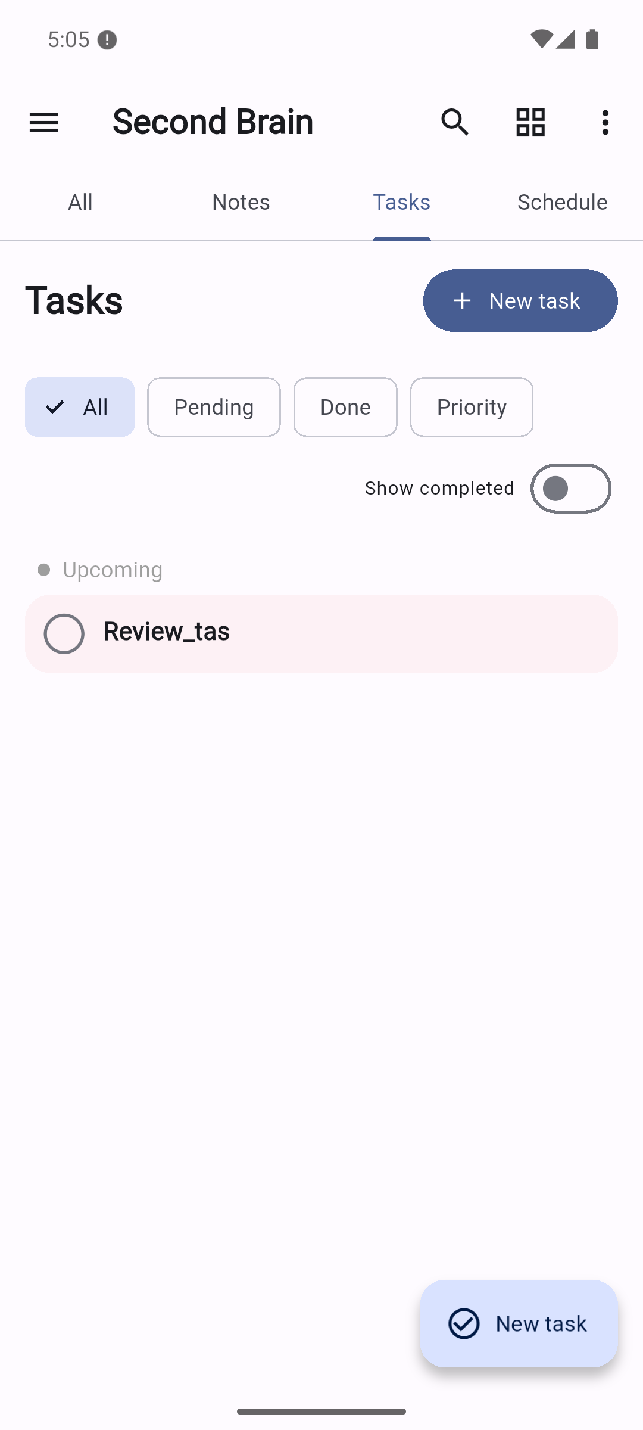  Task saved in Tasks pane.  Original full resolution screenshot

Screenshot evidence 17 to 18
17-task-expanded.png  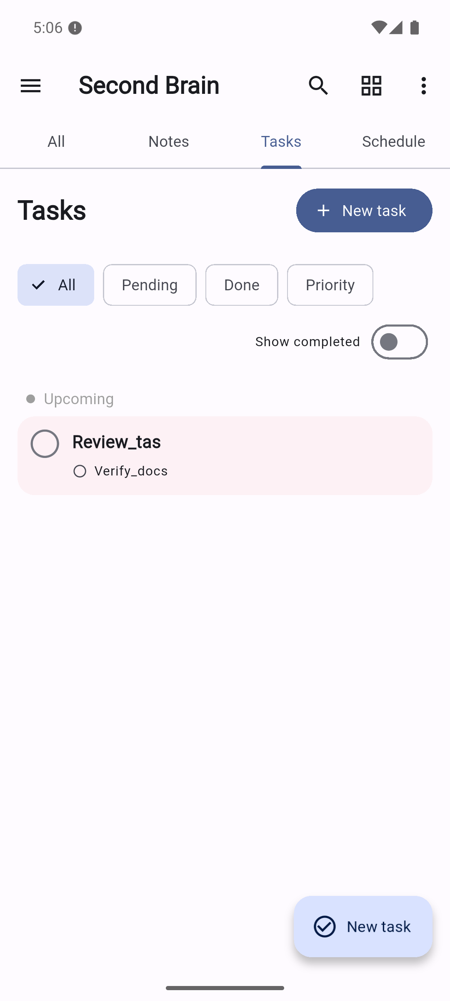  Expanded row reveals subtask.  Original full resolution screenshot | 18-task-collapsed.png  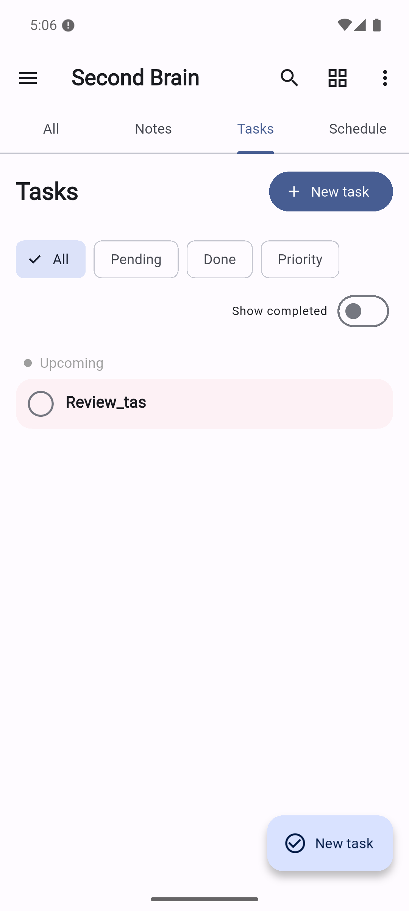  Attempted subtask interaction collapsed the row; not proof of completion.  Original full resolution screenshot

Screenshot evidence 19 to 20
19-schedule.png  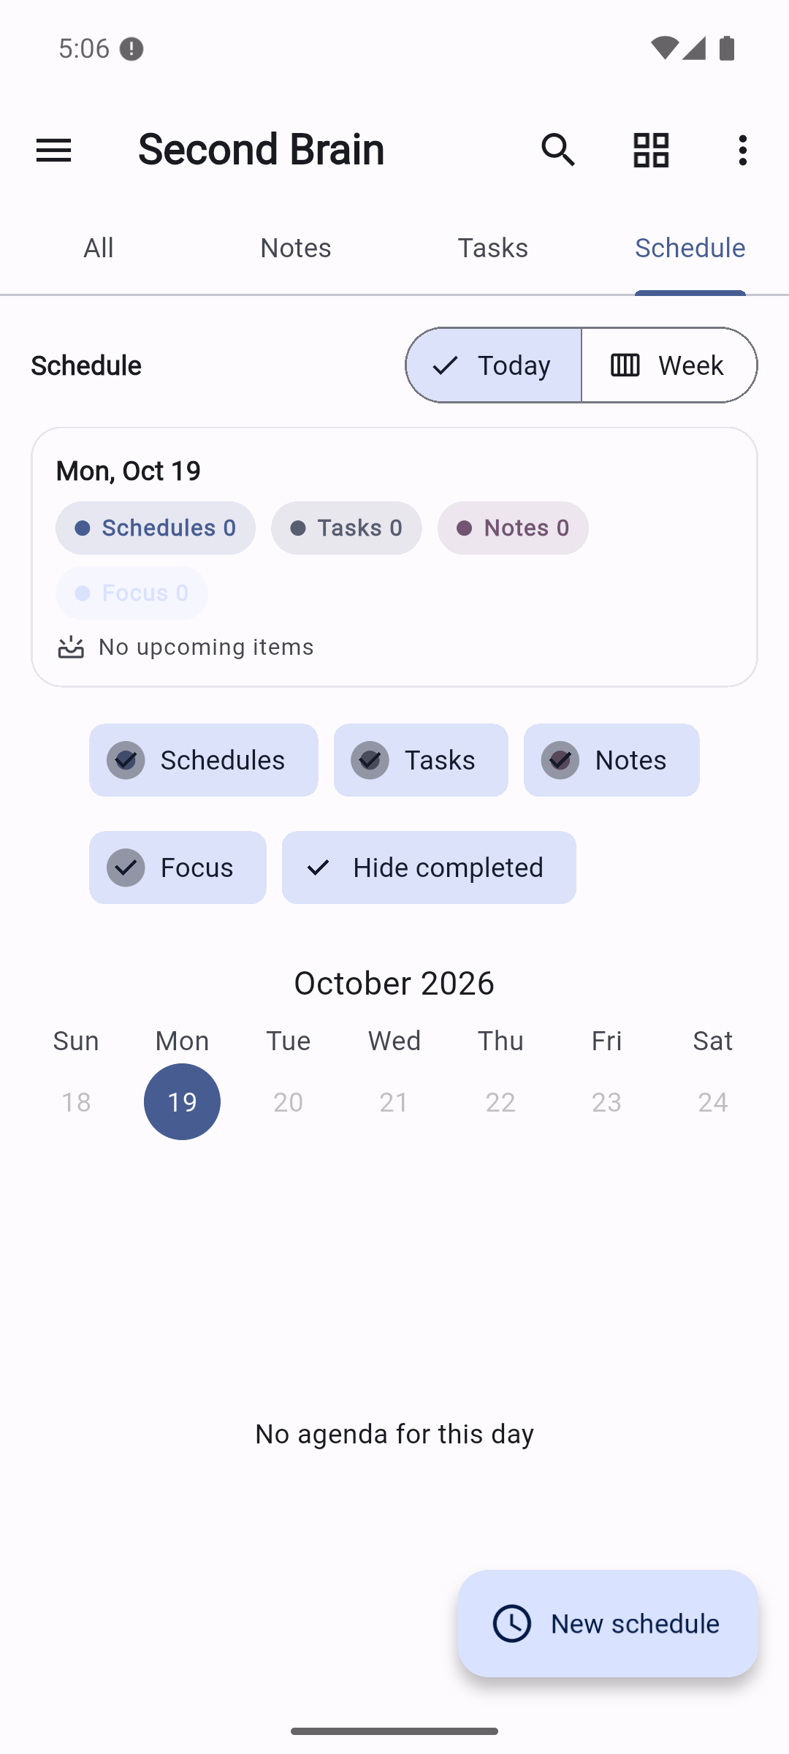  Empty schedule/day view.  Original full resolution screenshot | 20-schedule-placeholder.png  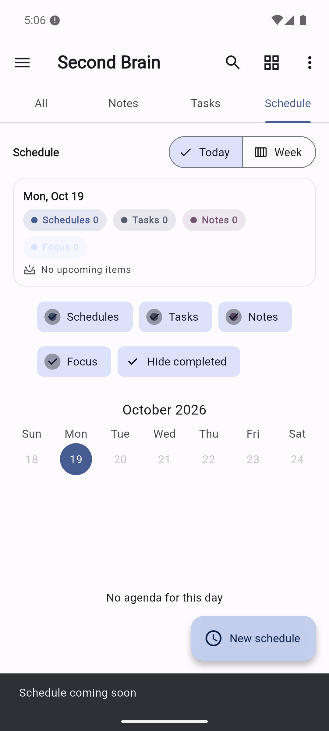  New schedule action reports Schedule coming soon. F11.  Original full resolution screenshot

Screenshot evidence 21 to 22
21-schedule-week.png  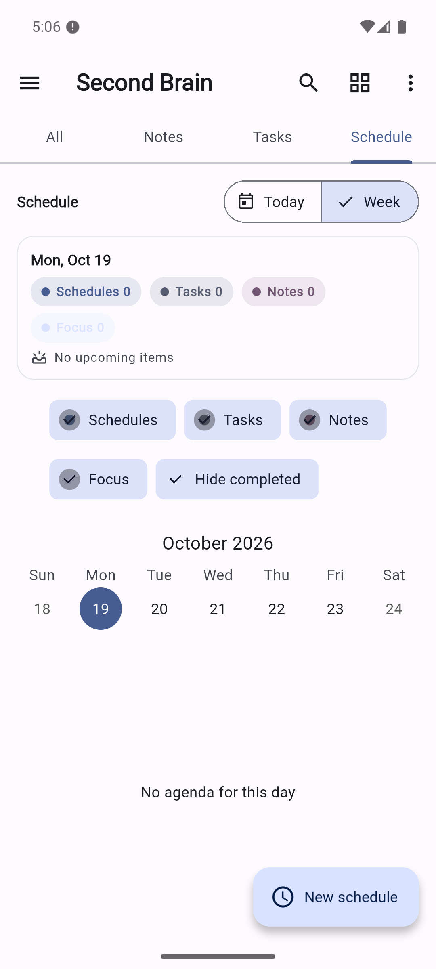  Week selection still has no agenda items.  Original full resolution screenshot | 22-schedule-with-task.png  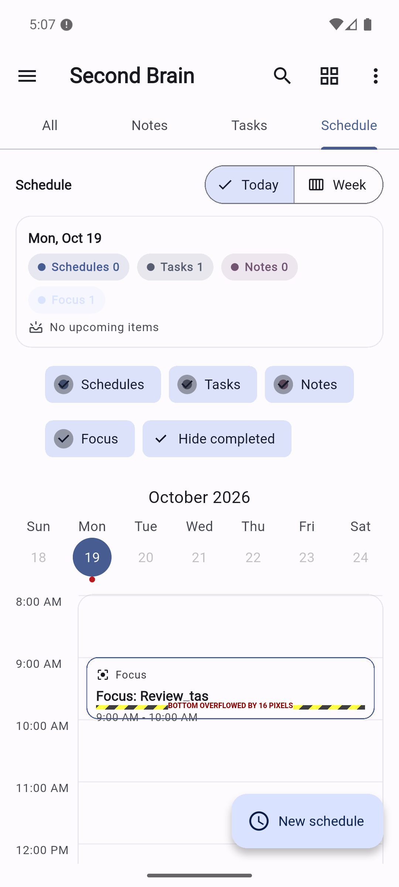  Dated task creates timeline/focus context; 16-pixel bottom overflow is visible. F18.  Original full resolution screenshot

Screenshot evidence 23 to 24
23-schedule-quick-add.png  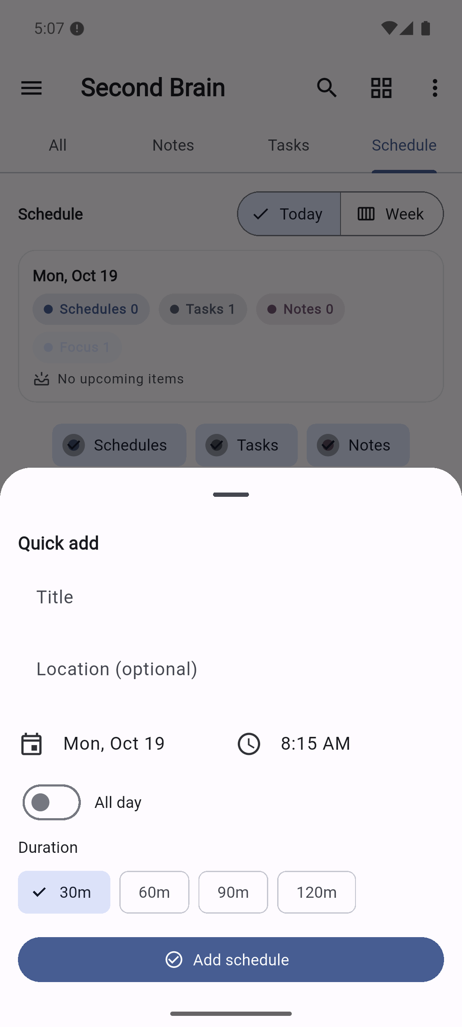  Long press on empty timeline slot opens quick-add.  Original full resolution screenshot | 24-schedule-created.png  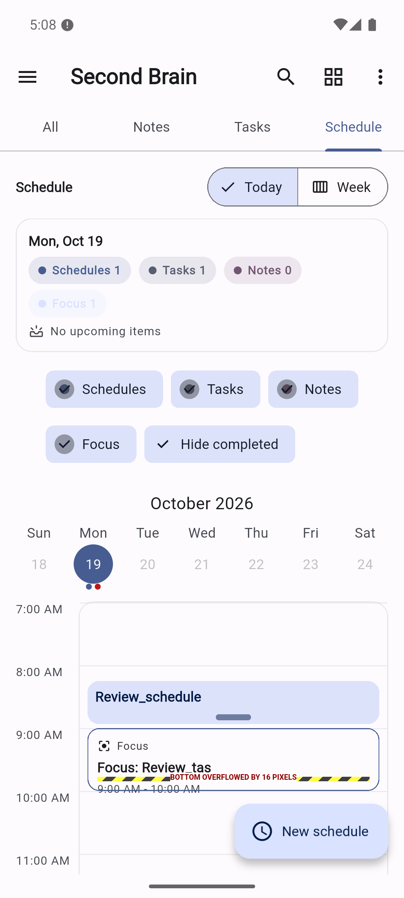  Review_schedule persisted and displayed; focus card still overflows.  Original full resolution screenshot

Screenshot evidence 25 to 26
25-settings.png  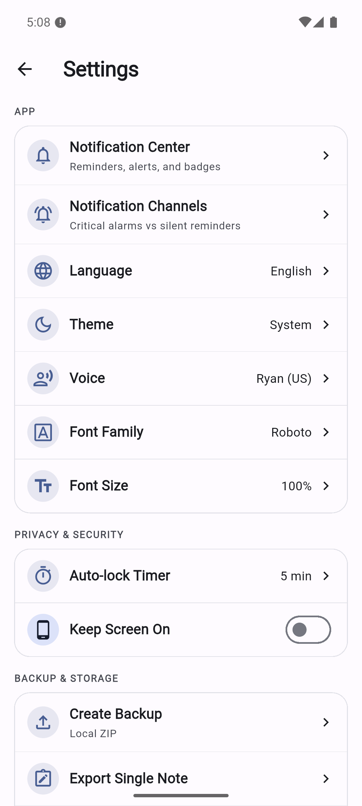  Light settings groups and controls.  Original full resolution screenshot | 26-notification-center.png  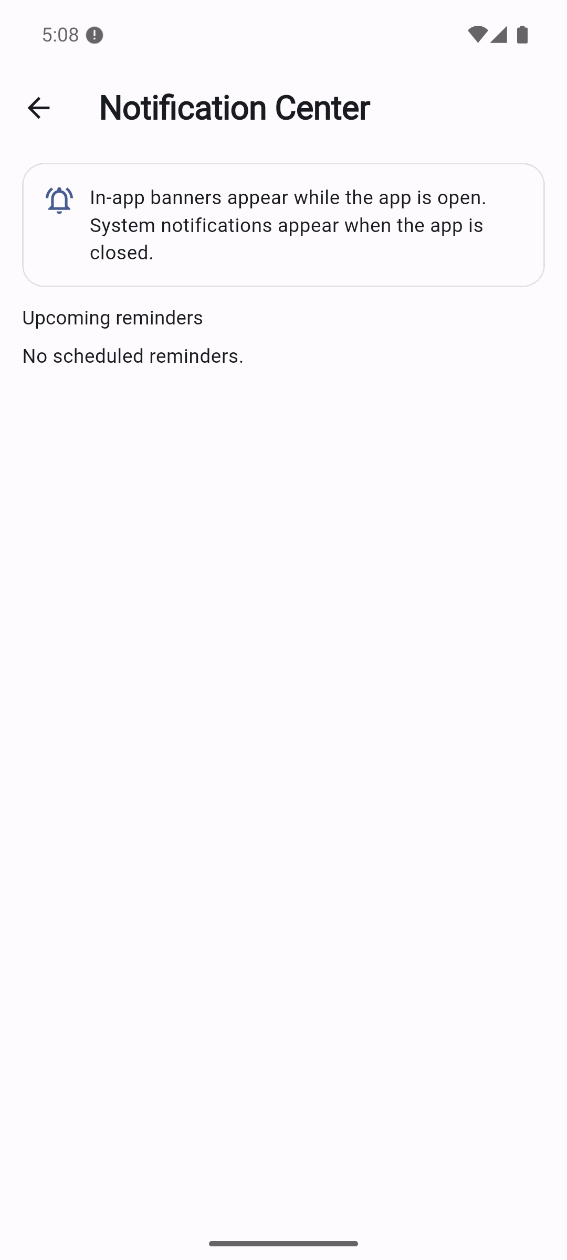  No scheduled reminders. This is not a notification-delivery test.  Original full resolution screenshot

Screenshot evidence 27 to 28
27-settings-dark.png  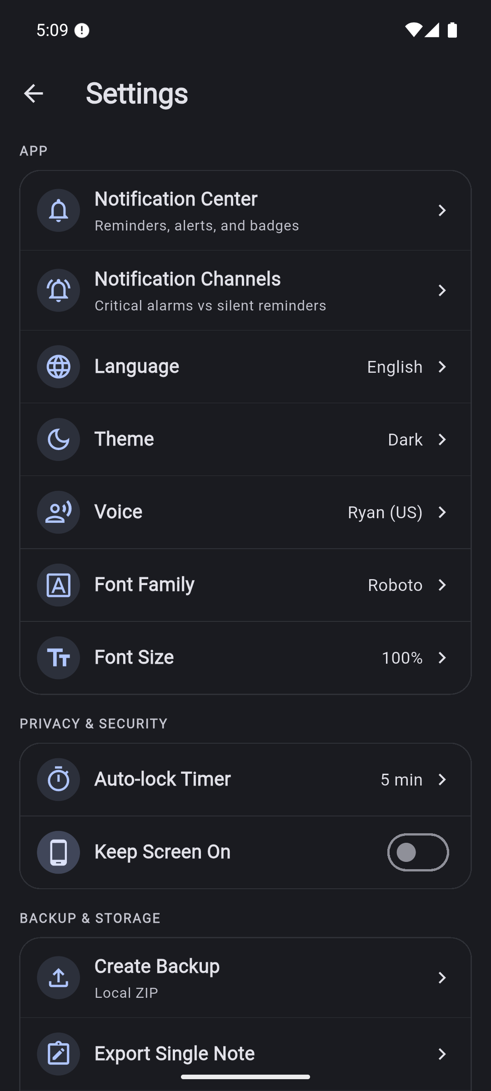  Theme changed to Dark and reflected immediately.  Original full resolution screenshot | 28-backup-and-version.png  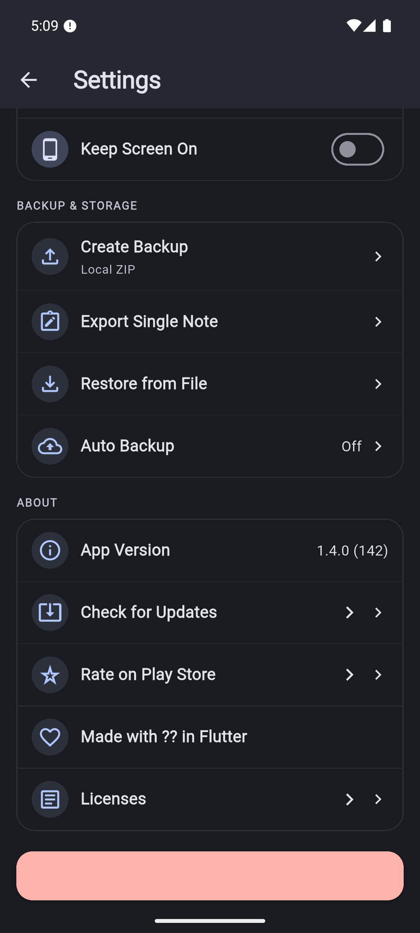  Backup options, hardcoded incorrect version, malformed About copy and dark logout visibility risk.  Original full resolution screenshot

Screenshot evidence 29 to 30
29-backup-share.png  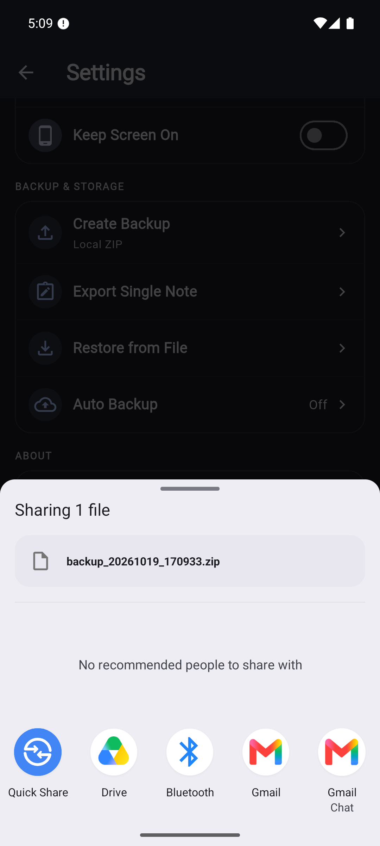  Actual generated ZIP in Android share sheet; canceled, no external recipient selected.  Original full resolution screenshot | 30-restore-success-message.png  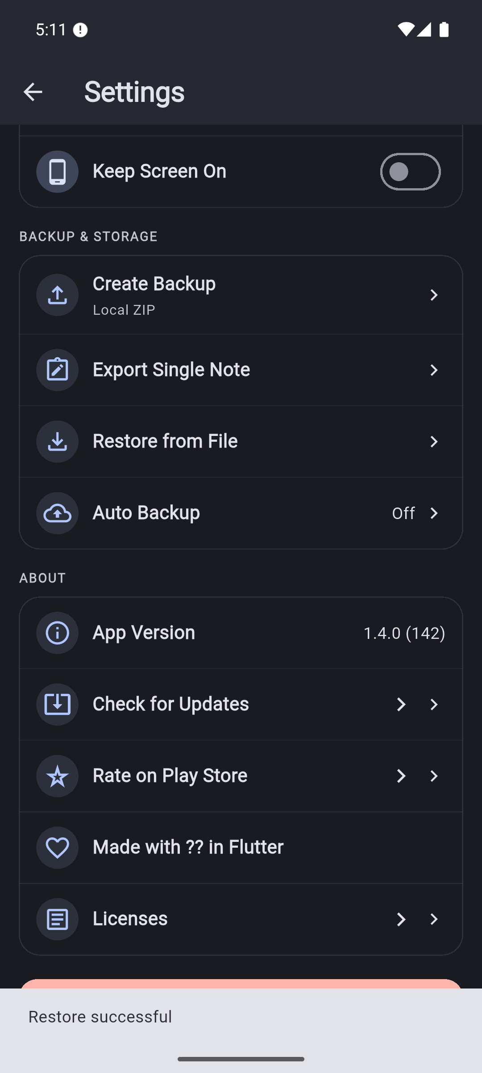  Valid missing-ID import reports Restore successful.  Original full resolution screenshot

Screenshot evidence 31 to 32
31-restore-note-missing.png  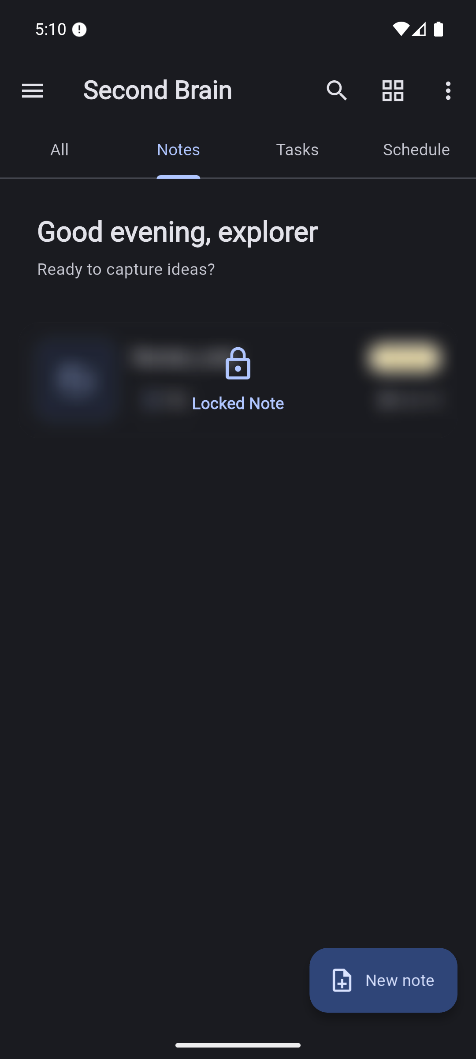  Only original note remains; Restore_probe absent. Database check corroborates F02.  Original full resolution screenshot | 32-search-locked-note.png  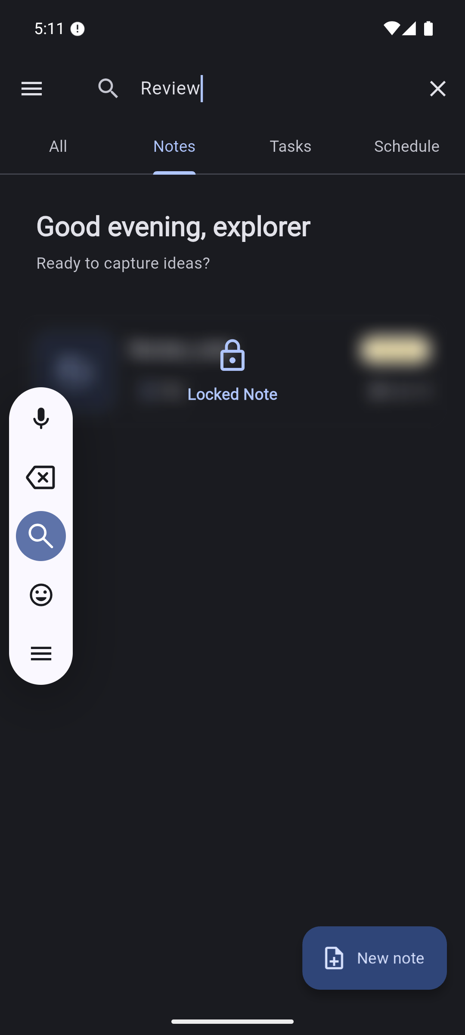  Home inline search query before submission; locked card remains visually redacted.  Original full resolution screenshot

Screenshot evidence 33 to 34
33-global-search.png  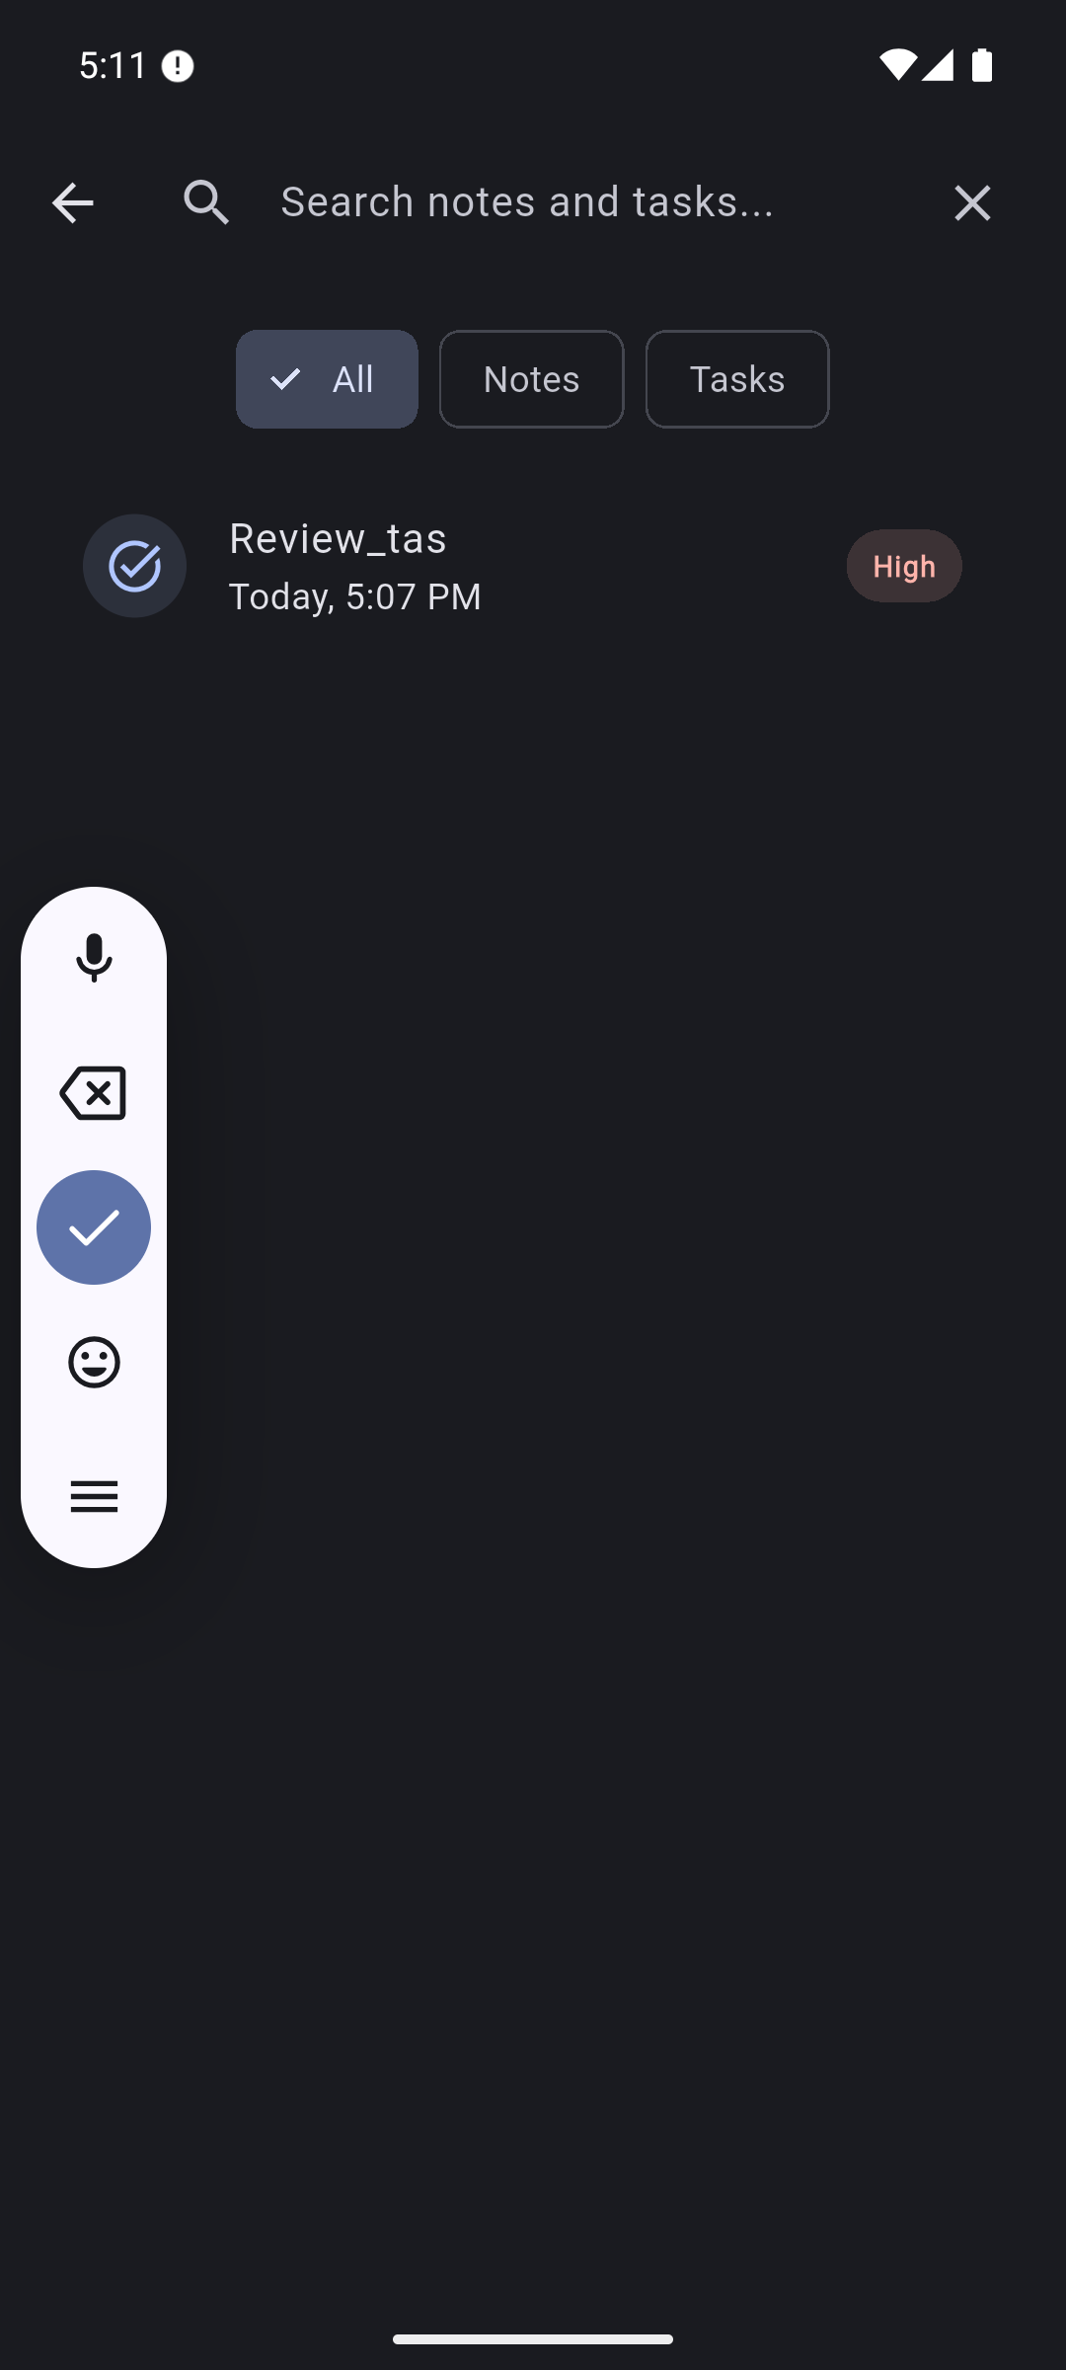  Task result for submitted Review query; destination field shows placeholder. F14.  Original full resolution screenshot | 34-search-clear-mismatch.png  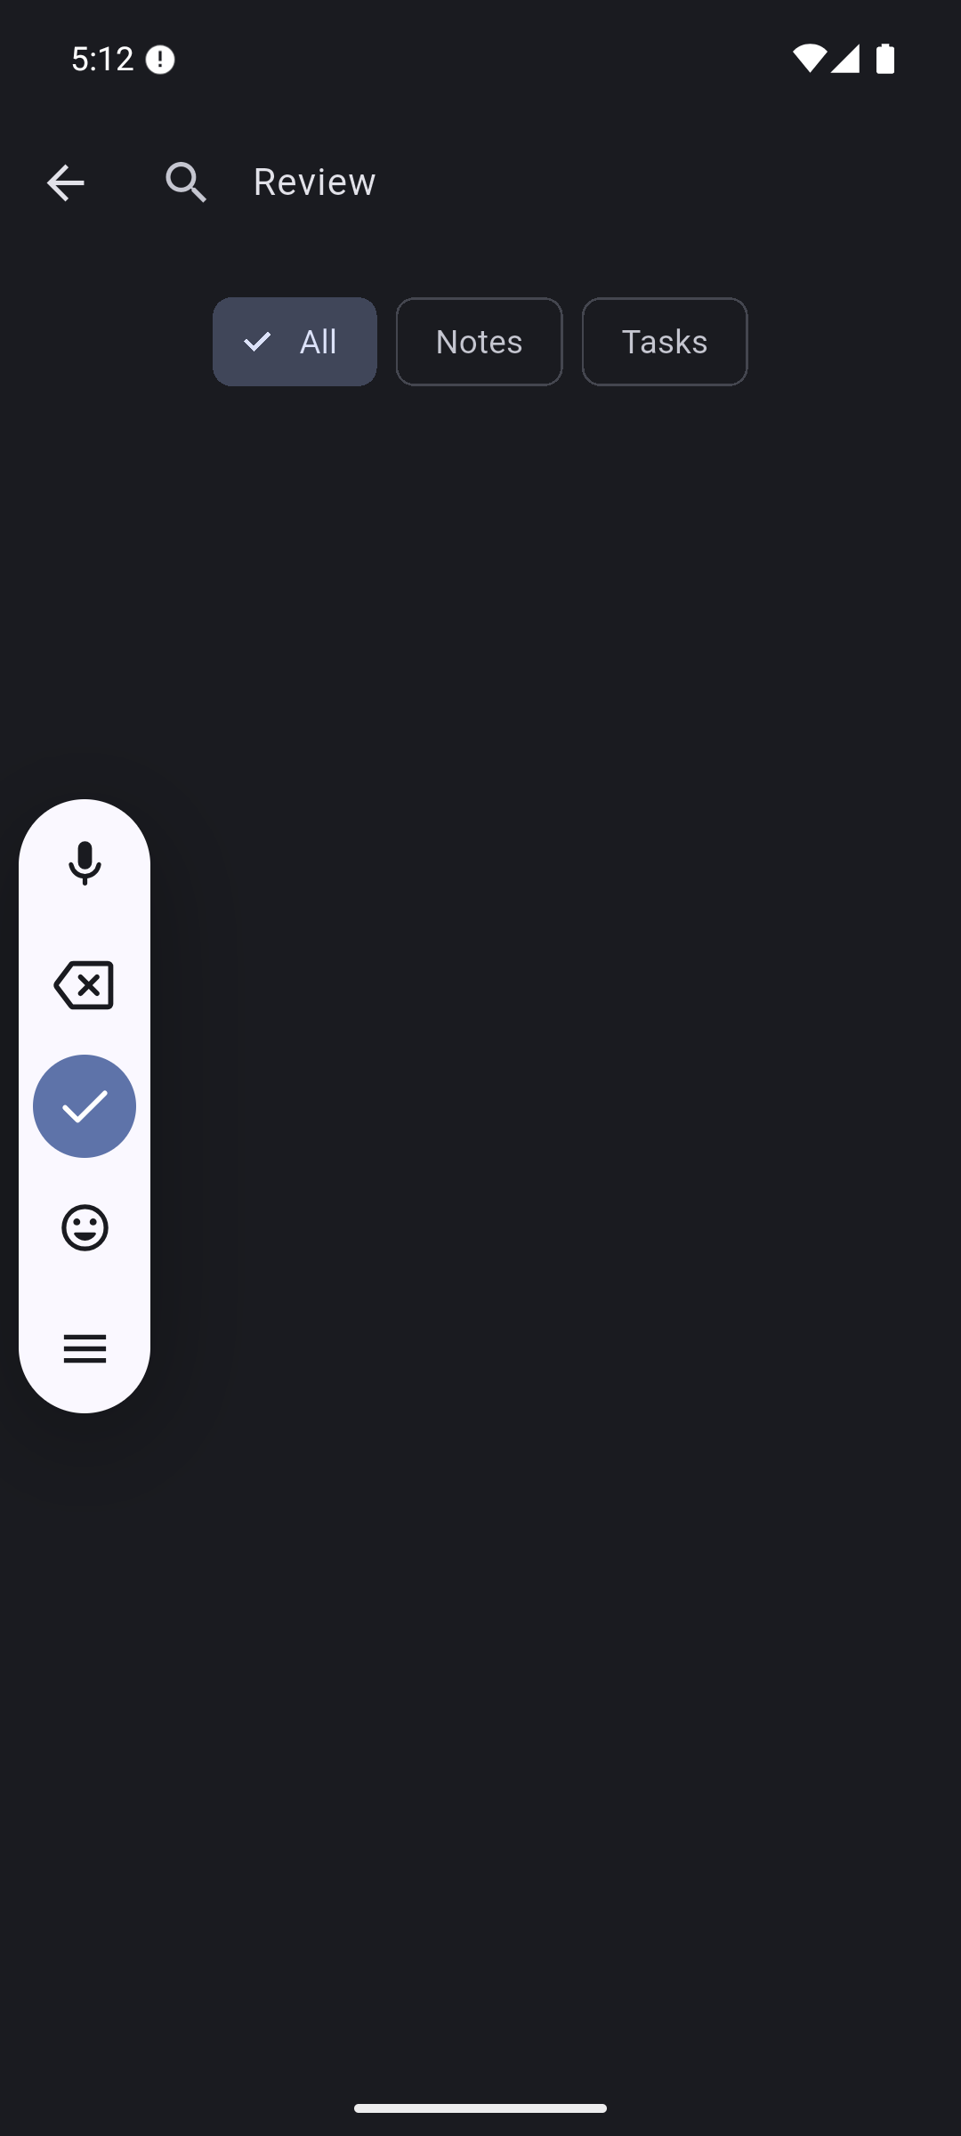  Clear removes results/state but leaves Review visible in input. F14.  Original full resolution screenshot

Screenshot evidence 35 to 35
35-cold-start-persistence.png
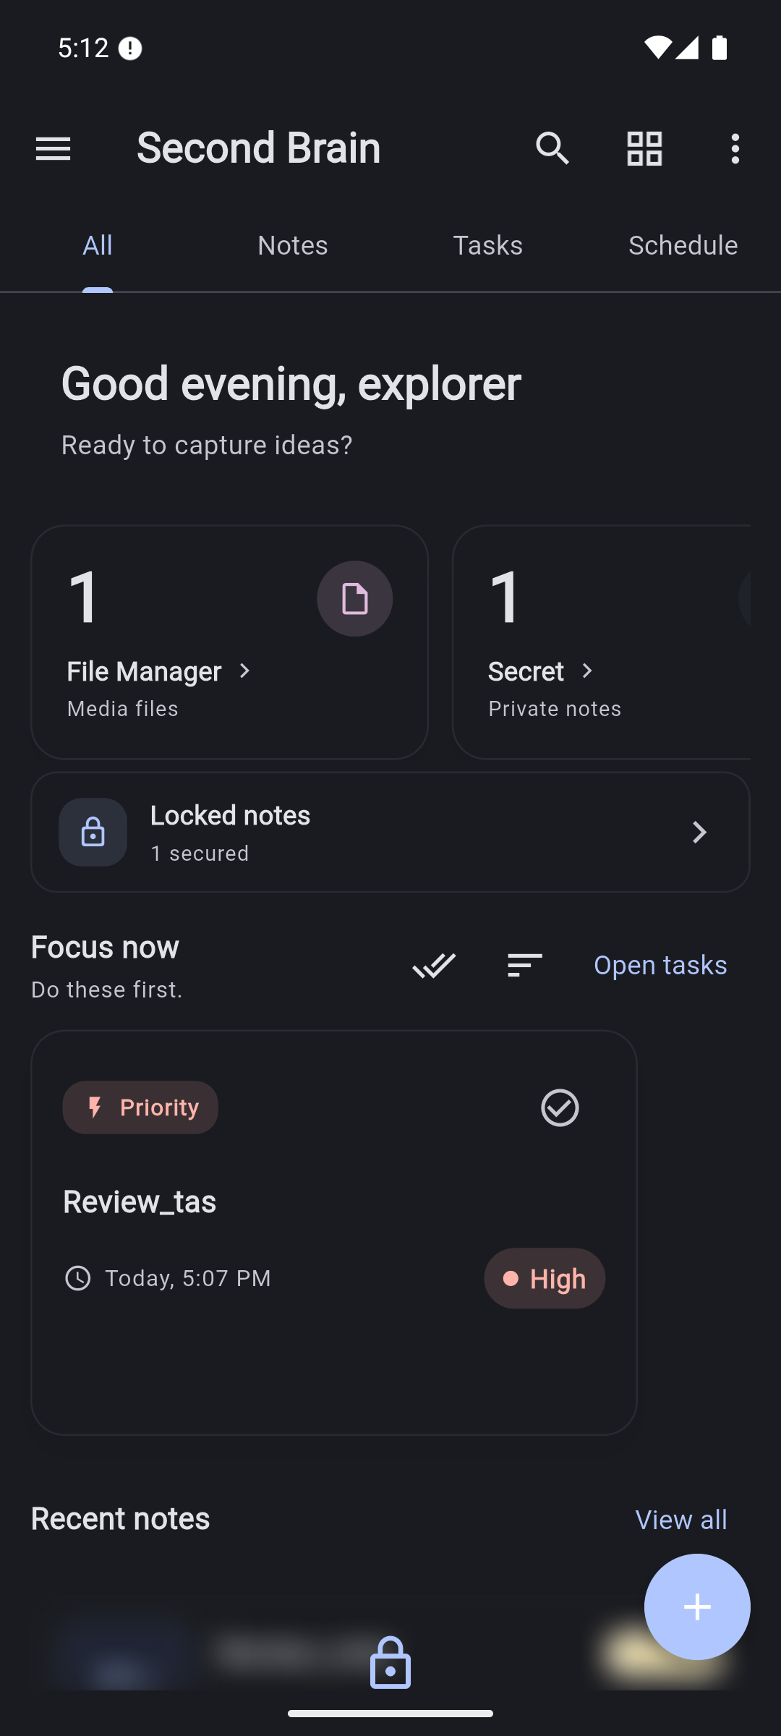
Stable dashboard after force-stop and relaunch; dark theme and fixture data persist.
Original full resolution screenshot

3 Nonvisual proof
Evidence | What it establishes
Baseline Dart inventory | All 65 Dart file paths, nonblank lines, bytes, SHA-256
Final Dart hashes | Application/test Dart files unchanged during review
Final analyzer | 29 diagnostics: 6 warnings and 23 info
Initial widget test | Original Quill compiler incompatibility
Test after compatibility | Existing test bootstrap failure
Final Flutter run | Fresh APK build/install, VM service, runtime layout assertion and intentional disconnect on force-stop
Android Flutter log | Plugin/runtime messages; layout assertion itself is in Flutter run log
ZIP inspection | Actual backup has one note JSON and no attachment file
Restore probe | Controlled valid notes-array import with ID 999999
Restore database result | Probe ID absent after successful toast
Cold-start counts | Note, attachment row, task, subtask and schedule survived process restart
Doctor | Toolchain and SDK-license caveat
Documentation validation | Current Markdown links, screenshot hashes, unchanged Dart sources, root layout

UI hierarchy XMLs in evidence/logs/ supplement action targeting and visible labels. They are not substitutes for screenshots or actual TalkBack testing. Intermediate build failures are explained in Verification. No raw app database is published as an evidence artifact; database checks retained only synthetic record/count summaries.

4 Diagram provenance
The editable tldraw board contains architecture and workflow diagrams built as editable shapes. The board was screenshotted, exported locally, and the saved PNG inspected. Sources are architecture.mmd and workflow.mmd.
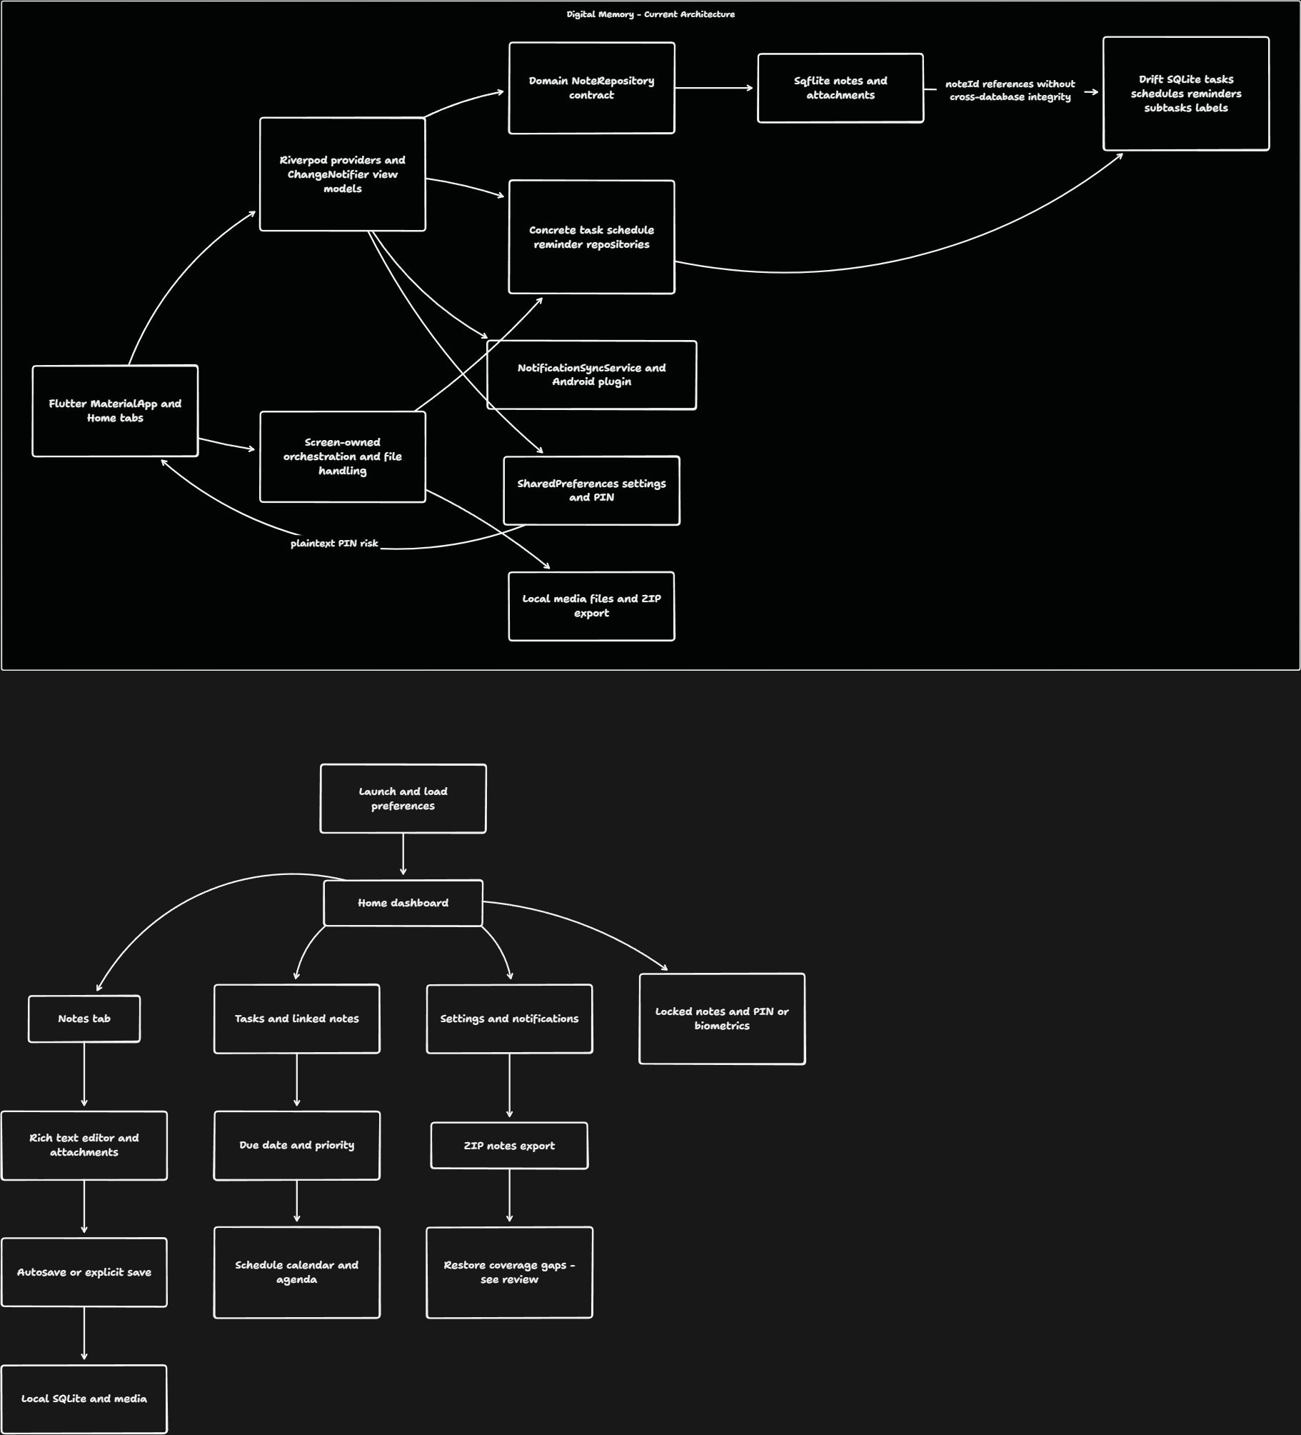

5 Interpretation limits
Screenshots show visible states, not complete correctness. The ZIP/database observations establish only the stated fixture behavior. This set does not establish encryption, full accessibility, physical-device performance, all supported media, notification delivery after reboot, all migrations, or other operating-system support. See Workflow for step-specific strengths, risks, and recommendations.

