Report

Outline:
Through the development of this project, I have created a gym tracking web application that records and displays the users workout stats. The user is able to create and account and log in, so when they are starting their working sessions, the data they input about each exercise such as repetitions or weight will be stored to their individual account. One of the applications primary functions is to keep a record of the users personal record for each exercise they submit and display it when they check their results.
The application I have created displays visual insight through a dynamic chart that showcases number of how many times each exercise has been completed. This allows the user to see both their historical overview along side their pr summaries.
The backend of my application makes use of node.js alongside express to handle routes, interactions with the database and sessions. Furthermore, SQL was used to in all components in storing the users data. In regards to the frontend functionality this system utilized CSS and JavaScript with an external library called chart.js which provides the responsive design aspects in the user interface.

Architecture:
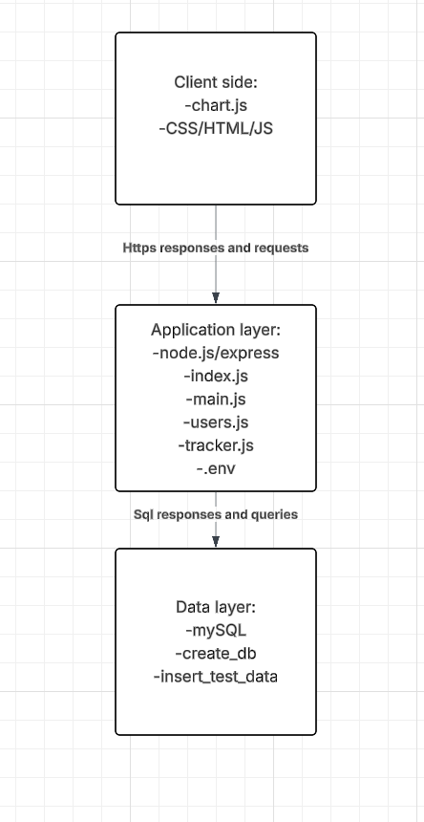
The client side components is responsible for rendering of the EJS templates, obtaining the user input. The Application layer is responsible for manging the input validation for prompts displayed in on the client side, sorting out database queries and managing HTTP requests. The variables associated with the database credentials are also stored in this layer (.env) where they can be loaded by the server. The data layer contains the mySQL database components of the application where user data is stored.

Data model:
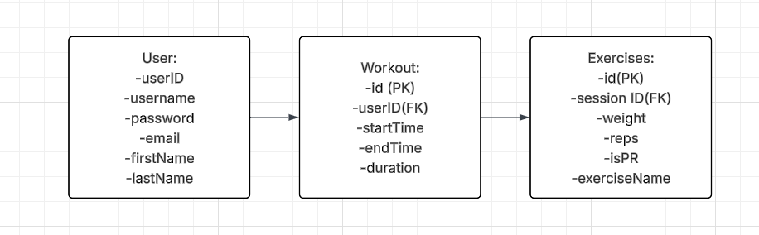
The database I created keeps track of the users details, workouts details and exercises. Each database is independent to that specific user which I done by making use of the primary key id which helps me identify them.The structure I have means the same user can have multiple workouts and each workout can store multiple exercises. This works because I established a one to many through the foreign key (userID) in workout and with the same concept occurring by similarly utilizing the foreign key (sessionID) in exercises.

User functionality:
Home page:
The home page acts as the introduction of the application and directs the users to what action they should take next. It displays the different navigation options present that the user can access before they log in. 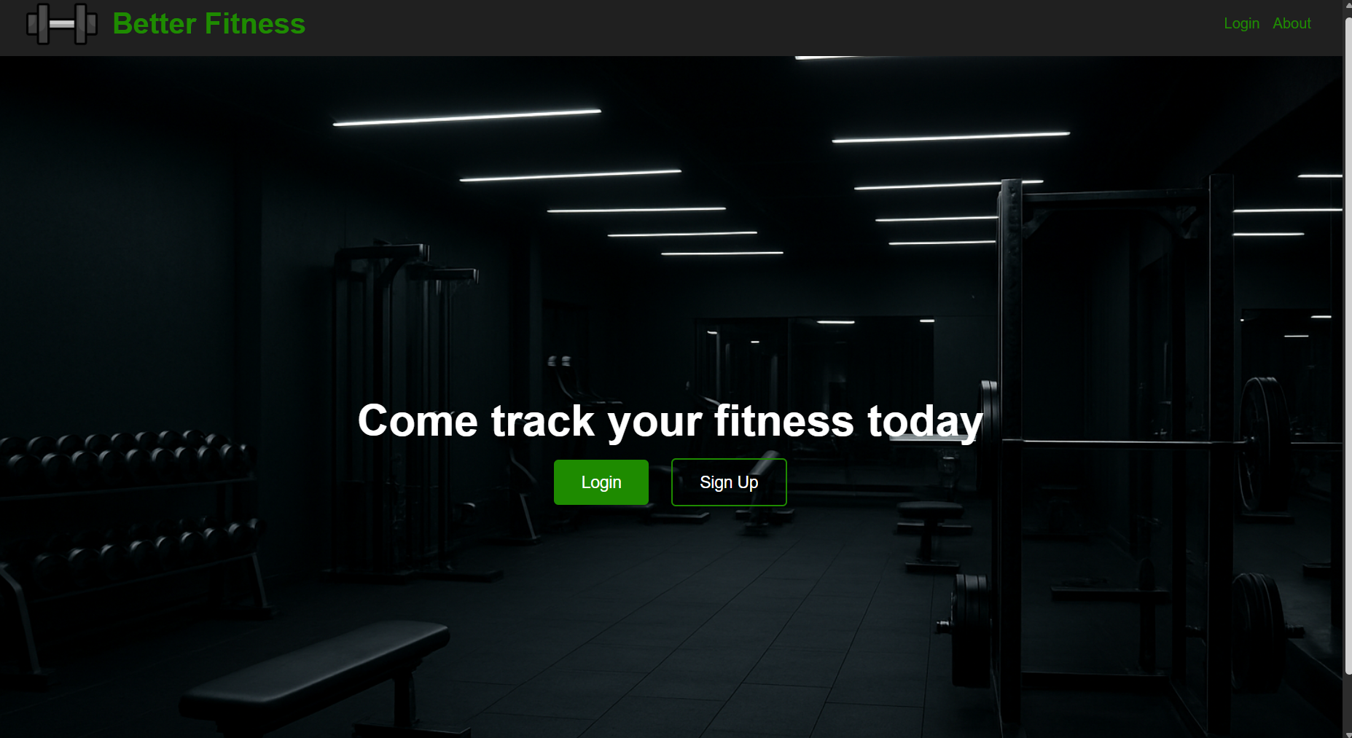
About:
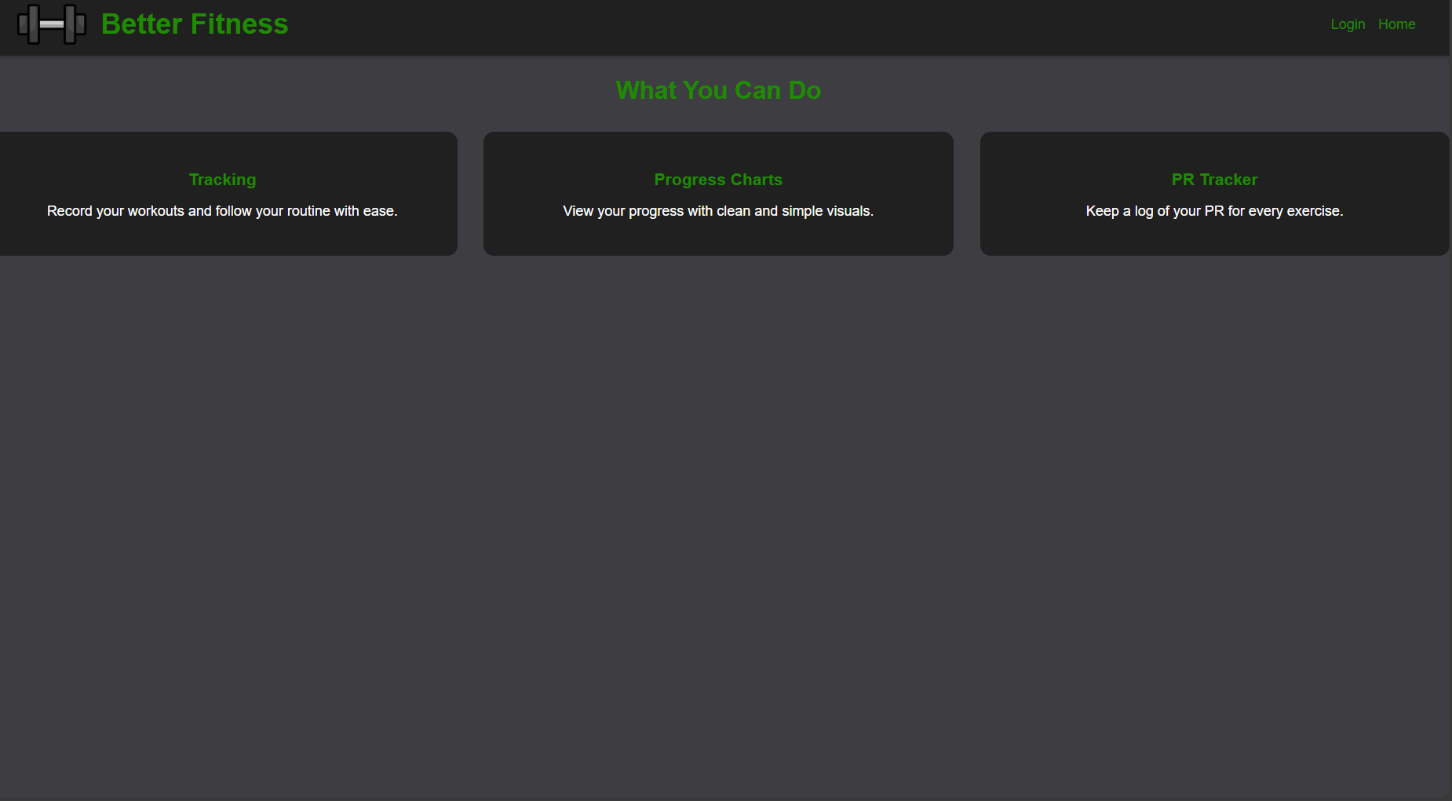
If the user press the about button on the home screen the will be directed to this about page where the functionality my system can carry out is listed.
Register page: 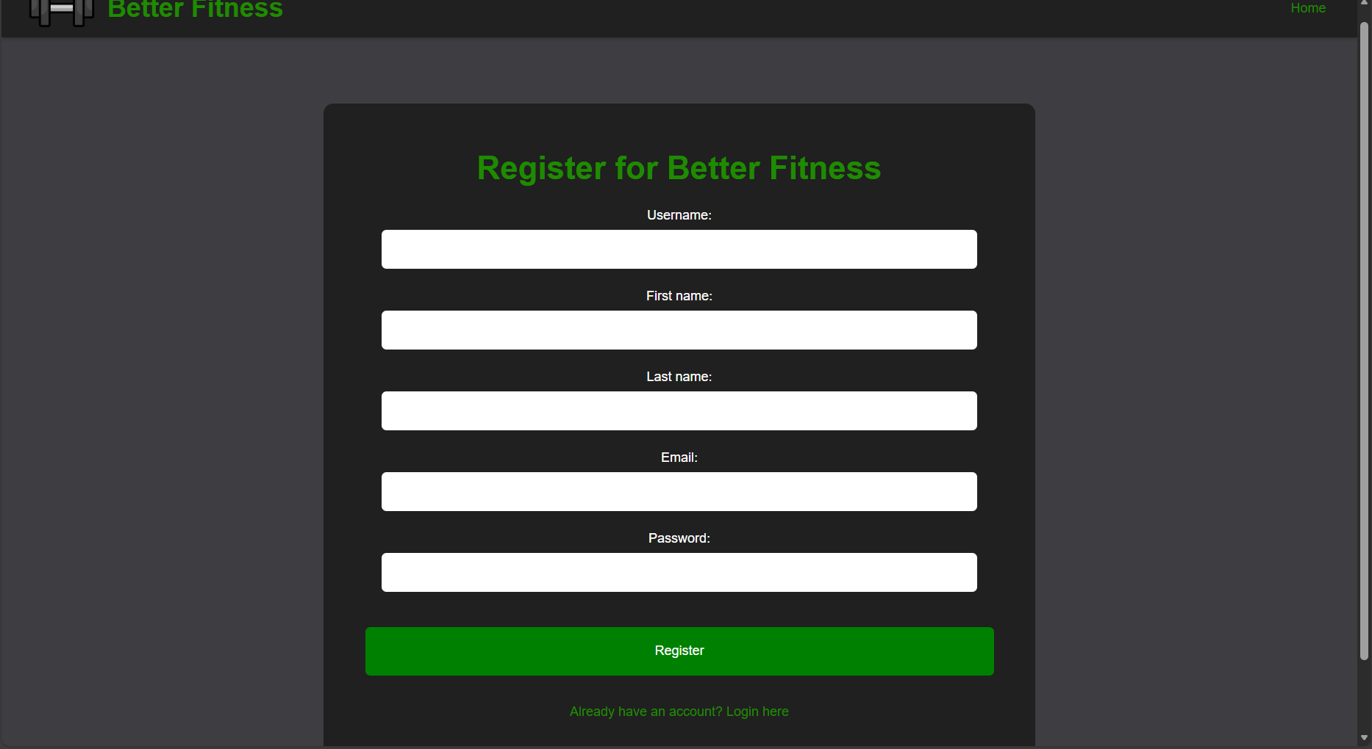
The registration page acts as the entry for new users to create their account. It houses the fields: username, first name, email, last name and password. When the user presses register, the system checks if the information is valid. The checks it makes include if the email is already in use and if the credentials input meets the requirements that each field has. If the checks met the requirements are then shown above the fields
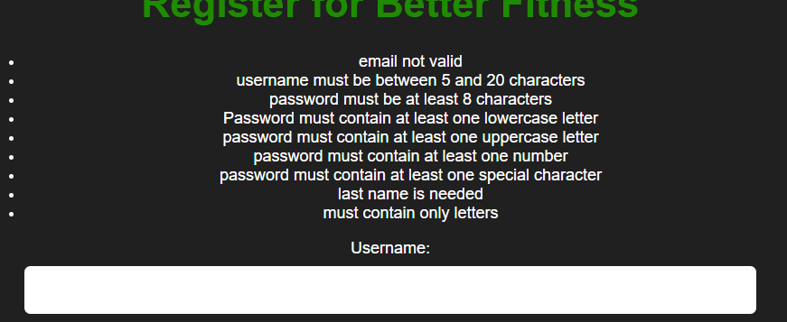
Once the user is able to successfully create an account they are directed to tracker page when they can start using the functionality my application as to offer.
Login page:
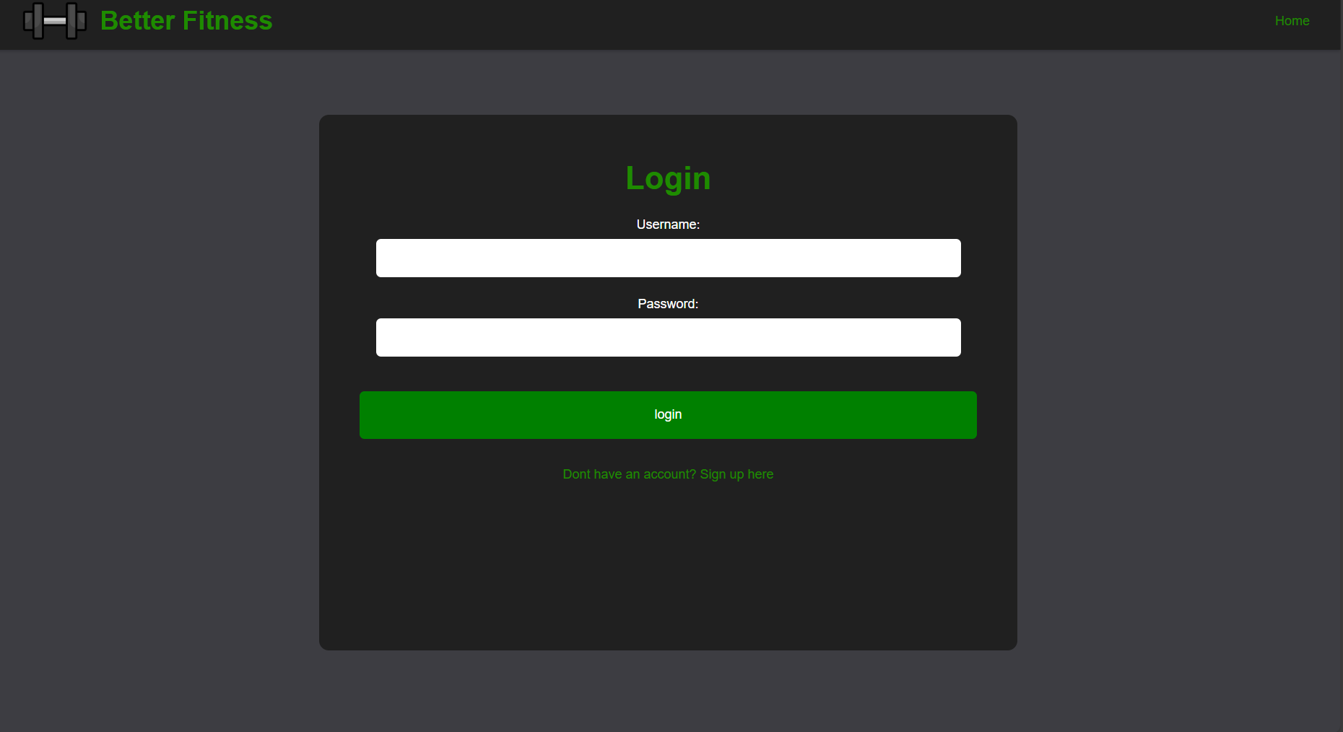
The login page allows the users who have already created an account to access their account and add onto their stored data. In order to log in the user enters both their username and password where, once again, the system verifies the credentials and any login errors are displayed at the above the fields to inform the users of what went wrong. Once the user passes system verification they are directed to the next page where they can start using the functionality the application has to offer.

Tracker page:
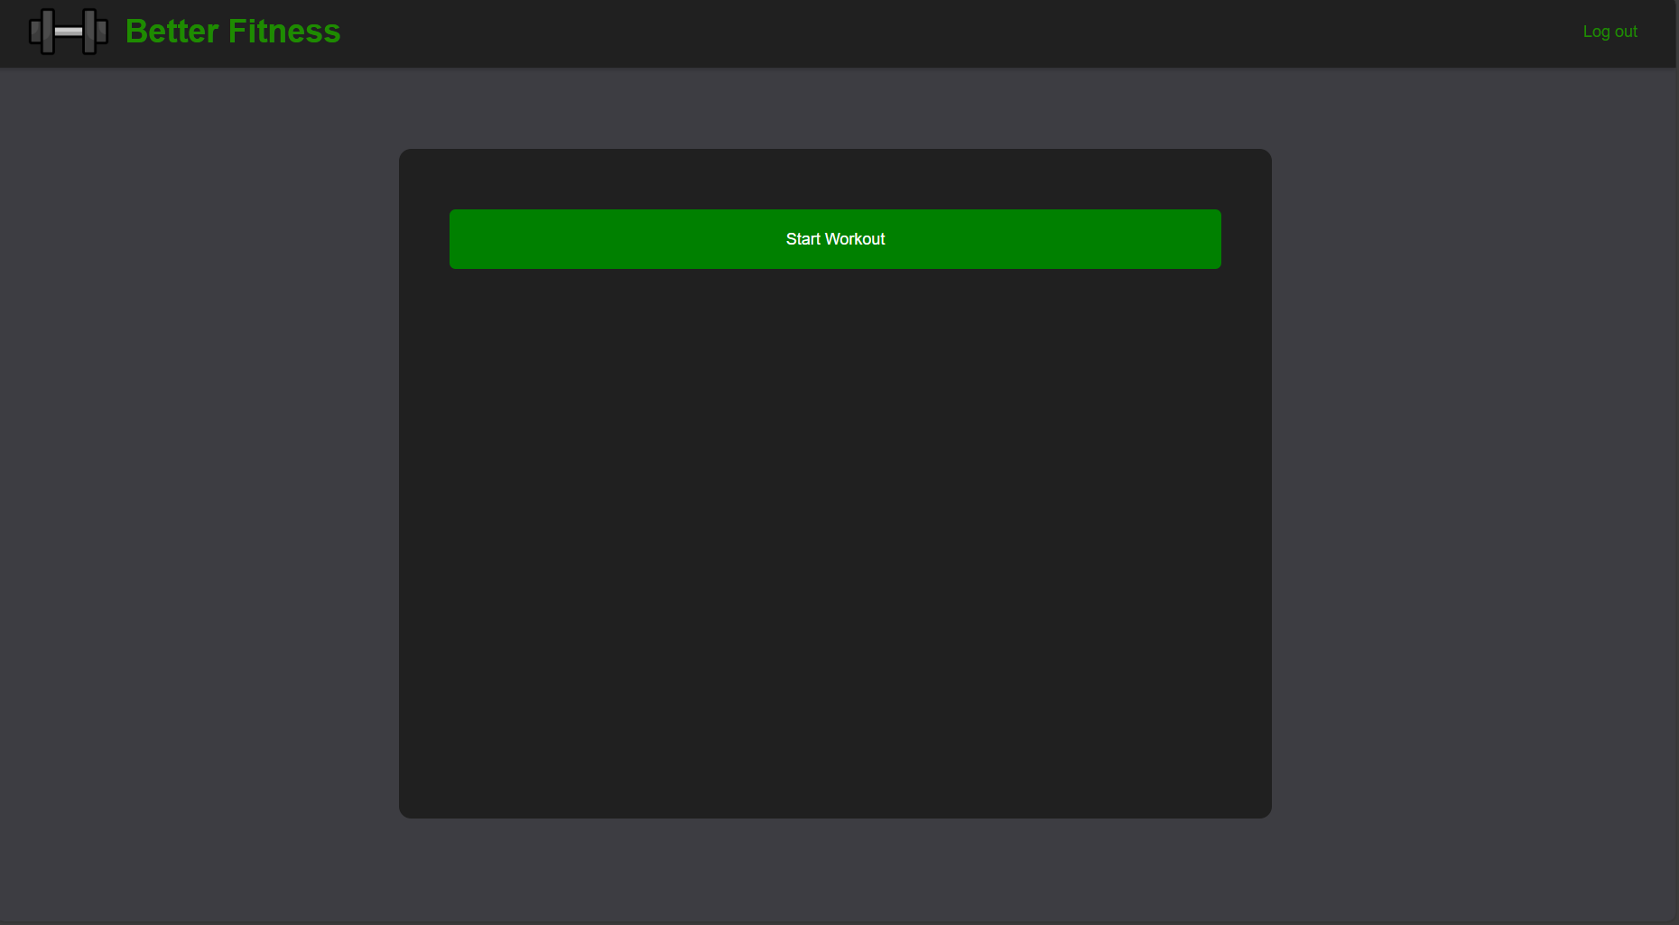
This is the first page that the user will be presented with once they login into their account. From this point onwards each page will have a link in the top right to allow the user to exit their account. Pressing the start workout button will then give the fields where they can input their data on the exercise stats. Once stats are inputted in the user presses add exercise to confirm their entry and enter it into the data base. Doing this also presents it on the screen so they can see what they have currently completed.
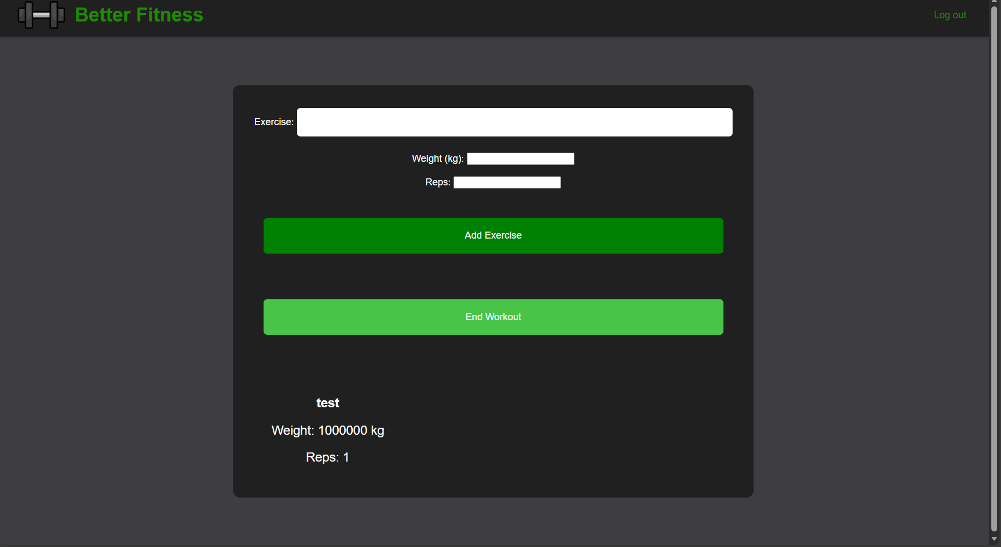
Once the user has inputted all the exercises they want to log they press end workout to proceed
Workout results:
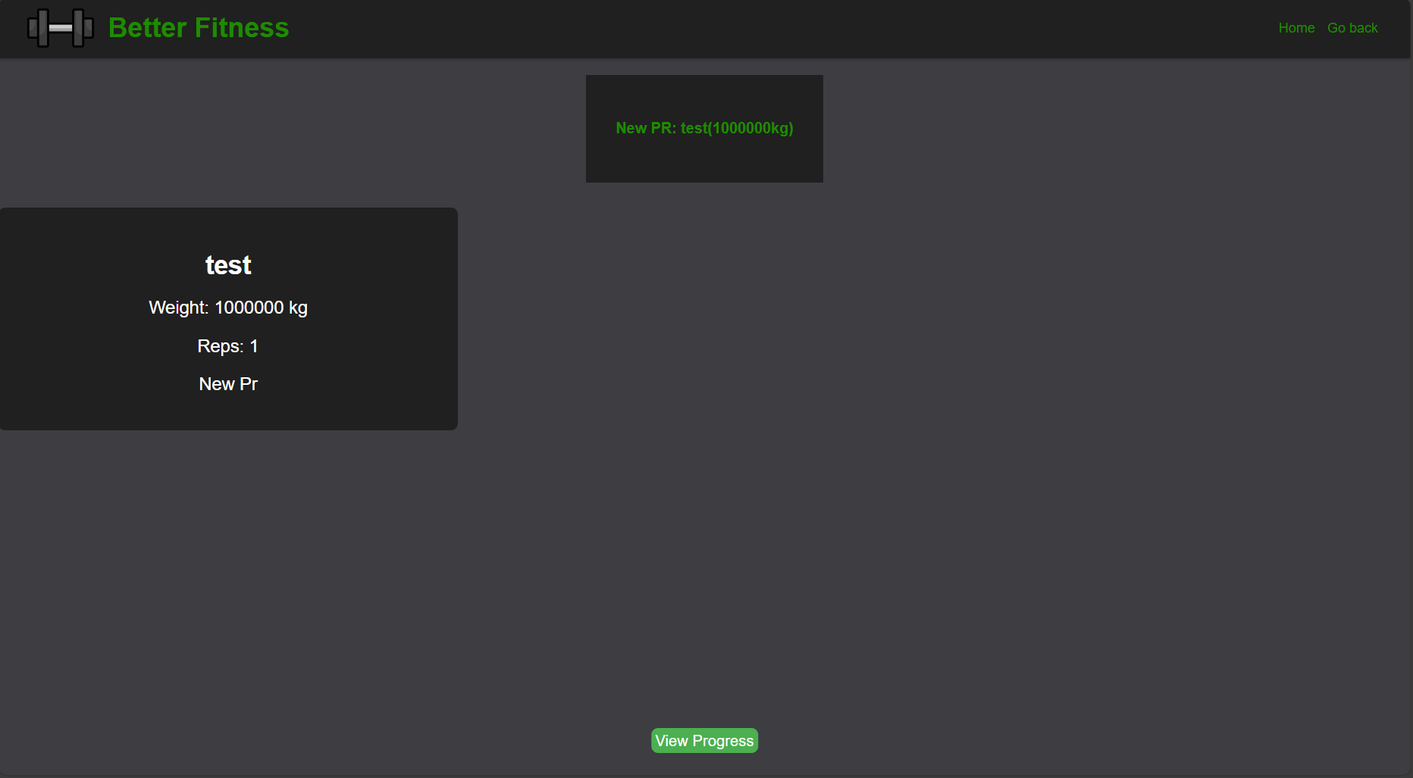
On this page all the users exercises they had just inputted will be displayed on this screen giving them and overview of what they have done. in the top box the prs the accomplished for there exercises will be displayed clearly. The user is given the option to go back using the link in the top right if they had forgot to add more exercises to this particular session. The view progress button takes them to the next page.
Charts:
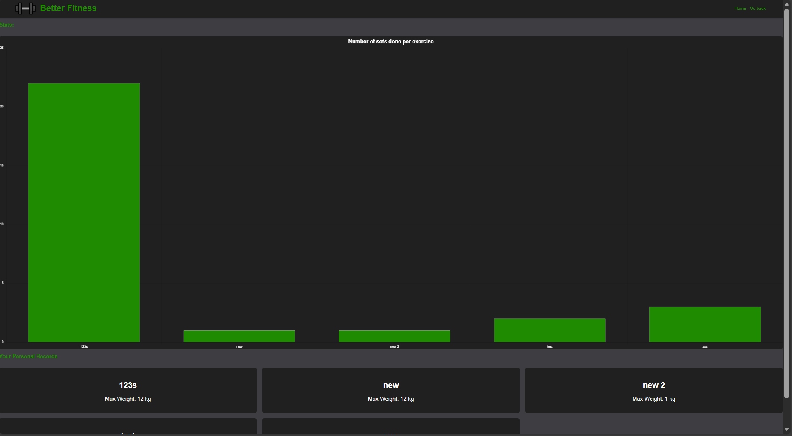
This page displays the users pr for every exercise they have submitted on that account. The page also consists of a chart that shows the number of times the user has completed every exercise they logged. The chart grows dynamically based on new workout data being inputted into the database. The chart is also interactive giving clear stats if the user hovers over the bar.
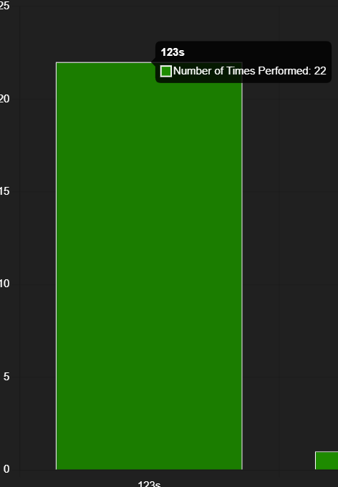

Advanced techniques:
An advanced technique that I used was the incorporation of an external library called chart.js. Chart.js is responsible for creating a responsive chart for the users training progress. It does this by getting the request from the client to the server telling it to fetch he exercise data in a JSON format.
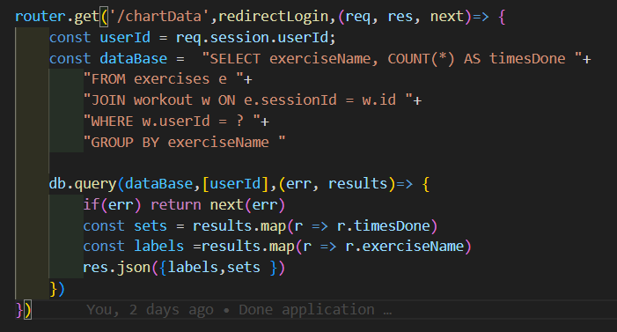
Once the data arrives a separate js script called exerciseChart.js gets passed the data which goes into a new chart object. In this object I customized the type of chart, the colours, labels and options so the bar chart would match my intended outcome.
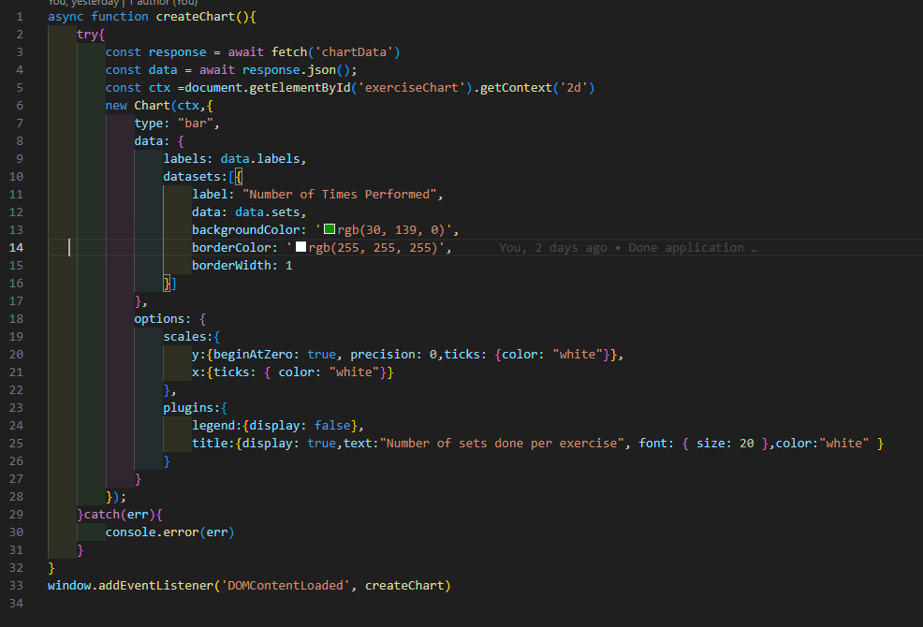

AI declaration:
The only use of ai in this project was the creation of the home page background image.

