**Global Navigation Satellite Systems Laboratory**

**(GNSS Labs)**

**Exercise 2**

**Zero Baseline Test**



*Tsung Huan Wu*

*Alexandr Sokolov*

*Hrishik Mishra*

**Course Instructor:**

**Professor Dr. Oliver Montenbruck**

**Abstract**

The NovAtel OEM-4 G2 dual-frequency GPS receiver and Dual frequency GPS receiver are used to acquiring GPS signals for one hour. In this report, the zero baseline test has been implemented to analyze the effect of different sources of measurement noise. A double difference mathematical model will be provided for both code and carrier phase observation. Because the baseline is exactly equal to zero, only the ambiguity and noise term would remain (including effect of different cable length from splitter to receivers). Therefore, Modeling the measurement noise could be fulfilled. Furthermore, the relation between elevation to signal-to-noise ratio and DLL and PLL will be discussed with and without forming the double difference. In addition, the receiver clock offset will also studied to comprehend the asynchronous and synchronous receiver.

**Contents**

**Chapter 1. Basic Mathematical Model and Analysis**

*1.1* *Mathematical model 4*

*1.2* *Noise 5*

*1.3 Mean value of the carrier phase double difference 5*

**Chapter 2. Double Difference Noise in different cases**

*2.1 Selection of the Satellite 5*

*2.2 Analysis and Comparison With Double Difference Measurements 7*

**Chapter 3. Estimation of DLL and PLL bandwidth**

*3.1 Delay Lock Loop and Phase Lock Loop 9*

*3.2 DLL and PLL Bandwidth**9*

**Chapter 4. Receiver Clock Offset**

*4.1 Maximum Clock Offset 10*

*4.2 Synchronization of Receivers 12*

# 

# 

# 

# 

# 

# 

# 

# 

# Chapter 1. Basic Mathematical Model and Analysis

### Mathematical model

The model of code and carrier phase observations with the receiver A from satellite j:

$$L_{A}^{j}=ρ_{A}^{j}+cδt_{A} - cδt^{j}+T_{A}^{j} - I_{A}^{j}+b_{A}^{j}+ϵ_{A}^{j}$$ (1.1)

$$P_{A}^{j}=ρ_{A}^{j}+cδt_{A} - cδt^{j}+T_{A}^{j}+ I_{A}^{j}+β_{A}^{j}+E_{A}^{j}$$ (1.2)

where $$P_{A}^{j}$$ and $$L_{A}^{j}$$ represents the code observation and the carrier phase observation. Term $$ρ_{A}^{j}$$ means the geometric distance from satellite j to receiver A and $$T_{A}^{j} , I_{A}^{j},b_{A}^{j}$$ and $$ϵ_{A}^{j}$$ are tropospheric delay, ionospheric delay, phase ambiguity and noise terms. In the following, only phase measurement model will be used to demonstrate the process, since the procedure is similar.

Single difference could easily get from two receivers, A and B, measuring the same satellite j at the same time epoch. Subtracting the equation 1.1 for two different receivers:

$${∇L}_{A,B}^{j}=ρ_{A}^{j}-ρ_{B}^{j}+∇cδt_{A,B} +∇T_{A,B}^{j} - ∇I_{A,B}^{j}+{∇b}_{A,B}^{j}+{∇ϵ}_{A,B}^{j}$$ (1.3)

The satellite clock offset of satellite (satellite ephemeris and satellite phase center variation of antenna) has been eliminated. But, the noize in single difference increased by factor of $$\sqrt{2}$$. Now, the double difference is computed from subtracting the single difference equation 1.3 with single difference for satellite *k*.

$$∆{∇L}_{A,B}^{j,k}=∆{∇ρ}_{A,B}^{j,k} +∆∇T_{A,B}^{j,k} - ∆∇I_{A,B}^{j,k}+{∆∇b}_{A,B}^{j,k}+{∆∇ϵ}_{A,B}^{j,k}$$ (1.4)

and receiver clock correction (also, the phase center variation of receiver’s antennas) has been taken out. The pseudoranges for two different receivers are zero in this particular experiment, which is done by using a splitter to feed the receivers with the same antenna. Therefore, the ionospheric and tropospheric correction could be also assumed the same from the model. The double difference model for the zero baseline test becomes:

$$∆{∇L}_{A,B}^{j,k}={∆∇b}_{A,B}^{j,k}+{∆∇ϵ}_{A,B}^{j,k}$$ (1.5)

, where $${∆∇b}_{A,B}^{j,k}$$ is the difference of ambiguity with different satellite and different receivers and it could be also represent as the wavelength times an integer number, $${∆∇λN}_{A,B}^{j,k}$$. In here, the ambiguity remains because the receivers generate different reference signals.

All in all, in the zero baseline test, the measurement model of the double difference will be

$$∆{∇L}_{A,B}^{j,k}={∆∇b}_{A,B}^{j,k}+{∆∇ϵ}_{A,B}^{j,k}$$

$$∆{∇P}_{A,B}^{j,k}={∆∇E}_{A,B}^{j,k}$$

Pseudorange, ionosphere correction, tropospheric correction, satellite correction, the clock correction and other error terms are all eliminated in the zero baseline test.

### Noise

The downside of forming the differences with GPS signals is that the noise level will be amplified. For single difference noise increased by factor of $$\sqrt{2}$$ and for double difference noise increased by factor of 2. The sources of the noise are basically uncorrelated because it all comes from different places and instruments, i.e satellites and receivers. So that the noise level of the double difference is :

$$σ({∆∇ϵ}_{A,B}^{j,k})=\sqrt{{σ^{2}(ϵ}_{A}^{j}){{+σ}^{2}(ϵ}_{B}^{j})+{σ^{2}(ϵ}_{A}^{k}){+σ^{2}(ϵ}_{B}^{k})}=\sqrt{{{4σ}^{2}(ϵ}_{A}^{j})}=2{σ^{}(ϵ}_{A}^{j})$$ (1.6)

,where $${σ(ϵ}_{A}^{j})$$ is the standard deviation of the measurement noise.

### 1.3 Mean value of the carrier phase double difference

In the equation 1.4, the only deterministic term is the integer ambiguity term. Therefore, if we look into the mean value of the observation, it would be only the difference of the ambiguities under the assumption the noise of the measurement noise is normally distributed. Although the mean value should remain at constant in most of the case, there might be a cycle slip while the SNR value is lower. This phenomenon would be further discussed in the following chapter.

# Chapter2. Double Difference Noise in different cases

In chapter 2, the selection of satellites within similar elevation (and consequently similar C/N0 ratio) will be performed first. After the selection, the double difference of different frequency will be computed for both high elevation and low elevation satellites to study the behavior of the noises.

### 2.1 Selection of the Satellite

Similar satellites are selected to generate the double difference. The selecting criteria are based on the C/N0 and the elevation angle from the receiver interface, skyplot.

From figure 2.1, satellite 1,4,11,19 and 32 are selected for the highest C/N0 value, while satellite 8 and 28 has the lower signal strength. With the help of the skyplot, figure 2.2, satellite [11, 32] and satellite [8, 28] are selected in order to study the performance under the different signal strength.

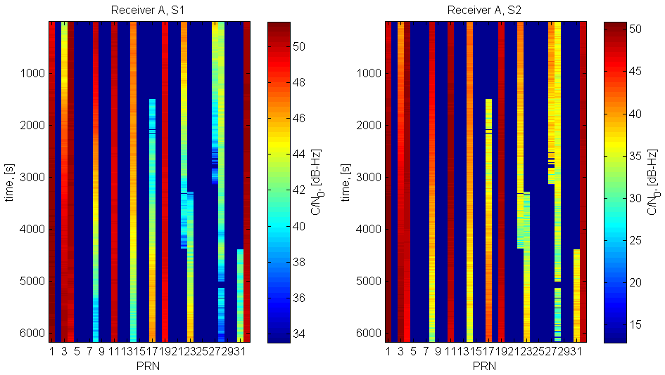

Figure 2.1 C/N0 value with all satellites

C/N0 is strongly dependent with two factors, the elevation angle and the transmitted power for different frequencies. First, from figure 2.2 and 2.3, satellite 1 and 4 has the clear pattern, which C/N0 is proportional to time and the elevation angle. The second factor is the different transmit power for different frequency channels. L1 signals are transmitted with higher power that the L2 signals. It can be easily observed from figure 2.1 that the L1 signal is stronger that the L2 signal.

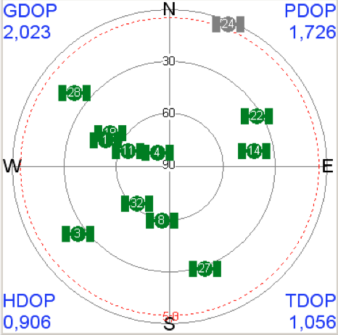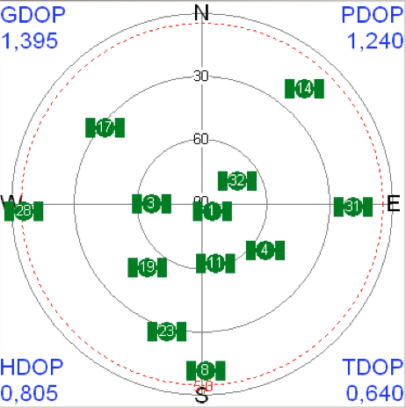

Figure 2.2 Skyplot Start (Right) and End (Left)

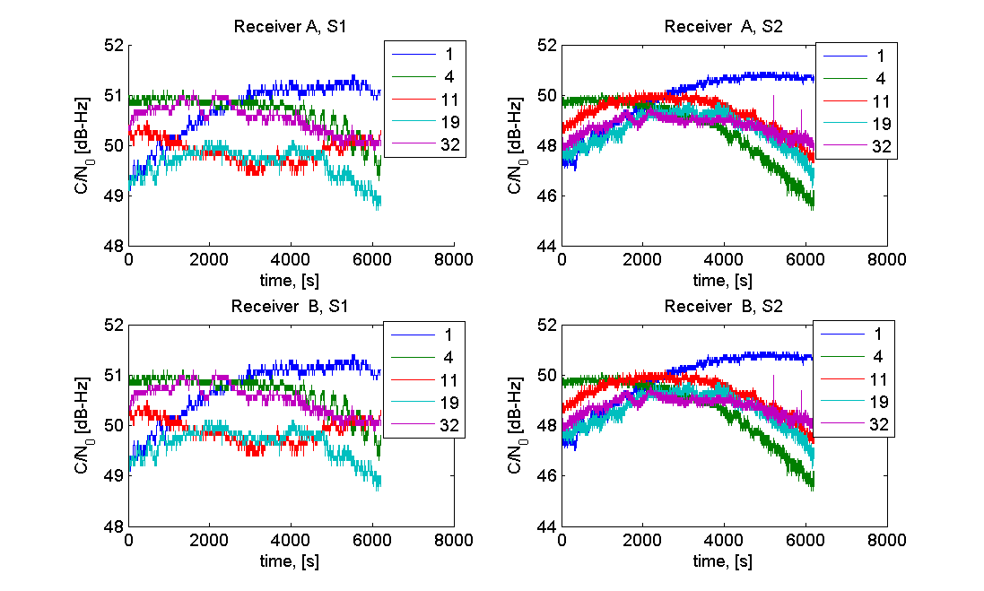

Figure 2.3 C/N0 for all selected satellites

### 2.2 Analysis and Comparison With Double Difference Measurements

The noise terms, remained in the measurement model, are ambiguities and the measurement error. The noise level could be expressed by the standard deviation of each double difference pair. The behavior with the high elevation pair is quite ideal. There is no cycle slip and the standard deviation is quite low. In the other side, the low elevation pair displays the cycle slip at the end of the measurement phase and the precision starts getting bigger.

|  |  |  |  |
| --- | --- | --- | --- |
|  |  | PRN: 11&32 (High elev.) | PRN: 8&28 (Low elev.) |
|  | $$σ_{C1}$$ | 0.1599 | 0.864 |
|  | $$σ_{P2}$$ | 0.0683 | 2.40 |
|  | $$σ_{L1}$$ | 0.0025 | 0.0085 |
|  | $$σ_{L2}$$ | 0.0025 | 0.0266 |

The C/A code is clearly less noisy than the P2 measurement with the low elevation pair although the P code was designed to achieve higher accuracy. This is simply caused by the transmitted power is weaker on L2 channel so that the signal is easily interfered by the noise. As for phase measurements, the L2 will also much more noise than the L1 signal. It’s up to 4 times difference in the low elevation pair.

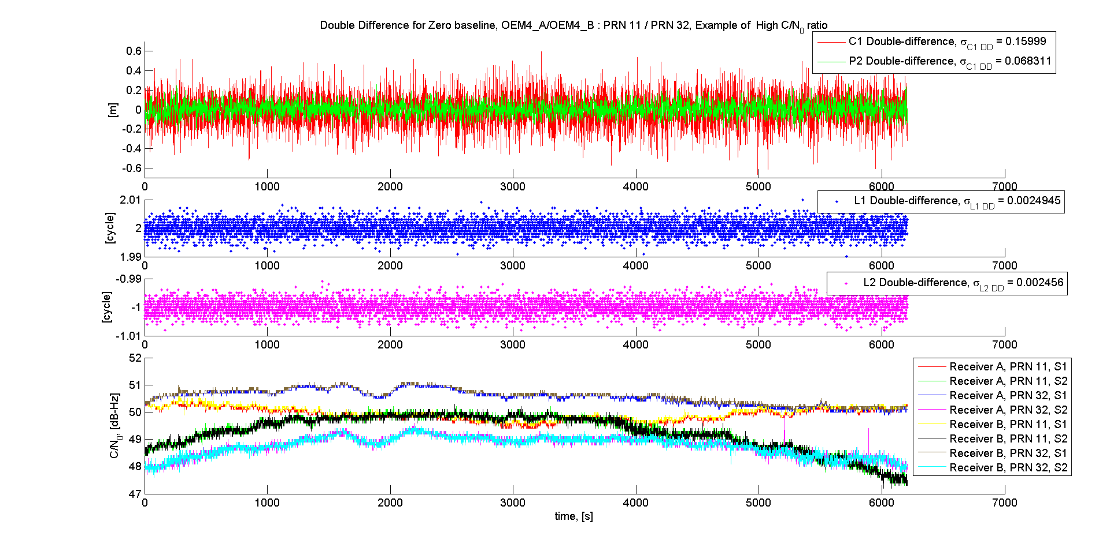

Figure 2.4 Double difference between satellite with high elevation angle

# 

Figure 2.5 Double difference between satellite with low elevation angle

From the figures 2.4 and 2.5 we can see that P2 code degraded much stronger than C1 code at low C/N0 ratio.

# Chapter3. Estimation of DLL and PLL bandwidth

In chapter 3, DLL and PLL will be briefly introduced. The estimation of the PLL and DLL bandwidth will also be studied and estimated by using the simplified model given by Prof. Montenbruck.

### 3.1 Delay Lock Loop and Phase Lock Loop

Receivers must have the ability to correlate or synchronize the reference signal, generated by itself, to the transmitted Code, generated by the satellite, with the highest possible value, so that the estimation of the pseudorange would be more accurate. To achieve such purpose, the tracking loop is often used as a feedback loop to adjust differences. Delay lock loop and phase lock loop are mostly used.

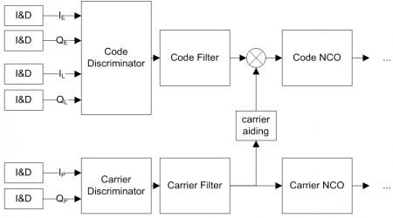

The general idea of PLL and DLL is expressed in the figure 3.1. However, DLL tracks and estimates the mismatched part between the local reference signals and the incoming signals, while PLL tracks mainly to the phase.



In this report, the simple model, equation 3.1, has been used to estimate the standard deviation of DLL and PLL. Bandwidth of the PLL and DLL is proportion to the standard deviation of the code observation and the carrier phase observation. This relationship could be explained by the size of the search bin inside the receiver. The smaller the bandwidth, the better the accuracy of the measurement. The estimation of the bandwidth, thus, could be derived from eq. 3.1.

### 3.2 DLL and PLL Bandwidth

The same pair of the satellites from chapter 2 has been used in the estimation of the bandwidth as well. Satellite 11 and 32 are for high elevation, and Satellite 8 and 28 are for low elevation. In here, the double difference also takes an important role, so that the only statistic remaining term is the noise term, which usually contribute from the thermal noise in the tracking loop.

C/A code and L1 double difference are analyzed in this section and the OEM-4 receiver chip employs a 0.1 chips at early-late correlator spacing. However, from eq.1.6, the noise is double by forming the double difference under the assumption that the noise terms are uncorrelated. So the standard deviation of $$σ_{C/A}$$ and $$σ_{PLL}$$ are divided by two. From table 3.1, we could observe that the result stays consistent with the previous analysis. The bandwidth is proportional to the standard deviation of the signals.

|  |  |  |
| --- | --- | --- |
| Parameters | at High Elevation | at Low Elevation |
| SAL1 | 50.2445 | 43.552 |
| $$σ_{C/A}$$ [m] | 0.16 | 0.864 |
| $$σ_{PLL}$$ [m] | 4.74e-4 | 1.6e-3 |
| BDLL [Hz] | 0.158 | 0.986 |
| BPLL [Hz] | 6.497 | 16.2 |

Table 3.1

# Chapter 4. receiver clock offset

The NovAtel OEM-4 receiver continuously steers its clock to GPS time and residual clock offsets are generally less than 20m. The measurements from two receivers in a zero baseline test are therefore well synchronized and can be differenced without further precautions. Many other receivers (Javad, Ashtech, Septentrio) exhibit clock offsets of up to 0.5 ms and measurements from different receivers are thus collected at slightly different epochs.

### 4.1 Maximum Clock Offset

The Zero-baseline test is conducted under the assumption that both Receivers adopt similar techniques to deal with the difference between satellite clock and receiver clock. As described in (1.4), the temporal errors due to relative receiver clock offset variability between receivers are assumed to cancel out during double differencing. However, in case of non-identical receivers, the double difference will have a considerable contribution of the relative clock offset variability towards temporal errors in measurements. In order to quantify the Maximum allowable Clock offset, we must first attempt to characterize the clock offset of each receiver. Clock offset is the time-difference between receiver-registered time and satellite-transmitted time after the signals are synchronized on a common measure of time, that is, the Atomic Time scale. There are two techniques available to manufacturers to deal with clock offset variability. 1) The steering mechanism followed in the NovAtel OEM-4 receiver which attempts to nullify the clock drift. 2) Alternatively, a receiver may make discrete jumps of receiver’s estimate of time when the offset itself is greater than a certain threshold value.

For the purpose of double differences, the former methodology presents a more tractable option as in the latter case, the abrupt changes in clock offset estimates need to be accounted for, which if unchecked will not necessarily cancel out. This will result in an error characteristic that is not aligned with positioning objectives.

Typically, clock offsets vary from milliseconds to seconds depending on receiver clock quality. The receiver clock offsets variability does not directly affect the double difference measurements. However, there is an effect due to the relative motion between satellite transmitter and the receiver during the time interval of the satellite clock offsets. In order to avoid additional computation of the satellite positions correctly, the clock offsets, therefore, have to be kept within a tolerance limit.

Since the carrier-phase measurements are precise to the order of 1mm, it is imperative that satellite position errors due to differential clock offsets do not exceed this amount. For GPS-satellites, with a relative velocity of 4 km/s with respect to receivers,

|  |  |  |
| --- | --- | --- |
|  | $Δx =δ{}_{u}⋅Δv_{vel}$ | 4.1 |

Where, is the position error, is the receiver clock-offset and is the relative velocity between satellite and receiver.

Using 4.1, with tolerance limits of 1mm,

|  |  |  |
| --- | --- | --- |
|  | $δ_{u,max}≤250 [ns]$ | 4.2 |

If the inequality of 4.2 is exceeded, then an alternative measurement model has to be employed that accounts for residual satellite movement as is given in **[1]**. In the following exercise, NovAtel OEM-4 receivers achieved a clock-offset error of .

|  |  |  |
| --- | --- | --- |
|  | $Δρ=δ_{u}⋅c$ | 4.3 |

Where, is the range error and is the electromagnetic propagation velocity. From 4.3, is found to be

|  |  |  |
| --- | --- | --- |
|  | $δ_{u}$ = $\frac{20 [m]}{c}=66.7 [ns]$ | 4.4 |

Since, 4.4 satisfies the inequality in 4.2, the zero baseline exercise can be assumed correct without modifying the measurement model.

Also, as mentioned in the question, the receivers with clock errors up to 0.5 ms can be used but with a modified observation model as described in **[1]**.

### 4.2 Synchronization of Receivers:

As mentioned before, if the receivers are not synchronized to a certain tolerance value, the differential clock offset results in satellite position errors which also need to be computed. As a result, the range measurement model has to be modified for the double difference.

|  |  |  |
| --- | --- | --- |
|  | $ρ{}_{1}^{kl}(t+δτ_{1})-ρ{}_{2}^{kl}(t+δτ_{2})≈c{}_{12}^{kl}(t,δτ_{1},δτ_{2})+ϵ$ | 4.5 |

Where, is the correction for the satellite movement within the time-interval of differential clock offset (. Similarly, the model for the phase measurement can be formulated.

|  |  |  |
| --- | --- | --- |
|  | $\frac{λ}{2π}⋅(φ{}_{1}^{kl}(t+δτ_{1})-φ{}_{2}^{kl}(t+δτ_{2}))≈c{}_{12}^{kl}(t,δτ_{1},δτ_{2})+λN{}_{12}^{kl}+ϵ$ | 4.6 |

In case of asynchronous receivers, the double difference observations over several epochs would be a slow drifting curve instead of a fixed value. This is attributable to satellite motion primarily. As a result, is obtained by interpolation at epochs due to clock jumps, change of reference satellite et al. This process of computing double difference by correcting for satellite positions is known as synchronization correction. That being said, if the receiver clock error difference does not satisfy 4.2, the observations will be erroneous.

# Reference

[1] Low-cost GPS-based Compass with Reliable Ambiguity Resolution and Cycle Slip Correction (Master thesis), Jane Jean Kiam.