**MARMARA UNIVERSITY**

**FACULTY OF ENGINEERING**

**COMPUTER ENGINEERING**

IE3081

MODELING AND DISCRETE SIMULATION

Homework 2 : Able-Baker Call Center Simulation

Name : Mustafa Tunahan

Surname : BAŞ

Student Id : 150119055

Delivery Date : 10.12.2022 Due Date : 12.12.2022

Purpose

The aim of this homework is to simulate a call center queue system with two queues with AnyLogic and observe the results by comparing different runs with different inputs and scenarios.

The Model

My model in AnyLogic looks like this :

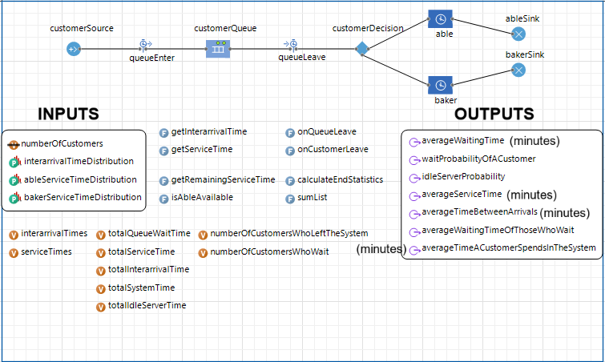

Simulation Runs

1. First Run

This run was made with the default input values from the textbook.

Input Values

|  |  |  |
| --- | --- | --- |
| **Interarrival Distribution Of Calls** | | |
| **Interarrival Times (minutes)** | **Probability** | **Cumulative Probability** |
| 1 | 0.25 | 0.25 |
| 2 | 0.40 | 0.65 |
| 3 | 0.20 | 0.85 |
| 4 | 0.15 | 1.00 |

|  |  |  |
| --- | --- | --- |
| **Able's Service Time Distribution** | | |
| **Service Times (minutes)** | **Probability** | **Cumulative Probability** |
| 2 | 0.30 | 0.30 |
| 3 | 0.28 | 0.58 |
| 4 | 0.25 | 0.83 |
| 5 | 0.17 | 1.00 |

|  |  |  |
| --- | --- | --- |
| **Baker's Service Time Distribution** | | |
| **Service Times (minutes)** | **Probability** | **Cumulative Probability** |
| 3 | 0.35 | 0.35 |
| 4 | 0.25 | 0.60 |
| 5 | 0.20 | 0.80 |
| 6 | 0.20 | 1.00 |

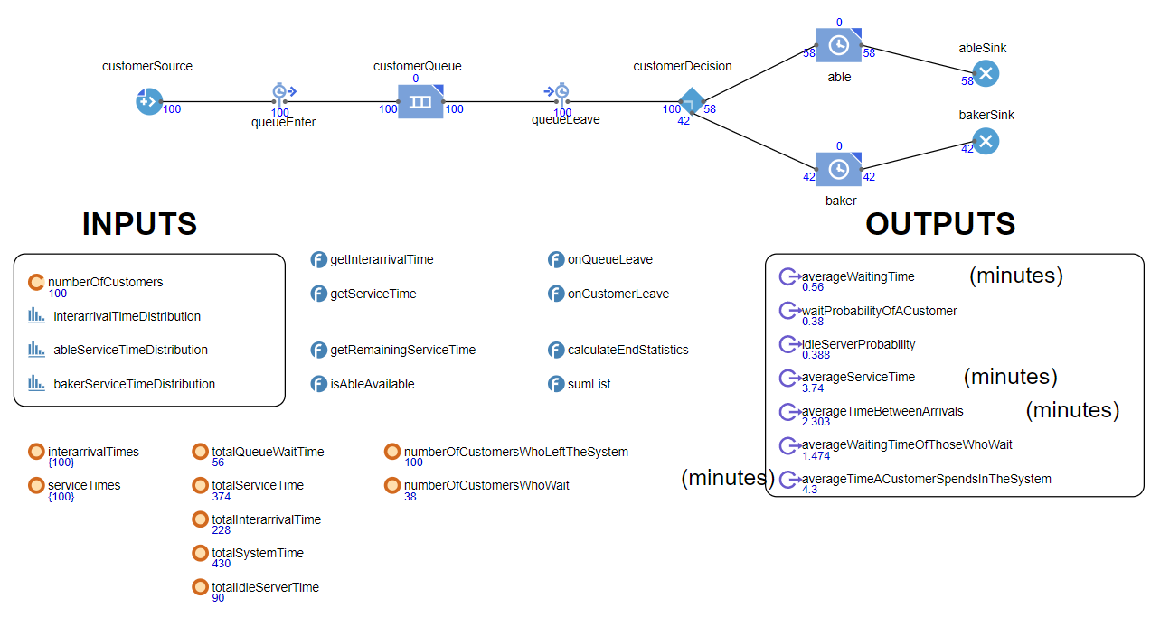Run Results

Outputs

* Average Waiting Time = 0.56 minutes
* The Probability That a Customer Has To Wait In The Queue = 0.38
* Probability Of Idle Server (The Proportion Of Time That The Server Is Idle) = 0.388
* Average Service Time = 3.74 minutes
* Average Time Between Arrivals = 2.303 minutes
* Average Waiting Time Of Those Who Wait = 1.474 minutes
* Average Time A Customer Spends In The System = 4.30 minutes

1. Second Run

This run was made with custom values that I determined.

Input Values

|  |  |  |
| --- | --- | --- |
| **Interarrival Distribution Of Calls** | | |
| **Interarrival Times (minutes)** | **Probability** | **Cumulative Probability** |
| 1 | 0.45 | 0.45 |
| 2 | 0.45 | 0.90 |
| 3 | 0.05 | 0.95 |
| 4 | 0.05 | 1.00 |

|  |  |  |
| --- | --- | --- |
| **Able's Service Time Distribution** | | |
| **Service Times (minutes)** | **Probability** | **Cumulative Probability** |
| 1 | 0.32 | 0.32 |
| 2 | 0.30 | 0.62 |
| 3 | 0.27 | 0.89 |
| 4 | 0.11 | 1.00 |

|  |  |  |
| --- | --- | --- |
| **Baker's Service Time Distribution** | | |
| **Service Times (minutes)** | **Probability** | **Cumulative Probability** |
| 4 | 0.20 | 0.20 |
| 5 | 0.25 | 0.45 |
| 6 | 0.30 | 0.75 |
| 7 | 0.25 | 1.00 |

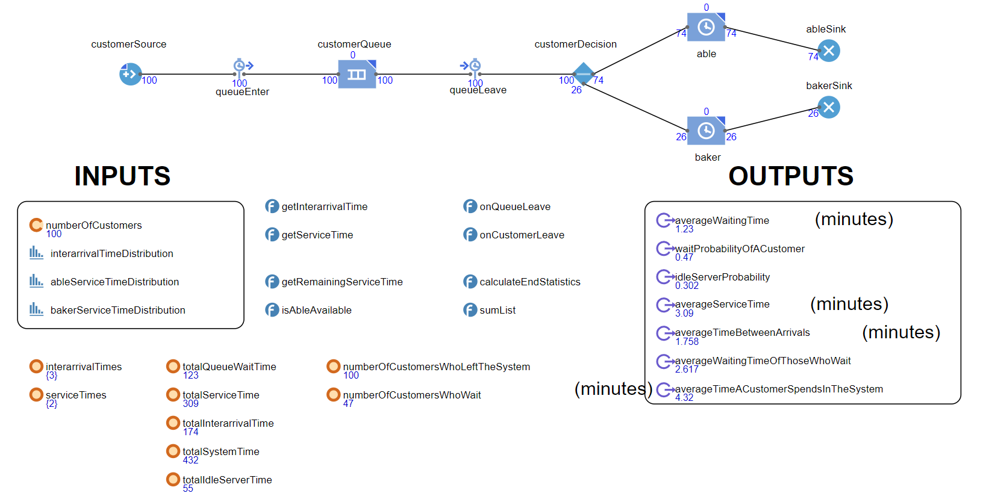Run Results

Outputs

* Average Waiting Time = 1.23 minutes
* The Probability That a Customer Has To Wait In The Queue = 0.47
* Probability Of Idle Server (The Proportion Of Time That The Server Is Idle) = 0.302
* Average Service Time = 3.09 minutes
* Average Time Between Arrivals = 1.758 minutes
* Average Waiting Time Of Those Who Wait = 2.617 minutes
* Average Time A Customer Spends In The System = 4.32 minutes

Comparison Between Two Runs

The two differences between the two scenarios are possible interarrival times and Able and Baker’s service times with their relative probabilities. The interarrival times range from 1 to 4 minutes in both runs, but in the second run the probabilities of lower interarrival times are increased significantly meaning we should expect customers more frequently in the second run.

Able’s service times range from 2 to 5 minutes in the first run and 1 to 4 minutes in the second run, also the probabilities of lower service times are slightly increased in the second run. When the calculations are done, the changes’ effects can be seen easily. In the first run, the expected service time of Able is (0.30 * 2 + 0.28 * 3 + 0.25 * 4 + 0.17 * 5) = 3.29 minutes whereas in the second run (0.32 * 1 + 0.30 * 2 + 0.27 * 3 + 0.11 * 4) = 2.17 minutes effectively reducing the average service time by more than one minute.

Baker’s service times range from 3 to 6 minutes in the first run and 4 to 7 minutes in the second run, also the probabilities of lower service times are slightly decreased in the second run. When the calculations are done, the changes’ effects can be seen easily. In the first run, the expected service time of Baker is (0.35 * 3 + 0.25 * 4 + 0.20 * 5 + 0.20 * 6) = 4.25 minutes whereas in the second run (0.20 * 4 + 0.25 * 5 + 0.30 * 6 + 0.25 * 7) = 5.6 minutes effectively increasing the average service time by more than one minute.

In the second run, customers arrive more frequently and the ability gap between Able and Baker is further apart where Able serves more than twice as fast as Baker does. Although Able serves around 1 minute faster compared to the first run, Baker serves around 1.5 minutes slower. Somehow the average service time is reduced in the second run to 3.09 minutes from 3.74 minutes in the first run and the idle server probability to 0.302 from 0.388. In both of the runs Able serves more customers than Baker does, however in the second run the difference is much more distinct. These results indicate that Able is rarely idle whereas Baker is very often idle due to Able being favored by the customers and working faster.

Although the average service time is reduced in the second run, increased frequency of arrivals causes the servers to be rather busier and thus average waiting time, waiting probability and, average waiting time of those who wait are respectively greater in the second run.

So in the second run, the queue times are increased and service times are decreased. These changes somehow balance out and the average time spent in the system is very similar between runs (4.30 minutes in the first run whereas 4.32 minutes in the second). The customer experience between the two scenarios are pretty similar, though the servers (especially Able) are less often idle compared to the first run.