****MARMARA UNIVERSITY**

**FACULTY OF ENGINEERING**

**COMPUTER ENGINEERING**

CSE2046 PROJECT 2

Name Student Number

Mustafa Tunahan BAŞ 150119055

Sadık AKGEDİK 150119052

Introduction: In this Project we were asked to design and implement an algorithm for Graph Coloring Problem. Graph Coloring (or Vertex Coloring) problem is defined as assignment of smallest number of colors to the vertices of an undirected graph, such that no adjacent vertices are of the same color

Task Division: We shared tasks equally. We wrote the code and report together.

The language used: We tried using Python and C# , ended up implementing the algorithm in C#.

The algorithm used: Welsh Powell graph coloring algorithm

What is the idea ?

The idea of Welsh Powell algorithm is to color the vertices starting from the ones with more degree.

How does it work ?

1. Welsh Powell first orders the vertices of the graph based on their degrees (number of edges connected to a vertex) in descending order and instantiates their colors as color-1 (uncolored)
2. It instantiates a variable “current-color” with color0.
3. Then it colors the first vertex in the sorted array of vertices with current-color.
4. It then iterates through the rest of the array of sorted vertices and color the ones that are not adjacent to any vertex colored with the current-color and are not colored yet.
5. Steps 3 and 4 are repeated respectively until there’s no vertex left uncolored.

Our Implementation

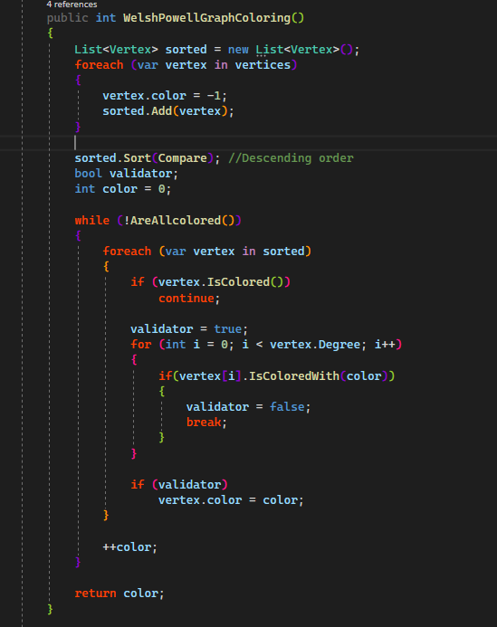

Conclusion: We’ve concluded that Welsh-Powell is currently one of the best algorithms to approximate the graph coloring problem although it produces close and similar results to many other alternatives since they’re all but approximations.

References

<https://www.geeksforgeeks.org/graph-coloring-set-2-greedy-algorithm/>

<https://en.wikipedia.org/wiki/Graph_coloring>

<https://dergipark.org.tr/en/download/article-file/254140>