**MARMARA UNIVERSITY**

**FACULTY OF ENGINEERING**

**COMPUTER ENGINEERING**

IE3081

MODELING AND DISCRETE SIMULATION

Homework 1 : Grocery Checkout Simulation

Name : Mustafa Tunahan

Surname : BAŞ

Student Id : 150119055

Delivery Date : 02.12.2022 Due Date : 05.12.2022

Purpose

The aim of this homework is to simulate a single-server queue grocery checkout system with AnyLogic and observe the results by comparing different runs with different inputs and scenarios.

The Model

My model in AnyLogic looks like this :

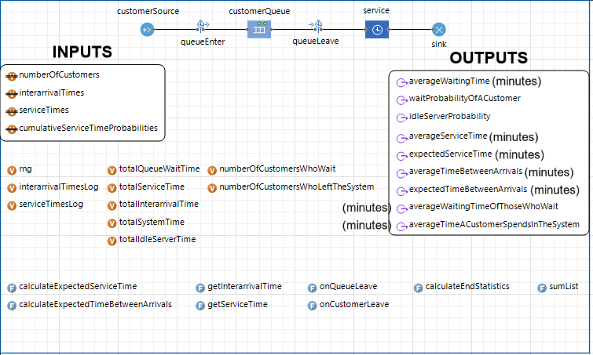

Simulation Runs

1. First Run

This run was made with the default input values from the textbook.

Input Values

|  |  |  |
| --- | --- | --- |
| **Interarrival Times (minutes)** | | |
| Minimum | | 1 |
| Maximum | | 8 |
| **Service Times (minutes)** | **Probability** | | | **Cumulative Probability** |
| 1 | 0.10 | | | 0.10 |
| 2 | 0.20 | | | 0.30 |
| 3 | 0.30 | | | 0.60 |
| 4 | 0.25 | | | 0.85 |
| 5 | 0.10 | | | 0.95 |
| 6 | 0.05 | | | 1.00 |

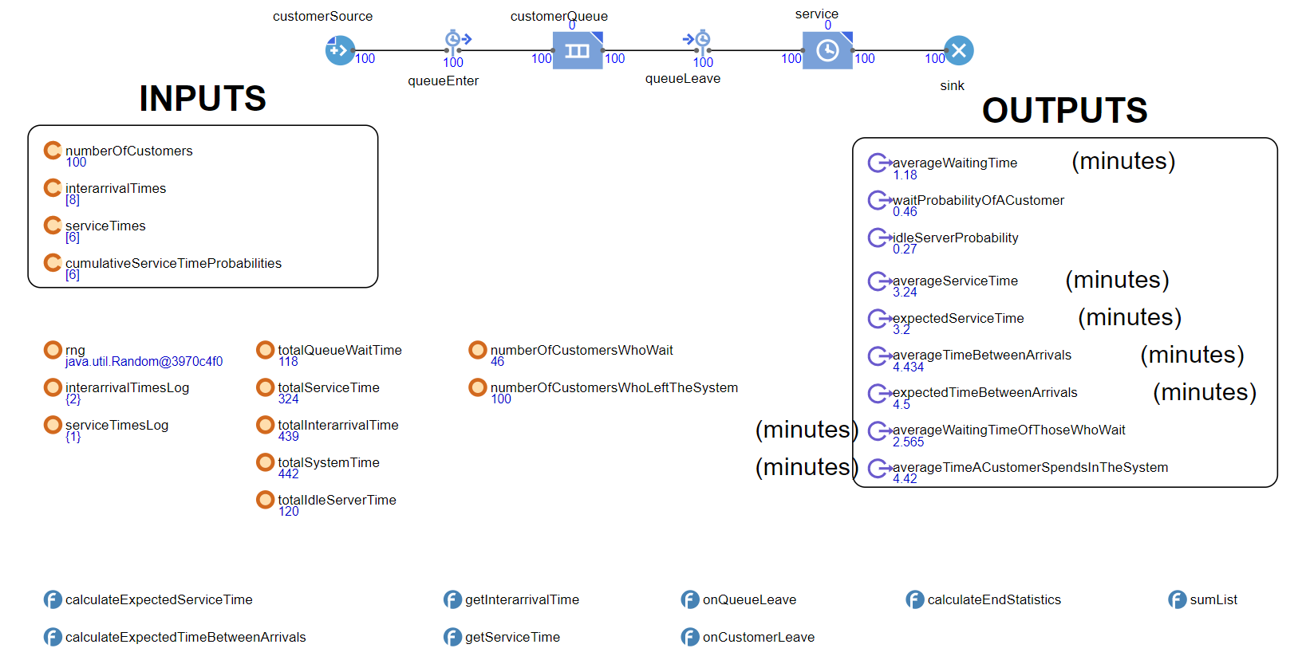Run Results

Outputs

* Average Waiting Time = 1.18 minutes
* The Probability That a Customer Has To Wait In The Queue = 0.46
* Probability Of Idle Server (The Proportion Of Time That The Server Is Idle) = 0.27
* Average Service Time = 3.24 minutes
* Expected Service Time = 3.2 minutes
* Average Time Between Arrivals = 4.434 minutes
* Expected Time Between Arrivals = 4.5 minutes
* Average Waiting Time Of Those Who Wait = 2.565 minutes
* Average Time A Customer Spends In The System = 4.42 minutes

1. Second Run

This run was made with custom values that I determined.

Input Values

|  |  |  |
| --- | --- | --- |
| **Interarrival Times (minutes)** | | |
| Minimum | | 2 |
| Maximum | | 5 |
| **Service Times (minutes)** | **Probability** | | | **Cumulative Probability** |
| 1 | 0.05 | | | 0.05 |
| 2 | 0.10 | | | 0.15 |
| 3 | 0.15 | | | 0.30 |
| 4 | 0.20 | | | 0.50 |
| 5 | 0.25 | | | 0.75 |
| 6 | 0.25 | | | 1.00 |

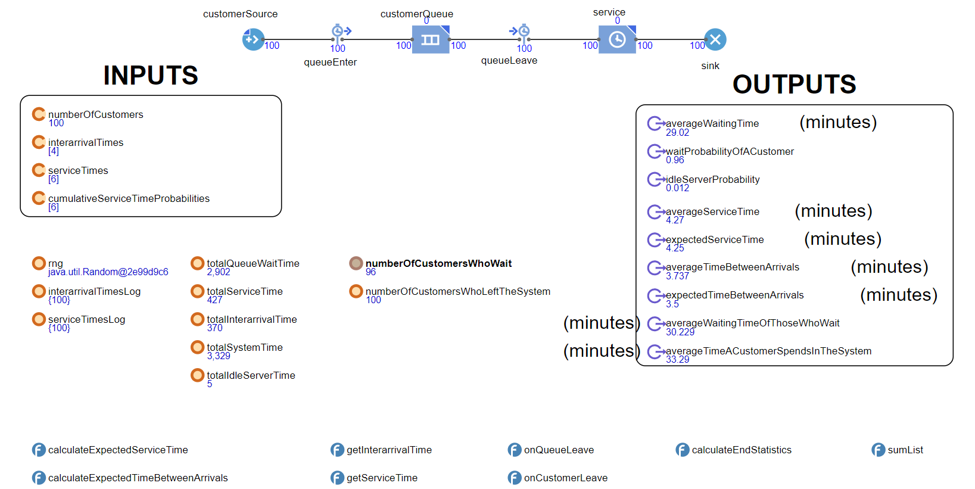Run Results

Outputs

* Average Waiting Time = 29.02 minutes
* The Probability That a Customer Has To Wait In The Queue = 0.96
* Probability Of Idle Server (The Proportion Of Time That The Server Is Idle) = 0.012
* Average Service Time = 4.27 minutes
* Expected Service Time = 4.25 minutes
* Average Time Between Arrivals = 3.737 minutes
* Expected Time Between Arrivals = 3.5 minutes
* Average Waiting Time Of Those Who Wait = 30.229 minutes
* Average Time A Customer Spends In The System = 33.29 minutes

Comparison Between Two Runs

The two differences between the two scenarios are possible interarrival times and service times with their relative probabilities. The interarrival times that range from 1 to 8 minutes are narrowed down to range from 2 to 5 minutes at the second run. Although we certainly can have ideas about how these new values would affect the system, calculating the expected time between arrivals and comparing them instead would provide us much more insight and certainty towards how the system will be affected. This value dropped down to 3.5 minutes at the second run which was 4.5 minutes at first which means we should expect customers to arrive at the grocery more frequently. This is certainly one of the factors why the system was so choked up at the second run.

As to the second difference, which is the service times, the possible service times remained same between the runs but their relative probabilities were changed so that quicker service times are less likely to occur in the second run which definitely leads to higher average service time. It’s indeed correct and the expected service time went up to 4.25 minutes at the second run from the 3.2 minutes at the first run. This is the second factor that causes the system to be busier at the second run.

The system is much more performant in the first scenario. The combined effects of increased customer frequency and increased service time lead to a dramatic result in the second scenario which is ,in my opinion, 20 to 25 times more inefficient than the first one. Here are some comparisons between the two scenarios :

* The average waiting time increased to 29 minutes from 1 minute which means the customers would have to wait almost half an hour just to get to the checkout.
* The probability of a customer waiting at the queue increased to 0.96 from 0.46 which means in 96% of the customers would have to wait at the queue in the second scenario compared to less than half of the customers having to wait at the queue in the first scenario.
* Idle server probability dropped from 0.27 to 0.012 in the second scenario which indicates that the counter won’t be able to take a break since it’s more than 99% of the time busy.
* In the second scenario, the average waiting time of those who wait with a value of 30.229 minutes is not much different from average waiting time compared to the ones of the first scenario since 96% of the customers wait.
* The average time a customer spends in the system increased to 33.29 minutes from 4.42 minutes between two runs. It got worse by a factor of 7.53 and now a customer has to stay in the grocery for more than half an hour in the grocery.

These results show us how little changes in the inputs can result in drastic effects in the system and its responses that would be so hard to guess or estimate intuitively. This also reminds us the importance of simulation without which this grocery business would be in so much trouble.