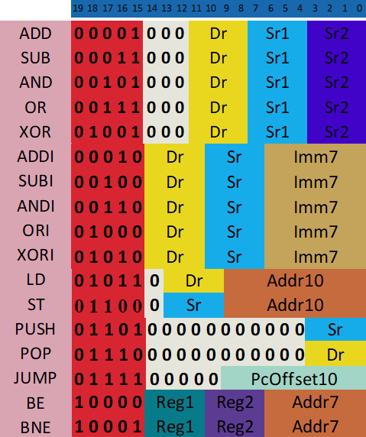ISA

Opcode : 5 bit

Sr = Source Register

Dr = Destination Register

Reg = Register

Imm = Immediate

Addr = Address

PcOffset = PC Offset

**Arithmetic Instructions****:** *SUB,ADD, AND, OR, XOR, ADDI, SUBI, ANDI, ORI, XORI*

Each arithmetic instruction will follow one of the two patterns below:

ADD DST SRC1 SRC2

ADDI DST SRC1 IMM7

***Memory Instructions* :***LD, ST, PUSH, POP*

These are the possible instructions :

LD DST ADDR

ST SRC ADDR

PUSH SRC

POP DST

**Jump Instructions** *: JUMP, BE, BNE*

These are the possible instructions:

JUMP PCOFFSET

BE REG1 REG2 ADDR

BNE REG1 REG2 ADDR