**1. Define a computer and explain its key characteristics.**

A computer is an electronic device that manipulates information, or data. It has the ability to store, retrieve, and process data. You may already know that you can use a computer to type documents, send email, play games, and browse the Web. It processes raw data to give information as output. An electronic device that accepts data as input, and transforms it under the influence of a set of special instructions called Programs, to produce the desired output (referred to as Information).

Characteristics of computers

* Programs: Computers can be programmed to perform sequences of operations, or programs, which allow them to perform a wide range of tasks.
* Data processor: Computers can store, process, and retrieve data whenever needed, making them also known as data processors.
* Input and output: Computers accept information as input and produce information as output.
* Speed: Computers can perform arithmetic and logical operations at high speeds.
* Other characteristics: Computers can also be characterized as accurate, reliable, versatile, and have storage capabilities.

**2. Describe the different generations of computers, from the first to the fifth.**

Computers have gone through five generations, each with different components and characteristics:

* First generation (1940–1956)

These computers were fragile and used vacuum tubes.

* Second generation (1956–1963)

These computers used transistors instead of vacuum tubes, making them smaller, faster, and more reliable.

* Third generation (1964–1971)

These computers used integrated circuit (IC) technology. An IC is a small electronic circuit printed on a chip that contains many circuit elements, such as transistors, diodes, and resistors.

* Fourth generation (1971–present)

These computers use VLSI microprocessor technology, which contains a computer's central processing unit (CPU) and other circuits.

* Fifth generation (present and beyond)

These computers use artificial intelligence (AI) technology, which allows computers to behave more like humans. AI is often used in programs like voice recognition, medicine, and entertainment.

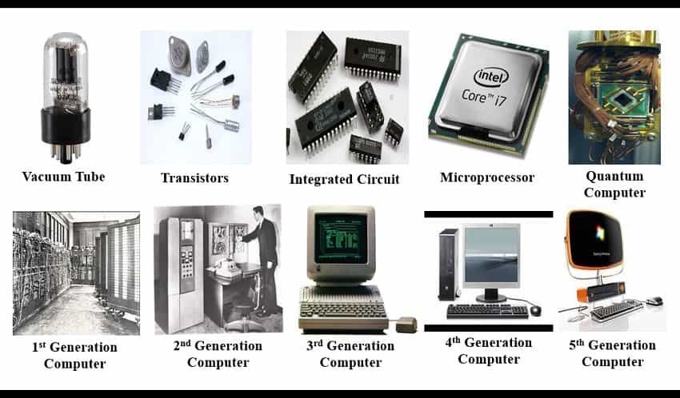

**3. Classify computers into Micro, Mini, Mainframe, and Supercomputers, and explain the differences between them.**

Computers can be classified into four types based on their size, processing power, and intended use:

* Supercomputers

These are the most powerful computers, capable of processing large amounts of data and performing complex calculations and simulations very quickly. They are often used for research, artificial intelligence, and big data computing.

* Mainframe computers

These are large, high-performance computers that are often used by large corporations and governmental organizations to manage large amounts of data. They are very expensive.

* Minicomputers

These are mid-range computers that are smaller and less powerful than mainframes, but more powerful than microcomputers. They are often used by small businesses and industries.

* Microcomputers

Also known as personal computers, these are small, affordable computers that are designed for personal or small business use. They are easy to use and can perform a wide variety of tasks, but they have low computing power and can only be used by one person at a time. Examples of microcomputers include desktop computers, laptops, tablets, smartphones, and palmtop computers.

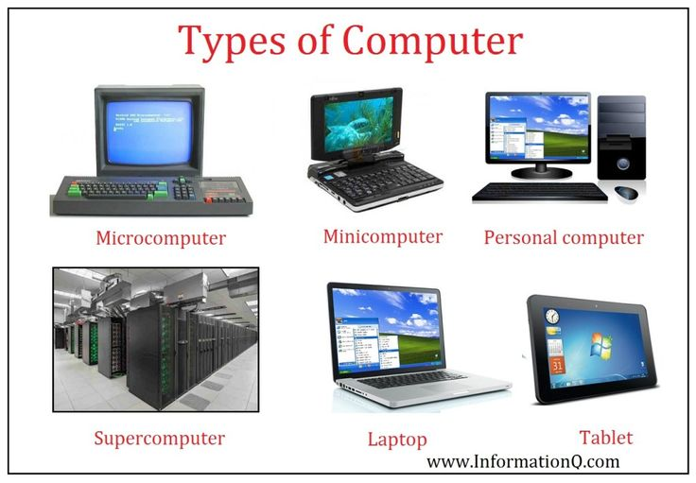

**4. Illustrate the block diagram of a computer and describe the functions of each component.**

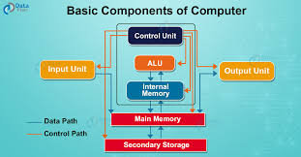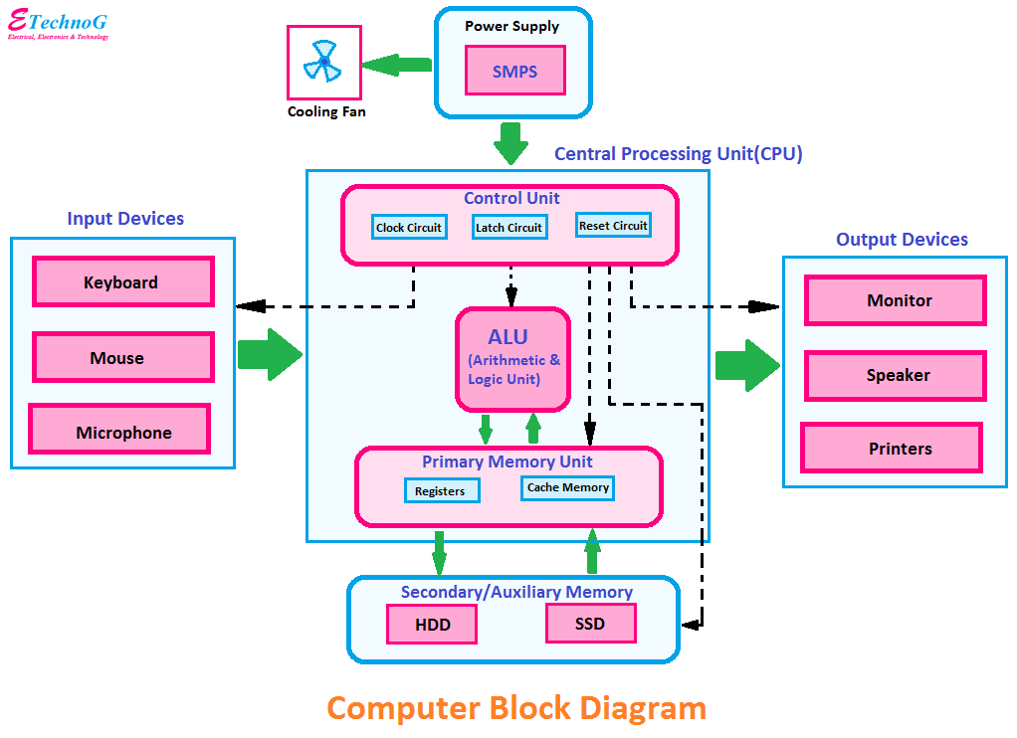

**Input**

All the data received by the computer goes through the [input unit](https://artoftesting.com/input-devices-of-computer). The input unit comprises different devices like a mouse, keyboard, scanner, etc. In other words, each of these devices acts as a mediator between the users and the computer.

The data that is to be processed is put through the input unit. The computer accepts the raw data in binary form. It then processes the data and produces the desired output.

**Major Functions of the Input Unit**

The 3 major functions of the input unit are-

* Take the data to be processed by the user.
* Convert the given data into machine-readable form.
* And then, transmit the converted data into the main memory of the computer. The sole purpose is to connect the user and the computer. In addition, this creates easy communication between them.

**CPU – Central Processing Unit**

Central Processing Unit or the [CPU](https://artoftesting.com/cpu-full-form-definition-types), is the brain of the computer. It works the same way a human brain works. As the brain controls all human activities, similarly the CPU controls all the tasks.

Moreover, the CPU conducts all the arithmetical and logical operations in the computer.

Now the CPU comprises of two units, namely – ALU (Arithmetic Logic Unit) and CU (Control Unit). Both of these units work in sync. The CPU processes the data as a whole.

Let us see what particular tasks are assigned to both units.

**ALU – Arithmetic Logic Unit**

The Arithmetic Logic Unit is made of two terms, arithmetic and logic. There are two primary functions that this unit performs.

1. Data is inserted through the input unit into the primary memory. Performs the basic arithmetical operations on it, like addition, subtraction, multiplication, and division. It performs all sorts of calculations required on the data. Then, it sends back data to the storage.
2. The unit is also responsible for performing logical operations like AND, OR, Equal to, Less than, etc.  In addition to this, it conducts merging, sorting, and selection of the given data.

**CU – Control Unit**

The control unit as the name suggests is the controller of all the activities/tasks and operations. All this is performed inside the computer.

The [memory unit](https://artoftesting.com/memory-units-of-computer) sends a set of instructions to the control unit. Then the control unit in turn converts those instructions. After that these instructions are converted to control signals.  
  
These control signals help in prioritizing and scheduling activities. Thus, the control unit coordinates the tasks inside the computer in sync with the input and output units.

**Memory Unit**

All the data that has to be processed or has been processed is stored in the memory unit. The memory unit acts as a hub of all the data. It transmits it to the required part of the computer whenever necessary.

The memory unit works in sync with the CPU. This helps in faster accessing and processing of the data. Thus, making tasks easier and quicker.

**Types of Computer Memory**

There are two types of computer memory-

**Primary Memory**

This type of memory cannot store a vast amount of data. Therefore, it is only used to store recent data. The data stored in this is temporary. It can get erased once the power is switched off. Therefore, is also called temporary memory or main memory.  
  
RAM stands for Random Access Memory. It is an example of primary memory. This memory is directly accessible by the CPU. It is used for reading and writing purposes. For data to be processed, it has to be first transferred to the RAM and then to the CPU.

**Secondary Memory**

As explained above, the primary memory stores temporary data. Thus it cannot be accessed in the future. For permanent storage purposes, [secondary memory](https://en.wikipedia.org/wiki/Computer_data_storage#Secondary_storage) is used. It is also called permanent memory or auxiliary memory. The hard disk is an example of secondary memory. Even in a power failure data does not get erased easily.

**Output**

There is nothing to be amazed by what the [output unit](https://artoftesting.com/computer-output-devices-example) is used for. All the information sent to the computer once processed is received by the user through the output unit. Devices like printers, monitors, projectors, etc. all come under the output unit.

The output unit displays the data either in the form of a soft copy or a hard copy. The printer is for the hard copy. The monitor is for the display. The output unit accepts the data in binary form from the computer. It then converts it into a readable form for the user.

**What are input and output devices? Provide examples of each.**

**Input Device Definition:** A piece of equipment/hardware which helps us enter data into a computer is called an input device. For example keyboard, mouse, etc.

**Output Device Definition:** A piece of equipment/hardware which gives out the result of the entered input, once it is processed (i.e. converts data from machine language to a human-understandable language), is called an output device. For example printer, monitor, etc.

**Explain the types of memory in a computer, focusing on RAM, ROM, and their variants.**

RAM stands for “random-access memory” and is a type of volatile memory. What does volatile memory mean? RAM uses transistors to store data, and these need electricity to work. Every time you shut down your computer, anything stored on this memory disappears. In other words: RAM is easily added to or changed.

For example, let’s say you’re browsing the web and clicking between tabs. In doing so, you’ll find that the data on tabs you already visited once is instantly available. This is because the data from your browser (and its tabs) is stored in your RAM for instant retrieval. When you power down your computer or make a hard-close on your browser, all that data disappears unless you save it as a file.

RAM is generally soldered onto a small rectangular circuit board called a “stick that sits in a slot on your PC’s motherboard. You can actually see it if you crack open your computer case and look inside. Each stick may be labeled with the amount of memory included, such as 8GB or 16GB.

The number of RAM sticks in your computer depends on your motherboard.

## Types of RAM

The different types of RAM are:

* **DDR** (double data rate)
* **DRAM** (dynamic RAM)
* **SRAM** (static RAM)
* **SDRAM** (synchronous dynamic RAM)

Each type works a little differently. DDR, for example, disappears if it’s not continually refreshed by a program or application. DDR is also the type we think of [when discussing RAM consumer computers](https://www.hp.com/gb-en/shop/tech-takes/what-are-gigabytes-of-ram?pStoreID=newegg/1000%270). There are 3 kinds of DDR memory that you may encounter when shopping: DDR3, DDR3L, and DDR4.

## Advantages of RAM

RAM is unique in that [it delivers data quickly to the user](https://www.hp.com/gb-en/shop/tech-takes/does-ram-speed-matter?pStoreID=newegg/1000%270), and it can store more data than ROM. It's a quiet, energy-efficient type of memory with no moving parts. If you need to change data, store new data, or add data to your computer (in the form of files, such as music or new programs), you’ll need RAM to do it.

### ****1. Expands****

You can expand your RAM by adding more to your motherboard as long as you have the necessary DIMM slots. It’s one of the [easier ways to upgrade your computing experience](https://www.hp.com/gb-en/shop/tech-takes/easiest-and-hardest-pc-parts-to-find-and-install?pStoreID=newegg/1000%270), too. If you’ve heard the phrase "add a stick of RAM," this is what they were talking about.

### ****2. Boosts overall experience****

Adequate DDR4 RAM can boost your computing experience, but what happens [if you don't have enough RAM for the tasks you do most](https://www.hp.com/gb-en/shop/tech-takes/how-much-ram-do-i-need-in-laptop?pStoreID=newegg/1000%270)? The computer has no choice but to retrieve the data from your hard drive. This is a slow process, so you'll experience lags when doing processes that shouldn't take long at all.

### ****3. Helps with performance-focused tasks****

Gaming or 3D rendering are just two examples where having enough RAM is important, since you really don’t want to have to wait for data when playing a fast-action title. 8GM is the minimum you’ll want in this situation, but it’s common to see computer enthusiasts adding more RAM to total 16GB or even 32GB of RAM.

## What is ROM?

ROM (read-only memory) is a non-volatile memory type. This means it receives data and permanently writes it on a chip, and it lasts even after you turn off your computer. The data is coded to not be overwritten, so it's used for things like your printer software or your startup programs. You can't change your ROM data just by doing ordinary computer activities.

In fact, you can’t actually directly access data stored in the ROM. If you need data from the ROM, you must first transfer it to the RAM, where your processor can then access it.

## Types of ROM

Most consumers won’t need to worry about the types of ROM, but it may be useful to know the terms so that you can easily identify that it is, indeed, a ROM storage option. Here are each of the types of ROM.

* **Mask ROM:** ROM that is “masked off,” or covered by opaque plates called photomasks
* **PROM:** Programmable read-only memory
* **EEPROM:** Electronically erasable programmable read-only memory
* **EPROM:** Erasable programmable read-only memory

Each type of ROM is programmed uniquely to its type, and it requires special conditions to be erased or rewritten. EPROM, for example, needs UV light to erase the data, while EEPROM uses a special circuit to rewrite data. Each type is also favored for particular uses. PROM, for example, is used in [BIOS](https://www.hp.com/gb-en/shop/tech-takes/how-to-enter-bios-setup-windows-pcs?pStoreID=newegg/1000%270) applications. Mask ROM is generally used for firmware.

## Advantages of ROM

ROM data stays put once written, regardless of how you use your computer or if it’s even powered on. ROM stores many of the important processes necessary to run your computer, such as the data in your BIOS. You couldn’t even power up your computer without ROM data. ROM is also cheaper per gigabyte than RAM.

**Differentiate between primary and secondary memory. Why is secondary?**

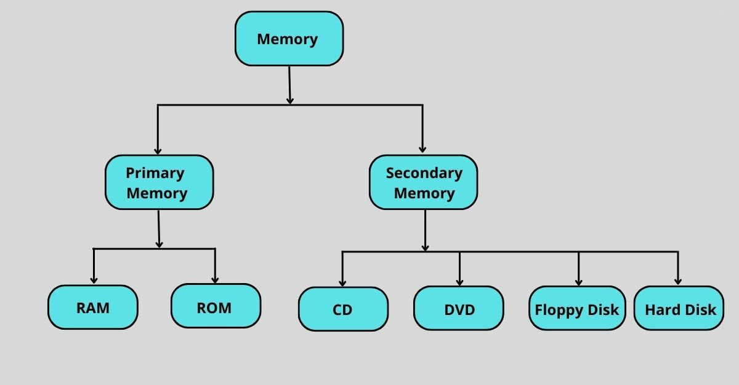

Primary storage, also known as main storage, refers broadly to the methods and technologies of storing data that must be accessed frequently. Primary storage includes both volatile primary memory, such as RAM and DRAM, and non-volatile storage media, such as [storage-class memory](https://www.purestorage.com/knowledge/what-is-storage-class-memory.html), [hybrid storage arrays](https://www.purestorage.com/knowledge/what-is-hybrid-storage.html), [all-flash arrays (AFAs)](https://www.purestorage.com/knowledge/what-is-an-all-flash-array.html), and [storage area networks (SANs)](https://www.purestorage.com/knowledge/what-is-storage-area-network.html).

According to [Gartner](https://www.gartner.com/reviews/market/primary-storage), primary storage also includes persistent data storage for container environments and [hybrid cloud IT operations](https://www.purestorage.com/knowledge/what-is-hybrid-cloud.html) that rely on a mix of cloud, on-premises, colocation, edge, and public cloud infrastructure.

Primary storage is all about supporting fast response times and input/output per second (IOPS)-sensitive structured data workloads. Business-critical applications, mission-critical data, as well as consolidation and support for virtual environments all rely on the fast and reliable response times of primary storage solutions.

### What Is Secondary Storage?

Secondary storage, also known as auxiliary storage, refers to the storage methods and technologies used for the long-term storage of non-critical data that doesn’t need to be accessed as frequently as primary storage. The goal of secondary storage is to retain data until you overwrite or delete it, meaning it exclusively relies upon non-volatile storage media such as HDDs and SSDs. This is in contrast to primary storage, which includes both volatile and non-volatile storage media for quick access to frequently used data.

### Differences between Primary and Secondary Storage

The key differences between primary and secondary storage can be summarized as follows:

**Speed of access:** Primary storage, often directly connected to the computer's processor, boasts rapid data retrieval speeds. In contrast, secondary storage, designed for long-term storage, typically has slower access times.

**Volatility vs. non-volatility:** Primary storage may include volatile storage media, which means its data is lost when the system is powered down, and non-volatile storage media, which retains its data even when the power is off. Secondary storage is always non-volatile.

**Capacity and storage space:** While primary storage offers limited capacity designed for immediate data processing tasks, secondary storage provides vast space suitable for long-term data retention.

**Applications:** As mentioned, data in primary storage must be accessed frequently and is used for business and mission-critical applications. Secondary storage is typically optimized for capacity and cost over performance and is a popular choice for backups and archives.

Secondary storage is necessary because memory, or primary storage, loses its data when a computer is turned off whereas secondary storage does not. Therefore, it is commonly known as non-volatile storage. The data on it stays there until it is deleted or overwritten by the user.

**8. What are the various types of secondary storage devices? Explain their uses**

Secondary storage devices can be classified as one of three types:

* Magnetic storage devices use magnetized fields on a spinning metal disk to locate stored information and data.
* Optical storage devices use lasers and microscopic light on a grooved (flat and indented) plastic or metal disk to locate stored information and data.
* Solid state storage devices make use of silicon microchips with transistors and an electrical current to determine the location of stored data.

Secondary storage devices are used as a means for users to permanently store data separate from the computer system itself. A few devices that make data more portable and secure include:

* Hard drives (magnetic storage)
* Magnetic tape (magnetic storage)
* CD, DVD, and Blu-ray disks (Optical storage)
* USB/flash drive (solid state storage)
* Memory chip/SSD card (solid state storage).
* **Discuss the concept of memory hierarchy and its importance in computer systems.** 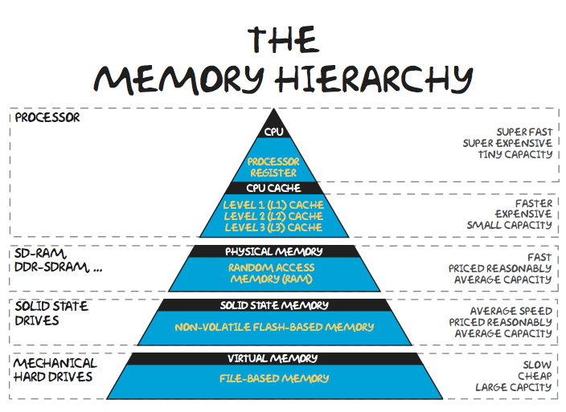

Memory hierarchy is about arranging different kinds of storage devices in a computer based on their size, cost and access speed, and the roles they play in application processing. The main purpose is to achieve efficient operations by organizing the memory to reduce access time while speeding up operations.

* **External Memory or Secondary Memory:** Comprising of Magnetic Disk, Optical Disk, and Magnetic Tape i.e. peripheral storage devices which are accessible by the processor via an I/O Module.
* **Internal Memory or Primary Memory:** Comprising of Main Memory, Cache Memory &[CPU registers](https://www.geeksforgeeks.org/different-classes-of-cpu-registers/). This is directly accessible by the processor.

## Memory Hierarchy Design

### 1. Registers

[Registers](https://www.geeksforgeeks.org/different-classes-of-cpu-registers/) are small, high-speed memory units located in the CPU. They are used to store the most frequently used data and instructions. Registers have the fastest access time and the smallest storage capacity, typically ranging from 16 to 64 bits.

### 2. Cache Memory

[Cache memory](https://www.geeksforgeeks.org/cache-memory-in-computer-organization/) is a small, fast memory unit located close to the CPU. It stores frequently used data and instructions that have been recently accessed from the main memory. Cache memory is designed to minimize the time it takes to access data by providing the CPU with quick access to frequently used data.

### ****3. Main Memory****

[Main memory](https://www.geeksforgeeks.org/memory-management-in-operating-system/), also known as RAM (Random Access Memory), is the primary memory of a computer system. It has a larger storage capacity than cache memory, but it is slower. Main memory is used to store data and instructions that are currently in use by the CPU.

#### Types of Main Memory

* **Static RAM:** [Static RAM](https://www.geeksforgeeks.org/difference-between-sram-and-dram/) stores the binary information in flip flops and information remains valid until power is supplied. It has a faster access time and is used in implementing cache memory.
* **Dynamic RAM:** It stores the binary information as a charge on the capacitor. It requires refreshing circuitry to maintain the charge on the capacitors after a few milliseconds. It contains more memory cells per unit area as compared to SRAM.

### 4. Secondary Storage

Secondary storage, such as [hard disk drives (HDD) and solid-state drives (SSD)](https://www.geeksforgeeks.org/difference-between-hard-disk-drive-hdd-and-solid-state-drive-ssd/), is a non-volatile memory unit that has a larger storage capacity than main memory. It is used to store data and instructions that are not currently in use by the CPU. Secondary storage has the slowest access time and is typically the least expensive type of memory in the memory hierarchy.

### 5. Magnetic Disk

[Magnetic Disks](https://www.geeksforgeeks.org/magnetic-disk-memory/) are simply circular plates that are fabricated with either a metal or a plastic or a magnetized material. The Magnetic disks work at a high speed inside the computer and these are frequently used.

### 6. Magnetic Tape

[Magnetic Tape](https://www.geeksforgeeks.org/magnetic-tape-memory/) is simply a magnetic recording device that is covered with a plastic film. It is generally used for the backup of data. In the case of a magnetic tape, the access time for a computer is a little slower and therefore, it requires some amount of time for accessing the strip.

## Characteristics of memory hierarchy

The key characteristics of a memory hierarchy include the following:

**Capacity.** Capacity is the volume of information that a memory device can store. As we move down the memory pyramid, the capacity or memory size increases.

**Access time.**Access time is the time interval from when a read/write request is made and when the data actually becomes available. It increases as we move from the top to the bottom of the memory hierarchy. Registers, which are present inside the CPU, have the shortest access time, meaning they are the fastest. At the bottom of the pyramid, magnetic tapes and similar storage devices have the greatest access time.

**Performance.**Without a memory hierarchy, there is a speed gap between CPU registers and the main memory. This increases access time and directly impacts the system's performance. Performance can be improved by reducing the number of levels required to access and manipulate data.

**Cost per bit.**The cost per bit is calculated by dividing the total cost of the memory by the total number of accessed bits. As we move from the top of the memory hierarchy to the bottom, the cost per bit decreases. This is because internal memory is costlier than external memory.

**What is cache memory? How does it improve system performance?**

Cache memory is a high-speed memory that stores frequently accessed data and instructions for faster access by the processor.

Cache memory operates on the principle of locality of reference, which means that frequently accessed data is likely to be accessed again in the near future. By storing this data in the cache memory, the processor can avoid accessing the slower main memory, reducing the overall processing time.

There are different levels of cache memory, with Level 1 (L1) cache being the fastest and closest to the processor, followed by Level 2 (L2) and Level 3 (L3) caches. The larger the cache size, the more data it can store and the faster the system performance.

Cache memory can improve system performance by reducing the time it takes for the processor to access frequently used data and instructions, resulting in faster processing speeds and better overall performance.

What is the use of function keys in the keyboard ?describe their usage

A function key is a special key found on most computer keyboards that provides you quick access to commonly used commands. The function keys are usually labeled F1 through F12 and are at the top of the keyboard above the number pad. Each function key can be programmed to perform specific tasks, making them an invaluable tool for any user who wants to get things done quickly and efficiently.

* **F1** – Displays the Help screen over almost all programs.
* **F2** – This key allows you to change the name of a specific file or folder.
* **F3** – Launches a search function for a currently active application.
* **F4** – Alt + F4 closes the currently active window.
* **F5**– Refreshes or reloads the page or document window.
* In most Internet browsers, pressing F6 moves the mouse pointer to the address bar.
* **F7** – In Microsoft Apps, this key is used to spell and grammar check a document
* **F8** – When having to turn on the computer, this key is used to connect the boot menu in Windows.
* **F9** – Refreshes a Microsoft Word document and sends and receives emails in Outlook.
* **F10** – Opens the menu bar of a currently open application. Shift + F10 is equivalent to right-clicking.
* **F11** – This key enters and exits the full-screen mode in Internet browsers.
* **F12** – In Microsoft Word, this key opens the Save As dialogue box.

**What are navigation keys in the keyboard? Describe their function?**

**Navigation keys**. These keys are used for moving around in documents or webpages and editing text. They include the arrow keys, Home, End, Page Up, Page Down, Delete, and Insert.

Using navigation keys

The navigation keys allow you to move the cursor, move around in documents and webpages, and edit text. The following table lists some common functions of these keys

Left Arrow, Right Arrow, Up Arrow, or Down Arrow

Move the cursor or selection one space or line in the direction of the arrow, or scroll a webpage in the direction of the arrow

Home

Move the cursor to the end of a line or move to the top of a webpage

End

Move the cursor to the end of a line or move to the bottom of a webpage

Ctrl + Home

Move to the top of a document

Ctrl + End

Move to the bottom of a document

Page Up

Move the cursor or page up one screen

Page Down

Move the cursor or page down one screen

Delete

Delete the character after the cursor, or the selected text; in Windows, delete the selected item and move it to the Recycle Bin

Insert

Turn Insert mode off or on. When Insert mode is on, text that you type is inserted at the cursor. When Insert mode is off, text that you type replaces existing characters.

**What are devices invented by IBM respect to computer evolution?**

Beginning in the 1990s, the company began downsizing its operations and divesting from [commodity production](https://en.wikipedia.org/wiki/Production_(economics)), most notably selling its personal computer division to the [Lenovo Group](https://en.wikipedia.org/wiki/Lenovo) in 2005. IBM has since concentrated on [computer services](https://en.wikipedia.org/wiki/Information_technology), [software](https://en.wikipedia.org/wiki/Software), [supercomputers](https://en.wikipedia.org/wiki/Supercomputer), and [scientific research](https://en.wikipedia.org/wiki/Scientific_method#Scientific_inquiry). Since 2000, its supercomputers have [consistently ranked](https://en.wikipedia.org/wiki/TOP500) among the most powerful in the world, and in 2001 it became the first company to generate more than 3,000 patents in one year, beating this record in 2008 with over 4,000 patents.[[12]](https://en.wikipedia.org/wiki/IBM#cite_note-:0-12) As of 2022, the company held 150,000 patents.[[15]](https://en.wikipedia.org/wiki/IBM#cite_note-15)

As one of the world's oldest and largest technology companies, IBM has been responsible for several [technological innovations](https://en.wikipedia.org/wiki/Technological_innovation), including the [automated teller machine](https://en.wikipedia.org/wiki/Automated_teller_machine) (ATM), [dynamic random-access memory](https://en.wikipedia.org/wiki/Dynamic_random-access_memory) (DRAM), the [floppy disk](https://en.wikipedia.org/wiki/Floppy_disk), the [hard disk drive](https://en.wikipedia.org/wiki/Hard_disk_drive), the [magnetic stripe card](https://en.wikipedia.org/wiki/Magnetic_stripe_card), the [relational database](https://en.wikipedia.org/wiki/Relational_model), the [SQL programming language](https://en.wikipedia.org/wiki/SQL), and the [UPC barcode](https://en.wikipedia.org/wiki/Universal_Product_Code). The company has made inroads in advanced [computer chips](https://en.wikipedia.org/wiki/Integrated_circuit), [quantum computing](https://en.wikipedia.org/wiki/Quantum_computing), [artificial intelligence](https://en.wikipedia.org/wiki/Artificial_intelligence), and [data infrastructure](https://en.wikipedia.org/wiki/Data_infrastructure).[[16]](https://en.wikipedia.org/wiki/IBM#cite_note-16)[[17]](https://en.wikipedia.org/wiki/IBM#cite_note-17)[[18]](https://en.wikipedia.org/wiki/IBM#cite_note-18) IBM employees and alumni have won various recognitions for their scientific research and inventions, including six [Nobel Prizes](https://en.wikipedia.org/wiki/Nobel_Prize) and six [Turing Awards](https://en.wikipedia.org/wiki/Turing_Award).[[19]](https://en.wikipedia.org/wiki/IBM#cite_note-19)

* Dial recorder – 1888
* Electric Tabulating Machine – 1889
* Time clock – 1889
* 6% of M1 Carbine in WW2 – 1943
* Vacuum based IBM701 -1952
* IBM305 RAMAC (HARD DISK) – 1956
* Transistorized designs with 7000-1400 series – 1958
* The FORTAN – 1961
* Selectric typewriter – 1961
* (IBM System/360 -1964, IBM System/370- 1970)-IBM Mainframe dominated early 1980
* Magnetic strip -1969 (ATM)
* IBM 5150 – IBM pc -1981
* Blue Gene -2009
* AI program WATSON -2011

