Assignment 1 Webpage 1 1.

Create a HTML page using the header tags, Body tags with the alignments and back ground colours 2. Also add the Links in the same page and also create a new page which include the details in the previous page 3. Use the Text tags and also show the difference in using the text tag and the base font tag with text face attribute and colour as well. 4. Also include the Formatting Styles and Headings: ¬ Include Bold, italics, ¬ Underline, Strike, Subscript, superscript and all six type of headings ¬ Font Styles ¬ Insert an image and also create a link using that image ¬ Use Marquee tag : Move text ¬ br, hr, pre, p 5. On every page, make a hyperlink for going back to home page and internal link also. 6. Make all the topics as hyperlinks and go to some other page for description 7. Include following specifications: ¬ In all these web pages only mention about use, attributes apply them. ¬ Insert a background image on home page ¬ Make all the topics as hyperlinks and go to some other page for description ¬ Insert a marquee showing HTML Tutorial as moving text. ¬ Use different font style for different topics ¬ On every page, make a hyperlink for going back to home page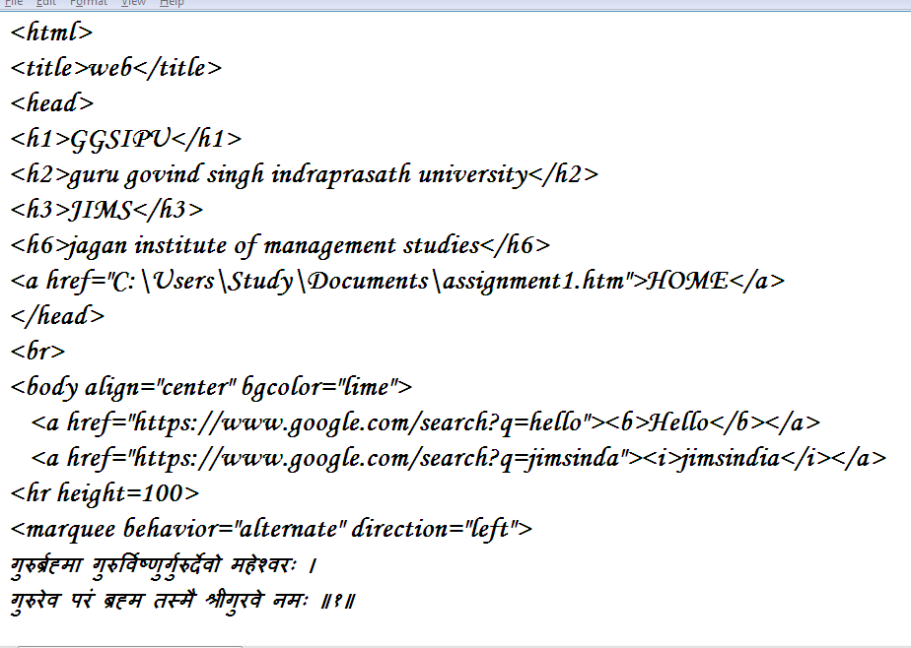

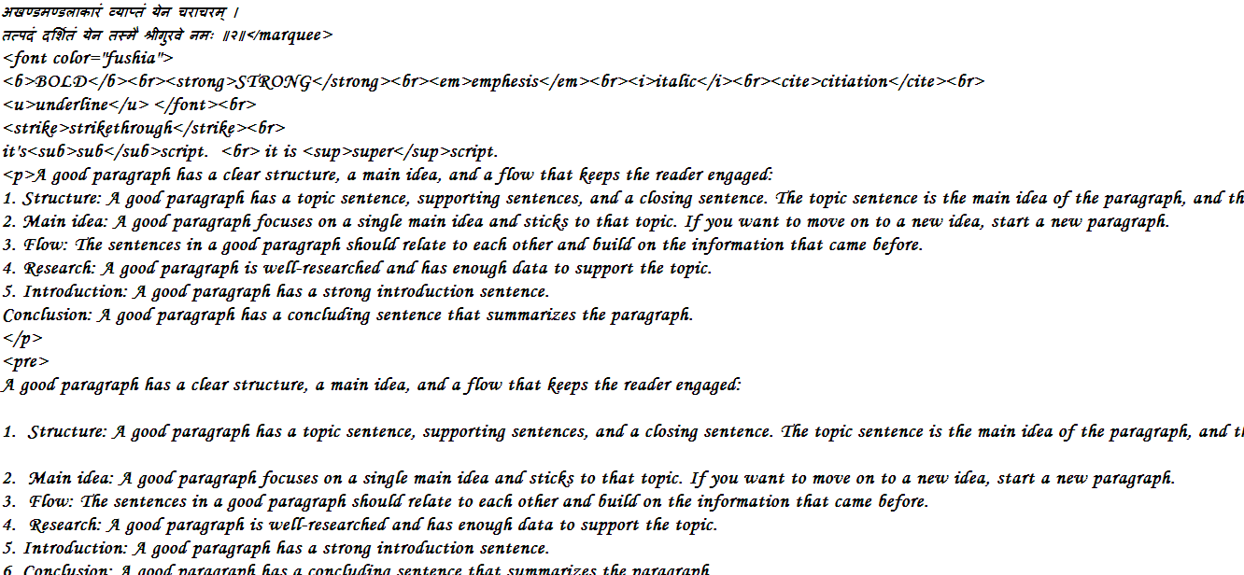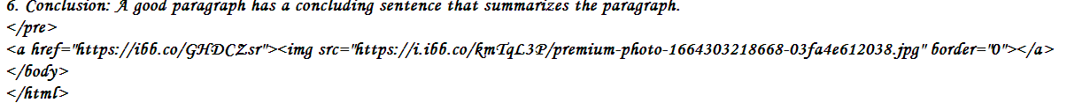

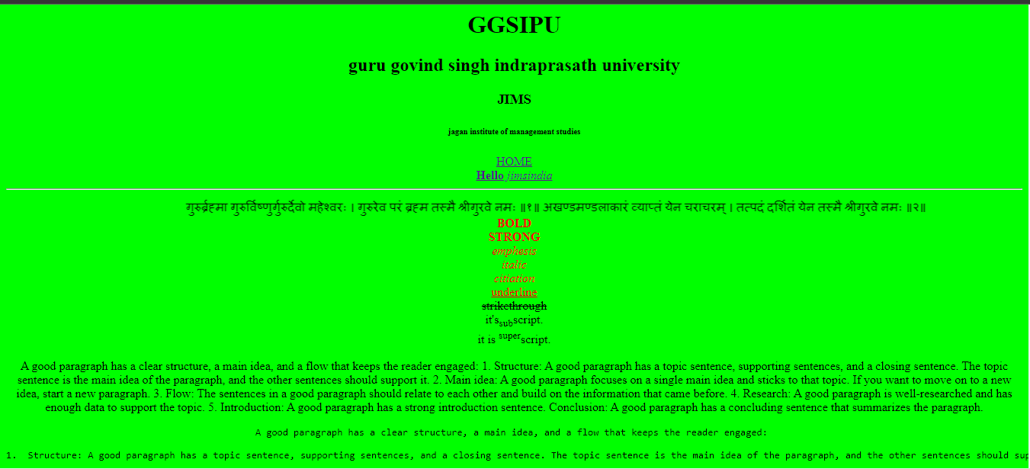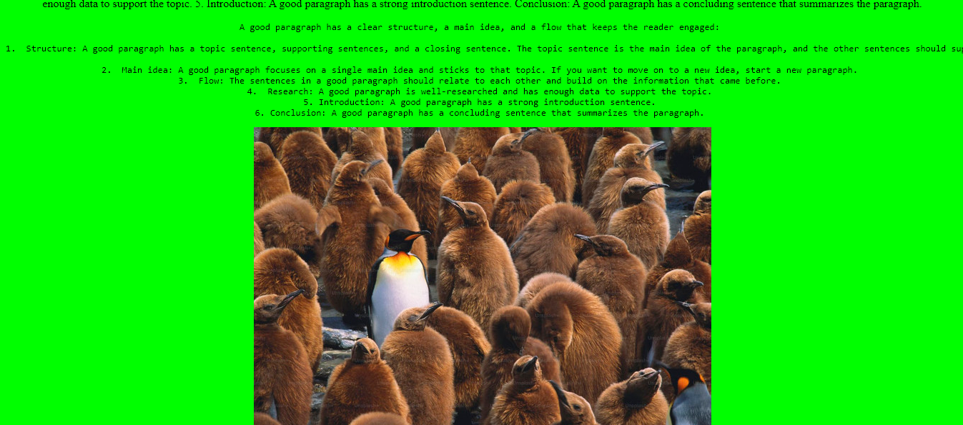

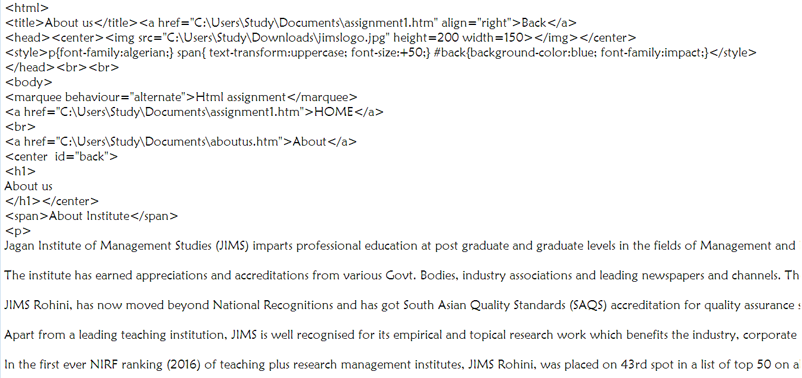

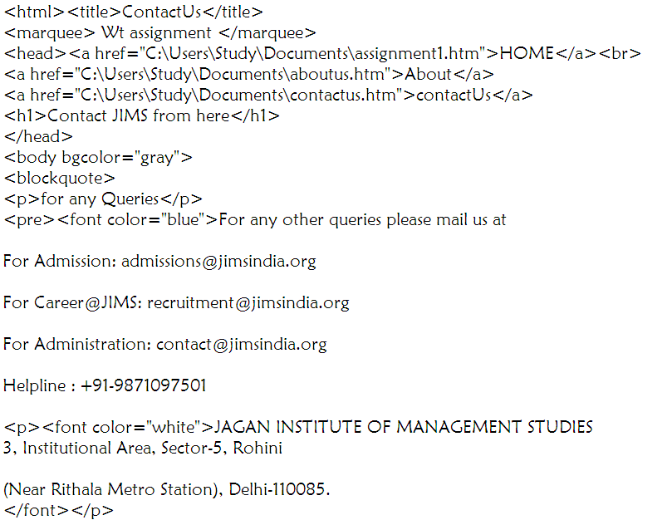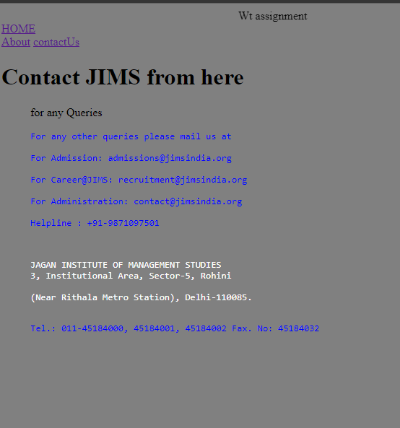

Assignment 1 Webpage 2 1

Create an unordered list nested inside ordered list and apply the following: ● Insert an image of Main item on top right corner of web page ● Display heading as a marquee. ● Use different font styles and colours for different ordered list items. ● Insert horizontal line after each ordered item. 2 Menu list, ordered, unordered list and Definition List, also use the nested listing

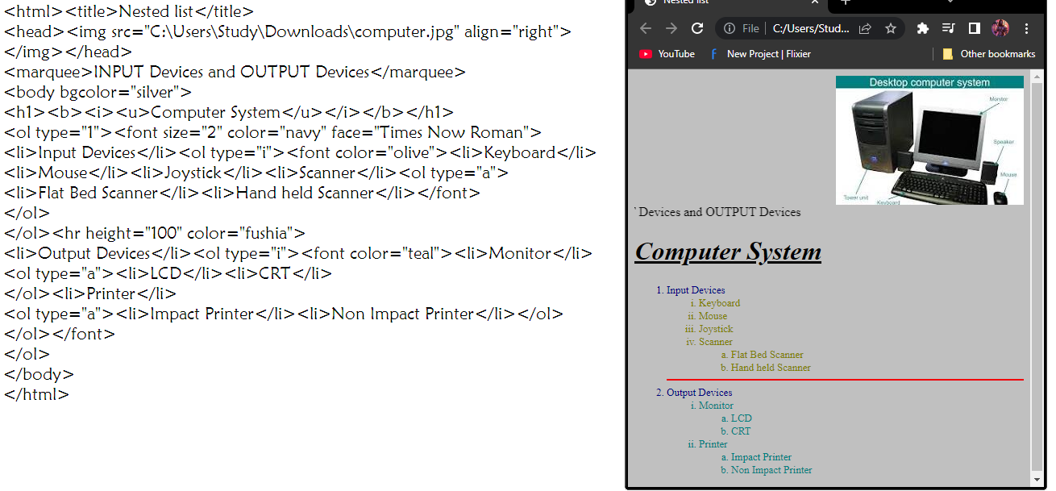

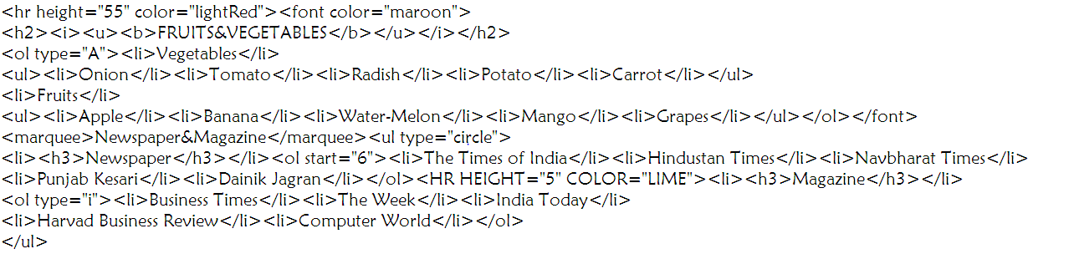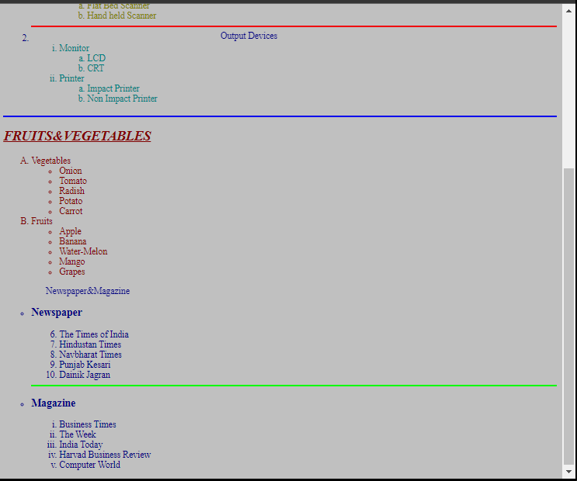

Assignment 1 Webpage 3 1

. Design a table with row span and column span and make use of attributes colspan, rowspan, width, height, cell padding, cell spacing etc. ¬ Create a table with 5 rows and 5 columns ….insert the data of your Qualifications with the marks or percentage and also write down the achievements in the link of a new page of achievements. Add the caption ¬ Create a table using the table background colour , text alignments and also the width and size of the borders and space , add the bg image as well

2. Display the Table

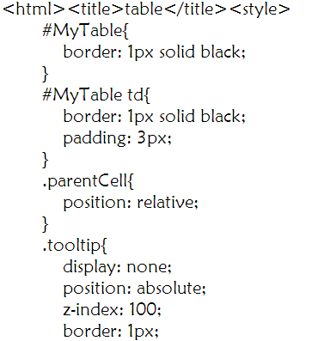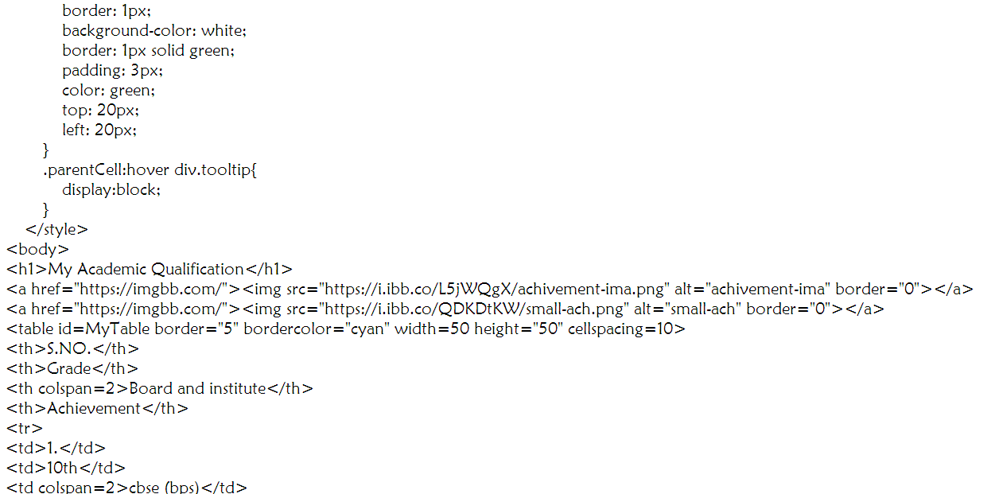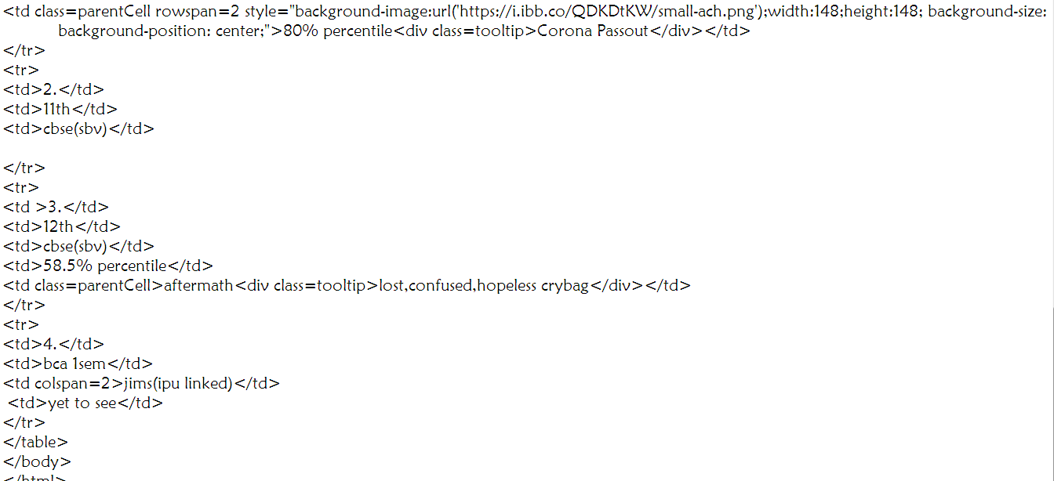

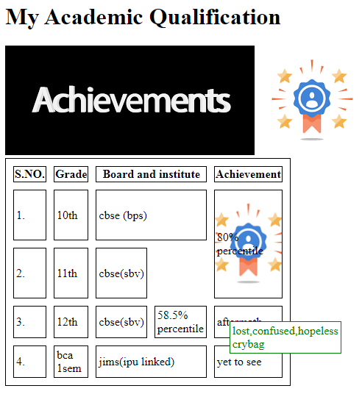

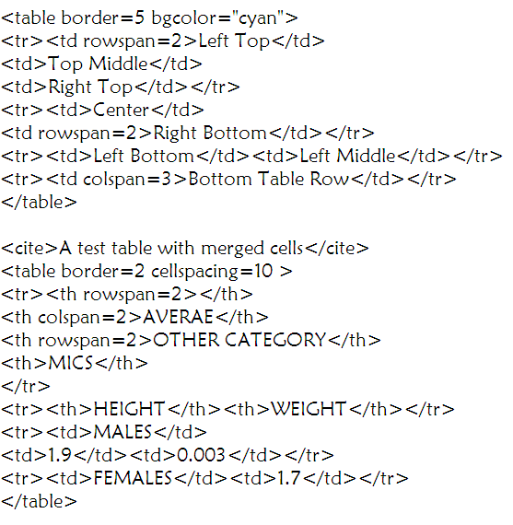

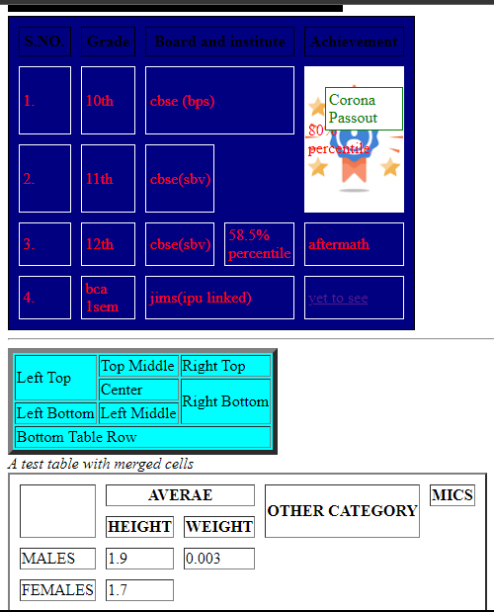  
Academics

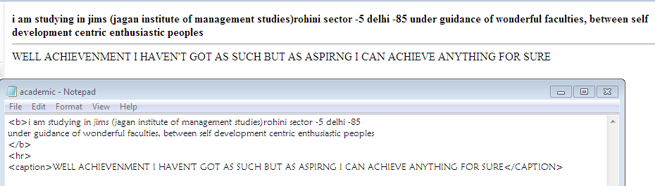

**Assignment 2**

Show the assignment in the source file and the web page format FRONT PAGE Orientation

to the Front Page environment and building web sites

1. Create a new site. Start with a web page using Your Name to name the page. Make it the

home page and view the web in navigation and folder. View record your observation.

2. On the home page, give a brief description about yourself & type the following sub heading “qualification”, “Hobbies”, & “Interest”, “Future Plans”, & “Address for communication”

3. Apply the most appropriate theme at the web page and the web site.

4. Apply font and colour styles on to your web page and preview.

5. Create a new web paged using the Front Page explorer and write your academic and

professional qualification. Places a bookmark at an appropriate place and save the page as

“qualification”.

6. Link the page, qualification.htm, with the sub-heading “qualification” in the home page.

7. Create a new page using the front page editor and write your hobbies and interest on it.

Save the page as “Hobbies.htm”.

8. Link the page, Hobbies.htm, with the sub-heading “hobbies” & “interest” in the home

page.

9. Create a new page and write a few lines on your future plans and save the page as

“future plan”.

10. Link the page. Future-plan.htm, with the sub heading “future plan” in the home page.

11. Create a new page, write your address for communication & save the page as “address”

12. Link the page, “address.htm” to the sub-heading “address” for communication page in

the page.

13. Interest a navigation bar in the page. 14. Test all hyperlink in the front-page editor and

record your observation

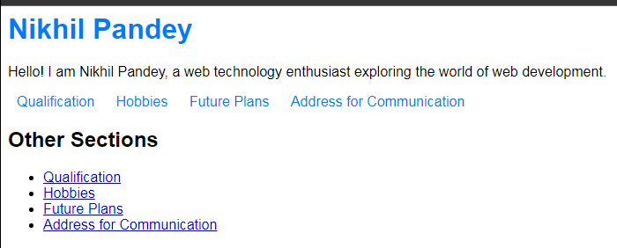

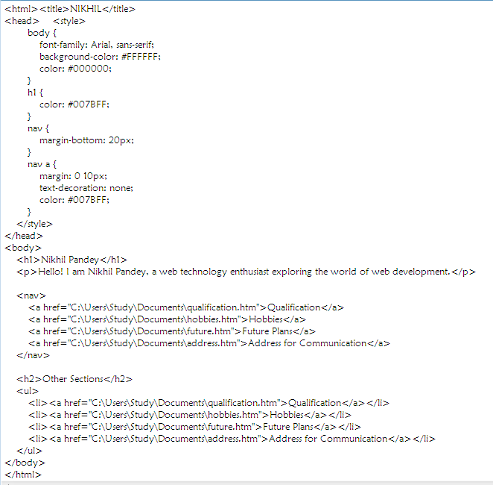



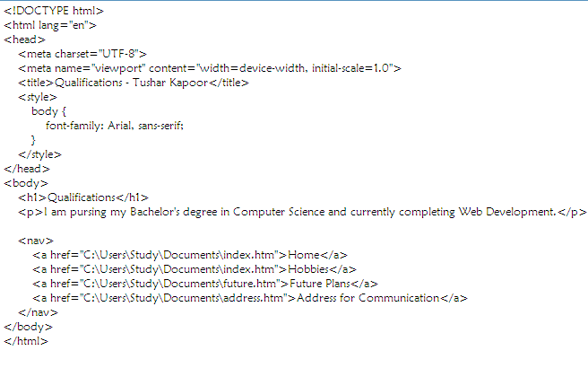

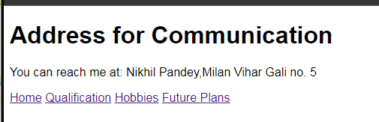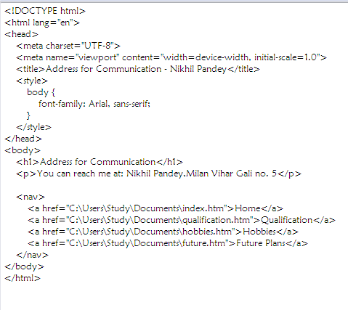

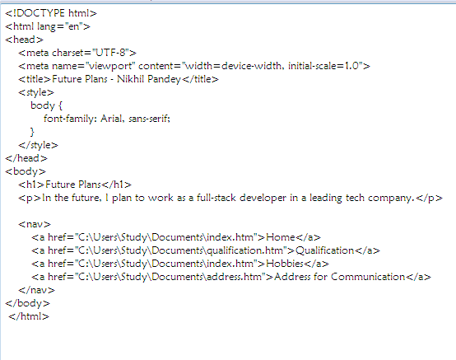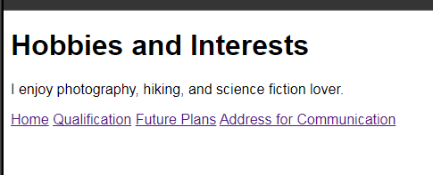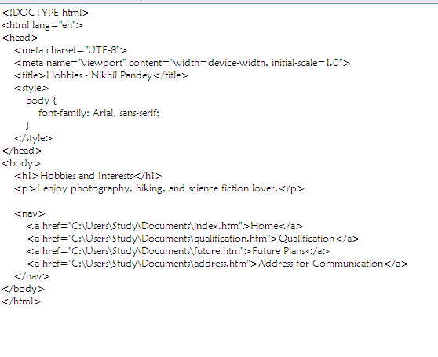

**Assignment 3**

