**Q1. Create a webpage describing yourself using inline style sheet.**

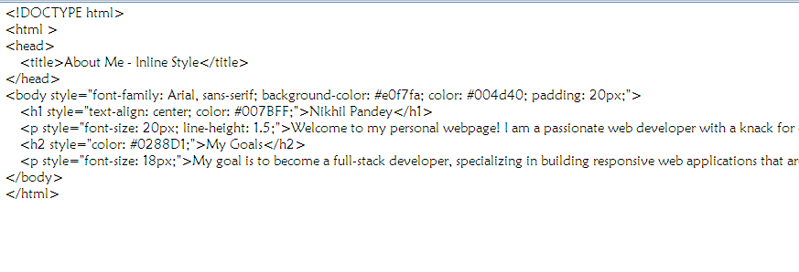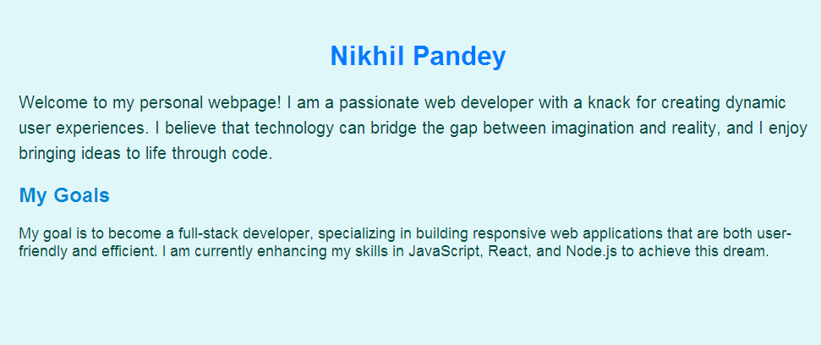

**Q2. Create a webpage showing the grouping in internal style sheet.**

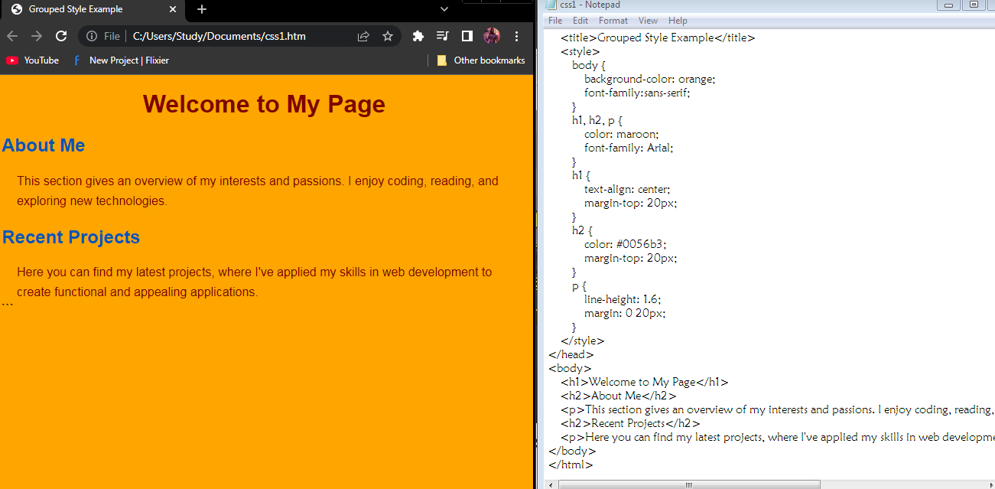

**Q3. Create a webpage containing a paragraph about incredible India using internal style sheet.**

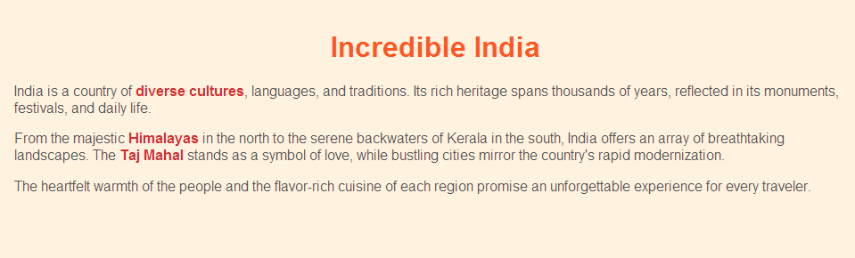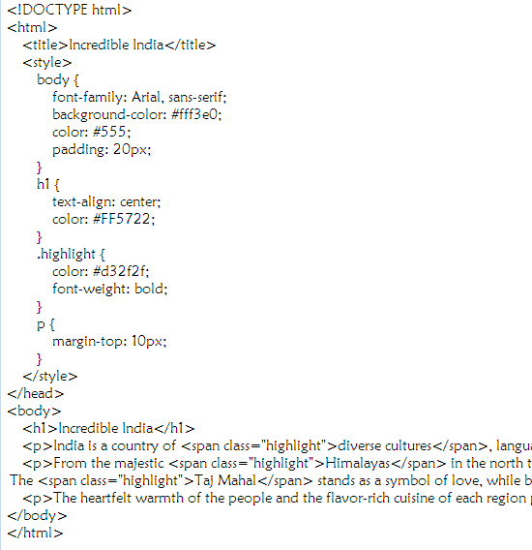

**Q4. Create a webpage describing your college and your college life using external style sheet.**

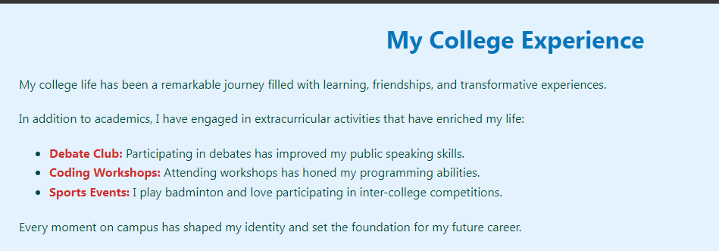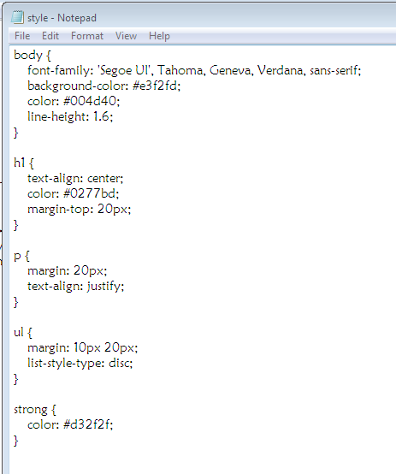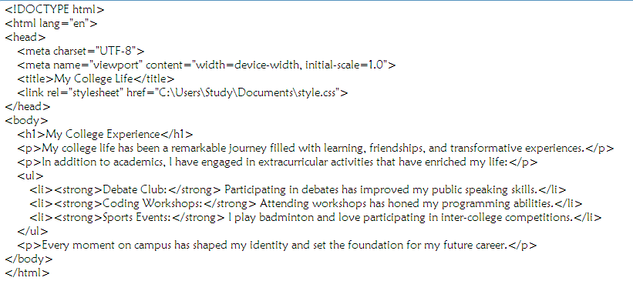

**Q5. Create a webpage containing a background image and apply all the background styling attributes.**

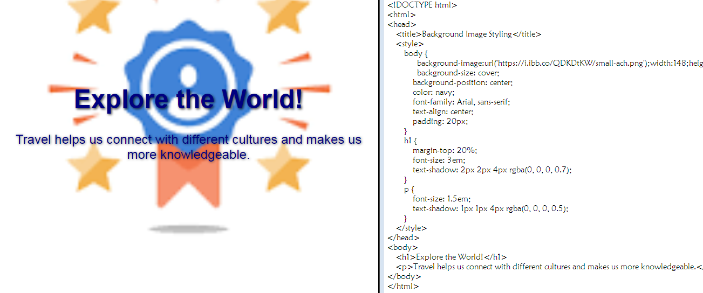

**Q6. Create a webpage showing the usage of font styling attributes.**

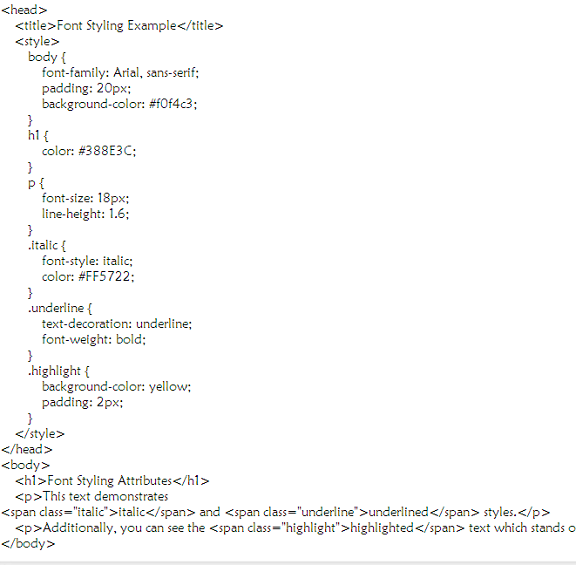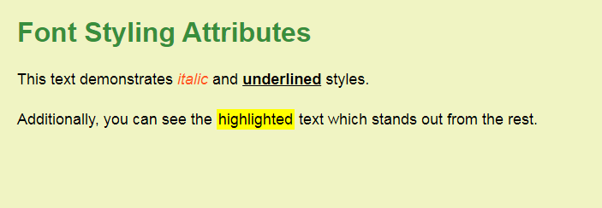

**Q7. Create a webpage containing two paragraph 1st paragraphs should be your qualification, 2nd is your interest and hobbies. (Both paragraphs have the same heading). Make use of Id selector.**

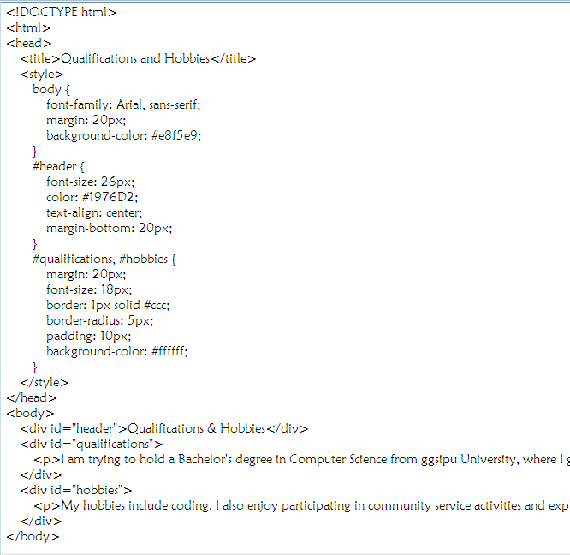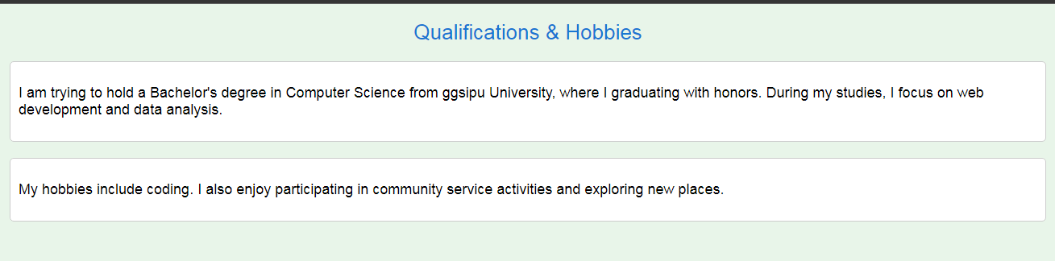

**Q8. Create a webpage showing the usage of class selector.**

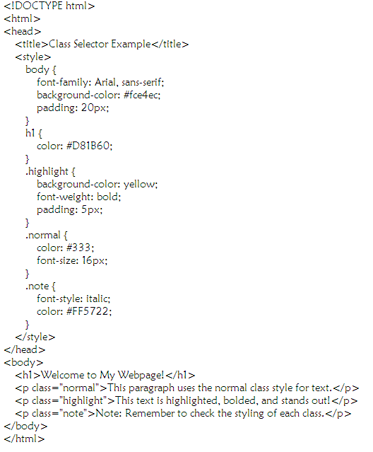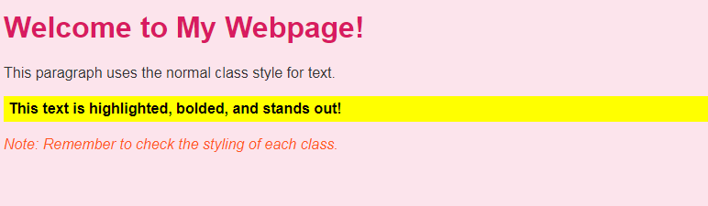

**Q9. Create a webpage containing details of different sun signs. Use all the text styling attributes.**

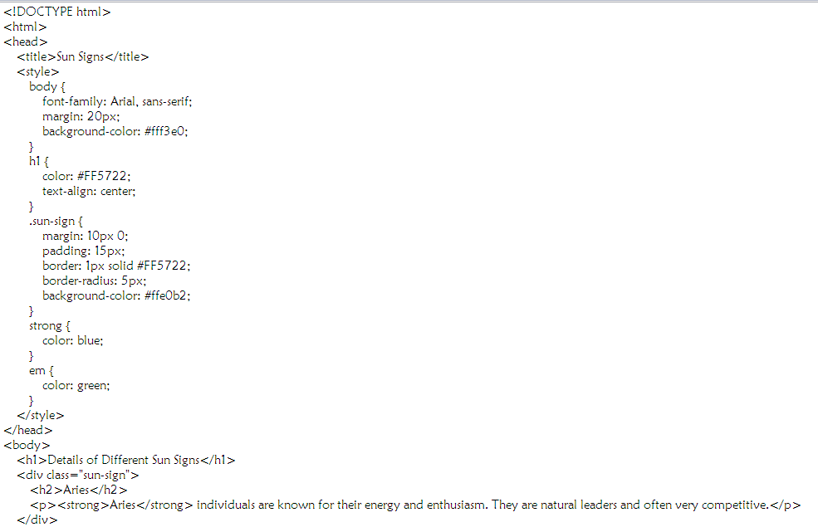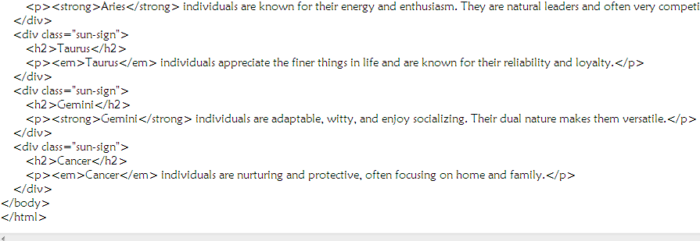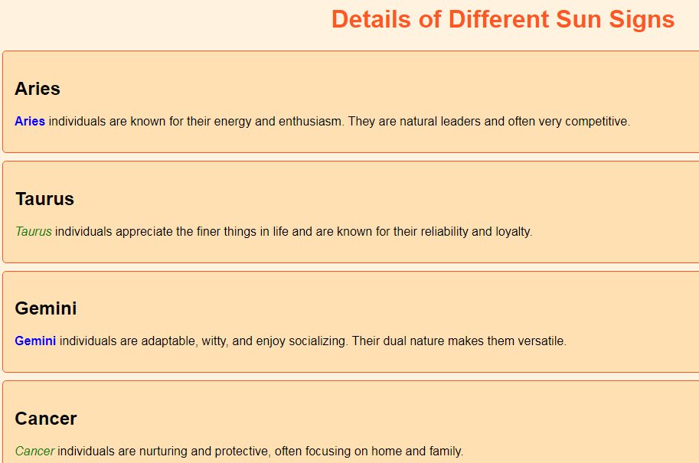

**Q10. Create a webpage containing the list of 9 planets, use all list styling attributes.**

