“AZURION RHYTHM GAME MANAGEMENT SYSTEM”

A Database System Design Project

Submitted in Partial Fulfillment of the Requirements for
ITIMT (Information Management) and for the program of
BACHELOR OF SCIENCE IN INFORMATION TECHNOLOGY
Carlos Hilado Memorial State University – Alijis Campus

Submitted by:

Trayfalgar, Jan Greoli
Judar, Ashley Kate
Rebatado, Kevin

Submitted to:

MARK JARUS TALANQUINES, MIT
Subject Professor

A.Y. 2024-2025

Operational Framework

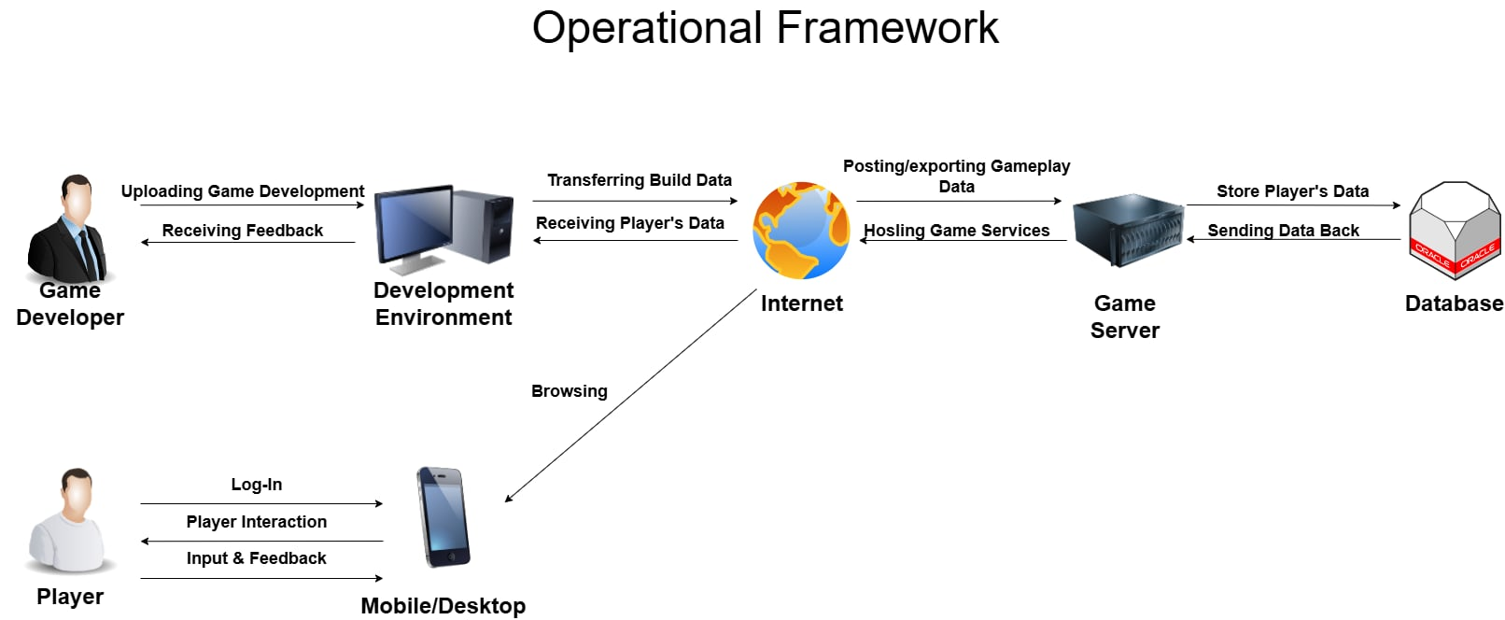

Context Diagram

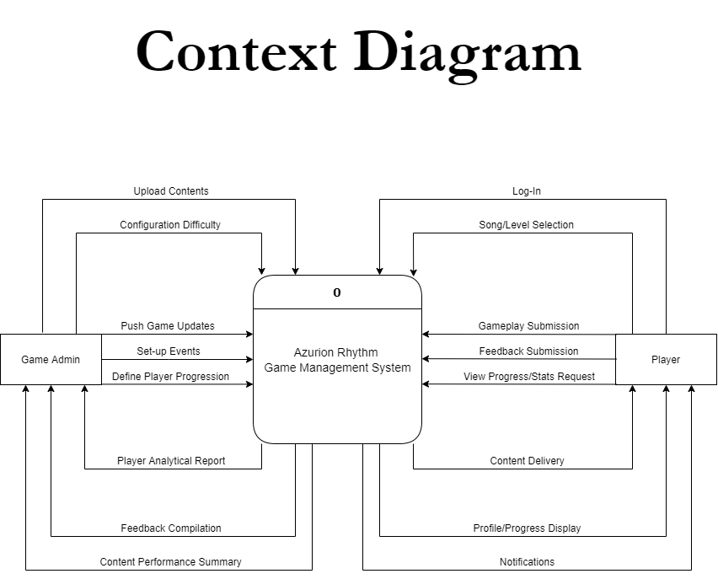

Data Flow Diagram

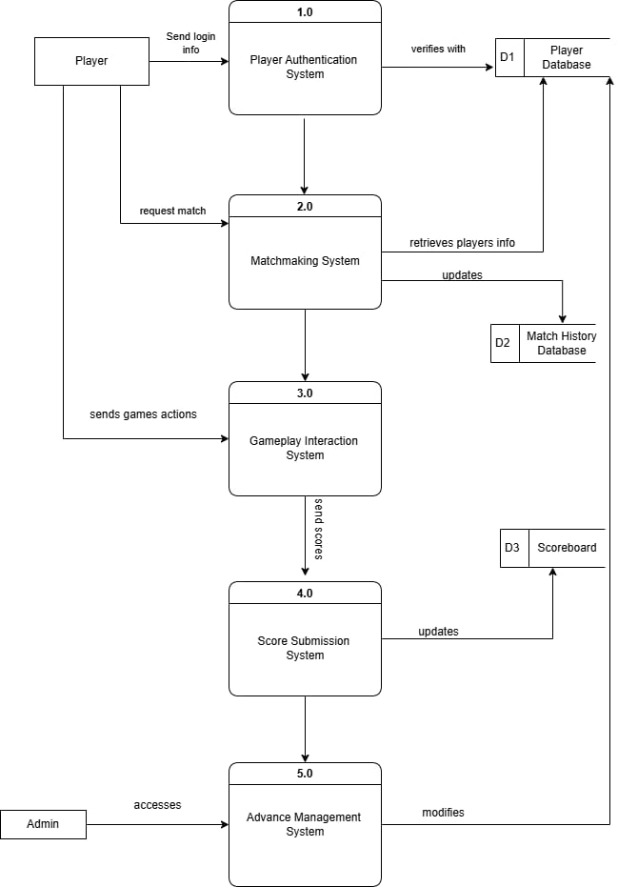

Entity Relationship Diagram

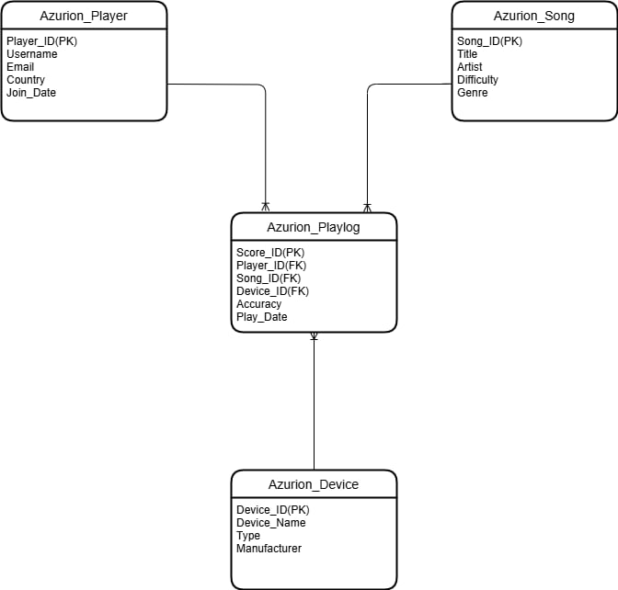

Data Dictionary

Player Table
Field Name | Type | Length | Description
Player_id | Int | 11 | Unique player ID
Username | Varchar | 50 | Player’s display name
Email | Varchar | 100 | Contact email
Join_date | Date | - | When the player joined

Songs Table
Field Name | Type | Length | Description
Songs_id | Int | 11 | Unique player for song
Title | Varchar | 50 | Song title
Artist | Varchar | 100 | Artist or Creator
Bpm | Float | - | Beats per minute
Audio_file | Varchar | 225 | File path or URL to audio
Difficulty | Varchar | 50 | e.g. Easy, Medium, Hard

GameSessions Table
Field Name | Type | Length | Description
Session_id | Int | 11 | Unique game session ID
Player_id | Int | 11 | Linked to Player.player_id
song_id | Int | 11 | Linked to Songs.song_id
score | Int | - | Player score for the session
accuracy | Float | - | Hit accuracy percentage
Combo_max | Int | - | Highest combo in this session
Session_time | Varchar | - | When the session took place

TimeLog Table
Field Name | Type | Length | Description
log_id | Int | 11 | Unique log entry
Player_id | Int | 11 | Linked to Player.player_id
login_time | Timestamp | - | Time the player logged in
logout_time | Timestamp | - | Time the player logged out
Session_id | Int | 11 | Related to GameSessions.session_id

GameModerator Table
Field Name | Type | Length | Description
moderator_id | Int | 11 | Unique moderator ID
username | Varchar | 11 | Moderator username
email | Varchar | 11 | Contact email
role | Varchar | - | e.g Admin,Chart Reviewer
Date_joined | Date | - | Date moderator joined the team

Use Case Diagram

