1. User can’t upload photo here 
2. Pop up of preview WO (Direct WO) - need UI changes

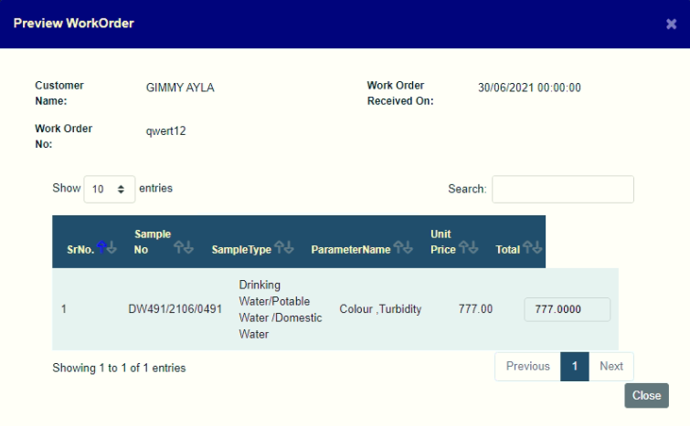

1. Pop up of Preview WO in enquiry - need UI changes

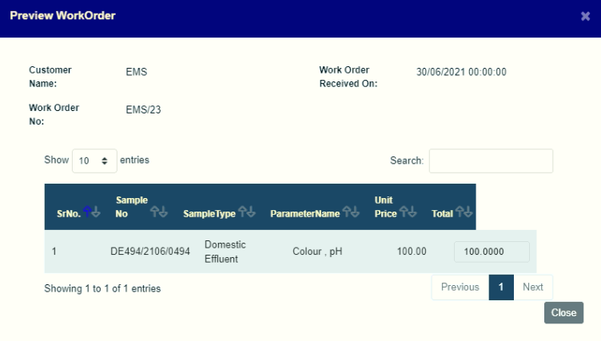

1. Problem with pH formula in Domestic Effluence

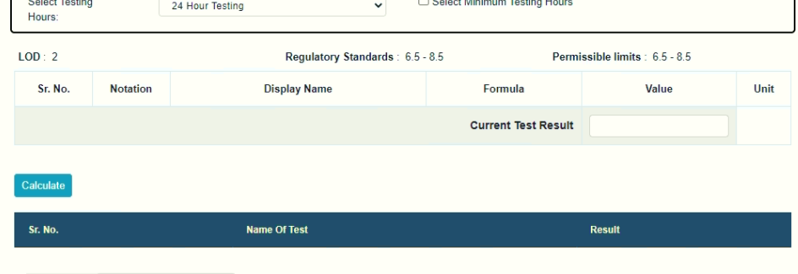

1. Problem with Colour formula in Domestic Effluence

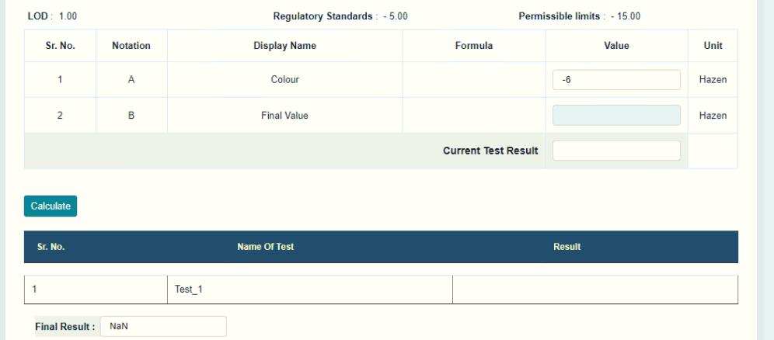

This result unable to forward to Reviewer, the pop will show with error

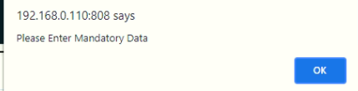

1. The width of the method selection box, at least 5 - 6 character should be appear

