1. After adding cost for 1st sample type, then grid is not updating for 1st sample type

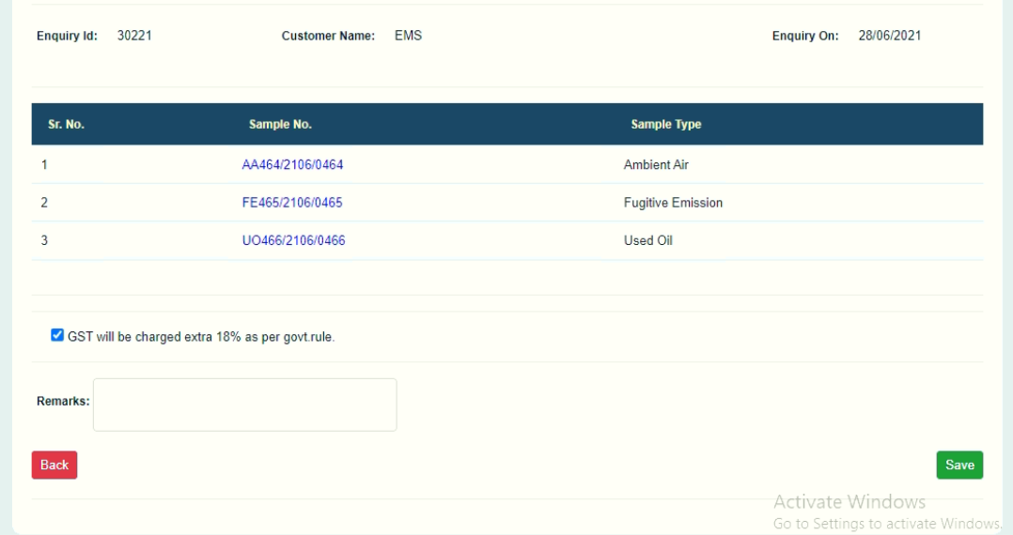

And after adding cost for 2nd sample type then grid will show 1st and 2nd sample type in the list

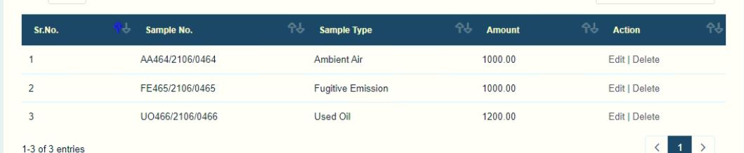

1. Parameter not showing in the list for Stack in quotation page

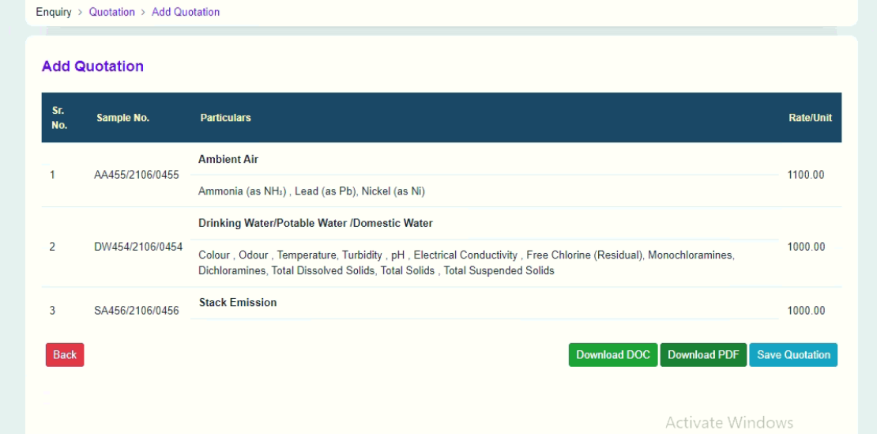

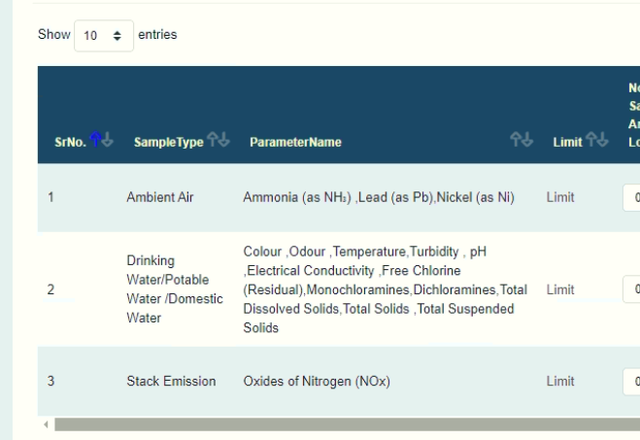

1. Sample id change in ARC report